Date: 25 February 2026

To the Landholder or Occupier,

Notification of 1080 PEST ANIMAL baiting program

The Department of Energy, Environment, and Climate Action (DEECA) will be undertaking a 1080 pest animal poisoning program using buried baits and canid pest ejectors on public land to manage predation on livestock.
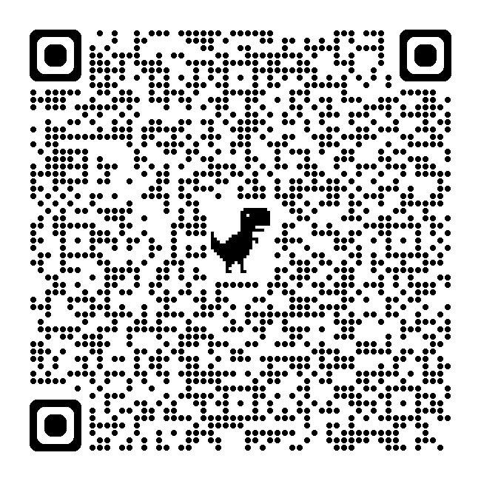
Baiting will occur from the 1 March 2026 to the 1 July 2026.

See attached map for an overview of where baiting will occur and for more detail refer to:
- https://agriculture.vic.gov.au/livestock-and-animals/livestock-health-and-welfare/livestock-predation-management/livestock-predation-management-in-eastern-victoria/baiting-notifications or
https://go.vic.gov.au/4dj5rCL
- Alternatively scan the QR code with a device

The use of the 1080 pest animal bait product will follow the product label and the Directions for the Use of 1080 and PAPP Pest Animal Bait Products in Victoria (DFU). When used following the product label and the DFU the chances of non-target animal impacts are reduced but there is still some risk.

Risk to your Animals

To minimise the risk of poisoning to your animals you are advised:
- Domestic animals, particularly dogs and cats, are susceptible to primary poisoning from ingesting 1080 pest animal bait products and secondary poisoning from ingesting contaminated carcasses.
  - Confine, muzzle and/or restrain your domestic animals, particularly dogs and cats, to prevent them from accessing 1080 pest animal poison baits or carcasses.
  - Closely watch the health and behaviour of your companion animals or livestock. If you notice any unusual or uncharacteristic behaviour, contact your local veterinarian at once.

- There is a delay in the poison action of 1080 and animals that have ingested 1080 pest animal bait products may die on your property.
  - Collect and destroy any poisoned carcasses you find by burning (following local regulations) or burying to a depth of at least 50 cm for rabbits and at least 1 metre for foxes, wild dogs and feral pigs.
  - Always dispose of carcasses away from natural features such as waterways.

Risk to Humans

Compound 1080 (sodium fluoroacetate) is a restricted schedule 7 poison and there is no known antidote. If you are handling poison bait and/or carcasses always use protective rubber gloves and wash hands and gloves thoroughly after contact.

If poisoning occurs immediately contact a doctor or the Poisons Information Centre on 13 11 26.
For further information please contact:

Gippsland Region
Wayne Peters
Team Leader Gippsland
Vertebrate Species Management Program Telephone: 0429 401 217
Hume Region
Craig Hamilton
Team Leader Hume and North West
Vertebrate Species Management Program Telephone: 0429 969 413
