Introduction
This document complements the suite of other guidance material available on the Code, and aims to provide participants with clarification on the requirements and expectations around the following Code components:
- Staff health
- Remote monitoring
- Health checks and treatment plans
- Housing acclimatisation program
- Muzzling
- Isolation housing
- Movement, transfer and sale of greyhounds
A checklist of activities is also provided to outline what is required to achieve and maintain compliance with the Code. Please note not all items on the list will be relevant to every establishment.
The following list of separate guidance documents are also available:
- Guide to developing an Establishment and Health Management Plan (EHMP)
- How to write a Standard Operating Procedure (SOP)
- Guide to developing emergency procedures
- Guide to understanding record keeping requirements
- Guide to understanding escape barriers and housing construction
- Code of Practice for the Keeping of Racing Greyhounds Frequently Asked Questions
Animal Welfare Victoria offers the following templates:
- Sample veterinary agreement
- Greyhound ID card
- Greyhound rehoming statement
- Greyhound record
- Sale guarantee
Greyhound Racing Victoria offers the Code Support Book that can be found on the Greyhound Care and Standards Website.

Staff health
The Code requires that staff health is protected at all greyhound establishments (see section 3.4).
Protecting staff health is achieved by ensuring all staff complete a staff induction process. The induction process must take place when staff first commence work at the establishment.
A staff induction protocol should inform staff on establishment protocols for the following:
- emergency management and response, including evacuation procedures
- hygiene and cleaning procedures
- any procedures relating to safety at the establishment
- general greyhound care and husbandry requirements, including whether any greyhounds are on specific treatment plans.
The above list is not comprehensive and provides a general overview of the information to be covered in a staff induction. Establishments should develop a staff induction protocol suited to their business and kennel needs, ensuring it is outlined in their EHMP.

Remote monitoring
The Code allows establishments to use remote monitoring (i.e. video cameras) in the following two circumstances:
- Overnight monitoring of greyhounds, where there are 51 or more greyhounds at the establishment (staff viewing footage may be off-site).
- Monitoring of whelping greyhounds (staff viewing footage must be on-site).
If establishments choose to use remote monitoring, it is recommended the Person in Charge ensures that:
- All cameras installed at the establishment have both audio and visual capabilities enabled at all times.
- All greyhounds being monitored are visible at all times.
- A back up power source is enabled for all cameras. For example, cameras can rely on batteries in the event that the establishment loses power.
- Footage from each camera is viewed by an appropriately qualified and/or experienced staff member at least every three hours
- A staff member who has completed their staff induction (and is therefore aware of all establishment protocols, including emergency procedures) is able to attend the property within 30 minutes, if issues or concerns are identified by the person monitoring the camera footage
- Procedures for remote monitoring are included in the establishment’s EHMP.

Health checks and treatment plans
The Code requires that all greyhounds receive an annual health check, and that a treatment plan is developed for any greyhound with health issues (e.g. injury or illness) (see section 6.2.3).
Health checks and treatment plans must be recorded in each individual greyhound record as applicable.

Health checks
The Person in Charge of any greyhound/s must arrange for a veterinary practitioner to conduct a health check on their greyhound/s on an annual basis. The Person in Charge could arrange for a health check to occur at the time of a greyhound’s annual Canine Cough vaccination.
The health check will include a thorough assessment of the greyhound’s wellbeing, where the vet will look for any signs of illness or other problems. The vet will generally check the greyhound’s weight, body condition, skin and fur, eyes and ears, teeth and mouth, and feel around the body, limbs and tail for any potential issues.
The vet may look for fleas or other parasites and will administer vaccinations if due.
Where issues are identified, the vet may recommend further tests or development of a treatment plan.

Treatment plans
Where a greyhound has a health issue, whether that be an injury, illness or other condition, the Person in Charge for that greyhound must work with their veterinary practitioner to develop a treatment plan.
A treatment plan details veterinary advice for the ongoing (either short-term or long-term) care of the greyhound. It includes anything your vet feels is necessary for the care and treatment of the greyhound. For example:
- administration of medication at certain times of the day (e.g. pain relief, antibiotics etc.)
- rehabilitation exercises
- daily monitoring requirements.

Housing acclimatisation program
A housing acclimatisation program looks to ensure greyhounds can adjust to a racing kennel after spending much of their time in a larger day yard or shared housing area.
Where relevant to the establishment, a housing acclimatisation program must be included in the EHMP. It must show how greyhounds will be, over time, assisted to adjust in moving from rearing pens and yards to racing kennels.
A housing acclimatisation program may include moving greyhounds into racing kennels for a certain amount of time per day, with time spent in the racing kennel gradually increasing over a period of days, weeks or months.
Any program must also consider how observations of any signs of stress, poor acclimatisation, or development of behavioural stereotypies will be recorded, including how these observations will be used as a management tool to assess the acclimatisation of the greyhound to new housing or changes to daily routine.

Isolation housing
Isolation housing is defined in the Code as:

“housing that is in a separate area to general greyhound housing and exercise areas, used specifically to house greyhounds diagnosed with or suspected of having an infectious disease.”

All greyhound establishments must have access to isolation housing. This can be on-site, managed according to protocols outlined in the EHMP, or managed off-site as part of the veterinary agreement.

If isolation housing is not available at the establishment or a veterinary clinic within reasonable distance, then the Person in Charge must seek advice from their veterinary practitioner on alterative options.

Muzzling
Muzzling requirements are outlined at chapter 6.2.5 of the Code. Establishments may also wish to document specific muzzling protocols in their EHMP.
Some examples of acceptable muzzles are shown below, noting they must be fitted to each individual greyhound so that they do not:
- restrict normal and necessary behaviour such as panting or drinking
- cause pain or distress to the greyhound.
A correctly fitted muzzle used to cover the nose and jaw area of a greyhound should not restrict normal and necessary behaviour such as panting and drinking. Taking measurements prior to purchasing or adjusting the muzzle will help to ensure a correct fit.
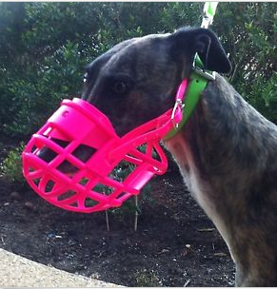
Yard muzzle – A yard muzzle is the safest and most comfortable muzzle. It allows the greyhound to drink, pant and vomit if necessary.

Basket muzzle – This can be made of wire or plastic and still allows the greyhound to drink, pant and vomit if necessary. Note that basket muzzles can become dislodged, so should not be left on unsupervised greyhounds.

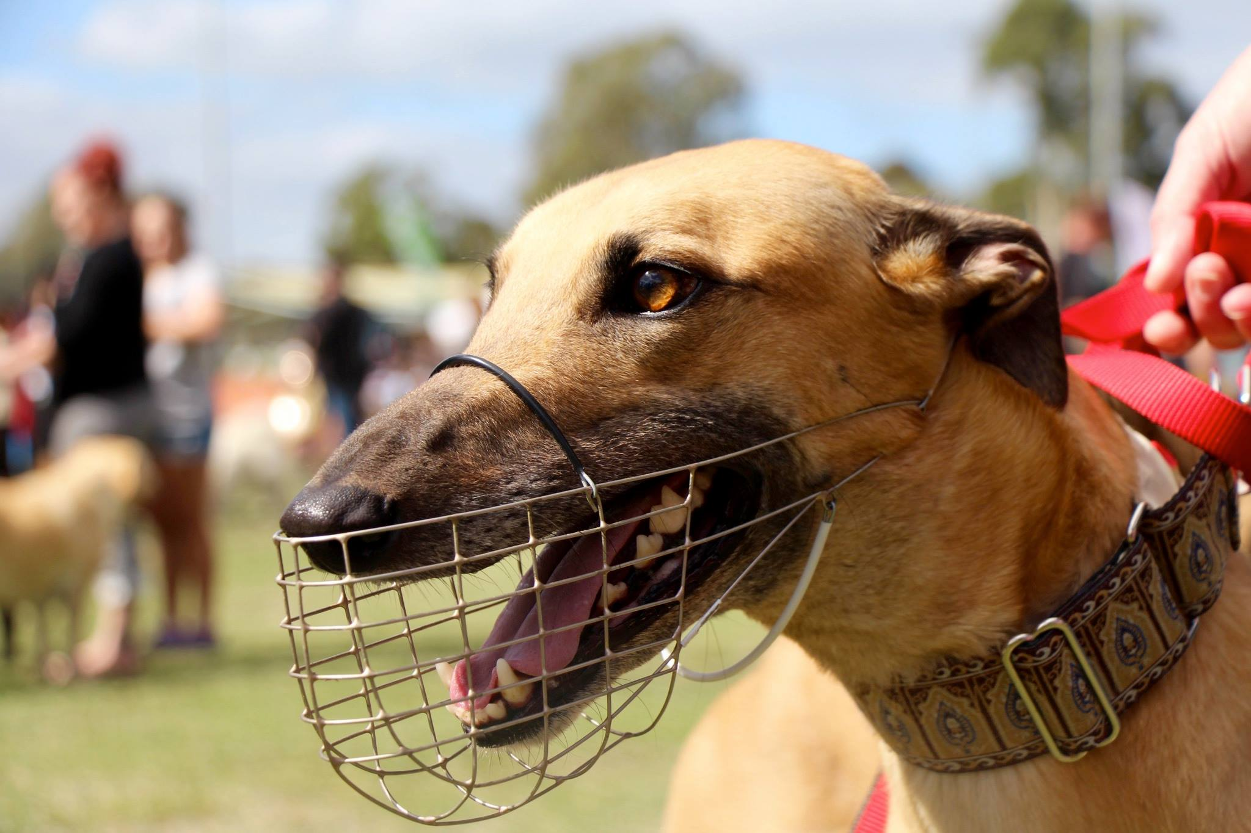
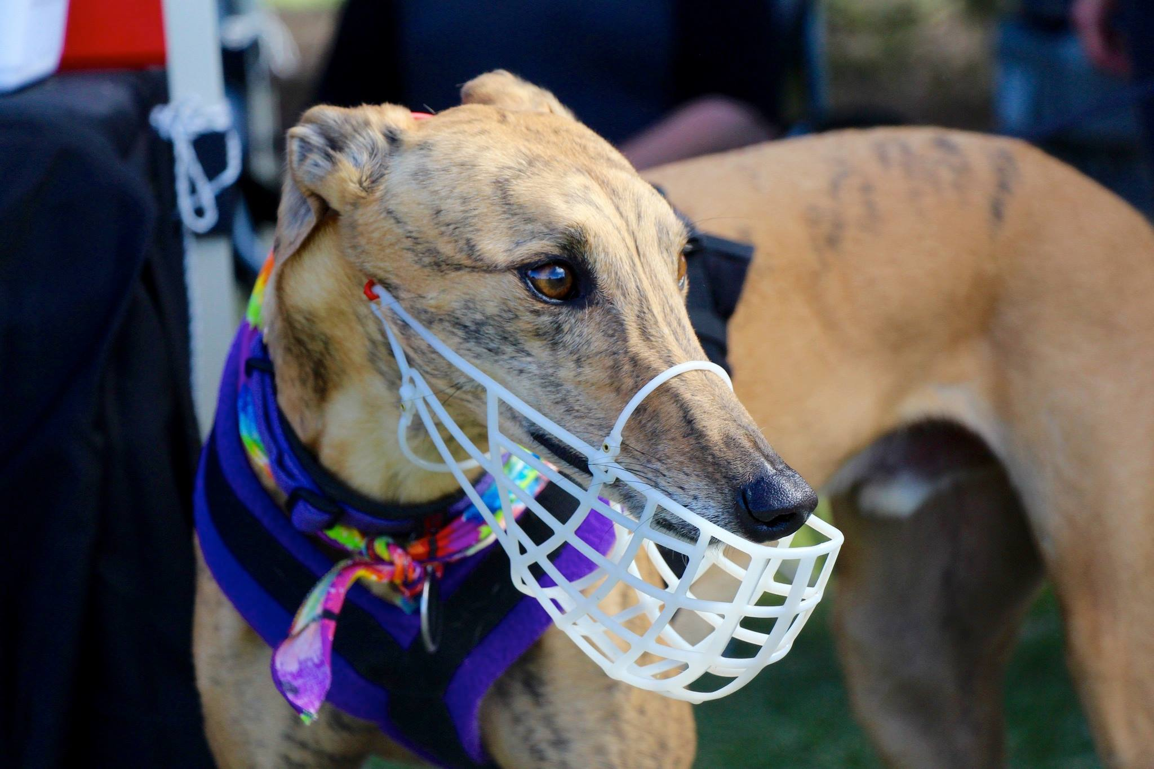

Movement, transfer and sale of greyhounds
All greyhounds being sold, given away or moved from an establishment must be accompanied by an up to date greyhound record (see section 7 of the Code).

The greyhound record must detail the greyhound’s full health history, including:
- any current or future treatment plan relevant to that greyhound
- details of any known physical abnormality or heritable defect (including injury).
Where there is a heritable defect, physical abnormality or injury, and a veterinary practitioner has provided advice on how it may affect the short or long-term welfare of the greyhound, that must also be included in the greyhound record.

Short-term transfers (i.e. four weeks or less)
The Person in Charge of any greyhound being moved or transferred between establishments for a period of four weeks or less must ensure:
- each greyhound is accompanied by their up to date greyhound record
- all relevant greyhound records are provided to the Person in Charge at the receiving establishment (either electronically or manually).

The Code does not apply any other requirements.

Sale, giving away or transfer to a GRV registered owner
The Person in Charge of any greyhound being sold, given away or transferred to another GRV registered owner must ensure that the greyhound does not permanently leave the establishment before eight weeks of age.

Upon leaving the establishment, the greyhound must:
- have all current vaccinations
- be accompanied by a copy of its up to date greyhound record
- be accompanied by a copy of the desexing certificate (if desexed)
- be transferred or sold in compliance with GRV requirements relevant at the time.

Movement, transfer or sale of greyhounds out of the industry
The Person in Chargeof any greyhound sold, given away or transferred to a party that is not associated with GRV, or any other Australian or New Zealand greyhound racing jurisdiction, must ensure that:
- the greyhound
  - has current vaccinations
  - is desexed before leaving the establishment, except if the receiving party has provided written agreement to desex the greyhound
  - is accompanied by a copy of the desexing certificate (if desexed).

- GRV is provided with:
  - the name, address, local government area, phone number and contact details of the new owner (including a registered shelter)
  - a copy of the greyhound’s desexing certificate (if desexed).

- New owners are provided with the up to date greyhound record (including any treatment plans), as well as literature about:
  - appropriate feeding
  - exercise
  - parasite control
  - housing
  - responsible pet ownership, including current legislation covering the registration of pet greyhounds with local council and any available training opportunities
  - the importance of greyhound training and socialisation
  - vaccination.
Literature is available free of charge on the Victorian Government’s website, through local councils, or on the GRV website.

Sale guarantee
Where GRV registered owners rehome a greyhound directly to independent community members who are not registered with GRV, a sale guarantee must be offered in accordance with section 7.2 of the Code.

The guarantee states that if a greyhound is returned to its former GRV registered owner within 21 days of sale or transfer, the former GRV registered owner must take back the greyhound and refund 100 per cent of the purchase price (if any).

This guarantee:
- does not apply to a greyhound rehomed through GRV’s Greyhound Adoption Program or any other adoption agency, rescue group or shelter.
- applies only if the greyhound is:
  - returned in the same state at which it was sold, or
  - accompanied by a statement from a veterinary practitioner that the greyhound is unacceptable for health or behavioural reasons that were likely to have been known at the time of sale or transfer.
A template sale guarantee will be made available at animalwelfare.vic.gov.au.

Checklist of activities
This section provides a checklist of activities to guide Persons in Charge to achieve and maintain compliance with the Code. Note: not all items on each list will be relevant to every establishment.

Staffing
- Ensure all staff are suitably qualified or experienced to care for the greyhounds at the establishment
- Ensure staffing rosters meet minimum staffing requirements
- If you are a new GRV participant, ensure you undergo minimum mandatory training and education as required for registration with GRV.
- Maintain ongoing training as appropriate.
- Ensure all staff complete the staff induction program.

Establishment operation
- Obtain signed agreement with establishment veterinarian(s) and place in records.
- Review the Guide to developing an Establishment and Health Management Plan (EHMP).
- Review the Guide to developing emergency procedures.
- Display emergency procedures in prominent location.
- Make an appointment with your establishment veterinary practitioner to review and approve relevant components of the EHMP.
- Ensure establishment animal transport vehicle meets minimum standards set out in the Code; make upgrades where possible.
- Ensure all greyhounds are securely confined and kennel areas can be locked.

Establishment records
- List of establishment staff names, including contact details and GRV registration number (if applicable).
- Copy of staff records, including dates on which staff completed their staff induction program, and competency/experience documentation.
- Where staff are appointed by the establishment, a complete set of staff rosters for a period of at least 12 months.
- Copy of veterinary agreement.
- Copy of EHMP.
- List of greyhounds sold or given away from the establishment, including a copy of the veterinary practitioner’s general health certificate for each greyhound.
- List of greyhounds moved to another establishment (both short-term and long-term movements).
- For greyhounds entering the establishment, as appropriate:
  - purchase or acquisition details
  - contact details of the previous owner and person in charge
  - previous location
  - microchip number
  - copy of transfer of ownership documentation (e.g. microchip transfer forms)
  - up to date greyhound record at the time of arrival.
- Prepare all records for easy inspection by Authorised Officers.

Greyhound records
- Ensure individual greyhound records meet minimum requirements outline in section 5.2 of the Code
  - Name, sex, birth date, distinguishing features, dam and sire details, microchip number
  - Health care and veterinary history, including vaccinations, parasite control, injuries, first aid or veterinary treatment, including administered medications, treatment plans etc.
  - Greyhound breeding records
  - Rehoming details
  - Euthanasia records (if applicable)
- Maintain all records for easy inspection by Authorised Officers.
- Ensure every kennel/pen displays a unique identifier that links to the relevant greyhound record/s (e.g. microchip number).
- Ensure a complete greyhound record accompanies any greyhound moved, sold or given away from the establishment.
Note: Records may be kept in hard copy or electronically.

Management of greyhounds
- Ensure all greyhounds are cared for as required by the Code and the EHMP, this includes food, water, grooming, exercise, socialisation, enrichment etc.
- Ensure vaccinations are up to date and vaccination certificates complete — file in records.
- Ensure all greyhounds receive their annual health check and annual Canine Cough vaccination.
- Determine whether any breeding animals have reached their maximum litter/age limit.
- Begin preparing greyhounds that are deemed unsuitable for racing or breeding for retirement in accordance with section 6.5 of the Code or your EHMP.

Facilities
- Review bedding/beds, enrichment objects, food receptacles, water bowls, cleaning equipment, etc. inventory as per minimum requirements in the Code; and purchase/replace equipment as required.
- Review facility (such as kennels/day yards/bull ring/slipping track/exercise areas etc) and upgrade as required to meet minimum standards of the Code.
- Prepare cost estimates for facility upgrades (recommended).
- Where your facilities are not currently compliant with the Code, you may wish to discuss this with GRV.

For more help on the Code’s requirements, please contact us at pet.welfare@ecodev.vic.gov.au.

