To weigh or not to weigh
Farming Systems Demonstrations (FSD)
Demonstration goal: To understand how much monitoring (frequency and number of animals verses mob based) is required to accurately predict weights and sale dates of lambs to optimise labour usage, lamb performance, feed use efficiency, replacement ewe selection and marketing outcomes.

Site location: Echuca district
Producer Group: Rich River BestWool/BestLamb
Group Coordinator: Kristy Howard
Agriculture Victoria Coordinator: Kirstie Anderson
Duration: 2018-2021

What are we aiming to achieve and why?
Increasingly lamb producers are aware that weighing lambs to determine growth rate can increase productivity by identifying lower than expected performance and addressing limitations. This enables increased pasture and ration utilisation by as lambs can be redirected to more suitable production systems. Furthermore, monitoring growth rates promotes greater compliance to processor requirements by not supplying out-of-specification lambs.
However, monitoring lamb live weight regularly requires significant resources including equipment, labour and time. In mixed farming businesses, this allocation of resources is often at the expense of other enterprises. There is also the potential to reduce lamb performance through increased time off feed and stress associated with mustering, yarding and handling.

This project aims to:
- Demonstrate increased lamb turn-off efficiency (percent of lambs turned off in defined lamb selling period) by monitoring growth rate.
- Demonstrate management options and decision support tools for lambs with varying live weight and growth performance.
- Increase awareness and understanding of the lamb supply chain and market specifications leading to increased compliance to lamb processor specifications.
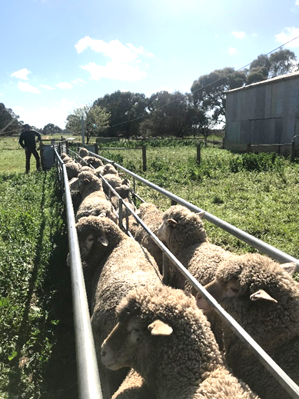
- Determine the cost: benefit of measuring individuals versus mob average for lamb finishing systems.
Method:
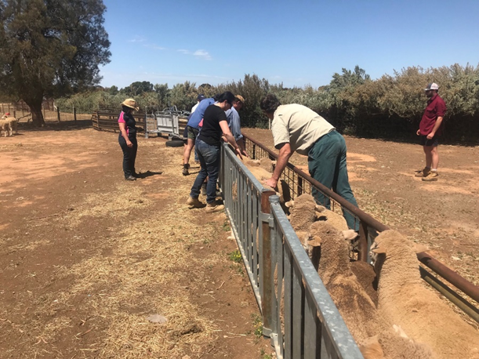
The demonstration takes place on at least four producer properties, using one mob of lambs per site and is monitored over two seasons.

Treatments for monitoring intensity include:
Treatment 1 – ‘I think I can pick them visually’
No monitoring until prior to sale (i.e. visual assessment until they are ready then draft into sale lots based on weight and draft off slow growers)
Hypothesis: Weighing before sale dates won’t supply any useful information or opportunities for increasing productivity in trade lamb operations.
Treatment 2 - ‘Some is better than none’
Mob based weighing and growth rate estimates (2 or 3 measurements post weaning and prior to sale date). All lambs in mob weighed.
Hypothesis: Weaning weight and individual weights won’t supply any useful information or opportunities for increasing productivity in trade lamb operations.
Treatment 3 – ‘Not the full Monty’
Weighing a Percentage of the mob from weaning to sale at regular intervals.
Hypothesis: Weighing a portion (20-50 per cent) of the mob provides the same amount of useful information or opportunities for increasing productivity in trade lamb operations.
Note: this dataset will be obtained by analysis of Treatments 2 and 4. There is no physical site location.
Treatment 4 – ‘The full Monty’
Individual animal monitoring (whole mob), marking to sale at regular intervals.
Hypothesis: Weighing all lambs within the mob using individual records provides the more useful information or opportunities for increasing productivity in trade lamb operations than mob-based systems.

Contacts
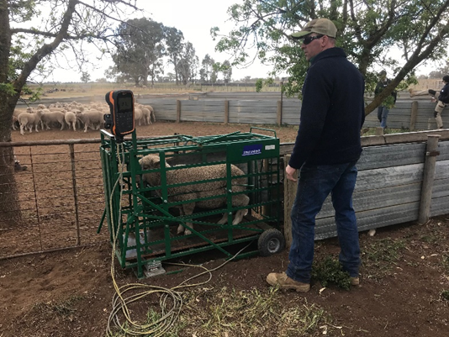
Kristie Anderson, kristie.anderson@agriculture.vic.gov.au
Disclaimer: This publication may be of assistance to you but the State of Victoria and its employees do not guarantee that the publication is without flaw of any kind or is wholly appropriate for your particular purposes and therefore disclaims all liability for any error, loss or other consequence which may arise from you relying on any information in this publication. While every effort has been made to ensure the currency, accuracy or completeness of the content we endeavour to keep the content relevant and up to date and reserve the right to make changes as require. The Victorian Government, authors and presenters do not accept any liability to any person for the information (or the use of the information) which is provided or referred to in the report.

Accessibility
If you would like to receive this publication in an accessible format, please telephone our Customer Service Centre on 136 186, email customer.service@ecodev.vic.gov.au or via the National Relay Service on 133 677, www.relayservice.com.au.
This document is also available at http://agriculture.vic.gov.au/agriculture/livestock/on-farm-demonstrations
www.victoriangovernmentdepartment.vic.gov.au

