Aerial spraying of agricultural chemicals
A guide for land managers to ensure spraying is undertaken responsibly

Aerial spraying of agricultural chemicals using a helicopter or fixed wing aircraft plays an important role in Australian agriculture and land management. When carried out correctly, it offers fast application and access to areas where ground-based spraying is not practical.
This guide outlines responsibilities and provides tips for land managers to assist in the safe and appropriate aerial spraying of agricultural chemicals.
Land managers should explore all control methods available to them. This guide assumes that land managers have appropriately assessed their chemical use method for pest/disease control as part of their integrated pest management plan.
Planning
Spraying chemicals requires careful management and preparation. Spray drift from any equipment (aerial or ground-based) can be harmful to human health, the environment, and livelihoods. Before engaging a spraying contractor, consider the potential harm of spray drift to any assets or sensitive areas both on-site and on adjacent land, including public land. Assets/sensitive areas include (but are not restricted to) crops, livestock, native vegetation, aquatic areas, houses, and other areas where people congregate (e.g. schools).
If you determine aerial spraying of chemicals is appropriate, work with the spraying contractor to manage all potential risks. If risks cannot be managed, then you must explore other control methods.
Engage a licensed pilot
The aerial spraying of agricultural chemicals must be undertaken by a pilot who has appropriate training and is licensed by Agriculture Victoria. The company the pilot works for must also be licensed by Agriculture Victoria. To check, call our Customer Service Centre on 1300 502 656 and ask to speak to a Chemical Standards Officer.
Choose the right chemical product and read the product label
Seek advice from a chemical reseller or agronomist. Read the product label thoroughly to ensure the most appropriate chemical is used for the situation. Chemical products must be used in accordance with all label directions. Labels can contain warnings, restraints, prohibitions, and a mandatory spray droplet size. Some chemicals are also prohibited for use by aircraft.
Agricultural Chemical Control Areas
Nine Agricultural Chemical Control Areas (ACCAs) have been established in Victoria to protect sensitive crops, including grapevines, vegetable crops and fruit/nut trees from spray drift damage. Within each ACCA, restrictions apply to the types of herbicides, their application method, and the time of year in which certain chemicals can be used.
To check if the location you intend to spray is within an ACCA, visit www.agriculture.vic.gov.au/chemicaluse or call our Customer Service Centre on 1300 502 656.
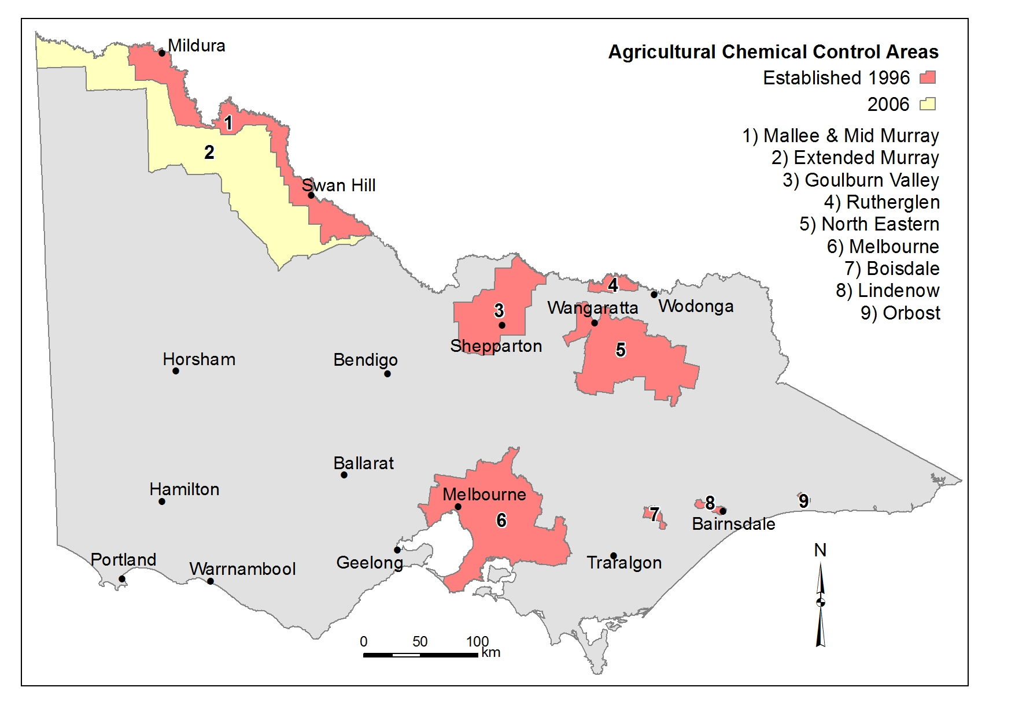
Notification and communication
Notification is required when chemicals are sprayed by aircraft (or a mister) within 200 metres of a school, hospital, aged care facility or children’s service.
At least 12 hours before spraying is to occur within 200 metres of these facilities, the occupier of the land must make every reasonable effort to inform the school principal, site manager or person in charge of the facility of:
• trade name of the chemical product to be used
• location of the proposed spraying
• proposed date, time, and duration of spraying.
At the time a person is employed or contracted to carry out spraying by aircraft or mister, the occupier of the land must advise them in writing of:
• the details of the location/s of any school, hospital, aged care service or children’s service within 200 m of the land to be sprayed.
At least 24 hours before spraying is to occur, the employee or spray contractor must provide the occupier of the land with:
• trade name of the chemical product to be used
• proposed time, date, and duration of the spraying.
Talk to all neighbours, including public land managers prior to aerial spraying, particularly if spraying near a different crop type, livestock, native vegetation, aquatic area, or house.
Good communication with neighbours before spraying can help to prevent misunderstandings and potential problems.
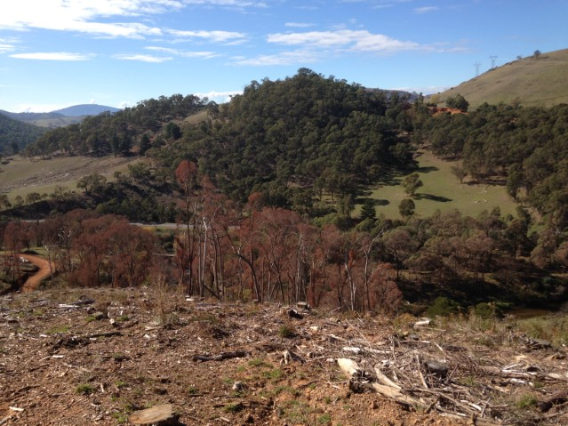
Manage the risk of off-target damage
If you consider the conditions to be unsuitable for spraying, you must discuss your concerns with the pilot. The drift of agricultural chemicals can be harmful to human health, the environment, and livelihoods. Steps must be taken to minimise spray drift damage at the planning stage.
Assets or sensitive areas at risk should be identified and buffer zones defined in advance. If there is a risk of spray drift causing damage, delay spraying until conditions are favourable.
Under the Agricultural and Veterinary Chemicals (Control of Use) Regulations 2017, one or more of the following methods must be used immediately before and during aerial spraying:
• smoke generating device used at ground level at or near the point of spraying
• smoke generating device fitted to the aircraft
• windsock operating and clearly visible to the pilot at ground level at or near the point of spraying
• automatic weather station located at or near the point of spraying, with information about the wind speed and direction available to the pilot
• the pilot is in continuous radio communication before and during spraying with a ground-based person, who is near the point of spraying and uses equipment to measure the wind speed and direction.
In Victoria it is an offence to carry out chemical spraying which:
• injures any plants that have economic value (e.g. crops) or stock outside the target area
• injures any land outside the target area, so growing plants, or keeping stock on that land would result in contamination
• is likely to contaminate any agricultural produce derived from plants or stock outside the target area, and/or
• destroys native vegetation unless a valid permit has been issued by local council or other relevant government agency.
There are also offences when spray drift impacts air quality, water quality, human health, and worker safety. These offences are investigated by other agencies, including the Environmental Protection Agency (EPA), local government and/or WorkSafe.
The pilot and land manager have a responsibility to manage the risk of off-target damage from spray drift. The land manager may be held liable for an offence committed by the pilot if they are found to have not taken all reasonable steps in preventing the offence.
Buffer zones
A buffer zone is an area of land where no chemical is applied between the target area and an asset or sensitive area. Buffer zones should be used to minimise the effect of spray drift on surrounding assets/sensitive areas. They allow the chemical spray to settle out of the air as it travels into the buffer zone before reaching and damaging an asset/sensitive area. Some product labels have mandatory buffer zones, which must be followed.
Maps
It is highly desirable that maps and/or diagrams relating to the target area and its surroundings are provided to the pilot as part of the planning process.
This information must highlight things such as nearby crop types, roads, native vegetation, aquatic areas, houses, public land, and potential hazards (e.g. overhead powerlines).
The location of nearby schools, hospitals, aged care facilities or children’s services must be provided to the pilot.
Ensure the information provided is accurate. It is an offence to provide maps and/or documents containing information that leads to the pilot committing an offence under the Agricultural and Veterinary Chemicals (Control of Use) Act 1992.
Record keeping
Keeping specified records is required by law for users of all agricultural chemicals in Victoria. Records must be made within 48 hours of use and kept for two years by the pilot. The land manager may ask the pilot for a copy of the record.
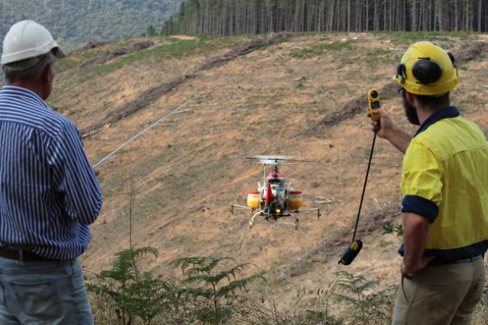
Take action if spray drift has occurred
If spray drift damage has occurred to crops, land, livestock, native vegetation, or aquatic areas, report it immediately by calling the Agriculture Victoria Customer Service Centre on 1300 502 656.
Public health issues
Individuals with health concerns relating to spray drift should contact the Environmental Health Officer at their local council. It is also essential to contact a doctor if health issues are encountered.
Environmental issues
For enquiries relating to the pollution or contamination of land, air or water, contact the Environmental Protection Authority on 1300 372 842.
Occupational Health and Safety
For enquiries relating to workplace occupational health and safety issues contact WorkSafe on 1800 136 089.
© The State of Victoria, July 2022
Authorised by Agriculture Victoria, 1 Spring Street, Melbourne.

This work is licensed under a Creative Commons Attribution 3.0 Australia licence. You are free to re-use the work under that licence, on the condition that you credit the State of Victoria as author. The licence does not apply to any images, photographs or branding, including the Victorian Coat of Arms, the Victorian Government logo and the Agriculture Victoria logo. To view a copy of this licence, visit http://creativecommons.org/licenses/by/3.0/au/deed.en
ISBN 978-1-925532-51-7 (Print)
ISBN 978-1-925532-52-4 (pdf/online)
Accessibility
If you would like to receive this publication in an alternative format, please telephone the Customer Service Centre 1300 502 656, email info@agriculture.vic.gov.au, via the National Relay Service on 133 677 www.relayservice.com.au. This document is also available on the internet at www.agriculture.vic.gov.au
Disclaimer
This publication may be of assistance to you but the State of Victoria and its employees do not guarantee that the publication is without flaw of any kind or is wholly appropriate for your particular purposes and therefore disclaims all liability for any error, loss or other consequence which may arise from you relying on any information in this publication.
www.agriculture.vic.gov.au/chemials

