Varroa: an exotic parasitic mite of honey bees
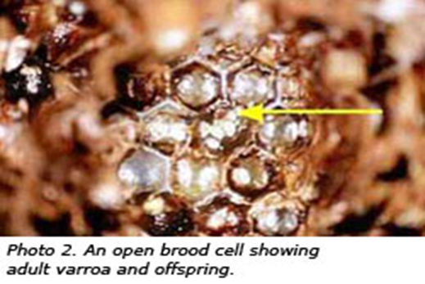
Varroa (Varroa destructor) is a parasite of adult honey bees and honey bee brood. It weakens and kills honey bee colonies and can also transmit honey bee viruses. Varroa is not in Australia, but if it becomes established, it will be a major problem to commercial and hobby beekeepers. Here’s what you can do to help.

How do i recognise varroa?
Adult female varroa are reddish-brown, shaped like a scallop shell, about 1.1 mm long and 1.7 mm broad and visible to the naked eye.
Females of Varroa jacobsoni, another exotic species, are smaller than females of V. destructor, being about 1.0 mm long and 1.5 mm wide.

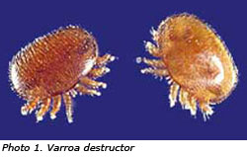
Photo courtesy Scott Bauer, USDA ARS Image Gallery
Photo courtesy Denis Anderson. CSIRO Entomology, Canberra

What should I do if I suspect varroa mite?
If you see or suspect varroa is present in your apiary, you must notify Agriculture Victoria on (03) 9217 4166, or alternatively the Exotic Plant Pest Hotline on 1800 084 881.
Notification is required by the Livestock Disease Control Act (1994). To not notify is to break the law and you could be fined.

Surveillance and testing for varroa
Early recognition of varroa is one of the most important factors influencing the chance of controlling the parasite and reducing its economic and social impact on the whole community.
Based on overseas experience, varroa is expected to cause a shortage of bees for pollination of bee dependant horticultural and seed crops.
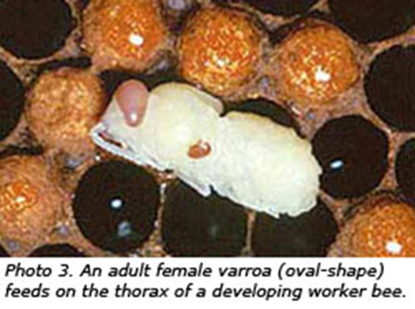
Photo courtesy Scott Bauer, USDA ARS Image Gallery
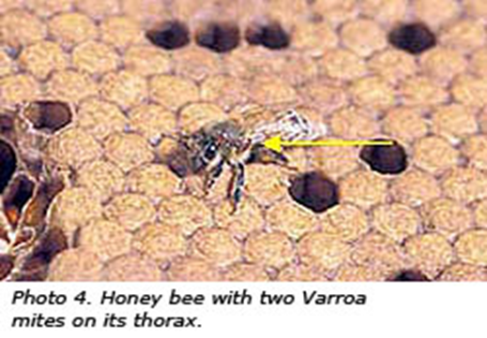
All beekeepers are required to regularly test their hives for varroa and report any varroa, or suspicion of varroa to Agriculture Victoria.
Beekeepers can use the ‘sugar shake’ test, which involves dusting approximately 300 adult bees with pure icing sugar.
An alternative is to examine at least 100 drone pupae. Remove these from their sealed cells and examine them for varroa. If drone pupae are not available, worker bee pupae can be examined instead.
If varroa or a suspect varroa is detected, place it in a small jar or vial containing methylated spirits and keep it a cool, safe place away from sunlight. Don’t mail or forward it until advised by an Agriculture Victoria apiary officer.
Reassemble the opened hive to its normal position. Mark the hive with a water proof felt pen so it can be easily identified later. Mark the lid and all the boxes of the hive with the same identification number.
Never take live specimens from the apiary as this may help to spread varroa.

Prevent the spread of varroa
Varroa can readily transfer between adult bees. Foraging and drifting bees, as well as swarms, can also spread varroa. In the case of foragers, mites can move from a bee to a flower and then hitch a ride with another bee or insect visiting the same flower and move to another bee colony or apiary.
The mites may be spread between colonies and apiaries when bees, including queen bees, bee brood, used hive components and used beekeeping equipment are interchanged during normal management apiary practices.
The normal movement of these items and apiary products over long distances is a very effective and fast means of spreading varroa.
Beekeepers can prevent further spread of varroa from an apiary by following simple biosecurity measures:
- never remove bees, hive components, equipment, honey combs for extracting and apiary products from an apiary without a written permit
- thoroughly wash hands, tools and equipment before leaving the apiary
- leave overalls, gloves, gauntlets and veil in a plastic bag at the apiary site until advised by a DEDJTR apiary officer
- inspect your vehicle to make sure there are no bees trapped inside or on the radiator or in boxes of combs and other material on-board. Check the tray of the truck, ute or trailer as well. Boxes of combs and other hive material on your vehicle in which bees might enter must be left at the apiary.
Photo courtesy Stephen Ausmus, USDA ARS Image Gallery

Be aware of the varroa life cycle
Varroa only produce offspring when honey bee brood is present in hives. Mated female varroa enter drone and worker brood cells containing mature larvae just before hive bees cap the cells. The female varroa move to the base of the cell and submerge themselves in the larval food. When the cell is capped, the submerged mites move to the larva and begin feeding.
Individual females lay up to six eggs, beginning about 60-70 hours after the cell was capped and thereafter at intervals of about 30 hours. The first egg laid is male and all the others are female. Eggs are laid on the base and walls of the cell, and sometimes on the developing bee.
Development of female varroa from egg to adult takes about 8 to 10 days. The long interval between the laying of individual eggs means that mites of different stages of development may be seen in the one cell. Protonymphs hatch from eggs about 12 hours after laying. A larger duetonymph stage occurs before the final adult stage.
The single male varroa mates with its sisters while they are in the brood cell. When the new adult bee emerges from its cell, the young varroa females and mother mite also leave the cell, often on the emerging bee.
The daughter mites feed on adult bees and after a short period enter other brood cells to lay eggs.
When there is no brood in the hive, such as in winter, all mites will be found on adult bees.

Field diagnosis
All stages of the mite are difficult to detect. In lightly infested colonies they are mostly found in sealed brood cells. The mites may be seen on drone and worker pupae in sealed brood cells. It is first necessary to uncap these cells and remove the pupae for examination.
Female mites may be found on adult bees, especially in over-wintering colonies that have no honey bee brood. They may be found between the first abdominal segments of an adult bee where they hide between the sclerites.
Mite numbers increase slowly within a hive. It may not be until several years of infestation that numbers are sufficiently high for honey bee larvae to be parasitised by several females. When this occurs, newly emerged adult bees with deformed wings, legs and abdomens may be found at the hive entrance.
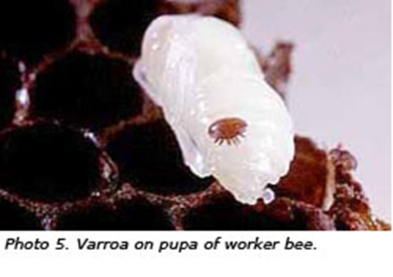
Patchy brood patterns may also be seen in advanced infestations. Colonies affected to this extent will usually die.
Photo courtesy Denis Anderson, CSIRO Entomology, Canberra

Safety
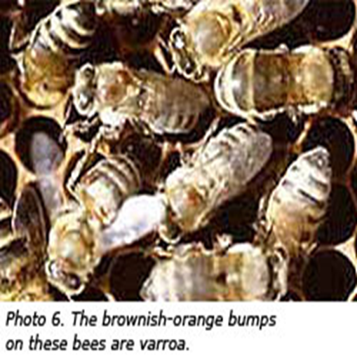
There is no danger to human health from varroa mite. Honey, comb honey and honey products are safe to eat.
Photo courtesy Lila De Guzman, USDA ARS Image Gallery

Contact Agriculture Victoria
If you see or suspect varroa is present in your apiary, you must notify Agriculture Victoria by calling (03) 9217 4166 in a timely manner. Alternatively, you can ring the Exotic Plant Pest Hotline on 1800 084 881.

Accessibility
If you would like to receive this publication in an accessible format, please telephone the Customer Contact Centre on 136 186.
This document is also available Word format at agriculture.vic.gov.au

