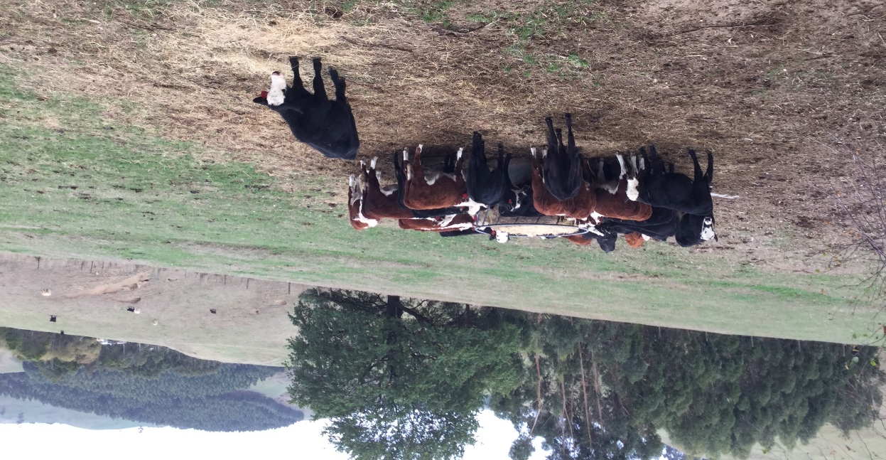
Coordinator – John Bowman, Agriculture Victoria, Leongatha.
Group – Mirboo North-Boolarra; 18 businesses
Enterprise mix
- Steer traders and breeding enterprises
Conserving surplus spring growth: silage or hay?
One of the most interesting parts of a BetterBeef group meeting is the informal group ‘whip around’ where the coordinator asks each producer to share their current farming issues and challenges. John Bowman, the Mirboo-North Boolarra group coordinator, finds most of the solutions to questions raised can be found within the group’s knowledge and experience, and they just need to be shared and discussed as a group.
Often a topic raised in the ‘whip around’ session can generate a lot of discussion, as was the case for the group at their October 2019 meeting. One of the producers raised the question: “I’m not sure if I should make silage this year or just stick with making hay rolls, what is the best way to conserve the extra spring growth?”.
John Bowman said the ensuing discussion was lively. It began with a couple of ex-dairy farmers sprouting the benefits of silage quality and early regrowth while others explained the extra cost. A whiteboard came into action to capture the details of the discussion.
Table 1: A summary of the whiteboard notes from the silage versus hay discussion
Advantages of silage | Disadvantages of silage
More megajoules of energy | Double the cost per bale
Gets off the paddock early | Less kilograms of dry matter per bale
Early paddock regrowth | Need specialist equipment
Possible second cut for hay | Hard to find good contractor
Cattle do better on silage | Weather may not be suitable
Ideal feed in autumn | Sometimes goes mouldy
Higher protein levels | Birds attack the plastic wrap
Only need two to three fine days | Need ‘soft hands’ to move rolls
More palatable to stock. | Problem disposing of wrap
Able to be stored outside | Environmental waste
Spreads the workload, as not all paddocks ready at once: early for silage then hay later | Need to move off paddock
 | Extra time to feed out
 | Does not store beyond first year
One of the participants in the group was a hay and silage contractor who John said was quietly taking it all in, before adding any comments. With a little prompting the contractor clarified the machinery requirements and the current costs for making the two fodders:
Hay cost $21 per large roll, producing 330 kg of dry matter (DM).
Silage cost $42 per roll (baled and wrapped), producing 250 kg of dry matter.
Cost analysis of silage and hay
There was considerable concern about the extra cost of making silage over hay, so the group listed some of the costs.
It was suggested the cost be calculated based on cents per megajoule (MJ) of energy per kg of dry matter (DM). So back to the whiteboard for a two-step process:
Step 1 | Step 2 | Answer
Total kg of DM per roll multiplied by MJ of energy per kg of DM. | Cost per roll divided by the answer from Step 1 | cents per megajoule of feed (c/MJ)
- Silage: Bale weight = 250 kg DM. MJ per kg DM = 9.5 MJ. Baling cost = $42 per roll.
250 kg x 9.5 = 2375 MJ | $42.00 / 2375 MJ | = 1.76 cents per MJ
- Hay: Bale weight = 330 kg DM. MJ per kg DM = 8.5 MJ. Baling cost = $21 per roll.
330kg x 8 MJ = 2640 MJ | $21.00 / 2640 MJ | = 0.7 cents per MJ
While silage may produce less dry matter per roll, it provides more megajoules of energy per kilogram of dry matter. That is, it has a higher energy density per kilogram of dry matter.
The hay worked out to be the cheaper feed on a cents per megajoule basis, but silage has a higher feed value, is more palatable and therefore results in better stock performance. Stock must also eat more hay to consume the same amount of megajoules provided by the silage.
Discussion followed on the cost versus benefit of having the paddock back ready to graze after the early silage had been harvested from the paddock, allowing for an extra grazing in spring. The extra pasture can result in 1000 kg of dry matter per hectare at 11 MJ = 11,000 megajoules per hectare, which can be eaten by steers and potentially add on another 100 kilograms of beef produced. At a liveweight sale price of $3.00 per kg = $300 per hectare, there’s the possibility of getting steers to market weight and off the farm earlier in the season.
John said these figures seemed to be ‘the clincher’ for the producer who had asked the initial question. He planned to make silage for the 2019 season and report back his findings for further discussion in winter 2020. Other group members are also reassessing their practices for conserving extra spring growth.

