Use of diatomaceous earth in beekeeping
Diatomaceous earth (DE), also known as amorphous silica, is sometimes recommended in other states or on-line as an in-hive control for small hive beetle.

Food grade de
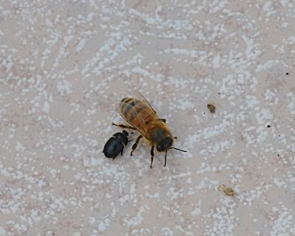
Beekeepers should understand the need to use ‘food grade’ DE in their hives, but they must also ensure they are using DE products which are registered agricultural chemicals.
Figure 1. Use only APVMA registered products to control small hive beetle.
The use of DE to control small hive beetle meets the national Agricultural and Veterinary Chemicals Code Act 1994 (“the AgVet Code”) definition of an agricultural chemical product.
This means that all DE products used in beekeeping must be registered with the Australian Pesticides and Veterinary Medicines Authority (the APVMA). An easy way to tell if a product is registered with the APVMA is to look at the product label for an “APVMA Approval Number”. These are recorded on every registered agricultural chemical product label. This applies to all DE products, ‘food grade’ or not, purchased online or from retail stores.

If a DE product is not registered with the APVMA, i.e. an unregistered agricultural chemical product, regardless of its food grade, use of that product is illegal in Victoria. Using an unregistered chemical is a serious offence and carries a maximum penalty of 200 penalty units which is currently valued at $33,000 if found guilty.
Currently DE products registered with the APVMA only have ‘on-label’ instructions for the control of stored grain storage pests or for use in domestic gardens as a tomato/vegetable dust.

Off label use
If a registered DE product does not have a beekeeping use pattern on the product label, there is some flexibility in Victoria relating to how it could be used ‘off-label’.

Off-label use of agricultural chemicals is permitted in Victoria as long as¹:
- The product is not a 'restricted use' chemical.
- The chemical is not used at a rate higher than the maximum application rate for that use, as stated on the label.
- The chemical is not used at intervals more frequent than the intervals for that use, as stated on the label.
- The chemical is not used in a way that the label specifically states it must not be used in (e.g. 'DO NOT apply to beehives’)
When planning to use a registered DE product in an off-label manner, beekeepers must manage the risks to food products, workers and the environment. As there are no clear label directions when using a product off-label, users are responsible for determining if the product will work without harmful effects
There are also legal requirements around the records which must be made after the use of any agricultural chemicals in or on beehives.
Where beekeepers want to use a DE product which is not registered with the APVMA or use a registered product outside the off-label use framework, they or their industry can apply for a permit from the APVMA. This process allows beekeepers to access to a standardised set of instructions on how to use DE in a safe and effective way to manage risks to the bees, the environment and any residues in the honey they are producing.

more information
For further information about use of agricultural chemical products in Victoria go to http://agriculture.vic.gov.au/agriculture/farm-management/chemicals
For further information about APVMA’s permit system go to https://apvma.gov.au/node/611
For further information about bees and beekeeping in Victoria go to http://agriculture.vic.gov.au/agriculture/livestock/honey-bees

¹ Full details of Victoria’s off-label use framework can be found on the Agriculture Victoria website at http://agriculture.vic.gov.au/agriculture/farm-management/chemicals/off-label-chemical-use.
Each State and Territory has its own off-label use framework and beekeepers need to ensure they are complying with the correct jurisdictions’ requirements at the time of use.

