Stock containment areas
Case study – Ben and Jodie Greene, Elmhurst - Western Victoria

Stock containment areas weren’t very popular in the 1982 drought, but today they are a valuable tool, according to Elmhurst farmer Ben Greene.

Farm information:
Producer: Ben and Jodie Greene
Location: Millbanks, Elmhurst
Property size: 1300 ha
Annual Rainfall: 600 mm
Soils: Sandy loams, heavy river flats
Enterprise: Limited cropping 100-200 ha triticale for feed; self-replacing Merino ewe flock; bought in Friesian bulls and steers.

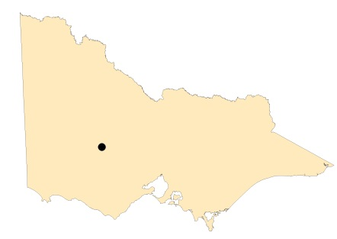
Map of Victoria identifying Elmhurst in Central Victoria.

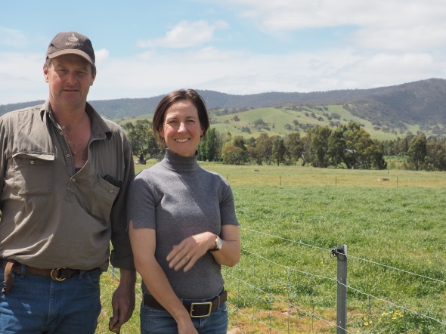

Photo: Ben and Jodie Green in a paddock.
When Ben’s father and uncle locked their sheep up and fed them grain in 1982, it was an unusual practice for the area. “They locked up 6,000 sheep in one paddock. They had no experience feeding sheep like that but everything came together and they got them through,” Ben, who was only a boy at the time, said.
The beef feedlot industry was still in its infancy at this stage and 6,000 sheep on feed was a bold call, but more than 30 years later, feeding in containment is an important practice that continues across Victoria.
Ben and wife Jodie live at “Millbanks”, near Elmhurst in the Pyrenees ranges, the upper catchment of the Wimmera River. The diverse farm has steep hills, intermediate rises, undulating land and river flats.
The family runs a self-replacing Merino flock for meat and wool, grow out Friesian bulls and trade in Friesian steers on an adjacent property.
After the successful drought feeding stint in 1982, Ben’s father constructed purpose-built stock containment areas in the early 1990s which were used to feed sheep in the 1994 drought
The stock containment areas also proved pivotal in feeding sheep during the drought years of 2002, 2006, 2007 and 2008.
Ben said Agriculture Victoria’s Drought Feeding Guide for Sheep had provided crucial guidance in designing and setting up the yards and feeding, watering and managing the stock.
“I still have the book that my father used and it is a great resource, especially with all the case studies of what others have done,” he said.
Ben said the hardest thing was making the actual decision to lock up sheep. “Once that is all done and dusted then it is relatively easy to manage,” he said.
FEEDING
Ben said it was important to do your numbers before putting stock in containment.
“We do a quick feed budget when heading into drought and work out what we need to feed the sheep until 30 June. Feed budgeting and money budgeting are the two big ticket items in drought planning.

“You have to draw a line in the sand and say ‘this is what we are up against’. Then you can work out if you have enough feed on hand and when you may have to buy some in and how much.”
Sheep are fed 1-2kg/head of straw for roughage and about 4.5kg/head of grain per week. This usually involves grain being fed on Monday, Wednesday and Friday.
“Feeding can generally be done within 2-3 hours in the morning which is a huge time saver. This is because we don’t have to drive over the farm as much delivering feed to multiple paddocks. Grain is stored within 200 metres of the stock containment areas and the sheep yards are there as well.”
Grain consists of wheat and triticale grown on the farm. Lime is also added to the grain for calcium but Ben has calculated that the sheep get adequate salt from the water supply.
Ben says it is important to carefully watch sheep while in containment. “A change in grain can upset them,” he says, citing an example of a mob developing acidosis when introduced to a different batch of grain.
Shy feeders are removed from containment on a weekly basis as they are identified and are typically turned back out into the paddock. They respond well to being fed without the competition.
After three months of being off green feed Vitamin E deficiency can be a problem. It is identified when otherwise healthy sheep are unable to rise. Sheep in containment for more than three months are drenched with Vitamin E to prevent this condition.
WATER
While feeding is a major consideration, the other huge benefit of containment is having one water point. “A big reason for containment on our farm has been to manage, develop and refine a system to avoid carting water.”
If reliable stock water is a challenge, having one watering point saves time and effort. Keeping sheep off vulnerable paddocks also preserves the pasture base and prevents soil erosion.
Millbanks’ traditional sources of dams, springs and wells all dried up in the 2006-07 drought. Since then Ben and Jodie have sunk deeper bores and consolidated many smaller dams into one, larger, deeper dam. They then started reticulating water around the farm. To date 70 per cent of the property has piped water and the process of combining dams to larger, low evaporation storages, continues.
While reticulation requires more labour (cleaning and checking troughs), it has reduced the problem of stock getting stuck in muddy dams and of large losses of water to evaporation.
MULTI-PURPOSE
Drought has been an important time to use the stock containment yards, but it is certainly not the only use.
With steep hills that must retain ground cover over drier times of the year, the containment areas provide an excellent place to feed sheep when the hills may be vulnerable if stocked.
“Stock containment areas help you manage your ground cover (on these hills) and preserve the asset of your pasture base. There is great winter and spring feed available on that hill country,” Ben said.
The areas are also ideal holding paddocks for times including shearing, drenching, crutching and for quarantining brought in stock.
ENVIRONMENTAL BENEFITS
The Greenes have learned plenty since 1982. They have honed their feeding and water conservation skills, improved their understanding of sheep health in containment and seen many advantages that stretch way beyond Millbanks’ farm boundary.
The Summers are not as dusty, the Wimmera River is not at risk of silting from soil off the hills and the land is more productive.
“I see containment areas as benefitting the whole community and not just us. The last thing I want to do is damage the river, and containment benefits the community because soils and water quality are protected” Ben said.
FURTHER INFORMATION
For further information or to obtain a copy of the relevant Drought Feeding Guide visit agriculture.vic.gov.au/dryseasons contact your local Agriculture Victoria Extension Officer or call the Customer Service Centre on 136 186.

Accessibility
If you would like to receive this publication in an accessible format, please telephone Agriculture Victoria on 136 186 or email drought.support@agriculture.vic.gov.au

This document is also available in (HTML and/or PDF and/or Word) format at agriculture.vic.gov.au

Disclaimer
Republished by Agriculture Victoria 2020.
This publication may be of assistance to you but the State of Victoria and its employees do not guarantee that the publication is without flaw of any kind or is wholly appropriate for your particular purposes and therefore disclaims all liability for any error, loss or other consequence which may arise from you relying on any information in this publication.

