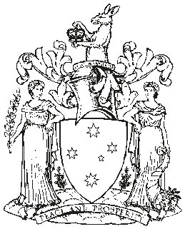 Victoria Government Gazette

No. S 237 Tuesday 18 June 2019
By Authority of Victorian Government Printer

Domestic Animals Act 1994
ORDER EXEMPTING GRV GREYHOUNDS FROM THE OPERATION OF SECTIONS 12B(a) AND 12C(a)
Order in Council
The Governor in Council under section 5 of the Domestic Animals Act 1994 makes the following Order:
1 Objective
The objective of this Order is to exempt a class of animal, being a GRV greyhound, from the operation of sections 12B(a) and 12C(a) of the Domestic Animals Act 1994.
2 Authorising provision
This Order is made under section 5 of the Domestic Animals Act 1994.
3 Commencement
This Order takes effect from 1 July 2019.
4 Exemption
A GRV greyhound is exempt from the operation of sections 12B(a) and 12C(a) of the
Domestic Animals Act 1994.
Note:
Section 3 of the Domestic Animals Act 1994 defines a GRV greyhound as a greyhound registered with Greyhound Racing
Victoria except a greyhound that has –
- gone through a greyhound adoption program operated by Greyhound Racing Victoria; or
- been retired from the industry and is being kept in the community as a pet by a person who is not registered by Greyhound Racing Victoria as a greyhound racing participant.
Dated 18 June 2019
Responsible Minister: JACLYN SYMES
Minister for Agriculture
PIETA TAVROU Clerk of the Executive Council

