Livestock Farm Monitor Project

Victoria │ Annual Report

2019-20

The Livestock Farm Monitor Project (LFMP) is Agriculture Victoria’s primary source of farm level information for sheep, beef and cropping production practices, resource use, and economic well-being.
The results of this annual survey provide the farm-level data required to inform Agriculture Victoria on decisions that have a farm level impact and to inform the direction of future policy design, research themes and service delivery programs.
Farmers who participate in the project increase their understanding of their farm business which builds resilience and improves their ability to adapt to change.
Results published in this report are not representative of an industry or a region.
Agriculture Victoria staff are grateful for the cooperation of the farmers who contributed their data to this project.
The theory and methods used to generate the profitability data in this report can be found in the references.
This report has been funded by Agriculture Victoria.
Further information regarding the LFMP may be obtained from:
Sam Henty
Agriculture Victoria
PO Box 3100, Bendigo DC, Victoria 3400
sam.henty@agriculture.vic.gov.au

Authorised and published by the Victorian Government, Department of Jobs, Precincts and Regions 2020. © The State of Victoria Department of Jobs, Precincts and Regions 2020.
This publication is copyright. No part may be reproduced by any process except in accordance with the provisions of the Copyright Act 1968.
For more information contact the DJPR Customer Service Centre 136 186.
ISSN 2205-8214 (online)
Disclaimer
This publication may be of assistance to you, but the State of Victoria and its employees do not guarantee that the publication is without flaw of any kind or is wholly appropriate for your particular purposes and therefore disclaims all liability for any error, loss or other consequence which may arise from you relying on any information in this publication.
Accessibility
If you would like to receive this publication in an accessible format, such as large print or audio, please telephone 136 186.
Deaf, hearing impaired or speech impaired? Call us via the National Relay Service on 133 677 or visit www. relayservice.com.au
This document is also available in PDF format on the Agriculture Victoria website.

State summary
In 2019-20, the Livestock Farm Monitor Project (LFMP) provided 94 participant Victorian sheep, beef and cropping producers with detailed financial and production performance information. Participating producers use this information to understand the cash, profit and wealth position of their business which helps inform on-farm decision making and build business resilience. The LFMP collated the individual business performance information of all surveyed farms to provide the insights reported below.
Average farm profits increased in each region in 2019-20 after two consecutive years of decreases. Surveyed farms located in South West Victoria recorded the highest average returns for the state, while farms in Gippsland and Northern Victoria had the largest annual percentage increases. Regardless of the average, each region had participant farms that recorded high returns and negative returns (Figure 1).
Average gross farm income was well above long-term average (Figure 9, 13 and 17) in each respective region. Despite an average reduction in stock weight sold per hectare (LFMP 2019), strong lamb, mutton and beef prices coupled with an increased quantity and value of stock and feed on-hand resulted in increased gross farm income in 2019-20.
For most participant farms, annual rainfall was close to average (Appendix A2, B2 and C2) which improved pasture growing conditions and meant that grazed pasture was the major component of livestock diets. Depleted feed reserves were bolstered across the state (as measured by positive average feed inventory gain in each region) as surplus pasture was conserved and stored as fodder. For Gippsland and South Western Victoria, a reduced reliance on purchased supplementary feed coupled with a decrease in market price of hay and grain contributed to decreases in average variable costs. Average variable costs increased in Northern Victoria as surveyed farms were forced to purchase feed to supplement reduced pasture growth from below average spring rainfall. Northern Victorian farms had the lowest stocking rates, sold the lowest quantities of stock and wool resulting in the lowest regional variable costs.
The unknown impact of the early stages of the coronavirus (COVID-19) pandemic to farm input supplies resulted in some surveyed farms pre-purchasing consumables late in 2019-20. If there were cuts in supply chains, producers wanted to ensure that they had adequate reserves of critical inputs such as animal drenches and vaccines. The reduction in meat processing plant capacity due to coronavirus (COVID-19) restrictions forced some farmers to renegotiate contracts to shift supply earlier and avoid unbudgeted costs of holding on to trading stock longer than planned due to processing limits.
Spring is a crucial time for most farms surveyed in the LFMP. Livestock breeding schedules are planned so that the high feed demand of lactating stock coincides with the high pasture growth rates over the spring months. The timing of breeding decisions is made months before producers can forecast whether the amount of rain received will be enough to produce the pasture required to match feed demand pre and post-parturition. When spring rainfall and pasture growth is low, producers can increase the level of supplementary feed in the diet to ensure feed demand is met. The level of supplementary feeding was analysed on surveyed farms across the state. Farms that received less than 40 per cent of their average spring rainfall had the highest levels of supplementary feeding (Figure 3). Surveyed farms who received higher than average spring rainfall had the lowest levels of supplementary feeding.
Positive farm profits in 2019-20 allowed a high proportion of surveyed farms to reduce the amount of debt owing (Figure 4). However, some farm business debt levels increased as managers chose to invest in land, plant and equipment and on-farm improvements. Debt was part of the business structures for a large proportion of surveyed farms. The use of debt increases the compulsory costs of farm businesses as principal and interest repayments must be paid in good years and poor. For this reason, farm management strategies employed throughout the year were influenced by the level of debt the business holds.
In 2019-20, there were profitable farms across all farm sizes with larger farms tending to have higher return on assets than smaller farms (Figure 2). Surveyed farms with effective areas less than 250 hectares had lower Return on Assets (ROA) than the larger land areas. Households on smaller farms are commonly supplemented by off-farm income which is not accounted for when estimating farm performance. Also, smaller farms often have low labour use efficiency and therefore high labour costs relative to the area operated.
Owner/Operator labour was the main source of labour on surveyed farms across the state accounting for approximately 60 per cent of the average labour used on-farm (Figure 5; Appendix A4, B4, andC4). Average effective area and enterprise mix explained the regional differences in total on-farm labour use. Surveyed farms in South West Victoria had larger average effective areas and required more input from each labour type to operate. Shearing contractors were the main source of contract labour in 2019-20.
Financial parameter bars: | G | N | SW
Gross Farm Income ($/ha) | $1,207 | $892 | $1,301
Variable costs ($/ha) | $425 | $378 | $473
Total Gross Margin ($/ha) | $782 | $514 | $827
Overhead costs | $528 | $462 | $372
Earnings before Interest and Tax (EBIT) ($/ha) | $254 | $53 | $455
Interest and lease cost ($/ha) | $69 | $63 | $83
Net Farm income ($/ha) | $169 | $0 | $368
Return on Assets (%) | 2.2% | 1.2% | 4.3%
Return on Equity (%) | 2.4% | 1.4% | 14.0%
Physical parameter bars: | G | N | SW
Effective area (ha) | 632 | 876 | 1,078
Financial year rainfall (mm) | 796 | 639 | 622
Stocking rate (DSE/ha) | 16.5 | 10.3 | 17.4
Beef sold (kg lwt/ha) | 412 | 272 | 719
Lamb sold (kg cwt/ha) | 170 | 139 | 115
Wool cut (kg Gr./ha) | 40 | 27 | 52
Pasture conserved (tDM/ha) | 0.5 | 0.2 | 0.4
Purchased feed in diet (% of ME consumed/farm) | 3% | 5% | 4%

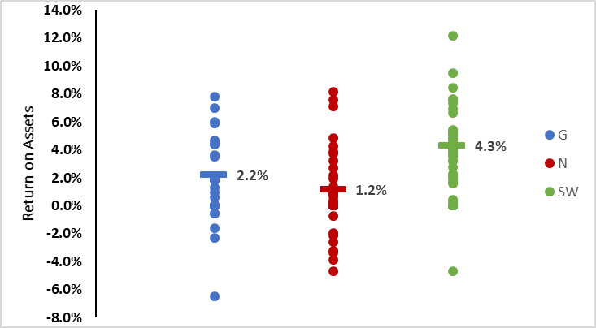
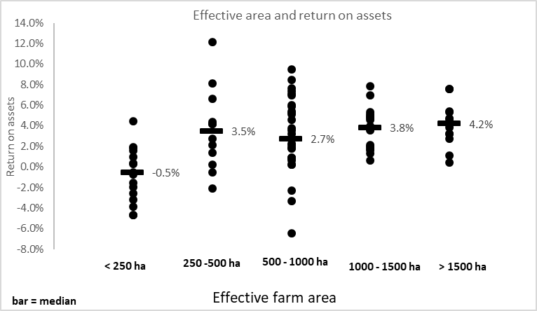
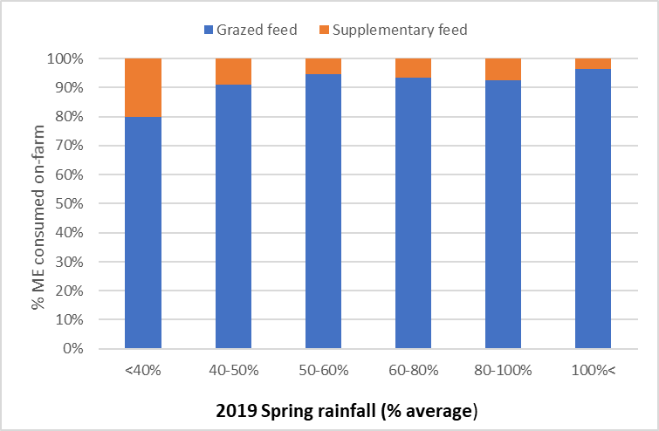
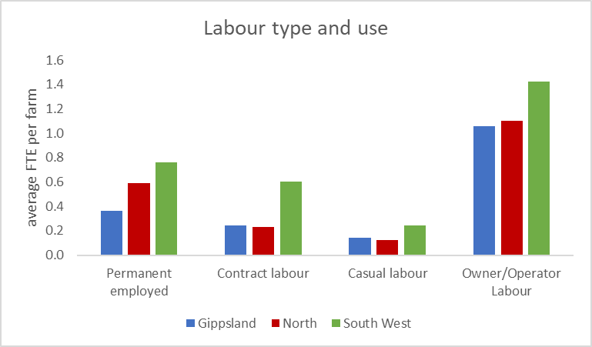
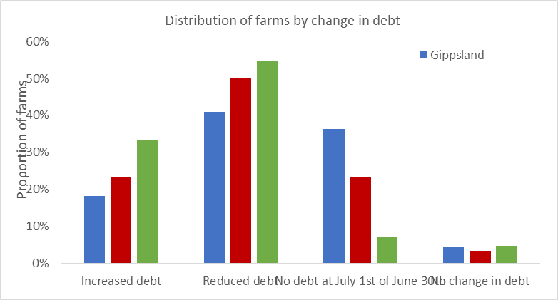

Gippsland
In 2019-20, average Gippsland farm profitability rebounded from the lows reported in 2018-19. Seasonal conditions improved for many farms in Central, South and West Gippsland. Repeated years of poor seasonal conditions in these sub-regions led many producers into forced sales and destocking. Conditions in 2019-20 offered some respite in these sub-regions and producers used better pasture growing conditions as an opportunity to rebuild herds by retaining trading stock. As a result, the average quantity of livestock sold reduced in 2019-20. Average gross farm income rose to similar levels recorded 2016-17 and well above the 10-year regional average (Figure 9) as the reduction in sales quantity was offset by strong beef prices and increases in livestock inventories.
No such seasonal relief was experienced in East Gippsland as the third consecutive below average winter and spring rainfall culminated in large-scale bushfires during early 2020. The compounding effect of drought and fires meant surveyed farms in East Gippsland further reduced already run-down livestock numbers to match decreased feed availability. Variable costs remained comparatively low as East Gippsland farms spent minimal amounts on fertiliser and supplementary feed. Reduced livestock inventories decreased gross farm income and farm returns.
On average, expenditure on pasture increased in Gippsland. The largest component of pasture costs was fertiliser. Businesses that experienced improved pasture growing conditions increased fertiliser application rates and used the excess pasture grown as an income source from either agistment or feed inventory gain. Surveyed farms in Gippsland on average spent more on fertiliser per hectare than the rest of the state. August and September 2019 were the peak months of parturition in sheep and beef respectively (Figure 6). Consequently, spring represented the months of highest feed demand. Improved pasture growing conditions over this period resulted in a high proportion of grazed feed in the average animal diet (Figure 7) and allowed producers to reduce purchased feed quantities and costs.
Surveyed farms in Gippsland recorded the highest average overhead costs per hectare. Overhead costs will not change in the short term, even if no production takes place. Of the studied regions, Gippsland has the smallest average effective area managed. High overhead costs per hectare on smaller area farms is commonly due to lower labour use efficiency which results in high permanent and imputed labour cost relative to the area operated.
Product quality, farm system, marketing strategies and luck all influenced the price received of the major products sold in 2019-20. The differences in managing of these factors is highlighted by the variability in price received across all farms for fine wool (13 per cent), lamb (19 per cent) and beef (18 per cent) (Figure 8; Appendix C6, C8, and C10).

Financial parameter bars: | G
Livestock trading profit/loss ($/ha) | 900
Wool sales income ($/ha) | 105
Crop sales income ($/ha) | 6
Feed inventory change ($/ha) | 119
Other Farm Income ($/ha) | 76
Livestock costs ($/ha) | 75
Livestock marketing costs ($/ha) | 82
Purchased feed and agistment ($/ha) | 72
Pasture costs ($/ha) | 191
Cropping costs ($/ha) | 4
Wages for permanent labour ($/ha) | 45
Repairs and Maintenance ($/ha) | 71
Other cash overhead costs ($/ha) | 104
Non-cash overhead costs ($/ha) | 309
Interest costs ($/ha) | 57
Lease costs ($/ha) | 28
Total assets managed ($/ha) | 13,478
Total debt ($/ha) | 1,843
Physical parameter bars: | G
Labour use (FTE/farm) | 1.8
Nitrogen applied (kg/effective ha) | 16
Phosphorus applied (kg/effective ha) | 10
Potassium applied (kg/effective ha) | 13
Mature cow calving rate | 86%
Beef price received ($/kg lwt) | 3.3
Average beef sale weight (Kg lwt/hd) | 477
Mature ewe lamb marking rate (Prime lamb) | 114%
Lamb Price received ($/kg cwt) | 8.4
Average lamb sale weight (Kg cwt/hd) | 21.2
Mature ewe lamb marking rate (Wool sheep) | 70%
Average micron (µ) | 17.5
Greasy wool price received ($/kg) | 10.7

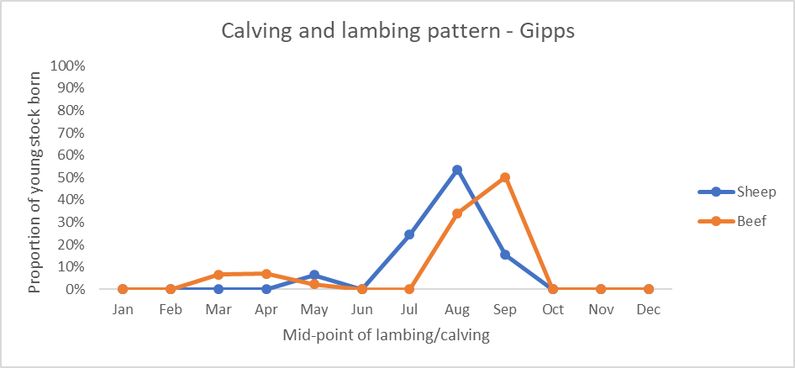
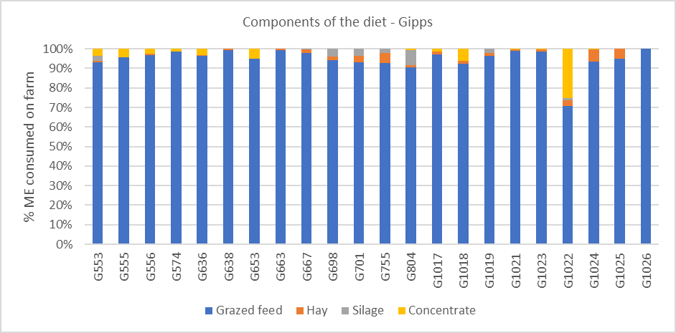
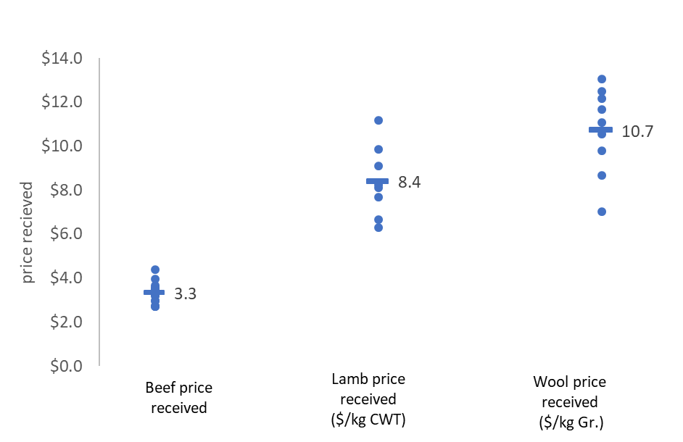
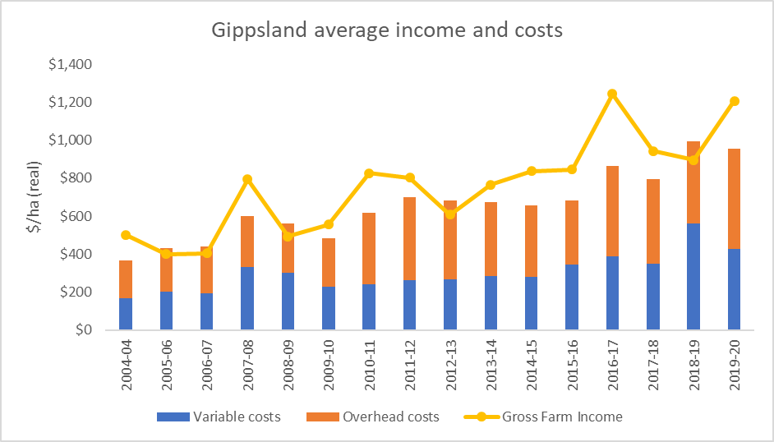

South West Victoria
Surveyed farms in south western Victoria were well positioned to take advantage of the excellent operating conditions during 2019-20. Having maintained quality on-farm pasture and high stocking rates after avoiding the worst of the dry seasonal conditions in 2018-19, producers were able to increase average wool production, beef and lamb sales. The increase in livestock production was coupled with record high lamb and beef prices resulting in the highest gross farm income recorded in the fifty years of the project (Figure 13; Appendix A12). Timely rainfall throughout the year provided good conditions for crop and pasture growth. Strong cash flows and good seasonal conditions allowed surveyed farms to increase application rates of maintenance and capital fertiliser. Additional on-farm dry matter growth resulted in grazed feed being the dominant component of the average animal diet and allowed producers to reduce purchased feed quantities and costs.
The distribution of lambing dates on surveyed farms in the south west (Figure 10) can be explained by the large proportion of self-replacing prime lamb enterprises. Parturition in prime lamb enterprises tends to peak in mid-winter as producers attempt to use the high pasture growth in spring to meet the feed demand of lactating ewes and target weights of lambs to be sold in early summer. South west farms had a higher proportion of autumn calving beef cows than other regions.
Profitable conditions and positive producer sentiment led to more on-farm capital expenditure. Additional total capital invested in businesses and positive revaluations of farmland resulted in a 30 per cent increase in average total assets managed per hectare from 2018-19. The increase in total assets managed was the reason earnings before interest and tax (EBIT) increased more than ROA (return on assets does not include capital appreciation).
Average wool price received by surveyed farms in south western Victoria decreased in 2019-20. Despite the decrease in market price received, average wool sheep gross margins increased from the 2018-19 levels. Wool producers were able to offset the reduced wool price by taking advantage of high mutton prices and reducing variable costs. Product quality, farm system, marketing strategies and luck all influenced the price received of the major products sold in 2019-20. The differences in managing of these factors is highlighted by the variability in price received across all farms for fine wool (14 per cent), lamb (13 per cent) and beef (14 per cent) (Figure 12; Appendix A6, A8, and A10).

Financial parameter bars: | SW
Livestock trading profit/loss ($/ha) | 941
Wool sales income ($/ha) | 180
Crop sales income ($/ha) | 89
Feed inventory change ($/ha) | 45
Other Farm Income ($/ha) | 47
Livestock costs ($/ha) | 136
Livestock marketing costs ($/ha) | 62
Purchased feed and agistment ($/ha) | 81
Pasture costs ($/ha) | 155
Cropping costs ($/ha) | 39
Wages for permanent labour ($/ha) | 35
Repairs and Maintenance ($/ha) | 60
Other cash overhead costs ($/ha) | 85
Non-cash overhead costs ($/ha) | 192
Interest costs ($/ha) | 65
Lease costs ($/ha) | 23
Total assets managed ($/ha) | 10,754
Total debt ($/ha) | 1,698
Physical parameter bars: | SW
Labour use (FTE/farm) | 3.0
Nitrogen applied (kg/effective ha) | 20
Phosphorus applied (kg/effective ha) | 16
Potassium applied (kg/effective ha) | 9
Mature cow calving rate | 92%
Beef price received ($/kg lwt) | 3.1
Average beef sale weight (Kg lwt/hd) | 516
Mature ewe lamb marking rate (Prime lamb) | 116%
Lamb Price received ($/kg cwt) | 8.3
Average lamb sale weight (Kg cwt/hd) | 20.4
Mature ewe lamb marking rate (Wool sheep) | 82%
Average micron (µ) | 17.3
Greasy wool price received ($/kg) | 11.1

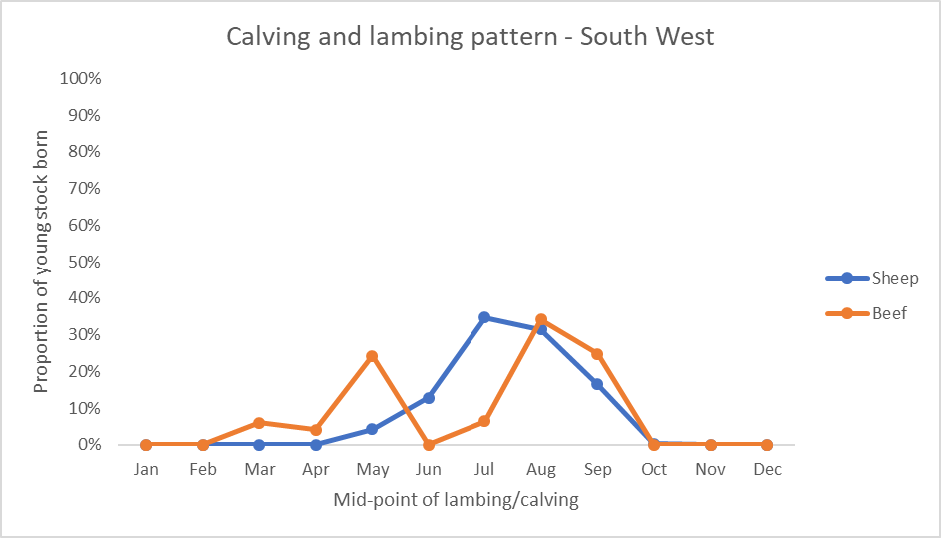
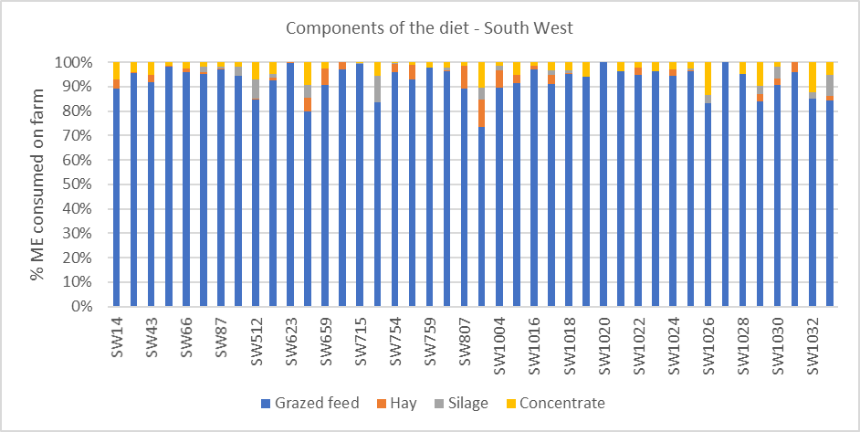
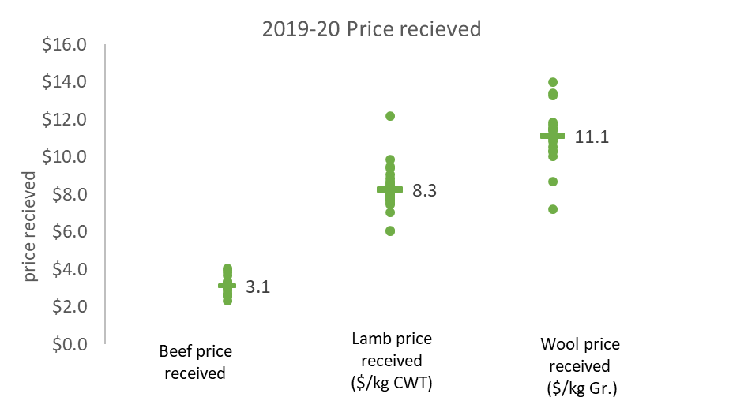
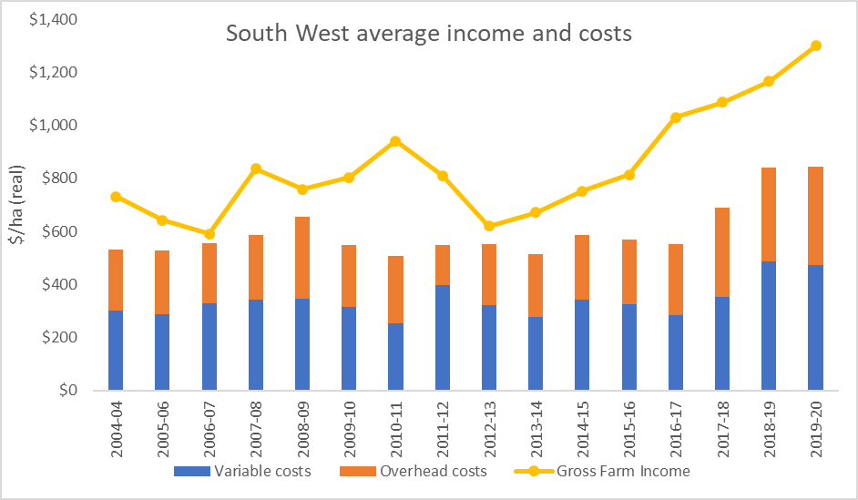

Northern Victoria
In 2019-20, surveyed farms in Northern Victoria experienced a year of contrasting rainfall conditions and mixed farm performance. Regional average farm profits increased from 2018-19 but were still below the 10-year average.
Dry conditions experienced from July through to December 2019 represented the third consecutive year surveyed farms received below average winter and spring rainfall. To offset reduced grazed pasture availability in spring, livestock diets on most farms were supplemented with purchased feed. On average, supplementary feed made up a higher proportion of livestock diets in northern Victoria than elsewhere in the state (Figure 15). As rainfall improved in 2020 so did the average rate of fertiliser application (LFMP 2019). The combination of expenditure on supplementary feed and fertiliser increased annual average variable costs to the highest level recorded by the project in Northern Victoria (Figure 17). Notably there was large variation in the variable costs between surveyed farms representing different management strategies in the difficult operating conditions (Appendix B1).
To take advantage of the good market prices, surveyed farms chose to increase the quantity of beef and lamb sold. High prices and increased livestock inventories led to the highest average gross farm income recorded by the project in northern Victoria (Figure 17). Product quality, farm system, marketing strategies and luck all influence to the price received of the major products sold in 2019-20. The differences in managing of these factors is highlighted by the variability in price received across all farms for fine wool (15 per cent), lamb (17 per cent) and beef (17 per cent) (Figure 16; Appendix B6, B8, and B10).
Average overhead costs increased for the region. Increases can be attributed to the changing dataset with the addition of a larger proportion of smaller farms (less than 250 ha) and more farms with large cropping enterprises. The high overhead costs per hectare on smaller area farms is commonly due to poor labour use efficiency (ha/FTE) which results in high permanent and imputed labour cost relative to the area operated. Cropping enterprises require the use of large machinery, increasing the depreciation cost and total overhead cost for these farms.
The distribution of lambing and calving dates on surveyed farms in northern Victoria can be explained by seasonal and pasture growing conditions. Rain-fed northern Victorian farms experience a shorter spring pasture growing period due to higher temperatures and drier conditions. Consequently, breeding schedules tended to be earlier on northern farms with majority of lambs and calves born in autumn and winter (Figure 14).

Financial parameter bars: | N
Livestock trading profit/loss ($/ha) | 596
Wool sales income ($/ha) | 100
Crop sales income ($/ha) | 37
Feed inventory change ($/ha) | 66
Other Farm Income ($/ha) | 93
Livestock costs ($/ha) | 60
Livestock marketing costs ($/ha) | 71
Purchased feed and agistment ($/ha) | 98
Pasture costs ($/ha) | 121
Cropping costs ($/ha) | 29
Wages for permanent labour ($/ha) | 34
Repairs and Maintenance ($/ha) | 49
Other cash overhead costs ($/ha) | 101
Non-cash overhead costs ($/ha) | 277
Interest costs ($/ha) | 30
Lease costs ($/ha) | 23
Total assets managed ($/ha) | 10,556
Total debt ($/ha) | 1,014
Physical parameter bars: | N
Labour use (FTE/farm) | 2.0
Nitrogen applied (kg/effective ha) | 10
Phosphorus applied (kg/effective ha) | 10
Potassium applied (kg/effective ha) | 2
Mature cow calving rate | 88%
Beef price received ($/kg lwt) | 3.1
Average beef sale weight (Kg lwt/hd) | 524
Mature ewe lamb marking rate (Prime lamb) | 109%
Lamb Price received ($/kg cwt) | 8.7
Average lamb sale weight (Kg cwt/hd) | 23.0
Mature ewe lamb marking rate (Wool sheep) | 82%
Average micron (µ) | 17.5
Greasy wool price received ($/kg) | 11.4

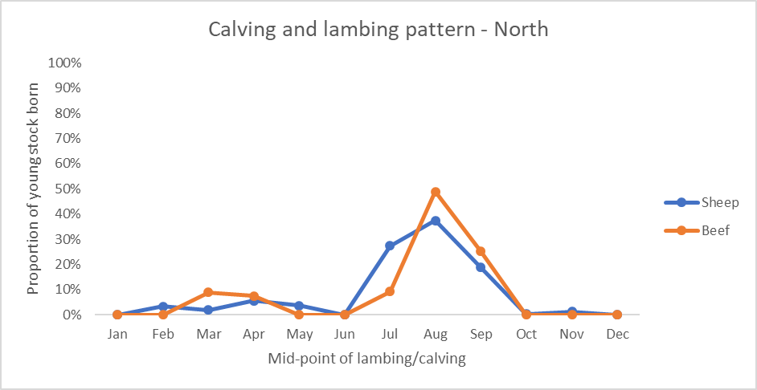
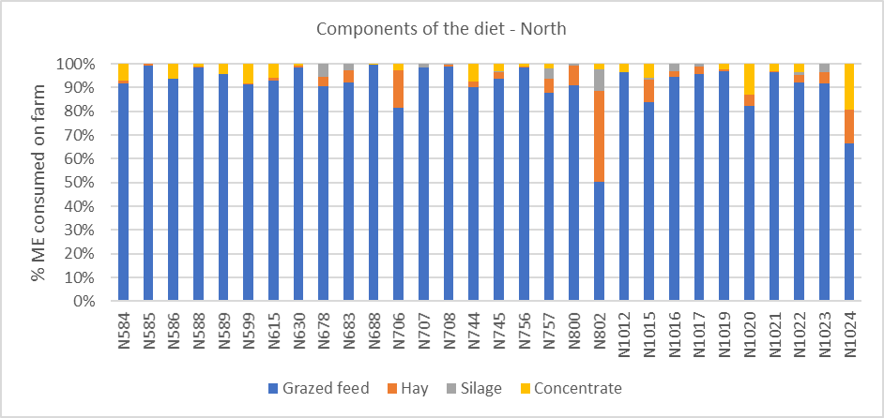
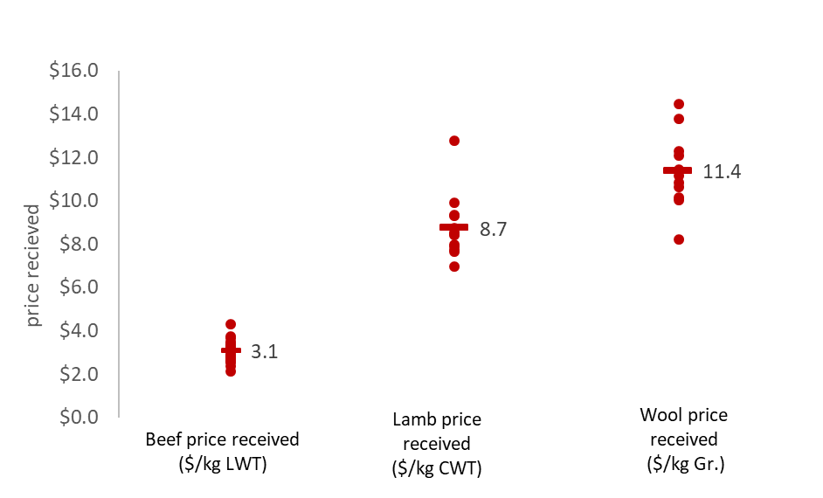
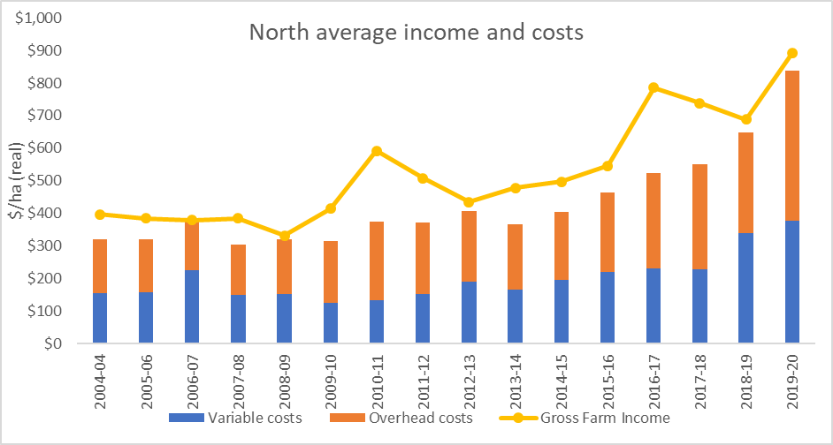

Glossary
Appreciation
An increase in the value of an asset in the marketplace.
often only applicable to land value.
Asset
Anything managed by the farm, whether it is owned or not. Assets include owned land and buildings, leased land, plant and machinery, fixtures and fittings, trading stock, farm investments (i.e. Farm Management Deposits), debtors, and cash.
Average
The sum of a collection of numbers divided by the count of numbers in the collection

Cash overheads
All fixed costs that have a cash cost to the business. Includes all overhead costs except imputed labour costs and depreciation.
Casual Labour
A casual employee is an employee engaged casually and paid by the hour. Casual loading is paid instead of annual leave, notice of termination, redundancy benefits and other attributes of permanent
Contract Labour
A contractor controls the work to be done and how it is to be performed. They can employ their own staff and can sub-contract or delegate.
Coefficient of variation (CV)
A measure of variability, which scales the standard deviation by the average to provide a relative measure of variability that accounts for differences in means

Concentrate
Category of feed that includes grains, oilseeds and pellets

Depreciation
Decrease in value over time of capital asset, usually as a result of using the asset. Depreciation is a non-cash cost of the business but reduces the book value of the asset and is therefore a cost.
Dry Sheep Equivalent (DSE)
Standard unit used to compare the ME requirements of different classes of stock for feed budgeting purposes

Earnings before interest & tax (EBIT)
Also known as ‘Operating Profit’, is the return on all the capital used in the business. Calculated as gross farm income minus total variable and total overhead costs.
Effective area
Total hectares managed minus the area of land which is of little or no value for livestock or crop production.
Equity
Total assets minus total liabilities. Equal to the total value of capital invested in the farm business by the owner/ operator(s).
Equity %
Total equity as a percentage of the total assets owned.
The proportion of the total assets owned by the business.
Feed inventory change
An estimate of the feed on hand at the start and end of the financial year.
Full time equivalent (FTE)
Standardised labour unit. Equal to 1,920 hours a year.
Calculated as 48 hours a week for 40 weeks a year.
Grazed area
Pasture area plus an estimate of annual cropping area grazed. If a farm has multiple livestock enterprises, grazed area is apportioned based on the total annual ME demand of each enterprise.

Grazed feed
Calculated using the back-calculation approach. Grazed feed is calculated as the difference between total metabolisable energy required by livestock over the year and amount of metabolisable energy consumed from other sources (hay, silage, grain and concentrates).
Total metabolisable energy required by livestock is a factor of age, weight, growth rate, pregnancy and lactation requirements and number of animals.
Gross income
The total income, cash and non-cash, received from a farm or enterprise, before any expenses are paid.
Gross margin
Gross farm income minus total variable costs.
Livestock costs
All expenses relating to assisting with herd and flock management. Includes: animal health costs, and shearing contractors.
Pasture costs
All costs associated with growing pasture including fertiliser, seed and chemical.
Livestock Marketing Costs
All costs associated with buying and selling livestock including freight and cartage.
Imputed
An estimated amount introduced into economic management analysis to allow reasonable comparisons between years and between other businesses.

Owner/Operator labour
Staff members (such as Family) that take income from business drawings rather than wages. The operators labour and management are an input to make a profit and so these must be costed and deducted to estimate the true profit and return to the capital in the business.
Interest and lease costs
Total interest plus total lease costs paid. Also known as ‘finance costs’.
Liability
Money owed to someone else, e.g. family or a financial institution.
Livestock trading profit
An estimate of the annual contribution to gross farm income by accounting for the changes in the number and value of livestock during the year. It is calculated as the trading income from sales minus purchases, plus changes in the value and number of livestock on hand at the start and end of the year, and accounting for births and deaths. An increase in livestock trading indicates there was an appreciation of livestock or an increase in livestock numbers over the year.
Median
The value separating the higher half from the lower half of a data sample

Net farm income
Earnings before interest and tax (EBIT) minus interest and lease costs. The amount of profit available for capital investment, loan principal repayments and tax.
Nominal terms
Dollar values or interest rates that include an inflation component.
Overhead costs
All fixed costs incurred by the farm business that do not vary with the level of production. These include cash overhead costs such as permanent labour and noncash costs such as owner-operator labour, family labour and depreciation of plant and equipment. It excludes interest, lease costs, capital expenditure, principal repayments, drawings and tax.
Permanent Labour
Farm staff who have an on-going expectation of work, generally work standard or set hours, entitled to paid leave and notice of termination

Real terms
Dollar values or interest rates that have no inflation component.
Return on equity (ROE)
Net farm income divided by the value of total equity.
Return on assets (ROA)
Earnings before interest and tax divided by the value of total assets under management, including owned and leased land.
Standard deviation
The standard deviation is a measure of how widely values are dispersed from the average value
Top 20%
Regional average for the top 20% of farms ranked by return on assets
Variable costs
Variable costs (sometimes called direct costs) vary directly as the output of an enterprise varies.
List of abbreviations
CV | Coefficient of variation
CWT | Carcass weight
DJPR | Department of Jobs, Precincts and Regions, Victoria
DSE | Dry Sheep Equivalent
LFMP | Livestock Farm Monitor Project
EBIT | Earnings before interest and tax
GM | Gross Margin
ha | Hectare(s)
kg | Kilograms
LWT | Live weight
ME | Metabolisable energy (MJ/kg DM)
ML | Megalitre
mm | Millimetres.
NFI | Net Farm Income
ROA | Return on assets
ROE | Return on equity
t | Tonne = 1,000 kg
tDM | Dry matter of feed stuffs measured in tonnes
yrs | Years old

References
Kay RD, Edwards WM, Duffy PA 'Farm Management' (Mcgraw-Hill Companies)
Malcolm B, Makeham J, Wright V 'The Farming Game - Agricultural Management and Marketing.' (Cambridge University Press: Melbourne)
Nuthall P ‘Farm Business Management: Analysis of Farming Systems ‘ (CAB international)

