Dairy Farm   
Monitor Project

Victoria │Annual Report

2018-19

# Acknowledgements

Participant farmers are gratefully acknowledged for their cooperation, patience and goodwill to willingly supply their farm information, for either the first time or 13th consecutive year.

The diligent work of Agriculture Victoria, Dairy Services staff who gathered the final performance data deserve particular thanks, especially Olive Montecillo, Tristan Wardley, Michele Jolliffe, David Shambrook, and Sarah Clack, who continued to be actively involved in the report through to its publication. Thanks to Dr Christie Ho and Dr Claire Lewis for providing a thorough review of the report.

The project was also made possible this year through the contributions of Dan Armstrong, Tom Farran, Cameron Smith, Paul Groves and Janet Sloan who collected farm data, in addition to data collected by Agriculture Victoria staff, and provided feedback and validation to ensure its accuracy.

Thank you to Brett Mitchard from Agriculture Victoria for creating the map used in this publication.

This report has been produced in conjunction with Dairy Australia.

Further information regarding the Dairy Farm Monitor Project may be obtained from:

**Claire Waterman**

Agriculture Victoria

PO Box 3100, Bendigo DC, Victoria 3400

Telephone: 03 5430 4697

claire.waterman@agriculture.vic.gov.au

To find out the latest information on the project visit the project website at www.agriculture.vic.gov.au/dairy

[www.agriculture.vic.gov.au/dairyfarmmonitor](http://www.agriculture.vic.gov.au/dairyfarmmonitor)

This publication is copyright. No part may be reproduced by any process except in accordance with the provisions of the *Copyright Act 1968*.

Authorised by the Victorian Government, 1 Spring Street, Melbourne.

Print managed by Finsbury Green.

ISSN 1835-9922

**Disclaimer**

This publication may be of assistance to you, but the State of Victoria and its employees do not guarantee that the publication is without flaw of any kind or is wholly appropriate for your particular purposes and therefore disclaims all liability for any error, loss or other consequence which may arise from you relying on any information in this publication.

**Accessibility**

If you would like to receive this publication in an accessible format, please telephone the department’s Customer Service Centre on 1300 502 656.

This document is also available in PDF and Word format at www.agriculture.vic.gov.au/dairyfarmmonitor[www.agriculture.vic.gov.au/dairyfarmmonitor](http://www.agriculture.vic.gov.au/dairyfarmmonitor)

or PDF format at

[www.dairyaustralia.com.au/dairyfarmmonitor](http://www.dairyaustralia.com.au/dairyfarmmonitor)

### Contents

Acknowledgements 2

List of Figures 4

List of Tables 4

How to read this report 5

What’s new in 2018-19 6

I. Summary 7

II. DFMP method 9

Part One: Statewide overview 12

Whole farm analysis 15

Risk 18

Physical measures 20

Part Two: The North 23

Whole Farm Analysis 25

Feed consumption and fertiliser 31

Part Three: The South West 33

Whole Farm Analysis 35

Feed consumption and fertiliser 42

Part Four: Gippsland 44

Whole Farm Analysis 46

Feed consumption and fertiliser 53

Part Five: Business confidence survey 55

Part Six: Greenhouse gas emissions 61

Part Seven: Historical analysis 67

[Appendices 72](https://vicgov.sharepoint.com/sites/VG000110/Dairy/DFM%202018-19/07.%20AR_FINAL/2018-19%20DFMP%20Annual%20Report%20v3%20accessible.docx#_Toc58579863)

APPENDIX A: Statewide summary tables 73

APPENDIX B: North summary tables 82

Appendix C: South West summary tables 102

Appendix D: Gippsland summary tables 122

Appendix E: Glossary of terms, abbreviations and standard value 143

# List of Figures

Figure 1. Dairy farm monitor project map - State average data 2018-19

Figure 2. Distribution of participant farms in 2018-19 across Victoria

Figure 3. Monthly rainfall 2018-19

Figure 4. Average earnings before interest and tax per kilogram of milk solids sold

Figure 5. Distribution of farms by return on total assets

Figure 6. Distribution of farms by return on equity

Figure 7. Sources of whole farm metabolisable energy

Figure 8. Estimated tonnes of homegrown feed consumed per milking hectare

Figure 9. Nutrient application per milking hectare

Figure 10. Monthly distribution of milk production

Figure 11. Monthly distribution of calving

Figure 12. 2018-19 annual rainfall and long-term average rainfall – North

Figure 13. Milk solids sold – North

Figure 14. Gross farm income per kilogram of milk solids – North

Figure 15. Whole farm variable and overhead costs per kilogram of milk solids – North

Figure 16. Whole farm earnings before interest and tax per kilogram of milk solids – North

Figure 17. Return on total assets – North

Figure 18. Return on equity – North

Figure 19. Sources of whole farm metabolisable energy – North

Figure 20. Estimated tonnes of homegrown feed removed per milking hectare – North

Figure 21. Nutrient application per usable hectare – North

Figure 22. 2018-19 annual rainfall and long-term average rainfall – South West

Figure 23. Milk solids sold – South West

Figure 24. Gross farm income per kilogram of milk solids – South West

Figure 25. Whole farm variable and overhead costs per kilogram of milk solids – South West

Figure 26. Whole farm earnings before interest and tax per kilogram of milk solids – South West

Figure 27. Return on total assets – South West

Figure 28. Return on equity – South West

Figure 29. Sources of whole farm metabolisable energy – South West

Figure 30. Estimated tonnes of homegrown feed removed per milking hectare – South West

Figure 31. Nutrient application per usable hectare – South West

Figure 32. 2018-19 annual rainfall and long-term average rainfall – Gippsland

Figure 33. Milk solids sold per hectare and per cow – Gippsland

Figure 34. Gross farm income per kilogram of milk solids – Gippsland

Figure 35. Whole farm variable and overhead costs per kilogram of milk solids – Gippsland

Figure 36. Whole farm earnings before interest and tax per kilogram of milk solids – Gippsland

Figure 37. Return on total assets – Gippsland

Figure 38. Return on equity – Gippsland

Figure 39. Sources of whole farm metabolisable energy – Gippsland

Figure 40. Estimated tonnes of homegrown feed removed per milking hectare – Gippsland

Figure 41. Nutrient application per hectare (usable area) – Gippsland

Figure 42. Expected change to farm business profit in 2019-20

Figure 43. Producer expectations of prices and production of milk in 2019-20

Figure 44. Producer expectations of production of fodder in 2019-20

Figure 45. Producer expectations of costs for the dairy industry in 2019-20

Figure 46. Major issues for individual businesses – 12-month outlook

Figure 47. Major issues for individual businesses – 5-year outlook

Figure 48. 2018-19 greenhouse gas emissions per tonne of milk solids produced (CO2 equivalent)

Figure 49. Greenhouse gas emissions per tonne of milk solids sold (CO2 equivalent) – North

Figure 50. Greenhouse gas emissions per tonne of milk solids sold (CO2 equivalent) – South West

Figure 51. Greenhouse gas emissions per tonne of milk solids sold (CO2 equivalent) – Gippsland

Figure 52. Historical farm profitability (real $) – North

Figure 53. Historical whole farm performance – North

Figure 54. Historical farm profitability (real $) – South West

Figure 55. Historical whole farm performance – South West

Figure 56. Historical farm profitability (real $) – Gippsland

Figure 57. Historical whole farm performance – Gippsland

# List of Tables

Table 1. Farm physical data – State overview 2018-19

Table 2. Average farm financial performance per kilogram of milk solids - Statewide

Table 3. Risk indicators - Statewide and by region

Table 4. Farm physical data – North

Table 5. Average farm financial performance per kilogram of milk solids – North

Table 6. Cost of production – North

Table 7. Farm physical data – South West

Table 8. Average farm financial performance per kilogram of milk solids – South West

Table 9. Cost of production – South West

Table 10. Farm physical data – Gippsland

Table 11. Average farm financial performance per kilogram of milk solids – Gippsland

Table 12. Cost of production – Gippsland

# How to read this report

This section explains calculations used and data presented in this report. The purpose of the different sections of the report is also described.

This report is presented in the following sections:

• Summary

• Dairy Farm Monitor Project method

• Statewide overview

• North region overview

• South West region overview

• Gippsland region overview

• Business confidence survey

• Greenhouse gas emissions report

• Historical analysis

• Appendices

Participants were selected for the project to represent a distribution of farm size, herd size and geographical location within each region. However, the farms selected do not fully represent the average of the dairy farm population as the participant farms were not chosen to be statistically representative.

The report provides visual representations of the data for the 2018-19 year. Data are presented for individual farms, as regional averages and for the regional top 25% of farms ranked by Return on Total Asset (RoTA). The presented averages should not be considered as the average for the dairy industry in a given region.

The top 25% of farms are presented as darker coloured bars in the regional overview figures. The RoTA was used to identify the top 25% of producers as it provides an assessment of whole farm performance irrespective of differences in location and production system.

The Quartile one (Q1) and Quartile three (Q3) data range for key measures are presented to provide an indication of the range in the data. The Q1 value is the quartile 1 value, that is, the value of which one quarter (25%) of data in that range are less than the average. The Q3 value is the quartile 3 value, that is, the value of which one quarter (25%) of data in that range is greater than the average. Therefore, the middle 50% of data reside between the Q1-Q3 data range. Given the differences in variation in the regional data, one region should not be compared to another.

This report refers to the group of participating farms in a given region by their regional name:

The 25 participating farms in the Northern Victoria region are referred to as ‘the North’.

The 25 participating farms in the South Western Victoria region are referred to as ‘the South West’.

The 25 participating farms in the Gippsland region are referred to as ‘Gippsland’.

The appendices include detailed data tables, a list of abbreviations, standard values used and a glossary of terms.

Milk production data are presented in kg MS as farmers are paid based on milk solids sold.

The report provides measures on a per kg MS basis, with occasional reference to measures on a per hectare or per cow basis. The Appendix Tables contain most of the financial information per kg MS.

Percentage differences are calculated as [(new value – original value)/original value]. For example, ‘costs went from $80/ha to $120/ha, a 50% increase’: [{(120-80)/80} x (100/1)] = [(40/80) x 100] = 0.5 x 100 = 50%, unless otherwise stated.

The top 25% consists of six farms from each of the North, the South West and Gippsland regions and 19 farms on a statewide basis. The 19 farms in the statewide top 25% are taken by considering all 75 as the one sample and not from combining the top farms from each region.

Any reference to ‘last year’ refers to the 2017-18 Dairy Farm Monitor Project (DFMP) Victoria Annual Report. Price and cost comparisons between years are nominal unless otherwise stated. Not all the participants from 2017-18 are in the 2018-19 report, as there were new participants in the 2018-19 dataset. It is important to bear this in mind when comparing datasets between years. At the start of each regional chapter, farms that are new to the project are identified in the footnote.

# What’s new in 2018-19

The Dairy Farm Monitor Report for 2018-19 includes several changes from last year’s report.

Fertiliser application rates are now reported on the milking area as compared with the usable area in previous years.

Regional land value averages were devised for farms located in the same area to enable a validation and standardising of land values. Participating farms were benchmarked against this average and if there was no reason for one property to be valued higher or lower than the average, its value was adjusted accordingly.

Average data does not include zero values for the indicators given below. A note to this effect is also given in the Appendix Tables.

• Silage, hay and other feed values ($/t)

• Land values

• Water asset values

• Equity values.

Keep an eye on the project website for further reports and updates at:

http://www.agriculture.vic.gov.au/dairyfarmmonitor

or

<http://www.dairyaustralia.com.au/dairyfarmmonitor>

# Summary

### Summary

It was a challenging year for the Victorian dairy industry in 2018-19 with mixed performance across the regions. Profit was constrained by continued dry seasonal conditions and high input costs, particularly in irrigation water, grain and fodder. These costs were only partially offset by a 6% increase in milk price. On average, Earnings Before Interest and Tax (EBIT) reduced to $85,000.

In 2018-19, average EBIT reduced from the previous year to $85,000, compared to $159,000 in 2017-18. There was also a negative shift in the distribution of farm performance, highlighted by a range in RoTA of -12.6% to 9.1%, compared to -5.3% to 10.6% in 2017-18. Of the 75 farms sampled across the three dairy regions in Victoria, 29 (39% of participants) recorded a negative RoTA.

Continued dry seasonal conditions contributed to a 20% average increase in variable costs. Farmers increased expenditure (in total dollars and per kg MS basis) on homegrown feed, including fertiliser, hay and silage conservation costs. These farms were rewarded with an increase in pasture harvested (conserved and grazed) and 44 farms (59% of participants) were able to build fodder reserves. Herd size remained similar at 357 cows compared with 2017-18. Purchased feed costs (total and per kg MS basis) also increased as the price of irrigation water and concentrates reached near record levels. Concentrate price increased 38% to $514/t DM. Average quantities fed reduced from 1.9 t DM/cow to 1.7 t DM/cow. Silage and hay prices also increased 65% and 30% respectively. While milk price improved 6% to $6.13/kg MS, compared to $5.81/kg MS in 2017-18, this only partially offset increased costs.

The top performing farms in the DFMP sample have shown timely decision making combined with a business analysis approach were key strategies to managing the dry conditions throughout the survey year. These farms recorded an average of 5% RoTA despite the challenges faced in 2018-19.

### The North

In the North, low rainfall and high irrigation costs presented many challenges for farmers. Rainfall was below average with 69% of the long-term average received. Farmers purchased additional feed and used carry-over water to manage the dry conditions. The price of water increased throughout the season affecting farmers who purchased water late in the year. By the end of the irrigation season, irrigators had received 100% allocation of their high reliability water shares and the median price of temporary (allocation) water was $470/ML. This contributed to feed costs increasing 37% to $4.40/kg MS.

On average, all performance indicators fell to the lowest levels in the 13-year history of the DFMP, with RoTA at -1.7%, EBIT at $24,000, Return on Equity (RoE) at -7.4% and net farm income at -$85,000.

### The South West

Average spring conditions in the South West enabled many farmers to capitalise on improved dry matter yield and to build fodder reserves. Dry conditions prevailed from November 2018 before rain arrived in May 2019 providing a good start to autumn across most of the region. Milk production decreased 2% from 502 kg MS/cow in 2017-18 to 492 kg MS/cow in 2018-19 reflecting some individuals’ decisions to manage seasonal risk. Of the same 24 farms that participated in the DFMP in 2017-18, 12 farms produced less milk on a per cow basis than they did in the previous year. Feed costs increased 10% to $3.20/kg MS from $2.90/kg MS in 2017-18.

Average EBIT and net farm income increased from the previous year but were the fifth lowest on record at $150,000 and $27,000, respectively. Average RoTA increased to 2.3% from 1.9% the previous year and RoE remained similar at -0.8%.

### Gippsland

Varied seasonal conditions impacted farm performance throughout Gippsland. South and west Gippsland experienced reasonable pasture growing conditions, while farms in the central and eastern areas had inconsistent rainfall that compromised pasture production. The dry 12 months leading into the spring in 2018 saw an increased reliance on irrigation water for dairy farms in the Macalister Irrigation District (MID). Water allocations reached 100% with no spill water by the end of the season, resulting in an increased need to use supplementary feed. Feed costs increased by 22% on average to $3.27/kg MS.

On average, farm EBIT reduced to $82,000 in 2018-19, from $148,000 in 2017-18. Net farm income also reduced to -$15,000, down from $52,000 the previous year and was the third lowest on record. Reduced farm profit contributed to a decrease in average RoTA and RoE, down to 1.7% and -2.3%, respectively in 2018-19.

### Farmer confidence

Following a challenging 2018-19 season, expectations about farm profit for the 2019-20 season are optimistic. Fifty-nine farmers (86% of responses) predicted their farm profit will improve. This was underpinned by strong sentiment (93% of responses) for improved milk price in the coming year and stable or improving milk production. Input costs and seasonal conditions are the most common challenges facing farmers in the next 12 months, while milk price is the major issue facing farmers over the medium term.

# DFMP method

### Dairy Farm Monitor method

This chapter describes the method used in the DFMP and defines the key terms used. The profit and production performance of dairying businesses is generated using whole farm analysis principles and is consistent with Dairy Australia’s DairyBase.

The DFMP provides the dairy industry and government with objective, farm-level information to assist with targeted and strategic decision making. The method was adapted from The Farming Game (Malcolm *et al*. 2005) and is consistent and comparable with previous DFMP and Dairy Australia’s DairyBase.

DairyBase is a national dairy database that enables dairy farmers to measure and compare farm business performance over time. The database stores farm-level data generated from the DFMP and publishes aggregated data from a minimum of six other farms. The standardised database provides the dairy industry with a consistent method and terms for farm financial reporting.

The DFMP method is presented as a profit map in Figure 1 and shows how the different measures are calculated. The performance of all project participants in 2018-19 is also shown.

The diagram illustrates the profit measures, as costs deducted from gross farm income. Growth in profit is achieved by investing in assets which generate income.

These assets can be owned with equity (one’s own capital) or debt (borrowed capital). The amount of growth is dependent on maximising the margin between income and costs, or cost efficiency relative to income generation.

**Gross farm income**

The farming business generates a gross farm income which is the sum of milk cash income (net), livestock trading profit and other sources.

**Variable costs**

Variable costs are the costs specific to an enterprise, such as herd, shed and feed costs. These costs vary in relation to the size of the enterprise. Subtracting variable costs for the dairy enterprise from gross farm income, gives the gross margin. Gross margins are often used to compare between similar enterprises and are commonly used in broad acre cropping and livestock enterprises. Gross margins are not generally used in isolation for economic analyses of dairy farming businesses due to the specific infrastructure investment required to operate a dairy farm making it less desirable to switch enterprise.

**Overhead costs**

Overhead costs are those costs not directly related to an enterprise as they are expenses incurred through the general operating of the business. The DFMP separates overheads into cash and non-cash overheads, to distinguish between different cash flows within the business.

Cash overheads include rates, insurance, and repairs and maintenance. Non-cash overheads include costs that are not actual cash receipts or expenditure; for example, depreciation on a piece of equipment. Imputed operator’s allowance for labour and management is also a non-cash overhead that must be costed and deducted from income if a realistic estimate of costs, profit and return on the capital of the business is to be obtained.

**Earnings before interest and tax**

Gross farm income minus variable and overhead costs is EBIT and is the return from all capital used in the business.

**Net farm income**

Net farm income is EBIT minus interest and lease costs and is the reward to the farmer’s own capital. Interest and lease costs are viewed as financing expenses, either for borrowed money or leased land that is being utilised.

Net farm income is then used to pay tax and what is remaining is net profit or surplus and therefore growth, which can be invested into the business to expand the equity base, either by direct reinvestment or the payment of debt.

**Return on total assets and return on equity**

Two economic indicators of whole farm performance are RoTA and RoE. They measure the return to their respective capital base.

An indicator of the overall earning rate of the total farm assets is RoTA, irrespective of the capital structure of the business. It is EBIT expressed as a percentage of the total assets under management in the farm business, including the value of leased assets.

A measure of the owner’s rate of return on their own capital investment in the business is RoE. It is net farm income expressed as a percentage of total equity (one’s own capital).

The equity percent of total capital or debt: equity ratio varies depending on the individual farm business and farm owner’s attitude towards risk.

Further RoTA from any increase in the value of assets over the year, such as capital appreciation, is not considered in the DFMP method. If land value increases 5% over the year, this is added to the return from farming to give total return to the investment. This RoTA can be compared with the performance of alternative investments with similar risk in the economy.

FIGURE 1. DAIRY FARM MONITOR PROJECT MAP - STATE AVERAGE DATA 2018-19 [1]Dairy Farm Monitor Project Profit map with state average data is presented showing how the different measures were calculated. 

# Part One: Statewide overview

## Statewide overview

This section compares the average performance and range in physical and financial indicators for all participant farms across the North, South West and Gippsland regions of Victoria.

Victoria produced 5.57 billion litres of milk in 2018-19, 63% of Australia’s total milk production. Victorian dairies accounted for 79% of national dairy exports, the largest consumers being Japan ($442 million) and China ($415 million). Most of Victoria’s dairy products are sold on the global market and as such returns to Victorian dairy farmers are strongly connected to global commodity prices.

The location of Victoria’s dairy farms is predominately in the North, South West and Gippsland regions. The approximate locations of the participating farms in 2018- 19 are shown in Figure 2.

FIGURE 2. DISTRIBUTION OF PARTICIPANT FARMS IN 2018-19 ACROSS VICTORIA

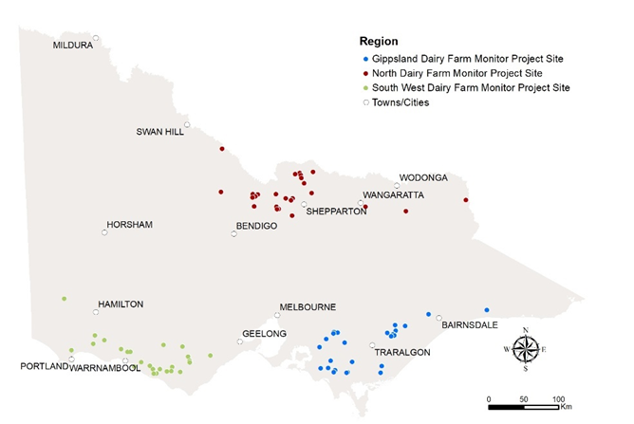

### 2018-19 seasonal conditions

Annual rainfall for much of the state was average to very much below average during 2018-19. Annual rainfall totals across the surveyed farms was 80% of the long-term average compared to 92% the previous year.

The North participants received 69% of average long-term rainfall with 336 mm, the driest of all the regions. Gippsland participants received 705 mm or 83% of the long-term average rainfall, while the South West participants received 746 mm or 93% of average long-term rainfall.

The significant reduction in rainfall in the North saw an increased reliance on irrigation water. Increasing demand drove higher water prices and soon made water purchases unprofitable for many. To offset the lack of water in summer many participating farmers selected to grow more cereal crops.

Gippsland experienced regional variation in seasonal conditions in 2018-19. Conditions were favourable in south and west Gippsland and farmers conserved multiple cuts of silage. Central Gippsland (e.g. Yarram) missed out on rainfall and pastures were severely impacted. There was a continued trend of decreasing rainfall in East Gippsland, leading to pasture growth limitations and an increased reliance on supplementary feeding. While farms within the MID received 100% of seasonal determinations, they did not receive spill allocation.

South West Victoria had improved seasonal conditions during 2018-19 with an average winter before turning dry from November 2018 onwards. Summer thunderstorms in some parts of the region provided a source of soil moisture to boost pastures when the autumn rains arrived in May 2019 (Figure 3).

The regional sections provide more detail on the 2018-19 seasonal conditions.

FIGURE 3. MONTHLY RAINFALL 2018-19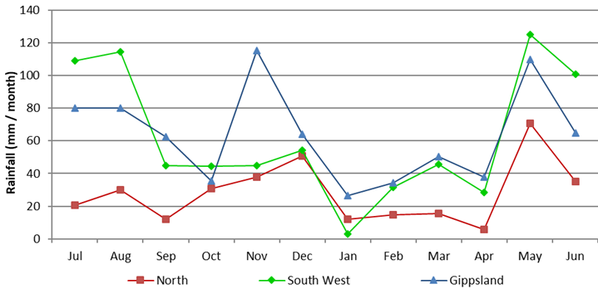

## Whole farm analysis

Average Victorian dairy farm performance in 2018-19 was among the lowest recorded in the 13-year history of the project. However, the performance amongst the regions was mixed. Dry seasonal conditions reduced pasture availability and led to increased operational costs. Milk price improved on the previous year easing some of the impact of higher input costs.

Average herd size across all three regions increased slightly this year to 357 cows from an average of 352 cows the previous year. Usable hectares decreased to 261 ha from 264 ha the previous year.

Average milk sold per cow decreased to 495 kg MS/cow from 503 kg MS/cow. This was seen across all regions.

Labour efficiency for the state remained stable at 107 cows/FTE and 51,993 kg MS/FTE.

On average, farmers relied on a greater proportion of homegrown feed in the diet compared to 2017-18. This year homegrown feed increased to 65% of total Metabolisable Energy (ME) consumed. Fodder inventories increased on average across all regions with 44 of the 75 farms building their reserves.

Table 1 presents the average farm physical parameters for the state and for each region. Further details can be found in Appendix Table 2 for each region.

TABLE 1. FARM PHYSICAL DATA – STATE OVERVIEW 2018-19

|  |  |  |  |  |
| --- | --- | --- | --- | --- |
| **Farm Physical Parameters** | **Statewide** | **North** | **South West** | **Gippsland** |
| Number of farms in sample | 75 | 25 | 25 | 25 |
| Annual rainfall 18-19 (mm) | 596 | 336 | 746 | 705 |
| Herd size | 357 | 399 | 364 | 307 |
| Total water use efficiency (t DM/100mm/ha) | 0.9 | 0.9 | 0.8 | 1.0 |
| Total usable area (hectares) | 261 | 271 | 325 | 186 |
| Milking cows per usable hectare | 1.6 | 1.6 | 1.1 | 1.9 |
| Milk sold (kg MS /cow) | 495 | 524 | 492 | 468 |
| Milk sold (kg MS /ha) | 757 | 829 | 553 | 888 |
| Home grown feed as % of ME consumed | 65% | 60% | 68% | 66% |
| Labour efficiency (cows /FTE) | 107 | 103 | 99 | 119 |
| Labour efficiency (kg MS /FTE) | 51,993 | 52,699 | 48,587 | 54,692 |

### Gross farm income

Gross farm income includes all farm income from milk sales, livestock trading and income from other farm sources such as milk share dividends.

Milk sales on average accounted for 91% of gross farm income, similar to the 90% seen the previous year. Total milk (net) income increased by 6% to $6.13/kg MS, up from $5.81/kg MS in the previous year.

In real terms (when the effects of inflation are excluded), the milk price received was the seventh highest in the 13-year history of the project. The North region experienced the greatest rise in milk price up 7% to $6.28/kg MS. This was the highest milk price recorded.

The South West had a 6% increase to $6.15/kg MS and Gippsland increased by 4% to $5.97/kg MS. Many farmers changed milk processors during the year to leverage a higher milk price as competition between processors intensified.

Prevailing economic and production conditions saw milk income supplemented with positive livestock trading results. In the 2018-19, season livestock trading contributed 8% to gross farm income on average. The remaining 1% was other farm income.

### Variable costs

Variable costs are those costs that vary with the size of production in the enterprise e.g. herd, shed and feed costs (including feed and water inventory changes). See Appendix Table 6 for a breakdown of variable costs as a percentage of total costs in each region.

Table 2 shows the largest cost was purchased feed and agistment costs at $2.33/kg MS. This was a 30% increase from the previous year, driven by the significant increase in concentrate price of 37% from $373/t DM up to $5.14/t DM. The elevated price was also seen in hay and silage prices. Purchased feed per milker remained similar at 2.3 t DM/cow between years.

Homegrown feed costs increased, primarily from higher irrigation costs ($0.31/kg MS). Fertiliser costs increased to $0.46/kg MS while the other categories remained similar between years.

Feed inventories increased on average across all regions contributing to lower variable costs, as shown by the negative values in Table 2. This was a welcome change compared to the feed inventory costs seen the previous year. However, water inventory change contributed to an average cost of $0.06/kg MS. Farms in the North utilised their water inventories as the temporary water price increased to near record high levels, and water balances were depleted by the end of the year.

Overall, variable costs increased 20% from $3.46/kg MS, up to $4.16/kg MS. The rise in milk income partially compensated the rise in variable costs with average gross margin decreasing to $2.59/kg MS, down from $2.95/kg MS the previous year.

### Overhead costs

Overhead costs are fixed costs incurred by the farm business that do not vary with the level of production. These include cash overhead costs, such as employed labour and non-cash costs, such as imputed owner-operator labour, family labour and depreciation of plant and equipment. Standard values used to calculate imputed labour can be found in Appendix E.

Average overhead costs increased this year to $2.34/kg MS, a 2% increase from $2.29/kg MS last year. There were small increases in employed labour, imputed labour and depreciation.

**TABLE 2. AVERAGE FARM FINANCIAL PERFORMANCE PER KILOGRAM MILK SOLIDS - STATEWIDE**

| **Farm income and cost category** | **Statewide** | **North** | **South West** | **Gippsland** |
| --- | --- | --- | --- | --- |
| **INCOME** |  |  |  |  |
| Milk income (net) | $6.13 | $6.28 | $6.15 | $5.97 |
| Livestock trading profit | $0.58 | $0.46 | $0.80 | $0.47 |
| All other farm income | $0.05 | $0.07 | $0.04 | $0.03 |
| Gross farm income | $6.76 | $6.81 | $6.99 | $6.47 |
| **VARIABLE COSTS** |  |  |  |  |
| Herd cost | $0.32 | $0.34 | $0.28 | $0.33 |
| Shed cost | $0.23 | $0.21 | $0.26 | $0.21 |
| Home grown feed cost | $1.30 | $1.67 | $1.13 | $1.11 |
| Purchased feed and agistment | $2.33 | $2.67 | $2.09 | $2.23 |
| Feed inventory change | -$0.07 | -$0.10 | -$0.02 | -$0.07 |
| Water inventory change | $0.06 | $0.17 | $0.00 | $0.00 |
| Total feed costs | $3.62 | $4.40 | $3.20 | $3.27 |
| Total variable costs | $4.17 | $4.95 | $3.74 | $3.81 |
| **GROSS MARGIN** |  |  |  |  |
| per kg MS | $2.59 | $1.85 | $3.26 | $2.66 |
| **OVERHEAD COSTS** |  |  |  |  |
| Employed labour | $0.57 | $0.60 | $0.55 | $0.57 |
| Repairs and maintenance | $0.34 | $0.34 | $0.40 | $0.29 |
| All other overheads | $0.30 | $0.29 | $0.33 | $0.29 |
| Imputed owner/operator and family labour | $0.89 | $0.87 | $0.97 | $0.85 |
| Depreciation | $0.23 | $0.21 | $0.31 | $0.16 |
| Total overhead costs | $2.34 | $2.31 | $2.55 | $2.15 |
| Variable and overhead costs | $6.50 | $7.26 | $6.29 | $5.96 |
| **EARNINGS BEFORE INTEREST AND TAX** |  |  |  |  |
| per kg MS | $0.25 | -$0.45 | $0.71 | $0.51 |

### Earnings before interest and tax

Gross farm income minus total variable and total overhead costs is EBIT. It excludes tax, interest and lease costs, and therefore provides a measure of operational efficiency for the whole farm business.

Average EBIT decreased across the state this year with an average of $0.25/kg MS, a reduction from $0.66/kg MS in 2017-18 (Figure 4). The decrease in EBIT was not consistent across the three regions. In the North EBIT was -$0.45/kg MS, the first time there has been a negative result since 2006-07. Gippsland EBIT also decreased to $0.51/kg MS, whereas the South West increased to $0.71/kg MS.

The change in EBIT across the regions reflects a challenging year for the Victorian dairy industry. Continued dry seasonal conditions induced high input costs, particularly for irrigation water, grain and fodder.

These costs were only partially compensated by increases in milk price. Aggregate farm profit from surveyed farms decreased to the levels seen in 2015-16, 2012-13 and 2006-07 at a return on total assets of 0.7%.

Figures 16, 26 and 36 in the regional sections present the range in EBIT received by participant farms this year.

**FIGURE 4. AVERAGE EARNINGS BEFORE INTEREST AND TAX PER KILOGRAM OF MILK SOLIDS SOLD**

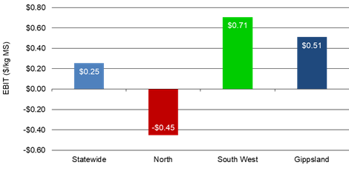

### Return on total assets and equity

The return from total assets under management, including owned and leased assets, is RoTA. It is calculated as EBIT divided by total assets.

Average RoTA was 0.7% in 2018-19, a decrease from 2.5% the previous year. The change in economic performance is shown by a greater number of farms shifting to the left in Figure 5. The range in RoTA was -13.2% to 9.1%.

Although improved milk price helped bolster farm incomes, for some businesses, the increases in costs offset much of the benefit. Across the state, 46 of the 75 farms (61%) recorded a positive RoTA, 10 farms less than the previous year.

Most farm businesses are a mix of owned and borrowed capital (i.e. bank loan). Return on equity is a measure of how efficiently the owner’s capital (share of the business) is being utilised. This can give insights into how appropriately the business is geared (level of debt) and whether capital is being put to profitable use.

The average RoE for the 75 participating farms was -3.5%, a decrease from the 0.4% RoE received by participants last year. The range in RoE for the State was between -37% and 11% this year, with a median RoE of 2.0% (Figure 6).

The decrease in average RoE for the State was driven by a -7.4% return in the North and a -2.3% return in the Gippsland region. Average state interest and lease charges increased 5% to $0.64/kg MS in 2018-19.

Further discussion of RoTA and RoE in the regional chapters. Appendix Table 1 presents RoTA and RoE for the participant farms for each region.

**FIGURE 5. DISTRIBUTION OF FARMS BY RETURN ON TOTAL ASSETS**

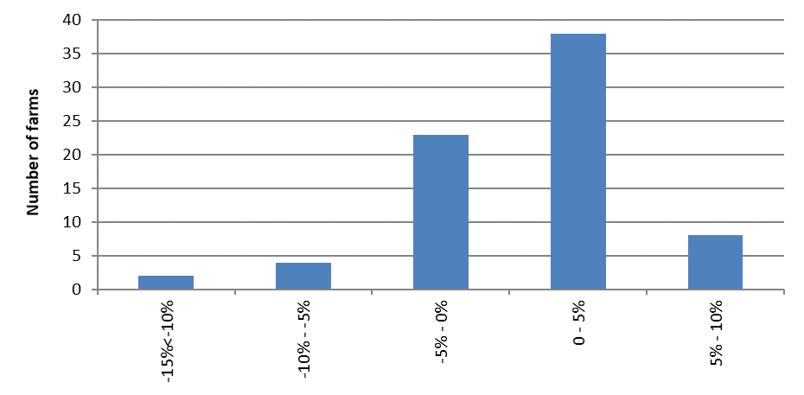

**FIGURE 6. DISTRIBUTION OF FARMS BY RETURN ON EQUITY**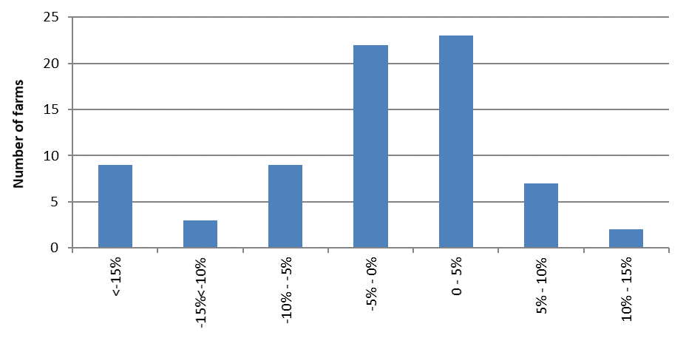

## Risk

“Risk is conventionally classified into two types: business risk and financial risk. Business risk is the risk any business faces regardless of how it is financed. It comes from production and price risk, uncertainty and variability. Business risk refers to variable yields of crops, reproduction rates, disease outbreaks, climatic variability, unexpected changes in markets and prices, fluctuations in inflation and interest rates, and personal mishap…. Financial risk derives from the proportion of other people’s money that is used in the business relative to the proportion of owner-operator’s capital…”[2]

As most farms use a mix of borrowed and owned capital, most farms are exposed to business and financial risk. What is important to understand is that risk drives return and having the balance between risk and return right can drive success.

Table 3 presents some key risk indicators. Refer to Appendix E for the definition of terms used in Table 3. The indicators in Table 3 can also be found in Appendix Tables 1, 3 and 8 for each region.

The cost structure ratio provides variable costs as a proportion of total costs. A lower ratio implies that overhead costs comprised a greater proportion of total costs which in turn indicates less flexibility in the business. Table 3 shows that across the state for every $1.00 spent, $0.64 was used to cover variable costs, a slight increase from last year ($0.60). It is however worth noting that cost structure varies significantly between regions and farms.

The debt service ratio shows interest and lease costs, as a proportion of gross farm income. A ratio of 10% this year means that on average farms repaid $0.10 of every dollar generated back to their creditors.

On average, equity levels across the state remained constant at 64%. In the North, equity increased, while in the South West and Gippsland equity slightly declined. It should be noted that when new farms enter the survey with different equity structures, results can be impacted.

**TABLE 3. RISK INDICATORS - STATEWIDE AND BY REGION**

|  |  |  |  |  |
| --- | --- | --- | --- | --- |
|  | **Statewide** | **North** | **South West** | **Gippsland** |
| Cost structure (percentage of total costs as variable costs) | 64% | 68% | 59% | 64% |
| Debt service ratio (percentage of income as finance costs) | 10% | 8% | 10% | 11% |
| Debt per cow | $4,801 | $4,651 | $5,140 | $4,611 |
| Equity percentage (ownership of total assets managed) | 64% | 65% | 63% | 63% |
| Percentage of feed imported (as a % of total ME) | 35% | 40% | 32% | 34% |

## Physical measures

**Feed consumption**

The contribution of different feed sources to the total ME consumed on the farm is presented in Figure 7. This includes feed consumed by dry cows and young stock.

A cow’s diet typically consists of grazed pasture and forages, conserved forage, concentrates including grains and other imported feeds. Grazed pasture on the usable area made up the majority of dietary ME across all regions. The North had 44% of directly grazed feed, the lowest proportion in the study. The South West used 45% of ME from grazed pasture and Gippsland had the largest proportion, with 56% of ME coming from directly grazed pasture.

Last year Northern participants sourced 46% of ME from grazed pasture. As temporary irrigation water become unprofitable for many farmers this year, feeding hay was used as a cost-effective alternative feed.

Elevated grain prices are likely to have contributed to the slight decrease in dietary ME from concentrates. As a proportion of total diet concentrates were used consistently across the state. The North obtained 29% of dietary ME from concentrates, and the South West and Gippsland used 28%.

Appendix Table 3 provides further information on purchased feed in each region.

Figure 8 and Appendix Table 2 for each region give an indication of the average quantity of homegrown feed removed per milking hectare. This accounts for the consumption of pasture that occurred on the milking area whether by milking, dry or young stock, and forage conservation.

Estimated homegrown feed consumed is calculated from the total ME required on farm, determined by stock numbers, liveweight, average distance walked to and from the dairy and milk production. Metabolisable Energy imported from other feed sources is subtracted from the total farm ME requirements over the year to give estimated total ME produced on farm. The ME produced on farm is divided into grazed and conserved feed, using records of the amount of conserved fodder produced.

Total homegrown feed removed from the milking area (by direct grazing plus conservation) in 2018-19 was 8.1 t DM/ha, an increase from 7.6 t DM/ha last year. Despite the dry conditions, DFMP farmers were able to directly graze and conserve greater quantities of pasture through using irrigation water, and timely rain events.

Favourable spring conditions assisted South West farmers in pasture conservation, with 13 of the 25 farms built their fodder reserves. Directly grazed pasture also increased combining to a total of 6.5 t DM/ha total homegrown feed removed, as compared with 5.8 t DM/ha the previous year.

Gippsland farms grazed higher quantities of pasture (7.9 t DM/ha as compared with 7.4 t DM/ha) and maintained conservation (1.1 t DM/ha compared with 1.2 t DM/ha in 2017-18). Regional variation in seasonal conditions resulted in mixed pasture performance among farms.

**FIGURE 7. SOURCES OF WHOLE FARM METABOLISABLE ENERGY**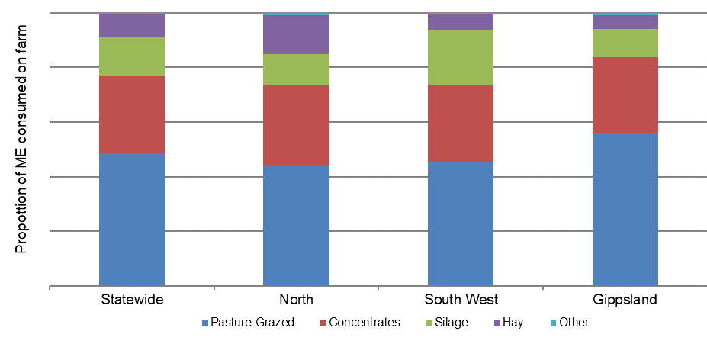

**FIGURE 8. ESTIMATED TONNES OF HOMEGROWN FEED REMOVED PER MILKING HECTARE**

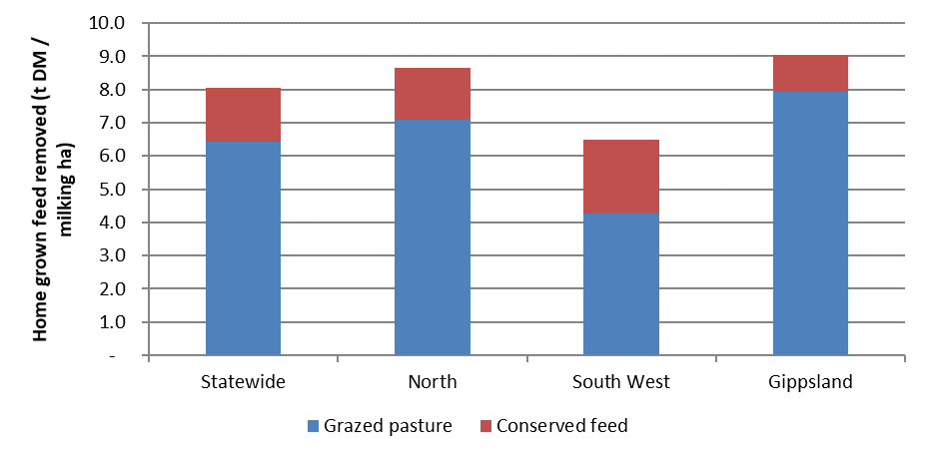

### Fertiliser application

Application of nutrients this year for the state and the regions is shown in Figure 9. Application of nutrients is now reported for the milking area rather than for the usable area in previous years.

Across the state, the total application of nutrients was 218 kg/ha. This comprised of nitrogen (142 kg N/ha), phosphorus (19 kg P/ha), potassium (34 kg K/ha) and sulphur (22 kg S/ha).

The North applied the least amount of nutrients at 144 kg /milking ha, compared with the South West at 239 kg/milking ha and Gippsland at 270 kg/milking ha.

The composition of nutrients varied across the regions. Nitrogen represents approximately two-thirds of the nutrients applied, with Gippsland applying the greatest proportion at 71% of all nutrients. The North applied the greatest proportion of phosphorus at 15% and sulphur at 13%. The South West applied the greatest proportion of potassium at 21%.

It should be noted that water availability, pasture species, soil type, pasture management, seasonal variation in response rates to fertilisers, amount of (and nutrient composition of) imported feeds, variations in long-term fertiliser strategies plus other factors will all influence pasture growth and fertiliser application strategies. These particular factors are not captured as part of this project.

Appendix Table 2 provides further information on nutrient application for participant farms in each region.

**FIGURE 9. NUTRIENT APPLICATION PER HECTARE**

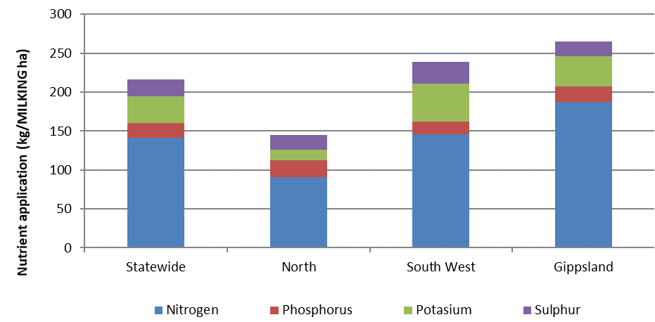

### Milk production

All three regions produced the greatest amount of milk during the spring period (Figure 10), however each region had its own unique milk production distribution.

The South West had an extended winter to spring milk production peak period, where historically a double peak would have occurred in autumn and spring. Over 60% of milk production occurred between July 2018 and December 2018. Winter milk comprised 29% of annual milk production, spring milk 33%, summer 22% and 16% for autumn, similar to the milk supply pattern seen in the previous year.

Gippsland showed strong seasonal supply in spring, maintaining the tradition of producing milk when there is normally a greater abundance of homegrown feed. More than 33% of milk was produced during spring, 26% in summer, 21% in autumn and 21% in winter.

In the North, milk production showed a double peak occurring in spring and then again in autumn. Winter milk comprised 22% of annual production, spring milk 31%, summer 24% and autumn 23%.

FIGURE 10. MONTHLY DISTRIBUTION OF MILK PRODUCTION

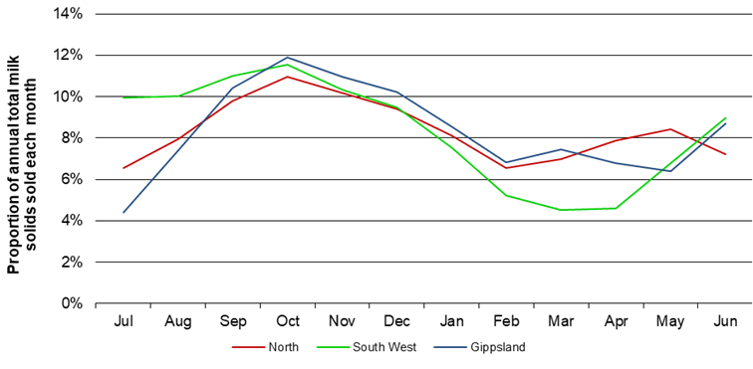

### Calving pattern

The calving pattern for all regions is shown in Figure 11.

The South West produced the greatest amount of calves in autumn (with 57% calves born between March and May). Some South West farms in the sample have reduced their milk production by changing their calving pattern as a risk management strategy in response to dry conditions. As farmers are transitioning, the effect of this change in calving pattern on milk supply for the South West average data remains to be seen.

The North exhibited two peaks for milk production (Figure 10) and this was matched by two key calving periods (August 2018 and March 2019) as shown in Figure 11. Gippsland once again had a strong winter calving period (over 35% of calves are born in August 2018) which was matched with peak milk production two months later in spring.

**FIGURE 11. MONTHLY DISTRIBUTION OF CALVING**

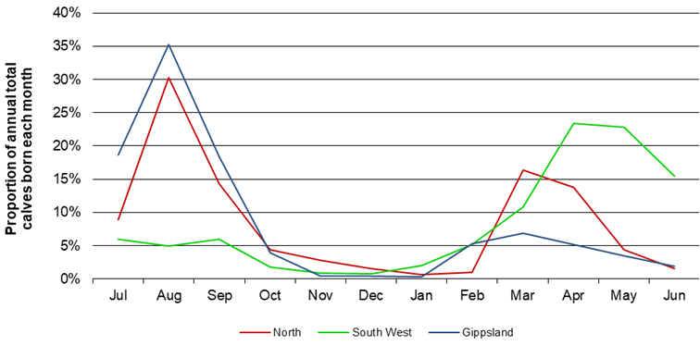

# Part Two: The North

## The North

The 2018-19 season presented several challenges for dairy farmers in the North, with

low rainfall and higher input prices, notably for water. On average, farms purchased

additional feed and used carry-over water to manage the dry conditions. By the end of

the season, irrigators had received 100% allocation of their High Reliability Water Shares (HRWS) and the median price of temporary (allocation) water was $470/ML.

Rainfall across surveyed farms in the North for the 2018-19 season was patchy, totalling 336 mm, or 69% of the long-term average of 488 mm (Figure 12). Excluding rainfall in November, March and May, which was close to the long-term average in the North East, most parts of Northern Victoria experienced low rainfall throughout the year. Rainfall from January 2019 to April 2019 was 36% of the long-term average. This year’s total annual rainfall was 25% lower than in 2017-18 and 45% lower than in 2016-17. The top performing farms received 40% more rain than the average reflecting the two farms out of six located in the North East.

Rainfall in early summer helped extend the irrigation interval. However, the interval was shortened due to high temperature and an increase in evapo-transpiration rates toward the end of summer which continued into autumn. Autumn was generally warm and dry until a substantial rainfall event in May 2019 occurred across the region.

Allocation of HRWS reached 100% in December 2018 for the Murray system and mid-March 2019 in the Goulburn system, the two main irrigation systems. The spot price of temporary water increased considerably and steadily throughout the year, from a weighted average price of $240/ML in July 2018 to $568/ML in May 2019, impacting those farmers who entered the market later. Many farmers regularly reviewed their feed budgets as additional fodder and irrigation allocations were required. Market prices increased, and farmers paid a lot more for feed and water throughout the season.

A few farmers reduced the amount of irrigation water applied to their pastures and sold off their entitlements to manage cash flow.

Across the Northern region there was a general increase in crops cut for hay after severe frost events in spring which improved the amount of fodder available. Irrigation commenced early and farmers were able to produce, and conserve home grown feed including summer crops.

**FIGURE 12. 2018-19 ANNUAL RAINFALL AND LONG-TERM AVERAGE RAINFALL – NORTH**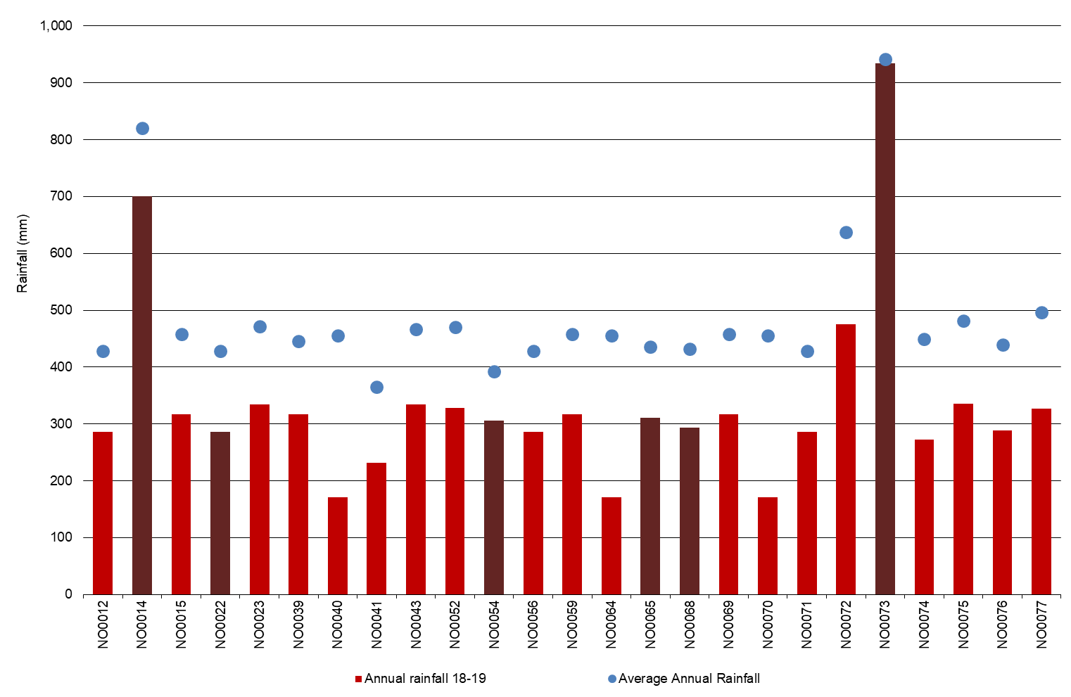

------------------------------

Three new farms (NO0075, NO0076 and NO0077) joined the Dairy Farm Monitor Project and one returned in 2018-19 (NO0052).

* The top 25% are shown as the darker bars in all graphs as ranked by RoTA.

## Whole Farm Analysis

The dry and challenging season was reflected in the profit for farms in the North in

2018-19. Average EBIT was -$0.45/kg MS, the lowest in the 13-year history of the project.

A substantial increase in feed costs, including irrigation water was only partially offset by the 7% improvement in milk price.

Key whole farm physical parameters for the North are presented below in Table 4. The Q1 – Q3 range shows the band in which the middle 50% of farms sit for each parameter.

The number of milkers per farm rose by 4% and a 1% increase in the average usable area kept the stocking rate at 1.6 cows/ha this year compared to 2017-18. The average homegrown feed as percentage of ME consumed was similar at 60% compared to 59% in 2017-18 (Table 4).

The top 25% of participants in the North had a higher proportion of homegrown feed as percentage of ME consumed at 68% compared to the regional average at 60%. They were able to grow more pasture and capitalise on better rainfall than the average of all DFMP North farms. The higher percentage of homegrown feed used by the top 25% was reflected in the total water use for these farms (975 mm/usable ha), which was 10% higher than the regional average (885 mm/usable ha).

Irrigation water use for the top performing farms was 1,372 ML/farm, 30% higher compared to the regional average of 1,052 ML/farm. This equated to 5 ML/irrigated ha compared to the average 5.5 ML/irrigated ha. They produced 11% more feed at 1 t DM/100mm/ha than the average of 0.9 t DM/100mm/ha.

The top performing group were more efficient than the average in their labour use per milking cow and milk solids sold per FTE. Their milk production per cow and price received for milk was only 2% and 3% higher than the average, respectively. However, their variable costs were 25% lower and their overhead costs were 10% lower than the average.

The top performing farms had lower average production per hectare and a lower stocking rate relative to all participants in the region.

**TABLE 4. FARM PHYSICAL DATA – NORTH**

|  |  |  |  |
| --- | --- | --- | --- |
| **Farm Physical Parameters** | **North Average** | **Q1 to Q3 range** | **Top 25% average** |
| Annual rainfall 2018-19 (mm) | 336 | 286 - 328 | 472 |
| Herd size | 399 | 245 - 460 | 632 |
| Total water use efficiency (t DM/100mm/ha) | 0.9 | 0.8 - 1.1 | 1.0 |
| Total usable area (hectares) | 271 | 162 - 311 | 466 |
| Milking cows per usable hectare | 1.6 | 1.2 - 1.8 | 1.5 |
| Milk sold (kg MS /cow) | 524 | 482 - 587 | 533 |
| Milk sold (kg MS /ha) | 829 | 591 - 1,029 | 751 |
| Home grown feed as % of ME consumed | 60% | 54% - 63% | 68% |
| Labour efficiency (cows /FTE) | 103 | 76 - 114 | 126 |
| Labour efficiency (kg MS /cow) | 52,699 | 41,005 - 60,796 | 62,770 |

### Milk solids sold

On average, farms in the North sold 524 kg MS/cow and 829 kg MS/ha (Figure 13). This was a slight decrease in milk sold on a per hectare (1%) and per cow basis, (2%) year-on-year.

Of the same 21 farms participating on both years, nine farms sold less milk per farm than they did the previous year, with an average decline of 2,760 kg MS, equivalent to 1% per farm.

Almost a third of the milk sold (31%) occurred in spring, with the greatest amount of milk sold in October 2018 with 22,500 kg MS/farm (Figure 10). The distribution of milk sold shows that most milk sold during the months of spring and in December 2018, with another slight peak in May 2019.

On average, total milk solids increased by 3% to 213,900 kg MS/farm, up from 208,000 kg MS/farm the previous year due to change in the sample. For farms that participated in both years, the increase was 1% year-on-year.

The top performing group sold less milk on a per hectare basis than the average and also less per cow and per hectare than the top performers in 2017-18.

Figure 13 also shows that the quantity of milk sold is not the only variable contributing to good performance.

**FIGURE 13. MILK SOLIDS SOLD – NORTH**

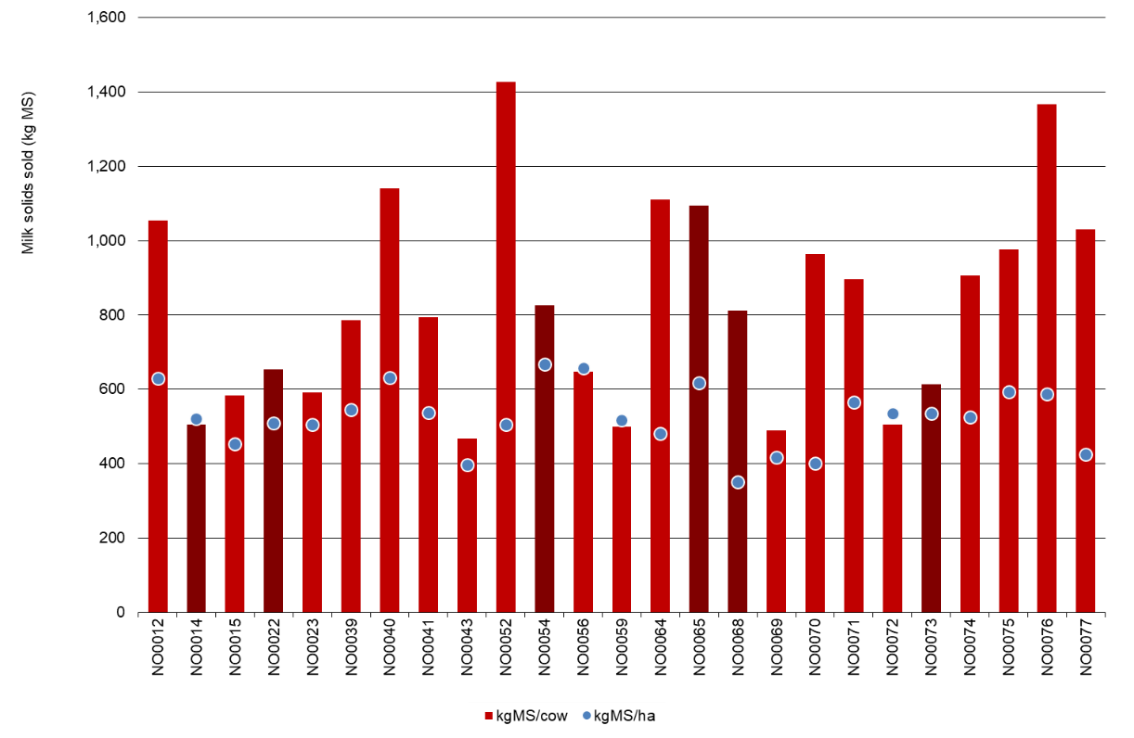

### Gross farm income

Gross farm income includes milk sales net of levies and charges, livestock trading profit and other farm income.

For farms in the North and on a per kg MS basis, milk income contributed 92%, livestock trading 7% and 1% other income to the gross income of $6.81/kg MS (Table 5).

Figure 14 shows the milk price received ranges from $5.78/kg MS to $7.11/kg MS. On average milk price increased to $6.28/kg MS, up 7% from $5.88/kg MS in 2017-18. It was the third highest in nominal terms since the start of the project in 2006-07 and the highest compared to the last three seasons. When the effects of inflation are removed, milk price was $5.97/kg MS in 2017-18, $5.32/kg MS in 2016-17, and $5.78/kg MS in 2015-16.

Farms that were in the top 25% received an average milk price of $6.49/kg MS compared to $6.12/kg MS last year. The top performing group recorded a milk price of 6% higher than in 2017-18.

Many farmers raised their bobby calves to take advantage of improved beef prices and also to manage their cashflows.

FIGURE 14. GROSS FARM INCOME PER KILOGRAM OF MILK SOLIDS – NORTH

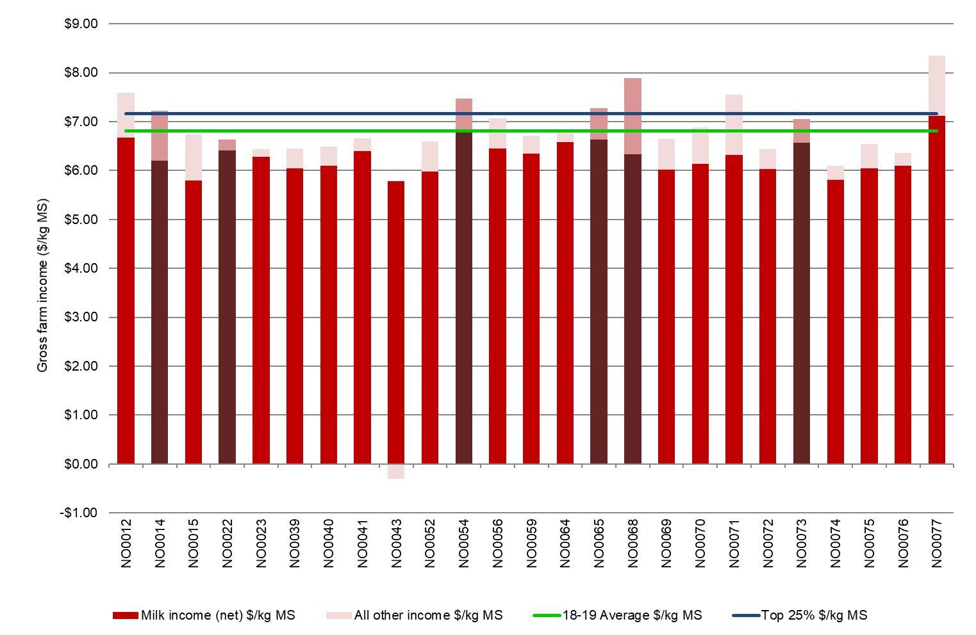

### Variable costs

Variable costs (shown in Figure 15) are all costs that vary with the size of production in the enterprise e.g. herd, shed and feed costs (including feed and water inventory changes).

Participant farms in the North spent an average of $4.95/kg MS on variable costs, an increase of 32% from 2017-18. Feed costs were the major variable cost for farms in the North, accounting for 61% of total costs and 65% of gross income. Last year feed costs accounted for 54% of total costs and 49% of gross income.

Feed costs increased by 37% to $4.40/kg MS from $3.21/kg MS in 2017-18 with a range of between $2.56/kg MS and $6.61/kg MS. The rise in feed costs was driven by higher costs of homegrown and purchased feeds compared to last year. The cost of homegrown feed ($1.67/kg MS) was 35% higher than last year. Increases in homegrown feed costs included fertiliser, hay and silage making and irrigation.

In the North, the 2018-19 season was all about water. Irrigation cost and water inventory change increased significantly, from $0.52/kg MS to $0.96/kg MS. These costs accounted for 15% of gross income in 2018-19, almost doubling from 8% last year.

Purchased feed accounted for 37% of total costs, an increase from 31% last year. The cost rose by almost half, from $1.82/kg MS to $2.67/kg MS. The average cost of purchased supplements per kg MS rose due to price increases as amount of purchased feed per milker was maintained at 2.7 t DM/cow. The amount of concentrates fed declined from 1.9 t DM/cow to 1.7 t DM/cow this year. The price of concentrates and hay increased substantially by 46% and 55%, respectively and silage price by 70% year-on-year.

On average feed inventory increased as farmers were able to conserve feed to manage the risk of higher feed costs in 2019-20. Total herd and shed costs were $0.55/kg MS, the same as last year.

The top 25% of farms also experienced higher variable costs in 2018-19 ($3.77/kg MS) but they were lower than the average. They incurred variable costs 24% lower than the average but 12% higher than last year’s top performers. They spent 26% less on feed, 17% less on shed costs and 4% more in herd costs compared to the average in 2017-18. They were also able to conserve feed, similar to last year. Like the average of all participant farms, the top performers decreased their water inventory but at a lower rate of $0.04/kg MS compared to $0.17/kg MS for the average.

Figure 15 shows the breakdown of total farm costs as variable and overhead costs per kg MS. A breakdown of the costs for individual farms can be found in Appendix Tables B6 and B7. The price of purchased feed is shown in Appendix Table B3.

### Overhead costs

Overhead costs are all fixed costs incurred by the farm business that do not vary with the level of production. These include cash overhead costs such as employed labour and non-cash costs such as imputed owner operator labour, family labour and depreciation of plant and equipment.

Average overhead costs this year ranged from $1.54/kg MS to $3.59/kg MS (Figure 15), a wider spread than last year. Average overhead costs for 2018-19 were $2.31/kg MS, an 8% rise from last year. Labour costs increased by 11% and accounted for 64% of the overhead cost (62% in 2017-18). The total number of FTE per farm increased by 7% to 3.8 FTE/farm.

The top performing farms had lower overhead costs than the average of all participant farms due to their lower other overheads and imputed labour. Their employed labour was 12% more than the average.

**FIGURE 15. WHOLE FARM VARIABLE AND OVERHEAD COSTS PER KILOGRAM OF MILK SOLIDS –NORTH**

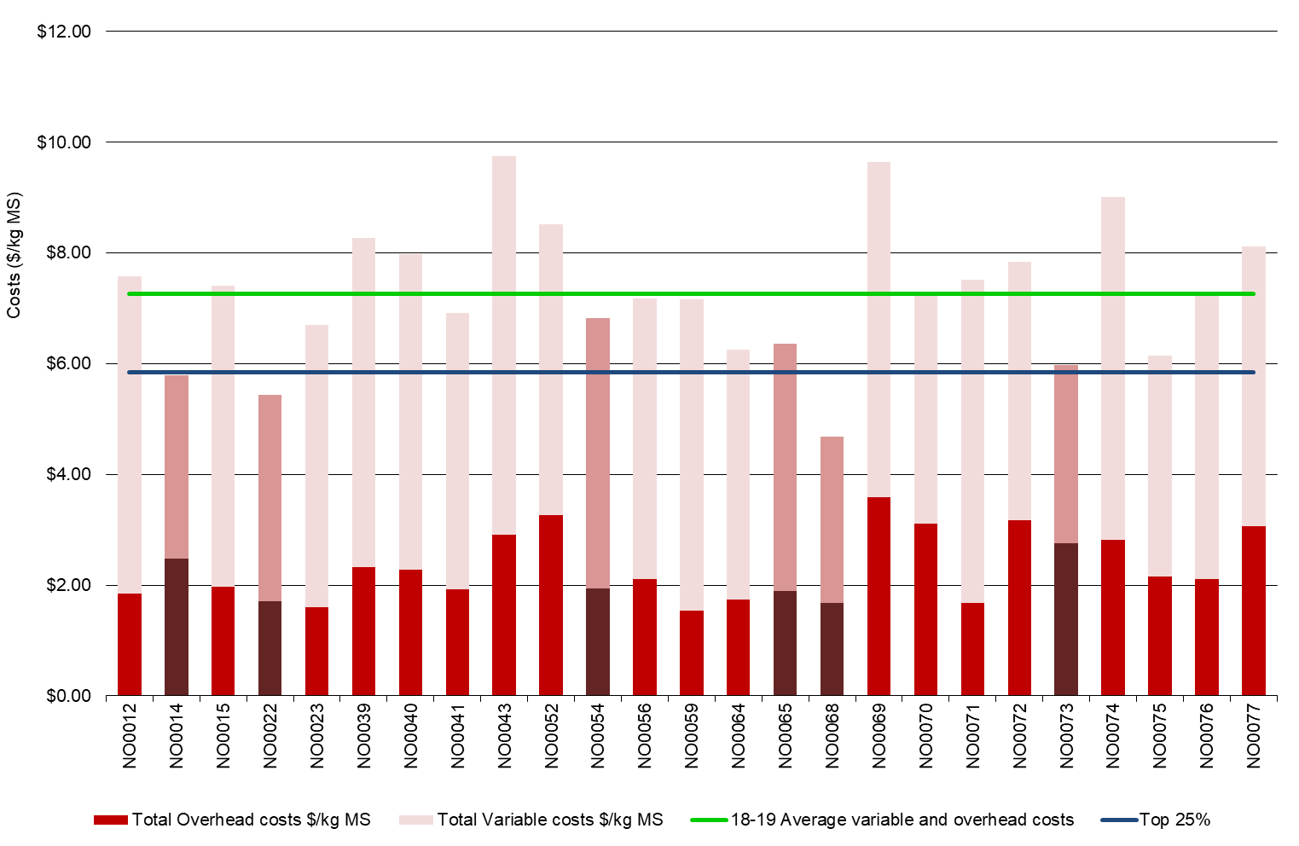

**TABLE 5. AVERAGE FARM FINANCIAL PERFORMANCE PER KILOGRAM OF MILK SOLIDS – NORTH**

|  |  |  |  |
| --- | --- | --- | --- |
| **Farm costs** | **North average** | **Q1 to Q3 range** | **Top 25% average** |
| **INCOME** |  |  |  |
| Milk income (net) | $6.28 | $6.04 - $6.45 | $6.48 |
| Livestock trading profit | $0.46 | $0.29 - $0.61 | $0.57 |
| Other farm income | $0.07 | $0.00 - $0.10 | $0.11 |
| Gross farm income | $6.81 | $6.45 - $7.22 | $7.17 |
| **VARIABLE COSTS** |  |  |  |
| Herd cost | $0.34 | $0.28 - $0.43 | $0.35 |
| Shed cost | $0.21 | $0.17 - $0.25 | $0.18 |
| Homegrown feed cost | $1.67 | $1.27 - $1.79 | $1.32 |
| Purchased feed and agistment | $2.67 | $2.40 - $3.07 | $2.04 |
| Feed inventory change | -$0.10 | -$0.22 - $0.07 | -$0.16 |
| Water inventory change | $0.17 | $0.00 - $0.29 | $0.04 |
| Total feed costs | $4.40 | $3.97 - $5.12 | $3.24 |
| Total variable costs | $4.95 | $4.47 - $5.70 | $3.77 |
| **GROSS MARGIN** |  |  |  |
| per kg MS | $1.85 | $1.12 - $2.76 | $3.40 |
| **OVERHEAD COSTS** |  |  |  |
| Employed labour | $0.60 | $0.44 - $0.78 | $0.67 |
| Repairs and maintenance | $0.34 | $0.23 - $0.47 | $0.42 |
| All other overheads | $0.29 | $0.22 - $0.32 | $0.25 |
| Imputed labour | $0.87 | $0.55 - $1.07 | $0.49 |
| Depreciation | $0.21 | $0.14 - $0.22 | $0.25 |
| Total overhead costs | $2.31 | $1.85 - $2.82 | $2.07 |
| Variable and overhead costs | $7.26 | $5.01 - $5.30 | $5.84 |
| **EARNINGS BEFORE INTEREST AND TAX** |  |  |  |
| per kg MS | -$0.45 | -$1.41 - $0.54 | $1.33 |

### Cost of Production

Cost of production gives an indication of the cost of producing one kilogram of milk solids. It is calculated as variable plus overhead costs and accounts for changes in fodder and livestock inventory.

Table 6 shows that the top performing group had 22% lower cost of production with inventory change ($5.77/kg MS) than the average of all farms ($7.38/kg MS). The difference between the top 25% and the average of all participants was greater than in 2017-18 (14% lower) but was similar to 2016-17. For the top group, all categories contributed to their lower cost of production than the average of all participant farms.

A negative change in inventory, such as -$0.13/kg MS for the top 25% in the North, indicates that fodder and water reserves increased and is therefore counted as a decrease to the cost of production. Half of the North sample (13 of the 25 farms) increased their long-term fodder reserves in 2018-19.

**TABLE 6. COST OF PRODUCTION – NORTH**

|  |  |  |  |
| --- | --- | --- | --- |
| **Farm costs** | **North average** | **Q1 to Q3 range** | **Top 25% average** |
| Cash cost of production ($/kg MS) | $6.12 | $5.86 - $6.79 | $5.23 |
| Cost of production without inventory changes ($/kg MS) | $7.20 | $6.55 - $7.87 | $5.97 |
| **INVENTORY CHANGE** |  |  |  |
| +/- feed and water inventory change | $0.06 | -$0.33 - $0.47 | -$0.13 |
| +/- livestock inventory change minus purchases | $0.12 | -$0.07 - $0.27 | -$0.07 |
| Cost of production with inventory change ($/kg MS) | $7.38 | $6.43 - $8.18 | $5.77 |

### Earnings Before Interest and Tax

Gross farm income minus total variable and total overhead costs is EBIT.

Average EBIT decreased substantially, from $0.65/kg MS last year to -$0.45 this year, with a range between -$4.28/kg MS to $2.70/kg MS (Figure 16). The range was much wider than last year’s -$1.21/kg MS and $3.16/kg MS, reflecting the impact of the challenging season on farm profit in 2018-19. This reflects the impact of the higher input prices and dry conditions on the bottom performers. Ten out of 25 farms posted positive EBIT compared to 20 in 2017-18 and 19 in 2016-17.

The EBIT of $1.33/kg MS for the top 25% is significantly higher than the average of all participant farms. Their variable and overhead costs were 24% and 10% lower than the average, respectively. They also received 3% more per kg MS for their milk and 5% higher of overall gross income.

**FIGURE 16. WHOLE FARM EARNINGS BEFORE INTEREST AND TAX PER KILOGRAM OF MILK SOLIDS – NORTH**

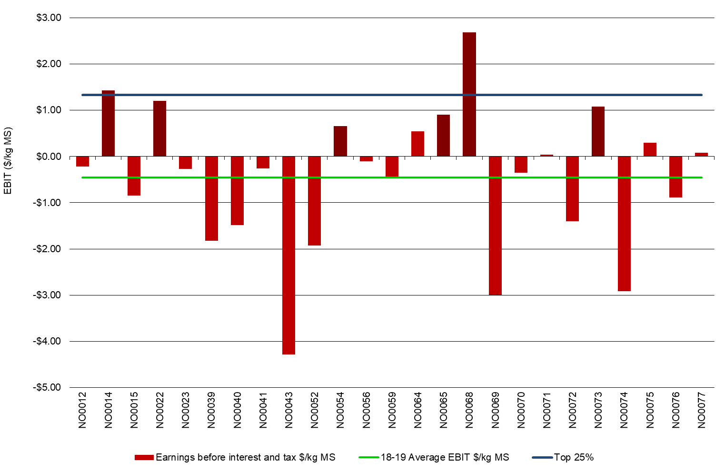

### Return on total assets and equity

The return on total assets under management, including owned and leased assets is calculated as EBIT divided by total assets.

Average RoTA of participant farms in the North was -1.7% in 2018-19, the lowest recorded in the 13-year history of the project. Three of the last four years have recorded below 1% RoTA compounding the negative performance in 2018-19. The slight increase in average milk price did not offset the significant increase in costs, particularly feed costs.

The range in participant performance was greater compared to last year, where RoTA was between -3.6% to 8.6% (Figure 173). This year, the range was -12.6% to 6.6%.

The top performing group registered an average of 3.7%. The highest individual farm since 2016-17 was NO0068; this year, their RoTA was 6.6% compared to last year’s 8.6%. Of the same 21 farms participating between years, average RoTA was -1.4% in 2018-19 compared to 2.6% the previous year.

A measure of the owner’s rate of return on their own capital investment in the business is RoE. The RoE this year was -7.4%, lower than last year’s 1.2% (Figure 18). The figure also reflects the various capital structures of businesses in the North.

Fewer than a third of the participants recorded positive RoE in 2018-19. Eight of the 25 farms in the North were worth more at the end of the year than they were a year ago. Of these farms, one farm recorded a RoE higher than their RoTA, indicating that the return on the additional assets was worth more than the cost of financing it.

The top performing group had an average of 3.8% RoE compared to their RoE of 10% last year.

FIGURE 17. RETURN ON TOTAL ASSETS – NORTH

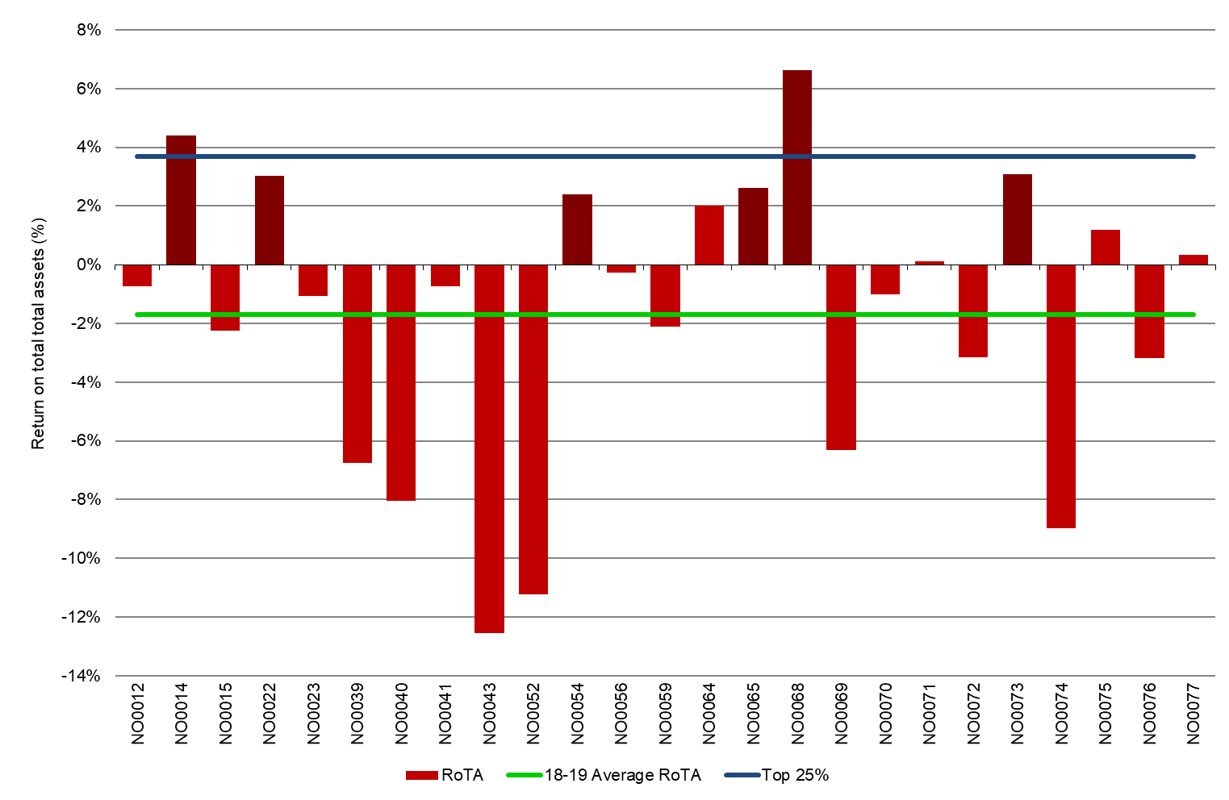

**FIGURE 18. RETURN ON EQUITY – NORTH**

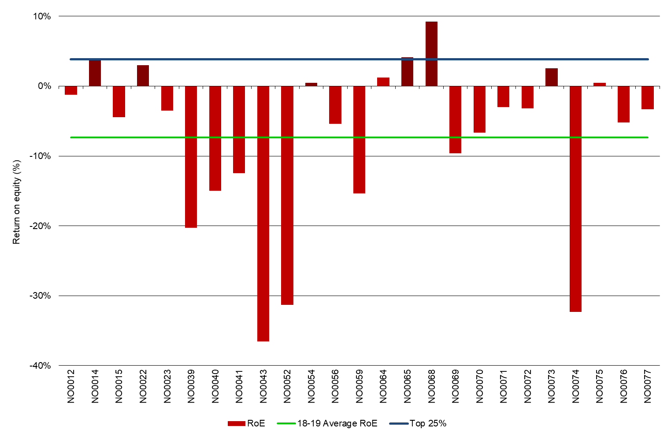

## Feed consumption and fertiliser

Farms in the North used a wide range of feeding systems. Directly grazed pasture

accounted for an average of 44% of total ME consumed. The average fertiliser use was

182 kg/ha comprised mainly of nitrogen fertiliser.

### Feed consumption

The relative contribution of each feed type to the ME consumed on each farm is shown in Figure 19. The broad range of sources of ME used on individual farms is evident.

North farms sourced 44% of their ME from directly grazed pasture, a slight reduction from 46% last year. The range was between 23% and 80% across the participant farms. Grazed pasture supplied 50% or more of ME consumed on only seven of the 25 farms, the same proportion as last year.

Concentrates were the most commonly used feed supplement. The variation in the proportion of concentrates contributing to the total ME consumed ranged from 12% to 41%, compared to 6% to 49% last year. All participant farms fed hay as part of the ME consumed and a range from 1% to 26% of the cows’ diet. One of the 25 participants did not feed silage and six farms fed silage at more than 15% of ME consumed.

On average, concentrates supplied 29% of ME consumed; 11% from silage, 14% from hay and 1% from other feed. Farmers fed less concentrates as portion of the diet and more silage.

The top performing farms obtained an average of 51% of the ME consumed from grazed pasture, slightly less than last year’s 54%. Total supplements were 49% of ME consumed compared to 56% for all participant farms.

**FIGURE 19. SOURCES OF WHOLE FARM METABOLISABLE ENERGY – NORTH**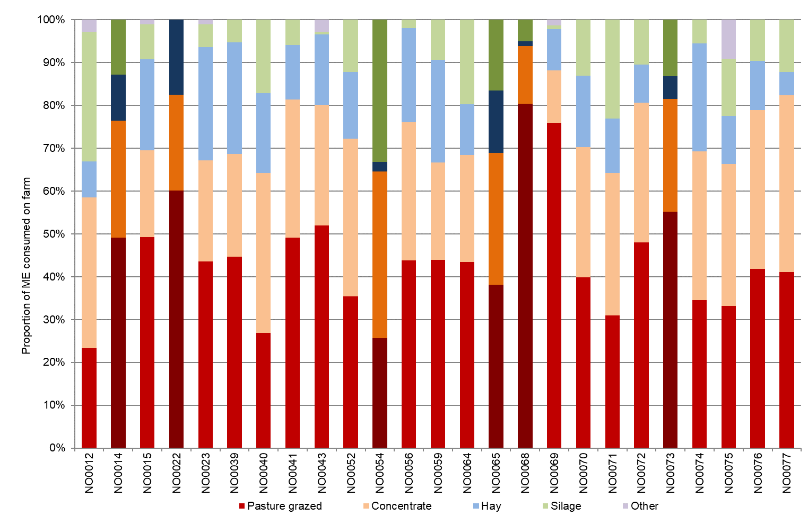

Figure 20 shows the estimated homegrown feed consumed per milking hectare for farms in the North.

Although the North experienced challenging seasonal conditions and higher water prices the average pasture consumption on the milking area (7.1 t DM/ha) was similar to last year’s 7 t DM/ha. Some farmers were also able to conserve additional feed at 1.6 t DM/ha compared to last year (1.1 t DM/ha).

The top 25% of farms were also able to conserve feed at similar quantity to the average. However, their grazed pasture consumption was higher, at 8.4 t DM/ha, than the average.

Similar to last year, 80% of the farms conserved feed on the milking area.

Potential sources of error in the method used to calculate home grown pasture consumed may come from the incorrect estimation of liveweight, amounts of fodder and concentrates fed, ME concentration of fodder, concentrate and pasture, wastage of feed and associative effects between feeds when they are digested by the animal. Comparing pasture consumption estimated using the back-calculation method between farms can lead to incorrect conclusions and a more useful approach is to compare pasture consumption on the same farm over time using the same method of estimation.

FIGURE 20. ESTIMATED TONNES OF HOMEGROWN FEED REMOVED PER MILKING HECTARE – NORTH

Average homegrown feed removed for North farms was 8.7 t DM/milking ha and Top 25% was 10.1 t DM/milking ha. Data provided in Appendix Table B2.


### Fertiliser application

All farms in the North applied fertiliser to their crops and pasture (Figure 21). This year, fertiliser application is reported on the milking area rather than usable area as in previous years. This enables a comparison between nutrient usage and pasture consumption on the same area.

The average fertiliser application was 182 kg/milking ha this year (Figure 21), 5% lower than last year. Nitrogen and potassium were the commonly applied nutrients. Application of nitrogen, phosphorus and sulphur decreased, but use of potassium increased by more than half from last year. Although there was a slight increase in homegrown feed as proportion of ME consumed, fertiliser usage was lower than last year. This highlights that other factors also have an impact on pasture growth and consumption, such as grazing management and timing of rainfall, and irrigation scheduling.

The values for Figure 20 and 21 can be found in Appendix Table B2.

**FIGURE 21. NUTRIENT APPLICATION PER USABLE HECTARE – NORTH**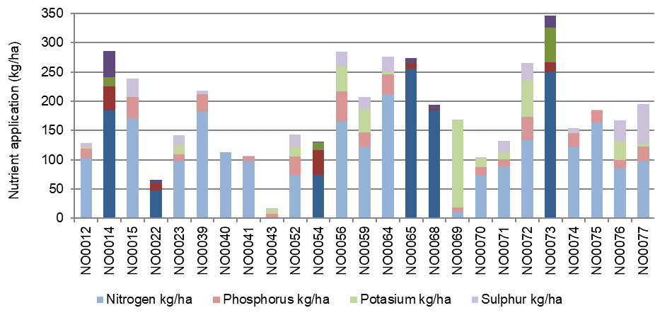

# Part Three: The South West

## The South West

During 2018-19 the South West region experienced average spring rainfall which enabled many farmers to capitalise on improved yields and build fodder reserves. Dry conditions prevailed from November 2018 before rain arrived in May 2019 providing a good start to autumn across most of the region.

On average, participating farms in the South West received 93% of their long-term average annual rainfall in 2018-19 (Figure 22). The timing of the rainfall (Figure 3) shows the most significant rain fell in August 2018 and May 2019, with a drier than average period over summer.

The season started out with an average spring. Many farmers were able to capitalise on the better conditions compared to last, to harvest above average pasture yields. Fodder conservation increased on the previous year which allowed farmers to restock silage and hay reserves.

Conditions turned dry from late November 2018 onwards which resulted in generally reduced pasture yields over summer. However, a series of thunderstorms in February 2019 across some parts of the region saw summer forage crops and pasture growth continue. Farmers in those parts of the region that missed the thunderstorms fed much of their surplus silage, hay and purchased fodder.

When the autumn rain arrived in May 2019, farms that had received thunderstorms in February benefited from the increased soil moisture and had good pasture growth heading into winter. Conversely, in the areas that missed out on rain, pasture growth took longer to reach full production heading into winter.

Some of the DFMP farmers reduced milk production as a risk management strategy, by changing their calving patterns (i.e. split to seasonal calving pattern) or reducing feeding levels. The timing of the decision was important. Farmers who made these important decisions early (in August 2018) were at an advantage compared to those who waited until later in the season (in February 2019). Individual economic performance was in most cases, similar to the previous year as lower production was compensated by improved milk price.

**FIGURE 22. ANNUAL RAINFALL AND LONG-TERM AVERAGE RAINFALL – SOUTH WEST**

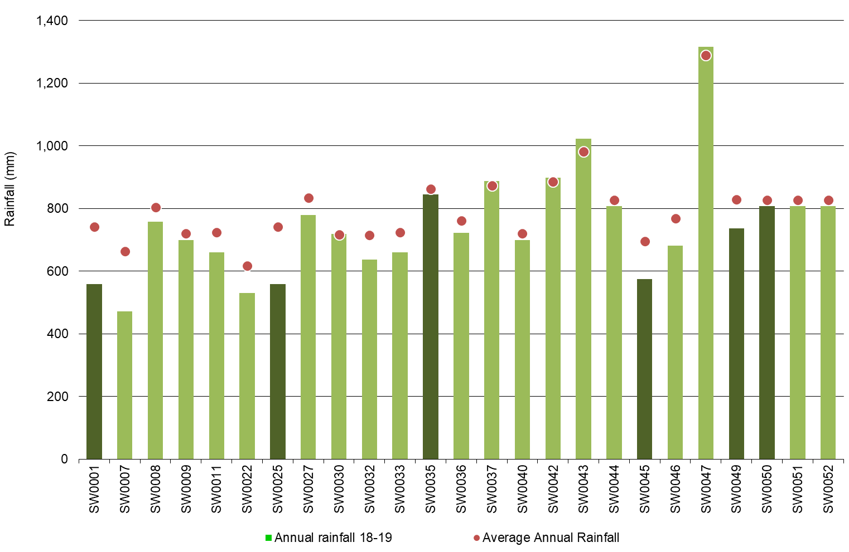

-----------------------

There was one new farm in 2018-19 South West sample: SW0052.

* The top 25% are shown as the darker bars in all graphs as ranked by RoTA.

## Whole Farm Analysis

The economic performance of the South West Victoria region improved in 2018-19. This was driven by increased milk prices and favourable seasonal conditions. Average EBIT and RoTA increased 47% and 19% on the previous year respectively yet remained below the long-term average for the region.

Key whole farm physical parameters for the South West are presented below in Table 6. The Q1 – Q3 range shows the band in which the middle 50% of farms sit for each parameter.

On average, farms maintained their herd and farm size compared to the previous year. Table 6 shows the average usable area and milking cows per hectare were 325 ha and 1.1 cows/ha, respectively, identical to last year.

The improvement in seasonal conditions enabled farmers to increase their homegrown feed as a proportion of ME consumed. The proportion increased to 68%, up from 62% the year before and returned to historic levels.

Farms in the top 25% group (ranked according to RoTA) had higher milk production measured per cow and per hectare, and higher labour efficiency, based on cows/FTE and kg MS/FTE.

**TABLE 7. FARM PHYSICAL DATA – SOUTH WEST**

|  |  |  |  |
| --- | --- | --- | --- |
| **Farm Physical Parameters** | **South West average** | **Q1 to Q3 range** | **Top 25% average** |
| Annual rainfall 2018-19 (mm) | 746 | 622 - 807 | 680 |
| Herd size | 364 | 180 - 505 | 427 |
| Total water use efficiency (t DM/ha/100 mm) | 0.8 | 0.6 - 0.9 | 1.0 |
| Total usable area (hectares) | 325 | 158 - 434 | 378 |
| Milking cows per usable hectare | 1.1 | 0.9 - 1.3 | 1.2 |
| Milk sold (kg MS /cow) | 492 | 456 - 530 | 537 |
| Milk sold (kg MS /ha) | 553 | 428 - 638 | 637 |
| Home grown feed as % of ME consumed | 68% | 61% - 74% | 70% |
| Labour efficiency (cows /FTE) | 99 | 83 - 115 | 106 |
| Labour efficiency (kg MS /cow) | 48,587 | 38,431 - 56,530 | 56,711 |

### Milk solids sold

On average, total milk solids reduced by 5% to 187,000 kg MS per farm, down from 196,000 kg MS the previous year. This was higher than the 2.5% reduction in milk production recorded by Dairy Australia for the South West region.

Approximately 60% of milk production occurred during the six months between July 2018 and December 2018, with a peak of 20,510 kg MS per farm in October 2018 (Figure 10). This extended autumn to spring milk production peak period continues the trend away from the double peak which historically occurred in autumn and in spring.

On a per hectare and per cow basis, milk production decreased by 3% and 2%, respectively. Milk production per cow decreased from 502 kg MS/cow to 492 kg MS/cow. Of the same 24 farms participating between years, 12 farms produced less milk on a per cow basis than they did the previous year (Figure 23). Milk production per hectare decreased from 569 kg MS/ha down to 553 kg MS/ha.

The top performing group produced more milk per cow and per ha than the average, however it was less than the top performing group last year on a per cow basis.

**FIGURE 23. MILK SOLIDS SOLD – SOUTH WEST**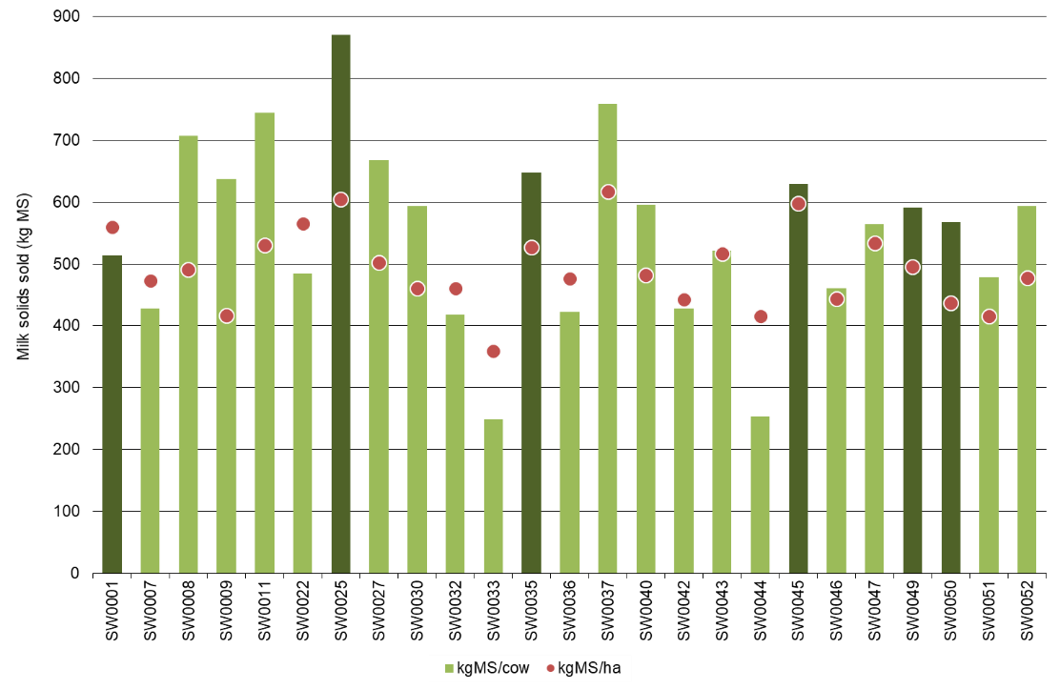

### Gross farm income

Gross farm income includes milk sales net of levies and charges, livestock trading profit and other farm income. For South West participants, these were $6.15/kg MS, $0.79/kg MS and $0.04/kg MS, respectively.

Figure 24 shows the milk price received ranged from $5.62/kg MS to $6.77/kg MS. On average, milk price increased to $6.15/kg MS, remaining elevated compared to the previous three years. When the effects of inflation are removed, milk price was $5.90/kg MS in 2017-18, $5.44/kg MS in 2016-17 and $5.78/kg MS in 2015-16.

Farms that were in the top 25% in the South West, ranked according to RoTA, received an average milk price of $6.44/kg MS, compared with $6.04/kg MS last year. The average and top performing group recorded a milk price 6% and 7% higher than the previous year, respectively.

**FIGURE 24. GROSS FARM INCOME PER KILOGRAM OF MILK SOLIDS – SOUTH WEST**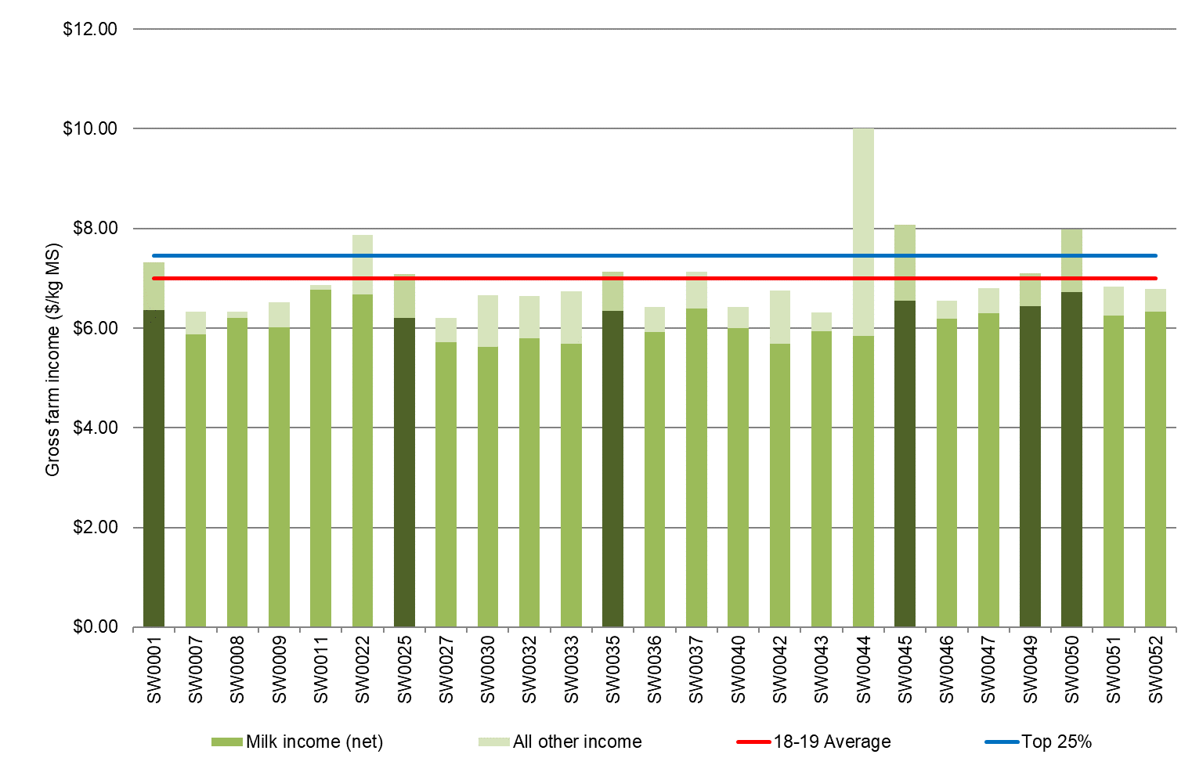

### Variable costs

Variable costs are all costs that vary with the size of production in the enterprise e.g. herd, shed and feed costs (including feed and water inventory changes).

Feed costs were the major variable cost on South West farms, accounting for 51% of total costs this year. Last year, feed costs accounted for 49% of total costs. Feed costs increased 10% to $3.20/kg MS from $2.90/kg MS the previous year. The increase emanated from a rise in both homegrown and purchased feed costs.

Homegrown feed categories that contributed to the increased costs were fertiliser and hay and silage making. Farmers in the South West capitalised on the improved seasonal conditions by growing and harvesting higher pasture yields.

Fodder reserves were utilised during the year as farmers fed back the quantities they conserved in spring, with some farmers accessing their long-term reserves. Most farms (14 of the 25 farms) had less feed on hand by the end of the year. However, when the inventory value of the feed is considered (i.e. standard values) there was an average fodder inventory gain of $0.02/kg MS. The range of fodder inventory change was between -$0.77/kg MS and $0.58/kg MS highlighting the impact of the varied season across participant farmers.

Purchased prices increased across all feed categories. Concentrates increased 36% to $512/t DM, silage increased 71% to $271/t DM and hay increased 11% to $274/t DM.

The level of concentrate feeding reduced from 2.0 t DM/cow to 1.8 t DM/cow in 2018-19 possibly in response to the rise in concentrate price. Silage fed increased with most of this sourced from homegrown silage at 1.8 t DM/cow compared with 0.1 t DM/cow of purchased silage. The quantity of hay fed reduced with the improved conditions as farmers fed 0.3 t DM/cow of purchased and 0.3 t DM/cow of homegrown hay.

Last year a total of 0.9 t DM/cow of hay was fed. Despite reduction in the amount of concentrate fed per cow, price rises caused concentrates to increase to $1.85/kg MS, a 21% increase. Fodder purchases decreased 18% to $0.18/kg MS.

Total herd and shed costs remained similar at $0.54/kg MS compared to $0.53/kg MS last year.

Figure 25 shows the breakdown of total farm costs as variable and overhead costs per kg MS. The breakdown of individual farm costs can be found in Appendix Tables C4 and C6.

### Overhead costs

Overhead costs are all fixed costs incurred by the farm business that do not vary with the level of production. These include cash overhead costs such as employed labour and non-cash costs such as imputed owner-operator labour, family labour and depreciation of plant and equipment.

Overhead costs increased slightly to $2.55/kg MS compared with $2.51/kg MS in 2017-18. While some farmers were able to attend to delayed repairs and maintenance with a return to improved conditions, other farmers reduced their expenditure. On average, there was a 3% decrease in repairs and maintenance per kg MS. Employed labour also decreased by 4% on a per kg MS basis.

Non-cash overheads increased in 2018-19. Imputed labour increased 4% to $0.97/kg MS and depreciation increased 6% to $0.31/kg MS.

Farms in the top performing group had lower overhead costs, compared to the average. While they had half the imputed labour costs, they spent more on employed labour. Farms with the highest RoTA had on average more FTE employed on farm, but they were able to produce more kg MS per labour unit and therefore had greater labour efficiency (Table 6 and Appendix Tables C5 and C7).

**FIGURE 25. WHOLE FARM VARIABLE AND OVERHEAD COSTS PER KILOGRAM OF MILK SOLIDS –SOUTH WEST**

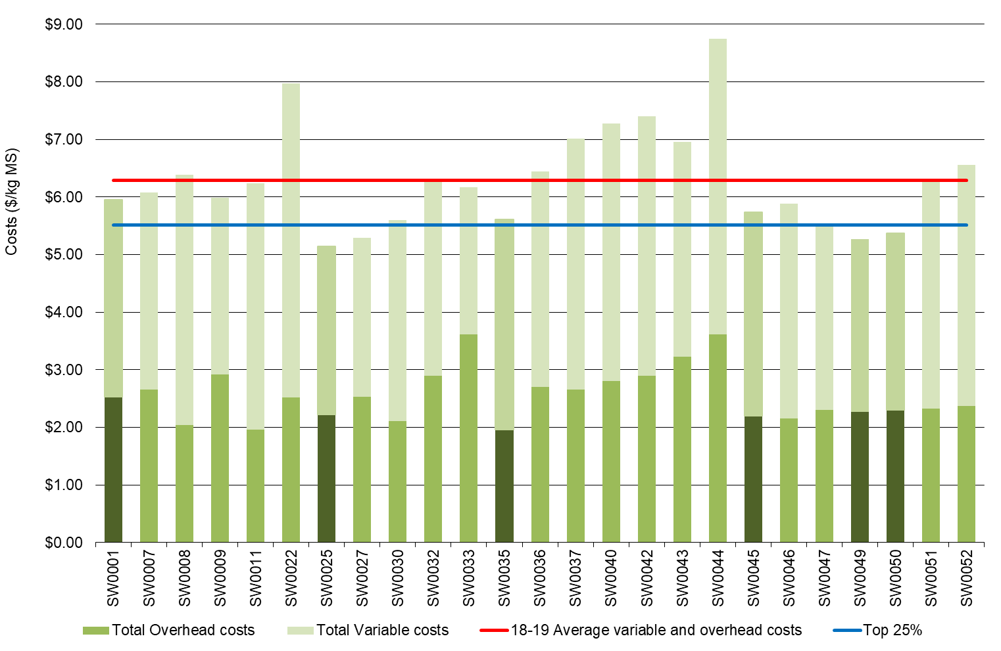

**TABLE 8. AVERAGE FARM FINANCIAL PERFORMANCE PER KILOGRAM OF MILK SOLIDS – SOUTH WEST**

|  |  |  |  |
| --- | --- | --- | --- |
| **Farm costs** | **South West average** | **Q1 to Q3 range** | **Top 25% average** |
| **INCOME** |  |  |  |
| Milk income (net) | $6.15 | $5.83 - $6.35 | $6.44 |
| Livestock trading profit | $0.80 | $0.47 - $0.98 | $0.91 |
| Other farm income | $0.04 | $0.00 - $0.08 | $0.10 |
| Gross farm income | $6.99 | $6.42 - $7.10 | $7.45 |
| **VARIABLE COSTS** |  |  |  |
| Herd cost | $0.28 | $0.25 - $0.27 | $0.23 |
| Shed cost | $0.26 | $0.22 - $0.25 | $0.22 |
| Homegrown feed cost | $1.13 | $0.48 - $1.11 | $0.97 |
| Purchased feed and agistment | $2.09 | $2.44 - $2.79 | $1.88 |
| Feed inventory change | -$0.02 | -$0.16 - -$0.07 | -$0.04 |
| Water inventory change | $0.00 | $0.00 - $0.00 | $0.00 |
| Total feed costs | $3.20 | $2.93 - $3.40 | $2.81 |
| Total variable costs | $3.74 | $3.42 - $3.89 | $3.26 |
| **GROSS MARGIN** |  |  |  |
| per kg MS | $3.26 | $2.44 - $3.40 | $4.18 |
| **OVERHEAD COSTS** |  |  |  |
| Employed labour | $0.55 | $0.20 - $0.76 | $0.59 |
| Repairs and maintenance | $0.40 | $0.30 - $0.53 | $0.48 |
| All other overheads | $0.33 | $0.27 - $0.40 | $0.30 |
| Imputed labour | $0.97 | $0.43 - $1.36 | $0.62 |
| Depreciation | $0.31 | $0.26 - $0.39 | $0.27 |
| Total overhead costs | $2.55 | $2.19 - $2.90 | $2.25 |
| Variable and overhead costs | $6.29 | $5.67 - $6.99 | $5.51 |
| **EARNINGS BEFORE INTEREST AND TAX** |  |  |  |
| per kg MS | $0.71 | -$0.03 - $1.11 | $1.93 |

### Cost of Production

Cost of production gives an indication of the cost of producing one kilogram of milk solids. It is calculated as variable plus overhead costs and accounts for changes in fodder, water and livestock inventory.

The cost of production with inventory change was $6.25/kg MS in 2018-19. There was a wide range in costs with most farms spending between $5.56/kg MS and $7.06/kg MS as shown by the Q1 - Q3 range in Table 9.

Where a negative change in inventory occurred, such as -$0.02/kg MS for the average of the South West, it indicates that fodder reserves increased and is therefore counted as a decrease in the cost of production. Half of the South West sample (13 of the 25 farms) built their long-term fodder reserves in 2018-19.

**TABLE 9. COST OF PRODUCTION – SOUTH WEST**

|  |  |  |  |
| --- | --- | --- | --- |
| **Farm costs** | **South West average** | **Q1 to Q3 range** | **Top 25% average** |
| Cash cost of production ($/kg MS) | $5.04 | $4.42 - $5.68 | $4.68 |
| Cost of production without inventory changes ($/kg MS) | $6.31 | $5.95 - $6.50 | $5.56 |
| **INVENTORY CHANGE** |  |  |  |
| +/- feed and water inventory change | -$0.02 | -$0.13 - $0.09 | -$0.04 |
| +/- livestock inventory change minus purchases | -$0.04 | -$0.28 - $0.05 | -$0.26 |
| Cost of production with inventory change ($/kg MS) | $6.25 | $5.56 - $7.06 | $5.26 |

### Earnings Before Interest and Tax

Gross farm income minus total variable and total overhead costs is EBIT.

Average EBIT rose to $0.71/kg MS from $0.48/kg MS the previous year, and 19 of the 25 farms recorded a positive result (Figure 26). Of the same 24 farms participating between years, 15 farms recorded higher profits than the previous year. The increase in milk price contributed to the improved profit performance as it compensated for the increased variable costs and lower milk production.

The top performing group recorded an EBIT of $1.93/kg MS, up from $1.73/kg MS the previous year. The top performing group recorded a higher milk price and demonstrated more efficient milk production with higher milk solids sold at lower costs, compared to the average.

**FIGURE 26. WHOLE FARM EARNINGS BEFORE INTEREST AND TAX PER KILOGRAM OF MILK SOLIDS - SOUTH WEST**

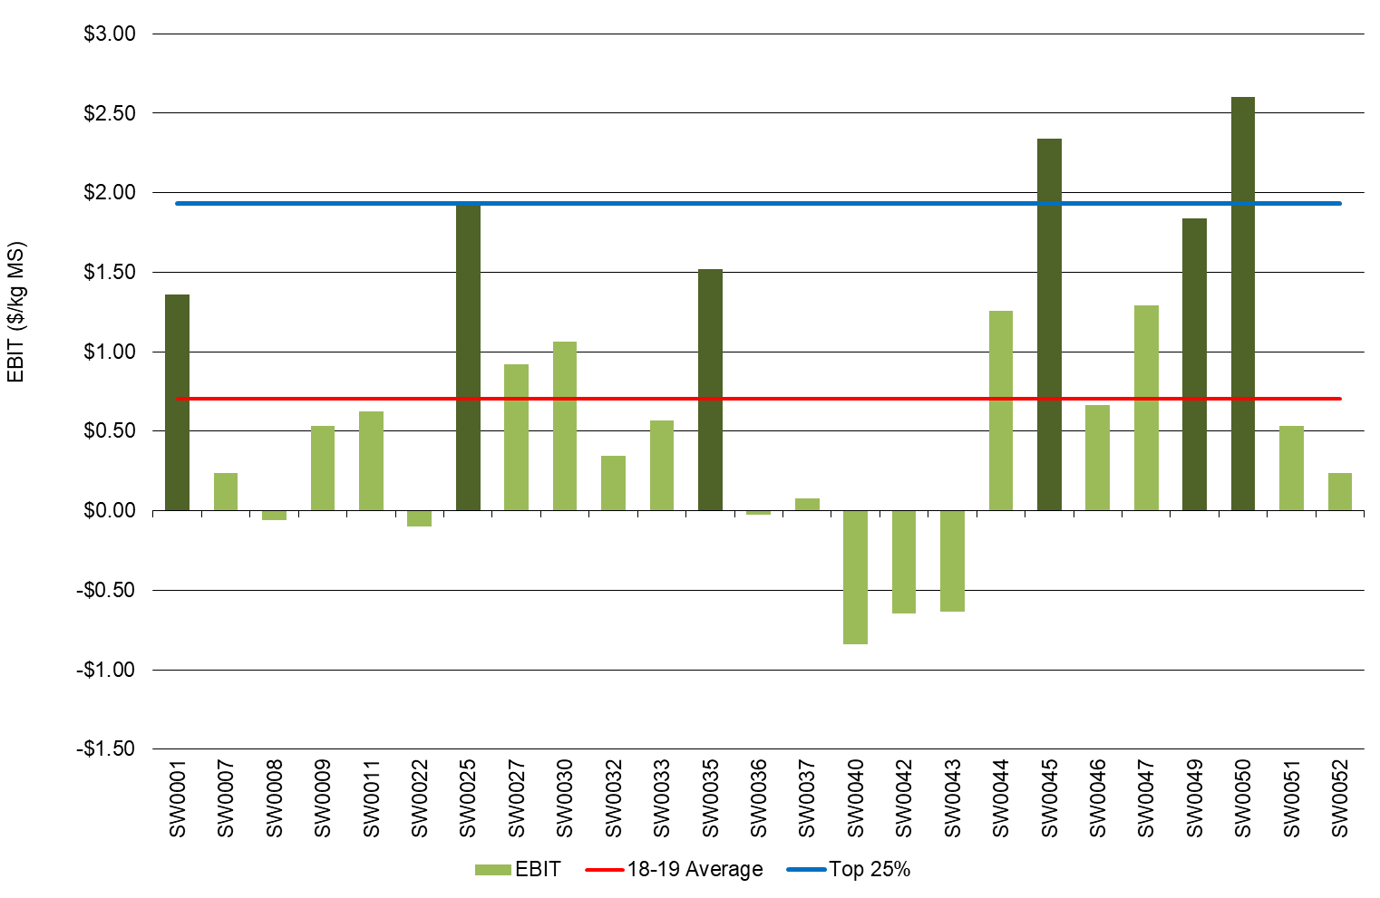

### Return on total assets and equity

The return from total assets under management, including owned and leased assets, is RoTA. It is calculated as EBIT divided by total assets and is a parallel measure of how efficiently capital is being used within the business.

In 2018-19 the average RoTA was 2.3%, up from 1.9% recorded the previous year (Figure 27). Farms in the top 25% more than doubled the average RoTA at 6.6%.

A measure of the owner’s rate of return on their own capital invested in the business is RoE.

Just under half of the participants recorded a positive RoE result in 2018-19, with 12 of the 25 farm businesses worth more at the end of the year than a year ago (Figure 28). Of these farms, five recorded a RoE higher than their RoTA indicating that the return on the additional assets was worth more than the cost of accessing it. These farmers have been able to grow their business this year.

The average group recorded a slightly higher RoE at -0.8% compared with -1.1% in 2017-18. However, the top performing group recorded a lower RoE at 7.4% compared to the top performing group the previous year at 7.7%.

Average equity improved slightly at $3.2 million or 64% while net farm income was $0.03/kg MS.

Mixed results were observed for debt levels across the region. Farmers that capitalised on positive operational conditions early were able to reduce trade debt.

Figures 27 and 28 were calculated excluding capital appreciation.

**FIGURE 27. RETURN ON TOTAL ASSETS - SOUTH WEST**

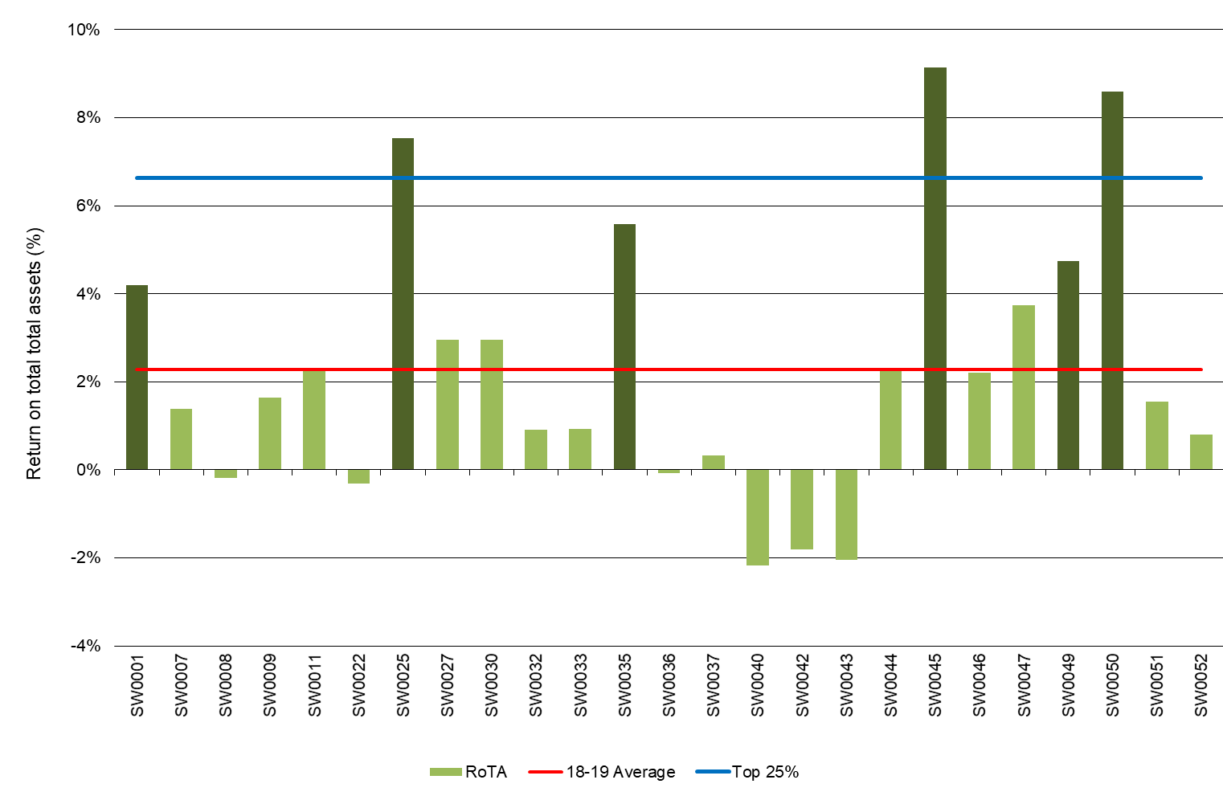

**FIGURE 28. RETURN ON EQUITY - SOUTH WEST**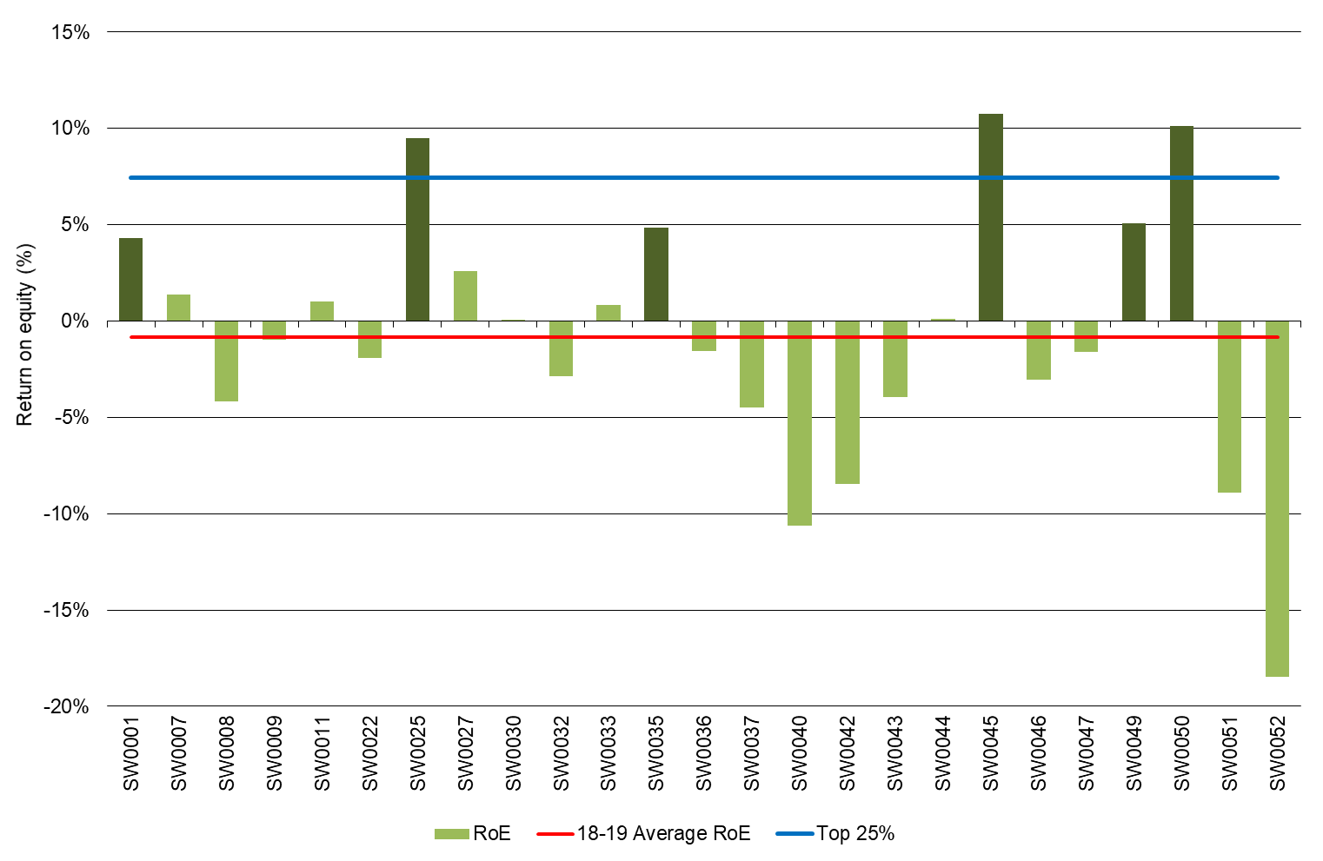

## Feed consumption and fertiliser

A return to near average seasonal conditions saw South West farmers harvested more

pasture on the milking area, cows consumed more ME from directly grazed pasture and increased the total amount of fertiliser applied compared to the previous year.

### Feed consumption

South West farms sourced 45% of their ME from directly grazed pasture, an increase from 41% in 2017-18. The range was between 24% and 64% across the participant farms. The improved seasonal conditions enabled farmers to grow and harvest greater quantities of pasture. Silage constituted 20% of the diet, an increase from 18% the previous year. The proportion of hay in the diet decreased from 9% in 2017-18 to 6% this year.

Concentrates were the most commonly used supplement again this year, accounting for 28% of the diet. The proportion of concentrates in the diet reduced from 33% recorded the previous year.

**FIGURE 29. SOURCES OF WHOLE FARM METABOLISABLE ENERGY – SOUTH WEST**

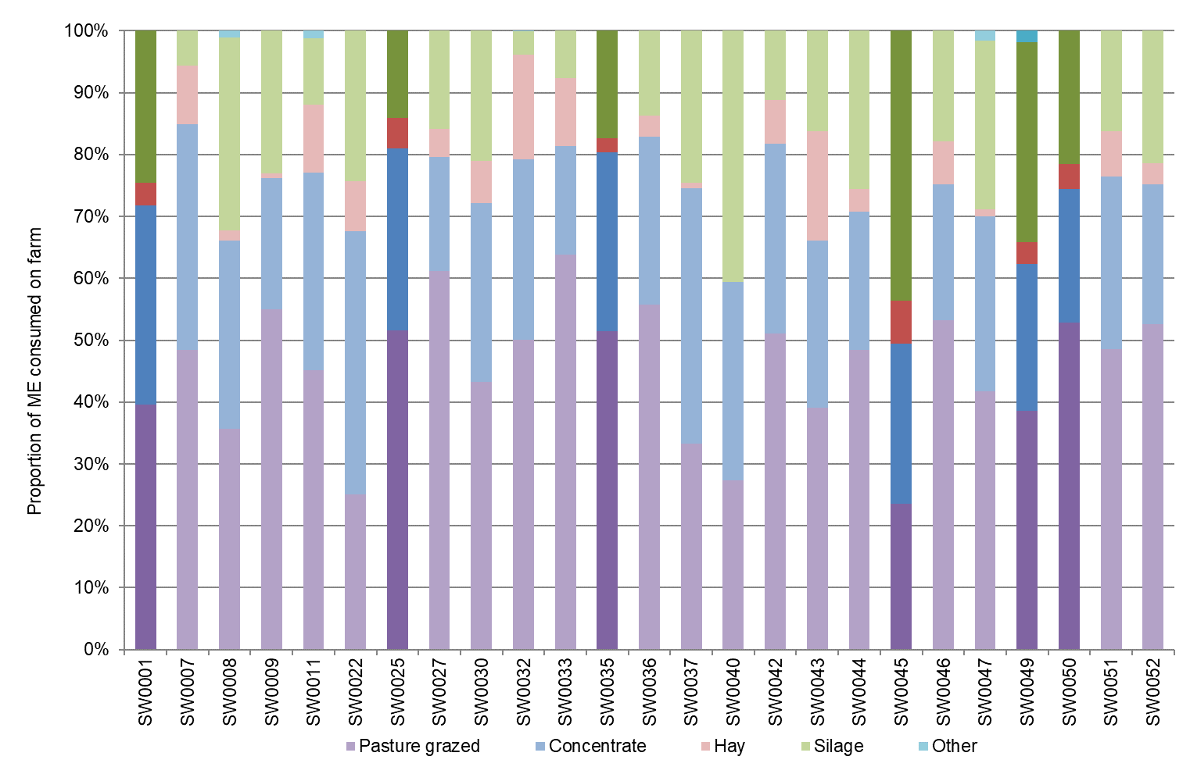

Homegrown feed consumption is shown in Figure 30. The improved seasonal conditions resulted in the average pasture harvested (grazed and conserved) from the milking area increasing from 5.8 t DM/ha the previous year to 6.5 t DM/ha in 2018-19. This result is slightly above the long-term average of 6.0 t DM/ha.

Directly grazed pasture increased to 4.3 t DM/ha, an increase of 10% from 3.9 t DM/ha the previous year. Greater pasture availability enabled farmers to reduce the reliance on supplementary feed compared to the previous year.

The mild spring conditions allowed farmers to conserve 15% more feed than 2017-18, from 1.9 t DM/ha to 2.2 t DM/ha in 2018-19.

Farms in the top performing group had greater pasture consumption compared to the average and compared to the top performing group the previous year. Grazed pasture was 4.8 t DM/ha for the top performing group in 2018-19, an increase from 4.8 t DM/ha for the same group last year. Conserved feed increased to 3.4 t DM/ha from 2.3 t DM/ha in 2017-18.

Potential sources of error in the method used to calculate home pasture consumed include estimation of liveweight, amounts of fodder and concentrates fed, ME concentration of fodder, concentrate and pasture, wastage of feed and associative effects between feeds when they are digested by the animal. Comparing pasture consumption estimated using the back-calculation method between farms can lead to incorrect conclusions and a more useful approach is to compare pasture consumption on the same farm over time using the same method of estimation.

**FIGURE 30. ESTIMATED TONNES OF HOMEGROWN FEED REMOVED PER MILKING HECTARE– SOUTH WEST**

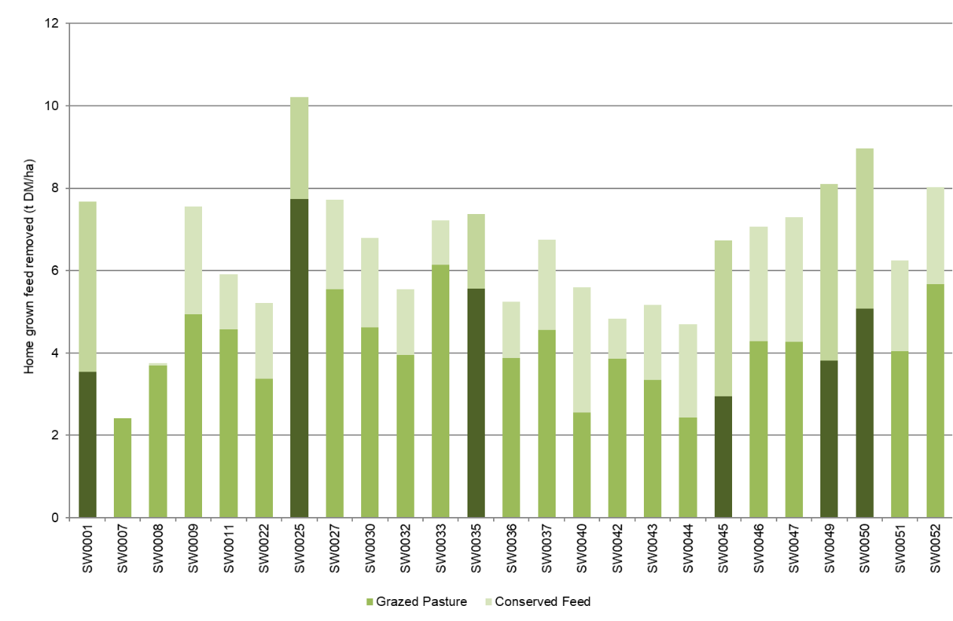

### Fertiliser application

Fertiliser application was reported on the milking area rather than the usable area as done in previous years. The average total nutrients applied was 239 kg/ha. This was comprised of nitrogen (146 kg N/ha,) phosphorus (16 kg P/ha), potassium (49 kg K/ha) and sulphur (28 kg S/ha) as shown in Figure 31. The individual values related to Figure 31 can be found in Appendix Table C2.

**FIGURE 31. NUTRIENT APPLICATION PER MILKING HECTARE– SOUTH WEST**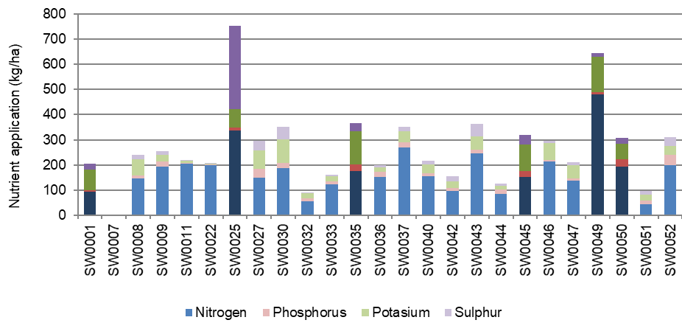

# Part Four: Gippsland

## Gippsland

Gippsland experienced varied seasonal conditions across the dairying region. In the

south and west it was a reasonable season with warmer winter temperatures and good

pasture growing conditions in spring. However, unreliable rainfall across central and east Gippsland caused challenges by exposing farmers to high input costs. Irrigators in the MID received 100% of water allocations, but with no spill water, which placed additional pressure on these farms.

The average rainfall across participating farms in Gippsland was 705 mm, about 81% of the long-term average (Figure 32). Gippsland farms on average received less rain than the previous year for the third consecutive year.

In south and west Gippsland, 2018 autumn pasture growth was poor. The slow start was eased with rainfall events at the start of spring. October 2018 was dry, and this threatened to cut spring short. However, rainfall occurred throughout November 2018 and into December 2018. Peak milk production for the region coincided with the rain and 12% of total milk solids sold were produced in October 2018.

A dry and hot summer was coupled with increasing grain prices. However, the extended spring rainfall had given many farmers in the region the opportunity to conserve hay and silage. Although summer was drier and hotter than average, some perennial pastures remained productive through to the break in May 2019.

The season in central and eastern Gippsland was characterised by inconsistent rainfall. The dry 12 months leading into the 2018 spring resulted in the water allocation in the MID to be capped at 100% with no spill water. Due to the unreliable nature of rainfall this year, farmers found their ability to grow pasture in summer and up until the autumn break 2019 compromised.

In the dryland areas of central and eastern Gippsland, spring growth was limited. Rain that occurred late in October 2018 and November 2018 provided a short-term reprieve to crops and the remaining pasture. Growth extended into December 2018 until soil moisture was again the limiting factor.

The east had good rainfall events in March 2019 that allowed some farmers to re-sow pastures and crops in preparation for the May 2019 break in what was otherwise a drier than average year.

FIGURE 32. ANNUAL RAINFALL AND LONG-TERM AVERAGE RAINFALL – GIPPSLAND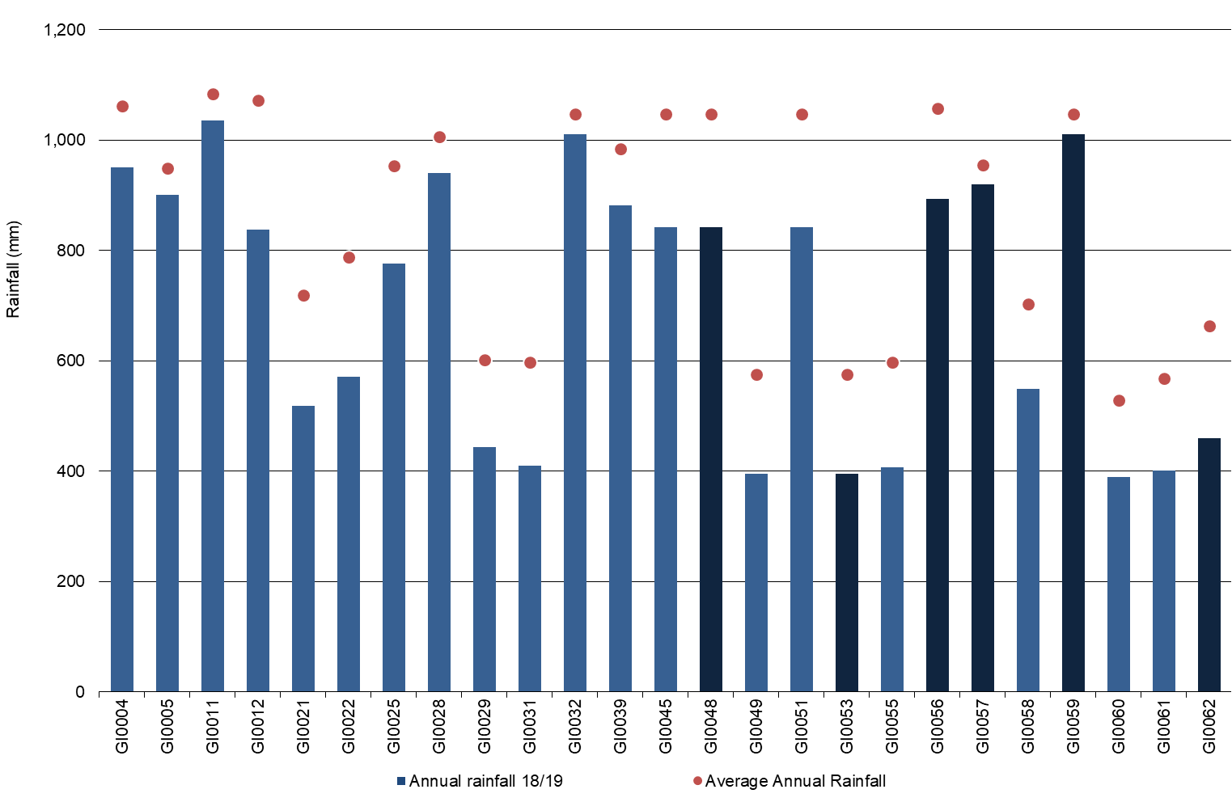

-----------------------------------

There were five new farms for the Gippsland region in 2018-19; GI0058, GI0059, GI0060, GI0061, and GI0062.

*Top 25% - The top 25% are shown as the darker bars in all graphs as ranked by RoTA.

## Whole Farm Analysis

Dry seasonal conditions and high feed prices decreased average profit in Gippsland.

Rain at critical times enabled some farmers in the south and west to conserve feed and

rely on grazed pasture. For central and eastern Gippsland, where conditions were dry,

exposure to higher feed and water prices had a significant effect on profit.

Key whole farm physical parameters for Gippsland are presented below in Table 10. The Q1 – Q3 range shows the band in which the middle 50% of farms sit for each parameter.

In 2018-19 herd size increased 5% to 307 cows per farm compared to the previous year. Stocking rate slightly increased from 1.8 cows/ha in 2017-18 to 1.9 cows/ha in 2018-19 while usable area decreased from 189 ha in 2017-18 to 186 ha in 2018-19.

The amount of homegrown feed as a % of ME consumed remained steady at 66% of the cows’ diet. The top performing farms in Gippsland received more rain than the average. As growing conditions were favourable for most of these businesses, water use efficiency, milk sold, and labour efficiency were higher than the average.

It is interesting to note that the top 25% (based on RoTA) are generally placed within the interquartile range for these production indicators meaning they are generally closer to the mean (middle) than the top. This suggests that management decisions around efficient resource use played a key role in their success this year.

**TABLE 10. FARM PHYSICAL DATA – GIPPSLAND**

|  |  |  |  |
| --- | --- | --- | --- |
| **Farm Physical Parameters** | **Gippsland average** | **Q1 to Q3 range** | **Top 25% average** |
| Annual rainfall (mm) | 705 | 444 - 901 | 754 |
| Herd size | 307 | 245 - 360 | 342 |
| Total water use efficiency (t DM/mm) | 0.9 | 0.8 - 1.0 | 1.0 |
| Total usable area (hectares) | 186 | 100 - 267 | 191 |
| Milking cows per usable hectare | 1.9 | 1.4 - 2.2 | 2.0 |
| Milk sold (kg MS /cow) | 468 | 403 - 536 | 489 |
| Milk sold (kg MS /ha) | 888 | 599 - 1,035 | 959 |
| Home grown feed as % of ME consumed | 66% | 59% - 75% | 69% |
| Labour efficiency (cows /FTE) | 119 | 99 - 131 | 142 |
| Labour efficiency (kg MS /cow) | 54,692 | 44,560 - 61,725 | 67,257 |

### Milk solids sold

Figure 33 shows the range in milk solids sold per cow and per hectare for Gippsland farms during the 2018-19 season. The average milk solids sold was 146,000 kg MS/farm, 468 kg MS/cow and 888 kg MS/ha.

In Gippsland, of the same 20 participating farms between years, milk production decreased on average, with 13 of the 20 farms producing less on a total kg MS basis. For these same farms, milk production per cow decreased by 1% to 454 and 12 farms produced less between years. Milk production per hectare decreased 5% to 845 kg MS/ha and 11 produced less between years.

The top 25% recorded slightly higher milk solids sold per hectare than the average of all participants, however production decreased from the top group last year. Four of the top five producers on a per hectare basis were not in the top 25% of farms.

FIGURE 33. MILK SOLIDS SOLD PER HECTARE AND PER COW – GIPPSLANDAverage milk sold was 468 kg MS/cow and 888 kg MS/ha for Gippsland farms. Milk solids sold per cow for each farm is shown as blue bars and per hectare in red dots. Data provided in Appendix Table D2. 


### Gross farm income

Gross farm income includes all farm income relating to the dairy farm business, whether from milk sales, livestock trading or any other dairy related income.

Gross farm income in 2018-19 was $6.47/kg MS, similar to 2017-18 season. Higher milk price and reduced output contributed to this result. The variation in gross farm income was $5.94/kg MS to $7.25/kg MS. The top 25% received slightly less than the average at $6.32/kg MS.

Average milk price improved by 4% to $5.97/kg MS from $5.74/kg MS last year. This is reflected in the range of milk prices received, $5.57/kg MS to $6.34/kg MS compared with $5.44/kg MS and $6.10/kg MS last year. On average, the top 25% received a similar price to other participants in the study. The prices received in Gippsland were consistent across the region, with many farms changing milk factories to leverage a higher milk price.

Livestock trading profit decreased by 2% and contributed $0.47/kg MS to gross farm income. The top 25% contributed $0.33/kg MS of livestock trading profit to gross farm income, which was 40% less than the average.

The remaining other income contributed $0.03/kg MS to gross farm income for the average and top 25%.

FIGURE 34. GROSS FARM INCOME PER KILOGRAM OF MILK SOLIDS – GIPPSLAND

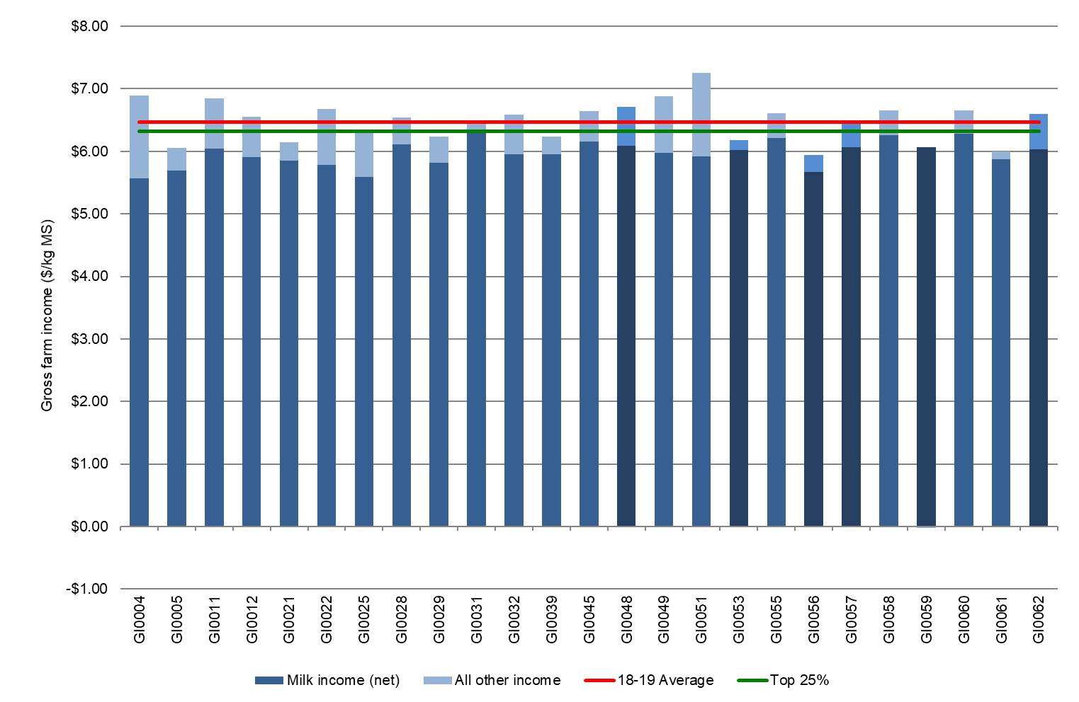

### Variable costs

Variable costs are costs that vary with goods produced e.g. herd, shed and feed costs. The separation of variable and overhead costs per kg MS is shown in Figure 35.

In 2018-19, variable costs in Gippsland increased by 19% to an average of $3.81/kg MS. Variable costs ranged between $2.26/kg MS and $5.29/kg MS. The top 25% of farms had average variable cost 13% lower than the average farm at $3.33/kg MS. The lower costs for the top 25% was reflective of the lower purchased feed costs.

Feed costs comprised 55% of total costs (variable plus overhead costs), at $3.27/kg MS, a 22% increase from last year. The increase in feed costs came from increases across both purchased and homegrown feed costs.

Purchased feed costs increased predominately due to the elevated feed prices. Concentrate price increased 32% to $518/t DM, silage increased 46% to $365/t DM and hay increased 18% to $341/t DM. Feeding levels remained similar with only a slight reduction in concentrates fed from 1.7 t DM/cow in 2017-18 to 1.6 t DM/cow in 2018-19. Silage and hay remained similar at 0.9 t DM/cow and 0.5 t DM/cow, respectively.

Homegrown feed costs increased across all categories. The DFMP farms applied more fertiliser per milking area in 2018-19 which contributed to the 30% increase in fertiliser costs to $0.54/kg MS. On average, farms conserved greater quantities of fodder compared to the previous year leading to 18% increase in hay and silage making costs to $0.22/kg MS in 2018-19. Irrigation costs also increased increasing the cost of homegrown feed.

On average there was an increase in feed inventory, with 18 farms able to build their fodder reserves in 2018-19. However, many farmers fed stored fodder reserves to manage the poorer pasture conditions. With feed reserves already low, many farms had to make the decision to decrease milk production or buy in feed at elevated prices.

Table 11 shows the range in average farm financial performance for Gippsland farms per kg MS sold, including a breakdown of variable and overhead costs.

Appendix Table D4 shows the variable costs per kg MS sold and the percentage breakdown can be found in Appendix Table D6.

### Overhead costs

Figure 35 illustrates the overhead costs per kg MS. Overhead costs are fixed costs incurred by the farm business that do not vary with the level of production. These include cash overhead costs such as employed labour and non-cash costs such as imputed owner-operator labour, family labour and depreciation of plant and equipment.

In Gippsland, total overhead costs ranged between $1.45/kg MS and $3.26/kg MS. Average overhead costs remained constant in 2018-19 at $2.16/kg MS. Employed labour contributed the highest cash overhead costs at $0.57/kg MS, the same as what was recorded in 2017-18. Imputed labour declined by 6% to $0.85/kg MS in 2018-19.

Overhead costs for the top 25% declined slightly to $1.63/kg MS compared with $1.75/kg MS last year. The top 25% employed less labour at $0.38/kg MS and lower imputed labour than the average. This increased labour efficiency per kg MS produced and helped to offset increased input prices.

A breakdown of overheads costs can be found in Appendix Tables D5 and D7.

FIGURE 35. WHOLE FARM VARIABLE AND OVERHEAD COSTS PER KILOGRAM OF MILK SOLIDS – GIPPSLAND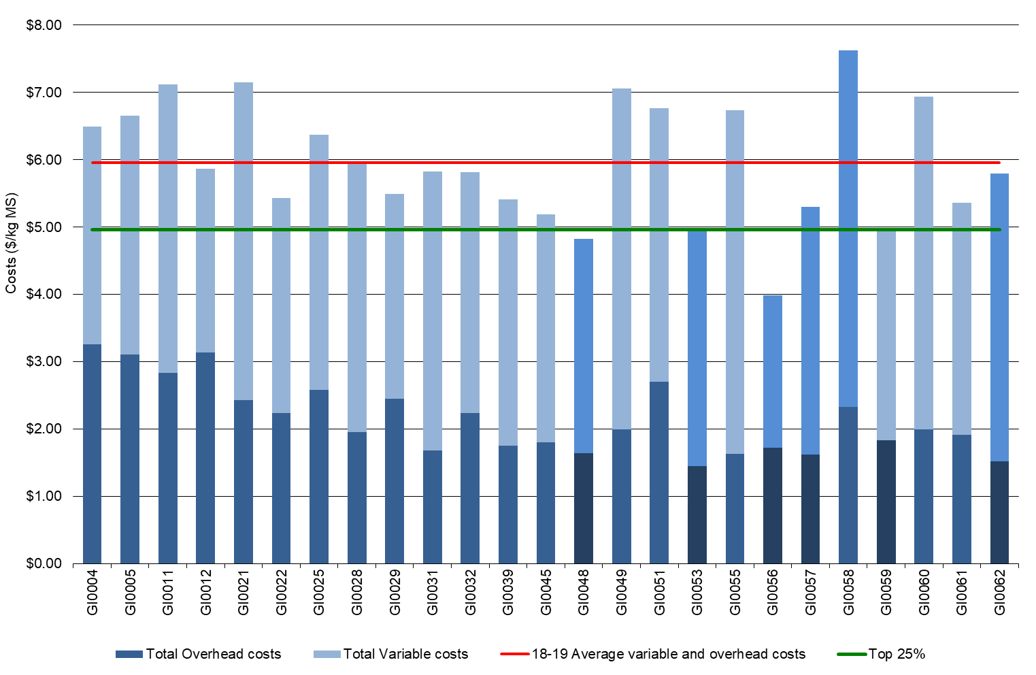

TABLE 11. AVERAGE FARM FINANCIAL PERFORMANCE PER KILOGRAM OF MILK SOLIDS – GIPPSLAND

|  |  |  |  |
| --- | --- | --- | --- |
| **Farm costs** | **Gippsland average** | **Q1 to Q3 range** | **Top 25% average** |
| **INCOME** |  |  |  |
| Milk income (net) | $5.97 | $5.85 - $6.08 | $5.99 |
| Livestock trading profit | $0.47 | $0.28 - $0.63 | $0.30 |
| Other farm income | $0.03 | $0.00 - $0.02 | $0.03 |
| Gross farm income | $6.47 | $6.23 - $6.65 | $6.32 |
| **VARIABLE COSTS** |  |  |  |
| Herd cost | $0.33 | $0.26 - $0.40 | $0.31 |
| Shed cost | $0.21 | $0.16 - $0.27 | $0.17 |
| Homegrown feed cost | $1.11 | $0.82 - $1.27 | $1.02 |
| Purchased feed and agistment | $2.23 | $1.70 - $2.86 | $1.90 |
| Feed inventory change | -$0.07 | -$0.16 - $0.00 | -$0.07 |
| Water inventory change | $0.00 | $0.00 - $0.00 | $0.00 |
| Total feed costs | $3.27 | $2.76 - $3.71 | $2.85 |
| Total variable costs | $3.81 | $3.24 - $4.15 | $3.33 |
| **GROSS MARGIN** |  |  |  |
| per kg MS | $2.66 | $2.33 - $3.20 | $2.99 |
| **OVERHEAD COSTS** |  |  |  |
| Employed labour | $0.57 | $0.29 - $1.05 | $0.38 |
| Repairs and maintenance | $0.29 | $0.19 - $0.34 | $0.20 |
| All other overheads | $0.29 | $0.22 - $0.36 | $0.19 |
| Imputed labour | $0.85 | $0.42 - $1.02 | $0.70 |
| Depreciation | $0.17 | $0.09 - $0.23 | $0.16 |
| Total overhead costs | $2.15 | $1.72 - $2.58 | $1.63 |
| Variable and overhead costs | $5.96 | $6.03 - $6.90 | $4.96 |
| **EARNINGS BEFORE INTEREST AND TAX** |  |  |  |
| per kg MS | $0.51 | -$0.14 - $0.97 | $1.36 |

### Cost of production

Cost of production gives an indication of the cost of one kg MS sold as well as the cost to maintain the livestock at current numbers. It is calculated as variable plus overhead costs and accounts for changes in fodder, water and livestock inventory.

Table 12 shows that the average cost of production with inventory change has increased from $5.42/kg MS last year, to $6.07/kg MS this year. The top 25% of farms have a lower cost of production at $5.08/kg MS.

Notably, feed inventory increased this year to $0.07/kg MS for the average and top 25% of farms. This suggests that fodder reserves were not utilised to manage feed demand to the same extent as last year and/or spring conditions were more conducive to conserving feed.

TABLE 12. COST OF PRODUCTION – GIPPSLAND

|  |  |  |  |
| --- | --- | --- | --- |
| **Farm costs** | **Gippsland average** | **Q1 to Q3 range** | **Top 25% average** |
| Cash cost of production ($/kg MS) | $5.03 | $4.24 - $5.99 | $4.18 |
| Cost of production without inventory changes ($/kg MS) | $6.04 | $5.34 - $6.87 | $5.03 |
| **INVENTORY CHANGE** |  |  |  |
| +/- feed and water inventory change | -$0.07 | -$0.16 - $0.00 | -$0.07 |
| +/- livestock inventory change minus purchases | $0.10 | -$0.05 - $0.36 | $0.12 |
| Cost of production with inventory change ($/kg MS) | $6.07 | $5.50 - $6.60 | $5.08 |

### Earnings Before Interest and Tax

Gross farm income minus total variable and total overhead costs is EBIT.

On average, EBIT reduced by 40% in Gippsland to $0.51/kg MS in 2018-19, from $0.84/kg MS in 2017-18. While 13 of the 20 farms participating between years recorded lower profits in 2018-19, the lower average performance was largely influenced by the decreased performance of the bottom 25%. These participants received similar rainfall on average but had higher costs.

The top 25% also recorded a decrease in EBIT from $1.67/kg MS to $1.36/kg MS (Figure 36).

Improved milk price was not enough to offset the increased cost of production and challenging seasonal conditions. A total of 17 farms returned a positive EBIT, representing a 47% decline in earnings across the Gippsland region.

Farms located in the MID recorded an average EBIT of $0.17/kg MS, 62% lower than the average. The lower performance of the MID farms compared to the average in 2018-19 was reflective of the below average rainfall and lower irrigation determinations (no spill allocation). This increased the reliance on supplementary feed and temporary irrigation water, often at elevated prices.

Dryland farms in central and east Gippsland were also influenced by the dry conditions and regular participants recorded decreased farm profits between years.

FIGURE 36. WHOLE FARM EARNINGS BEFORE INTEREST AND TAX PER KILOGRAM OF MILK SOLIDS – GIPPSLAND

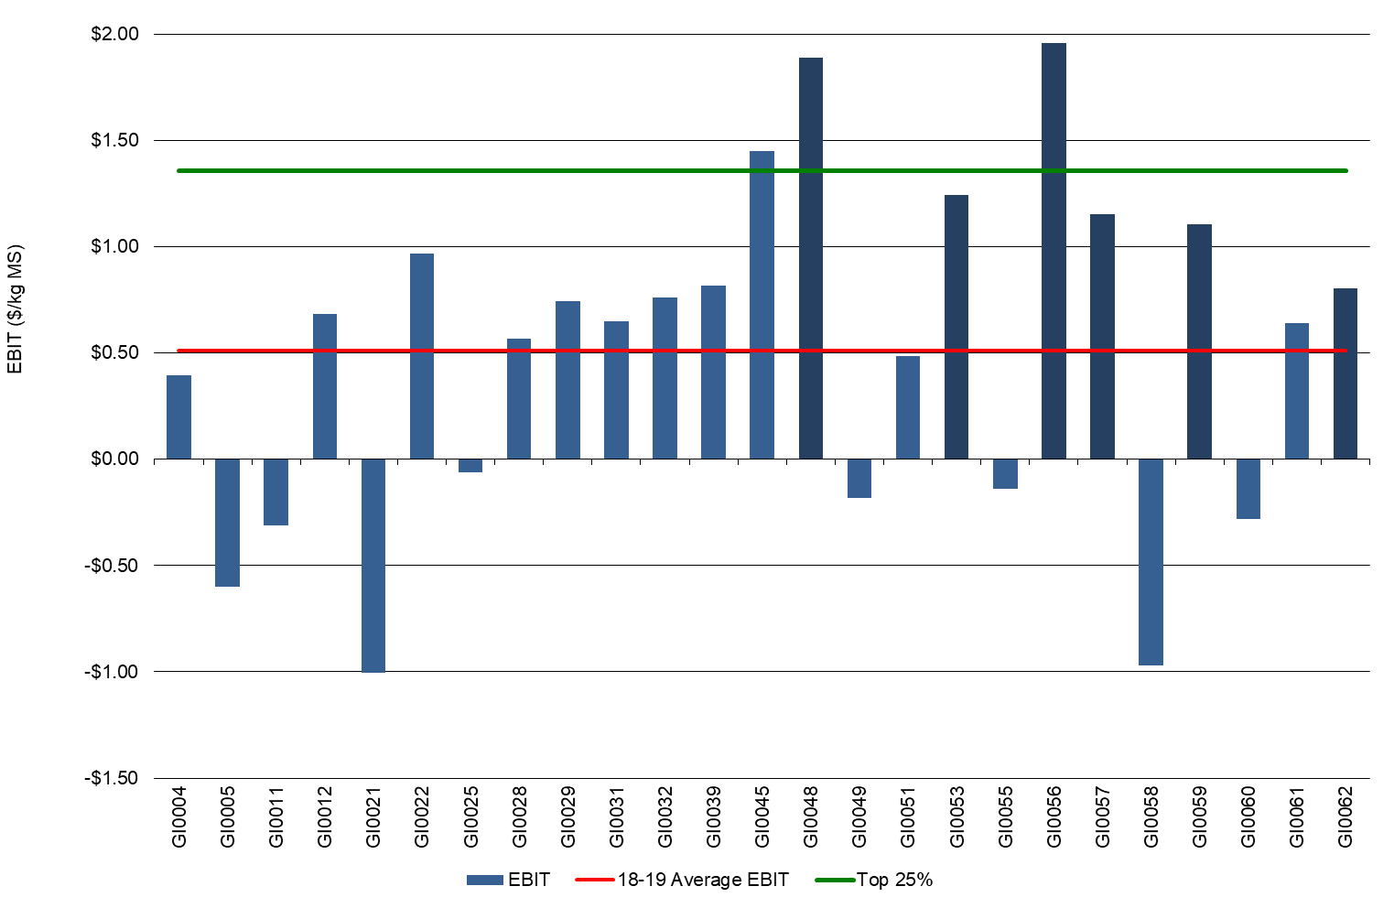

### Return on total assets and equity

Return on total assets, including owned and leased assets is a measure of how efficiently capital is being used.

In 2018-19, Gippsland participants averaged 1.7% RoTA. Seventeen farms (70%) returned a positive result, down from 85% in 2017-18. The range for all Gippsland participants was -3.3% and 6.2%. The top 25% returned an average RoTA of 4.7% compared to 6.9% last year, as shown in Figure 37.

As most farm businesses have a mix of owned and borrowed capital, equity is an important measure of risk. Half (12 out of 25) of the Gippsland farms returned a positive RoE in 2018-19 (Figure 38), a similar result as the previous two seasons. While average RoE was -2.3%, this number was impacted by the performance of farms in the lower quartile.

Interest and lease costs in 2018-19 remained similar to last year for both the average and top 25% at $0.69/kg MS and $0.44/kg MS, respectively. Average capital values are provided in Appendix D8.

FIGURE 37. RETURN ON TOTAL ASSETS – GIPPSLAND

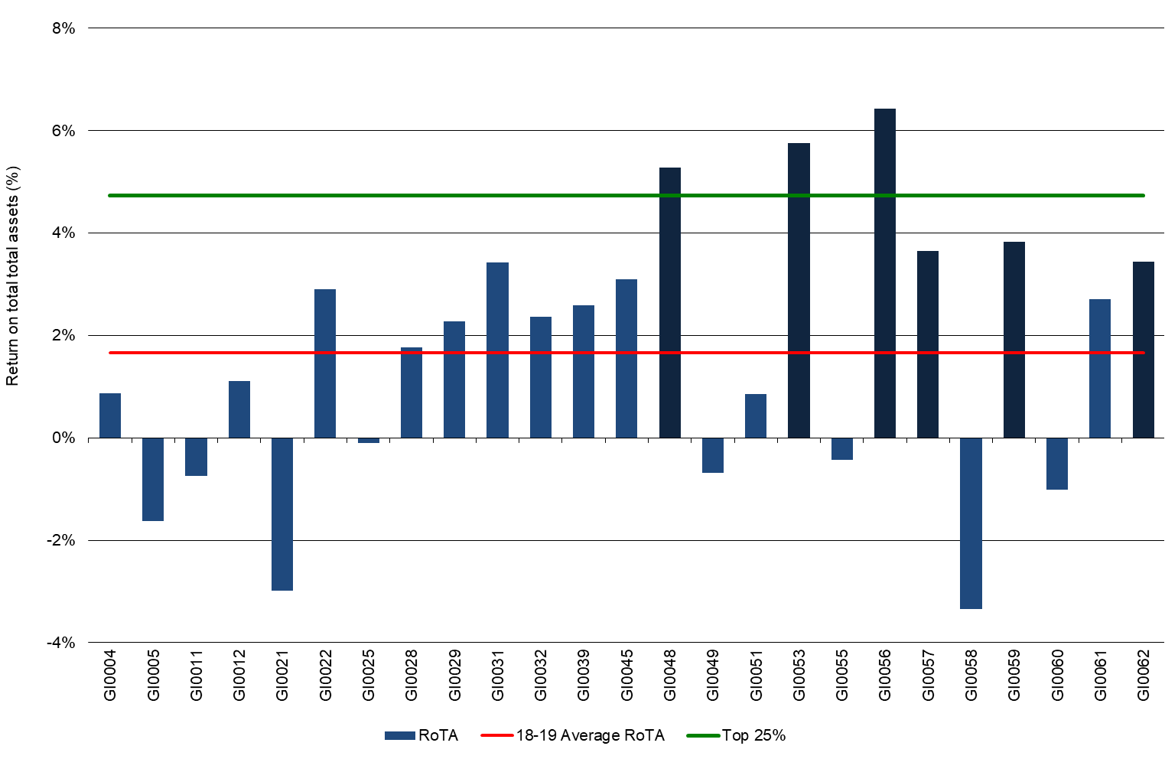

FIGURE 38. RETURN ON EQUITY – GIPPSLAND

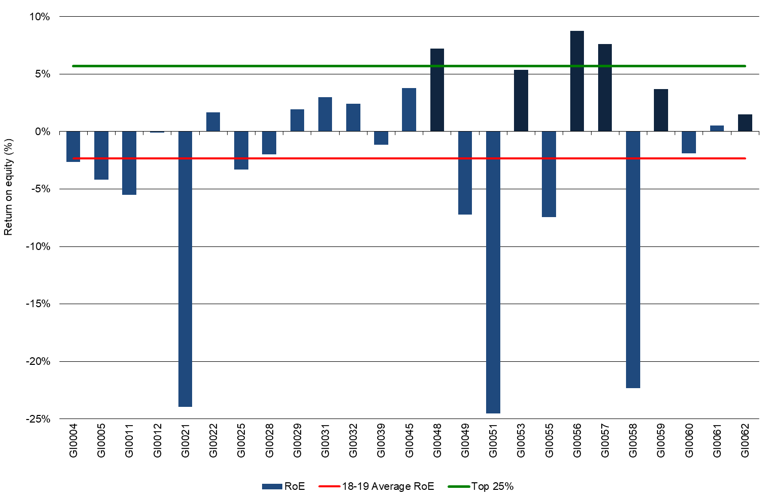

## Feed consumption and fertiliser

Most Gippsland farms (16 of the 25) were predominantly pasture based, sourcing half of

their ME requirements from grazed pasture.

Figure 39 shows the composition of ME consumed from different sources for each farm.

In Gippsland, the proportion of directly grazed pasture remained constant relative to last year. On average, dairy herds obtained 56% of ME on the usable area, compared to 55% last year. Total homegrown feed (pasture and conserved feed) as a percentage of ME consumed was 66%, again remaining consistent with last year’s results.

In Gippsland, concentrates were the most commonly used feed supplement (28% of total ME) and all participant farms fed hay as part of the ME consumed. The top 25% performers had a decreased reliance on ME from concentrates, declining from 34% in 2017-18 to 25% in 2018-19. This is due to the make-up of farms within the top 25% and for the same farms in the top 25% between years, they fed less concentrates as a percentage of total ME.

Pasture consumption is calculated as the difference between the total ME required on farm for all livestock classes and the ME provided from concentrates, silage, hay and other sources. Other feed included those feedstuffs not generally available to dairy farmers on the common market, such as almond hulls and citrus pulp. A further description of the method used to calculate ME sources and feed consumption is given in Appendix E.

FIGURE 39. SOURCES OF WHOLE FARM METABOLISABLE ENERGY – GIPPSLAND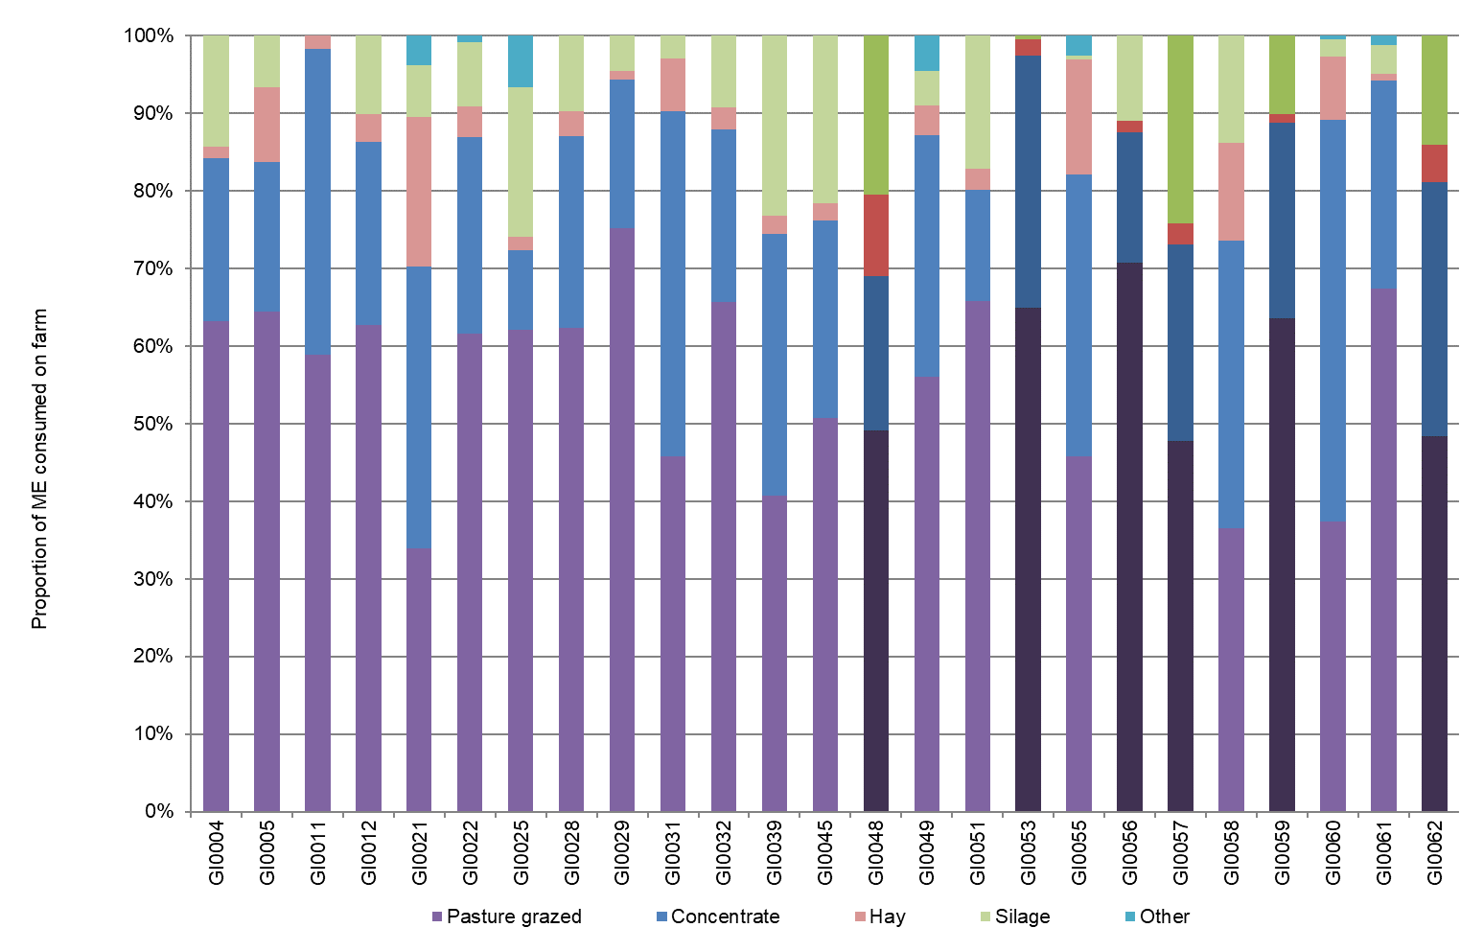

The estimated tonnes of dry matter of homegrown feed consumed per milking hectare is given in Figure 40. Homegrown feed can be grazed, or conserved fodder as shown in Figure 40.

Total homegrown feed consumed ranged from 3.7 t DM/ha to 15.0 t DM/ha with an average of 9.1 t DM/ha in 2018-19. This was higher than the average of 8.6 t DM/ha last year. The top 25% averaged 9.7 t DM/ha, a 10% decrease from last year.

The quantity of directly grazed pasture consumed was on average 7.9 t DM/ha, a slight increase from 7.4 t DM/ha last year. The quantity of feed conserved remained similar at 1.1 t DM/ha compared with 1.2 t DM/ha last year.

FIGURE 40. ESTIMATED TONNES OF HOMEGROWN FEED REMOVED PER MILKING HECTARE – GIPPSLAND

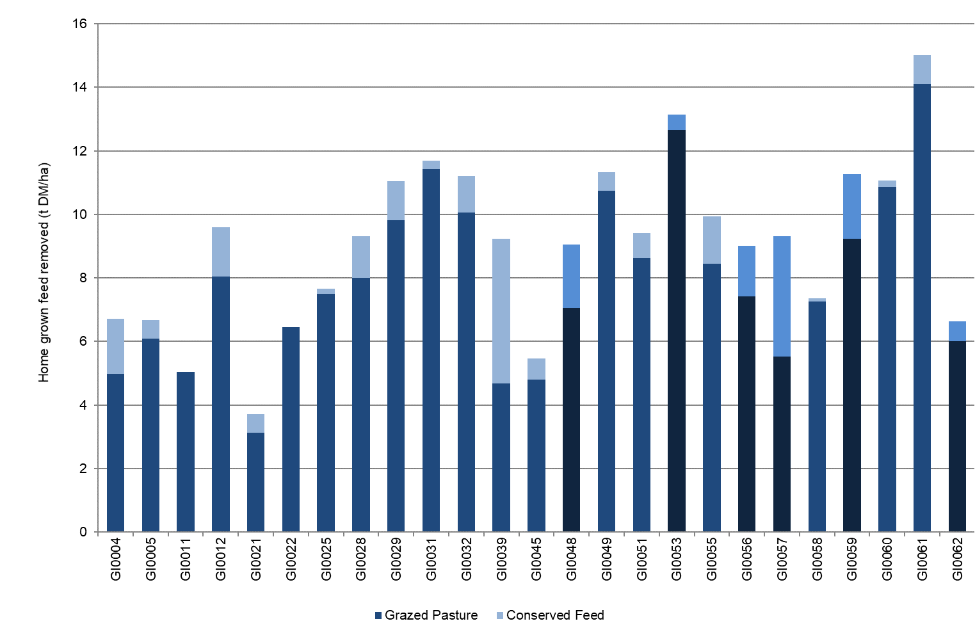

### Fertiliser application

Farms in Gippsland used a wide range of fertilisers and fertiliser application rates, both between farms and within the mix of key macronutrients on individual farms (Figure 41). The increasing use of organic substitutes, like compost, was also observed across the Gippsland region.

In 2018-19, the fertiliser application is reported per milking hectare rather than usable hectare as in previous years. This year, especially in the south and west, favourable growing conditions allowed for an increase in nutrient application. The increase in fertiliser application encouraged pasture growth and allowed some to farmers to replenish fodder reserves for the coming season. Average application rates for the main macronutrients were nitrogen at 191 kg N/ha phosphorus at 20 kg P/ha, potassium at 40 kg K/ha and sulphur at 20 kg S/ha.

The top 25% applied more nitrogen at 271 kg/ha, however most other nutrients remained relatively constant throughout the region.

The values for Figures 40 and 41 can be found in Appendix Table D2.

FIGURE 41. NUTRIENT APPLICATION PER HECTARE (MILKING HECTARE) – GIPPSLAND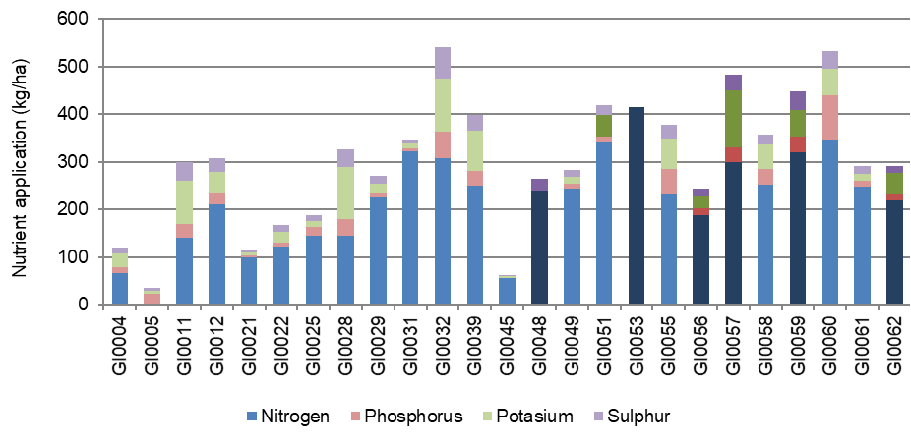

# Part Five: Business confidence survey

## Expectations and issues

Responses to this business confidence survey were collected in July 2019 about the 2019-20 financial year and the next five years to 2023-24. Six farmers did not complete the survey.

Following a challenging 2018-19 season, expectations about business profit for the 2019-20 were optimistic. Fifty-nine farmers (86%) predicted their business profit will

improve; six farmers (9%) expected to remain static or stable; three farmers (4%) were

not sure and one farmer (1%) expected their business profit to decline in 2019-20.

The 2018-19 survey was developed to consider different aspects of farming, from climate outlook to expectations about market conditions for dairy products bought and sold. While expectations of the coming year were generally positive regarding the seasonal outlook, there were slight regional differences.

Participants across the state were optimistic about business profit for the coming season. Those in the South West and Gippsland were more optimistic than farmers in the North with more than 90% expecting an improvement in their farm profit in 2019-20 (Figure 42).

Farmers in the North were less optimistic on the back of high feed and water prices. Two farmers in the North predicted their farm profits will remain stable and three were not sure how their farm profit in 2019-20 will unfold while one expected a decline in their farm profit.

FIGURE 42. EXPECTED CHANGE TO FARM BUSINESS PROFIT IN 2019-20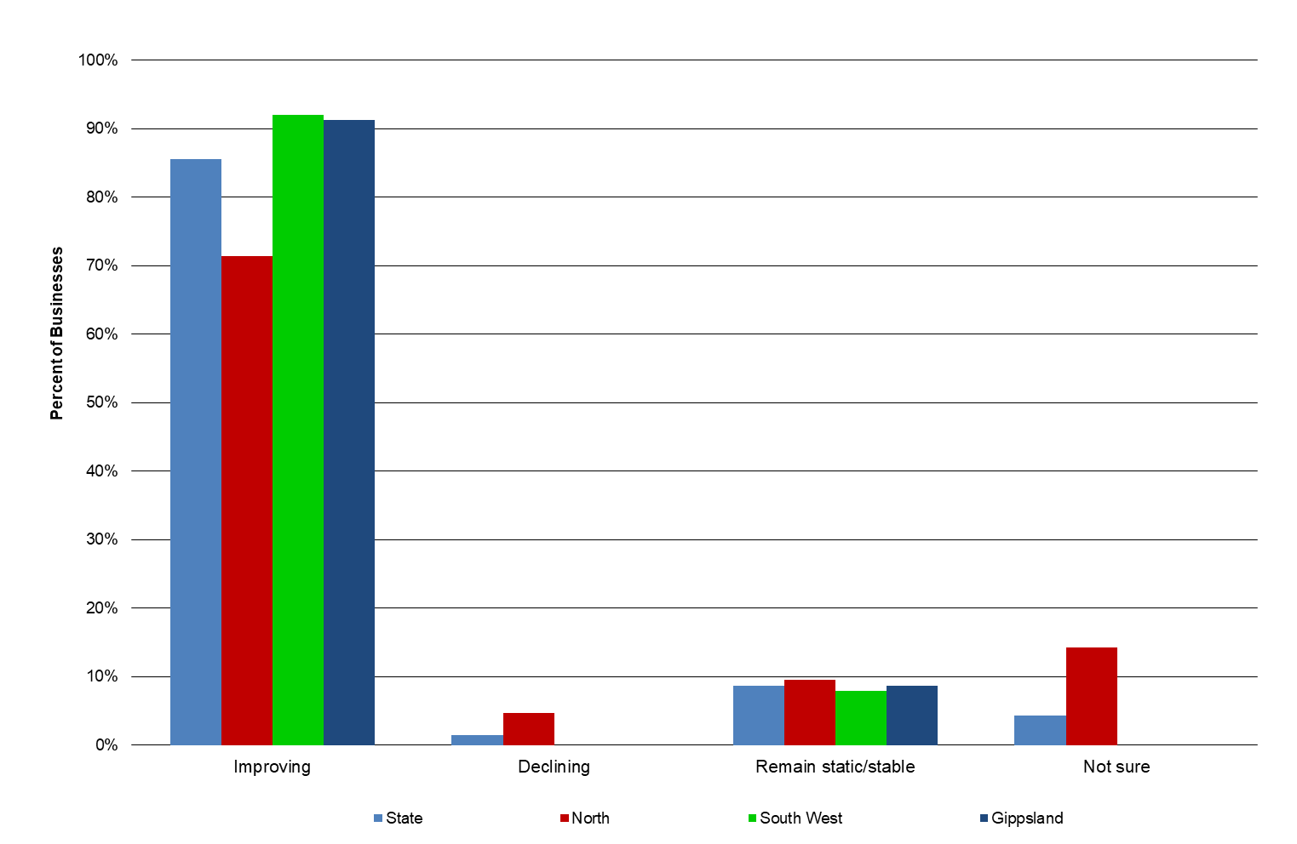

### Price and production expectations - milk

The majority of the respondents across the state (93%) were expecting milk price to improve in 2019-20 (Figure 43).

Farmers in Gippsland received the lowest milk price in 2018-19 amongst the three regions, and 95% of participants in the region expected their milk price to increase in the coming year. On the other hand, farmers in the North received the highest milk for the state and 86% of the participants expected their milk price to increase in 2019-20. Most of the South West farmers (96%) expect they will receive higher milk price this coming season.

Less than half (48%) of participants across the state indicated that they will increase milk production in 2019-20. Almost three-in-five farmers surveyed in Gippsland expected an increase in production while more farmers in the North expected to maintain their production level. This outlook was similar across the South West where almost 10% of farmers surveyed expect milk production to reduce.

FIGURE 43. PRODUCER EXPECTATIONS OF MILK PRICES AND PRODUCTION IN 2019-20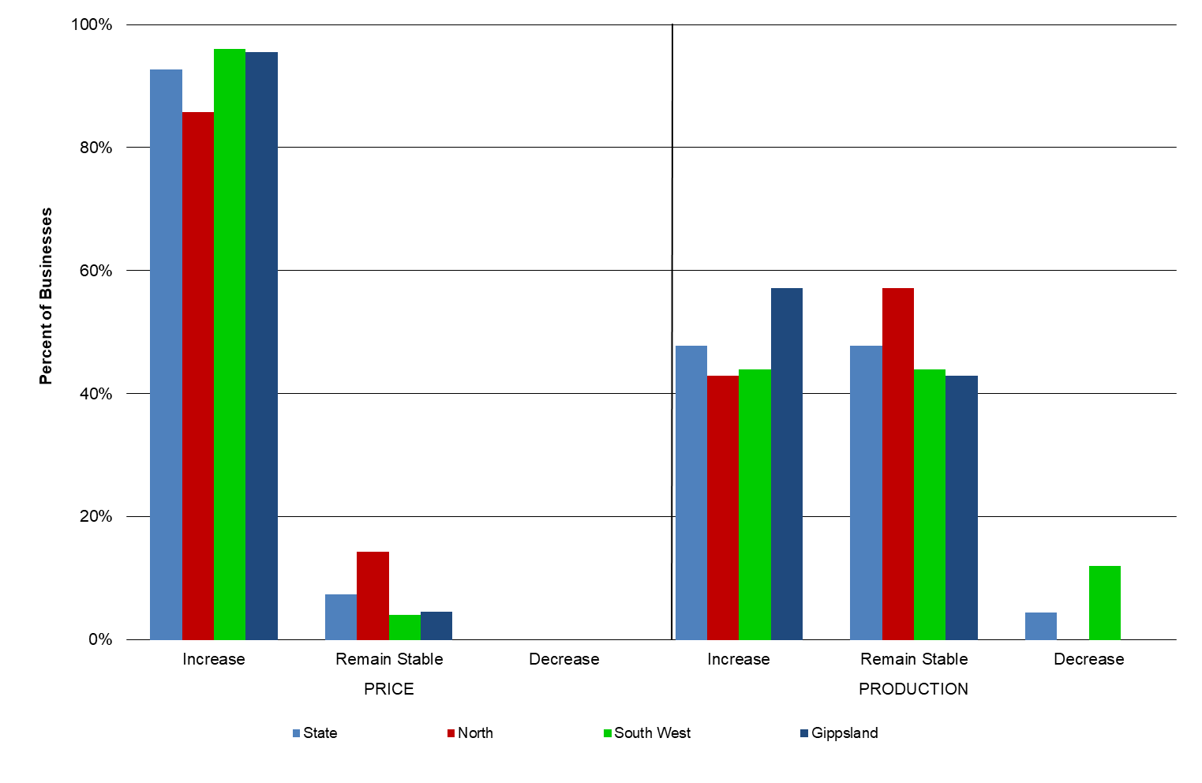

### Production expectations - fodder

Nine of the 75 farmers (12%) did not provide answers to the question regarding expectations of fodder production.

The outlook for fodder production varied across the state. While 41% indicated that they expected fodder production to increase in the coming year, more than half expected no change. Four farmers expected fodder production to decrease on their farms in 2019-20 (Figure 44).

Many participants were concerned about seasonal variability in the coming year. Despite most climate models forecasting drier spring rainfall, a slightly lower than long-term average rainfall in autumn 2019 has influenced the optimistic outlook of participants to increase or maintain fodder production.

FIGURE 44. PRODUCER EXPECTATIONS OF FODDER PRODUCTION IN 2019-20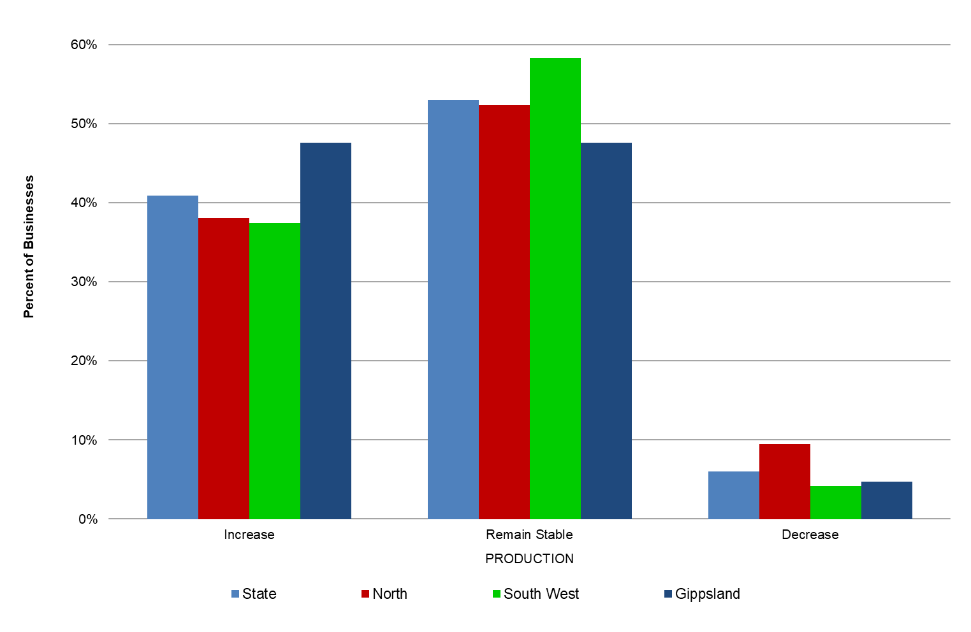

### Cost expectations

Data presented in Figure 45 details the expectations about costs for the dairy industry from participant farms in the project.

Many respondents expected input costs in all categories to remain unchanged. Unlike the outlook in 2018-19 where 74% of respondents across the state expected the cost of purchased feed to increase, this year only 18% expected higher costs for purchased feed. Other costs (fertiliser, fuel and oil, labour and repairs and maintenance) are expected to be maintained in 2019-20. More than 70% of the respondents expected their expenses on fertilisers to remain unchanged, 20% expected an increase in line with their expectation of increasing or maintaining fodder production.

In the 2017-18 survey, almost 70% of irrigators predicted their irrigation costs to increase in the 2018-19 season, which was proven.

For the coming 2019-20 season, half of the irrigators expect their irrigation cost to increase, while 47% expect their irrigation costs to remain constant. The survey was conducted in July 2019 and the price of temporary water (allocation) had been trading between $500/ML and $700/ML in Zone 1A Greater Goulburn and Zone 7 VIC Murray - Barmah to South Australia.

FIGURE 45. PRODUCER EXPECTATIONS OF COSTS FOR THE DAIRY INDUSTRY IN 2019-20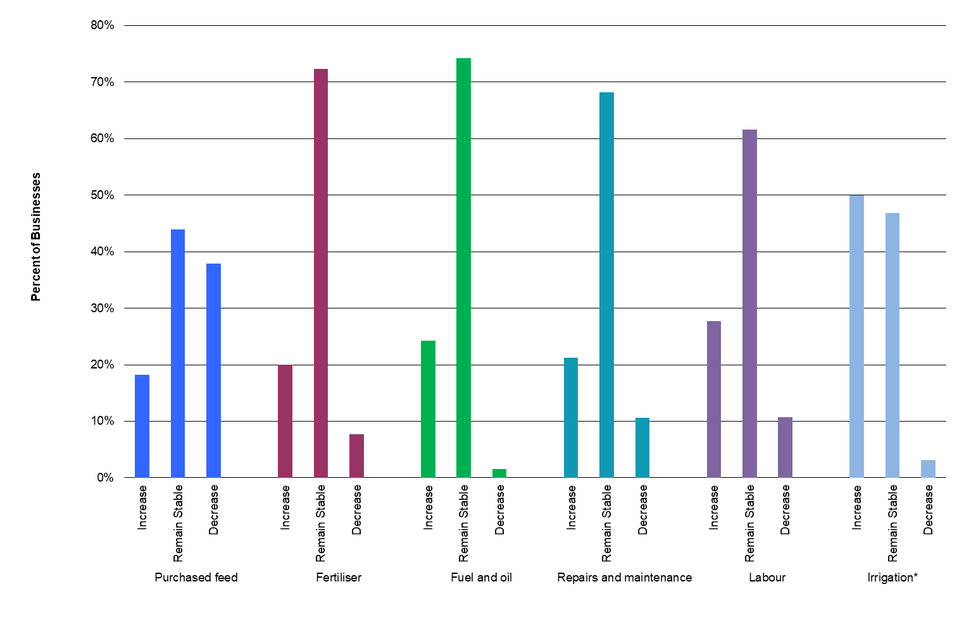

*\* Only includes responses from 32 irrigators*

### Comments from participants

In 2018-19, comments from participants centred on climate/ seasonal conditions and the impact on fodder production, water availability and price of inputs. This was summarised by one participant who commented “Milk price doesn’t hurt us as much as a bad season, but it does help when it is up.”

Participants were also concerned about how to maintain profitability under these conditions and with the declining terms of trade – the increase in cost of inputs were much higher than the increase in price received for milk.

Other participants identified heifer performance as an issue to manage in the coming year. While different farmers commented they were focused on succession planning, share-farming, debt consolidation, labour, extra land for pasture production and downsizing.

### Issues of importance to dairy businesses - the next 12 months

Participant farmers were asked to rank seven identified issues based on the level of importance to their business, for the upcoming season (Figure 46). Participants were also encouraged to identify other issues. The participants were asked to rank these issues from 1 to 8, with (1) being most important and (8) being least important.

Figure 46 shows that input costs were again the most important issue facing farmers in the short-term (12 months). The results are reinforced by farmers’ expectation for increased costs of purchased feed, fertiliser, and fuel and oil, and increased cost of water for irrigators (Figure 45).

Climate/season conditions was the second most important issue. It was highly important to farmers considering the rainfall in 2018-19 was lower than the long-term average in the North (31% lower) and 17% lower in Gippsland. South West received rainfall close to its long-term average at 93%. Farmers were concerned not only about the amount of rainfall but were also concerned with the distribution throughout the year.

Farmers received the highest milk price since the 2016-17 season, as such, milk price was the third important issue and pasture/fodder was fourth.

In Gippsland, the most important issues were input costs, climate/seasonal conditions and pasture/fodder. The most important issues in the North were climate/season conditions, water, and input costs. Milk price, input costs, and availability of pasture/fodder were the top three most important issues for the South West region.

Among the regions, only the farmers in the South West identified milk price as a priority of the 2019-20 season.

FIGURE 46. MAJOR ISSUES FOR INDIVIDUAL BUSINESSES – 12-MONTH OUTLOOK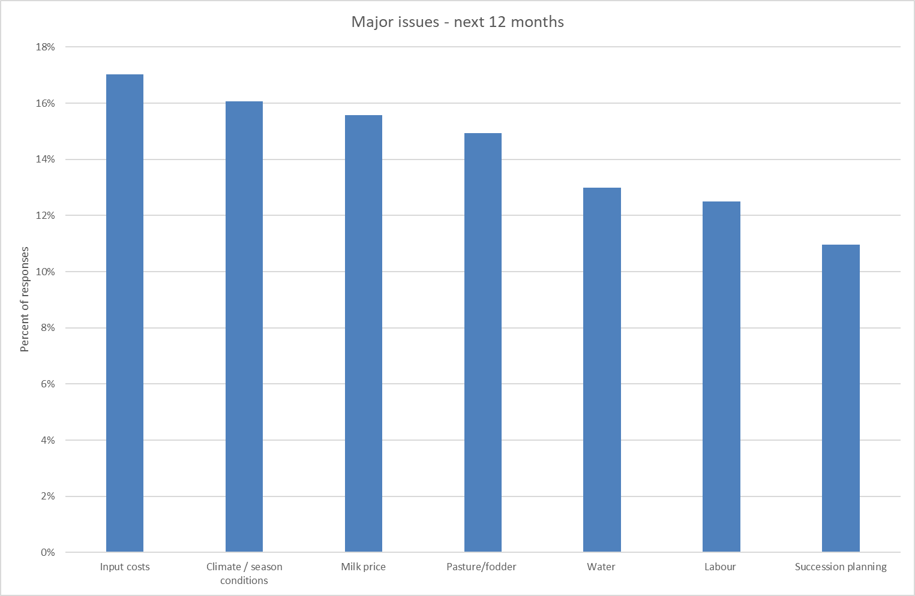

### Issues of importance to dairy businesses- the next five years

Participants were asked to rank in order of importance, seven identified issues facing their business over the next five years (Figure 47). These issues were categorised as: increasing input costs; volatility of milk price; and climate/seasonal conditions impacting on the amount and timing of rainfall events conducive for pasture growth. Participants also identified other issues they faced.

In the medium term (five years), milk price is the most important issue followed closely by input costs and climate/seasonal conditions.

The farmer-participants in Gippsland identified input costs as the most important issue they will face in the next five years. Climate/season conditions and milk price were the next important issues.

Climate/season condition and water were rated as the most important issues for farmers in the North as these issues are closely linked. When rainfall is similar or above the long-term average and the water storages are full, farmers will receive their full allocation and the price of water will be more affordable to dairy farmers.

Consistent with ranking of issues in the next 12 months for South West farmer-participants, farmers in this region identified input costs, climate/ season conditions and pasture/fodder as the most important over the next five years.

Farmers in the South West and Gippsland were more concerned about succession planning than the farmers in the North.

FIGURE 47. MAJOR ISSUES FOR INDIVIDUAL BUSINESSES – 5-YEAR OUTLOOK

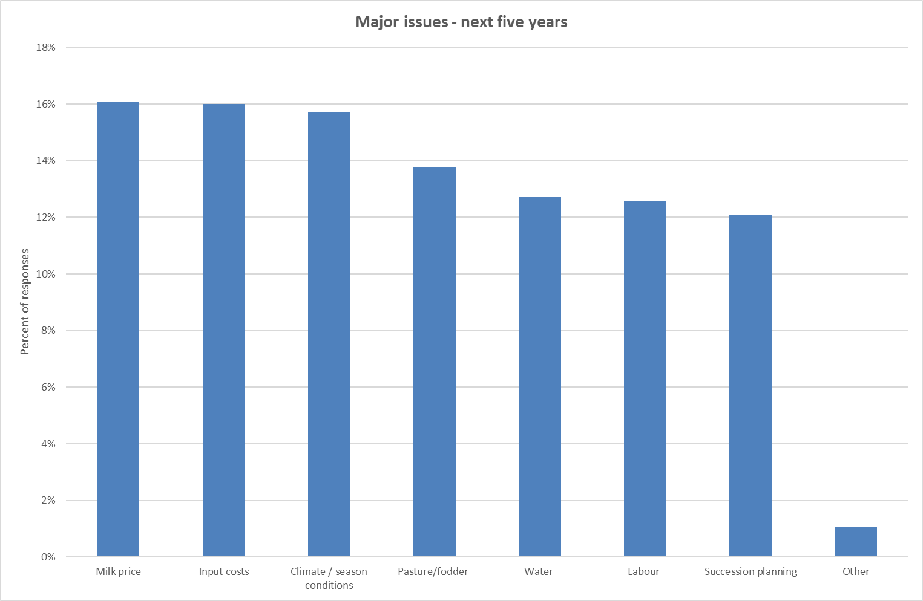

# Part Six: Greenhouse gas emissions

## 2018-19 Greenhouse gas emissions - Statewide

The average emissions estimated for the participating farms was 14.5 tonnes of

carbon dioxide equivalents per tonne of milk solids sold (t CO2-e/t MS) in 2018-19. The

most significant source of on-farm emissions was methane from ruminant digestion,

contributing 56% of total farm emissions. The next biggest contributor was from pre-farm emissions sources (carbon dioxide from purchased feed and fertiliser), contributing 13%.

Carbon dioxide equivalents (CO2-e) are used to standardise the greenhouse potentials from different gases. The Global Warming Potential (GWP) is the index used to convert relevant non-carbon dioxide gases to a carbon dioxide equivalent. This is calculated by multiplying the quantity of each gas by its GWP. All the data in this section is in CO2-e tonnes and expressed per tonne of milk solids sold (CO2-e /t MS).

The method of estimating Australia’s dairy industry greenhouse gas emissions reflects the latest research outcomes and aligns with international guidelines. The GWP for the three gases discussed in this report is 1: 25:298 (carbon dioxide; CO2: methane; CH4: nitrous oxide; N2O). This year the greenhouse emission was calculated through DairyBase using the Australian Dairy Carbon Calculator.

The distribution of different emissions for 2018-19 is shown in Figure 48. Greenhouse gas emissions per tonne of milk solids sold ranged from 10.6 t CO2-e /t MS to 20.3 t CO2-e /t MS with an average emission level of 14.5 CO2-e /t MS.

Methane was identified as the main greenhouse gas emitted from dairy farms, accounting for 9.4 t CO2-e/t MS, 65% of all greenhouse emissions. Methane produced from ruminant digestion (enteric CH4) was the major source of emissions from all farms in this report, with an average of 56% of total emissions (8.1 CO2-e /t MS). Methane from effluent ponds accounted for 9% of total emissions (1.3 CO2-e/t MS) on average across the state in 2018-19.

The second main greenhouse gas emission was carbon dioxide (CO2) produced primarily from fossil fuel consumption as either electricity or petrochemicals. Carbon dioxide accounted for 3.2 t CO2-e/t MS, 22% of emissions in 2018-19. The estimation of greenhouse gas emissions includes a pre-farm gate emission source. These are the greenhouse gases emitted during the manufacturing of fertilisers and the production of purchased fodder, grain and concentrates. Pre-farm gate sources accounted for 13% (1.9 CO2-e/t MS) of the carbon dioxide emissions and 9% (1.3 CO2-e/t MS) was from on-farm energy sources. Output levels were highly dependent on the source of electricity used with an increasing number for farms installing solar panels to generate electricity and offset the rising cost of electricity.

The third main greenhouse gas was N2O with an estimated emission of 1.9 t CO2-e/t MS, 13% of all emissions. This gas is produced from wastes (dung and urine); applied fertiliser and effluent ponds. Nitrous oxide emissions from fertiliser accounted for 3% of total emissions, effluent ponds accounted for 1% and excreta accounted for 4%. Nitrous oxide from indirect emissions was 5%. Nitrous oxide emissions from soils are highest in warm, waterlogged soils with readily available nitrogen. Over application of nitrogen, high stocking intensity and flood irrigation are all potential causes of increased nitrogen loss as N2O. Strategic fertiliser management practices can reduce N2O emissions and improve nitrogen efficiency.

The top 25% of farms had higher total farm emission (2,838 t CO2-e/farm) than the state average (2,603 t CO2-e/farm). However, their emissions were spread over higher milk production per farm than the average, resulting in their slightly lower emissions per kg MS sold (14.1 t CO2-e/t MS). The data demonstrated farms can achieve efficiency with lower greenhouse gas emissions intensity.

There is a growing importance to understand and monitor greenhouse gas emissions, and these are likely to become more important into the future. To find detailed information on the Australian National Greenhouse Gas Inventory, strategies for reducing greenhouse gasses and more details on sources of greenhouse gases on dairy farms visit the Australian Department of the Environment’s website at **www.environment.gov.au/climate-change.**

FIGURE 48. ESTIMATED 2018-19 GREENHOUSE GAS EMISSIONS PER TONNE OF MILK SOLIDS PRODUCED - STATEWIDE (CO2 EQUIVALENT)

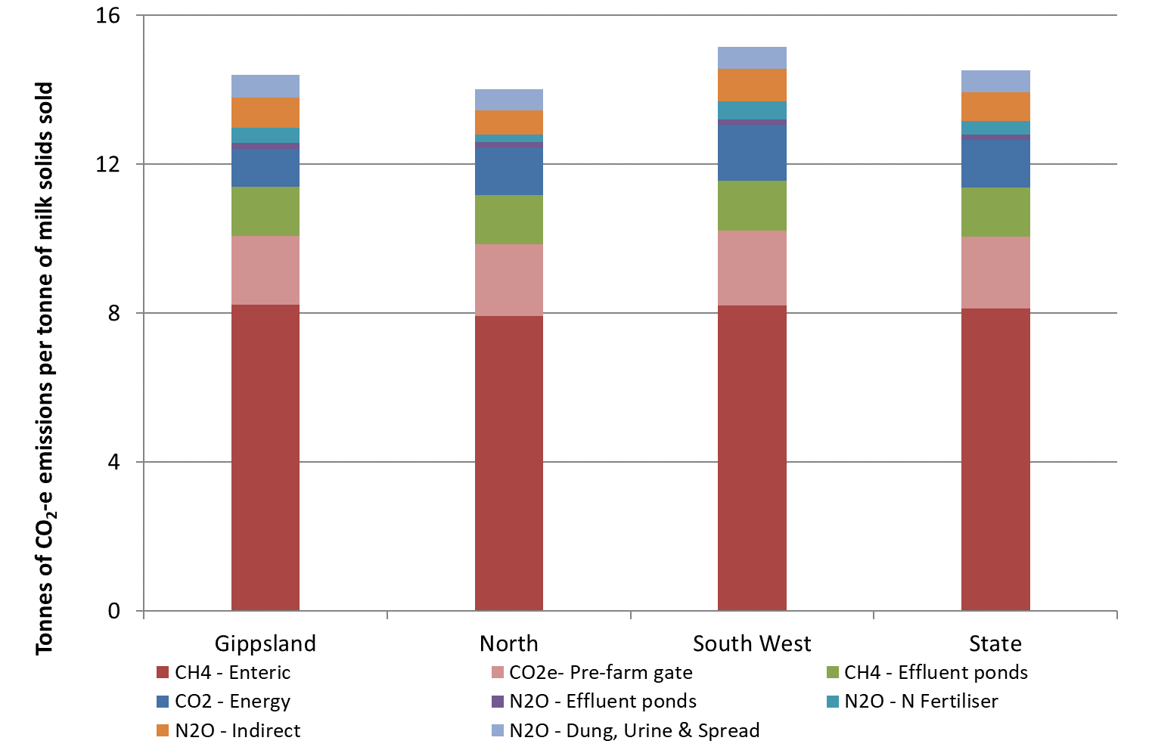

### Greenhouse gas emissions - North

Participant farms in the North were estimated to emit an average of 14 t CO2-e/t MS in

2018-19, mainly from methane produced by ruminant digestion (57%) and carbon dioxide from purchased feed and fertiliser (14%).

Methane was the main greenhouse gas emitted from participant farms in the North, accounting for 9.2 t CO2-e/t MS, 66% of the average total greenhouse emissions (Figure 49). Methane produced from ruminant digestion contributed 7.9 t CO2-e/t MS to regional average emissions while methane from effluent ponds accounted for 1.3 t CO2-e/t MS.

Carbon dioxide accounted for 3.2 t CO2-e/t MS, 23% of emissions in 2018-19, which comprised 1.3 t CO2-e/t MS from fossil fuels and 1.9 t CO2-e/t MS from pre-farm gate sources. At least nine participant farms in the North have installed solar panels to generate electricity and offset electricity costs.

Nitrous oxide emissions contributed 1.6 t CO2-e/t MS, 11% of all emissions. Direct emissions from applied nitrogen fertiliser, effluent management systems and animal wastes accounted for 0.9 t CO2-e/t MS. The balance of 0.6 t CO2-e/t MS came from ammonia and nitrate loss in soils as indirect sources.

The top 25% of farms had higher total emissions per farm, but higher production than the average meant the difference of higher emissions was minimal on per kg MS basis. Emissions from the top 25% of farms were 13.9 t CO2-e/t MS, which was slightly lower than the average of all participant farms. The emissions came from CH4 (9.3 t CO2-e/t MS); CO2 (2.8 t CO2-e/t MS) and N2O (1.8 t CO2-e/t MS). The top performers had lower CO2 emissions, higher N2O and similar CH4 emissions to the average.

FIGURE 49. ESTIMATED 2018-19 GREENHOUSE GAS EMISSIONS PER TONNE OF MILK SOLIDS PRODUCED - NORTH (CO2 EQUIVALENT) 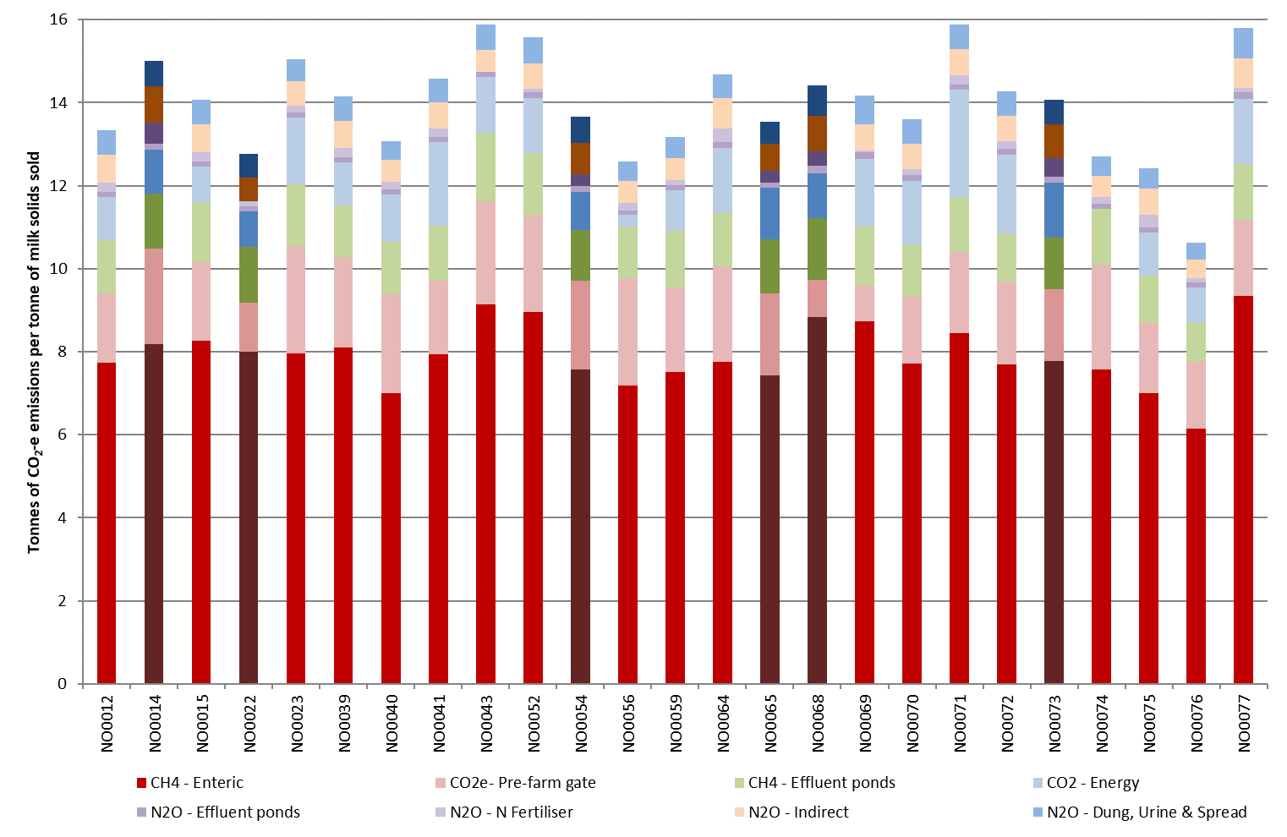

### Greenhouse gas emissions - South West

Participant farms in the South West were estimated to emit an average of 15.2 t CO2-e/t MS in 2018-19, the highest of all the regions. The two main sources of the emissions were methane gas from ruminant digestion (54% of the total emissions) and carbon dioxide from purchased feed and fertiliser (13%).

Methane was the main greenhouse gas emitted from participant farms in the South West accounting for 9.5 t CO2-e/t MS, 63% of the average total greenhouse emissions. Methane produced from ruminant digestion was 8.2 t CO2-e/t MS and CH4 from effluent ponds accounted for 1.3 t CO2-e/t MS (Figure 50).

Carbon dioxide emissions were 3.5 t CO2-e/t MS, 23% of emissions in 2018-19, comprised of 1.5 t CO2-e/t MS from fossil fuels and 2 t CO2-e/t MS from pre-farm gate sources. Nitrous oxide emissions contributed 2.1 t CO2-e/t MS, 14% of all emissions. Direct emissions from applied nitrogen fertiliser, effluent management systems and animal wastes accounted for 1.2 t CO2-e/t MS. The balance of 0.9 t CO2-e/t MS came from ammonia and nitrate loss in soils as indirect sources.

The average emissions of participant farms in the South West was 2,781 t CO2-e/farm, below the top 25% of farms (3,428 t CO2-e/farm). However, on a per tonne milk solids basis the top 25% of farms had lower emissions of 14.8 t CO2-e/t MS than the average (2% lower). The emissions of the top 25% came from methane (9.3 t CO2-e/t MS); carbon dioxide (3.3 t CO2-e/t MS) and nitrous oxide (2.2 t CO2-e/t MS).

FIGURE 50. ESTIMATED 2018-19 GREENHOUSE GAS EMISSIONS PER TONNE OF MILK SOLIDS PRODUCED - SOUTH WEST (CO2 EQUIVALENT)

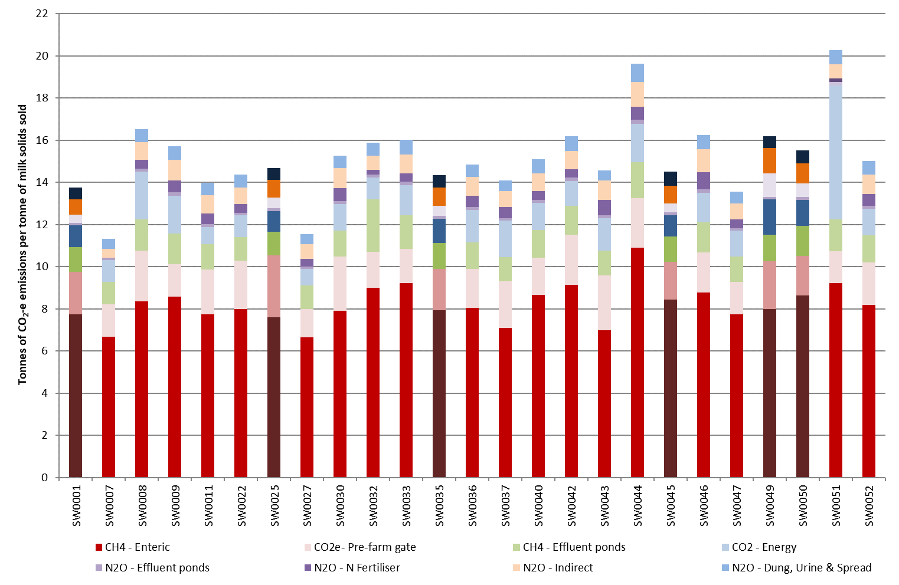

### Greenhouse gas emissions - Gippsland

Participant farms in Gippsland were estimated to emit an average of 14.5 t CO2-e/t MS

in 2018-19, mostly methane from ruminant digestion (57%) and carbon dioxide from

purchased feed and fertiliser (13%).

Methane was the main greenhouse gas emitted from participant farms in Gippsland accounting for 9.6 t CO2e/t MS, 66% of the average total greenhouse emissions.

Methane produced from ruminant digestion contributed 8.2 t CO2-e/t MS to regional average emissions while CH4 from effluent ponds accounted for 1.3 t CO2-e/t MS (Figure 51).

Carbon dioxide accounted for 2.9 t CO2-e/t MS, 20% of emissions in 2018-19, which comprised 1.0 t CO2-e/t MS from fossil fuels and 1.8 t CO2-e/t MS from pre-farm gate sources.

Nitrous oxide contributed 2 t CO2-e/t MS, 14% of all emissions. Direct emissions from applied nitrogen fertiliser, effluent management systems and animal wastes accounted for 1.2 t CO2-e/t MS. The balance of 0.8 t CO2e/t MS came from ammonia and nitrate loss in soils as indirect sources.

The average emissions of participant farms in Gippsland was 2,062 t CO2-e/farm, lower than the top 25% of farms (2,259 t CO2-e/farm). However, on a per tonne milk solids basis the top 25% of farms had 6% lower emissions of 13.6 t CO2-e/t MS than the average because they sold more milk per farm than the average. The emissions of the top 25% came from methane (8.8 t CO2-e/t MS); carbon dioxide (2.7 t CO2-e/t MS) and nitrous oxide (2.1 t CO2-e/t MS). The top performing farm emitted less CH4 and CO2, but more N2O.

FIGURE 51. ESTIMATED 2018-19 GREENHOUSE GAS EMISSIONS PER TONNE OF MILK SOLIDS PRODUCED - GIPPSLAND (CO2 EQUIVALENT)

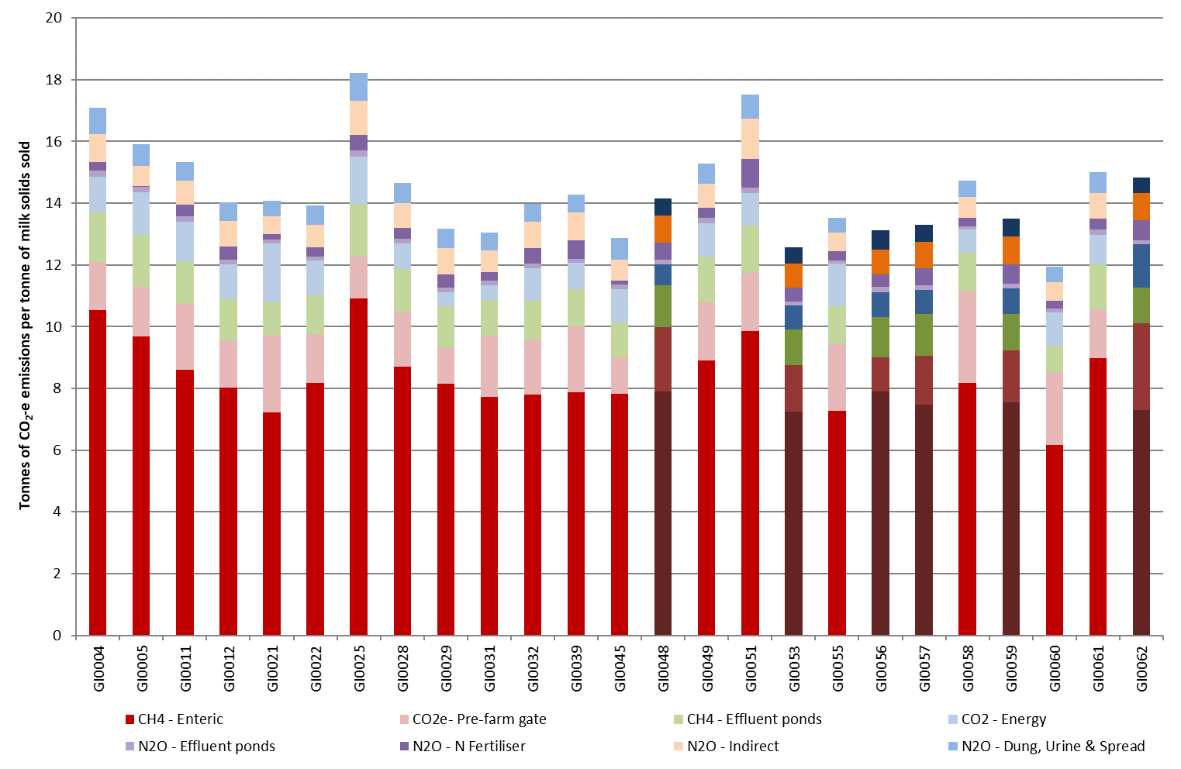

# Part Seven: Historical analysis

## Historical analysis

Dollar values are adjusted to allow comparison between years; however, some farms have not participated each year and care is needed when comparing performance across years.

The 2018-19 season was a challenging year for the Victorian dairy industry with continued dry seasonal conditions inducing high input costs, particularly for irrigation water, grain and fodder. The increase in these costs were only partially offset by a general increase in milk price. Farm profits were among the lowest recorded in the 13-year history of the project.

### The North

Farm profits in 2018-19 for the North region fell to the lowest recorded in the 13-year history of the project (Figure 52). Farm performance in 2018-19 was ‘all about water’ where temporary water allocations prices averaged $416/ML. The profit performance reflects the dry seasonal conditions and high input costs, with many farmers left with a negative net farm income at the end of 2018-19. Three of the last four years in Northern Victoria have recorded below average profits.

Although seasonal determinations of HRWS reached 100 per cent by the end of 2018-19 on the Goulburn and Murray irrigation systems, an increase in the temporary water price saw the purchase of temporary water become unprofitable for many businesses. To offset the lack of available water in summer, many participating farmers grew more homegrown cereal crops.

As a result, average EBIT and net farm income decreased to $24,000 and -$85,000, respectively. The difference between EBIT and net income is interest and lease costs, which increased slightly on the previous year, to $109,000 farm.

Average RoTA was -1.7% in 2018-19. This was negative for the second time in the history of the project (the other year was 2006-07) and RoE was -7.4% (Figure 53). The 13-year average for RoTA in the North was 3.5% and 1.3% for RoE.

FIGURE 52. FARM PROFITABILITY (REAL $) BETWEEN 2006-07 AND 2018-19 – NORTH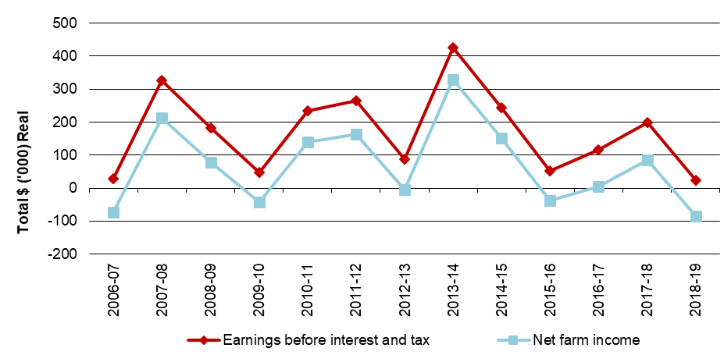

FIGURE 53. WHOLE FARM PERFORMANCE BETWEEN 2006-07 AND 2018-19 – NORTH

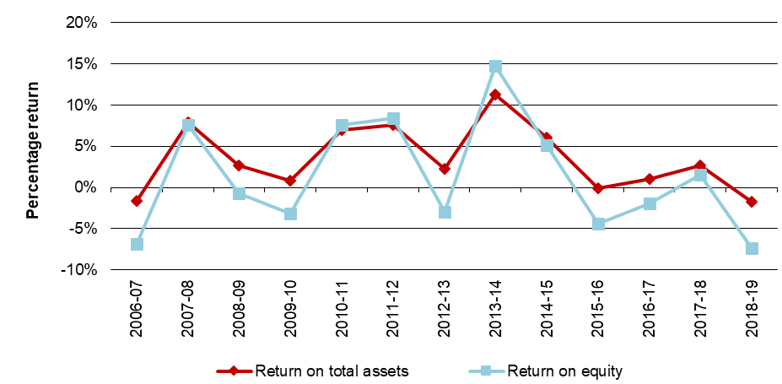

### The South West

Farm profit in the South West improved on the previous year across all indicators (Figure 54). Of the same 24 farms participating between years, 14 farms recorded a higher EBIT in total dollars.

The profit performance in 2018-19 was influenced by improved seasonal conditions and increased milk price, enabling farmers to increase pasture consumption and to conserve greater quantities of pasture. However, increased variable costs largely from higher costs of concentrate and hay, and homegrown feed costs. Some farms in the DFMP sample reduced milk production as a seasonal risk management strategy. This contributed to an overall decline in milk solids sold between years.

The EBIT and net farm income were the fifth and fourth lowest recorded in the 13-year history of the project with $150,000 and $27,000 respectively. Farms in the South West had the highest interest and lease costs of all the regions at $122,000. This was driven by higher liabilities at $2.13 million, larger farm size and an increasing asset base.

In 2018-19, average RoTA was 2.3%, the fourth lowest performance (Figure 55). The long-term average is 3.9%.

Average RoE remained in negative values at -0.8% this year, the same as that recorded the previous year. The long-term average is 1.9%. A negative RoE result indicated that farms are worth less than they were a year ago.

FIGURE 54. FARM PROFITABILITY (REAL $) BETWEEN 2006-07 AND 2018-19 – SOUTH WEST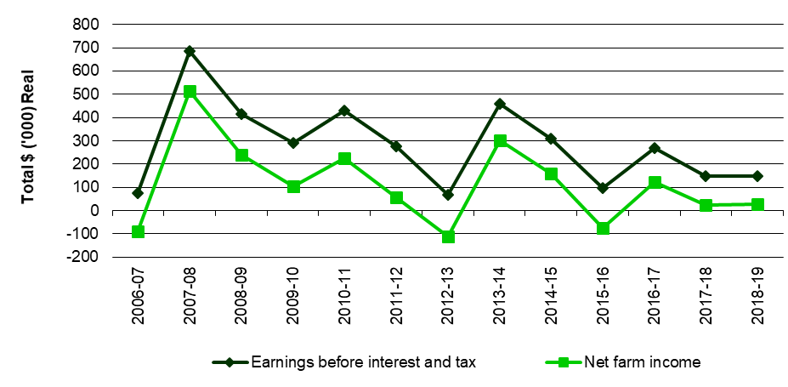

FIGURE 55. WHOLE FARM PERFORMANCE BETWEEN 2006-07 AND 2018-19 – SOUTH WEST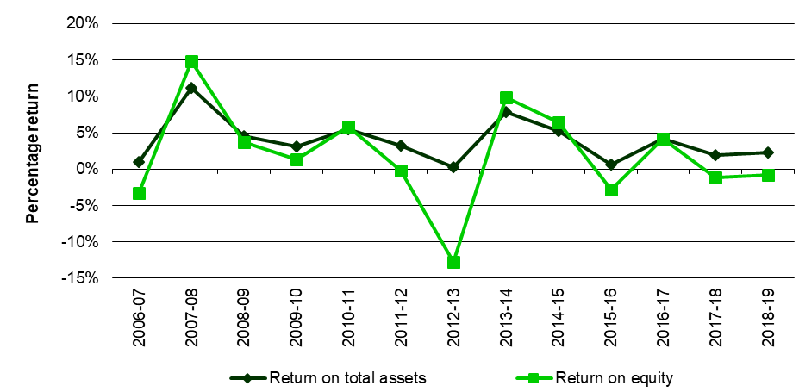

### Gippsland

Gippsland farm profit declined in 2018-19, recording the fourth lowest value in the 13-year history of the project. Regional variation in seasonal conditions contributed to the lower average performance. Of the same 20 farms participating in the previous year, the seven farms that recorded higher profits than the previous year were in south and west Gippsland.

On average, farm EBIT reduced to $82,000, from $144,000 in 2017-18 (Figure 56). The lower result in 2018-19 was skewed by the profit performance of the bottom 25% of participants. These farms felt the impacts of the dry seasonal conditions which limited pasture availability and increased costs (particularly grain and irrigation) without an improvement in milk production.

When interest and lease costs of $97,000 were considered, net farm income fell to -$15,000. This was also the third lowest profit performance recorded in the 13-year history (Figure 56).

Business performance measured as RoTA shows that on average, efficiency in Gippsland declined. On average, values decreased to 1.7% for RoTA and -2.3% for RoE in 2018-19 (Figure 57). The long-term average for these indicators are 3.6% and 2.9%, respectively.

FIGURE 56. FARM PROFITABILITY (REAL $) BETWEEN 2006-07 AND 2018-19 – GIPPSLAND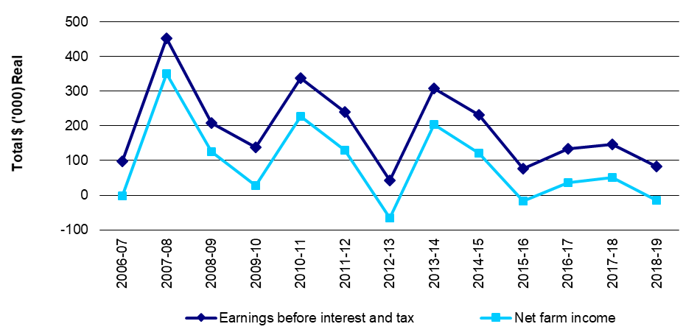

FIGURE 57. WHOLE FARM PERFORMANCE BETWEEN 2006-07 AND 2018-19 – GIPPSLAND

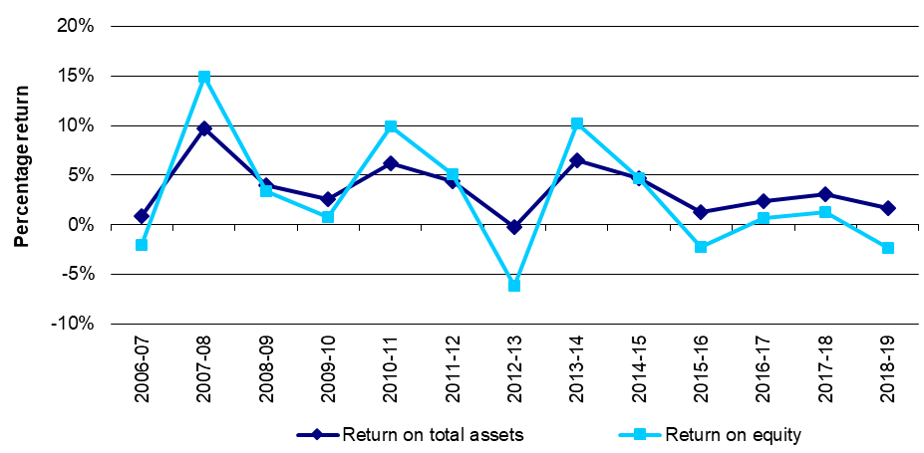

# Appendices

## 

## APPENDIX A: Statewide summary tables

**Table A1**

**Main financial indicators - Statewide**

|  |  |  |  |  |  |  |  |  |  |  |  |  |
| --- | --- | --- | --- | --- | --- | --- | --- | --- | --- | --- | --- | --- |
|  | Milk income (net)  ($/kg MS) | All other farm income  ($/kg MS) | Gross farm income  ($/kg MS) | Total variable costs  ($/kg MS) | Total overhead costs  ($/kg MS) | Cost structure (variable costs /total costs) (%) | Earnings Before Interest & Tax  ($/kg MS) | Return on total assets (%) | Interest & lease charges  ($/kg MS) | Debt servicing ratio  (% of income) | Net farm income (  $/kg MS) | Return on equity  (%) |
| Average | $6.13 | $0.63 | $6.76 | $4.17 | $2.34 | 64% | $0.25 | 0.7% | $0.64 | 9.5% | -$0.39 | -3.5% |
| Top 25% | $6.26 | $0.63 | $6.88 | $3.35 | $1.98 | 63% | $1.55 | 5.0% | $0.60 | 8.7% | $0.96 | 5.4% |

**Table A2**

**Physical information - Statewide**

|  |  |  |  |  |  |  |  |  |  |
| --- | --- | --- | --- | --- | --- | --- | --- | --- | --- |
|  | Total usable area  (ha) | Milking area (ha) | Total water use efficiency (t DM/100mm) | Number of milking cows (cows) | Milking cows per usable area (cows/ha) | Milk sold  (kg MS/cow) | Milk sold  (kg MS/ha) | Fat  (%) | Protein  (%) |
| Average | 261 | 162 | 0.9 | 357 | 1.6 | 495 | 757 | 4.3% | 3.5% |
| Top 25% | 306 | 202 | 1.0 | 421 | 1.7 | 502 | 817 | 4.2% | 3.4% |

**Table A2**

**Physical information - Statewide (continued)**

|  |  |  |  |  |  |  |  |  |  |
| --- | --- | --- | --- | --- | --- | --- | --- | --- | --- |
|  | Estimated grazed pasture**  (t DM/ha) | Estimated conserved feed**  (t DM/ha) | Home grown feed as % of ME consumed  (% of ME) | Nitrogen application*  (kg/ha) | Phosphorous application* (kg/ha) | Potassium application* (kg/ha) | Sulphur application* (kg/ha) | Labour efficiency (cows/FTE) | Labour efficiency (kg MS/FTE) |
| Average | 6.4 | 1.7 | 65% | 171.0 | 20.0 | 38.0 | 23.0 | 107 | 51,993 |
| Top 25% | 6.9 | 2.2 | 70% | 225.6 | 15.3 | 51.8 | 36.1 | 127 | 61,808 |

*on milking area

**Table A3**

**Purchased feed - Statewide**

|  |  |  |  |  |  |  |  |
| --- | --- | --- | --- | --- | --- | --- | --- |
|  | Purchased feed per milker**  (t DM/cow) | Concentrate price  ($/t DM) | Silage price  ($/t DM) | Hay price  ($/t DM) | Other feed price  ($/t DM) | Average purchased feed price  ($/t DM) | Purchased feed as % of ME consumed  (% of ME) |
| Average | 2.3 | $514 | $318 | $326 | $317 | $464 | 35% |
| Top 25% | 1.9 | $500 |  |  |  | $468 | 30% |

 ** All purchased feed including concentrates, hay, silage and other feed fed on the usable area to all classes of livestock divided by the number of cows

Calculation of average price of silage, hay and other feed excludes zero values

**Table A4**

**Variable costs - Statewide**

|  |  |  |  |  |  |  |  |  |  |
| --- | --- | --- | --- | --- | --- | --- | --- | --- | --- |
|  | AI and herd test  ($/kg MS) | Animal health ($/kg MS) | Calf rearing ($/kg MS) | Shed power  ($/kg MS) | Dairy supplies ($/kg MS) | Total herd and shed costs  ($/kg MS) | Fertiliser  ($/kg MS) | Irrigation  ($/kg MS) | Hay and silage making  ($/kg MS) |
| Average | $0.12 | $0.13 | $0.06 | $0 | $0 | $0.54 | $0.46 | $0.31 | $0.22 |
| Top 25% | $0.11 | $0.13 | $0.06 | $0.11 | $0.08 | $0.49 | $0.46 | $0.12 | $0.23 |

Calculation of average cost of irrigation excludes zero values

**Table A4**

**Variable costs - Statewide (continued)**

|  |  |  |  |  |  |  |  |  |  |
| --- | --- | --- | --- | --- | --- | --- | --- | --- | --- |
|  | Fuel and oil  ($/kg MS) | Pasture improvement/ cropping  ($/kg MS) | Other feed costs  ($/kg MS) | Fodder purchases  ($/kg MS) | Grain/ concentrates/ other  ($/kg MS) | Agistment costs ($/kg MS) | Feed and water inventory change  ($/kg MS) | Total feed costs ($/kg MS) | Total variable costs  ($/kg MS) |
| Average | $0.12 | $0.20 | $0.02 | $0.43 | $1.80 | $0.07 | -$0.01 | $3.62 | $4.17 |
| Top 25% | $0.10 | $0.14 | $0.03 | $0.20 | $1.60 | $0.07 | -$0.08 | $2.85 | $3.35 |

**Table A5**

**Overhead costs - Statewide**

|  |  |  |  |  |  |  |  |  |  |  |
| --- | --- | --- | --- | --- | --- | --- | --- | --- | --- | --- |
|  | Rates  ($/kg MS) | Farm Insurance ($/kg MS) | Motor vehicle expenses ($/kg MS) | Repairs and maintenance ($/kg MS) | Other overheads ($/kg MS) | Employed labour ($/kg MS) | Total cash overheads ($/kg MS) | Depreciation ($/kg MS) | Imputed labour cost ($/kg MS) | Total overheads ($/kg MS) |
| Average | $0.06 | $0.07 | $0.03 | $0.34 | $0.13 | $0.57 | $1.22 | $0.23 | $0.89 | $2.34 |
| Top 25% | $0.05 | $0.06 | $0.02 | $0.35 | $0.12 | $0.56 | $1.16 | $0.22 | $0.60 | $1.98 |

**Table A6**

**Variable costs % - Statewide**

|  |  |  |  |  |  |  |  |  |  |
| --- | --- | --- | --- | --- | --- | --- | --- | --- | --- |
|  | AI and herd test  % of costs | Animal health % of costs | Calf rearing  % of costs | Shed power  % of costs | Dairy supplies % of costs | Total herd and shed costs  % of costs | Fertiliser  % of costs | Irrigation  % of costs | Hay and silage making  % of costs |
| Average | 2.0% | 2.1% | 0.9% | 2.1% | 1.4% | 8.5% | 7.3% | 4.2% | 3.6% |
| Top 25% | 2.1% | 2.4% | 1.2% | 2.2% | 1.4% | 9.4% | 8.7% | 2.3% | 4.3% |

Calculation of average cost of irrigation excludes zero values

**Table A6**

**Variable costs % - Statewide (continued)**

|  |  |  |  |  |  |  |  |  |  |
| --- | --- | --- | --- | --- | --- | --- | --- | --- | --- |
|  | Fuel and oil  % of costs | Pasture improvement/ cropping  % of costs | Other feed costs  % of costs | Fodder purchases  % of costs | Grain/ concentrates/ other  % of costs | Agistment costs % of costs | Feed and water inventory change  % of costs | Total feed costs % of costs | Total variable costs  % of costs |
| Average | 1.8% | 3.0% | 0.4% | 6.1% | 27.9% | 1.2% | -0.3% | 55.2% | 63.7% |
| Top 25% | 1.8% | 2.5% | 0.5% | 3.6% | 29.8% | 1.3% | -1.4% | 53.4% | 62.8% |

**Table A7**

**Overhead costs % - Statewide**

|  |  |  |  |  |  |  |  |  |  |  |
| --- | --- | --- | --- | --- | --- | --- | --- | --- | --- | --- |
|  | Rates  % of costs | Farm Insurance % of costs | Motor vehicle expenses  % of costs | Repairs and maintenance % of costs | Other overheads  % of costs | Employed labour  % of costs | Total cash overheads  % of costs | Depreciation % of costs | Imputed labour cost % of costs | Total overheads  % of costs |
| Average | 1.0% | 1.1% | 0.5% | 5.4% | 2.1% | 9.0% | 19.1% | 3.6% | 13.7% | 36.3% |
| Top 25% | 1.0% | 1.1% | 0.4% | 6.6% | 2.3% | 10.3% | 21.6% | 4.1% | 11.6% | 37.2% |

**Table A8**

**Capital structure - Statewide**

|  |  |  |  |  |  |  |  |  |  |
| --- | --- | --- | --- | --- | --- | --- | --- | --- | --- |
|  | Farm assets* Land value ($/ha) | Farm assets* Land value ($/cow) | Farm assets* Permanent water value ($/ha) | Farm assets* Permanent water value ($/cow) | Other farm assets (per usable hectare) Plant and equipment ($/ha) | Other farm assets (per usable hectare) Livestock ($/ha) | Other farm assets (per usable hectare) Hay and grain ($/ha) | Other farm assets (per usable hectare) Other assets ($/ha) | Total assets ($/ha) |
| Average | $11,937 | $8,543 | $6,753 | $3,807 | $1,111 | $3,459 | $257 | $303 | $20,150 |
| Top 25% | $12,045 | $8,197 | $2,829 | $1,424 | $1,108 | $3,575 | $207 | $338 | $20,102 |

*Calculation of average values of land and water asset excludes zero values.

**Table A8**

**Capital structure - Statewide (continued)**

|  |  |  |  |  |
| --- | --- | --- | --- | --- |
|  | Liabilities per usable hectare ($/ha) | Liabilities per milking cow ($/cow) | Equity per usable hectare * ($/ha) | Average equity * (%) |
| Average | $7,169 | $4,801 | $12,981 | 64% |
| Top 25% | $6,582 | $4,406 | $13,519 | 68% |

*Calculation of average values equity excludes zero values.

**Table A9**

Historical data - Statewide

**Main financial indicators**

|  |  |  |  |  |  |  |  |  |  |  |  |  |
| --- | --- | --- | --- | --- | --- | --- | --- | --- | --- | --- | --- | --- |
| Year | Income  Milk income (net) Nominal ($/kg MS) | Income  Milk income (net) Real  ($/kg MS) | Income  Gross farm income Nominal ($/kg MS) | Income  Gross farm income Real  ($/kg MS) | Variable costs  Herd costs Nominal ($/kg MS) | Variable costs  Herd costs Real  ($/kg MS) | Variable costs  Shed costs Nominal ($/kg MS) | Variable costs  Shed costs Real  ($/kg MS) | Variable costs  Feed costs Nominal ($/kg MS) | Variable costs  Feed costs Real  ($/kg MS) | Total variable costs Nominal ($/kg MS) | Total variable costs  Real  ($/kg MS) |
| 2006-07 | $4.46 | $5.85 | $5.23 | $6.85 | $0.21 | $0.27 | $0.15 | $0.19 | $2.83 | $3.71 | $3.23 | $4.24 |
| 2007-08 | $6.57 | $8.23 | $7.80 | $9.78 | $0.24 | $0.30 | $0.14 | $0.18 | $3.39 | $4.25 | $3.79 | $4.75 |
| 2008-09 | $5.35 | $6.61 | $6.08 | $7.51 | $0.23 | $0.28 | $0.15 | $0.18 | $2.85 | $3.52 | $3.23 | $3.99 |
| 2009-10 | $4.46 | $5.35 | $5.17 | $6.19 | $0.22 | $0.26 | $0.16 | $0.19 | $2.20 | $2.64 | $2.58 | $3.09 |
| 2010-11 | $5.64 | $6.52 | $6.47 | $7.48 | $0.26 | $0.31 | $0.18 | $0.21 | $2.27 | $2.62 | $2.71 | $3.14 |
| 2011-12 | $5.52 | $6.31 | $5.97 | $6.83 | $0.26 | $0.30 | $0.19 | $0.22 | $2.33 | $2.66 | $2.78 | $3.17 |
| 2012-13 | $4.90 | $5.47 | $5.25 | $5.87 | $0.27 | $0.30 | $0.22 | $0.25 | $2.59 | $2.89 | $3.08 | $3.44 |
| 2013-14 | $6.79 | $7.35 | $7.44 | $8.07 | $0.28 | $0.30 | $0.22 | $0.23 | $2.90 | $3.14 | $3.39 | $3.68 |
| 2014-15 | $6.04 | $6.45 | $6.61 | $7.06 | $0.29 | $0.31 | $0.20 | $0.21 | $2.90 | $3.10 | $3.39 | $3.62 |
| 2015-16 | $5.40 | $5.71 | $5.90 | $6.24 | $0.28 | $0.30 | $0.19 | $0.20 | $3.15 | $3.33 | $3.62 | $3.83 |
| 2016-17 | $5.07 | $5.26 | $5.80 | $6.02 | $0.29 | $0.30 | $0.20 | $0.21 | $2.40 | $2.49 | $2.89 | $3.00 |
| 2017-18 | $5.81 | $5.90 | $6.41 | $6.51 | $0.31 | $0.32 | $0.22 | $0.22 | $2.93 | $2.98 | $3.46 | $3.52 |
| 2018-19 | $6.13 | $6.13 | $6.76 | $6.76 | $0.32 | $0.32 | $0.23 | $0.23 | $3.62 | $3.62 | $4.17 | $4.17 |
| Average |  | $6.24 |  | $7.01 |  | $0.30 |  | $0.21 |  | $3.15 |  | $3.66 |

Notes: 'Real' dollar values are the nominal values converted to 2019-20 dollar equivalents by the consumer price index (CPI) to allow for inflation

From 2016-17 Gross farm income does not include feed inventory changes and changes to the value of carry-over water. These are included in feed costs.

**Table A9**

Historical data - Statewide

**Main financial indicators (continued)**

|  |  |  |  |  |  |  |
| --- | --- | --- | --- | --- | --- | --- |
| Year | Overhead costs Cash overhead costs Nominal ($/kg MS) | Overhead costs Cash overhead costs Real  ($/kg MS) | Overhead costs Non-cash overhead costs Nominal  ($/kg MS) | Overhead costs Non-cash overhead costs Real  ($/kg MS) | Overhead costs Total overhead costs Nominal ($/kg MS) | Overhead costs Total overhead costs Real ($/kg MS) |
| 2006-07 | $0.77 | $1.01 | $1.17 | $1.53 | $1.94 | $2.54 |
| 2007-08 | $0.84 | $1.05 | $0.88 | $1.10 | $1.62 | $2.04 |
| 2008-09 | $0.82 | $1.01 | $0.88 | $1.09 | $1.70 | $2.10 |
| 2009-10 | $0.84 | $1.01 | $1.05 | $1.25 | $1.89 | $2.26 |
| 2010-11 | $1.00 | $1.16 | $1.02 | $1.18 | $2.02 | $2.34 |
| 2011-12 | $0.99 | $1.13 | $1.07 | $1.22 | $2.06 | $2.35 |
| 2012-13 | $0.99 | $1.11 | $1.09 | $1.21 | $2.08 | $2.32 |
| 2013-14 | $1.05 | $1.14 | $0.97 | $1.06 | $2.03 | $2.20 |
| 2014-15 | $1.08 | $1.15 | $0.90 | $0.96 | $1.97 | $2.11 |
| 2015-16 | $1.07 | $1.13 | $1.03 | $1.09 | $2.10 | $2.22 |
| 2016-17 | $1.09 | $1.13 | $1.06 | $1.10 | $2.16 | $2.24 |
| 2017-18 | $1.18 | $1.20 | $1.11 | $1.13 | $2.29 | $2.32 |
| 2018-19 | $1.22 | $1.22 | $1.12 | $1.12 | $2.34 | $2.34 |
| Average |  | $1.11 |  | $1.16 |  | $2.26 |

**Table A9**

Historical data - Statewide

**Main financial indicators (continued)**

|  |  |  |  |  |  |  |  |  |
| --- | --- | --- | --- | --- | --- | --- | --- | --- |
| Year | Profit Earnings before interest and tax  Nominal ($/kg MS) | Profit Earnings before interest and tax  Real  ($/kg MS) | Profit Interest & lease charges  Nominal  ($/kg MS) | Profit Interest & lease charges  Real  ($/kg MS) | Profit Net farm income  Nominal  ($/kg MS) | Profit Net farm income  Real  ($/kg MS) | Profit Return on total assets  % | Profit Return on equity  % |
| 2006-07 | $0.06 | $0.07 | $0.58 | $0.76 | -$0.52 | -$0.68 | 0.1% | -4.1% |
| 2007-08 | $2.39 | $2.99 | $0.63 | $0.79 | $1.75 | $2.20 | 9.8% | 12.4% |
| 2008-09 | $1.08 | $1.34 | $0.59 | $0.72 | $0.49 | $0.61 | 3.8% | 2.2% |
| 2009-10 | $0.65 | $0.78 | $0.68 | $0.81 | -$0.03 | -$0.03 | 2.2% | -0.3% |
| 2010-11 | $1.73 | $2.00 | $0.76 | $0.87 | $0.98 | $1.13 | 6.2% | 7.8% |
| 2011-12 | $1.14 | $1.31 | $0.71 | $0.81 | $0.43 | $0.49 | 5.0% | 4.4% |
| 2012-13 | $0.09 | $0.10 | $0.70 | $0.78 | -$0.60 | -$0.67 | 0.7% | -7.3% |
| 2013-14 | $2.02 | $2.19 | $0.65 | $0.70 | $1.38 | $1.49 | 8.5% | 11.6% |
| 2014-15 | $1.25 | $1.33 | $0.60 | $0.64 | $0.64 | $0.69 | 5.3% | 5.2% |
| 2015-16 | $0.18 | $0.19 | $0.59 | $0.63 | -$0.41 | -$0.43 | 0.6% | -3.2% |
| 2016-17 | $0.75 | $0.78 | $0.63 | $0.66 | $0.12 | $0.13 | 2.5% | 1.0% |
| 2017-18 | $0.66 | $0.67 | $0.61 | $0.62 | $0.05 | $0.05 | 2.5% | 0.4% |
| 2018-19 | $0.25 | $0.25 | $0.64 | $0.64 | -$0.39 | -$0.39 | 0.7% | -3.5% |
| Average |  | $1.08 |  | $0.73 |  | $0.35 | 3.7% | 2.0% |

**Table A10**

Historical data - Statewide

**Average farm physical information**

|  |  |  |  |  |  |  |  |
| --- | --- | --- | --- | --- | --- | --- | --- |
| Year | Total usable area (ha) | Milking area (ha) | Total water use efficiency  (t DM/100mm/ha) | Number of milking cows (cows) | Milking cows per usable area (cows/ha) | Milk sold (kg MS/cow) | Milk sold (kg MS/ha) |
| 2006-07 | 271 | 268 | 0.8 | 345 | 1.4 | 447 | 636 |
| 2007-08 | 265 | 250 | 0.8 | 332 | 1.3 | 489 | 612 |
| 2008-09 | 256 | 237 | 0.8 | 330 | 1.5 | 498 | 741 |
| 2009-10 | 232 | 219 | 0.8 | 307 | 1.5 | 496 | 752 |
| 2010-11 | 236 | 227 | 0.7 | 305 | 1.4 | 493 | 719 |
| 2011-12 | 237 | 160 | 0.7 | 328 | 1.6 | 508 | 800 |
| 2012-13 | 232 | 154 | 0.8 | 323 | 1.6 | 495 | 781 |
| 2013-14 | 242 | 157 | 0.8 | 335 | 1.6 | 498 | 810 |
| 2014-15 | 248 | 160 | 0.9 | 350 | 1.6 | 514 | 845 |
| 2015-16 | 252 | 162 | 0.7 | 345 | 1.6 | 511 | 818 |
| 2016-17 | 268 | 166 | 0.7 | 342 | 1.5 | 503 | 748 |
| 2017-18 | 264 | 166 | 0.7 | 352 | 1.5 | 503 | 752 |
| 2018-19 | 261 | 162 | 0.9 | 357 | 1.6 | 495 | 757 |
| Average | 251 | 191 | 0.8 | 335 | 1.5 | 496 | 752 |

**Table A10**

Historical data - Statewide

**Average farm physical information (continued)**

|  |  |  |  |  |  |
| --- | --- | --- | --- | --- | --- |
| Year | Estimated grazed pasture* (t DM/ha) | Estimated conserved feed* (t DM/ha) | Home grown feed as % of ME consumed (% of ME) | Concentrate price Nominal ($/T DM) | Concentrate price  Real  ($/T DM) |
| 2006-07 | 4.9 | 1.0 | 60% | $329 | $431 |
| 2007-08 | 4.8 | 1.0 | 64% | $425 | $533 |
| 2008-09 | 5.6 | 0.9 | 62% | $375 | $463 |
| 2009-10 | 6.2 | 0.8 | 66% | $273 | $327 |
| 2010-11 | 5.8 | 1.9 | 65% | $301 | $348 |
| 2011-12 | 6.2 | 1.0 | 57% | $296 | $338 |
| 2012-13 | 6.2 | 1.2 | 58% | $336 | $375 |
| 2013-14 | 6.6 | 1.4 | 62% | $388 | $421 |
| 2014-15 | 6.5 | 1.2 | 59% | $405 | $432 |
| 2015-16 | 5.8 | 1.2 | 53% | $402 | $425 |
| 2016-17 | 6.5 | 1.6 | 65% | $335 | $348 |
| 2017-18 | 6.1 | 1.5 | 62% | $373 | $379 |
| 2018-19 | 6.4 | 1.7 | 65% | $514 | $514 |
| Average | 6.0 | 1.3 | 61% |  | $410 |

* From 2006-07 to 2010-11 estimated grazed pasture and conserved feed was calculated per usable hectare

From 2011-12 estimated grazed pasture and conserved feed was calculated per hectare of milking area

## APPENDIX B: North summary tables

**Table B1**

**Main financial indicators - North**

| Farm number | Milk income (net)  ($/kg MS) | All other farm income  ($/kg MS) | Gross farm income  ($/kg MS) | Total variable costs  ($/kg MS) | Total overhead costs  ($/kg MS) | Cost structure (variable costs /total costs) (%) | Earnings Before Interest & Tax  ($/kg MS) | Return on total assets  (%) | Interest & lease charges  ($/kg MS) | Debt servicing ratio  (% of income) | Net farm income  ($/kg MS) | Return on equity  (%) |
| --- | --- | --- | --- | --- | --- | --- | --- | --- | --- | --- | --- | --- |
| NO0012 | $6.68 | $0.68 | $7.36 | $5.72 | $1.85 | 76% | -$0.22 | -0.7% | $0.09 | 1.2% | -$0.31 | -1.2% |
| ***NO0014*** | ***$6.20*** | ***$1.02*** | ***$7.22*** | ***$3.31*** | ***$2.48*** | ***57%*** | ***$1.43*** | ***4.4%*** | ***$0.63*** | ***8.7%*** | ***$0.81*** | ***3.7%*** |
| NO0015 | $5.80 | $0.77 | $6.56 | $5.45 | $1.96 | 74% | -$0.85 | -2.3% | $0.37 | 5.7% | -$1.22 | -4.5% |
| ***NO0022*** | ***$6.40*** | ***$0.23*** | ***$6.63*** | ***$3.73*** | ***$1.70*** | ***69%*** | ***$1.20*** | ***3.0%*** | ***$0.22*** | ***3.4%*** | ***$0.98*** | ***3.0%*** |
| NO0023 | $6.28 | $0.15 | $6.43 | $5.10 | $1.60 | 76% | -$0.27 | -1.1% | $0.36 | 5.5% | -$0.63 | -3.5% |
| NO0039 | $6.04 | $0.40 | $6.45 | $5.94 | $2.33 | 72% | -$1.82 | -6.8% | $0.90 | 14.0% | -$2.73 | -20.3% |
| NO0040 | $6.10 | $0.39 | $6.49 | $5.70 | $2.27 | 71% | -$1.49 | -8.0% | $0.28 | 4.3% | -$1.77 | -15.0% |
| NO0041 | $6.39 | $0.27 | $6.66 | $4.99 | $1.92 | 72% | -$0.26 | -0.7% | $0.93 | 13.9% | -$1.19 | -12.5% |
| NO0043 | $5.78 | -$0.30 | $5.47 | $6.85 | $2.91 | 70% | -$4.28 | -12.6% | $1.33 | 24.2% | -$5.61 | -36.6% |
| NO0052 | $5.98 | $0.62 | $6.60 | $5.25 | $3.27 | 62% | -$1.93 | -11.2% | $0.64 | 9.7% | -$2.57 | -31.3% |
| ***NO0054*** | ***$6.77*** | ***$0.70*** | ***$7.47*** | ***$4.88*** | ***$1.94*** | ***72%*** | ***$0.66*** | ***2.4%*** | ***$0.59*** | ***7.9%*** | ***$0.07*** | ***0.5%*** |
| NO0056 | $6.45 | $0.61 | $7.06 | $5.05 | $2.12 | 70% | -$0.11 | -0.3% | $0.71 | 10.1% | -$0.82 | -5.4% |
| NO0059 | $6.34 | $0.37 | $6.71 | $5.62 | $1.54 | 78% | -$0.44 | -2.1% | $0.63 | 9.4% | -$1.08 | -15.3% |
| NO0064 | $6.58 | $0.21 | $6.79 | $4.52 | $1.73 | 72% | $0.54 | 2.0% | $0.31 | 4.6% | $0.23 | 1.3% |
| ***NO0065*** | ***$6.63*** | ***$0.64*** | ***$7.27*** | ***$4.47*** | ***$1.89*** | ***70%*** | ***$0.90*** | ***2.6%*** | ***$0.63*** | ***8.6%*** | ***$0.28*** | ***4.1%*** |
| ***NO0068*** | ***$6.33*** | ***$1.02*** | ***$7.36*** | ***$3.00*** | ***$1.68*** | ***64%*** | ***$2.68*** | ***6.6%*** | ***$1.05*** | ***14.3%*** | ***$1.63*** | ***9.2%*** |
| NO0069 | $6.02 | $0.63 | $6.65 | $6.06 | $3.59 | 63% | -$3.00 | -6.3% | $0.50 | 7.5% | -$3.50 | -9.6% |
| NO0070 | $6.13 | $0.75 | $6.88 | $4.12 | $3.11 | 57% | -$0.35 | -1.0% | $0.86 | 12.5% | -$1.21 | -6.6% |
| NO0071 | $6.31 | $1.23 | $7.54 | $5.84 | $1.67 | 78% | $0.03 | 0.1% | $0.56 | 7.4% | -$0.52 | -3.0% |
| NO0072 | $6.03 | $0.41 | $6.44 | $4.67 | $3.18 | 59% | -$1.41 | -3.2% | $0.00 | 0.0% | -$1.41 | -3.2% |
| ***NO0073*** | ***$6.57*** | ***$0.48*** | ***$7.05*** | ***$3.21*** | ***$2.76*** | ***54%*** | ***$1.08*** | ***3.1%*** | ***$0.46*** | ***6.5%*** | ***$0.62*** | ***2.6%*** |
| NO0074 | $5.81 | $0.29 | $6.10 | $6.19 | $2.82 | 69% | -$2.91 | -9.0% | $0.98 | 16.0% | -$3.89 | -32.3% |
| NO0075 | $6.04 | $0.40 | $6.44 | $3.99 | $2.16 | 65% | $0.30 | 1.2% | $0.20 | 3.2% | $0.10 | 0.5% |
| NO0076 | $6.10 | $0.25 | $6.35 | $5.13 | $2.10 | 71% | -$0.88 | -3.2% | $0.30 | 4.8% | -$1.19 | -5.2% |
| NO0077 | $7.11 | $1.09 | $8.20 | $5.05 | $3.07 | 62% | $0.08 | 0.3% | $0.46 | 5.6% | -$0.38 | -3.3% |
| Average | $6.28 | $0.53 | $6.81 | $4.95 | $2.31 | 68% | -$0.45 | -1.7% | $0.56 | 8.4% | -$1.01 | -7.4% |
| Top 25%* | $6.48 | $0.68 | $7.17 | $3.77 | $2.07 | 64% | $1.33 | 3.7% | $0.60 | 8.2% | $0.73 | 3.8% |

* Top 25% are bold and italicised

**Table B2**

**Physical information - North**

| Farm number | Total usable area (ha) | Milking area (ha) | Total water use efficiency (t DM/100mm) | Number of milking cows (cows) | Milking cows per usable area (cows/ha) | Milk sold  (kg MS/cow) | Milk sold  (kg MS/ha) | Fat  (%) | Protein  (%) |
| --- | --- | --- | --- | --- | --- | --- | --- | --- | --- |
| NO0012 | 508 | 372 | 1.1 | 850 | 1.7 | 630 | 1,054 | 4.1% | 3.3% |
| ***NO0014*** | ***496*** | ***320*** | ***0.9*** | ***480*** | ***1.0*** | ***522*** | ***505*** | ***3.7%*** | ***3.3%*** |
| NO0015 | 244 | 92 | 0.8 | 314 | 1.3 | 453 | 583 | 4.5% | 3.5% |
| ***NO0022*** | ***226*** | ***105*** | ***1.1*** | ***290*** | ***1.3*** | ***509*** | ***653*** | ***4.6%*** | ***3.4%*** |
| NO0023 | 342 | 155 | 0.6 | 400 | 1.2 | 505 | 591 | 4.5% | 3.5% |
| NO0039 | 170 | 70 | 0.9 | 245 | 1.4 | 545 | 785 | 4.4% | 3.6% |
| NO0040 | 98 | 98 | 0.8 | 177 | 1.8 | 631 | 1,140 | 4.1% | 3.4% |
| NO0041 | 217 | 153 | 0.9 | 320 | 1.5 | 538 | 793 | 4.0% | 3.3% |
| NO0043 | 144 | 144 | 0.8 | 170 | 1.2 | 396 | 467 | 4.5% | 3.4% |
| NO0052 | 46 | 44 | 1.6 | 130 | 2.8 | 505 | 1,426 | 3.9% | 3.3% |
| ***NO0054*** | ***1,131*** | ***310*** | ***1.2*** | ***1,400*** | ***1.2*** | ***667*** | ***825*** | ***3.9%*** | ***3.3%*** |
| NO0056 | 264 | 90 | 0.8 | 260 | 1.0 | 657 | 647 | 3.9% | 3.2% |
| NO0059 | 311 | 75 | 0.7 | 300 | 1.0 | 517 | 499 | 4.4% | 3.4% |
| NO0064 | 289 | 254 | 1.1 | 666 | 2.3 | 482 | 1,111 | 4.7% | 3.6% |
| ***NO0065*** | ***200*** | ***108*** | ***0.8*** | ***355*** | ***1.8*** | ***618*** | ***1,095*** | ***4.1%*** | ***3.6%*** |
| ***NO0068*** | ***353*** | ***277*** | ***1.5*** | ***818*** | ***2.3*** | ***351*** | ***812*** | ***4.5%*** | ***3.6%*** |
| NO0069 | 162 | 100 | 0.8 | 190 | 1.2 | 418 | 490 | 4.9% | 3.7% |
| NO0070 | 110 | 110 | 0.9 | 265 | 2.4 | 401 | 965 | 4.8% | 3.8% |
| NO0071 | 174 | 80 | 0.9 | 275 | 1.6 | 565 | 896 | 4.0% | 3.3% |
| NO0072 | 195 | 57 | 0.8 | 184 | 0.9 | 536 | 505 | 4.2% | 3.5% |
| ***NO0073*** | ***389*** | ***230*** | ***0.6*** | ***447*** | ***1.1*** | ***534*** | ***614*** | ***3.8%*** | ***3.3%*** |
| NO0074 | 84 | 52 | 0.7 | 145 | 1.7 | 525 | 906 | 4.0% | 3.3% |
| NO0075 | 280 | 190 | 1.0 | 460 | 1.6 | 594 | 977 | 4.5% | 3.5% |
| NO0076 | 142 | 96 | 0.9 | 330 | 2.3 | 587 | 1,366 | 4.9% | 3.8% |
| NO0077 | 208 | 130 | 1.3 | 504 | 2.4 | 425 | 1,029 | 3.5% | 3.3% |
| Average | 271 | 149 | 0.9 | 399 | 1.6 | 524 | 829 | 4.2% | 3.5% |
| Top 25%* | 466 | 225 | 1.0 | 632 | 1.5 | 533 | 751 | 4.1% | 3.4% |

* Top 25% are bold and italicised

**Table B2**

**Physical information - North (continued)**

| Farm number | Estimated grazed pasture**  (t DM/ha) | Estimated conserved feed**  (t DM/ha) | Home grown feed as % of ME consumed  (% of ME) | Nitrogen application** (kg/ha) | Phosphorous application** (kg/ha) | Potassium application** (kg/ha) | Sulphur application** (kg/ha) | Labour efficiency (cows/FTE) | Labour efficiency  (kg MS/FTE) |
| --- | --- | --- | --- | --- | --- | --- | --- | --- | --- |
| NO0012 | 4.2 | 2.2 | 59% | 101.3 | 17.2 | 2.7 | 7.8 | 133 | 83,655 |
| ***NO0014*** | ***5.0*** | ***2.8*** | ***66%*** | ***183.9*** | ***41.6*** | ***16.2*** | ***44.1*** | ***85*** | ***44,124*** |
| NO0015 | 6.8 | 0.0 | 68% | 170.4 | 36.3 | 0.0 | 32.2 | 132 | 59,845 |
| ***NO0022*** | ***9.3*** | ***0.0*** | ***74%*** | ***47.1*** | ***12.9*** | ***0.0*** | ***6.0*** | ***114*** | ***58,028*** |
| NO0023 | 6.4 | 1.0 | 50% | 96.5 | 12.3 | 16.6 | 16.1 | 120 | 60,796 |
| NO0039 | 9.5 | 0.0 | 63% | 182.3 | 29.7 | 0.0 | 6.1 | 78 | 42,383 |
| NO0040 | 3.5 | 1.3 | 36% | 112.7 | 0.0 | 0.0 | 0.0 | 68 | 42,884 |
| NO0041 | 7.0 | 1.0 | 59% | 97.3 | 7.8 | 0.0 | 0.6 | 103 | 55,181 |
| NO0043 | 3.8 | 0.3 | 54% | 0.0 | 7.2 | 6.9 | 3.3 | 104 | 41,005 |
| NO0052 | 6.9 | 3.9 | 50% | 73.9 | 32.2 | 16.6 | 20.0 | 64 | 32,258 |
| ***NO0054*** | ***8.1*** | ***0.0*** | ***59%*** | ***73.5*** | ***43.1*** | ***12.9*** | ***1.2*** | ***103*** | ***68,765*** |
| NO0056 | 9.8 | 1.7 | 63% | 165.0 | 51.4 | 42.7 | 25.6 | 75 | 49,172 |
| NO0059 | 10.5 | 0.0 | 55% | 122.6 | 24.3 | 40.5 | 20.4 | 113 | 58,296 |
| NO0064 | 6.9 | 1.9 | 55% | 212.1 | 33.6 | 3.4 | 26.7 | 152 | 73,159 |
| ***NO0065*** | ***9.3*** | ***2.6*** | ***54%*** | ***255.6*** | ***8.1*** | ***0.0*** | ***10.2*** | ***99*** | ***60,931*** |
| ***NO0068*** | ***11.9*** | ***1.5*** | ***89%*** | ***183.7*** | ***3.3*** | ***0.0*** | ***7.3*** | ***243*** | ***85,266*** |
| NO0069 | 6.8 | 0.2 | 81% | 11.2 | 6.6 | 149.4 | 1.2 | 69 | 28,735 |
| NO0070 | 5.0 | 2.6 | 57% | 72.7 | 15.0 | 14.5 | 2.0 | 98 | 39,127 |
| NO0071 | 5.0 | 3.9 | 63% | 87.2 | 13.4 | 11.9 | 20.1 | 119 | 67,266 |
| NO0072 | 7.8 | 0.4 | 62% | 132.8 | 40.4 | 63.4 | 28.2 | 66 | 35,259 |
| ***NO0073*** | ***6.9*** | ***2.9*** | ***69%*** | ***250.4*** | ***16.5*** | ***58.3*** | ***20.6*** | ***111*** | ***59,509*** |
| NO0074 | 5.8 | 0.5 | 40% | 121.7 | 23.9 | 0.0 | 8.2 | 71 | 37,290 |
| NO0075 | 5.0 | 3.8 | 54% | 163.7 | 20.5 | 0.0 | 1.6 | 92 | 54,545 |
| NO0076 | 8.4 | 2.1 | 55% | 84.4 | 15.6 | 30.6 | 36.6 | 76 | 44,352 |
| NO0077 | 7.9 | 4.5 | 59% | 98.2 | 24.5 | 4.9 | 67.4 | 84 | 35,648 |
| Average | 7.1 | 1.6 | 60% | 124.0 | 21.5 | 19.7 | 16.5 | 103 | 52,699 |
| Top 25%* | 8.4 | 1.6 | 68% | 165.7 | 20.9 | 14.6 | 14.9 | 126 | 62,770 |

* Top 25% are bold and italicised

**on milking area

**Table B3**

**Purchased feed - North**

| Farm number | Purchased feed per milker**  (t DM/cow) | Concentrate price  ($/t DM) | Silage price ***  ($/t DM) | Hay price ***  ($/t DM) | Other feed price *** ($/t DM) | Average purchased feed price  ($/t DM) | Purchased feed as % of ME consumed (% of ME) |
| --- | --- | --- | --- | --- | --- | --- | --- |
| NO0012 | 3.1 | $533 | $0 | $252 | $378 | $484 | 41% |
| ***NO0014*** | ***2.5*** | ***$477*** | ***$0*** | ***$373*** | ***$0*** | ***$452*** | ***34%*** |
| NO0015 | 2.1 | $459 | $0 | $332 | $379 | $392 | 32% |
| ***NO0022*** | ***1.7*** | ***$568*** | ***$0*** | ***$422*** | ***$0*** | ***$540*** | ***26%*** |
| NO0023 | 3.4 | $463 | $371 | $332 | $377 | $381 | 50% |
| NO0039 | 2.0 | $478 | $0 | $424 | $0 | $447 | 37% |
| NO0040 | 5.1 | $467 | $328 | $303 | $0 | $388 | 64% |
| NO0041 | 3.0 | $551 | $0 | $295 | $0 | $468 | 41% |
| NO0043 | 3.6 | $553 | $0 | $283 | $417 | $402 | 46% |
| NO0052 | 3.5 | $516 | $0 | $286 | $0 | $406 | 50% |
| ***NO0054*** | ***2.8*** | ***$536*** | ***$0*** | ***$369*** | ***$0*** | ***$519*** | ***41%*** |
| NO0056 | 2.6 | $535 | $0 | $367 | $0 | $496 | 37% |
| NO0059 | 3.2 | $569 | $353 | $360 | $0 | $441 | 45% |
| NO0064 | 3.1 | $434 | $245 | $361 | $0 | $366 | 45% |
| ***NO0065*** | ***3.8*** | ***$525*** | ***$355*** | ***$363*** | ***$0*** | ***$452*** | ***46%*** |
| ***NO0068*** | ***0.6*** | ***$347*** | ***$0*** | ***$124*** | ***$0*** | ***$299*** | ***11%*** |
| NO0069 | 1.4 | $841 | $0 | $425 | $0 | $696 | 19% |
| NO0070 | 2.2 | $466 | $198 | $443 | $0 | $417 | 43% |
| NO0071 | 2.1 | $532 | $0 | $356 | $0 | $500 | 37% |
| NO0072 | 2.4 | $462 | $0 | $399 | $0 | $444 | 38% |
| ***NO0073*** | ***1.5*** | ***$472*** | ***$0*** | ***$314*** | ***$0*** | ***$441*** | ***31%*** |
| NO0074 | 4.1 | $570 | $0 | $461 | $0 | $515 | 60% |
| NO0075 | 3.0 | $403 | $243 | $304 | $452 | $381 | 46% |
| NO0076 | 2.6 | $591 | $0 | $392 | $0 | $545 | 45% |
| NO0077 | 2.0 | $465 | $0 | $0 | $0 | $465 | 41% |
| Average | 2.7 | $513 | $299 | $347 | $401 | $453 | 40% |
| Top 25%* | 2.2 | $487 |  |  |  | $451 | 32% |

* Top 25% are bold and italicised

** All purchased feed including concentrates, hay, silage and other feed fed on the usable area to all classes of livestock divided by the number of cows

*** Calculation of average price of silage, hay and other feed excludes zero values

**Table B4**

**Variable costs - North**

| Farm number | AI and herd test ($/kg MS) | Animal health ($/kg MS) | Calf rearing  ($/kg MS) | Shed power  ($/kg MS) | Dairy supplies ($/kg MS) | Total herd and shed costs  ($/kg MS) | Fertiliser  ($/kg MS) | Irrigation **  ($/kg MS) | Hay and silage making  ($/kg MS) |
| --- | --- | --- | --- | --- | --- | --- | --- | --- | --- |
| NO0012 | $0.17 | $0.17 | $0.06 | $0.11 | $0.13 | $0.64 | $0.50 | $0.19 | $0.42 |
| ***NO0014*** | ***$0.10*** | ***$0.16*** | ***$0.06*** | ***$0.11*** | ***$0.10*** | ***$0.54*** | ***$0.66*** | ***$0.00*** | ***$0.03*** |
| NO0015 | $0.17 | $0.14 | $0.01 | $0.10 | $0.07 | $0.49 | $0.38 | $1.03 | $0.36 |
| ***NO0022*** | ***$0.14*** | ***$0.11*** | ***$0.00*** | ***$0.14*** | ***$0.05*** | ***$0.45*** | ***$0.15*** | ***$0.72*** | ***$0.12*** |
| NO0023 | $0.13 | $0.09 | $0.00 | $0.11 | $0.07 | $0.40 | $0.25 | $0.66 | $0.04 |
| NO0039 | $0.09 | $0.14 | $0.02 | $0.13 | $0.10 | $0.48 | $0.22 | $1.54 | $0.15 |
| NO0040 | $0.09 | $0.15 | $0.03 | $0.13 | $0.07 | $0.47 | $0.14 | $1.07 | $0.18 |
| NO0041 | $0.13 | $0.15 | $0.02 | $0.10 | $0.03 | $0.42 | $0.16 | $1.04 | $0.17 |
| NO0043 | $0.10 | $0.16 | $0.04 | $0.24 | $0.19 | $0.74 | $0.08 | $2.42 | $0.02 |
| NO0052 | $0.09 | $0.15 | $0.05 | $0.17 | $0.07 | $0.52 | $0.27 | $0.85 | $0.19 |
| ***NO0054*** | ***$0.24*** | ***$0.22*** | ***$0.01*** | ***$0.10*** | ***$0.03*** | ***$0.60*** | ***$0.53*** | ***$0.18*** | ***$0.48*** |
| NO0056 | $0.17 | $0.26 | $0.02 | $0.10 | $0.02 | $0.58 | $0.43 | $0.35 | $0.23 |
| NO0059 | $0.09 | $0.04 | $0.01 | $0.12 | $0.06 | $0.33 | $0.19 | $0.85 | $0.30 |
| NO0064 | $0.08 | $0.14 | $0.07 | $0.15 | $0.10 | $0.55 | $0.32 | $0.87 | $0.34 |
| ***NO0065*** | ***$0.14*** | ***$0.12*** | ***$0.03*** | ***$0.08*** | ***$0.11*** | ***$0.47*** | ***$0.26*** | ***$0.54*** | ***$0.34*** |
| ***NO0068*** | ***$0.12*** | ***$0.13*** | ***$0.05*** | ***$0.10*** | ***$0.05*** | ***$0.46*** | ***$0.45*** | ***$0.51*** | ***$0.20*** |
| NO0069 | $0.13 | $0.11 | $0.06 | $0.11 | $0.09 | $0.51 | $0.48 | $1.89 | $0.12 |
| NO0070 | $0.17 | $0.19 | $0.07 | $0.15 | $0.15 | $0.73 | $0.26 | $0.22 | $0.13 |
| NO0071 | $0.24 | $0.20 | $0.03 | $0.15 | $0.11 | $0.72 | $0.26 | $0.93 | $0.34 |
| NO0072 | $0.16 | $0.21 | $0.06 | $0.11 | $0.14 | $0.68 | $0.47 | $0.19 | $0.36 |
| ***NO0073*** | ***$0.09*** | ***$0.16*** | ***$0.22*** | ***$0.12*** | ***$0.06*** | ***$0.65*** | ***$0.51*** | ***$0.06*** | ***$0.27*** |
| NO0074 | $0.21 | $0.10 | $0.11 | $0.19 | $0.13 | $0.75 | $0.50 | $0.17 | $0.16 |
| NO0075 | $0.14 | $0.08 | $0.01 | $0.08 | $0.05 | $0.37 | $0.36 | $0.70 | $0.26 |
| NO0076 | $0.08 | $0.21 | $0.05 | $0.06 | $0.04 | $0.44 | $0.22 | $1.75 | $0.11 |
| NO0077 | $0.14 | $0.21 | $0.10 | $0.13 | $0.20 | $0.77 | $0.22 | $1.06 | $0.02 |
| Average | $0.14 | $0.15 | $0.05 | $0.13 | $0.09 | $0.55 | $0.33 | $0.79 | $0.21 |
| Top 25%* | $0.14 | $0.15 | $0.06 | $0.11 | $0.07 | $0.53 | $0.43 | $0.34 | $0.24 |

* Top 25% are bold and italicised

** Calculation of average cost of irrigation excludes zero values

**Table B4**

**Variable costs - North (continued)**

| Farm number | Fuel and oil  ($/kg MS) | Pasture improvement/ cropping  ($/kg MS) | Other feed costs  ($/kg MS) | Fodder purchases  ($/kg MS) | Grain/ concentrates/ other  ($/kg MS) | Agistment costs  ($/kg MS) | Feed and water inventory change  ($/kg MS) | Total feed costs  ($/kg MS) | Total variable costs  ($/kg MS) |
| --- | --- | --- | --- | --- | --- | --- | --- | --- | --- |
| NO0012 | $0.10 | $0.34 | $0.00 | $0.15 | $2.10 | $0.34 | $0.95 | $5.09 | $5.72 |
| ***NO0014*** | ***$0.17*** | ***$0.10*** | ***$0.01*** | ***$0.49*** | ***$2.03*** | ***$0.00*** | ***-$0.73*** | ***$2.78*** | ***$3.31*** |
| NO0015 | $0.15 | $0.20 | $0.01 | $0.90 | $1.21 | $0.00 | $0.71 | $4.96 | $5.45 |
| ***NO0022*** | ***$0.07*** | ***$0.16*** | ***$0.00*** | ***$0.28*** | ***$1.63*** | ***$0.00*** | ***$0.14*** | ***$3.28*** | ***$3.73*** |
| NO0023 | $0.06 | $0.22 | $0.00 | $2.24 | $1.44 | $0.02 | -$0.24 | $4.69 | $5.10 |
| NO0039 | $0.09 | $0.37 | $0.00 | $1.61 | $1.38 | $0.21 | -$0.11 | $5.46 | $5.94 |
| NO0040 | $0.07 | $0.32 | $0.00 | $1.32 | $1.90 | $0.08 | $0.14 | $5.23 | $5.70 |
| NO0041 | $0.08 | $0.31 | $0.00 | $0.51 | $1.98 | $0.09 | $0.23 | $4.57 | $4.99 |
| NO0043 | $0.15 | $0.09 | $0.06 | $1.43 | $2.41 | $0.00 | -$0.57 | $6.11 | $6.85 |
| NO0052 | $0.11 | $0.13 | $0.00 | $1.15 | $2.25 | $0.29 | -$0.50 | $4.73 | $5.25 |
| ***NO0054*** | ***$0.11*** | ***$0.37*** | ***$0.00*** | ***$0.17*** | ***$2.26*** | ***$0.22*** | ***-$0.05*** | ***$4.28*** | ***$4.88*** |
| NO0056 | $0.13 | $0.14 | $0.00 | $0.41 | $2.00 | $0.00 | $0.80 | $4.48 | $5.05 |
| NO0059 | $0.03 | $0.23 | $0.08 | $1.49 | $1.51 | $0.00 | $0.61 | $5.29 | $5.62 |
| NO0064 | $0.08 | $0.18 | $0.02 | $1.19 | $1.24 | $0.09 | -$0.35 | $3.97 | $4.52 |
| ***NO0065*** | ***$0.11*** | ***$0.23*** | ***$0.00*** | ***$0.98*** | ***$1.79*** | ***$0.13*** | ***-$0.38*** | ***$4.00*** | ***$4.47*** |
| ***NO0068*** | ***$0.10*** | ***$0.20*** | ***$0.00*** | ***$0.04*** | ***$0.44*** | ***$0.00*** | ***$0.60*** | ***$2.54*** | ***$3.00*** |
| NO0069 | $0.18 | $0.24 | $0.00 | $0.38 | $1.40 | $0.04 | $0.81 | $5.55 | $6.06 |
| NO0070 | $0.10 | $0.21 | $0.00 | $0.65 | $1.46 | $0.30 | $0.07 | $3.39 | $4.12 |
| NO0071 | $0.05 | $0.35 | $0.00 | $0.35 | $2.34 | $0.03 | $0.47 | $5.12 | $5.84 |
| NO0072 | $0.06 | $0.34 | $0.17 | $0.64 | $1.77 | $0.00 | -$0.03 | $3.98 | $4.67 |
| ***NO0073*** | ***$0.09*** | ***$0.18*** | ***$0.00*** | ***$0.25*** | ***$1.53*** | ***$0.00*** | ***-$0.33*** | ***$2.56*** | ***$3.21*** |
| NO0074 | $0.11 | $0.22 | $0.07 | $2.00 | $2.35 | $0.00 | -$0.13 | $5.44 | $6.19 |
| NO0075 | $0.11 | $0.19 | $0.00 | $0.47 | $1.71 | $0.22 | -$0.40 | $3.62 | $3.99 |
| NO0076 | $0.10 | $0.08 | $0.01 | $0.43 | $2.18 | $0.00 | -$0.19 | $4.70 | $5.13 |
| NO0077 | $0.23 | $0.14 | $0.00 | $0.00 | $2.26 | $0.25 | $0.11 | $4.29 | $5.05 |
| Average | $0.11 | $0.22 | $0.02 | $0.78 | $1.78 | $0.09 | $0.06 | $4.40 | $4.95 |
| Top 25%* | $0.11 | $0.21 | $0.00 | $0.37 | $1.61 | $0.06 | -$0.13 | $3.24 | $3.77 |

* Top 25% are bold and italicised

**Table B5**

**Overhead costs - North**

| Farm number | Rates  ($/kg MS) | Farm Insurance ($/kg MS) | Motor vehicle expenses ($/kg MS) | Repairs and maintenance ($/kg MS) | Other overheads ($/kg MS) | Employed labour ($/kg MS) | Total cash overheads ($/kg MS) | Depreciation ($/kg MS) | Imputed labour cost ($/kg MS) | Total overheads ($/kg MS) |
| --- | --- | --- | --- | --- | --- | --- | --- | --- | --- | --- |
| NO0012 | $0.03 | $0.01 | $0.01 | $0.53 | $0.07 | $1.00 | $1.65 | $0.19 | $0.01 | $1.85 |
| ***NO0014*** | ***$0.06*** | ***$0.07*** | ***$0.03*** | ***$0.31*** | ***$0.06*** | ***$0.57*** | ***$1.10*** | ***$0.41*** | ***$0.97*** | ***$2.48*** |
| NO0015 | $0.06 | $0.09 | $0.03 | $0.33 | $0.07 | $0.54 | $1.13 | $0.17 | $0.66 | $1.96 |
| ***NO0022*** | ***$0.08*** | ***$0.05*** | ***$0.01*** | ***$0.23*** | ***$0.09*** | ***$0.45*** | ***$0.92*** | ***$0.07*** | ***$0.72*** | ***$1.70*** |
| NO0023 | $0.06 | $0.04 | $0.01 | $0.12 | $0.06 | $0.58 | $0.87 | $0.16 | $0.57 | $1.60 |
| NO0039 | $0.03 | $0.07 | $0.01 | $0.18 | $0.12 | $0.32 | $0.74 | $0.20 | $1.39 | $2.33 |
| NO0040 | $0.03 | $0.07 | $0.01 | $0.19 | $0.11 | $0.06 | $0.46 | $0.18 | $1.63 | $2.27 |
| NO0041 | $0.03 | $0.03 | $0.05 | $0.16 | $0.10 | $0.71 | $1.09 | $0.21 | $0.63 | $1.92 |
| NO0043 | $0.11 | $0.13 | $0.04 | $0.37 | $0.36 | $0.44 | $1.46 | $0.21 | $1.23 | $2.91 |
| NO0052 | $0.05 | $0.14 | $0.05 | $0.26 | $0.33 | $0.27 | $1.10 | $0.17 | $2.00 | $3.27 |
| ***NO0054*** | ***$0.02*** | ***$0.09*** | ***$0.00*** | ***$0.50*** | ***$0.14*** | ***$1.08*** | ***$1.83*** | ***$0.11*** | ***$0.00*** | ***$1.94*** |
| NO0056 | $0.06 | $0.09 | $0.02 | $0.47 | $0.06 | $0.25 | $0.95 | $0.09 | $1.07 | $2.12 |
| NO0059 | $0.04 | $0.04 | $0.02 | $0.21 | $0.05 | $0.52 | $0.87 | $0.11 | $0.56 | $1.54 |
| NO0064 | $0.03 | $0.06 | $0.02 | $0.37 | $0.07 | $0.57 | $1.13 | $0.22 | $0.39 | $1.73 |
| ***NO0065*** | ***$0.02*** | ***$0.04*** | ***$0.05*** | ***$0.40*** | ***$0.11*** | ***$0.70*** | ***$1.33*** | ***$0.14*** | ***$0.42*** | ***$1.89*** |
| ***NO0068*** | ***$0.07*** | ***$0.07*** | ***$0.01*** | ***$0.33*** | ***$0.15*** | ***$0.51*** | ***$1.14*** | ***$0.13*** | ***$0.40*** | ***$1.68*** |
| NO0069 | $0.12 | $0.07 | $0.04 | $0.49 | $0.20 | $0.78 | $1.70 | $0.14 | $1.76 | $3.59 |
| NO0070 | $0.04 | $0.13 | $0.02 | $0.52 | $0.31 | $0.81 | $1.83 | $0.27 | $1.00 | $3.11 |
| NO0071 | $0.03 | $0.06 | $0.08 | $0.25 | $0.06 | $0.28 | $0.75 | $0.15 | $0.77 | $1.67 |
| NO0072 | $0.09 | $0.04 | $0.05 | $0.31 | $0.14 | $1.50 | $2.13 | $0.25 | $0.80 | $3.18 |
| ***NO0073*** | ***$0.10*** | ***$0.06*** | ***$0.01*** | ***$0.76*** | ***$0.09*** | ***$0.70*** | ***$1.73*** | ***$0.62*** | ***$0.41*** | ***$2.76*** |
| NO0074 | $0.08 | $0.12 | $0.05 | $0.28 | $0.23 | $0.00 | $0.76 | $0.11 | $1.95 | $2.82 |
| NO0075 | $0.05 | $0.04 | $0.00 | $0.27 | $0.08 | $0.82 | $1.26 | $0.34 | $0.55 | $2.16 |
| NO0076 | $0.03 | $0.07 | $0.00 | $0.12 | $0.07 | $0.60 | $0.89 | $0.20 | $1.01 | $2.10 |
| NO0077 | $0.07 | $0.11 | $0.09 | $0.60 | $0.13 | $0.84 | $1.85 | $0.37 | $0.85 | $3.07 |
| Average | $0.06 | $0.07 | $0.03 | $0.34 | $0.13 | $0.60 | $1.23 | $0.21 | $0.87 | $2.31 |
| Top 25%* | $0.06 | $0.07 | $0.02 | $0.42 | $0.11 | $0.67 | $1.34 | $0.25 | $0.49 | $2.07 |

* Top 25% are bold and italicised

**Table B6**

**Variable costs % - North**

| Farm number | AI and herd test % of costs | Animal health % of costs | Calf rearing  % of costs | Shed power  % of costs | Dairy supplies % of costs | Total herd and shed costs  % of costs | Fertiliser  % of costs | Irrigation **  % of costs | Hay and silage making  % of costs |
| --- | --- | --- | --- | --- | --- | --- | --- | --- | --- |
| NO0012 | 2.2% | 2.2% | 0.8% | 1.5% | 1.7% | 8.4% | 6.5% | 2.6% | 5.6% |
| ***NO0014*** | ***1.7%*** | ***2.8%*** | ***1.1%*** | ***2.0%*** | ***1.7%*** | ***9.2%*** | ***11.5%*** | ***0.0%*** | ***0.6%*** |
| NO0015 | 2.3% | 1.9% | 0.1% | 1.3% | 1.0% | 6.6% | 5.2% | 13.9% | 4.9% |
| ***NO0022*** | ***2.5%*** | ***2.0%*** | ***0.1%*** | ***2.7%*** | ***1.0%*** | ***8.2%*** | ***2.8%*** | ***13.3%*** | ***2.2%*** |
| NO0023 | 2.0% | 1.3% | 0.0% | 1.7% | 1.0% | 6.0% | 3.8% | 9.9% | 0.7% |
| NO0039 | 1.1% | 1.7% | 0.2% | 1.6% | 1.2% | 5.9% | 2.7% | 18.7% | 1.8% |
| NO0040 | 1.1% | 1.9% | 0.4% | 1.6% | 0.9% | 5.9% | 1.8% | 13.5% | 2.3% |
| NO0041 | 1.9% | 2.2% | 0.3% | 1.4% | 0.4% | 6.1% | 2.3% | 15.1% | 2.4% |
| NO0043 | 1.0% | 1.7% | 0.4% | 2.5% | 2.0% | 7.6% | 0.8% | 24.8% | 0.2% |
| NO0052 | 1.0% | 1.8% | 0.6% | 2.0% | 0.8% | 6.1% | 3.2% | 9.9% | 2.2% |
| ***NO0054*** | ***3.5%*** | ***3.2%*** | ***0.2%*** | ***1.5%*** | ***0.4%*** | ***8.8%*** | ***7.8%*** | ***2.7%*** | ***7.1%*** |
| NO0056 | 2.4% | 3.7% | 0.3% | 1.4% | 0.3% | 8.0% | 5.9% | 4.8% | 3.2% |
| NO0059 | 1.3% | 0.5% | 0.2% | 1.7% | 0.8% | 4.6% | 2.7% | 11.8% | 4.2% |
| NO0064 | 1.3% | 2.2% | 1.2% | 2.5% | 1.5% | 8.7% | 5.1% | 13.9% | 5.4% |
| ***NO0065*** | ***2.2%*** | ***1.8%*** | ***0.4%*** | ***1.3%*** | ***1.7%*** | ***7.4%*** | ***4.1%*** | ***8.4%*** | ***5.4%*** |
| ***NO0068*** | ***2.7%*** | ***2.8%*** | ***1.0%*** | ***2.2%*** | ***1.1%*** | ***9.8%*** | ***9.5%*** | ***10.9%*** | ***4.4%*** |
| NO0069 | 1.4% | 1.1% | 0.7% | 1.2% | 0.9% | 5.3% | 5.0% | 19.6% | 1.2% |
| NO0070 | 2.3% | 2.6% | 1.0% | 2.1% | 2.1% | 10.1% | 3.6% | 3.1% | 1.8% |
| NO0071 | 3.2% | 2.7% | 0.3% | 1.9% | 1.4% | 9.6% | 3.4% | 12.4% | 4.6% |
| NO0072 | 2.0% | 2.7% | 0.8% | 1.4% | 1.7% | 8.7% | 6.0% | 2.4% | 4.6% |
| ***NO0073*** | ***1.6%*** | ***2.8%*** | ***3.6%*** | ***2.1%*** | ***1.0%*** | ***11.0%*** | ***8.6%*** | ***0.9%*** | ***4.5%*** |
| NO0074 | 2.4% | 1.1% | 1.2% | 2.1% | 1.5% | 8.3% | 5.6% | 1.8% | 1.8% |
| NO0075 | 2.3% | 1.3% | 0.2% | 1.4% | 0.9% | 6.0% | 5.9% | 11.4% | 4.3% |
| NO0076 | 1.1% | 2.9% | 0.7% | 0.8% | 0.6% | 6.0% | 3.0% | 24.2% | 1.6% |
| NO0077 | 1.7% | 2.6% | 1.2% | 1.6% | 2.4% | 9.4% | 2.7% | 13.1% | 0.3% |
| Average | 1.9% | 2.1% | 0.7% | 1.7% | 1.2% | 7.7% | 4.8% | 10.5% | 3.1% |
| Top 25%* | 2.3% | 2.6% | 1.1% | 2.0% | 1.1% | 9.1% | 7.4% | 6.1% | 4.0% |

* Top 25% are bold and italicised

** Calculation of average cost of irrigation excludes zero values

**Table B6**

**Variable costs % - North (continued)**

| Farm number | Fuel and oil  % of costs | Pasture improvement/cropping  % of costs | Other feed costs  % of costs | Fodder purchases  % of costs | Grain/ concentrates/ other  % of costs | Agistment costs  % of costs | Feed and water inventory change  % of costs | Total feed costs  % of costs | Total variable costs  % of costs |
| --- | --- | --- | --- | --- | --- | --- | --- | --- | --- |
| NO0012 | 1.3% | 4.4% | 0.0% | 2.0% | 27.8% | 4.5% | 12.5% | 67.1% | 75.5% |
| ***NO0014*** | ***3.0%*** | ***1.8%*** | ***0.2%*** | ***8.5%*** | ***35.0%*** | ***0.0%*** | ***-12.6%*** | ***47.9%*** | ***57.2%*** |
| NO0015 | 2.1% | 2.7% | 0.1% | 12.1% | 16.4% | 0.0% | 9.6% | 66.9% | 73.5% |
| ***NO0022*** | ***1.3%*** | ***3.0%*** | ***0.0%*** | ***5.2%*** | ***30.0%*** | ***0.0%*** | ***2.6%*** | ***60.4%*** | ***68.6%*** |
| NO0023 | 0.9% | 3.3% | 0.0% | 33.4% | 21.4% | 0.2% | -3.6% | 70.0% | 76.1% |
| NO0039 | 1.1% | 4.5% | 0.0% | 19.4% | 16.7% | 2.5% | -1.3% | 66.0% | 71.9% |
| NO0040 | 0.8% | 4.0% | 0.0% | 16.5% | 23.8% | 1.0% | 1.8% | 65.6% | 71.5% |
| NO0041 | 1.2% | 4.5% | 0.0% | 7.4% | 28.6% | 1.3% | 3.3% | 66.1% | 72.2% |
| NO0043 | 1.6% | 1.0% | 0.6% | 14.7% | 24.7% | 0.0% | -5.9% | 62.6% | 70.2% |
| NO0052 | 1.3% | 1.5% | 0.0% | 13.4% | 26.4% | 3.4% | -5.9% | 55.5% | 61.6% |
| ***NO0054*** | ***1.6%*** | ***5.4%*** | ***0.0%*** | ***2.5%*** | ***33.2%*** | ***3.2%*** | ***-0.8%*** | ***62.8%*** | ***71.5%*** |
| NO0056 | 1.8% | 1.9% | 0.0% | 5.8% | 27.9% | 0.0% | 11.1% | 62.5% | 70.5% |
| NO0059 | 0.5% | 3.3% | 1.0% | 20.8% | 21.0% | 0.0% | 8.5% | 73.9% | 78.5% |
| NO0064 | 1.3% | 2.9% | 0.3% | 19.0% | 19.9% | 1.5% | -5.5% | 63.6% | 72.3% |
| ***NO0065*** | ***1.8%*** | ***3.7%*** | ***0.0%*** | ***15.4%*** | ***28.1%*** | ***2.0%*** | ***-6.0%*** | ***62.9%*** | ***70.3%*** |
| ***NO0068*** | ***2.2%*** | ***4.3%*** | ***0.0%*** | ***0.9%*** | ***9.4%*** | ***0.0%*** | ***12.8%*** | ***54.4%*** | ***64.2%*** |
| NO0069 | 1.8% | 2.5% | 0.0% | 4.0% | 14.6% | 0.4% | 8.4% | 57.5% | 62.8% |
| NO0070 | 1.3% | 2.9% | 0.0% | 9.0% | 20.2% | 4.1% | 0.9% | 46.9% | 57.0% |
| NO0071 | 0.7% | 4.7% | 0.0% | 4.7% | 31.2% | 0.3% | 6.2% | 68.2% | 77.8% |
| NO0072 | 0.8% | 4.4% | 2.2% | 8.1% | 22.6% | 0.0% | -0.4% | 50.7% | 59.5% |
| ***NO0073*** | ***1.4%*** | ***3.0%*** | ***0.0%*** | ***4.2%*** | ***25.7%*** | ***0.0%*** | ***-5.5%*** | ***42.8%*** | ***53.8%*** |
| NO0074 | 1.2% | 2.5% | 0.8% | 22.2% | 26.1% | 0.0% | -1.5% | 60.4% | 68.7% |
| NO0075 | 1.8% | 3.0% | 0.1% | 7.7% | 27.8% | 3.6% | -6.5% | 58.9% | 64.9% |
| NO0076 | 1.4% | 1.1% | 0.1% | 6.0% | 30.1% | 0.0% | -2.6% | 64.9% | 70.9% |
| NO0077 | 2.8% | 1.7% | 0.0% | 0.0% | 27.8% | 3.0% | 1.3% | 52.8% | 62.2% |
| Average | 1.5% | 3.1% | 0.2% | 10.5% | 24.6% | 1.2% | 0.8% | 60.4% | 68.1% |
| Top 25%* | 1.9% | 3.5% | 0.0% | 6.1% | 26.9% | 0.9% | -1.6% | 55.2% | 64.3% |

* Top 25% are bold and italicised

**Table B7**

**Overhead costs % - North**

| Farm number | Rates  % of costs | Farm Insurance % of costs | Motor vehicle expenses % of costs | Repairs and maintenance % of costs | Other overheads % of costs | Employed labour % of costs | Total cash overheads % of costs | Depreciation % of costs | Imputed labour cost % of costs | Total overheads % of costs |
| --- | --- | --- | --- | --- | --- | --- | --- | --- | --- | --- |
| NO0012 | 0.4% | 0.1% | 0.1% | 7.0% | 0.9% | 13.2% | 21.8% | 2.5% | 0.2% | 24.5% |
| ***NO0014*** | ***1.1%*** | ***1.2%*** | ***0.5%*** | ***5.3%*** | ***1.0%*** | ***9.9%*** | ***18.9%*** | ***7.1%*** | ***16.8%*** | ***42.8%*** |
| NO0015 | 0.8% | 1.2% | 0.5% | 4.5% | 1.0% | 7.3% | 15.2% | 2.3% | 8.9% | 26.5% |
| ***NO0022*** | ***1.4%*** | ***1.0%*** | ***0.2%*** | ***4.2%*** | ***1.7%*** | ***8.3%*** | ***16.9%*** | ***1.2%*** | ***13.3%*** | ***31.4%*** |
| NO0023 | 0.8% | 0.6% | 0.2% | 1.8% | 0.9% | 8.6% | 12.9% | 2.5% | 8.6% | 23.9% |
| NO0039 | 0.4% | 0.9% | 0.1% | 2.2% | 1.5% | 3.9% | 8.9% | 2.4% | 16.9% | 28.1% |
| NO0040 | 0.4% | 0.8% | 0.2% | 2.3% | 1.3% | 0.7% | 5.8% | 2.3% | 20.4% | 28.5% |
| NO0041 | 0.4% | 0.5% | 0.8% | 2.3% | 1.5% | 10.3% | 15.8% | 3.0% | 9.0% | 27.8% |
| NO0043 | 1.1% | 1.4% | 0.5% | 3.8% | 3.6% | 4.6% | 15.0% | 2.2% | 12.7% | 29.8% |
| NO0052 | 0.5% | 1.7% | 0.6% | 3.1% | 3.8% | 3.1% | 12.9% | 2.0% | 23.4% | 38.4% |
| ***NO0054*** | ***0.3%*** | ***1.4%*** | ***0.0%*** | ***7.4%*** | ***2.0%*** | ***15.8%*** | ***26.9%*** | ***1.6%*** | ***0.0%*** | ***28.5%*** |
| NO0056 | 0.8% | 1.3% | 0.3% | 6.5% | 0.9% | 3.5% | 13.3% | 1.3% | 14.9% | 29.5% |
| NO0059 | 0.5% | 0.5% | 0.2% | 2.9% | 0.7% | 7.2% | 12.2% | 1.5% | 7.8% | 21.5% |
| NO0064 | 0.5% | 1.0% | 0.3% | 5.9% | 1.1% | 9.2% | 18.0% | 3.5% | 6.2% | 27.7% |
| ***NO0065*** | ***0.4%*** | ***0.7%*** | ***0.8%*** | ***6.3%*** | ***1.7%*** | ***11.0%*** | ***20.9%*** | ***2.3%*** | ***6.6%*** | ***29.7%*** |
| ***NO0068*** | ***1.6%*** | ***1.4%*** | ***0.2%*** | ***7.1%*** | ***3.3%*** | ***10.9%*** | ***24.4%*** | ***2.7%*** | ***8.6%*** | ***35.8%*** |
| NO0069 | 1.2% | 0.7% | 0.4% | 5.0% | 2.1% | 8.1% | 17.6% | 1.4% | 18.2% | 37.2% |
| NO0070 | 0.6% | 1.8% | 0.3% | 7.1% | 4.3% | 11.2% | 25.4% | 3.8% | 13.9% | 43.0% |
| NO0071 | 0.4% | 0.8% | 1.1% | 3.3% | 0.8% | 3.7% | 10.0% | 1.9% | 10.3% | 22.2% |
| NO0072 | 1.1% | 0.6% | 0.7% | 3.9% | 1.8% | 19.1% | 27.1% | 3.2% | 10.2% | 40.5% |
| ***NO0073*** | ***1.7%*** | ***1.0%*** | ***0.1%*** | ***12.8%*** | ***1.6%*** | ***11.8%*** | ***28.9%*** | ***10.3%*** | ***6.9%*** | ***46.2%*** |
| NO0074 | 0.8% | 1.4% | 0.6% | 3.1% | 2.6% | 0.0% | 8.5% | 1.2% | 21.7% | 31.3% |
| NO0075 | 0.7% | 0.7% | 0.1% | 4.3% | 1.3% | 13.4% | 20.5% | 5.6% | 9.0% | 35.1% |
| NO0076 | 0.4% | 1.0% | 0.1% | 1.7% | 0.9% | 8.3% | 12.4% | 2.7% | 14.0% | 29.1% |
| NO0077 | 0.9% | 1.4% | 1.1% | 7.4% | 1.6% | 10.4% | 22.7% | 4.6% | 10.5% | 37.8% |
| Average | 0.8% | 1.0% | 0.4% | 4.9% | 1.8% | 8.5% | 17.3% | 3.0% | 11.6% | 31.9% |
| Top 25%* | 1.1% | 1.1% | 0.3% | 7.2% | 1.9% | 11.3% | 22.8% | 4.2% | 8.7% | 35.7% |

* Top 25% are bold and italicised

**Table B8**

**Capital structure - North**

|  |  |  |  |  |  |  |  |  |  |
| --- | --- | --- | --- | --- | --- | --- | --- | --- | --- |
|  | Farm assets  Land value * ($/ha) | Farm assets Land value * ($/cow) | Farm assets Permanent water value *  ($/ha) | Farm assets Permanent water value *  ($/cow) | Other farm assets (per usable hectare) Plant and equipment ($/ha) | Other farm assets (per usable hectare) Livestock ($/ha) | Other farm assets (per usable hectare) Hay and grain ($/ha) | Other farm assets (per usable hectare) Other assets ($/ha) | Total assets ($/ha) |
| Average | $9,408 | $6,480 | $7,913 | $4,837 | $1,151 | $3,539 | $390 | $384 | $22,152 |
| Top 25% | $10,242 | $7,898 | $6,673 | $4,271 | $954 | $3,344 | $487 | $495 | $22,196 |

*Calculation of average values of land and water assets excludes zero values.

**Table B8**

**Capital structure - North (continued)**

|  |  |  |  |  |
| --- | --- | --- | --- | --- |
|  | Liabilities per usable hectare ($/ha) | Liabilities per milking cow ($/cow) | Equity per usable hectare *  ($/ha) | Average equity *  (%) |
| Average | $7,530 | $4,651 | $14,623 | 65% |
| Top 25% | $8,721 | $5,795 | $13,475 | 61% |

*Calculation of equity excludes zero values.

**Table B9**

Historical data - North

**Main financial indicators**

| Year | Income  Milk income (net) Nominal ($/kg MS) | Income  Milk income (net) Real  ($/kg MS) | Income  Gross farm income Nominal ($/kg MS) | Income  Gross farm income Real  ($/kg MS) | Variable costs  Herd costs Nominal ($/kg MS) | Variable costs  Herd costs Real  ($/kg MS) | Variable costs  Shed costs Nominal ($/kg MS) | Variable costs  Shed costs Real  ($/kg MS) | Variable costs  Feed costs Nominal ($/kg MS) | Variable costs  Feed costs Real  ($/kg MS) | Total variable costs Nominal ($/kg MS) | Total variable costs  Real  ($/kg MS) |
| --- | --- | --- | --- | --- | --- | --- | --- | --- | --- | --- | --- | --- |
| 2006-07 | $4.64 | $6.08 | $5.48 | $7.18 | $0.21 | $0.28 | $0.17 | $0.22 | $3.60 | $4.72 | $4.03 | $5.28 |
| 2007-08 | $6.53 | $8.19 | $7.86 | $9.85 | $0.23 | $0.28 | $0.15 | $0.19 | $4.37 | $5.48 | $4.70 | $5.89 |
| 2008-09 | $5.32 | $6.57 | $6.06 | $7.48 | $0.21 | $0.26 | $0.13 | $0.16 | $3.47 | $4.29 | $3.81 | $4.71 |
| 2009-10 | $4.46 | $5.34 | $5.19 | $6.22 | $0.23 | $0.28 | $0.15 | $0.18 | $2.71 | $3.25 | $3.09 | $3.71 |
| 2010-11 | $5.69 | $6.59 | $6.74 | $7.79 | $0.31 | $0.36 | $0.19 | $0.22 | $2.66 | $3.08 | $3.16 | $3.65 |
| 2011-12 | $5.64 | $6.45 | $6.06 | $6.93 | $0.26 | $0.30 | $0.18 | $0.20 | $2.52 | $2.88 | $2.95 | $3.38 |
| 2012-13 | $5.05 | $5.64 | $5.53 | $6.18 | $0.25 | $0.28 | $0.24 | $0.26 | $2.85 | $3.18 | $3.34 | $3.72 |
| 2013-14 | $6.83 | $7.40 | $7.46 | $8.09 | $0.27 | $0.29 | $0.21 | $0.23 | $3.13 | $3.39 | $3.61 | $3.91 |
| 2014-15 | $6.09 | $6.50 | $6.62 | $7.07 | $0.30 | $0.32 | $0.19 | $0.20 | $3.20 | $3.41 | $3.69 | $3.93 |
| 2015-16 | $5.46 | $5.78 | $5.98 | $6.32 | $0.30 | $0.31 | $0.18 | $0.19 | $3.59 | $3.79 | $4.06 | $4.29 |
| 2016-17 | $5.13 | $5.32 | $5.92 | $6.14 | $0.34 | $0.36 | $0.20 | $0.21 | $2.87 | $2.98 | $3.41 | $3.54 |
| 2017-18 | $5.87 | $5.97 | $6.55 | $6.65 | $0.34 | $0.35 | $0.20 | $0.21 | $3.21 | $3.26 | $3.75 | $3.81 |
| 2018-19 | $6.28 | $6.28 | $6.81 | $6.81 | $0.32 | $0.32 | $0.23 | $0.23 | $4.40 | $4.40 | $4.95 | $4.95 |
| Average |  | $6.31 |  | $7.13 |  | $0.31 |  | $0.21 |  | $3.70 |  | $4.21 |

Notes: 'Real' dollar values are the nominal values converted to 2019-20 dollar equivalents by the consumer price index (CPI) to allow for inflation

From 2016-17 Gross farm income does not include feed inventory changes and changes to the value of carry-over water. These are included in feed costs.

**Table B9**

Historical data - North

**Main financial indicators (continued)**

| Year | Overhead costs Cash overhead costs Nominal ($/kg MS) | Overhead costs Cash overhead costs Real ($/kg MS) | Overhead costs Non-cash overhead costs  Nominal ($/kg MS) | Overhead costs Non-cash overhead costs  Real ($/kg MS) | Overhead costs Total overhead costs Nominal ($/kg MS) | Overhead costs Total overhead costs Real ($/kg MS) |
| --- | --- | --- | --- | --- | --- | --- |
| 2006-07 | $0.82 | $1.07 | $1.10 | $1.07 | $1.92 | $2.52 |
| 2007-08 | $0.78 | $0.98 | $0.90 | $0.98 | $1.57 | $1.97 |
| 2008-09 | $0.74 | $0.92 | $0.82 | $0.92 | $1.56 | $1.93 |
| 2009-10 | $0.82 | $0.98 | $1.01 | $0.98 | $1.83 | $2.20 |
| 2010-11 | $1.01 | $1.17 | $1.05 | $1.17 | $2.06 | $2.39 |
| 2011-12 | $0.90 | $1.03 | $0.85 | $1.03 | $1.75 | $2.00 |
| 2012-13 | $0.94 | $1.05 | $0.87 | $1.05 | $1.81 | $2.02 |
| 2013-14 | $0.99 | $1.07 | $0.85 | $1.07 | $1.83 | $1.99 |
| 2014-15 | $1.03 | $1.10 | $0.81 | $1.10 | $1.84 | $1.97 |
| 2015-16 | $1.02 | $1.07 | $0.87 | $1.07 | $1.89 | $2.00 |
| 2016-17 | $1.13 | $1.18 | $1.01 | $1.18 | $2.14 | $2.22 |
| 2017-18 | $1.13 | $1.15 | $1.01 | $1.15 | $2.14 | $2.17 |
| 2018-19 | $1.23 | $1.23 | $1.08 | $1.23 | $2.31 | $2.31 |
| Average |  | $1.08 |  | $1.08 |  | $2.13 |

**Table B9**

Historical data - North

**Main financial indicators (continued)**

| Year | Profit Earnings before interest and tax Nominal ($/kg MS) | Profit Earnings before interest and tax Real ($/kg MS) | Profit Interest & lease charges Nominal ($/kg MS) | Profit Interest & lease charges Real ($/kg MS) | Profit Net farm income Nominal ($/kg MS) | Profit Net farm income Real ($/kg MS) | Profit Return on total assets  % | Profit Return on equity  % |
| --- | --- | --- | --- | --- | --- | --- | --- | --- |
| 2006-07 | -$0.47 | -$0.62 | $0.57 | $0.74 | -$1.04 | -$1.36 | -1.6% | -6.9% |
| 2007-08 | $1.59 | $1.99 | $0.55 | $0.69 | $1.04 | $1.30 | 7.9% | 7.6% |
| 2008-09 | $0.59 | $0.72 | $0.54 | $0.67 | $0.05 | $0.06 | 2.7% | -0.7% |
| 2009-10 | $0.20 | $0.24 | $0.51 | $0.62 | -$0.31 | -$0.38 | 0.8% | -3.1% |
| 2010-11 | $1.52 | $1.75 | $0.65 | $0.75 | $0.87 | $1.00 | 7.0% | 7.6% |
| 2011-12 | $1.36 | $1.55 | $0.57 | $0.66 | $0.78 | $0.89 | 7.6% | 8.4% |
| 2012-13 | $0.39 | $0.43 | $0.58 | $0.65 | -$0.19 | -$0.22 | 2.2% | -2.9% |
| 2013-14 | $2.02 | $2.19 | $0.56 | $0.60 | $1.46 | $1.58 | 11.3% | 14.7% |
| 2014-15 | $1.10 | $1.17 | $0.50 | $0.54 | $0.59 | $0.63 | 6.1% | 4.9% |
| 2015-16 | $0.03 | $0.03 | $0.46 | $0.49 | -$0.43 | -$0.46 | -0.1% | -4.4% |
| 2016-17 | $0.37 | $0.38 | $0.59 | $0.61 | -$0.22 | -$0.23 | 1.0% | -2.0% |
| 2017-18 | $0.65 | $0.66 | $0.55 | $0.56 | $0.10 | $0.10 | 2.5% | 1.2% |
| 2018-19 | -$0.45 | -$0.45 | $0.56 | $0.56 | -$1.01 | -$1.01 | -1.7% | -7.4% |
| Average |  | $0.77 |  | $0.62 |  | $0.15 | 3.5% | 1.3% |

**Table B10**

Historical data - North

**Average farm physical information**

| Year | Total usable area (ha) | Milking area (ha) | Total water use efficiency (t DM/100mm/ha) | Number of milking cows (cows) | Milking cows per usable area (cows/ha) | Milk sold (kg MS/cow) | Milk sold (kg MS/ha) |
| --- | --- | --- | --- | --- | --- | --- | --- |
| 2006-07 | 336 | 331 | 0.7 | 365 | 1.4 | 430 | 636 |
| 2007-08 | 294 | 258 | 0.8 | 321 | 1.1 | 511 | 559 |
| 2008-09 | 245 | 195 | 0.8 | 322 | 1.6 | 500 | 784 |
| 2009-10 | 216 | 195 | 0.7 | 282 | 1.6 | 515 | 806 |
| 2010-11 | 196 | 171 | 0.7 | 261 | 1.5 | 495 | 762 |
| 2011-12 | 193 | 128 | 0.7 | 304 | 1.9 | 516 | 957 |
| 2012-13 | 193 | 123 | 0.8 | 300 | 1.8 | 518 | 961 |
| 2013-14 | 210 | 130 | 0.8 | 332 | 1.9 | 522 | 995 |
| 2014-15 | 222 | 135 | 0.9 | 356 | 1.9 | 537 | 1020 |
| 2015-16 | 234 | 142 | 0.7 | 367 | 1.9 | 527 | 992 |
| 2016-17 | 274 | 152 | 0.7 | 370 | 1.7 | 499 | 827 |
| 2017-18 | 269 | 149 | 0.7 | 383 | 1.6 | 535 | 838 |
| 2018-19 | 271 | 149 | 0.9 | 399 | 1.6 | 524 | 829 |
| Average | 242 | 174 | 0.8 | 336 | 1.7 | 510 | 844 |

**Table B10**

Historical data - North

**Average farm physical information (continued)**

|  |  |  |  |  |  |
| --- | --- | --- | --- | --- | --- |
| Year | Estimated grazed pasture* (t DM/ha) | Estimated conserved feed* (t DM/ha) | Home grown feed as % of ME consumed (% of ME) | Concentrate price Nominal ($/t DM) | Concentrate price  Real  ($/t DM) |
| 2006-07 | 4.3 | 0.5 | 48% | $316 | $414 |
| 2007-08 | 3.1 | 0.7 | 47% | $398 | $499 |
| 2008-09 | 4.3 | 0.7 | 46% | $347 | $429 |
| 2009-10 | 5.0 | 0.6 | 51% | $256 | $307 |
| 2010-11 | 5.1 | 2.6 | 58% | $286 | $331 |
| 2011-12 | 7.1 | 1.1 | 53% | $267 | $305 |
| 2012-13 | 8.1 | 1.4 | 55% | $311 | $347 |
| 2013-14 | 7.6 | 1.6 | 57% | $366 | $397 |
| 2014-15 | 7.6 | 1.2 | 54% | $387 | $413 |
| 2015-16 | 7.1 | 1.1 | 50% | $389 | $411 |
| 2016-17 | 6.8 | 1.1 | 58% | $311 | $323 |
| 2017-18 | 7.0 | 1.4 | 59% | $352 | $357 |
| 2018-19 | 7.1 | 1.6 | 60% | $513 | $513 |
| Average | 6.2 | 1.2 | 53% |  | $388 |

* From 2006-07 to 2010-11 estimated grazed pasture and conserved feed was calculated per usable hectare

From 2011-12 estimated grazed pasture and conserved feed was calculated per hectare of milking area

## Appendix C: South West summary tables

**Table C1**

**Main financial indicators - South West**

| Farm number | Milk income (net)  ($/kg MS) | All other farm income  ($/kg MS) | Gross farm income  ($/kg MS) | Total variable costs  ($/kg MS) | Total overhead costs  ($/kg MS) | Cost structure (variable costs /total costs) (%) | Earnings Before Interest & Tax  ($/kg MS) | Return on total assets  (%) | Interest & lease charges  ($/kg MS) | Debt servicing ratio  (% of income) | Net farm income  ($/kg MS) | Return on equity  (%) |
| --- | --- | --- | --- | --- | --- | --- | --- | --- | --- | --- | --- | --- |
| ***SW0001*** | ***$6.37*** | ***$0.95*** | ***$7.31*** | ***$3.42*** | ***$2.54*** | ***57%*** | ***$1.36*** | ***4.2%*** | ***INCOME*** | ***8.7%*** | ***$0.72*** | ***4.3%*** |
| SW0007 | $5.87 | $0.46 | $6.32 | $3.43 | $2.66 | 56% | $0.24 | 1.4% | $0.64 | 0.1% | $0.24 | 1.4% |
| SW0008 | $6.20 | $0.13 | $6.33 | $4.35 | $2.04 | 68% | -$0.06 | -0.2% | $0.00 | 11.4% | -$0.78 | -4.2% |
| SW0009 | $6.01 | $0.50 | $6.52 | $3.07 | $2.91 | 51% | $0.53 | 1.6% | $0.72 | 11.1% | -$0.19 | -1.0% |
| SW0011 | $6.77 | $0.09 | $6.86 | $4.28 | $1.96 | 69% | $0.62 | 2.3% | $0.72 | 7.2% | $0.13 | 1.0% |
| SW0022 | $6.67 | $1.20 | $7.87 | $5.45 | $2.52 | 68% | -$0.10 | -0.3% | $0.49 | 4.4% | -$0.45 | -1.9% |
| ***SW0025*** | ***$6.20*** | ***$0.88*** | ***$7.08*** | ***$2.92*** | ***$2.23*** | ***57%*** | ***$1.93*** | ***7.5%*** | ***$0.35*** | ***3.0%*** | ***$1.72*** | ***9.5%*** |
| SW0027 | $5.71 | $0.49 | $6.21 | $2.76 | $2.53 | 52% | $0.92 | 2.9% | $0.21 | 4.7% | $0.63 | 2.6% |
| SW0030 | $5.62 | $1.04 | $6.66 | $3.49 | $2.11 | 62% | $1.07 | 3.0% | $0.29 | 15.9% | $0.01 | 0.1% |
| SW0032 | $5.80 | $0.85 | $6.64 | $3.40 | $2.90 | 54% | $0.34 | 0.9% | $1.06 | 12.8% | -$0.51 | -2.9% |
| SW0033 | $5.68 | $1.06 | $6.74 | $2.56 | $3.62 | 41% | $0.57 | 0.9% | $0.85 | 0.8% | $0.51 | 0.9% |
| ***SW0035*** | ***$6.34*** | ***$0.79*** | ***$7.13*** | ***$3.65*** | ***$1.97*** | ***65%*** | ***$1.52*** | ***5.6%*** | ***$0.05*** | ***18.2%*** | ***$0.22*** | ***4.9%*** |
| SW0036 | $5.92 | $0.50 | $6.42 | $3.74 | $2.70 | 58% | -$0.02 | -0.1% | $1.30 | 6.3% | -$0.43 | -1.5% |
| SW0037 | $6.39 | $0.70 | $7.09 | $4.36 | $2.66 | 62% | $0.08 | 0.3% | $0.41 | 7.7% | -$0.47 | -4.5% |
| SW0040 | $5.99 | $0.44 | $6.43 | $4.47 | $2.80 | 61% | -$0.84 | -2.2% | $0.55 | 16.6% | -$1.91 | -10.6% |
| SW0042 | $5.69 | $1.07 | $6.76 | $4.51 | $2.90 | 61% | -$0.64 | -1.8% | $1.07 | 9.9% | -$1.31 | -8.5% |
| SW0043 | $5.94 | $0.38 | $6.32 | $3.73 | $3.22 | 54% | -$0.64 | -2.0% | $0.67 | 4.4% | -$0.91 | -4.0% |
| SW0044 | $5.84 | $4.17 | $10.01 | $5.14 | $3.61 | 59% | $1.26 | 2.2% | $0.28 | 12.2% | $0.04 | 0.1% |
| ***SW0045*** | ***$6.55*** | ***$1.52*** | ***$8.07*** | ***$3.53*** | ***$2.20*** | ***62%*** | ***$2.34*** | ***9.1%*** | ***$1.22*** | ***2.1%*** | ***$2.17*** | ***10.7%*** |
| SW0046 | $6.18 | $0.37 | $6.55 | $3.73 | $2.16 | 63% | $0.67 | 2.2% | $0.17 | 13.8% | -$0.24 | -3.0% |
| SW0047 | $6.29 | $0.51 | $6.80 | $3.20 | $2.30 | 58% | $1.29 | 3.7% | $0.91 | 21.1% | -$0.14 | -1.6% |
| ***SW0049*** | ***$6.44*** | ***$0.66*** | ***$7.10*** | ***$2.99*** | ***$2.27*** | ***57%*** | ***$1.84*** | ***4.8%*** | ***$1.43*** | ***8.3%*** | ***$1.25*** | ***5.1%*** |
| ***SW0050*** | ***$6.72*** | ***$1.26*** | ***$7.98*** | ***$3.07*** | ***$2.30*** | ***57%*** | ***$2.60*** | ***8.6%*** | ***$0.59*** | ***7.0%*** | ***$2.05*** | ***10.1%*** |
| SW0051 | $6.25 | $0.58 | $6.83 | $3.97 | $2.33 | 63% | $0.54 | 1.5% | $0.55 | 14.9% | -$0.48 | -8.9% |
| SW0052 | $6.34 | $0.45 | $6.79 | $4.18 | $2.38 | 64% | $0.24 | 0.8% | $1.02 | 18.3% | -$1.01 | -18.5% |
| Average | $6.15 | $0.84 | $6.99 | $3.74 | $2.55 | 59% | $0.71 | 2.3% | $1.24 | 9.6% | $0.03 | -0.8% |
| Top 25%* | $6.44 | $1.01 | $7.45 | $3.26 | $2.25 | 59% | $1.93 | 6.6% | $0.67 | 7.9% | $1.36 | 7.4% |

* Top 25% are bold and italicised

**Table C2**

**Physical information - South West**

| Farm number | Total usable area (ha) | Milking area (ha) | Total water use efficiency (t DM/100mm) | Number of milking cows (cows) | Milking cows per usable area (cows/ha) | Milk sold  (kg MS/cow) | Milk sold  (kg MS/ha) | Fat  (%) | Protein  (%) |
| --- | --- | --- | --- | --- | --- | --- | --- | --- | --- |
| ***SW0001*** | ***523*** | ***250*** | ***1.0*** | ***480*** | ***0.9*** | ***560*** | ***514*** | ***3.9%*** | ***3.4%*** |
| SW0007 | 116 | 116 | 0.5 | 105 | 0.9 | 473 | 428 | 5.2% | 4.0% |
| SW0008 | 569 | 295 | 0.9 | 820 | 1.4 | 491 | 707 | 4.0% | 3.4% |
| SW0009 | 160 | 160 | 1.1 | 245 | 1.5 | 416 | 638 | 4.1% | 3.3% |
| SW0011 | 570 | 450 | 0.9 | 800 | 1.4 | 530 | 744 | 4.1% | 3.3% |
| SW0022 | 759 | 410 | 0.8 | 650 | 0.9 | 565 | 484 | 4.2% | 3.5% |
| ***SW0025*** | ***222*** | ***156*** | ***1.3*** | ***320*** | ***1.4*** | ***605*** | ***870*** | ***3.8%*** | ***3.3%*** |
| SW0027 | 125 | 99 | 0.9 | 166 | 1.3 | 503 | 667 | 5.2% | 3.9% |
| SW0030 | 264 | 180 | 0.8 | 340 | 1.3 | 460 | 593 | 4.5% | 3.7% |
| SW0032 | 204 | 130 | 0.6 | 185 | 0.9 | 461 | 418 | 5.1% | 4.0% |
| SW0033 | 146 | 56 | 0.6 | 101 | 0.7 | 360 | 249 | 4.5% | 3.6% |
| ***SW0035*** | ***175*** | ***135*** | ***0.8*** | ***215*** | ***1.2*** | ***527*** | ***647*** | ***3.7%*** | ***3.3%*** |
| SW0036 | 333 | 220 | 0.6 | 295 | 0.9 | 477 | 422 | 4.4% | 3.5% |
| SW0037 | 431 | 252 | 0.7 | 530 | 1.2 | 617 | 759 | 3.8% | 3.4% |
| SW0040 | 316 | 240 | 0.8 | 390 | 1.2 | 482 | 595 | 3.6% | 3.3% |
| SW0042 | 212 | 157 | 0.5 | 205 | 1.0 | 442 | 428 | 4.0% | 3.3% |
| SW0043 | 129 | 86 | 0.5 | 130 | 1.0 | 517 | 521 | 4.5% | 3.6% |
| SW0044 | 152 | 152 | 0.6 | 93 | 0.6 | 415 | 254 | 3.7% | 3.3% |
| ***SW0045*** | ***645*** | ***505*** | ***1.3*** | ***680*** | ***1.1*** | ***598*** | ***630*** | ***4.0%*** | ***3.4%*** |
| SW0046 | 434 | 290 | 0.9 | 450 | 1.0 | 444 | 461 | 4.2% | 3.4% |
| SW0047 | 596 | 305 | 0.6 | 630 | 1.1 | 533 | 564 | 4.2% | 3.5% |
| ***SW0049*** | ***423*** | ***305*** | ***0.9*** | ***505*** | ***1.2*** | ***495*** | ***591*** | ***4.1%*** | ***3.4%*** |
| ***SW0050*** | ***280*** | ***200*** | ***1.0*** | ***364*** | ***1.3*** | ***437*** | ***568*** | ***4.0%*** | ***3.2%*** |
| SW0051 | 165 | 120 | 0.7 | 190 | 1.2 | 416 | 478 | 3.7% | 3.2% |
| SW0052 | 169 | 102 | 0.9 | 210 | 1.2 | 478 | 594 | 4.4% | 3.6% |
| Average | 325 | 215 | 0.8 | 364 | 1.1 | 492 | 553 | 4.2% | 3.5% |
| Top 25%* | 378 | 259 | 1.0 | 427 | 1.2 | 537 | 637 | 3.9% | 3.3% |

* Top 25% are bold and italicised

**Table C2**

**Physical information - South West (continued)**

| Farm number | Estimated grazed pasture**  (t DM/ha) | Estimated conserved feed**  (t DM/ha) | Home grown feed as % of ME consumed  (% of ME) | Nitrogen application** (kg/ha) | Phosphorous application** (kg/ha) | Potassium application** (kg/ha) | Sulphur application** (kg/ha) | Labour efficiency (cows/FTE) | Labour efficiency  (kg MS/FTE) |
| --- | --- | --- | --- | --- | --- | --- | --- | --- | --- |
| ***SW0001*** | ***3.5*** | ***4.1*** | ***66%*** | ***93.4*** | ***5.4*** | ***82.1*** | ***22.7*** | ***107*** | ***59,775*** |
| SW0007 | 2.4 | 0.0 | 48% | 0.0 | 0.0 | 0.0 | 0.0 | 50 | 23,630 |
| SW0008 | 3.7 | 0.1 | 60% | 147.0 | 12.0 | 63.4 | 18.9 | 141 | 69,336 |
| SW0009 | 4.9 | 2.6 | 79% | 194.5 | 20.5 | 25.6 | 15.4 | 85 | 35,258 |
| SW0011 | 4.6 | 1.3 | 56% | 205.1 | 2.7 | 8.7 | 3.3 | 117 | 61,803 |
| SW0022 | 3.4 | 1.8 | 54% | 197.7 | 2.8 | 4.5 | 0.2 | 103 | 58,519 |
| ***SW0025*** | ***7.7*** | ***2.5*** | ***66%*** | ***336.3*** | ***12.1*** | ***73.9*** | ***330.8*** | ***74*** | ***44,445*** |
| SW0027 | 5.6 | 2.2 | 79% | 149.7 | 33.3 | 75.3 | 38.4 | 106 | 53,465 |
| SW0030 | 4.6 | 2.2 | 64% | 186.1 | 20.4 | 94.4 | 51.6 | 123 | 56,530 |
| SW0032 | 4.0 | 1.6 | 64% | 55.0 | 13.2 | 19.4 | 1.1 | 92 | 42,389 |
| SW0033 | 6.1 | 1.1 | 78% | 122.9 | 12.9 | 18.6 | 7.7 | 79 | 28,583 |
| ***SW0035*** | ***5.6*** | ***1.8*** | ***68%*** | ***174.5*** | ***27.3*** | ***130.7*** | ***34.0*** | ***115*** | ***60,590*** |
| SW0036 | 3.9 | 1.4 | 73% | 151.8 | 21.6 | 17.7 | 8.1 | 85 | 40,463 |
| SW0037 | 4.6 | 2.2 | 58% | 269.2 | 21.8 | 44.2 | 17.0 | 78 | 48,289 |
| SW0040 | 2.6 | 3.0 | 68% | 155.3 | 12.7 | 33.0 | 16.7 | 90 | 43,566 |
| SW0042 | 3.9 | 1.0 | 61% | 96.3 | 11.8 | 27.6 | 18.2 | 86 | 38,041 |
| SW0043 | 3.3 | 1.8 | 68% | 245.9 | 14.0 | 53.1 | 50.3 | 59 | 30,393 |
| SW0044 | 2.4 | 2.3 | 74% | 84.0 | 17.0 | 17.1 | 8.6 | 93 | 38,561 |
| ***SW0045*** | ***2.9*** | ***3.8*** | ***74%*** | ***150.7*** | ***25.2*** | ***104.7*** | ***37.7*** | ***125*** | ***74,668*** |
| SW0046 | 4.3 | 2.8 | 78% | 214.2 | 6.3 | 67.3 | 7.8 | 126 | 56,154 |
| SW0047 | 4.3 | 3.0 | 70% | 137.5 | 7.7 | 54.1 | 11.8 | 97 | 51,867 |
| ***SW0049*** | ***3.8*** | ***4.3*** | ***72%*** | ***479.6*** | ***9.1*** | ***141.6*** | ***15.6*** | ***108*** | ***53,646*** |
| ***SW0050*** | ***5.1*** | ***3.9*** | ***77%*** | ***192.4*** | ***29.1*** | ***63.9*** | ***22.2*** | ***108*** | ***47,142*** |
| SW0051 | 4.0 | 2.2 | 72% | 43.1 | 13.6 | 26.1 | 13.6 | 126 | 52,383 |
| SW0052 | 5.7 | 2.4 | 76% | 199.6 | 40.5 | 35.0 | 35.0 | 95 | 45,179 |
| Average | 4.3 | 2.2 | 68% | 171.3 | 15.7 | 51.3 | 31.5 | 99 | 48,587 |
| Top 25%* | 4.8 | 3.4 | 70% | 237.8 | 18.0 | 99.5 | 77.1 | 106 | 56,711 |

* Top 25% are bold and italicised

**on milking area

**Table C3**

**Purchased feed - South West**

| Farm number | Purchased feed per milker**  (t DM/cow) | Concentrate price  ($/t DM) | Silage price ***  ($/t DM) | Hay price ***  ($/t DM) | Other feed price *** ($/t DM) | Average purchased feed price  ($/t DM) | Purchased feed as % of ME consumed (% of ME) |
| --- | --- | --- | --- | --- | --- | --- | --- |
| ***SW0001*** | ***2.4*** | ***$518*** | ***$200*** | ***$361*** | ***$0*** | ***$485*** | ***34%*** |
| SW0007 | 2.9 | $555 | $300 | $199 | $0 | $439 | 52% |
| SW0008 | 3.1 | $555 | $138 | $146 | $402 | $379 | 40% |
| SW0009 | 1.1 | $448 | $0 | $0 | $0 | $448 | 21% |
| SW0011 | 3.0 | $520 | $0 | $353 | $639 | $464 | 44% |
| SW0022 | 3.7 | $479 | $0 | $397 | $0 | $470 | 46% |
| ***SW0025*** | ***2.3*** | ***$483*** | ***$0*** | ***$186*** | ***$0*** | ***$421*** | ***34%*** |
| SW0027 | 1.3 | $558 | $0 | $306 | $0 | $526 | 21% |
| SW0030 | 1.8 | $428 | $0 | $250 | $0 | $371 | 36% |
| SW0032 | 2.2 | $505 | $0 | $344 | $1 | $194 | 36% |
| SW0033 | 1.1 | $515 | $0 | $140 | $0 | $387 | 22% |
| ***SW0035*** | ***2.1*** | ***$500*** | ***$397*** | ***$0*** | ***$0*** | ***$487*** | ***32%*** |
| SW0036 | 1.6 | $535 | $0 | $0 | $0 | $535 | 27% |
| SW0037 | 3.0 | $487 | $0 | $0 | $0 | $487 | 42% |
| SW0040 | 1.9 | $492 | $0 | $0 | $0 | $492 | 32% |
| SW0042 | 2.6 | $588 | $319 | $253 | $0 | $470 | 39% |
| SW0043 | 2.1 | $617 | $0 | $241 | $0 | $555 | 32% |
| SW0044 | 2.0 | $511 | $0 | $289 | $0 | $477 | 26% |
| ***SW0045*** | ***2.2*** | ***$478*** | ***$0*** | ***$0*** | ***$0*** | ***$478*** | ***26%*** |
| SW0046 | 1.2 | $494 | $0 | $0 | $0 | $494 | 22% |
| SW0047 | 1.8 | $452 | $0 | $0 | $278 | $442 | 30% |
| ***SW0049*** | ***1.8*** | ***$541*** | ***$0*** | ***$353*** | ***$450*** | ***$515*** | ***28%*** |
| ***SW0050*** | ***1.2*** | ***$503*** | ***$0*** | ***$0*** | ***$0*** | ***$503*** | ***23%*** |
| SW0051 | 1.7 | $522 | $0 | $0 | $0 | $522 | 28% |
| SW0052 | 1.5 | $522 | $0 | $300 | $0 | $503 | 24% |
| Average | 2.06 | $512 | $271 | $274 | $354 | $462 | 32% |
| Top 25%* | 2.00 | $504 |  |  |  | $482 | 30% |

* Top 25% are bold and italicised

** All purchased feed including concentrates, hay, silage and other feed fed on the usable area to all classes of livestock divided by the number of cows

*** Calculation of average price of silage, hay and other feed excludes zero values

**Table C4**

**Variable costs - South West**

| Farm number | AI and herd test ($/kg MS) | Animal health ($/kg MS) | Calf rearing  ($/kg MS) | Shed power  ($/kg MS) | Dairy supplies ($/kg MS) | Total herd and shed costs  ($/kg MS) | Fertiliser  ($/kg MS) | Irrigation **  ($/kg MS) | Hay and silage making  ($/kg MS) |
| --- | --- | --- | --- | --- | --- | --- | --- | --- | --- |
| ***SW0001*** | ***$0.11*** | ***$0.08*** | ***$0.06*** | ***$0.11*** | ***$0.14*** | ***$0.50*** | ***$0.39*** | ***$0.04*** | ***$0.19*** |
| SW0007 | $0.08 | $0.19 | $0.01 | $0.12 | $0.08 | $0.49 | $0.00 | $0.00 | $0.00 |
| SW0008 | $0.05 | $0.11 | $0.09 | $0.15 | $0.09 | $0.49 | $0.52 | $0.11 | $0.12 |
| SW0009 | $0.11 | $0.10 | $0.00 | $0.26 | $0.09 | $0.56 | $0.55 | $0.04 | $0.09 |
| SW0011 | $0.15 | $0.14 | $0.03 | $0.15 | $0.09 | $0.55 | $0.40 | $0.00 | $0.20 |
| SW0022 | $0.11 | $0.17 | $0.22 | $0.12 | $0.19 | $0.79 | $0.49 | $0.00 | $0.12 |
| ***SW0025*** | ***$0.10*** | ***$0.12*** | ***$0.05*** | ***$0.12*** | ***$0.06*** | ***$0.45*** | ***$0.25*** | ***$0.03*** | ***$0.09*** |
| SW0027 | $0.09 | $0.08 | $0.01 | $0.10 | $0.20 | $0.48 | $0.54 | $0.00 | $0.31 |
| SW0030 | $0.05 | $0.07 | $0.10 | $0.14 | $0.05 | $0.41 | $0.71 | $0.00 | $0.08 |
| SW0032 | $0.15 | $0.04 | $0.15 | $0.12 | $0.08 | $0.54 | $0.25 | $0.00 | $0.12 |
| SW0033 | $0.11 | $0.05 | $0.01 | $0.13 | $0.11 | $0.42 | $0.15 | $0.00 | $0.23 |
| ***SW0035*** | ***$0.09*** | ***$0.08*** | ***$0.11*** | ***$0.12*** | ***$0.05*** | ***$0.45*** | ***$0.63*** | ***$0.00*** | ***$0.28*** |
| SW0036 | $0.13 | $0.09 | $0.03 | $0.13 | $0.12 | $0.51 | $0.60 | $0.08 | $0.25 |
| SW0037 | $0.14 | $0.16 | $0.02 | $0.08 | $0.13 | $0.52 | $0.57 | $0.08 | $0.11 |
| SW0040 | $0.21 | $0.05 | $0.06 | $0.15 | $0.09 | $0.56 | $0.35 | $0.00 | $0.16 |
| SW0042 | $0.04 | $0.15 | $0.03 | $0.21 | $0.13 | $0.56 | $0.60 | $0.00 | $0.13 |
| SW0043 | $0.05 | $0.08 | $0.03 | $0.15 | $0.13 | $0.44 | $0.80 | $0.00 | $0.02 |
| SW0044 | $0.18 | $0.22 | $0.00 | $0.28 | $0.27 | $0.95 | $0.95 | $0.00 | $0.85 |
| ***SW0045*** | ***$0.08*** | ***$0.09*** | ***$0.00*** | ***$0.09*** | ***$0.28*** | ***$0.55*** | ***$0.49*** | ***$0.00*** | ***$0.11*** |
| SW0046 | $0.15 | $0.17 | $0.01 | $0.15 | $0.11 | $0.58 | $0.85 | $0.00 | $0.64 |
| SW0047 | $0.13 | $0.14 | $0.10 | $0.16 | $0.04 | $0.57 | $0.42 | $0.00 | $0.60 |
| ***SW0049*** | ***$0.05*** | ***$0.05*** | ***$0.03*** | ***$0.10*** | ***$0.09*** | ***$0.31*** | ***$0.35*** | ***$0.03*** | ***$0.13*** |
| ***SW0050*** | ***$0.11*** | ***$0.19*** | ***$0.01*** | ***$0.11*** | ***$0.06*** | ***$0.47*** | ***$0.80*** | ***$0.00*** | ***$0.30*** |
| SW0051 | $0.17 | $0.11 | $0.09 | $0.27 | $0.10 | $0.74 | $0.29 | $0.00 | $0.35 |
| SW0052 | $0.13 | $0.13 | $0.17 | $0.11 | $0.08 | $0.62 | $0.64 | $0.00 | $0.52 |
| Average | $0.11 | $0.11 | $0.06 | $0.14 | $0.11 | $0.54 | $0.50 | $0.02 | $0.24 |
| Top 25%* | $0.09 | $0.10 | $0.04 | $0.11 | $0.11 | $0.45 | $0.49 | $0.02 | $0.18 |

* Top 25% are bold and italicised

** Calculation of average cost of irrigation excludes zero values

**Table C4**

**Variable costs - South West (continued)**

| Farm number | Fuel and oil  ($/kg MS) | Pasture improvement/ cropping  ($/kg MS) | Other feed costs  ($/kg MS) | Fodder purchases  ($/kg MS) | Grain/ concentrates/ other  ($/kg MS) | Agistment costs  ($/kg MS) | Feed and water inventory change  ($/kg MS) | Total feed costs  ($/kg MS) | Total variable costs  ($/kg MS) |
| --- | --- | --- | --- | --- | --- | --- | --- | --- | --- |
| ***SW0001*** | ***$0.17*** | ***$0.11*** | ***$0.03*** | ***$0.07*** | ***$2.12*** | ***$0.00*** | ***-$0.21*** | ***$2.92*** | ***$3.42*** |
| SW0007 | $0.05 | $0.00 | $0.00 | $0.54 | $2.07 | $0.30 | -$0.02 | $2.94 | $3.43 |
| SW0008 | $0.35 | $0.20 | $0.10 | $0.36 | $2.21 | $0.00 | -$0.11 | $3.86 | $4.35 |
| SW0009 | $0.21 | $0.22 | $0.03 | $0.00 | $1.21 | $0.22 | -$0.06 | $2.52 | $3.07 |
| SW0011 | $0.06 | $0.16 | $0.00 | $0.73 | $1.97 | $0.15 | $0.04 | $3.72 | $4.28 |
| SW0022 | $0.17 | $0.39 | $0.01 | $0.27 | $2.72 | $0.00 | $0.50 | $4.66 | $5.45 |
| ***SW0025*** | ***$0.13*** | ***$0.10*** | ***$0.03*** | ***$0.13*** | ***$1.56*** | ***$0.14*** | ***$0.03*** | ***$2.47*** | ***$2.92*** |
| SW0027 | $0.03 | $0.33 | $0.01 | $0.09 | $1.17 | $0.00 | -$0.20 | $2.27 | $2.76 |
| SW0030 | $0.12 | $0.31 | $0.00 | $0.42 | $1.55 | $0.12 | -$0.24 | $3.07 | $3.49 |
| SW0032 | $0.08 | $0.04 | $0.00 | $0.25 | $1.94 | $0.00 | $0.18 | $2.86 | $3.40 |
| SW0033 | $0.11 | $0.24 | $0.00 | $0.19 | $1.33 | $0.00 | -$0.11 | $2.13 | $2.56 |
| ***SW0035*** | ***$0.05*** | ***$0.28*** | ***$0.02*** | ***$0.20*** | ***$1.76*** | ***$0.00*** | ***-$0.02*** | ***$3.20*** | ***$3.65*** |
| SW0036 | $0.15 | $0.21 | $0.01 | $0.00 | $1.89 | $0.00 | $0.06 | $3.23 | $3.74 |
| SW0037 | $0.15 | $0.14 | $0.06 | $0.00 | $2.49 | $0.00 | $0.22 | $3.84 | $4.36 |
| SW0040 | $0.17 | $0.43 | $0.21 | $0.00 | $2.00 | $0.00 | $0.58 | $3.91 | $4.47 |
| SW0042 | $0.17 | $0.18 | $0.03 | $0.63 | $2.46 | $0.00 | -$0.26 | $3.95 | $4.51 |
| SW0043 | $0.14 | $0.19 | $0.00 | $0.15 | $1.97 | $0.00 | $0.02 | $3.30 | $3.73 |
| SW0044 | $0.23 | $0.72 | $0.00 | $0.21 | $2.01 | $0.00 | -$0.77 | $4.20 | $5.14 |
| ***SW0045*** | ***$0.13*** | ***$0.01*** | ***$0.08*** | ***$0.00*** | ***$1.75*** | ***$0.00*** | ***$0.40*** | ***$2.98*** | ***$3.53*** |
| SW0046 | $0.11 | $0.06 | $0.04 | $0.00 | $1.53 | $0.00 | -$0.10 | $3.15 | $3.73 |
| SW0047 | $0.09 | $0.30 | $0.00 | $0.00 | $1.58 | $0.00 | -$0.35 | $2.63 | $3.20 |
| ***SW0049*** | ***$0.16*** | ***$0.09*** | ***$0.00*** | ***$0.13*** | ***$1.76*** | ***$0.00*** | ***$0.02*** | ***$2.68*** | ***$2.99*** |
| ***SW0050*** | ***$0.18*** | ***$0.28*** | ***$0.04*** | ***$0.00*** | ***$1.49*** | ***$0.00*** | ***-$0.48*** | ***$2.61*** | ***$3.07*** |
| SW0051 | $0.15 | $0.17 | $0.00 | $0.00 | $2.11 | $0.00 | $0.16 | $3.23 | $3.97 |
| SW0052 | $0.20 | $0.51 | $0.01 | $0.08 | $1.50 | $0.00 | $0.09 | $3.56 | $4.18 |
| Average | $0.14 | $0.23 | $0.03 | $0.18 | $1.85 | $0.04 | -$0.02 | $3.20 | $3.74 |
| Top 25%* | $0.14 | $0.14 | $0.03 | $0.09 | $1.74 | $0.02 | -$0.04 | $2.81 | $3.26 |

* Top 25% are bold and italicised

**Table C5**

**Overhead costs - South West**

| Farm number | Rates  ($/kg MS) | Farm Insurance ($/kg MS) | Motor vehicle expenses ($/kg MS) | Repairs and maintenance ($/kg MS) | Other overheads ($/kg MS) | Employed labour ($/kg MS) | Total cash overheads ($/kg MS) | Depreciation ($/kg MS) | Imputed labour cost ($/kg MS) | Total overheads ($/kg MS) |
| --- | --- | --- | --- | --- | --- | --- | --- | --- | --- | --- |
| ***SW0001*** | ***$0.04*** | ***$0.08*** | ***$0.05*** | ***$0.64*** | ***$0.11*** | ***$0.76*** | ***$1.68*** | ***$0.45*** | ***$0.41*** | ***$2.54*** |
| SW0007 | $0.07 | $0.08 | $0.03 | $0.54 | $0.10 | $1.59 | $2.41 | $0.09 | $0.15 | $2.66 |
| SW0008 | $0.04 | $0.07 | $0.01 | $0.39 | $0.09 | $0.62 | $1.22 | $0.42 | $0.40 | $2.04 |
| SW0009 | $0.09 | $0.06 | $0.00 | $0.31 | $0.19 | $0.42 | $1.06 | $0.28 | $1.57 | $2.91 |
| SW0011 | $0.04 | $0.06 | $0.09 | $0.14 | $0.27 | $1.19 | $1.78 | $0.18 | $0.00 | $1.96 |
| SW0022 | $0.08 | $0.06 | $0.02 | $0.52 | $0.22 | $0.57 | $1.46 | $0.38 | $0.67 | $2.52 |
| ***SW0025*** | ***$0.04*** | ***$0.05*** | ***$0.07*** | ***$0.41*** | ***$0.13*** | ***$0.97*** | ***$1.67*** | ***$0.12*** | ***$0.43*** | ***$2.23*** |
| SW0027 | $0.06 | $0.11 | $0.08 | $0.29 | $0.14 | $0.05 | $0.73 | $0.48 | $1.33 | $2.53 |
| SW0030 | $0.09 | $0.02 | $0.05 | $0.18 | $0.17 | $0.26 | $0.77 | $0.38 | $0.96 | $2.11 |
| SW0032 | $0.05 | $0.04 | $0.02 | $0.51 | $0.28 | $0.23 | $1.15 | $0.30 | $1.45 | $2.90 |
| SW0033 | $0.11 | $0.20 | $0.05 | $0.19 | $0.19 | $0.05 | $0.80 | $0.31 | $2.51 | $3.62 |
| ***SW0035*** | ***$0.00*** | ***$0.04*** | ***$0.06*** | ***$0.42*** | ***$0.15*** | ***$0.10*** | ***$0.77*** | ***$0.08*** | ***$1.11*** | ***$1.97*** |
| SW0036 | $0.06 | $0.07 | $0.04 | $0.35 | $0.06 | $0.59 | $1.18 | $0.51 | $1.01 | $2.70 |
| SW0037 | $0.05 | $0.08 | $0.00 | $0.62 | $0.05 | $0.78 | $1.59 | $0.30 | $0.77 | $2.66 |
| SW0040 | $0.11 | $0.15 | $0.04 | $0.34 | $0.11 | $1.04 | $1.79 | $0.32 | $0.69 | $2.80 |
| SW0042 | $0.07 | $0.05 | $0.02 | $0.48 | $0.13 | $0.72 | $1.47 | $0.21 | $1.22 | $2.90 |
| SW0043 | $0.06 | $0.15 | $0.14 | $0.06 | $0.11 | $0.03 | $0.55 | $0.30 | $2.37 | $3.22 |
| SW0044 | $0.14 | $0.08 | $0.01 | $0.76 | $0.19 | $0.00 | $1.17 | $0.56 | $1.89 | $3.61 |
| ***SW0045*** | ***$0.04*** | ***$0.06*** | ***$0.01*** | ***$0.56*** | ***$0.28*** | ***$0.51*** | ***$1.46*** | ***$0.32*** | ***$0.43*** | ***$2.20*** |
| SW0046 | $0.04 | $0.13 | $0.01 | $0.45 | $0.07 | $0.55 | $1.26 | $0.32 | $0.58 | $2.16 |
| SW0047 | $0.04 | $0.05 | $0.01 | $0.43 | $0.14 | $1.06 | $1.73 | $0.23 | $0.34 | $2.30 |
| ***SW0049*** | ***$0.04*** | ***$0.08*** | ***$0.01*** | ***$0.37*** | ***$0.21*** | ***$0.54*** | ***$1.24*** | ***$0.40*** | ***$0.63*** | ***$2.27*** |
| ***SW0050*** | ***$0.08*** | ***$0.11*** | ***$0.03*** | ***$0.45*** | ***$0.05*** | ***$0.68*** | ***$1.40*** | ***$0.22*** | ***$0.68*** | ***$2.30*** |
| SW0051 | $0.00 | $0.16 | $0.01 | $0.31 | $0.16 | $0.13 | $0.75 | $0.36 | $1.21 | $2.33 |
| SW0052 | $0.07 | $0.08 | $0.04 | $0.39 | $0.06 | $0.24 | $0.88 | $0.18 | $1.32 | $2.38 |
| Average | $0.06 | $0.08 | $0.04 | $0.40 | $0.15 | $0.55 | $1.28 | $0.31 | $0.97 | $2.55 |
| Top 25%* | $0.04 | $0.07 | $0.04 | $0.48 | $0.16 | $0.59 | $1.37 | $0.27 | $0.62 | $2.25 |

* Top 25% are bold and italicised

**Table C6**

**Variable costs % - South West**

| Farm number | AI and herd test % of costs | Animal health % of costs | Calf rearing  % of costs | Shed power  % of costs | Dairy supplies % of costs | Total herd and shed costs  % of costs | Fertiliser  % of costs | Irrigation **  % of costs | Hay and silage making  % of costs |
| --- | --- | --- | --- | --- | --- | --- | --- | --- | --- |
| ***SW0001*** | ***1.9%*** | ***1.4%*** | ***0.9%*** | ***1.8%*** | ***2.3%*** | ***8.4%*** | ***6.6%*** | ***0.7%*** | ***3.2%*** |
| SW0007 | 1.4% | 3.1% | 0.2% | 2.0% | 1.4% | 8.0% | 0.0% | 0.0% | 0.0% |
| SW0008 | 0.8% | 1.7% | 1.4% | 2.4% | 1.4% | 7.7% | 8.2% | 1.7% | 1.9% |
| SW0009 | 1.8% | 1.6% | 0.0% | 4.3% | 1.5% | 9.3% | 9.2% | 0.7% | 1.5% |
| SW0011 | 2.4% | 2.2% | 0.4% | 2.4% | 1.4% | 8.9% | 6.5% | 0.0% | 3.3% |
| SW0022 | 1.3% | 2.1% | 2.7% | 1.5% | 2.4% | 10.0% | 6.1% | 0.0% | 1.5% |
| ***SW0025*** | ***1.9%*** | ***2.2%*** | ***1.0%*** | ***2.3%*** | ***1.2%*** | ***8.7%*** | ***4.8%*** | ***0.5%*** | ***1.7%*** |
| SW0027 | 1.7% | 1.5% | 0.2% | 1.8% | 3.9% | 9.2% | 10.2% | 0.0% | 5.8% |
| SW0030 | 0.9% | 1.2% | 1.7% | 2.5% | 1.0% | 7.4% | 12.7% | 0.0% | 1.4% |
| SW0032 | 2.4% | 0.6% | 2.4% | 1.8% | 1.3% | 8.6% | 4.0% | 0.0% | 1.8% |
| SW0033 | 1.8% | 0.9% | 0.2% | 2.1% | 1.8% | 6.8% | 2.4% | 0.0% | 3.8% |
| ***SW0035*** | ***1.6%*** | ***1.5%*** | ***2.0%*** | ***2.1%*** | ***0.9%*** | ***8.0%*** | ***11.2%*** | ***0.0%*** | ***5.0%*** |
| SW0036 | 2.0% | 1.4% | 0.5% | 2.0% | 1.9% | 7.9% | 9.3% | 1.2% | 3.9% |
| SW0037 | 1.9% | 2.2% | 0.3% | 1.1% | 1.8% | 7.4% | 8.2% | 1.2% | 1.6% |
| SW0040 | 2.8% | 0.7% | 0.8% | 2.1% | 1.2% | 7.7% | 4.8% | 0.0% | 2.2% |
| SW0042 | 0.5% | 2.0% | 0.5% | 2.8% | 1.7% | 7.5% | 8.1% | 0.0% | 1.7% |
| SW0043 | 0.8% | 1.1% | 0.4% | 2.1% | 1.9% | 6.3% | 11.4% | 0.0% | 0.3% |
| SW0044 | 2.0% | 2.5% | 0.0% | 3.2% | 3.0% | 10.8% | 10.9% | 0.0% | 9.7% |
| ***SW0045*** | ***1.4%*** | ***1.6%*** | ***0.1%*** | ***1.7%*** | ***4.9%*** | ***9.6%*** | ***8.6%*** | ***0.0%*** | ***1.9%*** |
| SW0046 | 2.6% | 2.9% | 0.2% | 2.5% | 1.8% | 9.9% | 14.5% | 0.0% | 10.9% |
| SW0047 | 2.5% | 2.5% | 1.8% | 2.9% | 0.7% | 10.4% | 7.6% | 0.0% | 11.0% |
| ***SW0049*** | ***0.9%*** | ***0.9%*** | ***0.5%*** | ***1.8%*** | ***1.7%*** | ***5.9%*** | ***6.7%*** | ***0.6%*** | ***2.6%*** |
| ***SW0050*** | ***2.0%*** | ***3.5%*** | ***0.1%*** | ***2.0%*** | ***1.0%*** | ***8.6%*** | ***14.8%*** | ***0.0%*** | ***5.5%*** |
| SW0051 | 2.7% | 1.7% | 1.5% | 4.2% | 1.6% | 11.7% | 4.7% | 0.0% | 5.5% |
| SW0052 | 2.0% | 2.0% | 2.5% | 1.7% | 1.2% | 9.5% | 9.8% | 0.0% | 7.9% |
| Average | 1.8% | 1.8% | 0.9% | 2.3% | 1.8% | 8.6% | 8.1% | 0.3% | 3.8% |
| Top 25%* | 1.6% | 1.9% | 0.8% | 1.9% | 2.0% | 8.2% | 8.8% | 0.3% | 3.3% |

* Top 25% are bold and italicised

** Calculation of average cost of irrigation excludes zero values

**Table C6**

**Variable costs % - South West (continued)**

| Farm number | Fuel and oil  % of costs | Pasture improvement/ cropping  % of costs | Other feed costs  % of costs | Fodder purchases  % of costs | Grain/ concentrates/ other  % of costs | Agistment costs  % of costs | Feed and water inventory change  % of costs | Total feed costs  % of costs | Total variable costs  % of costs |
| --- | --- | --- | --- | --- | --- | --- | --- | --- | --- |
| ***SW0001*** | ***2.9%*** | ***1.8%*** | ***0.5%*** | ***1.2%*** | ***35.5%*** | ***0.0%*** | ***-3.5%*** | ***49.1%*** | ***57.4%*** |
| SW0007 | 0.8% | 0.1% | 0.0% | 8.8% | 34.1% | 4.9% | -0.3% | 48.4% | 56.4% |
| SW0008 | 5.5% | 3.2% | 1.6% | 5.6% | 34.5% | 0.0% | -1.8% | 60.4% | 68.1% |
| SW0009 | 3.5% | 3.7% | 0.5% | 0.0% | 20.2% | 3.6% | -1.0% | 42.0% | 51.3% |
| SW0011 | 1.0% | 2.6% | 0.0% | 11.7% | 31.6% | 2.4% | 0.7% | 59.7% | 68.6% |
| SW0022 | 2.2% | 4.9% | 0.1% | 3.3% | 34.1% | 0.0% | 6.3% | 58.4% | 68.4% |
| ***SW0025*** | ***2.4%*** | ***1.9%*** | ***0.6%*** | ***2.6%*** | ***30.3%*** | ***2.7%*** | ***0.6%*** | ***48.0%*** | ***56.7%*** |
| SW0027 | 0.5% | 6.2% | 0.2% | 1.8% | 22.1% | 0.0% | -3.8% | 43.0% | 52.1% |
| SW0030 | 2.2% | 5.5% | 0.0% | 7.6% | 27.8% | 2.1% | -4.3% | 54.9% | 62.3% |
| SW0032 | 1.2% | 0.7% | 0.0% | 3.9% | 30.8% | 0.0% | 2.9% | 45.4% | 54.0% |
| SW0033 | 1.7% | 3.9% | 0.0% | 3.0% | 21.5% | 0.0% | -1.7% | 34.6% | 41.4% |
| ***SW0035*** | ***0.9%*** | ***5.0%*** | ***0.3%*** | ***3.5%*** | ***31.4%*** | ***0.0%*** | ***-0.4%*** | ***57.0%*** | ***65.0%*** |
| SW0036 | 2.3% | 3.2% | 0.1% | 0.0% | 29.3% | 0.0% | 1.0% | 50.2% | 58.1% |
| SW0037 | 2.1% | 2.0% | 0.9% | 0.0% | 35.5% | 0.0% | 3.2% | 54.7% | 62.1% |
| SW0040 | 2.3% | 6.0% | 2.9% | 0.0% | 27.6% | 0.0% | 7.9% | 53.8% | 61.4% |
| SW0042 | 2.4% | 2.5% | 0.4% | 8.4% | 33.3% | 0.0% | -3.5% | 53.3% | 60.9% |
| SW0043 | 2.1% | 2.7% | 0.0% | 2.2% | 28.4% | 0.0% | 0.3% | 47.4% | 53.7% |
| SW0044 | 2.6% | 8.2% | 0.0% | 2.4% | 23.0% | 0.0% | -8.8% | 48.0% | 58.8% |
| ***SW0045*** | ***2.3%*** | ***0.2%*** | ***1.5%*** | ***0.0%*** | ***30.5%*** | ***0.0%*** | ***7.0%*** | ***52.0%*** | ***61.7%*** |
| SW0046 | 1.8% | 1.0% | 0.7% | 0.0% | 26.1% | 0.0% | -1.6% | 53.4% | 63.4% |
| SW0047 | 1.6% | 5.5% | 0.0% | 0.0% | 28.6% | 0.0% | -6.4% | 47.8% | 58.2% |
| ***SW0049*** | ***3.1%*** | ***1.7%*** | ***0.0%*** | ***2.5%*** | ***33.4%*** | ***0.0%*** | ***0.4%*** | ***50.9%*** | ***56.8%*** |
| ***SW0050*** | ***3.4%*** | ***5.2%*** | ***0.7%*** | ***0.0%*** | ***27.8%*** | ***0.0%*** | ***-8.9%*** | ***48.5%*** | ***57.2%*** |
| SW0051 | 2.4% | 2.7% | 0.1% | 0.0% | 33.4% | 0.0% | 2.5% | 51.3% | 63.1% |
| SW0052 | 3.0% | 7.7% | 0.2% | 1.3% | 23.0% | 0.0% | 1.4% | 54.3% | 63.8% |
| Average | 2.3% | 3.5% | 0.5% | 2.8% | 29.3% | 0.6% | -0.5% | 50.7% | 59.2% |
| Top 25%* | 2.5% | 2.6% | 0.6% | 1.6% | 31.5% | 0.4% | -0.8% | 50.9% | 59.1% |

* Top 25% are bold and italicised

**Table C7**

**Overhead costs %- South West**

| Farm number | Rates  % of costs | Farm Insurance % of costs | Motor vehicle expenses % of costs | Repairs and maintenance % of costs | Other overheads % of costs | Employed labour % of costs | Total cash overheads % of costs | Depreciation % of costs | Imputed labour cost % of costs | Total overheads % of costs |
| --- | --- | --- | --- | --- | --- | --- | --- | --- | --- | --- |
| ***SW0001*** | ***0.7%*** | ***1.4%*** | ***0.9%*** | ***10.7%*** | ***1.8%*** | ***12.7%*** | ***28.2%*** | ***7.5%*** | ***6.9%*** | ***42.6%*** |
| SW0007 | 1.2% | 1.4% | 0.5% | 8.9% | 1.7% | 26.1% | 39.7% | 1.5% | 2.5% | 43.6% |
| SW0008 | 0.7% | 1.1% | 0.1% | 6.1% | 1.4% | 9.7% | 19.0% | 6.6% | 6.3% | 31.9% |
| SW0009 | 1.5% | 1.0% | 0.0% | 5.1% | 3.1% | 7.1% | 17.8% | 4.7% | 26.2% | 48.7% |
| SW0011 | 0.7% | 0.9% | 1.5% | 2.2% | 4.3% | 19.0% | 28.6% | 2.8% | 0.0% | 31.4% |
| SW0022 | 1.1% | 0.7% | 0.2% | 6.5% | 2.7% | 7.1% | 18.4% | 4.8% | 8.4% | 31.6% |
| ***SW0025*** | ***0.8%*** | ***1.0%*** | ***1.3%*** | ***8.0%*** | ***2.6%*** | ***18.8%*** | ***32.5%*** | ***2.4%*** | ***8.4%*** | ***43.3%*** |
| SW0027 | 1.2% | 2.1% | 1.5% | 5.5% | 2.6% | 0.9% | 13.8% | 9.1% | 25.1% | 47.9% |
| SW0030 | 1.6% | 0.4% | 1.0% | 3.1% | 3.1% | 4.6% | 13.8% | 6.8% | 17.2% | 37.7% |
| SW0032 | 0.8% | 0.7% | 0.4% | 8.2% | 4.5% | 3.7% | 18.2% | 4.8% | 23.0% | 46.0% |
| SW0033 | 1.8% | 3.2% | 0.8% | 3.2% | 3.1% | 0.9% | 13.0% | 5.0% | 40.6% | 58.6% |
| ***SW0035*** | ***0.0%*** | ***0.6%*** | ***1.1%*** | ***7.6%*** | ***2.7%*** | ***1.9%*** | ***13.8%*** | ***1.5%*** | ***19.8%*** | ***35.0%*** |
| SW0036 | 0.9% | 1.1% | 0.6% | 5.5% | 0.9% | 9.2% | 18.3% | 8.0% | 15.7% | 41.9% |
| SW0037 | 0.7% | 1.2% | 0.1% | 8.8% | 0.7% | 11.2% | 22.6% | 4.3% | 10.9% | 37.9% |
| SW0040 | 1.5% | 2.0% | 0.6% | 4.7% | 1.6% | 14.3% | 24.6% | 4.4% | 9.5% | 38.6% |
| SW0042 | 0.9% | 0.6% | 0.3% | 6.5% | 1.8% | 9.7% | 19.8% | 2.9% | 16.5% | 39.1% |
| SW0043 | 0.8% | 2.1% | 2.1% | 0.9% | 1.5% | 0.5% | 7.9% | 4.3% | 34.1% | 46.3% |
| SW0044 | 1.6% | 0.9% | 0.1% | 8.7% | 2.1% | 0.0% | 13.3% | 6.4% | 21.6% | 41.2% |
| ***SW0045*** | ***0.6%*** | ***1.0%*** | ***0.2%*** | ***9.8%*** | ***4.9%*** | ***8.8%*** | ***25.4%*** | ***5.5%*** | ***7.4%*** | ***38.3%*** |
| SW0046 | 0.7% | 2.2% | 0.2% | 7.7% | 1.2% | 9.3% | 21.3% | 5.4% | 9.9% | 36.6% |
| SW0047 | 0.8% | 1.0% | 0.1% | 7.8% | 2.5% | 19.3% | 31.5% | 4.1% | 6.2% | 41.8% |
| ***SW0049*** | ***0.8%*** | ***1.5%*** | ***0.2%*** | ***7.0%*** | ***3.9%*** | ***10.2%*** | ***23.6%*** | ***7.6%*** | ***12.0%*** | ***43.2%*** |
| ***SW0050*** | ***1.4%*** | ***2.0%*** | ***0.6%*** | ***8.4%*** | ***1.0%*** | ***12.6%*** | ***26.0%*** | ***4.2%*** | ***12.7%*** | ***42.8%*** |
| SW0051 | 0.0% | 2.5% | 0.1% | 4.8% | 2.5% | 2.0% | 12.0% | 5.8% | 19.2% | 36.9% |
| SW0052 | 1.0% | 1.2% | 0.6% | 5.9% | 0.9% | 3.7% | 13.4% | 2.7% | 20.2% | 36.2% |
| Average | 1.0% | 1.4% | 0.6% | 6.5% | 2.4% | 8.9% | 20.7% | 4.9% | 15.2% | 40.8% |
| Top 25%* | 0.7% | 1.3% | 0.7% | 8.6% | 2.8% | 10.8% | 24.9% | 4.8% | 11.2% | 40.9% |

* Top 25% are bold and italicised

**Table C8**

**Capital structure - South West**

|  |  |  |  |  |  |  |  |  |  |
| --- | --- | --- | --- | --- | --- | --- | --- | --- | --- |
|  | Farm assets* Land value ($/ha) | Farm assets* Land value ($/cow) | Farm assets* Permanent water value ($/ha) | Farm assets* Permanent water value ($/cow) | Other farm assets (per usable hectare) Plant and equipment ($/ha) | Other farm assets (per usable hectare) Livestock ($/ha) | Other farm assets (per usable hectare) Hay and grain ($/ha) | Other farm assets (per usable hectare) Other assets ($/ha) | Total assets ($/ha) |
| Average | $11,096 | $10,190 | $1,884 | $1,520 | $1,081 | $2,745 | $213 | $148 | $15,434 |
| Top 25% | $10,635 | $9,066 |  |  | $1,319 | $2,963 | $139 | $414 | $15,963 |

 *Calculation of average values of land and water asset excludes zero values.

**Table C8**

**Capital structure - South West (continued)**

|  |  |  |  |  |
| --- | --- | --- | --- | --- |
|  | Liabilities per usable hectare ($/ha) | Liabilities per milking cow ($/cow) | Equity per usable hectare* ($/ha) | Average equity * (%) |
| Average | $5,832 | $5,140 | $9,602 | 63% |
| Top 25% | $4,942 | $4,267 | $11,020 | 70% |

*Calculation of average values equity excludes zero values.

**Table C9**

Historical data - South West

**Main financial indicators**

| Year | Income  Milk income (net) Nominal ($/kg MS) | Income  Milk income (net) Real  ($/kg MS) | Income  Gross farm income Nominal ($/kg MS) | Income  Gross farm income Real  ($/kg MS) | Variable costs  Herd costs Nominal ($/kg MS) | Variable costs  Herd costs Real  ($/kg MS) | Variable costs  Shed costs Nominal ($/kg MS) | Variable costs  Shed costs Real  ($/kg MS) | Variable costs  Feed costs Nominal ($/kg MS) | Variable costs  Feed costs Real  ($/kg MS) | Total variable costs Nominal ($/kg MS) | Total variable costs  Real  ($/kg MS) |
| --- | --- | --- | --- | --- | --- | --- | --- | --- | --- | --- | --- | --- |
| 2006-07 | $4.31 | $5.64 | $5.05 | $6.62 | $0.19 | $0.24 | $0.13 | $0.17 | $2.61 | $3.42 | $2.97 | $3.89 |
| 2007-08 | $6.56 | $8.23 | $7.91 | $9.92 | $0.21 | $0.27 | $0.14 | $0.18 | $2.95 | $3.70 | $3.32 | $4.17 |
| 2008-09 | $5.40 | $6.67 | $6.13 | $7.57 | $0.22 | $0.27 | $0.15 | $0.19 | $2.55 | $3.15 | $2.93 | $3.61 |
| 2009-10 | $4.55 | $5.45 | $5.23 | $6.27 | $0.21 | $0.25 | $0.16 | $0.19 | $2.00 | $2.39 | $2.37 | $2.83 |
| 2010-11 | $5.62 | $6.50 | $6.34 | $7.33 | $0.21 | $0.24 | $0.18 | $0.21 | $2.10 | $2.42 | $2.48 | $2.87 |
| 2011-12 | $5.56 | $6.35 | $5.97 | $6.83 | $0.23 | $0.26 | $0.21 | $0.24 | $2.35 | $2.69 | $2.79 | $3.19 |
| 2012-13 | $4.90 | $5.47 | $5.24 | $5.85 | $0.24 | $0.27 | $0.21 | $0.24 | $2.60 | $2.91 | $3.06 | $3.42 |
| 2013-14 | $6.91 | $7.49 | $7.54 | $8.17 | $0.25 | $0.27 | $0.23 | $0.24 | $2.90 | $3.14 | $3.37 | $3.65 |
| 2014-15 | $6.16 | $6.58 | $6.70 | $7.15 | $0.25 | $0.27 | $0.20 | $0.22 | $2.88 | $3.08 | $3.34 | $3.57 |
| 2015-16 | $5.47 | $5.78 | $5.95 | $6.29 | $0.24 | $0.26 | $0.19 | $0.20 | $3.14 | $3.31 | $3.57 | $3.77 |
| 2016-17 | $5.25 | $5.45 | $5.98 | $6.21 | $0.25 | $0.26 | $0.20 | $0.21 | $2.14 | $2.22 | $2.59 | $2.69 |
| 2017-18 | $5.80 | $5.89 | $6.42 | $6.52 | $0.29 | $0.29 | $0.24 | $0.24 | $2.90 | $2.95 | $3.43 | $3.48 |
| 2018-19 | $6.15 | $6.15 | $6.99 | $6.99 | $0.32 | $0.32 | $0.23 | $0.23 | $3.20 | $3.20 | $3.74 | $3.74 |
| Average |  | $6.28 |  | $7.06 |  | $0.27 |  | $0.21 |  | $2.97 |  | $3.45 |

Notes: 'Real' dollar values are the nominal values converted to 2019-20 dollar equivalents by the consumer price index (CPI) to allow for inflation

From 2016-17 Gross farm income does not include feed inventory changes and changes to the value of carry-over water. These are included in feed costs.

**Table C9**

Historical data - South West

**Main financial indicators (continued)**

| Year | Overhead costs Cash overhead costs Nominal ($/kg MS) | Overhead costs Cash overhead costs Real ($/kg MS) | Overhead costs Non-cash overhead costs  Nominal ($/kg MS) | Overhead costs Non-cash overhead costs  Real ($/kg MS) | Overhead costs Total overhead costs Nominal ($/kg MS) | Overhead costs Total overhead costs Real ($/kg MS) |
| --- | --- | --- | --- | --- | --- | --- |
| 2006-07 | $0.79 | $1.04 | $0.99 | $1.29 | $1.78 | $2.33 |
| 2007-08 | $0.95 | $1.19 | $0.84 | $1.06 | $1.69 | $2.12 |
| 2008-09 | $0.92 | $1.14 | $0.89 | $1.10 | $1.81 | $2.23 |
| 2009-10 | $0.89 | $1.07 | $1.03 | $1.24 | $1.92 | $2.31 |
| 2010-11 | $1.06 | $1.23 | $1.08 | $1.25 | $2.14 | $2.48 |
| 2011-12 | $1.11 | $1.27 | $1.29 | $1.48 | $2.40 | $2.74 |
| 2012-13 | $0.95 | $1.06 | $1.20 | $1.34 | $2.15 | $2.40 |
| 2013-14 | $1.14 | $1.24 | $1.00 | $1.09 | $2.14 | $2.32 |
| 2014-15 | $1.15 | $1.23 | $0.92 | $0.99 | $2.08 | $2.22 |
| 2015-16 | $1.10 | $1.16 | $1.10 | $1.16 | $2.19 | $2.32 |
| 2016-17 | $1.11 | $1.16 | $1.12 | $1.16 | $2.23 | $2.31 |
| 2017-18 | $1.30 | $1.32 | $1.22 | $1.24 | $2.51 | $2.55 |
| 2018-19 | $1.28 | $1.28 | $1.27 | $1.27 | $2.55 | $2.55 |
| 2019-20 | $0.79 | $1.18 | $0.99 | $1.20 | $1.78 | $2.38 |
| Average |  | $1.04 |  | $1.29 |  | $2.33 |

**Table C9**

Historical data - South West

**Main financial indicators (continued)**

| Year | Profit Earnings before interest and tax Nominal ($/kg MS) | Profit Earnings before interest and tax Real ($/kg MS) | Profit Interest & lease charges Nominal ($/kg MS) | Profit Interest & lease charges Real ($/kg MS) | Profit Net farm income Nominal ($/kg MS) | Profit Net farm income Real ($/kg MS) | Profit Return on total assets  % | Profit Return on equity  % |
| --- | --- | --- | --- | --- | --- | --- | --- | --- |
| 2006-07 | MS) | $0.40 | $0.59 | $0.78 | -$0.29 | -$0.38 | 1.0% | -3.3% |
| 2007-08 | $0.30 | $3.62 | $0.72 | $0.91 | $2.17 | $2.72 | 11.2% | 14.8% |
| 2008-09 | $2.89 | $1.64 | $0.69 | $0.86 | $0.63 | $0.78 | 4.5% | 3.7% |
| 2009-10 | $1.32 | $1.09 | $0.80 | $0.96 | $0.10 | $0.12 | 3.0% | 1.3% |
| 2010-11 | $0.91 | $1.98 | $0.95 | $1.09 | $0.77 | $0.89 | 5.5% | 5.8% |
| 2011-12 | $1.71 | $0.89 | $0.90 | $1.02 | -$0.12 | -$0.13 | 3.3% | -0.2% |
| 2012-13 | $0.78 | $0.03 | $0.78 | $0.87 | -$0.75 | -$0.84 | 0.2% | -12.7% |
| 2013-14 | $0.03 | $2.20 | $0.69 | $0.75 | $1.33 | $1.44 | 7.9% | 9.9% |
| 2014-15 | $2.03 | $1.37 | $0.62 | $0.66 | $0.66 | $0.71 | 5.2% | 6.2% |
| 2015-16 | $1.28 | $0.19 | $0.68 | $0.72 | -$0.49 | -$0.52 | 0.6% | -2.8% |
| 2016-17 | $0.18 | $1.21 | $0.63 | $0.66 | $0.53 | $0.55 | 4.2% | 4.3% |
| 2017-18 | $1.16 | $0.49 | $0.60 | $0.61 | -$0.12 | -$0.12 | 1.9% | -1.1% |
| 2018-19 | $0.48 | $0.71 | $0.67 | $0.67 | $0.03 | $0.03 | 2.3% | -0.8% |
| 2019-20 | $0.71 | $1.22 | $0.59 | $0.81 | -$0.29 | $0.40 | 3.9% | 1.9% |
| Average |  | $0.40 |  | $0.78 |  | -$0.38 | 1.0% | -3.3% |

**Table C10**

Historical data - South West

**Average farm physical information**

| Year | Total usable area (ha) | Milking area (ha) | Total water use efficiency  (t DM/100mm/ha) | Number of milking cows (cows) | Milking cows per usable area (cows/ha) | Milk sold  (kg MS/cow) | Milk sold  (kg MS/ha) |
| --- | --- | --- | --- | --- | --- | --- | --- |
| 2006-07 | 286 | 285 | 0.8 | 386 | 1.4 | 500 | 688 |
| 2007-08 | 320 | 317 | 0.8 | 387 | 1.2 | 489 | 591 |
| 2008-09 | 330 | 328 | 0.8 | 384 | 1.3 | 510 | 649 |
| 2009-10 | 302 | 298 | 0.8 | 366 | 1.3 | 503 | 665 |
| 2010-11 | 322 | 319 | 0.7 | 369 | 1.2 | 491 | 585 |
| 2011-12 | 327 | 225 | 0.7 | 387 | 1.2 | 507 | 605 |
| 2012-13 | 308 | 205 | 0.8 | 369 | 1.2 | 506 | 601 |
| 2013-14 | 330 | 214 | 0.8 | 390 | 1.2 | 503 | 600 |
| 2014-15 | 333 | 223 | 0.9 | 389 | 1.2 | 525 | 627 |
| 2015-16 | 320 | 222 | 0.7 | 378 | 1.2 | 523 | 625 |
| 2016-17 | 326 | 224 | 0.7 | 368 | 1.1 | 525 | 595 |
| 2017-18 | 333 | 225 | 0.6 | 378 | 1.1 | 502 | 569 |
| 2018-19 | 325 | 215 | 0.8 | 364 | 1.1 | 492 | 553 |
| 2019-20 | 320 | 254 | 0.8 | 378 | 1.2 | 506 | 612 |
| Average | 286 | 285 | 0.8 | 386 | 1.4 | 500 | 688 |

**Table C8**

Historical data - South West

**Average farm physical information (continued)**

| Year | Estimated grazed pasture* (t DM/ha) | Estimated conserved feed*  (t DM/ha) | Home grown feed as % of ME consumed (% of ME) | Concentrate price Nominal ($/t DM) | Concentrate price Real  ($/t DM) |
| --- | --- | --- | --- | --- | --- |
| 2006-07 | 4.8 | 1.1 | 61% | $332 | $435 |
| 2007-08 | 5.1 | 1.3 | 71% | $425 | $533 |
| 2008-09 | 5.3 | 1.2 | 68% | $390 | $482 |
| 2009-10 | 6.0 | 1.0 | 71% | $287 | $344 |
| 2010-11 | 5.1 | 1.6 | 67% | $302 | $349 |
| 2011-12 | 4.2 | 1.0 | 55% | $309 | $353 |
| 2012-13 | 4.0 | 1.5 | 58% | $342 | $382 |
| 2013-14 | 4.6 | 1.5 | 62% | $395 | $428 |
| 2014-15 | 4.5 | 1.2 | 59% | $408 | $436 |
| 2015-16 | 3.4 | 1.5 | 51% | $400 | $423 |
| 2016-17 | 4.8 | 2.2 | 67% | $345 | $358 |
| 2017-18 | 3.9 | 1.9 | 62% | $377 | $383 |
| 2018-19 | 4.3 | 2.2 | 68% | $512 | $512 |
| 2019-20 | 4.6 | 1.5 | 63% | $332 | $417 |
| Average | 4.8 | 1.1 | 61% | $425 | $435 |

* From 2006-07 to 2010-11 estimated grazed pasture and conserved feed was calculated per usable hectare

From 2011-12 estimated grazed pasture and conserved feed was calculated per hectare of milking area

## Appendix D: Gippsland summary tables

**Table D1**

**Main financial indicators - Gippsland**

| Farm number | Milk income (net)  ($/kg MS) | All other farm income  ($/kg MS) | Gross farm income  ($/kg MS) | Total variable costs  ($/kg MS) | Total overhead costs  ($/kg MS) | Cost structure (variable costs /total costs) (%) | Earnings Before Interest & Tax  ($/kg MS) | Return on total assets  (%) | Interest & lease charges  ($/kg MS) | Debt servicing ratio  (% of income) | Net farm income  ($/kg MS) | Return on equity  (%) |
| --- | --- | --- | --- | --- | --- | --- | --- | --- | --- | --- | --- | --- |
| GI0004 | $5.57 | $1.33 | $6.89 | $3.24 | $3.26 | 50% | $0.39 | 0.9% | $1.10 | 16% | -$0.71 | -2.7% |
| GI0005 | $5.69 | $0.36 | $6.05 | $3.54 | $3.11 | 53% | -$0.60 | -1.6% | $0.49 | 8% | -$1.09 | -4.2% |
| GI0011 | $6.05 | $0.76 | $6.80 | $4.29 | $2.83 | 60% | -$0.31 | -0.7% | $0.93 | 14% | -$1.24 | -5.5% |
| GI0012 | $5.91 | $0.64 | $6.55 | $2.73 | $3.14 | 46% | $0.68 | 1.1% | $0.72 | 11% | -$0.03 | -0.1% |
| GI0021 | $5.85 | $0.29 | $6.15 | $4.71 | $2.43 | 66% | -$1.00 | -3.0% | $1.24 | 20% | -$2.25 | -24.0% |
| GI0022 | $5.79 | $0.62 | $6.40 | $3.20 | $2.24 | 59% | $0.97 | 2.9% | $0.62 | 10% | $0.35 | 1.7% |
| GI0025 | $5.59 | $0.73 | $6.31 | $3.79 | $2.58 | 59% | -$0.06 | -0.1% | $0.99 | 16% | -$1.06 | -3.3% |
| GI0028 | $6.11 | $0.44 | $6.54 | $4.02 | $1.95 | 67% | $0.57 | 1.8% | $0.84 | 13% | -$0.28 | -2.0% |
| GI0029 | $5.82 | $0.42 | $6.24 | $3.04 | $2.45 | 55% | $0.75 | 2.3% | $0.29 | 5% | $0.45 | 2.0% |
| GI0031 | $6.34 | $0.12 | $6.47 | $4.14 | $1.68 | 71% | $0.65 | 3.4% | $0.21 | 3% | $0.43 | 3.0% |
| GI0032 | $5.95 | $0.63 | $6.58 | $3.58 | $2.24 | 61% | $0.76 | 2.4% | $0.07 | 1% | $0.69 | 2.4% |
| GI0039 | $5.96 | $0.28 | $6.23 | $3.66 | $1.76 | 68% | $0.82 | 2.6% | $0.91 | 15% | -$0.09 | -1.2% |
| GI0045 | $6.16 | $0.48 | $6.64 | $3.39 | $1.80 | 65% | $1.45 | 3.1% | $0.84 | 13% | $0.60 | 3.8% |
| GI0048 | $6.08 | $0.62 | $6.71 | $3.18 | $1.64 | 66% | $1.89 | 5.3% | $0.40 | 6% | $1.48 | 7.2% |
| GI0049 | $5.98 | $0.90 | $6.88 | $5.07 | $1.99 | 72% | -$0.18 | -0.7% | $0.66 | 10% | -$0.84 | -7.2% |
| GI0051 | $5.92 | $1.33 | $7.25 | $4.07 | $2.70 | 60% | $0.49 | 0.8% | $1.74 | 24% | -$1.26 | -24.5% |
| GI0053 | $6.02 | $0.16 | $6.18 | $3.48 | $1.45 | 71% | $1.24 | 5.8% | $0.35 | 6% | $0.89 | 5.4% |
| GI0055 | $6.21 | $0.39 | $6.60 | $5.10 | $1.63 | 76% | -$0.14 | -0.4% | $0.91 | 14% | -$1.04 | -7.5% |
| GI0056 | $5.66 | $0.28 | $5.94 | $2.26 | $1.72 | 57% | $1.96 | 6.4% | $0.39 | 7% | $1.57 | 8.7% |
| GI0057 | $6.07 | $0.38 | $6.45 | $3.68 | $1.62 | 70% | $1.15 | 3.6% | $0.76 | 12% | $0.40 | 7.6% |
| GI0058 | $6.26 | $0.40 | $6.65 | $5.29 | $2.33 | 69% | -$0.97 | -3.3% | $0.97 | 15% | -$1.94 | -22.3% |
| GI0059 | $6.06 | -$0.02 | $6.04 | $3.10 | $1.83 | 63% | $1.11 | 3.8% | $0.49 | 8% | $0.62 | 3.7% |
| GI0060 | $6.28 | $0.37 | $6.65 | $4.94 | $1.99 | 71% | -$0.28 | -1.0% | $0.19 | 3% | -$0.47 | -1.9% |
| GI0061 | $5.88 | $0.12 | $6.00 | $3.45 | $1.91 | 64% | $0.64 | 2.7% | $0.59 | 10% | $0.05 | 0.5% |
| GI0062 | $6.04 | $0.56 | $6.59 | $4.27 | $1.52 | 74% | $0.80 | 3.4% | $0.66 | 10% | $0.14 | 1.5% |
| Average | $5.97 | $0.50 | $6.47 | $3.81 | $2.15 | 64% | $0.51 | 1.7% | $0.69 | 11% | -$0.18 | -2.3% |
| Top 25%* | $5.99 | $0.33 | $6.32 | $3.33 | $1.63 | 67% | $1.36 | 4.7% | $0.51 | 8% | $0.85 | 5.7% |

* Top 25% are bold and italicised

**Table D2**

**Physical information - Gippsland**

| Farm number | Total usable area (ha) | Milking area (ha) | Total water use efficiency (t DM/100mm) | Number of milking cows (cows) | Milking cows per usable area (cows/ha) | Milk sold  (kg MS/cow) | Milk sold  (kg MS/ha) | Fat  (%) | Protein  (%) |
| --- | --- | --- | --- | --- | --- | --- | --- | --- | --- |
| GI0004 | 143 | 135 | 0.8 | 195 | 1.4 | 327 | 446 | 4.5% | 3.6% |
| GI0005 | 91 | 84 | 0.7 | 154 | 1.7 | 354 | 599 | 4.0% | 3.2% |
| GI0011 | 89 | 75 | 0.5 | 130 | 1.5 | 414 | 604 | 3.8% | 3.4% |
| GI0012 | 100 | 70 | 1.0 | 150 | 1.5 | 481 | 721 | 3.9% | 3.3% |
| GI0021 | 307 | 188 | 0.6 | 360 | 1.2 | 501 | 587 | 5.1% | 3.9% |
| GI0022 | 423 | 280 | 1.2 | 420 | 1.0 | 573 | 569 | 4.0% | 3.5% |
| GI0025 | 180 | 100 | 1.0 | 320 | 1.8 | 297 | 529 | 4.6% | 3.4% |
| GI0028 | 168 | 99 | 1.0 | 255 | 1.5 | 488 | 740 | 3.9% | 3.5% |
| GI0029 | 103 | 103 | 1.2 | 238 | 2.3 | 437 | 1,006 | 4.5% | 3.4% |
| GI0031 | 73 | 73 | 0.9 | 330 | 4.5 | 473 | 2,136 | 4.1% | 3.5% |
| GI0032 | 155 | 115 | 1.2 | 300 | 1.9 | 536 | 1,038 | 4.4% | 3.3% |
| GI0039 | 193 | 130 | 0.9 | 280 | 1.5 | 501 | 726 | 4.2% | 3.6% |
| GI0045 | 267 | 165 | 0.9 | 380 | 1.4 | 465 | 662 | 5.0% | 3.8% |
| ***GI0048*** | ***342*** | ***180*** | ***0.9*** | ***500*** | ***1.5*** | ***503*** | ***736*** | ***4.2%*** | ***3.4%*** |
| GI0049 | 72 | 72 | 1.3 | 265 | 3.7 | 373 | 1,372 | 4.5% | 3.5% |
| GI0051 | 305 | 162 | 1.0 | 430 | 1.4 | 403 | 569 | 4.1% | 3.2% |
| ***GI0053*** | ***92*** | ***92*** | ***1.4*** | ***300*** | ***3.3*** | ***522*** | ***1,702*** | ***4.4%*** | ***3.4%*** |
| GI0055 | 296 | 100 | 0.7 | 245 | 0.8 | 603 | 499 | 4.0% | 3.4% |
| ***GI0056*** | ***189*** | ***125*** | ***0.8*** | ***335*** | ***1.8*** | ***358*** | ***634*** | ***5.3%*** | ***3.8%*** |
| ***GI0057*** | ***174*** | ***174*** | ***1.0*** | ***377*** | ***2.2*** | ***469*** | ***1,015*** | ***4.5%*** | ***3.6%*** |
| GI0058 | 147 | 100 | 0.9 | 330 | 2.2 | 565 | 1,267 | 3.9% | 3.4% |
| ***GI0059*** | ***180*** | ***142*** | ***0.9*** | ***320*** | ***1.8*** | ***538*** | ***956*** | ***4.2%*** | ***3.4%*** |
| GI0060 | 304 | 121 | 0.7 | 480 | 1.6 | 655 | 1,035 | 4.1% | 3.6% |
| GI0061 | 89 | 89 | 1.3 | 360 | 4.0 | 331 | 1,339 | 4.6% | 3.3% |
| ***GI0062*** | ***167*** | ***103*** | ***1.0*** | ***220*** | ***1.3*** | ***542*** | ***712*** | ***4.5%*** | ***3.5%*** |
| Average | 186 | 123 | 1.0 | 307 | 1.9 | 468 | 888 | 4.3% | 3.5% |
| Top 25%* | 191 | 136 | 1.0 | 342 | 2.0 | 489 | 959 | 4.5% | 3.5% |

* Top 25% are bold and italicised

**Table D2**

**Physical information - Gippsland (continued)**

| Farm number | Estimated grazed pasture**  (t DM/ha) | Estimated conserved feed**  (t DM/ha) | Home grown feed as % of ME consumed  (% of ME) | Nitrogen application** (kg/ha) | Phosphorous application** (kg/ha) | Potassium application** (kg/ha) | Sulphur application** (kg/ha) | Labour efficiency (cows/FTE) | Labour efficiency  (kg MS/FTE) |
| --- | --- | --- | --- | --- | --- | --- | --- | --- | --- |
| GI0004 | 5.0 | 1.7 | 79% | 66.5 | 13.2 | 28.9 | 11.8 | 99 | 32,533 |
| GI0005 | 6.1 | 0.6 | 70% | 3.7 | 19.8 | 7.1 | 6.1 | 81 | 28,606 |
| GI0011 | 5.0 | 0.0 | 59% | 140.3 | 29.5 | 89.7 | 40.8 | 112 | 46,506 |
| GI0012 | 8.0 | 1.5 | 75% | 211.6 | 23.1 | 44.5 | 28.7 | 65 | 31,099 |
| GI0021 | 3.1 | 0.6 | 39% | 99.5 | 3.3 | 6.9 | 6.7 | 89 | 44,545 |
| GI0022 | 6.5 | 0.0 | 72% | 123.2 | 6.8 | 23.2 | 14.0 | 117 | 66,907 |
| GI0025 | 7.5 | 0.2 | 77% | 145.8 | 18.2 | 12.2 | 12.6 | 144 | 42,837 |
| GI0028 | 8.0 | 1.3 | 75% | 144.2 | 36.6 | 108.1 | 38.0 | 96 | 46,854 |
| GI0029 | 9.8 | 1.2 | 80% | 225.2 | 9.7 | 19.4 | 16.5 | 102 | 44,560 |
| GI0031 | 11.4 | 0.3 | 46% | 321.1 | 7.9 | 9.2 | 5.6 | 150 | 70,888 |
| GI0032 | 10.1 | 1.2 | 78% | 306.7 | 55.7 | 111.3 | 66.8 | 104 | 55,608 |
| GI0039 | 4.7 | 4.6 | 66% | 249.7 | 31.6 | 84.0 | 34.1 | 119 | 59,391 |
| GI0045 | 4.8 | 0.7 | 75% | 56.0 | 1.0 | 3.2 | 1.2 | 131 | 60,867 |
| ***GI0048*** | ***7.1*** | ***2.0*** | ***65%*** | ***240.0*** | ***0.0*** | ***0.0*** | ***24.7*** | ***115*** | ***57,836*** |
| GI0049 | 10.7 | 0.6 | 59% | 243.8 | 9.2 | 14.8 | 15.2 | 156 | 58,099 |
| GI0051 | 8.6 | 0.8 | 84% | 341.2 | 12.0 | 45.3 | 19.5 | 105 | 42,261 |
| ***GI0053*** | ***12.7*** | ***0.5*** | ***65%*** | ***415.0*** | ***0.0*** | ***0.0*** | ***0.0*** | ***146*** | ***76,212*** |
| GI0055 | 8.4 | 1.5 | 52% | 233.9 | 50.3 | 64.4 | 28.9 | 105 | 63,263 |
| ***GI0056*** | ***7.4*** | ***1.6*** | ***83%*** | ***189.2*** | ***13.2*** | ***25.4*** | ***16.4*** | ***227*** | ***81,298*** |
| ***GI0057*** | ***5.5*** | ***3.8*** | ***72%*** | ***298.9*** | ***30.5*** | ***120.7*** | ***32.8*** | ***120*** | ***56,019*** |
| GI0058 | 7.3 | 0.1 | 37% | 252.2 | 32.1 | 52.0 | 21.3 | 92 | 52,177 |
| ***GI0059*** | ***9.2*** | ***2.0*** | ***74%*** | ***319.1*** | ***33.4*** | ***56.6*** | ***39.5*** | ***115*** | ***61,725*** |
| GI0060 | 10.9 | 0.2 | 40% | 344.5 | 94.2 | 56.5 | 37.7 | 92 | 60,021 |
| GI0061 | 14.1 | 0.9 | 71% | 247.8 | 11.5 | 14.5 | 17.1 | 171 | 56,729 |
| ***GI0062*** | ***6.0*** | ***0.6*** | ***57%*** | ***218.5*** | ***15.5*** | ***43.2*** | ***13.2*** | ***130*** | ***70,454*** |
| Average | 7.9 | 1.1 | 66% | 217.5 | 22.3 | 41.6 | 22.0 | 119 | 54,692 |
| Top 25%* | 8.0 | 1.8 | 69% | 280.1 | 15.4 | 41.0 | 21.1 | 142 | 67,257 |

* Top 25% are bold and italicised

**on milking area

**Table D3**

**Purchased feed - Gippsland**

| Farm number | Purchased feed per milker**  (t DM/cow) | Concentrate price  ($/t DM) | Silage price ***  ($/t DM) | Hay price ***  ($/t DM) | Other feed price *** ($/t DM) | Average purchased feed price  ($/t DM) | Purchased feed as % of ME consumed (% of ME) |
| --- | --- | --- | --- | --- | --- | --- | --- |
| GI0004 | 1.2 | $549 | $0 | $0 | $0 | $549 | 21% |
| GI0005 | 1.7 | $518 | $410 | $174 | $0 | $339 | 30% |
| GI0011 | 2.0 | $564 | $0 | $452 | $0 | $548 | 41% |
| GI0012 | 1.5 | $516 | $0 | $235 | $0 | $509 | 25% |
| GI0021 | 3.7 | $416 | $336 | $379 | $48 | $378 | 61% |
| GI0022 | 2.0 | $486 | $0 | $393 | $136 | $460 | 28% |
| GI0025 | 1.3 | $511 | $0 | $252 | $167 | $355 | 23% |
| GI0028 | 1.7 | $608 | $0 | $397 | $0 | $591 | 25% |
| GI0029 | 1.0 | $540 | $0 | $0 | $0 | $540 | 20% |
| GI0031 | 2.7 | $508 | $200 | $345 | $0 | $450 | 54% |
| GI0032 | 1.4 | $533 | $0 | $0 | $0 | $533 | 22% |
| GI0039 | 1.8 | $445 | $0 | $0 | $0 | $445 | 34% |
| GI0045 | 1.6 | $532 | $0 | $0 | $0 | $532 | 25% |
| ***GI0048*** | ***2.6*** | ***$488*** | ***$194*** | ***$341*** | ***$0*** | ***$353*** | ***35%*** |
| GI0049 | 2.1 | $497 | $400 | $471 | $327 | $463 | 41% |
| GI0051 | 1.1 | $613 | $0 | $302 | $0 | $575 | 16% |
| ***GI0053*** | ***1.9*** | ***$533*** | ***$0*** | ***$276*** | ***$0*** | ***$498*** | ***35%*** |
| GI0055 | 2.8 | $563 | $736 | $402 | $282 | $502 | 48% |
| ***GI0056*** | ***0.7*** | ***$488*** | ***$0*** | ***$0*** | ***$0*** | ***$488*** | ***17%*** |
| ***GI0057*** | ***1.4*** | ***$576*** | ***$0*** | ***$235*** | ***$0*** | ***$544*** | ***28%*** |
| GI0058 | 4.5 | $475 | $315 | $392 | $0 | $412 | 63% |
| ***GI0059*** | ***1.5*** | ***$539*** | ***$0*** | ***$347*** | ***$0*** | ***$524*** | ***26%*** |
| GI0060 | 3.4 | $495 | $0 | $247 | $0 | $446 | 60% |
| GI0061 | 1.3 | $450 | $0 | $508 | $344 | $445 | 29% |
| ***GI0062*** | ***3.0*** | ***$506*** | ***$329*** | ***$332*** | ***$0*** | ***$444*** | ***43%*** |
| Average | 2.0 | $518 | $365 | $341 | $217 | $477 | 34% |
| Top 25%* | 1.8 | $522 |  |  |  | $475 | 31% |

* Top 25% are bold and italicised

** All purchased feed including concentrates, hay, silage and other feed fed on the usable area to all classes of livestock divided by the number of cows

*** Calculation of average price of silage, hay and other feed excludes zero values

**Table D4**

**Variable costs - Gippsland**

| Farm number | AI and herd test ($/kg MS) | Animal health ($/kg MS) | Calf rearing  ($/kg MS) | Shed power  ($/kg MS) | Dairy supplies ($/kg MS) | Total herd and shed costs  ($/kg MS) | Fertiliser  ($/kg MS) | Irrigation **  ($/kg MS) | Hay and silage making  ($/kg MS) |
| --- | --- | --- | --- | --- | --- | --- | --- | --- | --- |
| GI0004 | $0.00 | $0.12 | $0.03 | $0.17 | $0.06 | $0.37 | $0.37 | $0.00 | $0.12 |
| GI0005 | $0.08 | $0.06 | $0.01 | $0.18 | $0.10 | $0.43 | $0.87 | $0.00 | $0.14 |
| GI0011 | $0.08 | $0.01 | $0.01 | $0.19 | $0.16 | $0.44 | $0.55 | $0.00 | $0.00 |
| GI0012 | $0.11 | $0.12 | $0.03 | $0.07 | $0.09 | $0.42 | $0.50 | $0.00 | $0.08 |
| GI0021 | $0.11 | $0.13 | $0.01 | $0.25 | $0.10 | $0.60 | $0.31 | $0.00 | $0.16 |
| GI0022 | $0.14 | $0.16 | $0.03 | $0.09 | $0.03 | $0.44 | $0.54 | $0.02 | $0.13 |
| GI0025 | $0.00 | $0.14 | $0.08 | $0.17 | $0.14 | $0.53 | $0.81 | $0.04 | $0.36 |
| GI0028 | $0.18 | $0.18 | $0.08 | $0.12 | $0.05 | $0.61 | $0.91 | $0.00 | $0.22 |
| GI0029 | $0.15 | $0.08 | $0.06 | $0.11 | $0.08 | $0.48 | $0.40 | $0.32 | $0.13 |
| GI0031 | $0.09 | $0.18 | $0.04 | $0.05 | $0.07 | $0.43 | $0.28 | $0.41 | $0.02 |
| GI0032 | $0.20 | $0.11 | $0.23 | $0.11 | $0.02 | $0.66 | $0.74 | $0.00 | $0.22 |
| GI0039 | $0.09 | $0.14 | $0.03 | $0.13 | $0.08 | $0.47 | $0.89 | $0.00 | $0.51 |
| GI0045 | $0.16 | $0.13 | $0.10 | $0.12 | $0.12 | $0.63 | $0.11 | $0.00 | $0.47 |
| ***GI0048*** | ***$0.14*** | ***$0.09*** | ***$0.12*** | ***$0.14*** | ***$0.05*** | ***$0.54*** | ***$0.46*** | ***$0.00*** | ***$0.27*** |
| GI0049 | $0.19 | $0.24 | $0.18 | $0.20 | $0.22 | $1.03 | $0.46 | $0.39 | $0.06 |
| GI0051 | $0.19 | $0.29 | $0.09 | $0.10 | $0.08 | $0.74 | $0.97 | $0.00 | $0.43 |
| ***GI0053*** | ***$0.17*** | ***$0.07*** | ***$0.11*** | ***$0.09*** | ***$0.13*** | ***$0.57*** | ***$0.33*** | ***$0.27*** | ***$0.05*** |
| GI0055 | $0.12 | $0.11 | $0.15 | $0.07 | $0.03 | $0.49 | $0.38 | $0.31 | $0.07 |
| ***GI0056*** | ***$0.13*** | ***$0.17*** | ***$0.06*** | ***$0.14*** | ***$0.02*** | ***$0.53*** | ***$0.57*** | ***$0.00*** | ***$0.25*** |
| ***GI0057*** | ***$0.11*** | ***$0.16*** | ***$0.06*** | ***$0.11*** | ***$0.04*** | ***$0.48*** | ***$0.55*** | ***$0.00*** | ***$0.45*** |
| GI0058 | $0.23 | $0.09 | $0.01 | $0.19 | $0.08 | $0.60 | $0.31 | $0.23 | $0.01 |
| ***GI0059*** | ***$0.10*** | ***$0.20*** | ***$0.03*** | ***$0.14*** | ***$0.06*** | ***$0.53*** | ***$0.73*** | ***$0.00*** | ***$0.30*** |
| GI0060 | $0.14 | $0.13 | $0.12 | $0.09 | $0.08 | $0.57 | $0.50 | $0.23 | $0.73 |
| GI0061 | $0.20 | $0.17 | $0.04 | $0.14 | $0.13 | $0.68 | $0.25 | $0.42 | $0.10 |
| ***GI0062*** | ***$0.06*** | ***$0.06*** | ***$0.01*** | ***$0.08*** | ***$0.03*** | ***$0.25*** | ***$0.61*** | ***$0.20*** | ***$0.19*** |
| Average | $0.13 | $0.14 | $0.07 | $0.13 | $0.08 | $0.54 | $0.54 | $0.11 | $0.22 |
| Top 25%* | $0.12 | $0.13 | $0.07 | $0.12 | $0.06 | $0.48 | $0.54 | $0.08 | $0.25 |

* Top 25% are bold and italicised

** Calculation of average cost of irrigation excludes zero values

**Table D4**

**Variable costs - Gippsland (continued)**

| Farm number | Fuel and oil  ($/kg MS) | Pasture improvement/ cropping  ($/kg MS) | Other feed costs  ($/kg MS) | Fodder purchases  ($/kg MS) | Grain/ concentrates/ other  ($/kg MS) | Agistment costs  ($/kg MS) | Feed and water inventory change  ($/kg MS) | Total feed costs  ($/kg MS) | Total variable costs  ($/kg MS) |
| --- | --- | --- | --- | --- | --- | --- | --- | --- | --- |
| GI0004 | $0.11 | $0.22 | $0.03 | $0.00 | $2.02 | $0.00 | -$0.01 | $2.86 | $3.24 |
| GI0005 | $0.09 | $0.02 | $0.00 | $0.61 | $1.38 | $0.23 | -$0.22 | $3.11 | $3.54 |
| GI0011 | $0.15 | $0.02 | $0.05 | $0.33 | $2.61 | $0.27 | -$0.14 | $3.84 | $4.29 |
| GI0012 | $0.13 | $0.08 | $0.08 | $0.02 | $1.61 | $0.00 | -$0.18 | $2.31 | $2.73 |
| GI0021 | $0.16 | $0.18 | $0.00 | $1.43 | $1.83 | $0.00 | $0.04 | $4.11 | $4.71 |
| GI0022 | $0.18 | $0.26 | $0.02 | $0.20 | $1.56 | $0.00 | -$0.14 | $2.76 | $3.20 |
| GI0025 | $0.13 | $0.43 | $0.01 | $0.11 | $1.10 | $0.00 | $0.27 | $3.26 | $3.79 |
| GI0028 | $0.10 | $0.22 | $0.02 | $0.11 | $2.03 | $0.00 | -$0.21 | $3.41 | $4.02 |
| GI0029 | $0.13 | $0.07 | $0.00 | $0.00 | $1.19 | $0.36 | -$0.03 | $2.56 | $3.04 |
| GI0031 | $0.06 | $0.10 | $0.00 | $0.54 | $2.31 | $0.27 | -$0.28 | $3.70 | $4.14 |
| GI0032 | $0.13 | $0.21 | $0.00 | $0.00 | $1.61 | $0.00 | $0.01 | $2.91 | $3.58 |
| GI0039 | $0.07 | $0.11 | $0.00 | $0.00 | $1.91 | $0.00 | -$0.31 | $3.19 | $3.66 |
| GI0045 | $0.11 | $0.10 | $0.05 | $0.00 | $1.83 | $0.00 | $0.09 | $2.76 | $3.39 |
| ***GI0048*** | ***$0.07*** | ***$0.11*** | ***$0.00*** | ***$0.60*** | ***$1.20*** | ***$0.00*** | ***-$0.07*** | ***$2.64*** | ***$3.18*** |
| GI0049 | $0.08 | $0.07 | $0.05 | $0.50 | $2.21 | $0.23 | $0.00 | $4.03 | $5.07 |
| GI0051 | $0.19 | $0.28 | $0.06 | $0.09 | $1.36 | $0.00 | -$0.05 | $3.33 | $4.07 |
| ***GI0053*** | ***$0.03*** | ***$0.03*** | ***$0.02*** | ***$0.14*** | ***$1.70*** | ***$0.39*** | ***-$0.05*** | ***$2.91*** | ***$3.48*** |
| GI0055 | $0.11 | $0.41 | $0.00 | $0.72 | $2.64 | $0.15 | -$0.16 | $4.62 | $5.10 |
| ***GI0056*** | ***$0.06*** | ***$0.01*** | ***$0.00*** | ***$0.00*** | ***$0.93*** | ***$0.00*** | ***-$0.09*** | ***$1.73*** | ***$2.26*** |
| ***GI0057*** | ***$0.05*** | ***$0.21*** | ***$0.00*** | ***$0.06*** | ***$1.50*** | ***$0.38*** | ***$0.01*** | ***$3.21*** | ***$3.68*** |
| GI0058 | $0.10 | $0.13 | $0.02 | $1.71 | $2.19 | $0.00 | $0.00 | $4.69 | $5.29 |
| ***GI0059*** | ***$0.05*** | ***$0.08*** | ***$0.00*** | ***$0.08*** | ***$1.41*** | ***$0.10*** | ***-$0.17*** | ***$2.57*** | ***$3.10*** |
| GI0060 | $0.15 | $0.04 | $0.00 | $0.28 | $2.55 | $0.00 | -$0.11 | $4.38 | $4.94 |
| GI0061 | $0.04 | $0.08 | $0.03 | $0.07 | $1.76 | $0.00 | $0.02 | $2.76 | $3.45 |
| ***GI0062*** | ***$0.06*** | ***$0.15*** | ***$0.23*** | ***$0.68*** | ***$1.95*** | ***$0.00*** | ***-$0.04*** | ***$4.02*** | ***$4.27*** |
| Average | $0.10 | $0.14 | $0.03 | $0.33 | $1.78 | $0.10 | -$0.07 | $3.27 | $3.81 |
| Top 25%* | $0.05 | $0.10 | $0.04 | $0.26 | $1.45 | $0.15 | -$0.07 | $2.85 | $3.33 |

* Top 25% are bold and italicised

**Table D5**

**Overhead costs - Gippsland**

| Farm number | Rates  ($/kg MS) | Farm Insurance ($/kg MS) | Motor vehicle expenses ($/kg MS) | Repairs and maintenance ($/kg MS) | Other overheads ($/kg MS) | Employed labour ($/kg MS) | Total cash overheads ($/kg MS) | Depreciation ($/kg MS) | Imputed labour cost ($/kg MS) | Total overheads ($/kg MS) |
| --- | --- | --- | --- | --- | --- | --- | --- | --- | --- | --- |
| GI0004 | $0.11 | $0.14 | $0.08 | $0.31 | $0.16 | $0.00 | $0.80 | $0.23 | $2.24 | $3.26 |
| GI0005 | $0.13 | $0.11 | $0.12 | $0.04 | $0.09 | $0.00 | $0.48 | $0.08 | $2.54 | $3.11 |
| GI0011 | $0.06 | $0.06 | $0.01 | $0.64 | $0.10 | $0.17 | $1.04 | $0.37 | $1.43 | $2.83 |
| GI0012 | $0.14 | $0.06 | $0.01 | $0.21 | $0.22 | $0.42 | $1.06 | $0.20 | $1.88 | $3.14 |
| GI0021 | $0.08 | $0.11 | $0.01 | $0.29 | $0.28 | $1.05 | $1.81 | $0.12 | $0.50 | $2.43 |
| GI0022 | $0.08 | $0.05 | $0.12 | $0.51 | $0.11 | $0.96 | $1.82 | $0.17 | $0.24 | $2.24 |
| GI0025 | $0.12 | $0.09 | $0.01 | $0.30 | $0.18 | $0.16 | $0.86 | $0.21 | $1.52 | $2.58 |
| GI0028 | $0.06 | $0.05 | $0.01 | $0.07 | $0.12 | $0.73 | $1.04 | $0.13 | $0.79 | $1.95 |
| GI0029 | $0.10 | $0.05 | $0.04 | $0.36 | $0.14 | $0.62 | $1.31 | $0.09 | $1.05 | $2.45 |
| GI0031 | $0.04 | $0.06 | $0.02 | $0.28 | $0.10 | $1.10 | $1.60 | $0.09 | $0.00 | $1.68 |
| GI0032 | $0.07 | $0.02 | $0.07 | $0.43 | $0.06 | $0.54 | $1.18 | $0.34 | $0.72 | $2.24 |
| GI0039 | $0.06 | $0.04 | $0.02 | $0.19 | $0.08 | $0.39 | $0.78 | $0.16 | $0.81 | $1.76 |
| GI0045 | $0.07 | $0.07 | $0.02 | $0.31 | $0.11 | $0.35 | $0.94 | $0.09 | $0.77 | $1.80 |
| ***GI0048*** | ***$0.05*** | ***$0.04*** | ***$0.02*** | ***$0.19*** | ***$0.04*** | ***$0.41*** | ***$0.77*** | ***$0.05*** | ***$0.82*** | ***$1.64*** |
| GI0049 | $0.06 | $0.10 | $0.00 | $0.46 | $0.16 | $1.10 | $1.88 | $0.11 | $0.00 | $1.99 |
| GI0051 | $0.05 | $0.10 | $0.01 | $0.36 | $0.30 | $1.28 | $2.10 | $0.18 | $0.42 | $2.70 |
| ***GI0053*** | ***$0.04*** | ***$0.04*** | ***$0.01*** | ***$0.18*** | ***$0.17*** | ***$0.29*** | ***$0.73*** | ***$0.14*** | ***$0.58*** | ***$1.45*** |
| GI0055 | $0.06 | $0.06 | $0.07 | $0.17 | $0.04 | $0.33 | $0.73 | $0.05 | $0.85 | $1.63 |
| ***GI0056*** | ***$0.06*** | ***$0.07*** | ***$0.00*** | ***$0.32*** | ***$0.12*** | ***$0.02*** | ***$0.59*** | ***$0.26*** | ***$0.87*** | ***$1.72*** |
| ***GI0057*** | ***$0.00*** | ***$0.02*** | ***$0.01*** | ***$0.16*** | ***$0.07*** | ***$1.10*** | ***$1.35*** | ***$0.09*** | ***$0.18*** | ***$1.62*** |
| GI0058 | $0.00 | $0.06 | $0.04 | $0.31 | $0.16 | $1.11 | $1.69 | $0.28 | $0.37 | $2.33 |
| ***GI0059*** | ***$0.07*** | ***$0.04*** | ***$0.01*** | ***$0.21*** | ***$0.06*** | ***$0.44*** | ***$0.84*** | ***$0.30*** | ***$0.70*** | ***$1.83*** |
| GI0060 | $0.06 | $0.07 | $0.01 | $0.33 | $0.03 | $0.49 | $0.99 | $0.17 | $0.83 | $1.99 |
| GI0061 | $0.05 | $0.08 | $0.00 | $0.34 | $0.14 | $1.24 | $1.85 | $0.06 | $0.00 | $1.91 |
| ***GI0062*** | ***$0.05*** | ***$0.02*** | ***$0.01*** | ***$0.17*** | ***$0.12*** | ***$0.02*** | ***$0.39*** | ***$0.11*** | ***$1.02*** | ***$1.52*** |
| Average | $0.07 | $0.06 | $0.03 | $0.29 | $0.13 | $0.57 | $1.14 | $0.16 | $0.85 | $2.15 |
| Top 25%* | $0.04 | $0.04 | $0.01 | $0.20 | $0.10 | $0.38 | $0.78 | $0.16 | $0.70 | $1.63 |

* Top 25% are bold and italicised

**Table D6**

**Variable costs % - Gippsland**

| Farm number | AI and herd test % of costs | Animal health % of costs | Calf rearing  % of costs | Shed power  % of costs | Dairy supplies % of costs | Total herd and shed costs  % of costs | Fertiliser  % of costs | Irrigation **  % of costs | Hay and silage making  % of costs |
| --- | --- | --- | --- | --- | --- | --- | --- | --- | --- |
| GI0004 | 0.0% | 1.9% | 0.4% | 2.5% | 0.9% | 5.7% | 5.6% | 0.0% | 1.8% |
| GI0005 | 1.2% | 1.0% | 0.1% | 2.8% | 1.5% | 6.4% | 13.0% | 0.0% | 2.1% |
| GI0011 | 1.1% | 0.2% | 0.1% | 2.7% | 2.2% | 6.2% | 7.8% | 0.0% | 0.0% |
| GI0012 | 1.8% | 2.1% | 0.5% | 1.2% | 1.5% | 7.1% | 8.6% | 0.0% | 1.3% |
| GI0021 | 1.5% | 1.8% | 0.1% | 3.5% | 1.4% | 8.4% | 4.4% | 0.0% | 2.2% |
| GI0022 | 2.5% | 3.0% | 0.5% | 1.6% | 0.5% | 8.1% | 9.8% | 0.4% | 2.4% |
| GI0025 | 0.0% | 2.2% | 1.2% | 2.7% | 2.2% | 8.3% | 12.8% | 0.7% | 5.6% |
| GI0028 | 3.0% | 3.1% | 1.3% | 2.1% | 0.8% | 10.2% | 15.3% | 0.0% | 3.7% |
| GI0029 | 2.8% | 1.5% | 1.1% | 1.9% | 1.5% | 8.7% | 7.2% | 5.8% | 2.4% |
| GI0031 | 1.6% | 3.1% | 0.7% | 0.9% | 1.2% | 7.5% | 4.7% | 7.1% | 0.4% |
| GI0032 | 3.4% | 2.0% | 3.9% | 1.8% | 0.4% | 11.4% | 12.6% | 0.0% | 3.8% |
| GI0039 | 1.7% | 2.7% | 0.6% | 2.3% | 1.4% | 8.7% | 16.4% | 0.0% | 9.4% |
| GI0045 | 3.2% | 2.6% | 2.0% | 2.2% | 2.2% | 12.1% | 2.1% | 0.0% | 9.0% |
| ***GI0048*** | ***3.0%*** | ***1.9%*** | ***2.6%*** | ***2.8%*** | ***1.0%*** | ***11.3%*** | ***9.6%*** | ***0.0%*** | ***5.5%*** |
| GI0049 | 2.6% | 3.4% | 2.6% | 2.9% | 3.1% | 14.6% | 6.5% | 5.5% | 0.9% |
| GI0051 | 2.7% | 4.4% | 1.3% | 1.4% | 1.1% | 10.9% | 14.3% | 0.0% | 6.3% |
| ***GI0053*** | ***3.4%*** | ***1.5%*** | ***2.3%*** | ***1.8%*** | ***2.7%*** | ***11.6%*** | ***6.7%*** | ***5.5%*** | ***0.9%*** |
| GI0055 | 1.8% | 1.6% | 2.3% | 1.1% | 0.5% | 7.2% | 5.7% | 4.6% | 1.0% |
| ***GI0056*** | ***3.4%*** | ***4.4%*** | ***1.6%*** | ***3.6%*** | ***0.4%*** | ***13.3%*** | ***14.2%*** | ***0.0%*** | ***6.2%*** |
| ***GI0057*** | ***2.1%*** | ***3.1%*** | ***1.1%*** | ***2.0%*** | ***0.7%*** | ***9.0%*** | ***10.4%*** | ***0.0%*** | ***8.5%*** |
| GI0058 | 3.1% | 1.2% | 0.2% | 2.5% | 1.0% | 7.9% | 4.1% | 3.0% | 0.1% |
| ***GI0059*** | ***1.9%*** | ***4.1%*** | ***0.6%*** | ***2.9%*** | ***1.3%*** | ***10.8%*** | ***14.7%*** | ***0.0%*** | ***6.0%*** |
| GI0060 | 2.1% | 1.9% | 1.8% | 1.3% | 1.1% | 8.2% | 7.2% | 3.3% | 10.6% |
| GI0061 | 3.8% | 3.3% | 0.7% | 2.6% | 2.4% | 12.7% | 4.7% | 7.8% | 1.8% |
| ***GI0062*** | ***1.0%*** | ***1.1%*** | ***0.3%*** | ***1.5%*** | ***0.5%*** | ***4.3%*** | ***10.5%*** | ***3.5%*** | ***3.2%*** |
| Average | 2.2% | 2.3% | 1.2% | 2.2% | 1.3% | 9.2% | 9.2% | 1.9% | 3.8% |
| Top 25%* | 2.4% | 2.7% | 1.4% | 2.4% | 1.1% | 10.0% | 11.0% | 1.5% | 5.1% |

* Top 25% are bold and italicised

** Calculation of average cost of irrigation excludes zero values

**Table D6**

**Variable costs - Gippsland (continued)**

| Farm number | Fuel and oil  % of costs | Pasture improvement/ cropping  % of costs | Other feed costs  % of costs | Fodder purchases  % of costs | Grain/ concentrates/ other  % of costs | Agistment costs  % of costs | Feed and water inventory change  % of costs | Total feed costs  % of costs | Total variable costs  % of costs |
| --- | --- | --- | --- | --- | --- | --- | --- | --- | --- |
| GI0004 | 1.8% | 3.4% | 0.4% | 0.0% | 31.2% | 0.0% | -0.2% | 44.1% | 49.8% |
| GI0005 | 1.3% | 0.3% | 0.0% | 9.1% | 20.7% | 3.5% | -3.3% | 46.8% | 53.2% |
| GI0011 | 2.1% | 0.3% | 0.7% | 4.7% | 36.7% | 3.8% | -1.9% | 54.0% | 60.2% |
| GI0012 | 2.2% | 1.3% | 1.3% | 0.3% | 27.4% | 0.0% | -3.1% | 39.4% | 46.5% |
| GI0021 | 2.2% | 2.6% | 0.0% | 20.0% | 25.6% | 0.0% | 0.6% | 57.5% | 65.9% |
| GI0022 | 3.2% | 4.8% | 0.4% | 3.6% | 28.7% | 0.0% | -2.6% | 50.7% | 58.9% |
| GI0025 | 2.1% | 6.8% | 0.2% | 1.8% | 17.2% | 0.0% | 4.2% | 51.2% | 59.5% |
| GI0028 | 1.7% | 3.6% | 0.3% | 1.9% | 34.0% | 0.0% | -3.5% | 57.1% | 67.3% |
| GI0029 | 2.4% | 1.2% | 0.0% | 0.0% | 21.7% | 6.5% | -0.6% | 46.6% | 55.3% |
| GI0031 | 1.1% | 1.8% | 0.0% | 9.2% | 39.6% | 4.6% | -4.9% | 63.6% | 71.1% |
| GI0032 | 2.3% | 3.5% | 0.0% | 0.0% | 27.7% | 0.0% | 0.1% | 50.1% | 61.5% |
| GI0039 | 1.3% | 2.1% | 0.0% | 0.0% | 35.3% | 0.0% | -5.6% | 58.9% | 67.6% |
| GI0045 | 2.2% | 2.0% | 1.0% | 0.0% | 35.3% | 0.0% | 1.7% | 53.2% | 65.3% |
| ***GI0048*** | ***1.4%*** | ***2.3%*** | ***0.0%*** | ***12.4%*** | ***24.9%*** | ***0.0%*** | ***-1.5%*** | ***54.7%*** | ***66.0%*** |
| GI0049 | 1.1% | 1.0% | 0.7% | 7.0% | 31.3% | 3.2% | -0.1% | 57.1% | 71.7% |
| GI0051 | 2.9% | 4.1% | 0.8% | 1.4% | 20.0% | 0.0% | -0.7% | 49.2% | 60.1% |
| ***GI0053*** | ***0.6%*** | ***0.5%*** | ***0.5%*** | ***2.8%*** | ***34.5%*** | ***7.9%*** | ***-0.9%*** | ***59.0%*** | ***70.6%*** |
| GI0055 | 1.6% | 6.1% | 0.0% | 10.7% | 39.2% | 2.2% | -2.4% | 68.5% | 75.8% |
| ***GI0056*** | ***1.6%*** | ***0.2%*** | ***0.0%*** | ***0.0%*** | ***23.5%*** | ***0.0%*** | ***-2.2%*** | ***43.6%*** | ***56.9%*** |
| ***GI0057*** | ***1.0%*** | ***3.9%*** | ***0.0%*** | ***1.2%*** | ***28.2%*** | ***7.1%*** | ***0.2%*** | ***60.5%*** | ***69.5%*** |
| GI0058 | 1.2% | 1.8% | 0.3% | 22.4% | 28.7% | 0.0% | 0.0% | 61.5% | 69.4% |
| ***GI0059*** | ***1.0%*** | ***1.6%*** | ***0.0%*** | ***1.5%*** | ***28.6%*** | ***2.1%*** | ***-3.5%*** | ***52.1%*** | ***62.9%*** |
| GI0060 | 2.1% | 0.6% | 0.0% | 4.1% | 36.8% | 0.0% | -1.6% | 63.1% | 71.3% |
| GI0061 | 0.8% | 1.5% | 0.6% | 1.4% | 32.8% | 0.0% | 0.3% | 51.6% | 64.3% |
| ***GI0062*** | ***1.0%*** | ***2.6%*** | ***3.9%*** | ***11.8%*** | ***33.7%*** | ***0.0%*** | ***-0.7%*** | ***69.4%*** | ***73.8%*** |
| Average | 1.7% | 2.4% | 0.4% | 5.1% | 29.7% | 1.6% | -1.3% | 54.5% | 63.8% |
| Top 25%* | 1.1% | 1.8% | 0.7% | 5.0% | 28.9% | 2.9% | -1.4% | 56.5% | 66.6% |

* Top 25% are bold and italicised

**Table D7**

**Overhead costs - Gippsland**

| Farm number | Rates  % of costs | Farm Insurance % of costs | Motor vehicle expenses % of costs | Repairs and maintenance % of costs | Other overheads % of costs | Employed labour % of costs | Total cash overheads % of costs | Depreciation % of costs | Imputed labour cost % of costs | Total overheads % of costs |
| --- | --- | --- | --- | --- | --- | --- | --- | --- | --- | --- |
| GI0004 | 1.7% | 2.2% | 1.2% | 4.8% | 2.4% | 0.0% | 12.3% | 3.5% | 34.4% | 50.2% |
| GI0005 | 2.0% | 1.6% | 1.7% | 0.5% | 1.4% | 0.0% | 7.3% | 1.2% | 38.3% | 46.8% |
| GI0011 | 0.8% | 0.8% | 0.2% | 9.0% | 1.4% | 2.3% | 14.6% | 5.1% | 20.1% | 39.8% |
| GI0012 | 2.4% | 1.0% | 0.2% | 3.6% | 3.7% | 7.1% | 18.0% | 3.5% | 32.0% | 53.5% |
| GI0021 | 1.1% | 1.5% | 0.2% | 4.0% | 3.9% | 14.7% | 25.3% | 1.7% | 7.0% | 34.1% |
| GI0022 | 1.4% | 0.9% | 2.2% | 9.4% | 2.0% | 17.6% | 33.6% | 3.2% | 4.4% | 41.1% |
| GI0025 | 1.9% | 1.5% | 0.2% | 4.6% | 2.8% | 2.4% | 13.4% | 3.3% | 23.8% | 40.5% |
| GI0028 | 1.0% | 0.8% | 0.2% | 1.2% | 2.0% | 12.2% | 17.3% | 2.1% | 13.3% | 32.7% |
| GI0029 | 1.8% | 1.0% | 0.8% | 6.5% | 2.6% | 11.3% | 23.9% | 1.7% | 19.1% | 44.7% |
| GI0031 | 0.6% | 1.1% | 0.4% | 4.8% | 1.8% | 18.8% | 27.4% | 1.5% | 0.0% | 28.9% |
| GI0032 | 1.2% | 0.4% | 1.1% | 7.4% | 1.0% | 9.2% | 20.3% | 5.8% | 12.4% | 38.5% |
| GI0039 | 1.0% | 0.7% | 0.5% | 3.6% | 1.5% | 7.2% | 14.4% | 3.0% | 15.0% | 32.4% |
| GI0045 | 1.4% | 1.3% | 0.3% | 6.0% | 2.2% | 6.8% | 18.1% | 1.8% | 14.8% | 34.7% |
| ***GI0048*** | ***1.1%*** | ***0.9%*** | ***0.5%*** | ***4.0%*** | ***0.8%*** | ***8.6%*** | ***15.9%*** | ***1.1%*** | ***17.1%*** | ***34.0%*** |
| GI0049 | 0.9% | 1.4% | 0.0% | 6.5% | 2.3% | 15.6% | 26.7% | 1.6% | 0.0% | 28.3% |
| GI0051 | 0.7% | 1.4% | 0.2% | 5.3% | 4.4% | 18.9% | 31.0% | 2.7% | 6.2% | 39.9% |
| ***GI0053*** | ***0.9%*** | ***0.8%*** | ***0.2%*** | ***3.6%*** | ***3.5%*** | ***6.0%*** | ***14.9%*** | ***2.7%*** | ***11.8%*** | ***29.4%*** |
| GI0055 | 0.9% | 0.8% | 1.0% | 2.5% | 0.5% | 4.9% | 10.8% | 0.8% | 12.7% | 24.2% |
| ***GI0056*** | ***1.4%*** | ***1.7%*** | ***0.1%*** | ***7.9%*** | ***3.1%*** | ***0.5%*** | ***14.8%*** | ***6.4%*** | ***21.9%*** | ***43.1%*** |
| ***GI0057*** | ***0.0%*** | ***0.3%*** | ***0.1%*** | ***3.0%*** | ***1.3%*** | ***20.7%*** | ***25.4%*** | ***1.7%*** | ***3.4%*** | ***30.5%*** |
| GI0058 | 0.0% | 0.8% | 0.5% | 4.1% | 2.2% | 14.6% | 22.1% | 3.6% | 4.9% | 30.6% |
| ***GI0059*** | ***1.4%*** | ***0.8%*** | ***0.2%*** | ***4.3%*** | ***1.3%*** | ***9.0%*** | ***16.9%*** | ***6.0%*** | ***14.2%*** | ***37.1%*** |
| GI0060 | 0.9% | 1.0% | 0.1% | 4.7% | 0.5% | 7.1% | 14.3% | 2.5% | 11.9% | 28.7% |
| GI0061 | 1.0% | 1.6% | 0.0% | 6.3% | 2.7% | 23.1% | 34.6% | 1.1% | 0.0% | 35.7% |
| ***GI0062*** | ***0.9%*** | ***0.4%*** | ***0.2%*** | ***3.0%*** | ***2.0%*** | ***0.3%*** | ***6.8%*** | ***1.9%*** | ***17.6%*** | ***26.2%*** |
| Average | 1.1% | 1.1% | 0.5% | 4.8% | 2.1% | 9.6% | 19.2% | 2.8% | 14.2% | 36.2% |
| Top 25%* | 0.9% | 0.8% | 0.2% | 4.3% | 2.0% | 7.5% | 15.8% | 3.3% | 14.3% | 33.4% |

* Top 25% are bold and italicised

**Table D8**

**Capital structure - Gippsland**

|  |  |  |  |  |  |  |  |  |  |
| --- | --- | --- | --- | --- | --- | --- | --- | --- | --- |
|  | Farm assets* Land value ($/ha) | Farm assets* Land value ($/cow) | Farm assets* Permanent water value ($/ha) | Farm assets* Permanent water value ($/cow) | Other farm assets (per usable hectare) Plant and equipment ($/ha) | Other farm assets (per usable hectare) Livestock ($/ha) | Other farm assets (per usable hectare) Hay and grain ($/ha) | Other farm assets (per usable hectare) Other assets ($/ha) | Total assets ($/ha) |
| Average | $15,448 | $8,976 | $5,213 | $2,068 | $1,099 | $4,094 | $169 | $378 | $22,864 |
| Top 25% | $12,946 | $7,020 |  |  | $986 | $3,789 | $113 | $180 | $19,780 |

*Calculation of average values of land and water asset excludes zero values.

**Table D8**

**Capital structure - Gippsland (continued)**

|  |  |  |  |  |
| --- | --- | --- | --- | --- |
|  | Liabilities per usable hectare ($/ha) | Liabilities per milking cow ($/cow) | Equity per usable hectare * ($/ha) | Average equity *(%) |
| Average | $8,145 | $4,611 | $14,719 | 63% |
| Top 25% | $5,960 | $3,339 | $13,820 | 73% |

*Calculation of average values equity excludes zero values.

**Table D9**

Historical data - Gippsland

**Main financial indicators**

|  |  |  |  |  |  |  |  |  |  |  |  |  |
| --- | --- | --- | --- | --- | --- | --- | --- | --- | --- | --- | --- | --- |
| Year | Income  Milk income (net) Nominal ($/kg MS) | Income  Milk income (net) Real  ($/kg MS) | Income  Gross farm income Nominal ($/kg MS) | Income  Gross farm income Real  ($/kg MS) | Variable costs  Herd costs Nominal ($/kg MS) | Variable costs  Herd costs Real  ($/kg MS) | Variable costs  Shed costs Nominal ($/kg MS) | Variable costs  Shed costs Real  ($/kg MS) | Variable costs  Feed costs Nominal ($/kg MS) | Variable costs  Feed costs Real  ($/kg MS) | Total variable costs Nominal ($/kg MS) | Total variable costs  Real  ($/kg MS) |
| 2006-07 | $4.46 | $5.85 | $5.16 | $6.77 | $0.23 | $0.30 | $0.15 | $0.19 | $2.31 | $3.03 | $2.72 | $3.57 |
| 2007-08 | $6.62 | $8.31 | $7.58 | $9.51 | $0.27 | $0.34 | $0.13 | $0.17 | $2.80 | $3.51 | $3.30 | $4.13 |
| 2008-09 | $5.32 | $6.58 | $6.05 | $7.48 | $0.25 | $0.31 | $0.15 | $0.19 | $2.61 | $3.22 | $3.01 | $3.72 |
| 2009-10 | $4.38 | $5.25 | $5.07 | $6.08 | $0.22 | $0.26 | $0.17 | $0.20 | $1.95 | $2.33 | $2.33 | $2.79 |
| 2010-11 | $5.59 | $6.47 | $6.34 | $7.33 | $0.28 | $0.32 | $0.19 | $0.22 | $2.06 | $2.38 | $2.52 | $2.91 |
| 2011-12 | $5.37 | $6.13 | $5.89 | $6.73 | $0.29 | $0.33 | $0.18 | $0.21 | $2.12 | $2.42 | $2.59 | $2.96 |
| 2012-13 | $4.75 | $5.30 | $4.99 | $5.57 | $0.31 | $0.35 | $0.22 | $0.25 | $2.31 | $2.58 | $2.85 | $3.18 |
| 2013-14 | $6.62 | $7.18 | $7.33 | $7.94 | $0.31 | $0.33 | $0.21 | $0.23 | $2.67 | $2.90 | $3.19 | $3.46 |
| 2014-15 | $5.88 | $6.28 | $6.51 | $6.95 | $0.32 | $0.34 | $0.20 | $0.21 | $2.63 | $2.80 | $3.15 | $3.36 |
| 2015-16 | $5.28 | $5.58 | $5.79 | $6.12 | $0.30 | $0.32 | $0.20 | $0.21 | $2.73 | $2.89 | $3.24 | $3.42 |
| 2016-17 | $4.84 | $5.02 | $5.50 | $5.71 | $0.27 | $0.28 | $0.20 | $0.20 | $2.21 | $2.29 | $2.68 | $2.78 |
| 2017-18 | $5.74 | $5.84 | $6.26 | $6.36 | $0.31 | $0.31 | $0.21 | $0.22 | $2.69 | $2.73 | $3.21 | $3.26 |
| 2018-19 | $5.97 | $5.97 | $6.47 | $6.47 | $0.32 | $0.32 | $0.23 | $0.23 | $3.27 | $3.27 | $3.81 | $3.81 |
| Average |  | $6.13 |  | $6.85 |  | $0.32 |  | $0.21 |  | $2.80 |  | $3.33 |

Notes: 'Real' dollar values are the nominal values converted to 2019-20 dollar equivalents by the consumer price index (CPI) to allow for inflation

From 2016-17 Gross farm income does not include feed inventory changes and changes to the value of carry-over water. These are included in feed costs.

**Table D9**

Historical data - Gippsland

**Main financial indicators (continued)**

|  |  |  |  |  |  |  |
| --- | --- | --- | --- | --- | --- | --- |
| Year | Overhead costs Cash overhead costs Nominal ($/kg MS) | Overhead costs Cash overhead costs Real ($/kg MS) | Overhead costs Non-cash overhead costs  Nominal ($/kg MS) | Overhead costs Non-cash overhead costs  Real ($/kg MS) | Overhead costs Total overhead costs Nominal ($/kg MS) | Overhead costs Total overhead costs Real ($/kg MS) |
| 2006-07 | $0.69 | $0.91 | $1.44 | $1.88 | $2.13 | $2.79 |
| 2007-08 | $0.80 | $1.00 | $0.90 | $1.13 | $1.59 | $2.00 |
| 2008-09 | $0.78 | $0.97 | $0.93 | $1.15 | $1.71 | $2.11 |
| 2009-10 | $0.80 | $0.96 | $1.09 | $1.31 | $1.90 | $2.27 |
| 2010-11 | $0.93 | $1.08 | $0.93 | $1.07 | $1.86 | $2.15 |
| 2011-12 | $0.95 | $1.09 | $1.05 | $1.20 | $2.01 | $2.29 |
| 2012-13 | $1.09 | $1.21 | $1.19 | $1.33 | $2.28 | $2.54 |
| 2013-14 | $1.04 | $1.13 | $1.07 | $1.16 | $2.11 | $2.28 |
| 2014-15 | $1.05 | $1.12 | $0.96 | $1.02 | $2.00 | $2.14 |
| 2015-16 | $1.09 | $1.15 | $1.13 | $1.19 | $2.22 | $2.34 |
| 2016-17 | $1.03 | $1.07 | $1.07 | $1.11 | $2.10 | $2.18 |
| 2017-18 | $1.11 | $1.13 | $1.10 | $1.12 | $2.21 | $2.25 |
| 2018-19 | $1.14 | $1.14 | $1.01 | $1.01 | $2.15 | $2.15 |
| Average |  | $1.07 |  | $1.21 |  | $2.27 |

**Table D9**

Historical data - Gippsland

**Main financial indicators (continued)**

|  |  |  |  |  |  |  |  |  |
| --- | --- | --- | --- | --- | --- | --- | --- | --- |
| Year | Profit Earnings before interest and tax Nominal ($/kg MS) | Profit Earnings before interest and tax Real ($/kg MS) | Profit Interest & lease charges Nominal ($/kg MS) | Profit Interest & lease charges Real ($/kg MS) | Profit Net farm income Nominal ($/kg MS) | Profit Net farm income Real ($/kg MS) | Profit Return on total assets  % | Profit Return on equity  % |
| 2006-07 | $0.31 | $0.41 | $0.57 | $0.75 | -$0.26 | -$0.34 | 0.8% | -2.1% |
| 2007-08 | $2.69 | $3.38 | $0.61 | $0.77 | $2.08 | $2.61 | 9.7% | 14.9% |
| 2008-09 | $1.28 | $1.58 | $0.51 | $0.63 | $0.76 | $0.94 | 4.0% | 3.4% |
| 2009-10 | $0.80 | $0.95 | $0.70 | $0.84 | $0.10 | $0.12 | 2.6% | 0.7% |
| 2010-11 | $1.96 | $2.27 | $0.67 | $0.77 | $1.29 | $1.49 | 6.1% | 9.9% |
| 2011-12 | $1.30 | $1.48 | $0.65 | $0.75 | $0.64 | $0.74 | 4.4% | 5.1% |
| 2012-13 | -$0.14 | -$0.15 | $0.73 | $0.81 | -$0.86 | -$0.96 | -0.2% | -6.2% |
| 2013-14 | $2.03 | $2.20 | $0.69 | $0.75 | $1.34 | $1.45 | 6.4% | 10.2% |
| 2014-15 | $1.36 | $1.45 | $0.68 | $0.73 | $0.68 | $0.72 | 4.7% | 4.6% |
| 2015-16 | $0.33 | $0.35 | $0.64 | $0.67 | -$0.30 | -$0.32 | 1.3% | -2.3% |
| 2016-17 | $0.73 | $0.75 | $0.68 | $0.70 | $0.05 | $0.05 | 2.3% | 0.7% |
| 2017-18 | $0.84 | $0.86 | $0.69 | $0.71 | $0.15 | $0.15 | 3.0% | 1.0% |
| 2018-19 | $0.51 | $0.51 | $0.69 | $0.69 | -$0.18 | -$0.18 | 1.7% | -2.3% |
| Average |  | $1.23 |  | $0.74 |  | $0.50 | 3.6% | 2.9% |

**Table D10**

Historical data - Gippsland

**Average farm physical information**

|  |  |  |  |  |  |  |  |
| --- | --- | --- | --- | --- | --- | --- | --- |
| Year | Total usable area (ha) | Milking area (ha) | Total water use efficiency  (t DM/100mm/ha) | Number of milking cows (cows) | Milking cows per usable area (cows/ha) | Milk sold  (kg MS/cow) | Milk sold  (kg MS/ha) |
| 2006-07 | 191 | 187 | 0.8 | 282 | 1.4 | 405 | 579 |
| 2007-08 | 181 | 174 | 0.9 | 289 | 1.6 | 464 | 741 |
| 2008-09 | 182 | 172 | 0.9 | 276 | 1.6 | 483 | 803 |
| 2009-10 | 172 | 160 | 0.8 | 268 | 1.7 | 472 | 792 |
| 2010-11 | 190 | 187 | 0.8 | 285 | 1.6 | 494 | 811 |
| 2011-12 | 189 | 126 | 0.6 | 291 | 1.7 | 501 | 843 |
| 2012-13 | 194 | 134 | 0.8 | 299 | 1.7 | 462 | 781 |
| 2013-14 | 186 | 126 | 0.8 | 284 | 1.8 | 468 | 835 |
| 2014-15 | 189 | 123 | 0.9 | 304 | 1.8 | 479 | 890 |
| 2015-16 | 201 | 122 | 0.7 | 291 | 1.7 | 482 | 836 |
| 2016-17 | 203 | 122 | 0.8 | 290 | 1.7 | 486 | 823 |
| 2017-18 | 189 | 124 | 0.9 | 294 | 1.8 | 471 | 849 |
| 2018-19 | 186 | 123 | 1.0 | 307 | 1.9 | 468 | 888 |
| Average | 189 | 145 | 0.8 | 289 | 1.7 | 472 | 805 |

**Table D10**

Historical data - Gippsland

**Average farm physical information (continued)**

|  |  |  |  |  |  |
| --- | --- | --- | --- | --- | --- |
| Year | Estimated grazed pasture* (t DM/ha) | Estimated conserved feed*  (t DM/ha) | Home grown feed as % of ME consumed (% of ME) | Concentrate price Nominal ($/t DM) | Concentrate price  Real  ($/t DM) |
| 2006-07 | 5.6 | 1.2 | 71% | $339 | $444 |
| 2007-08 | 7.2 | 1.1 | 74% | $451 | $566 |
| 2008-09 | 7.2 | 0.8 | 71% | $385 | $476 |
| 2009-10 | 7.6 | 0.9 | 73% | $273 | $327 |
| 2010-11 | 7.1 | 1.7 | 69% | $315 | $364 |
| 2011-12 | 7.4 | 0.9 | 62% | $311 | $355 |
| 2012-13 | 6.9 | 0.6 | 62% | $356 | $397 |
| 2013-14 | 7.6 | 1.0 | 68% | $403 | $437 |
| 2014-15 | 7.4 | 1.1 | 66% | $419 | $448 |
| 2015-16 | 6.9 | 1.0 | 59% | $418 | $442 |
| 2016-17 | 7.8 | 1.4 | 70% | $350 | $363 |
| 2017-18 | 7.4 | 1.2 | 66% | $391 | $398 |
| 2018-19 | 7.9 | 1.1 | 66% | $518 | $518 |
| Average | 7.2 | 1.1 | 67% |  | $426 |

* From 2006-07 to 2010-11 estimated grazed pasture and conserved feed was calculated per usable hectare

From 2011-12 estimated grazed pasture and conserved feed was calculated per hectare of milking area

## Appendix E: Glossary of terms, abbreviations and standard value

### Glossary of terms

**All other income**

Income to the farm from all sources except milk. Includes livestock trading profit, dividends, interest payments received, and rent from farm cottages.

**Appreciation**

An increase in the value of an asset in the marketplace.

Often only applicable to land value.

**Asset**

Anything managed by the farm, whether it is owned or not. Assets include owned land and buildings, leased land, plant and machinery, fixtures and fittings, trading stock, farm investments (i.e. Farm Management Deposits), debtors, and cash.

**Cash overheads**

All fixed costs that have a cash cost to the business. Includes all overhead costs except imputed labour costs and depreciation.

**Cost of production**

The cost of producing the main product of the business; milk. Usually expressed in terms of the main enterprise output i.e. dollars per kg MS. It is reported at the following levels;

* Cash cost of production; variable costs plus cash overhead costs
* Cost of production excluding inventory changes; variable costs plus cash and non-cash overhead costs
* Cost of production including inventory changes; variable costs plus cash and non-cash overhead costs, accounting for feed inventory change and livestock inventory change minus livestock purchases

**Cost structure**

Variable costs as a percentage of total costs, where total costs equal variable costs plus overhead costs.

**Debt servicing ratio**

Interest and lease costs as a percentage of gross farm income.

**Depreciation**

Decrease in value over time of capital asset, usually as a result of using the asset. Depreciation is a non-cash cost of the business but reduces the book value of the asset and is therefore a cost.

**Earnings before interest & tax (EBIT)**

Gross income minus total variable and total overhead costs.

**Employed labour cost**

Cash cost of any paid employee, including on-costs such as superannuation and WorkCover.

**Equity**

Total assets minus total liabilities. Equal to the total value of capital invested in the farm business by the owner/ operator(s).

**Equity %**

Total equity as a percentage of the total assets owned.

The proportion of the total assets owned by the business.

**Feed costs**

Cost of fertiliser, irrigation (including effluent), hay and silage making, fuel and oil, pasture improvement, fodder purchases, grain/concentrates, agistment and lease costs associated with any of the above costs, and feed inventory change.

**Feed inventory change**

An estimate of the feed on hand at the start and end of the financial year to capture feed used in the production of milk and livestock.

**Finance costs**

See interest and lease costs.

**Full time equivalent (FTE)**

Standardised labour unit. Equal to 2,400 hours a year.

Calculated as 48 hours a week for 50 weeks a year.

**Grazed pasture**

Calculated using the back calculation approach. Grazed pasture is calculated as the difference between total metabolisable energy required by livestock over the year and amount of metabolisable energy available from other sources (hay, silage, grain and concentrates).

Total metabolisable energy required by livestock is a factor of age, weight, growth rate, pregnancy and lactation requirements, walking distance to shed, terrain and number of animals.

Total metabolisable energy available is the sum of metabolisable energy from all feed sources except pasture, calculated as (weight (kg) x dry matter content (DM %) x metabolisable energy (MJ/kg DM)).

**Gross farm income**

Farm income including milk sales, livestock trading and other income such as income from grants and rebates.

**Gross margin**

Gross farm income minus total variable costs.

**Herd costs**

Cost of artificial insemination (AI) and herd tests, animal health and calf rearing.

**Imputed**

An estimated amount introduced into economic management analysis to allow reasonable comparisons between years and between other businesses.

**Imputed labour cost**

An allocated allowance for the cost of owner/operator, family and sharefarmer time in the business, valued at $30.33 per hour.

**Interest and lease costs**

Total interest plus total lease costs paid.

**Labour cost**

Cost of the labour resource on farm. Includes both imputed and employed labour costs.

**Labour efficiency**

FTEs per cow and per kg MS. Measures productivity of the total labour resources in the business.

**Labour resource**

Any person who works in the business, be they the owner, family, sharefarmer or employed on a permanent, part time or contract basis.

**Liability**

Money owed to someone else, e.g. family or a financial institute such as a bank.

**Livestock trading profit**

An estimate of the annual contribution to gross farm income by accounting for the changes in the number and value of livestock during the year. It is calculated as the trading income from sales minus purchases, plus changes in the value and number of livestock on hand at the start and end of the year, and accounting for births and deaths. An increase in livestock trading indicates there was an appreciation of livestock or an increase in livestock numbers over the year.

**Milk income**

Income from the sale of milk. This is net of compulsory levies and charges.

**Milking area**

Total usable area minus out-blocks or run-off areas.

**Net farm income**

*Previously reported as business profit.*

Earnings before interest and tax (EBIT) minus interest and lease costs. The amount of profit available for capital investment, loan principal repayments and tax.

**Nominal terms**

Dollar values or interest rates that include an inflation component.

**Number of milkers**

Total number of cows milked for at least three months.

**Other income**

Income to the farm from other farm owned assets and farm business related external sources. Includes milk factory dividends, interest payments received, and rent from farm cottages.

**Overhead costs**

All fixed costs incurred by the farm business that do not vary with the level of production. These include cash overhead costs such as employed labour and noncash costs such as imputed owner-operator labour, family labour and depreciation of plant and equipment. It excludes interest, lease costs, capital expenditure, principal repayments, drawings and tax.

**Real terms**

Dollar values or interest rates that have no inflation component.

**Return on equity (RoE)**

Net farm income divided by the value of total equity.

**Return on total assets (RoTA)**

Earnings before interest and tax divided by the value of total assets under management, including owned and leased land.

**Shed costs**

Cost of shed power and dairy supplies such as filter socks, rubberware, vacuum pump oil etc.

**Top 25%**

Regional or State average for the top 25% of farms ranked by return on total assets; can also be referred to as the top group, top performers within a region or the state

**Total income**

See gross farm income.

**Total usable area**

Total hectares managed minus the area of land which is of little or no value for livestock production eg house and shed area.

**Total water use efficiency**

Home grown feed consumed or harvested per 100 mm water applied (rainfall and irrigation) to the usable hectares on the farm.

**Variable costs**

All costs that vary with the size of production in the enterprise e.g. herd, shed and feed costs (including feed inventory change).

**Water inventory change**

An estimate of the irrigation water on hand at the start and end of the financial year to capture water used in the production of pasture and crops.

|  |  |
| --- | --- |
| List of abbreviations | |
| **AI** | Artificial insemination |
| **CH4** | Methane gas |
| **CO2** | Carbon dioxide gas |
| **CO2-e** | Carbon dioxide equivalent |
| **CoP** | Cost of production |
| **DFMP** | Dairy Farm Monitor Project |
| **DM** | Dry matter of feed stuffs |
| **DJPR** | Department of Jobs, Precincts and Regions, Victoria |
| **EBIT** | Earnings before interest and tax |
| **FTE** | Full time equivalent |
| **GWP** | Global Warming Potential. |
| **ha** | Hectare(s) |
| **HRWS** | High Reliability Water Shares |
| **kg** | Kilograms |
| **LRWS** | Low Reliability Water Shares. |
| **ME** | Metabolisable energy (MJ/kg DM) |
| **MJ** | Megajoules of energy |
| **mm** | Millimetres. 1 mm is equivalent to 4 points or 1/25th of an inch of rainfall |
| **MS** | Milk solids (protein and fat) |
| **N2O** | Nitrous oxide gas |
| **Q1** | First quartile, i.e. the value of which one quarter, or 25%, of data in that range is less than the average |
| **Q3** | Third quartile, i.e. the value of which one quarter, or 25%, of data in that range is greater than the average |
| **RoTA** | Return on total assets |
| **RoE** | Return on equity |
| **t** | Tonne = 1,000 kg |
| **Top 25%** | Regional or State average for the top 25% of farms ranked by return on total assets; can also be referred to as the top group, top performers within a region or the state |

### Standard values

Irrigation values

The 2018-19 standard values to estimate the inventory values of irrigation water in the North were:

|  |  |  |
| --- | --- | --- |
| **Category** | **Opening value ($/ML)** | **Closing value ($/ML)** |
| HRWS 1 | $3,816 | $3,816 |
| LRWS 2 | $520 | $520 |
| Carry over water (allocation) 3 | $416 | $416 |
| Ground water (permanent)* | $1,348 | $1,348 |
| Ground water (temporary)* | $144 | $144 |

Weighted average of all trades in trading zone 1A Greater Goulburn and Zone 7 Barmah to South Australian border: (1) above $1000/ML; (2) above $100/ML; (3) above $50/ML.

* Weighted average of transactions above $10/ML in northern Victoria.

Source: waterregister.com.au

### Livestock values

The standard vales used to estimate the inventory values of livestock were:

|  |  |  |
| --- | --- | --- |
| **Category** | **Opening value ($/hd)** | **Closing value ($/hd)** |
| Mature cows | $1,600 | $1,600 |
| 16-17 heifers | $1,200 | $1,600 |
| 17-18 heifers | $600 | $1,200 |
| 18-19 calves |  | $600 |
| Mature bulls | $2,400 | $2,400 |

### Imputed owner/operator and family labour

In 2018-19, the imputed owner/operator and family labour rate was $30.33/hr based on a full time equivalent (FTE) working 48 hours/week for 50 weeks of the year, same rate as in 2017-18.

1. Profit map adapted from Queensland Dairy Accounting Scheme - 2010 with permission from Ray Murphy, Department of Employment, Economic Development and Innovation, Queensland.
2. Malcolm, L.R., Makeham, J.P. and Wright, V. (2005), The Farming Game, Agricultural Management and Marketing, Cambridge University Press, New York. p180.