Managing almond trees with less water in the Mallee

Introduction
Irrigators may be faced with managing almond trees with less water due to dry seasonal conditions. In this situation a range of decisions may need to be made including:
- the purchase of additional water from a low availability market
- prioritise water onto preferred patches
- giving other patches reduced volumes with consequent reductions in production
- abandoning poorly performing patches, and
- possibly removing plantings of lowest priority and bringing forward redevelopment plans.
The success of a drought irrigation strategy must consider the impacts in both the drought season(s) and subsequent seasons.

water requirements
Almonds have relatively high-water requirements compared to other horticultural crops. Mature almond trees growing in the Mallee require about 1,200–1,500 mm (12–15 ML/ha) of water annually. Figure 1 (from Skewes 2013) demonstrates the yield decline that occurs when less water is applied to Nonpareil across consecutive seasons on a range of properties, managers and management approaches.

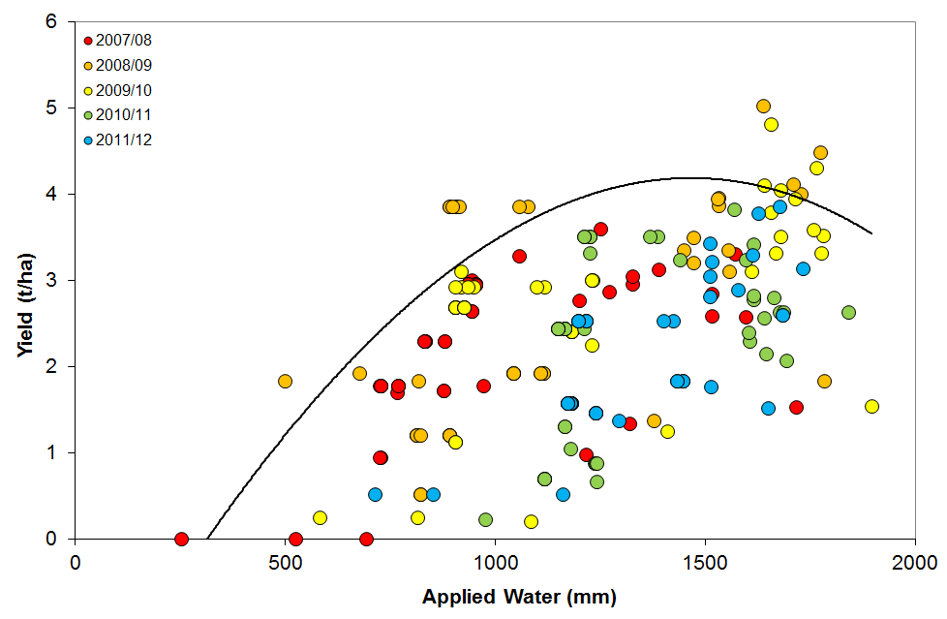
Figure 1. Almond yield response to water — Riverland and Sunraysia

Growth stages and water requirements
The period from budburst onwards is a time of rapid vegetative growth that is necessary to establish buds and carbohydrate reserves for future crops.
Almond kernel development follows a three-stage process. During stage one, rapid growth of the hull, shell and integuments occurs. This stage ends once hull, shell and kernel have reached their maximum size, about two months after flowering. Water stress during this period results in increased nut drop and smaller kernels.
Stage two is a period of rapid kernel expansion. Maximum size is reached followed by shell hardening and kernel expansion. Almonds are very sensitive to water deficits during this period, and water demand is high.
The final period of fruit growth is the pre-harvest period of stage three. Hull, shell and kernel differentiation is complete. The kernel begins to accumulate solids. Maturity is signaled by the onset of hull split and the formation of an abscission layer. Both are impacted by irrigation. Too much water can increase the duration of the hull split period and delay harvest, and too little can increase hull tights.
Standard crop coefficients are available in order to determine local irrigation requirements

regulated deficit irrigation (RDI)
Restricting water on almonds is complicated because non-fruiting spurs formed in one year may produce fruit in subsequent seasons. The carryover effects of water stress on yield will depend on the severity of stress and time of year in which it is applied. A lack of water late in the season up until harvest leads to a reduction in fruiting spurs and future yield potential. This occurring over one season may not lead to a dramatic decrease in the following season’s yield, but the effect can be cumulative if consecutive years of deficit occur, and the number of fruiting spurs decreases. If spur numbers are already reduced due to a year of deficit irrigation, future production will decline more if low water is extended due to low water supply. This phenomenon was observed in trials where production was unaffected by stress in the first two years of a four-year trial but were reduced in the final two years.
Regulated deficit irrigation is the practice of withholding some water at the least sensitive crop growth stage and regulating the level of crop stress imposed (mild or moderate), aiming to minimise the impact of reduced irrigation on productivity.
It is generally recognised that for almonds the hull split period is the most suitable, and that water savings of 10–15 per cent can be achieved. Moderate stress at the onset of hull split helps to reduce hull rot and synchronise hull split.
Pre- and post-harvest stress have the most severe carryover impact as it affects fruit set and kernel yield in subsequent seasons and should be avoided.

sustained deficit irrigation (SDI)
Sustained Deficit Irrigation (SDI) differs significantly to RDI. With SDI the water deficit is not created by withholding water at a particular growth stage, but by applying a lesser volume of water at each irrigation event for the entire season.
Sommer (2012) found that reducing irrigation application by 15 per cent below normal plant requirement using either an RDI or an SDI approach had no negative effect on kernel size or yield over a three-season investigation. Deficits of greater than 15 per cent are likely to reduce both kernel size and yield. Interestingly, trees appeared to adapt better to SDI rather than RDI where deficits are imposed before harvest. Other studies have also confirmed this.

irrigation strategy
During the most recent period of low water allocation in the Mallee (2007–09), two methods of applying reduced water application were employed by growers: (1) frequent shallow irrigations, or (2) less frequent deeper irrigations (typical application depths). The deeper irrigations (well monitored without creating deep drainage) have generally proven to be more efficient. Actual water use by trees is greater in this situation as less water is lost to evaporation and a greater percentage of the rootzone has access to water. If applications are too shallow, water will not infiltrate deeply into the soil, eventually leading to a higher percentage of water lost to evaporation. This is most applicable to orchards with low level sprinklers.
If daily drip irrigations are normal practice it is generally considered that in a low water scenario, attempts should be made to continue daily irrigation, at a likely reduced depth, leading to SDI.

Water saving practices

Immediate strategies

Water budgeting
Estimating the monthly water requirements for each patch using average water use figures and historical irrigation records can be used to develop a drought management plan and prioritise allocation of water to patches. See Water Budget Planning for more information on developing a water budget.
Budgeting can be conducted in conjunction with accessing ET_{o} figures to determine cumulative water use, as well as seven-day forecasts in order to prioritise patches. An example is available at the Australian Almonds web site.

Install irrigation scheduling devices
It is crucial to use soil moisture monitoring devices to accurately check soil water levels and allow irrigations to be scheduled more precisely. Monitoring allows the effectiveness of water saving practices to be readily determined. Tensiometers have often been a recommended tool as they are relatively cheap, easy to install and use.
Tensiometers, however, are not particularly useful for intensively drip irrigated orchards where daily irrigations take place. More sophisticated (and expensive) scheduling tools are recommended in this situation. Devices that are continuously logged will provide far greater information, accuracy and effectiveness in monitoring irrigation applications. They are particularly useful in being able to immediately determine appropriate irrigation depth and encourage confident, informed decisions regarding this.
Determining irrigation application depth, and making appropriate adjustments, is something that can generally be adopted quickly with more sophisticated devices, even though it generally takes longer to learn how to use and fully understand the information generated from these tools. If multiple sensor depths are installed, the active rootzone is quickly determined. The long-term benefit from adopting continuously logged soil moisture monitoring and the production benefits that are possible should also be considered.

Check, manage and maintain the irrigation system
Irrigation systems should be checked for any leaks or blockages. The accuracy of water meters should be checked by cross-referencing readouts with application rates and system specifications. If irrigation uniformity is poor an irrigation consultant may be needed to advise on improvements. Correcting these issues may only result in modest water savings, but during a period of low water availability those savings may be significant. The effect an inefficient system has on an orchard will be exacerbated during times of drought (as will soil variation). More information can be found on Almond drip irrigation performance audit.
Good system hygiene practices should still be maintained. If flushing the system, consider directing flush water towards the orchard rather than running to waste down headlands.

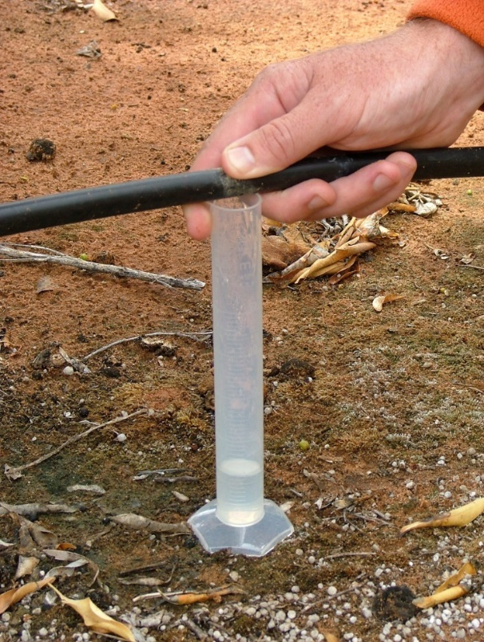
Figure 2. Monitoring dripper discharge (Photo: Jeremy Giddings)

Avoid leaching losses
Ensure water is not applied and lost below the root zone by carefully monitoring soil moisture levels and irrigation depth. Sampling for soil salinity is recommended to determine if a strategic leaching program is needed. Water during a period of low availability may have elevated salinity levels.

Mulch the wetted strip
Applying mulch helps reduce soil evaporation and is often a general recommendation to save water. Mulch left on the surface, however, is not compatible with almond production.
Some managers have successfully incorporated mulch near dripper lines to overcome this issue. Incorporation helps avoid the loss of mulch as well as kernel contamination at harvest. Mulch certification is important for use in almond orchards, particularly if sourced from animal or green waste. Unwanted material such as glass can be an issue in green waste. Many in the industry would like to begin incorporating mulch into almond orchards, however, much work is still to be done to overcome contamination issues. The application of mulch should be carefully considered.

Reduce the wetted area
This is most applicable to young plantings. If irrigating with low level sprinklers, changing over to a sprinkler head, adaptor, or installing a sleeve over the head of the sprinkler creates a narrower throw, eliminating water application onto the inter-row area where roots have not yet significantly colonised. Run times can be significantly shortened while still ensuring the majority of an underdeveloped rootzone is watered. This may require moving sprinkler heads closer to the butt of the tree.
For drip irrigated orchards plugs can be installed on emitters between trees, leaving only the emitters near the tree functioning.

Irrigate at night
Low-level sprinkler irrigation at night can provide water savings of 20–30 per cent compared with daytime irrigation by reducing evaporation losses. However, the water savings with drip irrigation systems are variable depending on the amount of mulch, leaf litter and shade over the wetted soil surface.

Eliminate water runoff
Irrigation water should be kept in the orchard. If water runoff from the soil surface is occurring, break up soil crusts to improve water penetration and soil aeration. The traditional methods of improving water penetration are applying gypsum and/or ripping. Ripping in a low water supply scenario is not recommended due to the additional stress created through root damage, and the reduced ability of the tree to take advantage of any rainfall.
Pulsing can help to improve water penetration and soil aeration.

Reduce or cease windbreak irrigation
This can save water but consider the long-term importance of windbreaks. Also, be aware that unirrigated windbreaks can scavenge water from the adjacent crop, so deep ripping or trenching to trim windbreak roots might be required.

Re-use back-flush water
Contact an irrigation designer to ensure excessive back-flush volumes are not being generated to begin with. Some minor savings may be possible. The back-flush water that is created from drip irrigation filters can be reused if run to a settling tank. Discuss this option with an irrigation designer. Media filters generally use 4.0–5.0 per cent of the water pumped to backflush, disc and screen filters 1.5–2.0 per cent.

Reduce transpiration
Kaolin-clay-based foliar spray products are claimed to reduce water losses through leaves. In farm trials there was no significant effect on tree stress measurements. No water savings or reduction in plant stress with their application has been documented.
New products frequently enter the industry, and there is always the possibility that some may prove to be of benefit in the future. If using these products, consider leaving untreated areas in order to determine the effectiveness of whatever was applied.

Buy/trade water
Buying or leasing-in water, if available, can be a viable option. Consider the long-term value of the trees and crops compared with the cost of water. If the cost of water is less than the value of produce lost by withholding that volume of water (including any ongoing recovery to production), then buying permanent or temporary water should be seriously considered. Although developed for winegrapes, spreadsheets such as that produced by CCW (Consolidated Co-operative Wineries – membership required) are available to quickly determine if buying water is a viable option.
Rural Financial Counsellors may be able to help you use these tools (Ph. 1300 735 578).
The almond industry has also developed a sensitivity analysis which takes into account kernel returns and the cost of water (assuming an average yield of 4.5 t/ha).

Full cover weed control
Removing weeds and eliminating sods will reduce competition for water. Sods are best sprayed with herbicide at recommended rates.

Keep informed about water allocations
Maintain contact with the water supply authority for the latest information on water allocations, water flows and water levels in storage. Obtain information on current and next season’s likely water allocation scenarios to enable better long-term decision making. This information can be sourced from state (eg http://waterregister.vic.gov.au/), and local water authority web sites, and Apps such as Water Market Watch and Waterflow. Look at long-term weather forecast information to help schedule irrigations.

Canopy reduction
Although little work has been done for almonds on the effectiveness of canopy reduction as a water saving strategy, some producers have significantly pruned their trees on either side in alternate years in an effort to reinvigorate their trees. After a couple of seasons, the trees are thought to return to full production, based on grower experience. If this is less than the time period taken for recovery after low water supply, this option may be worth considering.
Severe pruning also increases new growth, potentially leading to high water requirements which may negate any water savings benefit. Removing pruning’s and mulch from the orchard may be an issue, especially on long rows.

Longer-term strategies

Install valves for each patch
Water use differs with variety, and significantly with tree age. Installing valves to separate patches that have different water requirements will allow more accurately matching crop water needs with irrigation applications. Variable speed drives become a more beneficial option in these situations.

Install more sophisticated scheduling equipment
More sophisticated scheduling equipment (e.g., capacitance probes) will enable far more accurate irrigation applications and assessment of additional rainfall effectiveness. Leaching losses can be completely avoided while still ensuring that irrigations are fully effective.

Convert to more efficient irrigation systems
Drip irrigation is potentially the most efficient irrigation system currently available and has been widely adopted by the almond industry. Conversion to drip is often a standard horticultural recommendation when water allocations are low, or predicted to be low, however, there are varying opinions regarding the relative merits of drip and low-level sprinkler across the almond industry, based on individual experience.
An almond irrigation benchmarking study (Schache and Pollock 2013) found the average irrigation application over 10 years was 11.4 ML/ha for drip, and 12.7 ML/ha for low-level sprinklers. Industry experience and opinion suggests that there is a 1–2 ML/ha difference in water requirements between drip and low-level sprinkler, under the same agronomic conditions.
For most crop types the general consensus is that under a low water scenario, irrigating with drip is the preferred method (see Neale Bennett case study).
If looking to convert to drip remember a new permanent drip system requires substantial investment and should be professionally designed. Consider the long-term financial viability of taking this step. If there is a high probability that low water availability will continue in the future, serious consideration should be given to installing drip irrigation.
It is important to be aware that converting to drip from a full cover irrigation system changes the distribution of water in the root zone. Roots take time to respond to this change in water pattern, and trees will experience stress until the root system has adjusted. In a normal season, generous drip irrigation applications are recommended in the first year following conversion. Inadvertently superimposing water deficit on top of the conversion, is likely to lead to significant stress.
Sub surface drip irrigation (SSDI) systems can be problematic in a low water scenario because almond roots search for soil moisture and are known to readily block emitters regardless of chemical injection or emitter impregnation. Driplines installed immediately below the surface may need to be brought to the surface during water stress to avoid this. For driplines installed deeper (typically 20–30cm) avoiding root intrusion may be more difficult. There is a general trend away from SSDI in the almond industry.
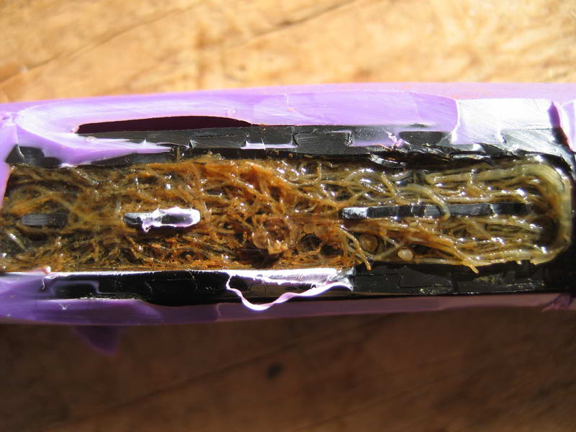
Figure 3. Root penetration into emitters can be an issue for almond producers, particularly in a low water supply situation (Photo: Peter Henry)

System uniformity
In situations when every drop counts, system uniformity is a must. Maintaining system uniformity involves adopting standard recommendations regarding system design and maintenance, but for many almond growers this may also involve addressing drip system drainage. On undulating ground, the water remaining in submains and laterals when irrigation is turned off usually drains to the lowest point in the valve, with emitters in this area continuing to emit water after the valve is turned off. This is not a big issue for conventionally managed drip irrigation systems. When daily drip irrigation events (especially pulsing) occur over the majority of the season this drainage (often termed water drain-back) becomes more critical. Many in the almond industry are looking at adopting technology, such as non-drain dripline and non-return valves on laterals or submains (slave valves) in order to address drainage and waterlogging issues. For more information see Drip Drainage factsheet.

Normalised Difference Vegetation Index (NDVI)
NDVI as well as other measures, is a tool which is becoming readily adopted by the almond industry to assess tree canopy condition from aerial or satellite imagery. Their use in assessing canopy health uniformity is seen as very useful by managers. As mentioned earlier poor irrigation uniformity becomes exacerbated under low water scenarios and these tools provide a great method to assess this. Using retrospective NDVI readings can also allow an understanding of previous canopy health under ample water conditions to be compared to current conditions, at the same growth stage, etc. This allows the manager to have a greater understanding of trending crop health under low water conditions.

Stem water potential
The use of stem water potential can complement other monitoring tools such as using ET_{o} and soil moisture monitoring. Midday stem water potential is an integrated measure of soil moisture and weather conditions and reflects the current level of water management. Stem water potential enables the detection of stress before it becomes too severe in particular patches, as well as provide data to maintain a sustained deficit on the tree. It is often used to maintain a 15–20 per cent deficit at hull split and may be an option to monitor a sustained deficit over the season if necessary.

water budget planning
Table 1 is a sample water budget for a 20 ha drip irrigated almond orchard. The property has an entitlement of 250 ML. The table considers a scenario where the orchard’s allocation has reached only 50 per cent, leaving 125 ML available.
Discussions with processors should take place when prioritising patches. Typical annual water use for each block needs to be estimated from previous records and experience. The proposed allocation for each patch can then be determined, and the management strategy implemented.
Patch | Tree age (yrs) | Area (ha) | Typical annual water use (ML) | Proposed water application (ML) | Management strategy
1 | 2 | 4 | 24 | 10 | Clips to mid-tree drippers
2 | 10 | 4 | 48 | 48 | Full production
3 | 20 | 4 | 48 | 26 | Early harvest then abandon
4 | 20 | 4 | 48 | 41 | SDI of 15%
5 | 25 | 4 | 48 | 0 | Off-year anticipated and older trees. Re-develop immediately
 | TOTAL | 20 | 216 | 125
Table 1. Sample of a water budget for almond orchard with a 50 per cent allocation (This is an example and should be used as a guide only).

case studY

Neale Bennett Merbein VIC
In 2007/08 the market price of temporary water reached more than $1,000/ML in the first half of the season, as irrigators responded to a seasonal outlook of very low allocation being made to entitlements. While some held carryover from the previous season, it was seen as insufficient to maintain crops.
The market price of water reduced significantly later in the season as other states increased allocation, and demand eased as large horticultural operators had purchased sufficient water to preserve their crops and buying pressure dropped away from the market.
The initial allocation at the start of the 2007/08 season was 0 per cent, and 23 per cent by November 15, increases through the season resulted in a final allocation of 43 per cent by season’s end. In the following season, a total allocation of 35 per cent was eventually received, with 100 per cent allocations returning from 2009/10 onwards.
Neale and Debbie Bennett grow 16 ha of almonds at Merbein, supplied with water by Lower Murray Water in Victoria, 15 km from Mildura.

Two approaches
- “Purchased high security entitlement with allocation, as the bank was prepared to lend against this asset. Had this asset at the end, and it is a great asset now, especially as we are located in the High Impact Zone (HIZ)”.
- “Changes to irrigation management, particularly the conversion from low level sprinkler to drip irrigation. Water savings were marginal at the time (was applying 12 ML/ha with low levels) but we had greater confidence that a larger volume of this water was going to the tree, and not evaporation. Typically use 12–13 ML/ha now. Other things we did were:
  - Installed plugs on the emitters between young trees, leaving only 6–8 emitters per tree
  - Adopt strong weed control
  - Collect filter backflush water into a tank and with some pre-filtering, injected back into the suction line.”

Next time
“Back in 2007 managing low water availability was unchartered. Given more mature plantings exist now, I’d look at bringing forward any re-development plans for certain patches and attempt to apply full water requirements to the remainder. Cutting back on water can effect over three years of production with smaller nuts produced as a result.”

further information
Irrigation Services, Agriculture Victoria. irrigation@agriculture.vic.gov.au
Sommer, KJ. (2012). Optimising water use of Australian Almond production through deficit irrigation strategies. Department of Primary Industries, Victoria.
Almond Board of Australia (2011a). Final Report. HAL Project 07005 — Sustainable Optimisation of Australian Almond Production. Technical Report, Almond Board of Australia
Skewes, M.A., 2013. Tree Crop Drought Information Package, Factsheet. PIRSA, Adelaide, p. 6.
Schache, M and Pollock, L. (2013) Almond Irrigation Benchmarking Report: 2002–2012. Department of Primary Industries, Victoria.
Profile Establishment Fact Sheet. Almond Board of Australia.
UC Drought Management. http://ucmanagedrought.ucdavis.edu/

acknowledgments
Neale Bennett — Almond producer, Merbein VIC, Almond Board of Australia Chairman
Josh Fielke — Industry Development Officer, Almond Board of Australia
Ben Brown and Michael Ward — Select Harvests
Brett Rosenzweig — Former Industry Development Officer, Almond Board of Australia
Brendan Sidhu and Scott McKenzie — Century Orchards, Loxton SA
Mark Skewes — Research Scientist, SARDI
Trevor Sluggett — Agronomy Manager, Total Eden, Renmark SA
Michael Treeby — Group Leader, Agriculture Victoria Research

Accessibility
If you would like to receive this publication in an accessible format, please telephone Agriculture Victoria, Irrigation Services on 136 186.
This document is also available in (Word) format at www.agriculture.vic.gov.au

