BestWool/BestLamb – To wean or not to wean prime lambs
St Arnaud Group - May 2021

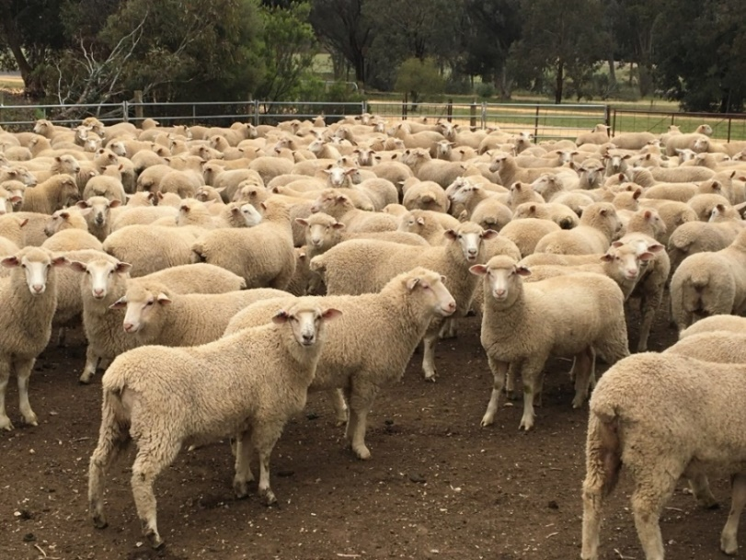
Group – St Arnaud BWBL
Coordinator – Dr Steve Cotton
AgVic Demonstration Coordinator – Rachel Coombes
- 19 businesses, St Arnaud district
Enterprise mix
- Mixed grazing – sheep, beef, and cropping

Over the last two years, farmers in the St Arnaud BestWool/BestLamb (BWBL) group have been managing trial mobs and collecting data for a weaning demonstration. The aim is to see if there are production benefits from weaning at 12 weeks from the start of lambing as opposed to not weaning the lambs and leaving them on the ewes until they are at a marketable weight.
The two years of data collected so far, showed that in most cases there was little difference between the weights of weaned or unweaned lambs. In fact, the weaned lambs from two farms were heavier than the unweaned lambs by the time they were sold at around 22 weeks of age. At no point have lambs incurred a significant setback after weaning, which was an early concern amongst the group.
Adding to the story, one of the 2020 demonstration farmers sold the trial lambs direct to the abattoir and there were no significant differences between the carcass weights or the lean meat yield of the weaned and unweaned lambs. This is contradictory to what the producers were expecting to find given published data that suggested weaned lambs will dress one to two per cent lower than unweaned lambs.
Management ease key driver to change
Despite the results showing little difference between the performance of the weaned and unweaned lambs, there were other factors that convinced the group to change. The group have found management of weaned ewes and lambs to be simpler and beneficial to their farming systems. The fact that the weaned ewes have lower nutritional requirements means they can be moved onto lesser value pastures, leaving more of the high-quality feed available for lambs. This has led to one producer increasing his stocking rate. Another producer just enjoys the fact that he and his son don’t need to draft the ewes off before they can weigh the lambs, which makes the job much shorter.
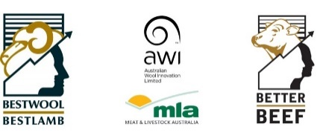
BestWool/BestLamb – To wean or not to wean prime lambs
St Arnaud Group - May 2021
After two years of the demonstration, the producers have seen the benefits of weaning their prime lambs at 12 weeks of age. The producers have found the results of the trial to be promising but they will be weaning this year because of the easier management within their production systems. “The data is giving us confidence that lambs won’t be compromised by weaning, however, it’s the ease of management that is making us change our practices”, one group member explained.
A webinar about the demonstration will be presented on Tuesday, June 8 at 7pm. To register, go to Eventbrite. For more information, please contact Rachel Coombes, Agriculture Victoria on 0436 001 258 or email, or Steve Cotton on 0447 352 321 or email.
This Producer Demonstration Site is funded by Meat & Livestock Australia and Agriculture Victoria. For more information, please contact Rachel Coombes, Agriculture Victoria on 0436 001 258 or email, or Steve Cotton on 0447 352 321 or email. Refer to the Agriculture Victoria website for more information about our network of On-Farm Demonstrations.

Accessibility
If you would like to receive this publication in an accessible format, contact Agriculture Victoria on beef.sheepnetworks@agriculture.vic.gov.au
This document is also available in PDF and Word format at http://agriculture.vic.gov.au/on-farm-demos

Disclaimer
This publication may be of assistance to you but the State of Victoria and its employees do not guarantee that the publication is without flaw of any kind or is wholly appropriate for your particular purposes and therefore disclaims all liability for any error, loss or other consequence which may arise from you relying on any information in this publication.
Issued May 2021

