BestWool/BestLamb – Prime Lamb Production Systems
Boohramon Group - June 2021

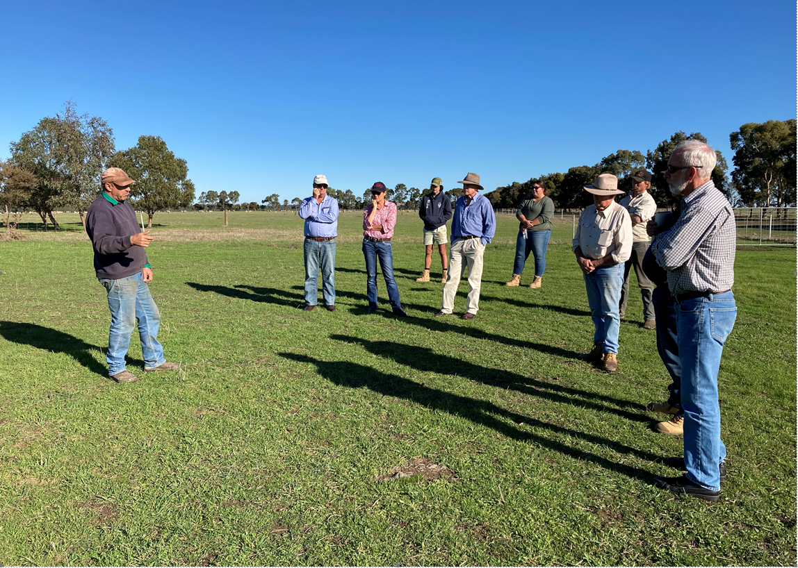

Coordinator – Chris Mirams
Group – Boohramon BestWool/BestLamb
Enterprise mix - Prime lamb
Exploring different production systems is the focus of the Boorhaman BestWool/BestLamb (BWBL) group in northern Victoria, which inspired a three-day tour of properties in south western Victoria in April. The group were keen to see how the prime lamb production systems differed from their own, what they could learn and apply to their own businesses.
Like all BWBL groups, the Boorhaman group has been unable to meet face to face since April 2020. Online Zoom meetings became the order of the day which successfully kept the group connected. However, between restrictions and lockdowns the group undertook a road trip, described by coordinator Chris Mirams as a chance to “get out of their patch and be challenged”. A three-day bus tour is an activity the group keenly value and plan for each year in their calendar.
The key motivator for the trip down south was to visit sheep producers to see how they measure success, what their key performance indicators are and the profit drivers in their businesses. Members were especially interested in looking at a range of lamb finishing systems.
The group visited four businesses consisting of Charlie de Fagely’s property at Dobie, south of Ararat, Darren Schurmann’s Kingaroy Partnership near Hamilton, Andrew Edgar’s farm at Nareen and Johnny Gardner’s South Mokanger property near Hamilton.
With the focus on lamb finishing systems, group members looked at pasture and grazing management, including stocking rates, lamb growth rates, pasture improvement and composition, and the flexibility around grazing management including the use of stock containment areas and sacrifice paddocks. Some systems sold lambs as stores while others finished lambs in containment for direct consignment.
Following each property visit the group discussed and reflected on the highlights, what they had learnt and what they could incorporate into their own systems. The group were impressed by the fact that each business had a dedicated strategy with a clearly executed plan.
Pasture performance was a recurring theme, as was good sheep handling facilities which were recognised as an important investment resulting in efficient systems and happy and safe employees.
Deferred grazing using stock containment areas and sacrifice paddocks was a feature of all management regimes they visited. There was a range of lamb finishing systems, influenced by factors including time of lambing, target lamb weights and feed rations. Some businesses lambed earlier, taking advantage of extra time to finish lambs, while others ran a higher stocking rate, lambed later, and sold lambs as stores.
The Boorhaman group wanted to compare the profitability of lambing time and the tour opened their eyes to a variety of systems. As a producer of prime lambs finishing lambs doesn’t have to be the main focus, and that selling store lambs doesn’t always have to be your Plan B but can in fact be Plan A. Selling lambs as stores may be more suited to north east producers given their annual rainfall range of 400 - 800 ml and a shorter growing season.
The group was challenged by the resilient and sustainable systems they saw and by the innovative and sometimes left field thinking of their peers in southern Victoria. “Boorhaman group members know each other well,” Chris Mirams said. “They are happy to share and challenge each other about the setups they saw which provoked their thinking.”
These systems will be further questioned and explored at their next BWBL meeting to see what could be profitably adapted by members of the Boorhaman group.
For more information contact group coordinator Chris Mirams by email.

Accessibility
If you would like to receive this publication in an accessible format, contact Agriculture Victoria on beef.sheepnetworks@agriculture.vic.gov.au
This document is also available in PDF and Word format at http://agriculture.vic.gov.au/on-farm-demos

Disclaimer
This publication may be of assistance to you but the State of Victoria and its employees do not guarantee that the publication is without flaw of any kind or is wholly appropriate for your particular purposes and therefore disclaims all liability for any error, loss or other consequence which may arise from you relying on any information in this publication.
Issued July 2021

