Validation of anthrax ICT kit for sheep
General information for private veterinarians
If you identify any sheep that has died suddenly or is found dead including at lairage, please test for anthrax using an ICT.
The Victorian sheep and goat industries have provided funding to Agriculture Victoria to undertake a project to determine the sensitivity and specificity of the immunochromatographic test (ICT) for anthrax when used in sheep.

Background:
Anthrax exclusion testing should be carried out on all sudden, unexplained deaths of susceptible species. In cattle and sheep, field testing is carried out using an ICT kit. The ICT kit has proved to be a reliable method for the rapid determination of the anthrax status of cattle and sheep that have died suddenly. The test kit has been validated for use in cattle, however similar work is required in sheep.

Sampling requirements and payments
Within the ICT project, the payment for anthrax exclusion testing in sheep with unexplained sudden death will be $300 (+GST) per property. Please note: This is higher than, and is instead of, the general payment of $200.
Up to 10 sheep that have experienced sudden death can be sampled from the same property. Only carcasses that are less than 48 hours old can be sampled. Sampling of multiple carcasses per investigation is strongly encouraged.
To be eligible for the $300 payment, in addition to the general requirements (notification to the department, performing an ICT and completion of the ICT project specific Record of Disease Event (RODE)/ laboratory submission form), private veterinarians are also required to submit an EDTA blood sample and the used ICT kit to the Veterinary Services Laboratory AgriBio Bundoora for confirmatory testing. These samples are to be forwarded to the laboratory regardless of the test result (i.e. all ICT tests, including those that are negative, must have blood samples submitted to the laboratory). Samples should be collected as aseptically as possible and forwarded ASAP. Please see the flow diagram on the next page for the steps that are to be followed. Where anthrax is not suspected following a negative ICT result and a further investigation of the cause of death is undertaken by the practitioner (including necropsy), the investigation may be eligible for other subsidies following approval by your District Veterinary Officer.
Private veterinarians must have been trained in the use of the ICT by Agriculture Victoria Animal Health & Welfare (AH&W) staff. Training users in the use of the ICT is a requirement of the Australian and New Zealand standard diagnostic procedure for anthrax. ICT kits will only be provided to accredited veterinarians so if you have not undertaken training or would like refresher training please contact your local Agriculture Victoria AH&W staff member to organise it.
The instructions as set out in the Standard Operating Procedure for anthrax investigations (provided at the training session) must be followed. Veterinarians must inform their District Veterinary Officer (DVO), Veterinary Officer (VO) or Senior Veterinary Officer (SVO) prior to collecting samples for the anthrax investigation. If the SVO, DVO, VO or other AH&W staff member is not contactable do not leave a message. Instead, immediately ring the all-hours Emergency Animal Disease Hotline on 1800 675 888.
The project will run from 1 January 2018 until 31 March 2023.
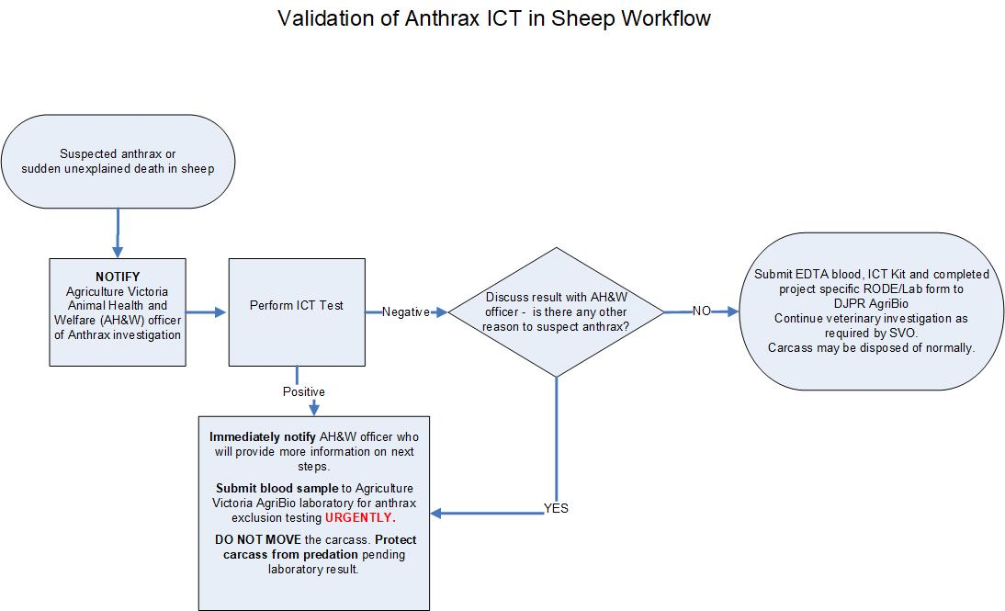Figure 1 Anthrax investigation flow chart.
Follow the steps below if you suspect anthrax or have a sudden unexplained death in a sheep
- Notify an Agriculture Victoria Animal Health and Welfare officer of an Anthrax investigation
- Perform the ICT test
  - If Negative discuss result with the Animal Health and Welfare officer- is there any other reason to suspect anthrax?
    - If NO submit EDTA blood, the used ICT kit and completed ICT project specific RODE/LAB form to Veterinary Diagnostic Services Laboratory AgriBio. Continue the veterinary investigations as required by the AgVic veterinary officer. Carcass may disposed of normally.
  - If the ICT is POSITIVE or if the ICT kit is negative but there is still reason to suspect anthrax, immediately notify the AgVic Animal Health and Welfare officer who will provide more information on next steps.
  - SUBMIT blood samples to Veterinary Diagnostic Services Laboratory AgriBio for anthrax exclusion testing URGENTLY
  - DO NOT MOVE the carcass. PROTECT the carcass from predation pending the laboratory result.
Please send submission forms, results and invoices to the Agriculture Victoria SVO in your region:
Northern- fax 5762 1685 or email northern.ag@agriculture.vic.gov.au
South West – fax 8660 2954 or email sw.ag@agriculture.vic.gov.au
South East – fax 5152 6865 or email se.ag@agriculture.vic.gov.au

Authorised and published by Department of Jobs, Precincts and Regions, 1 Spring Street, Melbourne, Victoria 3000  ISBN 978-1925733-48-8 (pdf/online)  Accessibility  If you would like to receive this publication in an accessible format, such as large print, audio or in another language, please call the Department of Jobs, Precincts and Regions on 1300 502 656, email info@agriculture.vic.gov.au or go to www.agriculture.vic.gov.au | Disclaimer  This publication may be of assistance to you but the State of Victoria and its employees do not guarantee that the publication is without flaw of any kind or is wholly appropriate for your particular purposes and therefore disclaims all liability for any error, loss or other consequence which may arise from you relying on any information in this publication.  For more information about Agriculture Victoria go to www.agriculture.vic.gov.au or call the Customer Service Centre on 1300 502 656.

