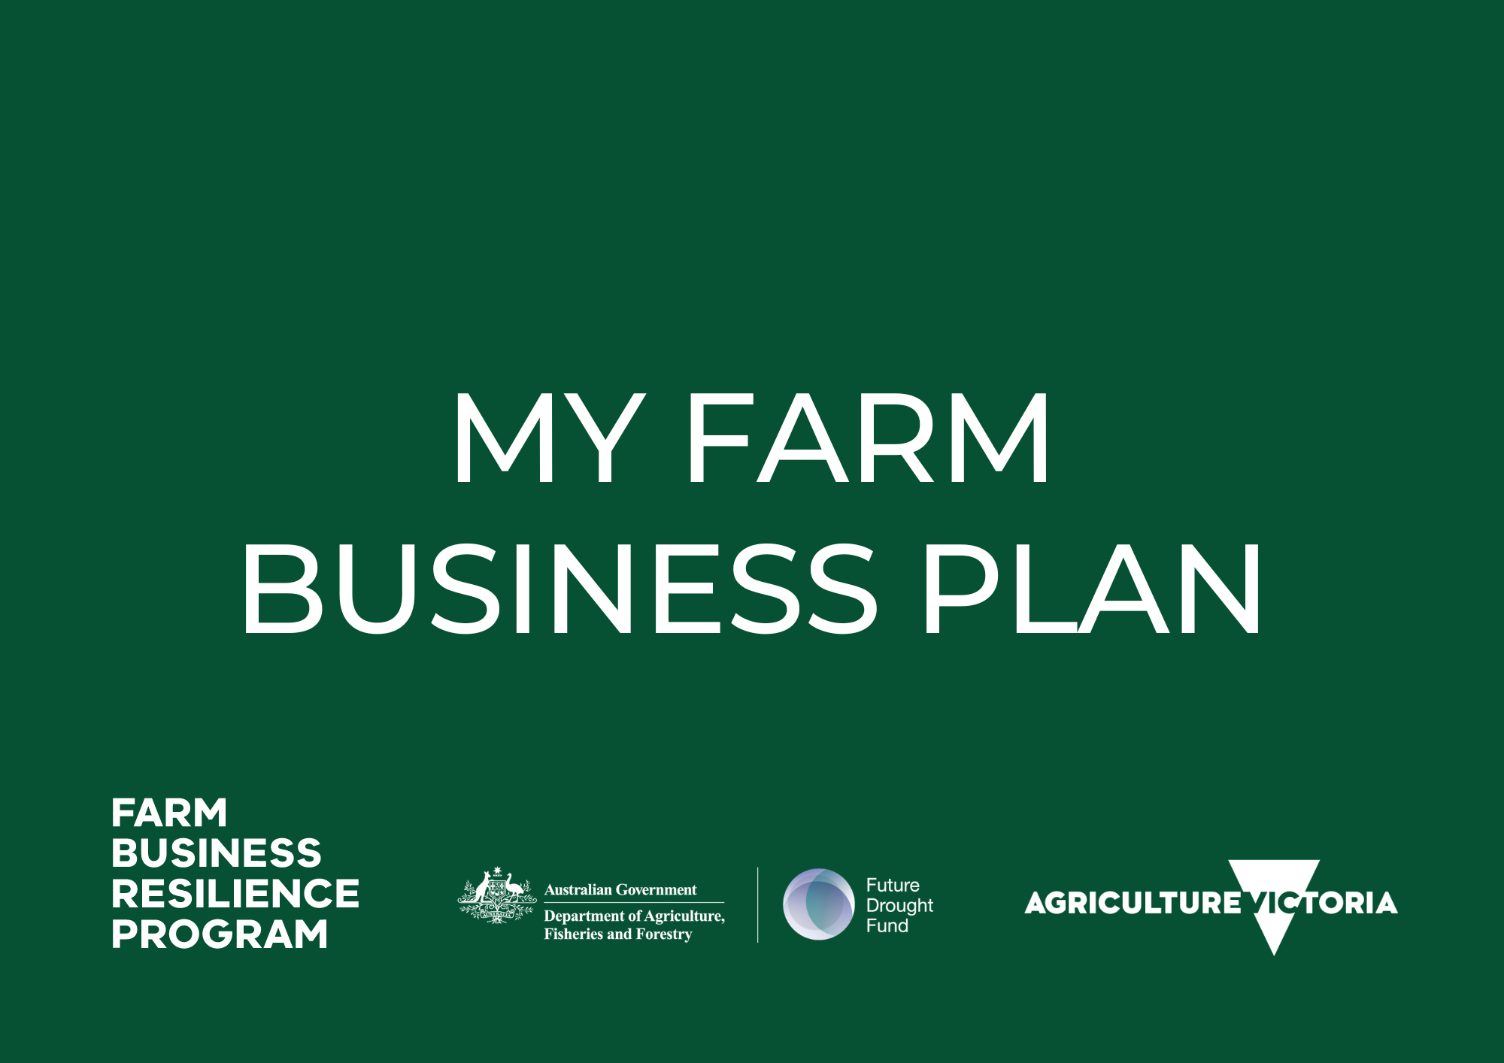

Author
Producer Name: ___________________________

Producer Signature: ________________________

Date: _____________

Farm Business Details
Business / Property Name: _________________________

Farm Address: ___________________________________

Town: _________________________________________
Enterprise(s):
☐ Sheep  ☐ Beef  ☐ Dairy | ☐ Grains  ☐ Horticulture  ☐ Mixed
☐ Other: ____________________________________
Farm Size (Ha): __________________________________
What is your business model (family farm, corporate structure etc.):
______________________________________________

Farm Business Vision Statement
Where do you want your farm business to be?

__________________________________________________________________________________________________________________________________________________________________________________________________________________________________________________________________________________________________________________________________________________________________________________________________________________________________________________________________________________________________________________________________________________________________________________________________________________________________________________________________________________________________________________________________________________________________________________________________

SWOT Analysis of: my business finances or drought preparedness for example or: ___________________
An analysis of your current enterprise(s) in comparison with other enterprise possibilities. The analysis of your Strengths, Weaknesses, Opportunities and Threats (SWOT) can be a useful decision making tool for both small and large scale decision making.
STRENGTHS | WEAKNESSES
OPPORTUNITIES | THREATS

STRATEGIES TO BUILD ON
Ways to build strengths

Ways to take advantage of opportunities

Ways to reduce the effects of weaknesses

Ways to reduce the effects of threats

SET S.M.A.R.T. GOALS for: my business finances or drought preparedness for example or: ___________________
Specific, measurable, achievable, relevant, time bound
Goal title / topic | 1 Year | 5 years | 10 years

SWOT Analysis of: _________________________________________________________________
An analysis of your current enterprise(s) in comparison with other enterprise possibilities. The analysis of your Strengths, Weaknesses, Opportunities and Threats (SWOT) can be a useful decision making tool for both small and large scale decision making.
STRENGTHS | WEAKNESSES
OPPORTUNITIES | THREATS

STRATEGIES TO BUILD ON
Ways to build strengths

Ways to take advantage of opportunities

Ways to reduce the effects of weaknesses

Ways to reduce the effects of threats

SET S.M.A.R.T. GOALS for: ____________________________________________________________
Specific, measurable, achievable, relevant, time bound
Goal title / topic | 1 Year | 5 years | 10 years

SWOT Analysis of: _________________________________________________________________
An analysis of your current enterprise(s) in comparison with other enterprise possibilities. The analysis of your Strengths, Weaknesses, Opportunities and Threats (SWOT) can be a useful decision making tool for both small and large scale decision making.
STRENGTHS | WEAKNESSES
OPPORTUNITIES | THREATS

STRATEGIES TO BUILD ON
Ways to build strengths

Ways to take advantage of opportunities

Ways to reduce the effects of weaknesses

Ways to reduce the effects of threats

SET S.M.A.R.T. GOALS for: ____________________________________________________________
Specific, measurable, achievable, relevant, time bound
Goal title / topic | 1 Year | 5 years | 10 years

SWOT Analysis of: _________________________________________________________________
An analysis of your current enterprise(s) in comparison with other enterprise possibilities. The analysis of your Strengths, Weaknesses, Opportunities and Threats (SWOT) can be a useful decision making tool for both small and large scale decision making.
STRENGTHS | WEAKNESSES
OPPORTUNITIES | THREATS

STRATEGIES TO BUILD ON
Ways to build strengths

Ways to take advantage of opportunities

Ways to reduce the effects of weaknesses

Ways to reduce the effects of threats

SET S.M.A.R.T. GOALS for: ____________________________________________________________
Specific, measurable, achievable, relevant, time bound
Goal title / topic | 1 Year | 5 years | 10 years

Action Plan
This A3 page is designed to prioritise the actions, opportunities and goals from each of the SWOT analyses.
Issue or opportunity identified | Priority  (1-5) | Farm management action proposed | Time frame | Information or support required | Outcome | Review date

