Dairy Farm Monitor Project

2022-23 Victorian overview

In 2022-23, average profits across Victorian participants rose by 67% to $2.87 per kilogram of milk solids (kg MS). Prices offered for milk supply increased on average by 33% and was the highest on record (accounting for inflation). Livestock trading profits reflected the type of livestock sold and the timing of sales as market prices declined sharply in the second half of the financial year.
Climatic conditions varied across the state – to include significant flooding (in Northern Victoria), storms, hail damage and very wet conditions throughout the year.
Increased costs, most notably for purchased feed, were accompanied by general increases in costs across all categories. The widespread October flood event with subsequent storms in Northern Victoria put greater pressure on sourcing quality feeds at higher prices. South West Victoria and Gippsland managed wetter and drier (than typical) conditions for other portions of the year. Statewide, homegrown feed quality and quantity produced was reduced in 2022-23 compared to 2021-22.

Dairying in Victoria
There were approximately 2,773 dairy farm businesses in Victoria that produced 5.14 billion litres or 63% of Australia’s national milk production in 2022-23.

Dairy Farm Monitor Project farm locations and rainfall in 2022-23
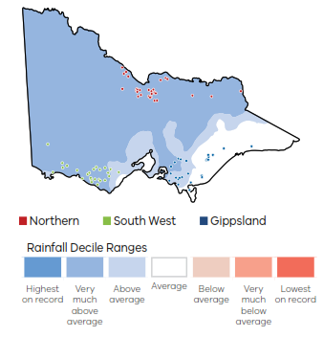

In 2022-23 farm profitability for the state has been influenced by:
33% increase in average milk price to $9.77/kg MS
9% in herd and shed costs to $0.69/kg MS
25% in total feed costs to $4.35/kg MS
10% in overhead costs to $2.94/kg MS.

Profitability
Despite elevated costs across most areas of the business, the statewide average profit (earnings before interest and tax, EBIT per farm) was the second highest on record, accounting for inflation. This outcome reflects participants receiving the highest milk price recorded in 17 years.

In 2022-23, 96% of all Victorian participants had a positive profit (77 out of 80)
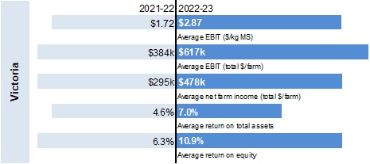

Future Expectations 2023-24
Of the farmers who responded, 4-in-5 farmers expect business returns to improve or remain stable.

