Data summaries related to the wild dog management program

# Version 2

Dave Ramsey, Justin Cally Arthur Rylah Institute October 2024

# Overview

Summaries of data from the wild dog management program are given for the financial years 2013/14 to 2022/23 inclusive (i.e. 10 years). Summaries are provided for the number of dingoes removed by trapping and the number of livestock (e.g. sheep, cattle, goats, other livestock) confirmed to have been either killed or maimed as a result of predation. In addition, an estimate of the total abundance of dingos on public land within the footprint of the unprotection order boundaries is also supplied, separately for the eastern and western boundary areas.

1

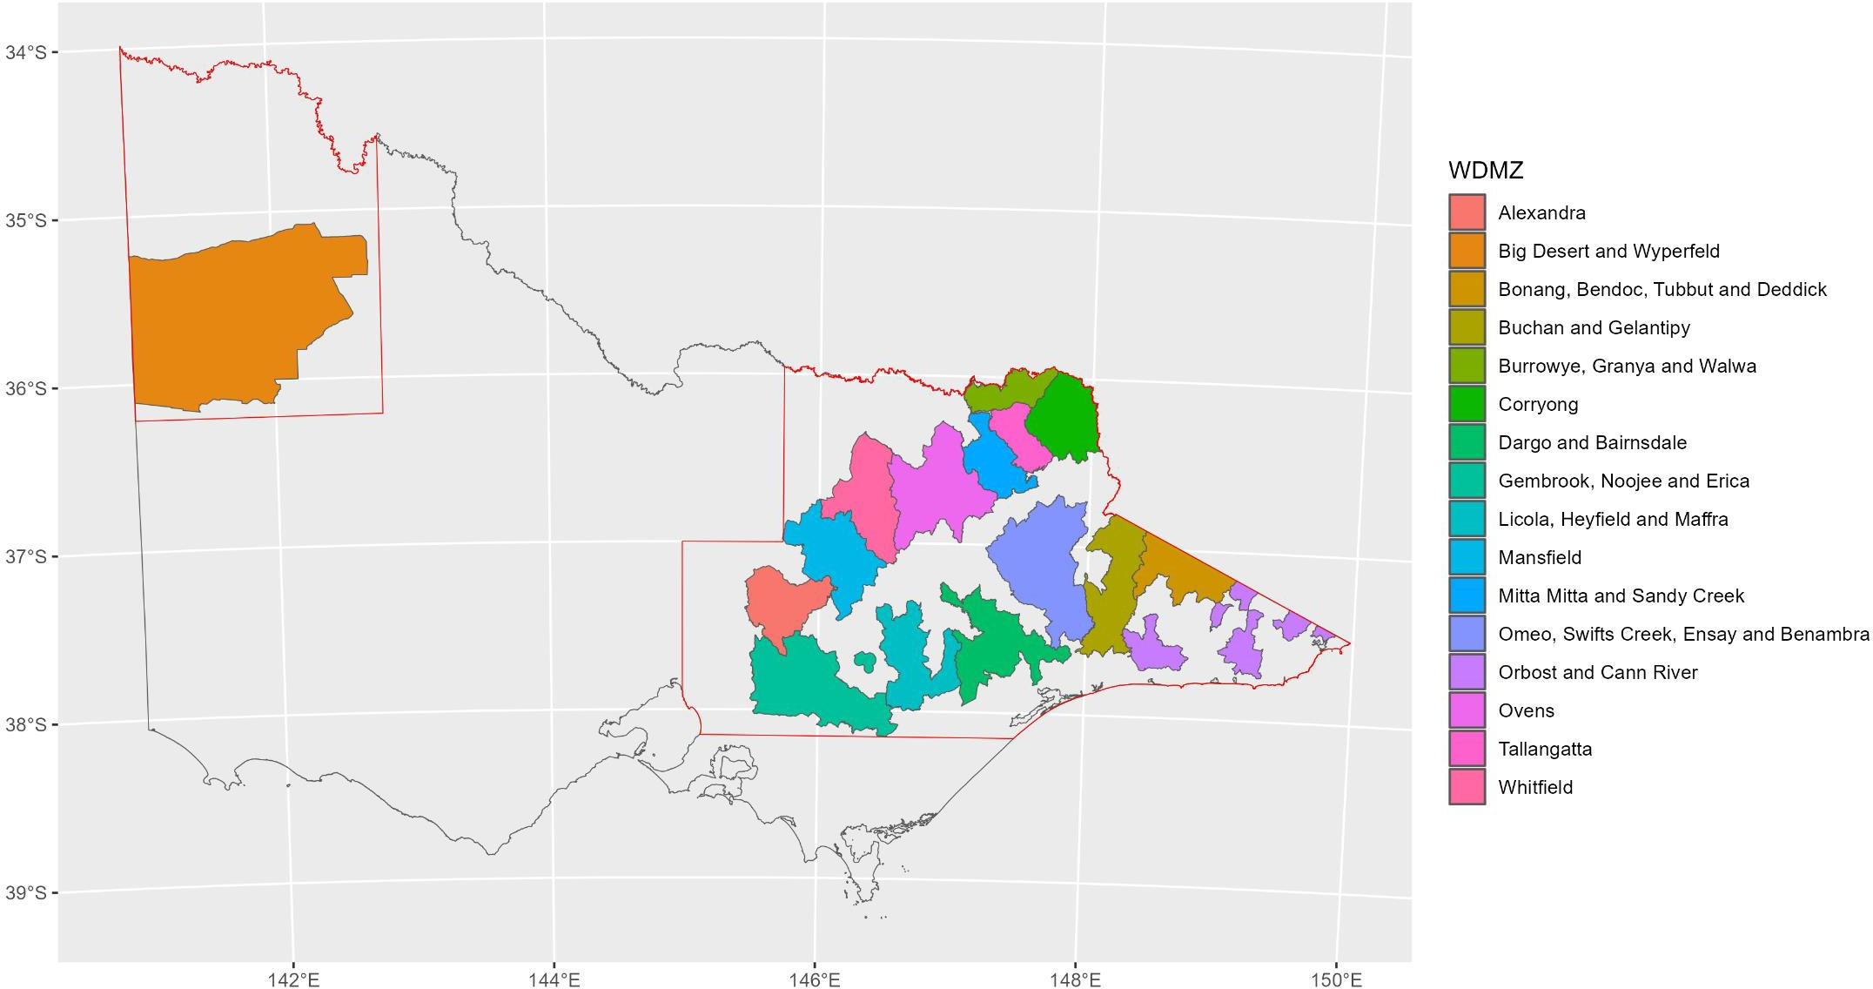

**Map 1.** Map of the wild dog management zones (WDMZ). Red polygon gives the boundaries of the unprotection order footprint.

2

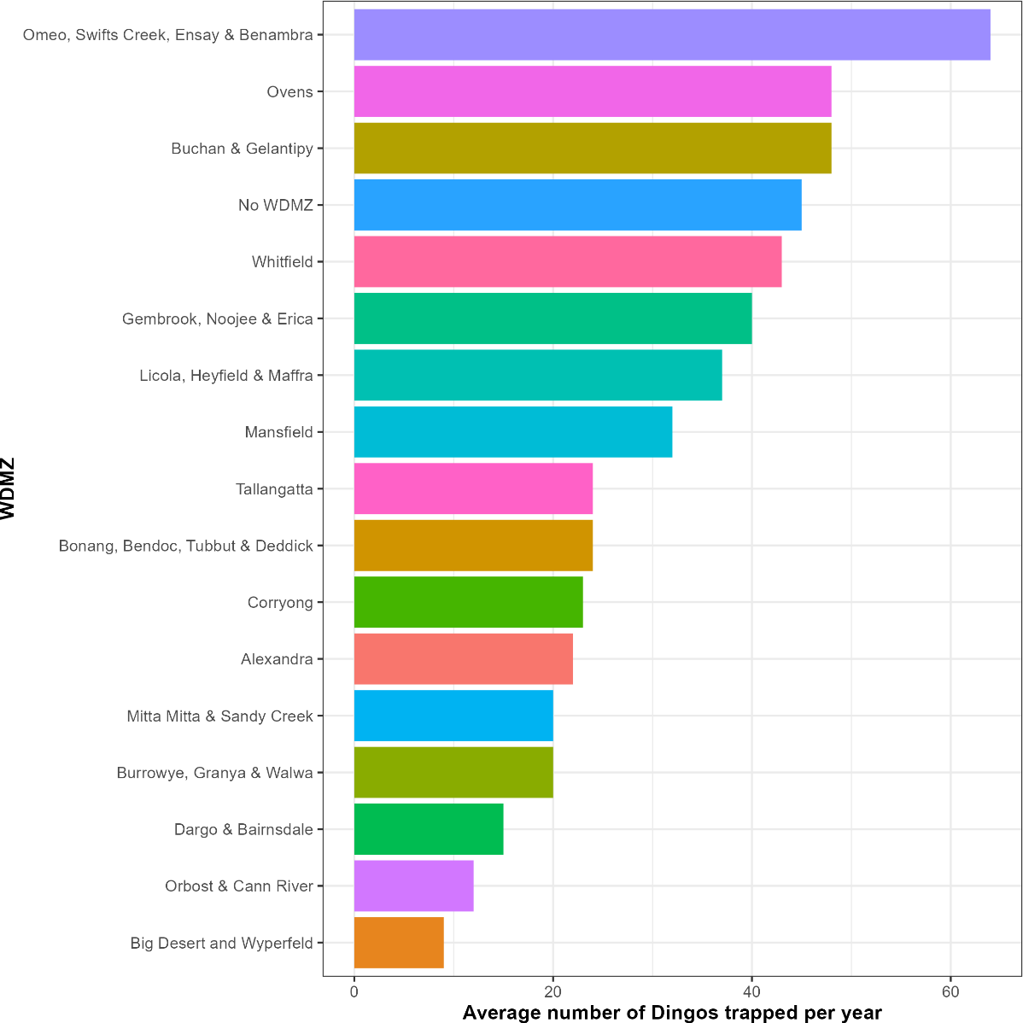

**Figure 1.** The average number of dingos removed by the wild dog trapping program each year for each wild dog management zone (WDMZ) between 2013/14 and 2022/23.

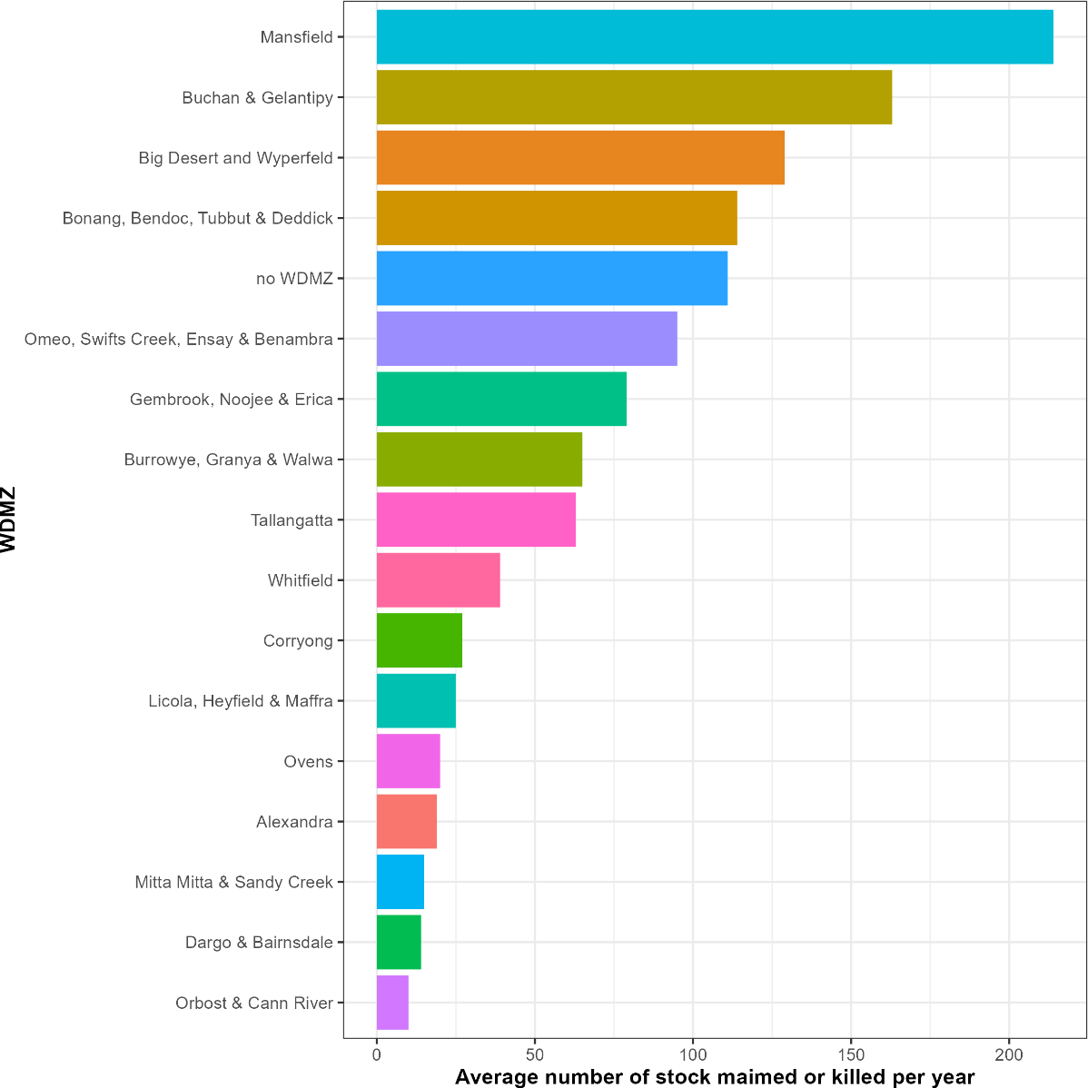

*

**Figure 2**. The average number of stock (sheep, cattle, goats and other livestock) confirmed as maimed or killed as a result of predation each year within each wild dog management zone (WDMZ) between 2013/14 and 2022/23.

*The predation figure for the 2020/21 financial year in this management zone is not considered an accurate representation of stock losses for that year. The average annual number of livestock predated is 46 for the Big Desert and Wyperfeld region between 2015/2016 – 2022/2023 (excluding the anomalous figure for 2020/21).

## Summary of wild dog program data by financial year

The figures below present summaries of the total number of dingos removed (Figure 3) by the wild dog trapping program and the number of stock confirmed maimed or killed as a result of predation (Figure 4) for each wild dog management zone (WDMZ) for each financial year (FY) between 2013/14 and 2022/23.

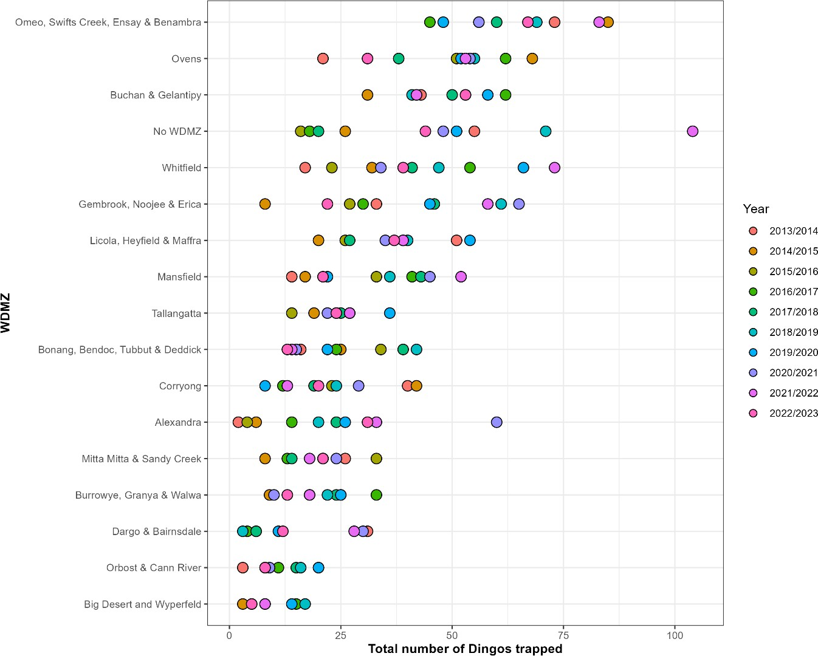

**Figure 3.** The total number of dingos removed by the wild dog trapping program for each wild dog management zone (WDMZ) for each financial year between 2013/14 and 2022/23.

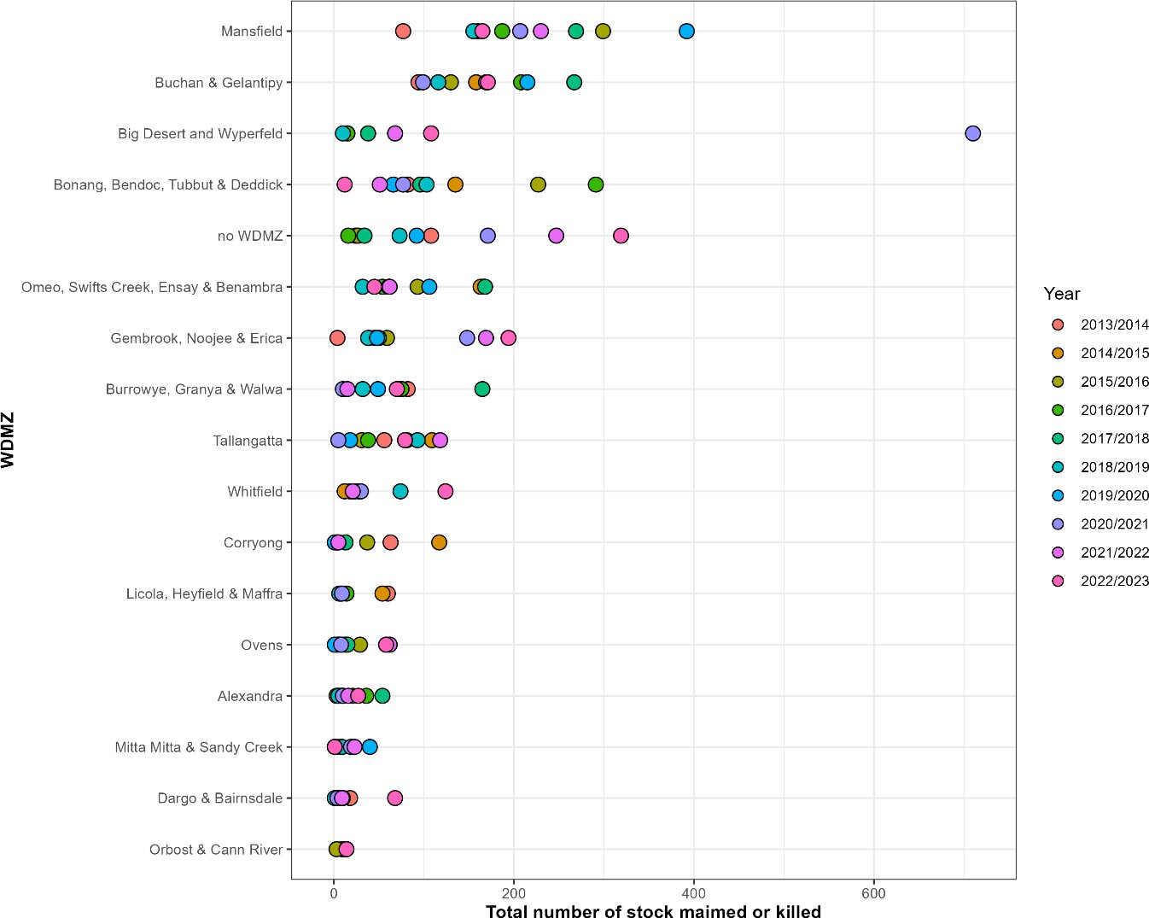

*

**Figure 4.** The total number of stock (sheep, cattle, goats and other livestock) confirmed as maimed or killed as a result of predation within each wild dog management zone (WDMZ) for each financial year between 2013/14 and 2022/23.

*The figure of 710 for the Big Desert Wyperfeld region is not considered an accurate representation of stock losses for the 2020/2021 financial year. The average annual number of livestock predated is 46 for the Big Desert and Wyperfeld region between 2015/2016 – 2022/2023 (excluding the anomalous figure for 2020/21).

## Summary of total livestock numbers

**Table 1**. Number of livestock (sheep, cattle, other ungulates, poultry) attributed to property identification codes (PICs) within each management zone (WDMZ) for the financial year 2022/23 only1.

|  |  |  |  |  |  |  |  |  |  |  |  |  |
| --- | --- | --- | --- | --- | --- | --- | --- | --- | --- | --- | --- | --- |
|  | Sheep | | | Cattle | | | Other ungulate species | | | Poultry (chicken, duck, geese, turkey, quail, partridge, pheasant, guinea fowl, emu) | | |
| (beef, dairy) | | | (goat, pig, horse, alpaca,  buffalo, bison, camel, deer) | | |
| **Management Zone (WDMZ)** | Number of PICs | Number of Stock | Number of PICs without Number of Stock Defined | Number of PICs | Number of Stock | Number of PICs without Number of Stock Defined | Number of PICs | Number of Stock | Number of PICs without Number of Stock Defined | Number of PICs | Number of Stock | Number of PICs without Number of Stock Defined |
| Alexandra | 190 | 38,516 | 27 | 631 | 57,447 | 93 | 228 | 2,332 | 31 | 139 | 1,670 | 4 |
| Big Desert and Wyperfeld | 318 | 335,189 | 46 | 132 | 8,020 | 20 | 83 | 1,169 | 18 | 28 | 56,406 | 3 |
| Bonang, Bendoc, Tubbut and Deddick | 45 | 27,484 | 5 | 84 | 10,336 | 5 | 27 | 324 | 7 | 13 | 154 | 0 |
| Buchan and Gelantipy | 77 | 19,139 | 7 | 139 | 18,522 | 14 | 53 | 599 | 11 | 16 | 262 | 0 |
| Burrowye, Granya and Walwa | 149 | 31,363 | 21 | 331 | 37,420 | 40 | 109 | 1,388 | 12 | 86 | 5,954 | 13 |
| Corryong | 99 | 15,512 | 9 | 411 | 71,022 | 40 | 86 | 911 | 9 | 44 | 5,454 | 4 |
| Dargo and Bairnsdale | 236 | 33,657 | 40 | 642 | 38,715 | 67 | 259 | 1,205 | 43 | 216 | 2,448 | 19 |
| Gembrook, Noojee and Erica | 527 | 13,272 | 56 | 1,692 | 94,013 | 223 | 1,116 | 5,855 | 104 | 864 | 1,158,924 | 36 |
| Licola, Heyfield and Maffra | 121 | 4,477 | 18 | 454 | 41,932 | 45 | 168 | 641 | 39 | 143 | 1,646 | 14 |
| Mansfield | 508 | 166,936 | 53 | 980 | 61,394 | 104 | 501 | 5,754 | 54 | 410 | 7,302 | 21 |
| Mitta Mitta and Sandy Creek | 84 | 10,244 | 11 | 398 | 56,785 | 38 | 102 | 1,848 | 15 | 93 | 2,350 | 4 |
| Omeo, Swifts Creek, Ensay and Benambra | 189 | 148,269 | 24 | 335 | 52,686 | 40 | 123 | 882 | 21 | 65 | 8,802 | 1 |
| Orbost and Cann River | 39 | 2,906 | 4 | 193 | 24,220 | 26 | 33 | 217 | 2 | 18 | 344 | 0 |
| Ovens | 299 | 25,560 | 36 | 1,107 | 82,496 | 128 | 396 | 2,857 | 40 | 300 | 7,330 | 11 |
| Tallangatta | 51 | 15,149 | 9 | 154 | 21,656 | 21 | 41 | 316 | 14 | 32 | 696 | 0 |
| Whitfield | 388 | 46,822 | 53 | 1,237 | 103,737 | 141 | 374 | 3,495 | 50 | 270 | 12,072 | 15 |

1Livestock data is supplied by producers and has not been verified by DEECA.

## Summary of dingo abundance estimates

Abundance estimates were derived from an array of 357 remote infrared cameras set on public land in Victoria during 2021 and 2022 using camera trap distance sampling methods (Cally & Ramsey, 2023; Howe et al., 2017). Additional cameras were also set within the Big Desert and Wyperfeld national park during 2023. The locations of cameras including those that detected the presence of dingoes are given in Figure 5. Distance sampling and image counts of Dingos recorded on cameras were analysed using density surface models (Miller et al., 2019). Estimates were then subdivided into populations inhabiting the eastern and western portions of the unprotection order boundaries.

Note that the following estimates (Table 2) are preliminary in nature and have moderate to high uncertainty. The predicted distribution of dingoes across public land in each region is given in Figure 6.

**Table 2**: Abundance estimates for the Dingo on public land within the unprotection order boundaries in eastern and western Victoria. SD – standard deviation, CV – coefficient of variation, Lower CI –

lower 90% confidence limit, Upper – upper 90% confidence limit, Density – average density.

|  |  |  |  |  |  |  |  |
| --- | --- | --- | --- | --- | --- | --- | --- |
| **Region** | **Estimate** | **SD** | **CV** | **Lower CI** | **Upper CI** | **Area**  **(km2)** | **Density**  **(dingoes/km2)** |
| **Eastern** | 4,900 | 2,095 | 0.43 | 2,640 | 8,880 | 40,909 | 0.12 |
| **Western** | 110 | 66 | 0.61 | 40 | 230 | 6,864 | 0.02 |

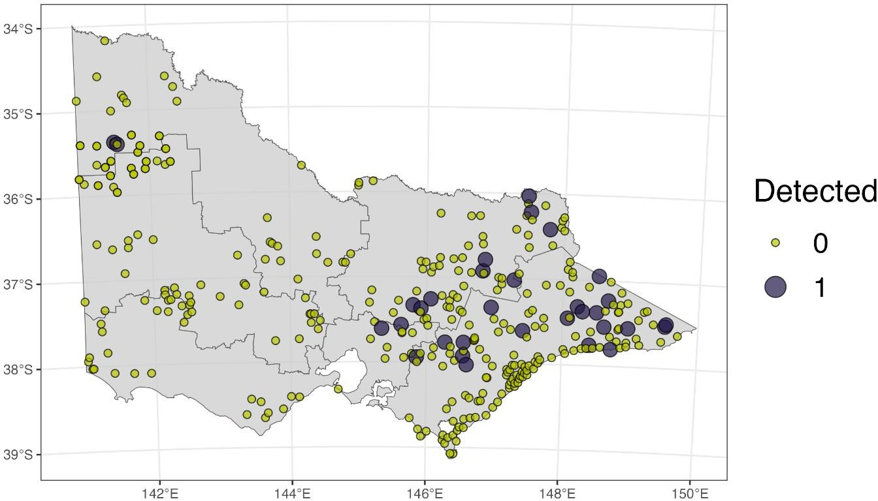

**Figure 5**. Locations of remote infrared cameras (yellow circles) and camera locations that recorded dingo presence (purple circles).

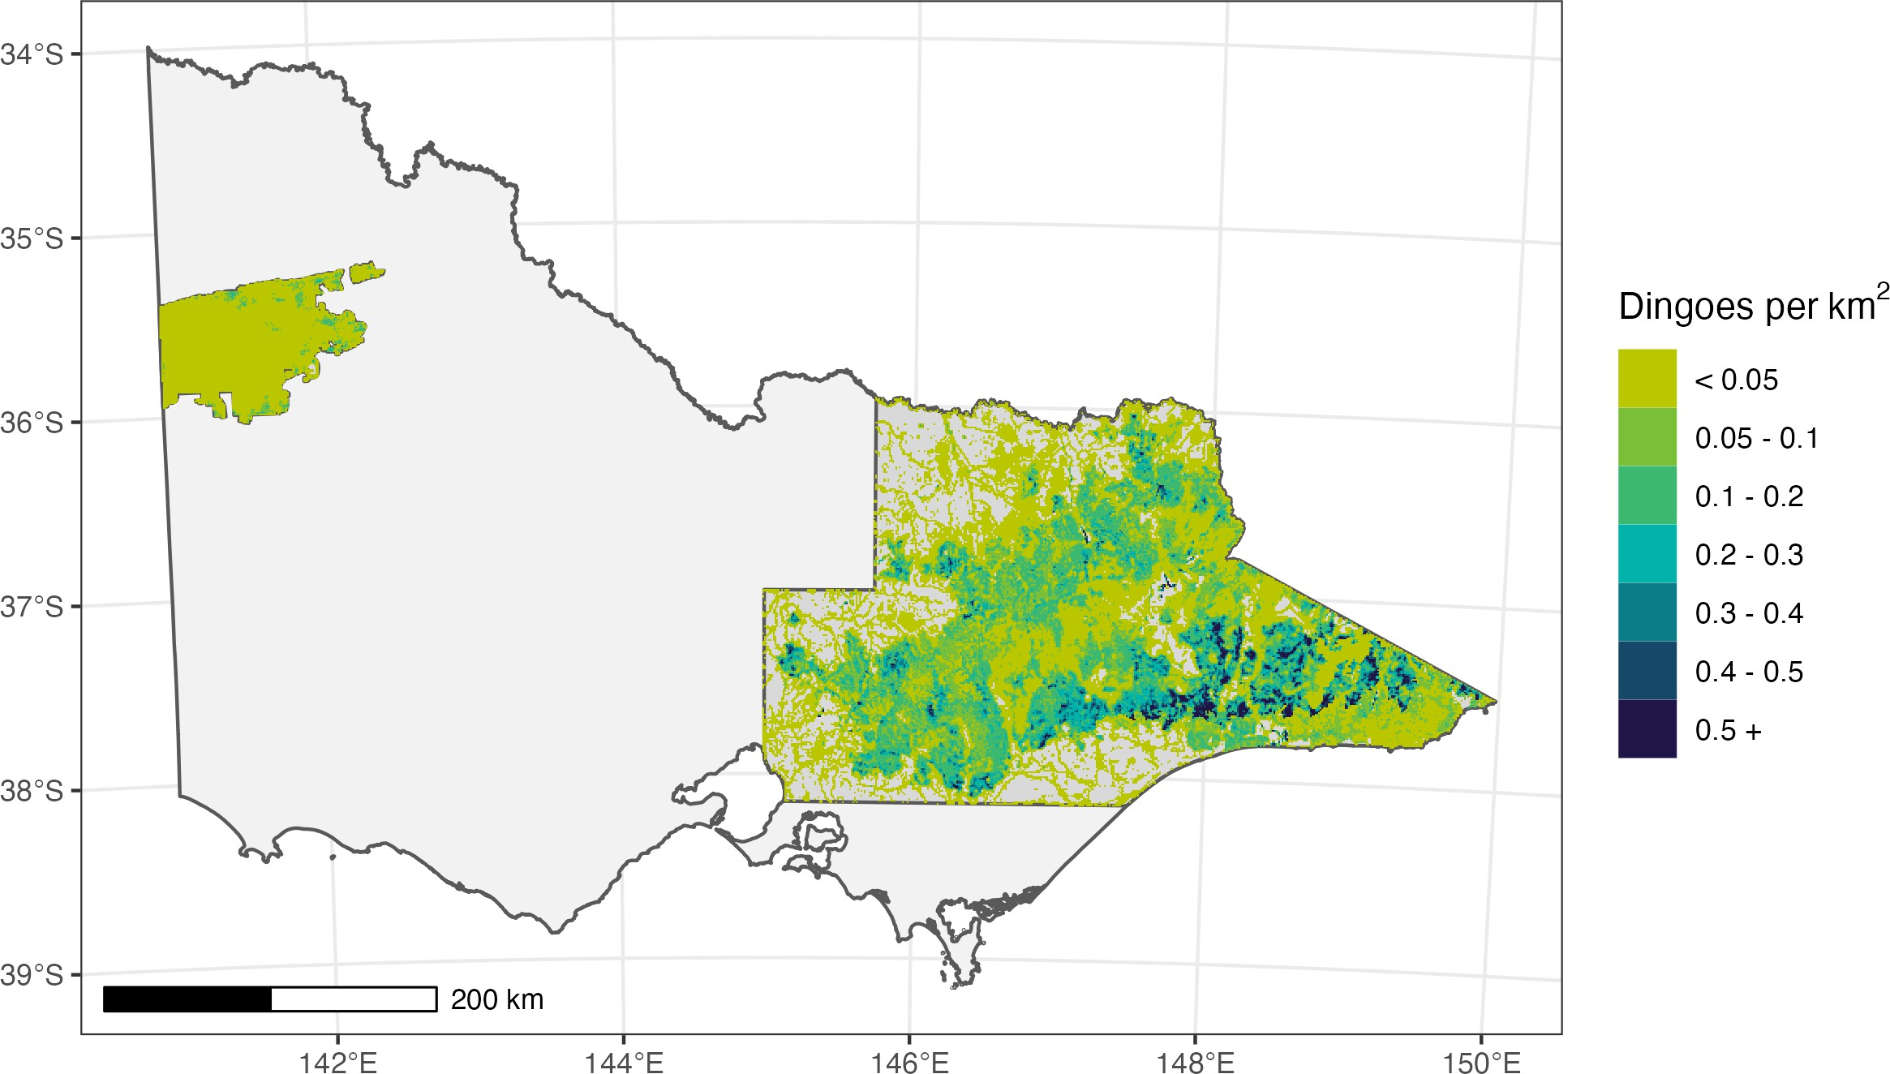

**Figure 6**. Distribution of dingo abundance on public land within the footprint of the unprotection order boundaries (eastern and western).

# Appendix – Tables of supporting data

## Summary of wild dog program data

**Table 1**. The yearly average and total number of dingos removed by the wild dog trapping program for each wild dog management zone (WDMZ) between 2013/14 and 2022/23. Results are ordered from highest to lowest total removals.

|  |  |  |
| --- | --- | --- |
| **WDMZ** | **Yearly average** | **Total** |
| Omeo, Swifts Creek, Ensay & Benambra | 64 | 642 |
| Ovens | 48 | 485 |
| Buchan & Gelantipy | 48 | 475 |
| No WDMZ | 45 | 453 |
| Whitfield | 43 | 426 |
| Gembrook, Noojee & Erica | 40 | 395 |
| Licola, Heyfield & Maffra | 37 | 368 |
| Mansfield | 32 | 324 |
| Tallangatta | 24 | 245 |
| Bonang, Bendoc, Tubbut & Deddick | 24 | 244 |
| Corryong | 23 | 230 |
| Alexandra | 22 | 220 |
| Mitta Mitta & Sandy Creek | 20 | 199 |
| Burrowye, Granya & Walwa | 20 | 197 |
| Dargo & Bairnsdale | 15 | 131 |
| Orbost & Cann River | 12 | 118 |
| Big Desert and Wyperfeld | 9 | 75 |
| **Average** |  |  |

**Table 2**. The yearly average and total number of stock (sheep, cattle, goats and other livestock) confirmed as maimed or killed as a result of predation within each wild dog management zone (WDMZ) between 2013/14 and 2022/23. Results are ordered from highest to lowest total.

|  |  |  |
| --- | --- | --- |
| **WDMZ** | **Yearly average** | **Total** |
| Mansfield | 214 | 2141 |
| Buchan & Gelantipy | 163 | 1627 |
| Bonang, Bendoc, Tubbut & Deddick | 114 | 1140 |
| no WDMZ | 111 | 1111 |
| Big Desert and Wyperfeld1 | 129 | 1032 |
| Omeo, Swifts Creek, Ensay & Benambra | 95 | 950 |
| Gembrook, Noojee & Erica | 79 | 794 |
| Burrowye, Granya & Walwa | 65 | 648 |
| Tallangatta | 63 | 628 |
| Whitfield | 39 | 388 |
| Corryong | 27 | 247 |
| Ovens | 20 | 202 |
| Alexandra | 19 | 189 |
| Licola, Heyfield & Maffra | 25 | 151 |
| Mitta Mitta & Sandy Creek | 15 | 147 |
| Dargo & Bairnsdale | 14 | 137 |
| Orbost & Cann River | 10 | 39 |

1The figure of 710 for the Big Desert Wyperfeld region is not considered an accurate representation of stock losses for the 2020-2021 financial year. The average annual number of livestock predated is 46 for the Big Desert and Wyperfeld region between 2015/2016 – 2022/2023 (excluding the anomalous figure of 710). This also impacts the accuracy of the “total” figure, which would more accurately be approximately 368 (assuming the longer-term average of 46 for the year 2020/21).

**Table 3**. The total number of stock (sheep, cattle, other) in each wild dog management zone (WDMZ) during the 2022/2023 FY as well as the total number of stock confirmed maimed or killed as a result of predation.

|  |  |  |  |  |  |
| --- | --- | --- | --- | --- | --- |
| **WDMZ** | **Total sheep** | **Total cattle** | **total other** | **Total stock** | **Total stock killed** |
| **Alexandra** | 38516 | 57447 | 2332 | 98,295 | 27 |
| Big Desert and Wyperfeld | 335189 | 8020 | 1169 | 344,378 | 108 |
| Bonang, Bendoc, Tubbut and Deddick | 27484 | 10336 | 324 | 38,144 | 12 |
| Buchan and Gelantipy | 19139 | 18522 | 599 | 38,260 | 171 |
| Burrowye, Granya and Walwa | 31363 | 37420 | 1388 | 70,171 | 70 |
| Corryong | 15512 | 71022 | 911 | 87,445 | 0 |
| Dargo and Bairnsdale | 33657 | 38715 | 1205 | 73,577 | 68 |
| Gembrook, Noojee and Erica | 13272 | 94013 | 5855 | 113,140 | 194 |
| Licola, Heyfield and Maffra | 4477 | 41932 | 641 | 47,050 | 0 |
| Mansfield | 166936 | 61394 | 5754 | 234,084 | 165 |
| Mitta Mitta and Sandy Creek | 10244 | 56785 | 1848 | 68,877 | 1 |
| Omeo, Swifts Creek, Ensay and Benambra | 148269 | 52686 | 882 | 201,837 | 45 |
| Orbost and Cann River | 2906 | 24220 | 217 | 27,343 | 14 |
| Ovens | 25560 | 82496 | 2857 | 110,913 | 58 |
| Tallangatta | 15149 | 21656 | 316 | 37,121 | 79 |
| Whitfield | 46822 | 103737 | 3495 | 154,054 | 124 |
| No WDMZ | NA | NA | NA | NA | 319 |
| **Total** |  |  |  | **1,744,689** | **1455** |

**Table 4.** The total abundance of dingoes in each wild dog management zone (WDMZ) estimated from monitoring undertaken during 2021, 2022 and 2023 as well as the total number of dingoes trapped by the wild dog management program during 2022/2023.

|  |  |  |
| --- | --- | --- |
| **WDMZ** | **Total abundance** | **total trapped** |
| **Alexandra** | 165 | 31 |
| Big Desert and Wyperfeld | 110 | 5 |
| Bonang, Bendoc, Tubbut and Deddick | 160 | 13 |
| Buchan and Gelantipy | 367 | 53 |
| Burrowye, Granya and Walwa | 32 | 13 |
| Corryong | 110 | 20 |
| Dargo and Bairnsdale | 361 | 12 |
| Gembrook, Noojee and Erica | 373 | 22 |
| Licola, Heyfield and Maffra | 207 | 37 |
| Mansfield | 129 | 21 |
| Mitta Mitta and Sandy Creek | 114 | 21 |
| Omeo, Swifts Creek, Ensay and Benambra | 335 | 67 |
| Orbost and Cann River | 286 | 8 |
| Ovens | 228 | 31 |
| Tallangatta | 90 | 24 |
| Whitfield | 106 | 39 |
| No WDMZ | 1838 | 44 |
| **Total** | **5010** | **461** |

## Summary of wild dog program data by financial year

Tables below present summaries of the total number of dingos removed (Table 4) by the wild dog trapping program and the number of stock confirmed maimed or killed as a result of predation (Table 5) for each wild dog management zone (WDMZ) for each financial year (FY) between 2013/14 and 2022/23. Results are ordered from highest to lowest total removals within each year.

**Table 5.** The total number of dingos removed by the wild dog trapping program for each wild dog management zone (WDMZ) for each financial year between 2013/14 and 2022/23. Results are ordered from highest to lowest total removals.

|  |  |  |
| --- | --- | --- |
| **FY** | **WDMZ** | **Total** |
| **2013/2014** | Omeo, Swifts Creek, Ensay & Benambra | 73 |
|  | No WDMZ | 55 |
|  | Licola, Heyfield & Maffra | 51 |
|  | Buchan & Gelantipy | 43 |
|  | Corryong | 40 |
|  | Gembrook, Noojee & Erica | 33 |
|  | Dargo & Bairnsdale | 31 |
|  | Mitta Mitta & Sandy Creek | 26 |
|  | Burrowye, Granya & Walwa | 25 |
|  | Tallangatta | 24 |
|  | Ovens | 21 |
|  | Whitfield | 17 |
|  | Bonang, Bendoc, Tubbut & Deddick | 16 |
|  | Mansfield | 14 |
|  | Orbost & Cann River | 3 |
|  | Alexandra | 2 |

|  |  |  |
| --- | --- | --- |
| **FY** | **WDMZ** | **Total** |
| **2014/2015** | Omeo, Swifts Creek, Ensay & Benambra | 85 |
|  | Ovens | 68 |
|  | Corryong | 42 |
|  | Whitfield | 32 |
|  | Buchan & Gelantipy | 31 |
|  | No WDMZ | 26 |
|  | Bonang, Bendoc, Tubbut & Deddick | 25 |
|  | Licola, Heyfield & Maffra | 20 |
|  | Orbost & Cann River | 20 |
|  | Tallangatta | 19 |
|  | Mansfield | 17 |
|  | Burrowye, Granya & Walwa | 9 |
|  | Gembrook, Noojee & Erica | 8 |
|  | Mitta Mitta & Sandy Creek | 8 |
|  | Alexandra | 6 |
|  | Dargo & Bairnsdale | 6 |
|  | Big Desert and Wyperfeld | 3 |

|  |  |  |
| --- | --- | --- |
| **2015/2016** | Omeo, Swifts Creek, Ensay & Benambra | 56 |
|  | Buchan & Gelantipy | 53 |
|  | Ovens | 51 |
|  | Bonang, Bendoc, Tubbut & Deddick | 34 |
|  | Mansfield | 33 |
|  | Mitta Mitta & Sandy Creek | 33 |
|  | Gembrook, Noojee & Erica | 27 |
|  | Licola, Heyfield & Maffra | 26 |
|  | Corryong | 23 |
|  | Whitfield | 23 |
|  | Burrowye, Granya & Walwa | 18 |
|  | No WDMZ | 16 |
|  | Tallangatta | 14 |
|  | Big Desert and Wyperfeld | 8 |
|  | Orbost & Cann River | 8 |
|  | Alexandra | 4 |

|  |  |  |
| --- | --- | --- |
| **2016/2017** | Buchan & Gelantipy | 62 |
|  | Ovens | 62 |
|  | Whitfield | 54 |
|  | Omeo, Swifts Creek, Ensay & Benambra | 45 |
|  | Mansfield | 41 |
|  | Licola, Heyfield & Maffra | 39 |
|  | Burrowye, Granya & Walwa | 33 |
|  | Gembrook, Noojee & Erica | 30 |
|  | Tallangatta | 27 |
|  | Bonang, Bendoc, Tubbut & Deddick | 24 |
|  | No WDMZ | 18 |
|  | Big Desert and Wyperfeld | 15 |
|  | Alexandra | 14 |
|  | Mitta Mitta & Sandy Creek | 13 |
|  | Corryong | 12 |
|  | Orbost & Cann River | 11 |
|  | Dargo & Bairnsdale | 4 |

|  |  |  |
| --- | --- | --- |
| **2017/2018** | Omeo, Swifts Creek, Ensay & Benambra | 60 |
|  | Buchan & Gelantipy | 50 |
|  | Gembrook, Noojee & Erica | 46 |
|  | Mansfield | 43 |
|  | Whitfield | 41 |
|  | Bonang, Bendoc, Tubbut & Deddick | 39 |
|  | Ovens | 38 |
|  | Licola, Heyfield & Maffra | 27 |
|  | Tallangatta | 25 |
|  | Alexandra | 24 |
|  | Burrowye, Granya & Walwa | 24 |
|  | No WDMZ | 20 |
|  | Corryong | 19 |
|  | Orbost & Cann River | 15 |
|  | Mitta Mitta & Sandy Creek | 14 |
|  | Dargo & Bairnsdale | 6 |
|  | Big Desert and Wyperfeld | 5 |

|  |  |  |
| --- | --- | --- |
| **2018/2019** | No WDMZ | 71 |
|  | Omeo, Swifts Creek, Ensay & Benambra | 69 |
|  | Gembrook, Noojee & Erica | 61 |
|  | Ovens | 55 |
|  | Whitfield | 47 |
|  | Bonang, Bendoc, Tubbut & Deddick | 42 |
|  | Buchan & Gelantipy | 41 |
|  | Licola, Heyfield & Maffra | 40 |
|  | Mansfield | 36 |
|  | Tallangatta | 27 |
|  | Corryong | 24 |
|  | Burrowye, Granya & Walwa | 22 |
|  | Mitta Mitta & Sandy Creek | 21 |
|  | Alexandra | 20 |
|  | Big Desert and Wyperfeld | 17 |
|  | Orbost & Cann River | 16 |
|  | Dargo & Bairnsdale | 3 |

|  |  |  |
| --- | --- | --- |
| **2019/2020** | Whitfield | 66 |
|  | Buchan & Gelantipy | 58 |
|  | Licola, Heyfield & Maffra | 54 |
|  | Ovens | 52 |
|  | No WDMZ | 51 |
|  | Omeo, Swifts Creek, Ensay & Benambra | 48 |
|  | Gembrook, Noojee & Erica | 45 |
|  | Tallangatta | 36 |
|  | Alexandra | 26 |
|  | Burrowye, Granya & Walwa | 25 |
|  | Bonang, Bendoc, Tubbut & Deddick | 22 |
|  | Mansfield | 22 |
|  | Mitta Mitta & Sandy Creek | 21 |
|  | Orbost & Cann River | 20 |
|  | Big Desert and Wyperfeld | 14 |
|  | Dargo & Bairnsdale | 11 |
|  | Corryong | 8 |

|  |  |  |
| --- | --- | --- |
| **2020/2021** | Gembrook, Noojee & Erica | 65 |
|  | Alexandra | 60 |
|  | Omeo, Swifts Creek, Ensay & Benambra | 56 |
|  | Ovens | 54 |
|  | No WDMZ | 48 |
|  | Mansfield | 45 |
|  | Buchan & Gelantipy | 42 |
|  | Licola, Heyfield & Maffra | 35 |
|  | Whitfield | 34 |
|  | Dargo & Bairnsdale | 30 |
|  | Corryong | 29 |
|  | Mitta Mitta & Sandy Creek | 24 |
|  | Tallangatta | 22 |
|  | Bonang, Bendoc, Tubbut & Deddick | 15 |
|  | Burrowye, Granya & Walwa | 10 |
|  | Orbost & Cann River | 9 |

|  |  |  |
| --- | --- | --- |
| **2021/2022** | No WDMZ | 104 |
|  | Omeo, Swifts Creek, Ensay & Benambra | 83 |
|  | Whitfield | 73 |
|  | Gembrook, Noojee & Erica | 58 |
|  | Ovens | 53 |
|  | Mansfield | 52 |
|  | Buchan & Gelantipy | 42 |
|  | Licola, Heyfield & Maffra | 39 |
|  | Alexandra | 33 |
|  | Dargo & Bairnsdale | 28 |
|  | Tallangatta | 27 |
|  | Burrowye, Granya & Walwa | 18 |
|  | Mitta Mitta & Sandy Creek | 18 |
|  | Bonang, Bendoc, Tubbut & Deddick | 14 |
|  | Corryong | 13 |
|  | Big Desert and Wyperfeld | 8 |
|  | Orbost & Cann River | 8 |

|  |  |  |
| --- | --- | --- |
| **2022/2023** | Omeo, Swifts Creek, Ensay & Benambra | 67 |
|  | Buchan & Gelantipy | 53 |
|  | No WDMZ | 44 |
|  | Whitfield | 39 |
|  | Licola, Heyfield & Maffra | 37 |
|  | Alexandra | 31 |
|  | Ovens | 31 |
|  | Tallangatta | 24 |
|  | Gembrook, Noojee & Erica | 22 |
|  | Mansfield | 21 |
|  | Mitta Mitta & Sandy Creek | 21 |
|  | Corryong | 20 |
|  | Bonang, Bendoc, Tubbut & Deddick | 13 |
|  | Burrowye, Granya & Walwa | 13 |
|  | Dargo & Bairnsdale | 12 |
|  | Orbost & Cann River | 8 |
|  | Big Desert and Wyperfeld | 5 |

|  |  |  |
| --- | --- | --- |
| **2023/2024 (YTD)\*** | Omeo, Swifts Creek, Ensay and Benambra | 40 |
|  | Buchan and Gelantipy | 25 |
|  | Tallangatta | 25 |
|  | Whitfield | 22 |
|  | Licola, Heyfield and Maffra | 20 |
|  | Alexandra | 19 |
|  | Gembrook, Noojee and Erica | 17 |
|  | no WDMZ | 14 |
|  | Dargo and Bairnsdale | 14 |
|  | Burrowye, Granya and Walwa | 12 |
|  | Bonang, Bendoc, Tubbut and Deddick | 8 |
|  | Corryong | 6 |
|  | Ovens | 6 |
|  | Orbost and Cann River | 5 |
|  | Mansfield | 3 |
|  | Mitta Mitta and Sandy Creek | 5 |
|  | Big Desert and Wyperfeld | 0 |

*Up to 4 February 2024

**Table 6**. The total number of stock (sheep, cattle, goats and other livestock) confirmed as maimed or killed as a result of predation within each wild dog management zone (WDMZ) for each financial year between 2013/14 and 2022/23. Results are ordered from highest to lowest total.

|  |  |  |
| --- | --- | --- |
| **FY** | **WDMZ** | **Total** |
| **2013/2014** | Omeo, Swifts Creek, Ensay & Benambra | 166 |
|  | no WDMZ | 108 |
|  | Buchan & Gelantipy | 94 |
|  | Bonang, Bendoc, Tubbut & Deddick | 82 |
|  | Burrowye, Granya & Walwa | 82 |
|  | Mansfield | 77 |
|  | Corryong | 63 |
|  | Licola, Heyfield & Maffra | 60 |
|  | Tallangatta | 56 |
|  | Dargo & Bairnsdale | 18 |
|  | Whitfield | 18 |
|  | Alexandra | 10 |
|  | Orbost & Cann River | 9 |
|  | Ovens | 5 |
|  | Gembrook, Noojee & Erica | 4 |
|  | Mitta Mitta & Sandy Creek | 4 |

|  |  |  |
| --- | --- | --- |
| **2014/2015** | **Omeo, Swifts Creek, Ensay & Benambra** | **163** |
|  | Mansfield | 160 |
|  | Buchan & Gelantipy | 158 |
|  | Bonang, Bendoc, Tubbut & Deddick | 135 |
|  | Corryong | 117 |
|  | Tallangatta | 109 |
|  | Burrowye, Granya & Walwa | 75 |
|  | Licola, Heyfield & Maffra | 54 |
|  | Gembrook, Noojee & Erica | 45 |
|  | no WDMZ | 24 |
|  | Orbost & Cann River | 13 |
|  | Ovens | 12 |
|  | Whitfield | 12 |
|  | Dargo & Bairnsdale | 9 |
|  | Alexandra | 7 |
|  | Mitta Mitta & Sandy Creek | 1 |

|  |  |  |
| --- | --- | --- |
| **2015/2016** | **Mansfield** | **299** |
|  | Bonang, Bendoc, Tubbut & Deddick | 227 |
|  | Buchan & Gelantipy | 130 |
|  | Omeo, Swifts Creek, Ensay & Benambra | 93 |
|  | Burrowye, Granya & Walwa | 75 |
|  | Gembrook, Noojee & Erica | 59 |
|  | Corryong | 37 |
|  | Tallangatta | 31 |
|  | Ovens | 29 |
|  | Whitfield | 28 |
|  | no WDMZ | 27 |
|  | Mitta Mitta & Sandy Creek | 20 |
|  | Big Desert and Wyperfeld | 15 |
|  | Licola, Heyfield & Maffra | 8 |
|  | Dargo & Bairnsdale | 6 |
|  | Alexandra | 3 |
|  | Orbost & Cann River | 3 |

|  |  |  |
| --- | --- | --- |
| **2016/2017** | **Bonang, Bendoc, Tubbut & Deddick** | **291** |
|  | Buchan & Gelantipy | 208 |
|  | Mansfield | 187 |
|  | Burrowye, Granya & Walwa | 75 |
|  | Omeo, Swifts Creek, Ensay & Benambra | 54 |
|  | Gembrook, Noojee & Erica | 39 |
|  | Tallangatta | 38 |
|  | Alexandra | 36 |
|  | Whitfield | 23 |
|  | Mitta Mitta & Sandy Creek | 22 |
|  | no WDMZ | 16 |
|  | Big Desert and Wyperfeld | 15 |
|  | Licola, Heyfield & Maffra | 14 |
|  | Dargo & Bairnsdale | 10 |
|  | Ovens | 7 |
|  | Corryong | 3 |

|  |  |  |
| --- | --- | --- |
| **2017/2018** | **Mansfield** | **269** |
|  | Buchan & Gelantipy | 267 |
|  | Omeo, Swifts Creek, Ensay & Benambra | 168 |
|  | Burrowye, Granya & Walwa | 165 |
|  | Bonang, Bendoc, Tubbut & Deddick | 96 |
|  | Tallangatta | 81 |
|  | Alexandra | 54 |
|  | Gembrook, Noojee & Erica | 50 |
|  | Big Desert and Wyperfeld | 38 |
|  | no WDMZ | 34 |
|  | Whitfield | 29 |
|  | Ovens | 15 |
|  | Corryong | 13 |
|  | Mitta Mitta & Sandy Creek | 8 |
|  | Dargo & Bairnsdale | 7 |

|  |  |  |
| --- | --- | --- |
| **2018/2019** | **Mansfield** | **155** |
|  | Buchan & Gelantipy | 116 |
|  | Bonang, Bendoc, Tubbut & Deddick | 103 |
|  | Tallangatta | 93 |
|  | Whitfield | 74 |
|  | no WDMZ | 73 |
|  | Gembrook, Noojee & Erica | 38 |
|  | Burrowye, Granya & Walwa | 32 |
|  | Omeo, Swifts Creek, Ensay & Benambra | 32 |
|  | Big Desert and Wyperfeld | 10 |
|  | Mitta Mitta & Sandy Creek | 9 |
|  | Licola, Heyfield & Maffra | 6 |
|  | Alexandra | 5 |
|  | Ovens | 5 |
|  | Corryong | 3 |
|  | Dargo & Bairnsdale | 1 |

|  |  |  |
| --- | --- | --- |
| **2019/2020** | **Mansfield** | **392** |
|  | Buchan & Gelantipy | 215 |
|  | Omeo, Swifts Creek, Ensay & Benambra | 106 |
|  | no WDMZ | 92 |
|  | Big Desert and Wyperfeld | 68 |
|  | Bonang, Bendoc, Tubbut & Deddick | 66 |
|  | Burrowye, Granya & Walwa | 49 |
|  | Gembrook, Noojee & Erica | 48 |
|  | Mitta Mitta & Sandy Creek | 40 |
|  | Whitfield | 29 |
|  | Alexandra | 21 |
|  | Tallangatta | 18 |
|  | Dargo & Bairnsdale | 5 |
|  | Corryong | 1 |
|  | Ovens | 1 |

|  |  |  |
| --- | --- | --- |
| **2020/2021** | **Big Desert and Wyperfeld1** | **710** |
|  | Mansfield | 207 |
|  | no WDMZ | 171 |
|  | Gembrook, Noojee & Erica | 148 |
|  | Buchan & Gelantipy | 99 |
|  | Bonang, Bendoc, Tubbut & Deddick | 77 |
|  | Omeo, Swifts Creek, Ensay & Benambra | 61 |
|  | Whitfield | 30 |
|  | Mitta Mitta & Sandy Creek | 19 |
|  | Alexandra | 10 |
|  | Burrowye, Granya & Walwa | 10 |
|  | Licola, Heyfield & Maffra | 9 |
|  | Ovens | 8 |
|  | Corryong | 5 |
|  | Tallangatta | 5 |
|  | Dargo & Bairnsdale | 4 |

1The figure of 710 for the Big Desert Wyperfeld region is not considered an accurate representation of stock losses for the 2020-2021 financial year. The average annual number of livestock predated is 46 for the Wyperfeld /Big Desert region between 2015/2016 – 2022/2023 (excluding the anomalous figure for 2020/21).

|  |  |  |
| --- | --- | --- |
| **2021/2022** | **no WDMZ** | **247** |
|  | Mansfield | 230 |
|  | Buchan & Gelantipy | 169 |
|  | Gembrook, Noojee & Erica | 169 |
|  | Tallangatta | 118 |
|  | Big Desert and Wyperfeld | 68 |
|  | Omeo, Swifts Creek, Ensay & Benambra | 62 |
|  | Ovens | 62 |
|  | Bonang, Bendoc, Tubbut & Deddick | 51 |
|  | Mitta Mitta & Sandy Creek | 23 |
|  | Whitfield | 21 |
|  | Alexandra | 16 |
|  | Burrowye, Granya & Walwa | 15 |
|  | Dargo & Bairnsdale | 9 |
|  | Corryong | 5 |

|  |  |  |
| --- | --- | --- |
| **2022/2023** | **no WDMZ** | **319** |
|  | Gembrook, Noojee & Erica | 194 |
|  | Buchan & Gelantipy | 171 |
|  | Mansfield | 165 |
|  | Whitfield | 124 |
|  | Big Desert and Wyperfeld | 108 |
|  | Tallangatta | 79 |
|  | Burrowye, Granya & Walwa | 70 |
|  | Dargo & Bairnsdale | 68 |
|  | Ovens | 58 |
|  | Omeo, Swifts Creek, Ensay & Benambra | 45 |
|  | Alexandra | 27 |
|  | Orbost & Cann River | 14 |
|  | Bonang, Bendoc, Tubbut & Deddick | 12 |
|  | Mitta Mitta & Sandy Creek | 1 |

|  |  |  |
| --- | --- | --- |
| **2023/2024 (YTD)\*** | Mansfield | 106 |
|  | Buchan & Gelantipy | 94 |
|  | Whitfield | 86 |
|  | Dargo & Bairnsdale | 79 |
|  | Ovens | 67 |
|  | Gembrook, Noojee & Erica | 64 |
|  | Omeo, Swifts Creek, Ensay & Benambra | 60 |
|  | no WDMZ | 56 |
|  | Burrowye, Granya & Walwa | 34 |
|  | Big Desert and Wyperfeld | 26 |
|  | Alexandra | 21 |
|  | Bonang, Bendoc, Tubbut & Deddick | 8 |
|  | Tallangatta | 7 |
|  | Orbost & Cann River | 3 |
|  | Corryong | 3 |
|  | Mitta Mitta & Sandy Creek | 1 |
|  | Licola, Heyfield & Maffra | 0 |

*Up to 4 February 2024

# References

Cally, J. G., & Ramsey, D. S. L. (2023). *Abundance of deer in Victoria: Regional and statewide estimates of deer density and their impact on vegetation*.

Howe, E. J., Buckland, S. T., Després-Einspenner, M.-L., & Kühl, H. S. (2017). Distance sampling with camera traps. *Methods in Ecology and Evolution*, *8*, 1558–1565.

Miller, D. L., Rexstad, E. A., Burt, M. L., & Bravington, M. V. (2019). *dsm: Density Surface Modelling of Distance Sampling Data. R package version 2.2.18* (R package version 2.2.18). R package version

2.2.18. <http://github.com/DistanceDevelopment/dsm>

Rowcliffe, M. (2023). *activity: Animal Activity Statistics*. https://CRAN.R-project.org/package=activity