Planning your recovery
Whole Farm Planning course EOI now open for fire impacted landholders

Share your experiences, ideas and prepare a new plan for your farm

Expressions of Interest for Whole Farm Planning courses are now open for landholders impacted by the recent bushfires. A Whole Farm Plan can help design a farm that is easier to manage, more productive and offers environmental benefits.

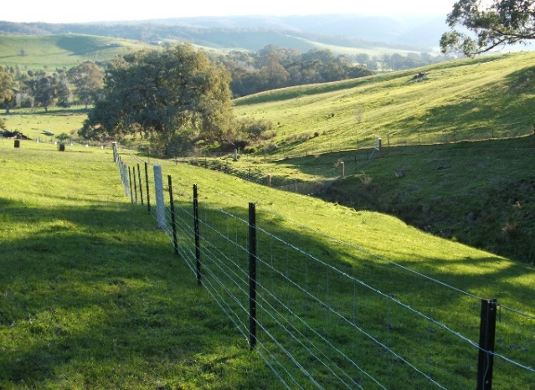
This EOI will be used to identify groups of landholders to run courses. We will be in contact when we have enough participants in your area.

Participants meet for up to 6 sessions to cover farm management and recovery topics.

An online format will also be available.

Workshop topics include:
- Farm design and layout
- Setting current and future goals
- Soils, biodiversity and land classing
- Pasture and grazing/feed management
- Farm water supply planning
- Farm business planning
Agriculture Victoria is working with Victorian farmers and industry to prepare for, respond to
and recover from natural disasters, including fires, floods and storms.

- Looking after yourself
- Risk management.
A free laminated property map will be provided as part of the course.

To express interest in this first round of courses by 30 April 2026:
Please fill out the form at:
https://forms.office.com/r/Ky1eKXn8N3

Or use the QR code:

For more information contact:
Kylie Macreadie on 0427 052 352

Or Email: recovery@agriculture.vic.gov.au

“I did the FarmPlan 21 course following the Moyston fire. It helped me redesign paddocks and importantly got me off the farm and sharing with others for a few hours each week.” David Coad, Moyston.

