Validation of anthrax ICT kit for sheep

General information for private veterinarians
If you identify any sheep that has died suddenly or is found dead including at lairage, please test for anthrax using an ICT.
The Victorian sheep and goat industries have provided funding to Agriculture Victoria to undertake a project to determine the sensitivity and specificity of the immunochromatographic test (ICT) for anthrax when used in sheep.

Background:
Anthrax exclusion testing should be carried out on all sudden, unexplained deaths of susceptible species. In cattle and sheep, field testing is carried out using an ICT kit. The ICT kit has proved to be a reliable method for the rapid determination of the anthrax status of cattle and sheep that have died suddenly. The test kit has been validated for use in cattle, however similar work is required in sheep.

Sampling requirements and payments
Within the ICT project, the payment for anthrax exclusion testing in sheep with unexplained sudden death will be $300 (+GST) per property. Please note: This is higher than, and is instead of, the general payment of $200.

Up to 10 sheep that have experienced sudden death can be sampled from the same property. Only carcasses that are less than 48 hours old can be sampled. Sampling of multiple carcasses per investigation is strongly encouraged.

To be eligible for the $300 payment, in addition to the general requirements (notification to the department, performing an ICT and completion of the ICT project specific Record of Disease Event (RODE)/ laboratory submission form), private veterinarians are also required to submit an EDTA blood sample and the used ICT kit to the DJPR AgriBio Bundoora veterinary laboratory for confirmatory testing. These samples are to be forwarded to the laboratory regardless of the test result (i.e. all ICT tests, including those that are negative, must have blood samples submitted to the laboratory). Samples should be collected as aseptically as possible and forwarded ASAP. Please see the flow diagram on the next page for the steps that are to be followed. Where anthrax is not suspected following a negative ICT result and a further investigation of the cause of death is undertaken by the practitioner (including necropsy), the investigation may be eligible for other subsidies following approval by your District Veterinary Officer.

Private veterinarians must have been trained in the use of the ICT by Agriculture Victoria Animal Health & Welfare (AH&W) staff. Training users in the use of the ICT is a requirement of the Australian and New Zealand standard diagnostic procedure for anthrax. ICT kits will only be provided to accredited veterinarians so if you have not undertaken training or would like refresher training please contact your local Agriculture Victoria AH&W staff member to organise it.

The instructions as set out in the Standard Operating Procedure for anthrax investigations (provided at the training session) must be followed. Veterinarians must inform their District Veterinary Officer (DVO), Veterinary Officer (VO) or Senior Veterinary Officer (SVO) prior to collecting samples for the anthrax investigation. If the SVO, DVO, VO or other AH&W staff member is not contactable do not leave a message. Instead, immediately ring the all-hours Emergency Animal Disease Hotline on 1800 675 888.

The project will run from 1 January 2018 until 31 March 2023.
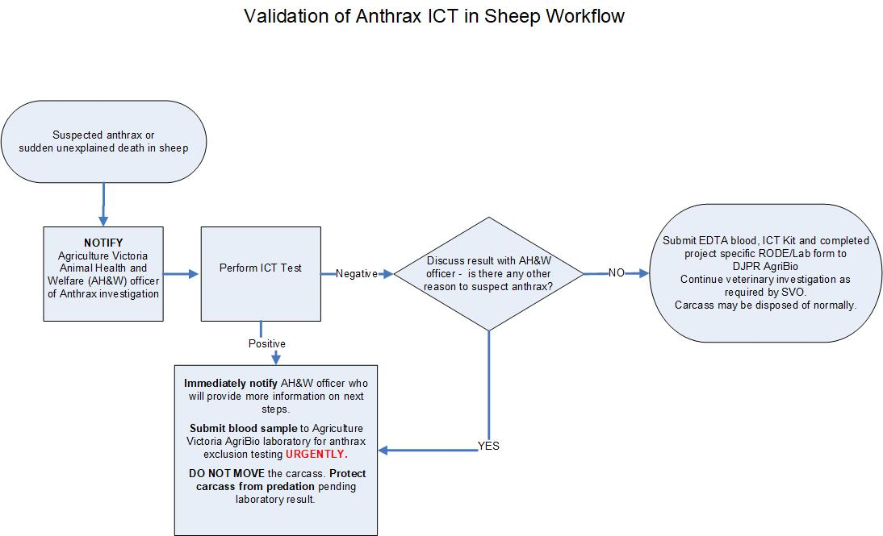Figure 1 Anthrax investigation flow chart.

Please send invoices to:

Email: South West – sw.ag@ecodev.vic.gov.au
South-East – se.ag@ecodev.vic.gov.au
Northern – northern.ag@ecodev.vic.gov.au

If you have any questions, please contact:

Julia Sarandopoulos  Research Project Manager  julia.sarandopoulos@agriculture.vic.gov.au  0429 223 407 | OR | Leanna Dries  Research Project Leader  leanna.dries@agriculture.vic.gov.au  0429 357 494

