Demonstration goal: To assess the practical use of drones to remotely monitor sheep welfare during lambing and at other critical times in the year, to see if the technology reduces time and labour costs.
Site location: Boort
Producer group: Boort BestWool/BestLamb (BWBL)
Group and demonstration coordinator: Erica Schelfhorst
Duration: 2018–2021

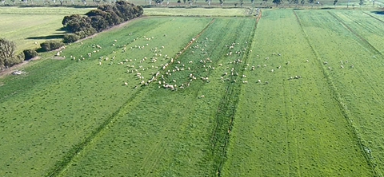

What are we aiming to achieve and why? Time is a valuable resource that many producers constantly lack. Time could be more effectively allocated to tasks if some of the more time/labour-consuming jobs were quicker to undertake.
The use of technology to save time and labour is an increasing area of interest for the Boort BWBL farmers.
Several group members have purchased time-saving devices such as auto-drafts and electronic identification equipment (to record weights, pregnancy status etc.) in order to reduce the time and labour costs associated with sheep handling and the collection of data that is used to make better on-farm decisions.

Drones have been marketed to farmers as a time-saving device. The Boort BWBL farmers were therefore interested in testing the effectiveness and practicality of using a drone to check sheep welfare during lambing and at other times of the year to determine if the drone did indeed save time.
Method
- Demonstrate and measure the practical uses of a drone used on-farm to:
- check sheep welfare at lambing
- identify the level of disturbance to the lambing ewe using a drone versus normal practice
- undertake other sheep husbandry tasks; for example, check the level and colour of water troughs in summer.
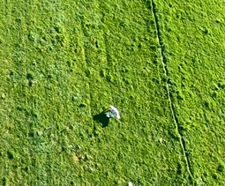
- Generate an accurate record of the time taken to check sheep during lambing using normal practice versus using a drone at 1) initial use and 2) once trained and skilled in flying a drone (e.g. a year later).
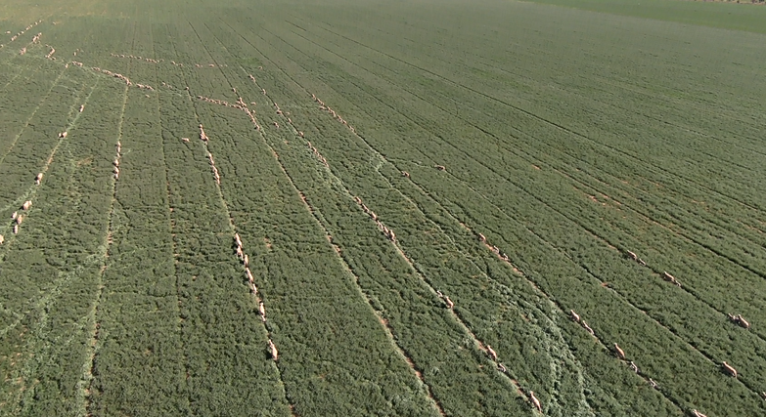
- Increase the technical skill and knowledge of producers in using and flying a drone.
Aerial view from drone, 2019

Partners: This demonstration is conducted with Agriculture Victoria and co-funded by Meat & Livestock Australia (MLA).
Ewe and twin lambs- view from drone
Contact
Erica Schelfhorst
E: Erica.Shelfhorst@agriculture.vic.gov.au
More information https://agriculture.vic.gov.au/support-and-resources/funds-grants-programs/farming-systems-demonstrations-program

Disclaimer
Any recommendations, suggestions or opinions contained in this publication do not necessarily represent the policy or views of Meat & Livestock Australia (MLA). No person should act on the basis of the contents of this publication without first obtaining specific, independent professional advice. MLA takes no responsibility, in any way whatsoever, to any person in respect to the document, including any errors or omissions therein, arising through negligence or otherwise however caused.
© Meat & Livestock Australia 2019 ABN 39 081 678 364
This work is copyright. Apart from any use permitted under the Copyright Act 1968, all rights are expressly reserved. Requests for further authorisation should be directed to the Corporate Communications Manager, PO Box 1961, North Sydney, NSW 2059 or info@mla.com.au.
Published in January 2020.

