Statistics of animal use in research and teaching, Victoria
1 January 2017 – 31 December 2017
Report No. 35

Published by Animal Welfare Victoria
Department of Jobs, Precincts and Regions
1 Spring Street Melbourne, Victoria 3000
June 2019
© Copyright State Government of Victoria 2018. This publication is copyright. No part may be reproduced by any process except in accordance with provisions of the Copyright Act 1968.
Authorised by the Victorian Government, Melbourne.
Print Managed by Finsbury Green
ISBN 978-1-76090-130-1 (pdf/online/MS word)
Accessibility
If you would like to receive this publication in an alternative format, please telephone
DJPR Customer Service Centre 136 186 or email sp.licensing@ecodev.vic.gov.au

Disclaimer
This publication may be of assistance to you, but the State of Victoria and its employees do not guarantee that the publication is without flaw of any kind or is wholly appropriate for your particular purposes and therefore disclaims all liability for any error, loss or other consequence which may arise from you relying on any information in this publication.
Table of Contents

Introduction 6
PART 1 NUMBER OF ANIMALS REPORTED AS USED IN 2017 7
1.1 Number of Animals Reported as Used, by Animal Type 7
1.2 Number of Animals Used, by Animal Type and Project Purpose 9
1.2.1 Animals Used to Understand Human / Animal Biology 13
1.2.2 Animals Used to Achieve Environmental Purposes 14
1.2.3 Animals Used for Improvement of Human / Animal Health / Welfare 15
1.2.4 Animals Used to Achieve Educational Purposes 16
1.2.5 Animals Used for Improvement of Animal Management / Production 17
1.3 Number of Animals Used by Animal Type by Source 18
1.4 Number of Animals Used, by Animal Type by Procedure Type 21
1.4.1 Number of Animals Used by Procedure and by Project Purpose 25
1.4.2 Number of Animals Used by Procedure Type and Procedure Impact 27
1.4.3 Number of Animals Used by Procedure Type and Procedure Benefit 29
1.5 Number of Animals Used, by Animal Type by Project Benefit 31
1.5.1 Number of Animals Used, by Project Impact by Project Benefit 35
1.6 Number of Animals Used and Animal Deaths 36
PART 2 ANIMAL USE STATISTICS FROM 2007 TO 2017 39
2.1 Number of Animals Used, 2007–2017 39
2.1.1 Animals Used in Scientific Procedures 39
2.2 Number of Specified Animals Used, 2007–2017 40
2.2.1. Number of Specified Mice Used, 2007–2017 40
2.2.2 Number of Specified Animals Excluding Mice and Non-human Primates, 2007 – 2017 41
2.2.3 Number of Specified Primates, 2007 – 2017 41
2.3 Number of Animals Used in Genetic Modification Procedures and Number of Projects 42
2.4 Number of Specified Animals in Breeding Colonies, by Animal Type, 2007–2017 42
2.5 Number of Licences and Projects 43

List of Tables

Table 1.1 Number of Animals Reported as Used by Animal Type 7
Table 1.2 Ten Most Used Animals in 2017 8
Table 1.3 Number of Animals Reported in Breeding Colonies 8
Table 1.4 Number of Animals Used by Animal Type and Project Purpose 9
Table 1.5 Number of Animals Used by Project Purpose 12
Table 1.6 Animals Used to Understand Human / Animal Biology 13
Table 1.7 Animals Used to Achieve Environmental Purposes 14
Table 1.8 Animals Used for Improvement of Human / Animal Health / Welfare 15
Table 1.9 Animals Used to Achieve Educational Purposes 16
Table 1.10 Animals for Improvement of Animal Management / Production 17
Table 1.11 Number of Animals Used by Animal Type by Source 18
Table 1.12 Number of Animals Used by Animal Type by Procedure Type 21
Table 1.13 Number of Animals Used by Procedure and by Project Purpose 25
Table 1.14 Number of Animals Used by Procedure Type and Impact 27
Table 1.15 Number of Animals Used by Procedure Type and Procedure Benefit 29
Table 1.16 Number of Animals Used by Animal Type by Project Benefit 31
Table 1.17 Number of Animals Used, by Project Impact by Project Benefit 35
Table 1.18 Number of Animals Used and Deaths by Type 36
Table 1.19 Number of Specified Animals Used and Deaths by Type 38
Table 2.1 Number of Non-Genetically Modified Specified Animals in Breeding Colonies by Animal Type, 2007–2017 42
Table 2.2 Number of Genetically Modified Specified Animals in Breeding Colonies by Animal Type, 2007–2017 43
Table 2.2 Number of Active Licences and Number of Projects, 2007–2017 43

List of Figures

Figure 1.1 Animals Used by Project Purpose 12
Figure 1.2 Animals Used to Understand Human / Animal Biology 13
Figure 1.3 Animals Used to Achieve Environmental Purposes 14
Figure 1.4 Animals Used for Improvement of Human / Animal Health / Welfare 15
Figure 1.5 Animals Used to Achieve Educational Purposes 16
Figure 1.6 Animals Used for Improvement of Animal Management / Production 17
Figure 1.7 Percentage of Animals Used by Impact 28
Figure 2.1 Number of Animals Used, 2007–2017 39
Figure 2.2 Percentage of Animals Used by Project Purpose, 2012–2017 39
Figure 2.3 Percentage of Animals Used by Procedure Type, 2012–2017 40
Figure 2.4 Number of Specified Mice Used, 2007–2017 40
Figure 2.5 Number of Specified Animals, Excluding Mice and Non-human Primates, 2007–2017 41
Figure 2.6 Number of Non-human Primates, 2007-2017 41
Figure 2.7 Number of Animals Used in Genetic Modification Procedures and Number of Projects, 2007–17 42
Figure 2.8 Number of Specified Mice in Breeding Colonies, 2007–2017 43

Introduction

Animal Welfare Victoria under the Department of Jobs, Precincts and Regions (DPJR), regulates and monitors the use of animals for research, teaching, and testing in Victoria. It safeguards the well-being of animals by granting licences only to individuals or institutions that meet DPJR’s licensing requirements; conducting audits to ensure that requirements under the Australian code for the care and use of animals for scientific purposes, 8th ed. 2013 are being met; providing advice on best practice in animal use in research, teaching and testing for scientific procedures; and providing training programs to stakeholders.
Each year, all individuals and organisations licensed under the Prevention of Cruelty to Animals Act 1986 are required to submit data on their use of animals for scientific procedures and breeding in compliance with Regulation 100 of the Prevention of Cruelty to Animals Regulations 2008. This reporting requirement is one of the several techniques in place that enables Animal Welfare Victoria to monitor animal welfare.
This report presents information on animal use of all licence holders in 2017. Part 1 presents animal use statistics in 2017, including the purpose, source, and deaths. Part 2 presents yearly statistics of animal use from 2007 to 2017.
This report informs the DPJR’s policy development and compliance programs and is a useful tool in informing the community about the nature and purpose of animal use in Victoria.
Further information on the data collected for this report may be found in the 2017 return guidelines, available at www.agriculture.vic.gov.au/ART.

PART 1 NUMBER OF ANIMALS REPORTED AS USED IN 2017

1.1 Number of Animals Reported as Used, by Animal Type
In 2017, a total of 1,571,374 animals were reported to be used for teaching, research, and testing (scientific procedures). The table below shows the number of animals used by type. This shows a 45% increase from 2016’s animal use figure of 1,080,136. This increase is attributed to the 125% increase in the number of fishes used (from 294,950 in 2016 to 666,089 in 2017) and the 954% increase in the number of amphibians used (from 3,713 in 2016 to 39,146 in 2017).
‘Specified animals’ are guinea pigs, rats, mice, and rabbits not bred in their native habitat; and non-human primates. Only licensed breeders can supply these species to research organisations for use in projects.

Table 1.1 Number of Animals Reported as Used by Animal Type

Animal Type | Number of animals
*Guinea pig (lab) | 4,020
*Macaques | 104
*Marmosets | 122
*Mouse (lab) | 521,636
*Primates other | 1
*Rabbit (lab) | 1,680
*Rat (lab) | 20,859
Amphibians | 39,146
Bird exotic captive | 10
Bird exotic wild | 747
Bird native captive | 376
Bird native wild | 57,536
Bird other | 37
Cats (non-wild) | 538
Cats (wild) | 43
Cattle | 27,362
Cephalopods | 124
Crustaceans | 16,065
Dasyurids | 1,163
Dogs (non-wild) | 4,469
Dogs, foxes (wild) | 853
Exotic feral mammal other | 625
Exotic Zoo mammal | 34
Ferret (lab) | 1,018
Fish | 666,089
Goats (domestic) | 1,629
Hares (wild) | 31
Horses (domestic) | 551
Koalas | 824
Laboratory mammal other | 2,636
Lizards | 3,177
Macropods | 2,817
Mice (wild) | 1,358
Monotremes | 69
Native mammal other | 1,518
Native Rats, Mice | 1,627
Other domestic mammals | 2,149
Pigs (domestic) | 4,699
Possums, Gliders | 1,784
Poultry | 90,488
Rabbits (wild) | 1,015
Rats (wild) | 341
Reptile other | 4
Seals, Sealions | 2,971
Sheep (domestic) | 86,719
Snakes | 63
Tortoises/ turtle | 81
Whales, Dolphins | 166
Total | 1,571,374
*Specified animals.
The 10 most used animals in 2017 are listed in Table 1.2 below.

Table 1.2 Ten Most Used Animals in 2017
Row Labels | Number of animals
Fish | 666,089
*Mouse (lab) | 521,636
Poultry | 90,488
Sheep (domestic) | 86,719
Bird native wild | 57,536
Amphibians | 39,146
Cattle (domestic) | 27,360
*Rat (lab) | 20,859
Crustaceans | 16,065
Pigs (domestic) | 4,699
*Specified animals.

The total reported number of specified animals in breeding colonies was 1,524,439. The table below shows the number of specified animals in breeding colonies, excluding the offspring supplied to research or teaching projects (these are recorded in Table 1.1).

Table 1.3 Number of Animals Reported in Breeding Colonies
Animal Type | Number of animals
*Guinea pig (lab) | 48
*Macaques | 476
*Marmosets | 744
*Mouse (lab) | 1,479,459
*Rabbit (lab) | 86
*Rat (lab) | 43,626
Total | 1,524,439
*Specified animals.

1.2 Number of Animals Used, by Animal Type and Project Purpose

Of the total 1,571,374 animals used for scientific purposes, 679,260 were used for understanding human / animal biology; 477,224 were used for pursuing environmental objectives; 225,688 for maintenance / improvement of human / animal health / welfare; 110,932 for achieving educational objectives; and 78,270 for improving animal management / production. The animals used for each purpose is presented in the table below.

Table 1.4 Number of Animals Used by Animal Type and Project Purpose
Animal Type | Educational objectives | Environmental objectives | Improve animal  management/production | Maintenance/improvement human/animal health/welfare | Understand human/animal biology | Total
*Guinea pig (lab) | 141 |  |  | 3,635 | 244 | 4,020
*Macaques |  |  |  | 44 | 60 | 104
*Marmosets |  |  |  | 1 | 121 | 122
*Mouse (lab) | 10,376 | 30 | 5,615 | 125,123 | 380,492 | 521,636
*Primates other |  |  |  | 1 |  | 1
*Rabbit (lab) | 57 |  | 14 | 1,203 | 406 | 1,680
*Rat (lab) | 1,345 | 32 | 170 | 7,930 | 11,382 | 20,859
Amphibians | 1,408 | 12,975 | 818 | 66 | 23,879 | 39,146
Bird exotic captive |  |  |  |  | 10 | 10
Bird exotic wild |  | 747 |  |  |  | 747
Bird native captive | 85 | 157 |  | 76 | 58 | 376
Bird native wild | 10,068 | 38,304 |  | 228 | 8,936 | 57,536
Bird other | 2 |  |  | 35 |  | 37
Cats (non-wild) | 356 | 3 | 9 | 155 | 15 | 538
Cats (wild) | 12 | 15 | 16 |  |  | 43
Cattle | 3,542 | 110 | 17,856 | 5,692 | 162 | 27,362
Cephalopods | 3 | 30 | 85 |  | 6 | 124
Crustaceans | 185 | 2,400 | 13,463 |  | 17 | 16,065
Dasyurids | 51 | 1,070 | 20 |  | 22 | 1,163
Dogs (non-wild) | 1,587 | 2,062 | 141 | 456 | 223 | 4,469
Dogs, foxes (wild) | 15 | 836 |  | 2 |  | 853
Exotic feral mammal other |  | 625 |  |  |  | 625
Exotic Zoo mammal |  |  | 3 | 31 |  | 34
Ferret (lab) | 8 |  |  | 1,010 |  | 1,018
Fish | 4,233 | 404,708 | 9,606 | 3,888 | 243,654 | 666,089
Goats (domestic) | 37 |  | 999 | 593 |  | 1,629
Hares (wild) | 1 | 30 |  |  |  | 31
Horses (domestic) | 217 |  | 23 | 230 | 81 | 551
Koalas | 83 | 591 | 30 | 3 | 117 | 824
Laboratory mammal other |  |  |  | 460 | 2,176 | 2,636
Lizards | 124 | 1,112 |  |  | 1,941 | 3,177
Macropods | 115 | 2,346 |  | 16 | 340 | 2,817
Mice (wild) | 151 | 934 |  | 273 |  | 1,358
Monotremes | 5 | 63 |  |  | 1 | 69
Native mammal other | 215 | 1,043 | 17 | 208 | 35 | 1,518
Native Rats, Mice | 342 | 1,259 |  | 12 | 14 | 1,627
Other domestic mammals | 128 | 1 | 2,000 | 20 |  | 2,149
Pigs (domestic) | 189 |  | 3,648 | 675 | 187 | 4,699
Possums, Gliders | 165 | 1,447 |  | 172 |  | 1,784
Poultry | 25,262 | 252 | 5,716 | 55,733 | 3,525 | 90,488
Rabbits (wild) | 22 | 673 | 320 |  |  | 1,015
Rats (wild) | 214 | 127 |  |  |  | 341
Reptile other | 4 |  |  |  |  | 4
Seals, Sealions |  | 2,971 |  |  |  | 2,971
Sheep (domestic) | 50,154 | 15 | 17,685 | 17,713 | 1,152 | 86,719
Snakes |  | 59 |  | 2 | 2 | 63
Tortoises/ turtle | 30 | 33 | 16 | 2 |  | 81
Whales, Dolphins |  | 164 |  |  | 2 | 166
Total | 110,932 | 477,224 | 78,270 | 225,688 | 679,260 | 1,571,374
*Specified animals.

Table 1.5 Number of Animals Used by Project Purpose
Project Purpose | Number of animals
Understand human/animal biology | 679,260
Environmental objectives | 477,224
Maintenance/improvement human/animal health/welfare | 225,688
Educational objectives | 110,932
Improve animal management/production | 78,270
Total | 1,571,374

Figure 1.1 Animals Used by Project Purpose

The 10 most used animals for each objective was chosen for analysis purposes. The most used animal for activities relating to the improvement of human and animal health and welfare and for understanding human and animal biology was the laboratory mouse. Fish and native wild bird were used most for activities relating to environmental purposes, while the domestic sheep was used most for educational purposes and for the improvement of animal management and production.

1.2.1 Animals Used to Understand Human / Animal Biology
The 10 most used animals for activities relating to the understanding of human and animal biology are presented below.

Table 1.6 Animals Used to Understand Human / Animal Biology
Animal Used | Number of animals
*Mouse (lab) | 380,492
Fish | 243,654
Amphibians | 23,879
*Rat (lab) | 11,382
Bird native wild | 8,936
Poultry | 3,525
Laboratory mammal other | 2,176
Lizards | 1,941
Sheep (domestic) | 1,152
*Rabbit (lab) | 406
*Specified animals.

Figure 1.2 Animals Used to Understand Human / Animal Biology
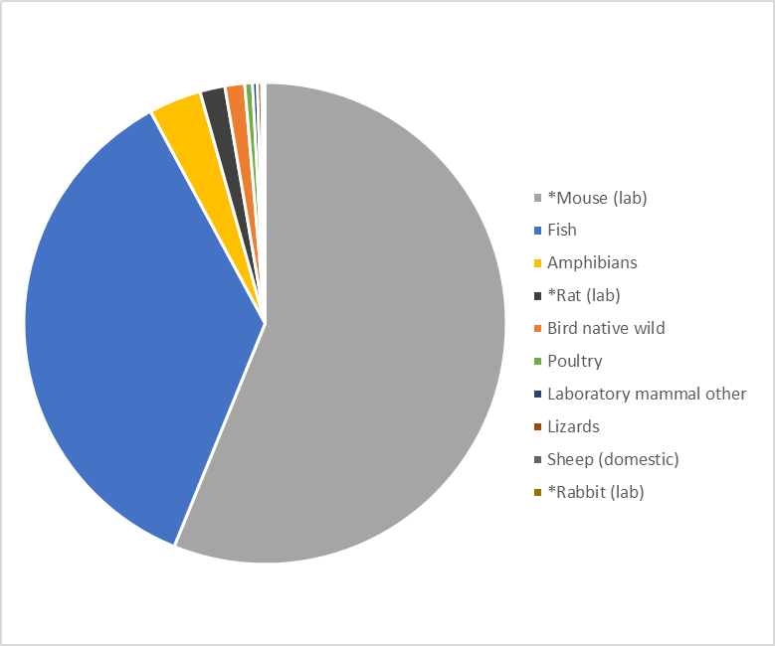
*Specified animals.

1.2.2 Animals Used to Achieve Environmental Purposes
The 10 most used animals for environmental purposes are presented below.

Table 1.7 Animals Used to Achieve Environmental Purposes
Animal Type | Number of animals
Fish | 404,708
Bird native wild | 38,304
Amphibians | 12,975
Seals, Sealions | 2,971
Crustaceans | 2,400
Macropods | 2,346
Dogs (non-wild) | 2,062
Possums, Gliders | 1,447
Native Rats, Mice | 1,259
Lizards | 1,112

Figure 1.3 Animals Used to Achieve Environmental Purposes
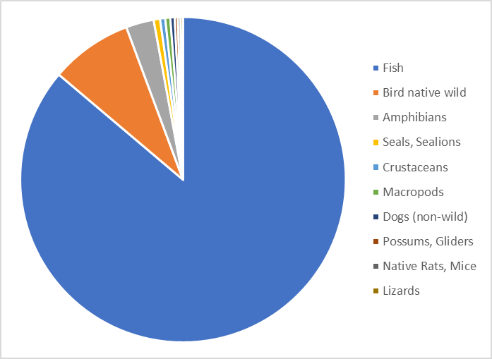

1.2.3 Animals Used for Improvement of Human / Animal Health / Welfare
The 10 most used animals for activities relating to the improvement human and animal health and welfare are presented below.

Table 1.8 Animals Used for Improvement of Human / Animal Health / Welfare
Animal Type | Number of animals
*Mouse (lab) | 125,123
Poultry | 55,733
Sheep (domestic) | 17,713
*Rat (lab) | 7,930
Cattle (domestic) | 5,694
Fish | 3,888
*Guinea pig (lab) | 3,635
*Rabbit (lab) | 1,203
Ferret (lab) | 1,010
Pigs (domestic) | 675
*Specified animals.

Figure 1.4 Animals Used for Improvement of Human / Animal Health / Welfare
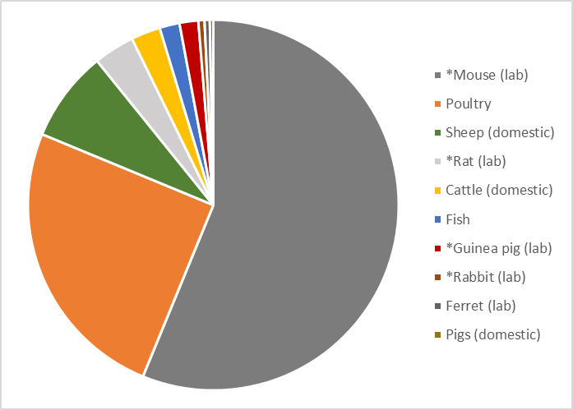
*Specified animals.

1.2.4 Animals Used to Achieve Educational Purposes
The 10 most used animals to achieve educational purposes are presented below.

Table 1.9 Animals Used to Achieve Educational Purposes
Animal Type | Number of animals
Sheep (domestic) | 50,154
Poultry | 25,262
*Mouse (lab) | 10,376
Bird native wild | 10,068
Fish | 4,233
Cattle (domestic) | 3,542
Dogs (non-wild) | 1,587
Amphibians | 1,408
*Rat (lab) | 1,345
Cats (non-wild) | 356
*Specified animals.

Figure 1.5 Animals Used to Achieve Educational Purposes
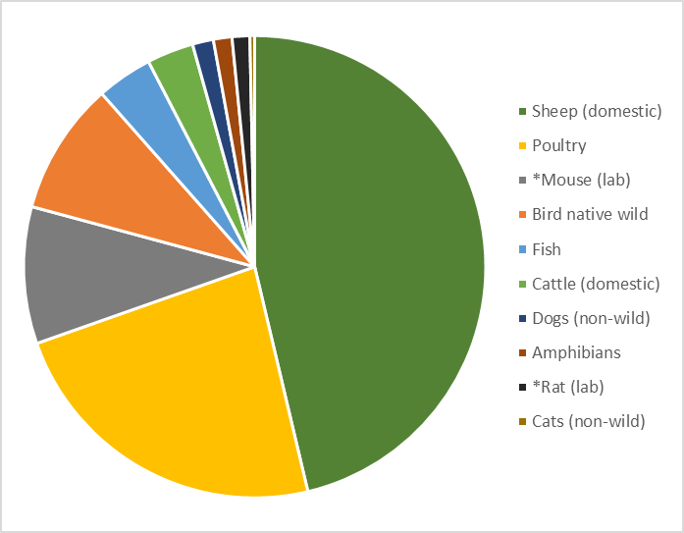*Specified animals.

1.2.5 Animals Used for Improvement of Animal Management / Production

The top 10 animals used for activities for the improvement of animal management and production are presented below.

Table 1.10 Animals for Improvement of Animal Management / Production
Row Labels | Number of animals
Cattle (domestic) | 17,856
Sheep (domestic) | 17,685
Crustaceans | 13,463
Fish | 9,606
Poultry | 5,716
*Mouse (lab) | 5,615
Pigs (domestic) | 3,648
Other domestic mammals | 2,000
Goats (domestic) | 999
Amphibians | 818
*Specified animals.

Figure 1.6 Animals Used for Improvement of Animal Management / Production
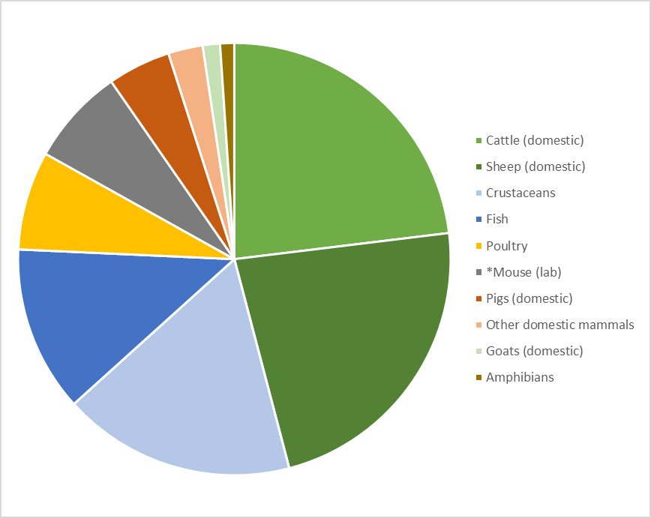*Specified animals.

1.3 Number of Animals Used by Animal Type by Source
The animals used for scientific research, teaching and testing come from various sources. In 2017, around 43.1% of the animals used for scientific purposes came from the animals’ natural habitat; followed by specified animals bred by the licence holder for their own supply at around 34.7%; and privately-owned animals on farms at 8.1%.

Table 1.11 Number of Animals Used by Animal Type by Source
Animal Type | *Interstate Licenced Supplier | *Overseas Supplier | *Vic SABL Supplier | Animals in their natural habitat |  | Australian captive colony/zoo |  | Commercial supplier | Municipal pound | Other source | Own Derivation | Private donation | Privately owned animals on a farm | Removed from Aust. natural habitat |  | Total
*Guinea pig (lab) | 26 |  | 124 |  |  |  |  |  |  |  | 3,870 |  |  |  |  | 4,020
*Macaques |  |  | 40 |  |  |  |  |  |  |  | 64 |  |  |  |  | 104
*Marmosets |  |  | 109 |  |  |  |  |  |  |  | 13 |  |  |  |  | 122
*Mouse (lab) | 35,259 | 5,408 | 58,990 |  |  |  |  |  |  | 2,227 | 419,752 |  |  |  |  | 521,636
*Primates other |  |  |  |  |  |  |  |  |  | 1 |  |  |  |  |  | 1
*Rabbit (lab) | 394 | 99 | 394 |  |  |  |  |  |  |  | 793 |  |  |  |  | 1,680
*Rat (lab) | 6,817 |  | 6,210 |  |  |  |  |  |  | 269 | 7,563 |  |  |  |  | 20,859
Amphibians |  |  |  | 35,842 |  | 11 |  | 513 |  |  | 829 |  |  | 1,951 |  | 39,146
Bird exotic captive |  |  |  |  |  |  |  |  |  |  |  | 10 |  |  |  | 10
Bird exotic wild |  |  |  | 747 |  |  |  |  |  |  |  |  |  |  |  | 747
Bird native captive |  |  |  | 18 |  | 191 |  | 77 |  |  |  | 80 |  | 10 |  | 376
Bird native wild |  |  |  | 57,422 |  | 4 |  |  |  |  |  |  |  | 110 |  | 57,536
Bird other |  |  |  |  |  |  |  |  |  | 2 | 0 |  | 35 |  |  | 37
Cats (non-wild) |  |  |  | 3 |  |  |  | 4 | 35 | 344 | 135 |  | 17 |  |  | 538
Cats (wild) |  |  |  | 43 |  |  |  |  |  |  |  |  |  |  |  | 43
Cattle |  |  |  |  |  |  |  |  |  |  |  | 2 |  |  |  | 2
Cattle (domestic) |  |  |  |  |  |  |  | 606 |  | 92 | 11,970 | 5 | 14,687 |  |  | 27,360
Cephalopods |  |  |  | 30 |  |  |  |  |  |  |  |  |  | 94 |  | 124
Crustaceans |  |  |  | 2,316 |  |  |  | 4,341 |  |  |  |  |  | 9,408 |  | 16,065
Dasyurids |  |  |  | 1,129 |  | 28 |  |  |  |  | 6 |  |  |  |  | 1,163
Dogs (non-wild) |  |  |  | 2,046 |  |  |  |  | 2 | 1,097 | 813 | 146 | 365 |  |  | 4,469
Dogs, foxes (wild) |  |  |  | 853 |  |  |  |  |  |  |  |  |  |  |  | 853
Exotic feral mammal other |  |  |  | 625 |  |  |  |  |  |  |  |  |  |  |  | 625
Exotic Zoo mammal |  |  |  |  |  | 34 |  |  |  |  |  |  |  |  |  | 34
Ferret (lab) |  |  |  |  |  |  |  | 1,018 |  |  | 0 |  |  |  |  | 1,018
Fish |  |  |  | 561,308 |  | 4 |  | 7,789 |  | 2,192 | 83,208 |  | 45 | 11,543 |  | 666,089
Goats (domestic) |  |  |  |  |  |  |  | 32 |  | 5 |  |  | 1,592 |  |  | 1,629
Hares (wild) |  |  |  | 31 |  |  |  |  |  |  |  |  |  |  |  | 31
Horses (domestic) |  |  |  |  |  |  |  | 91 |  | 150 | 152 | 24 | 134 |  |  | 551
Koalas |  |  |  | 815 |  | 3 |  |  |  |  |  |  |  | 6 |  | 824
Laboratory mammal other |  |  |  |  |  |  |  |  |  |  | 2,636 |  |  |  |  | 2,636
Lizards |  |  |  | 1,375 |  |  |  | 0 |  |  | 135 |  |  | 1,667 |  | 3,177
Macropods |  |  |  | 2,326 |  | 413 |  |  |  |  | 78 |  |  |  |  | 2,817
Mice (wild) |  |  |  | 1,358 |  |  |  |  |  |  |  |  |  |  |  | 1,358
Monotremes |  |  |  | 69 |  |  |  |  |  |  |  |  |  |  |  | 69
Native mammal other |  |  |  | 1,488 |  | 24 |  |  |  |  |  |  |  | 6 |  | 1,518
Native Rats, Mice |  |  |  | 1,546 |  | 12 |  |  |  | 57 |  |  |  | 12 |  | 1,627
Other domestic mammals |  |  |  |  |  |  |  |  |  | 132 | 17 |  | 2,000 |  |  | 2,149
Pigs (domestic) |  |  |  |  |  |  |  | 1,157 |  | 200 | 172 |  | 3,170 |  |  | 4,699
Possums, Gliders |  |  |  | 1,586 |  | 2 |  |  |  | 172 |  |  |  | 24 |  | 1,784
Poultry |  |  |  |  |  |  |  | 56,314 |  | 33 | 7,100 |  | 27,041 |  |  | 90,488
Rabbits (wild) |  |  |  | 628 |  |  |  |  |  | 368 |  |  | 19 |  |  | 1,015
Rats (wild) |  |  |  | 341 |  |  |  |  |  |  |  |  |  |  |  | 341
Reptile other |  |  |  | 4 |  |  |  |  |  |  | 0 |  |  |  |  | 4
Seals, Sealions |  |  |  | 2,971 |  |  |  |  |  |  |  |  |  |  |  | 2,971
Sheep (domestic) |  |  |  |  |  |  |  | 2,590 |  | 541 | 5,509 |  | 78,079 |  |  | 86,719
Snakes |  |  |  | 61 |  |  |  | 0 |  |  |  |  |  | 2 |  | 63
Tortoises/ turtle |  |  |  | 48 |  | 2 |  |  |  | 30 |  |  |  | 1 |  | 81
Whales, Dolphins |  |  |  | 166 |  |  |  |  |  |  |  |  |  |  |  | 166
Grand Total | 42,496 | 5,507 | 65,867 |  | 677,195 |  | 728 | 74,532 | 37 | 7912 | 544,815 | 267 | 127,184 |  | 24,834 |  | 1,571,374
*Specified animals.

1.4 Number of Animals Used, by Animal Type by Procedure Type

The procedures conducted on animals depend on several factors such as the purpose of the project, the field of study or research, or new technologies developed. Before these procedures are conducted on animals, these procedures must be reviewed and approved by the nominated Animal Ethics Committee under strict parameters prescribed under the Australian code for the care and use of animals for scientific purposes, 8th ed. 2013.

Table 1.12 Number of Animals Used by Animal Type by Procedure Type
Animal Type | Attachment/insertion of devices for long-term monitoring | Aversive stimuli for behavioural training or stress integral to experiment | Gene manipulative technology | Immunomodulatory methods | In vivo production of monoclonal antibody | In vivo production of polyclonal antibody | Induction of infection | Induction of neoplasia | Induction of other disease model e.g. diabetes, cardiac disease | Interference with the central nervous system or sensory capacity or controlling brain centres | Ionising radiation exposure | Neuromuscular blocking agents or electro-immobilisation |  | Other procedure | Skin irritancy test of chemical, cosmetic or other preparation | Toxicity testing | Total
*Guinea pig (lab) | 171 |  |  | 36 |  |  | 1,033 |  | 14 | 128 |  |  |  | 2,484 |  | 154 | 4,020
*Macaques | 6 |  |  |  |  |  | 30 |  | 35 |  |  | 2 |  | 31 |  |  | 104
*Marmosets | 5 |  |  |  |  |  |  |  |  | 92 |  | 13 |  | 12 |  |  | 122
*Mouse (lab) | 795 | 2,310 | 34,241 | 28,750 | 709 | 1,098 | 80,315 | 71,955 | 57,938 | 4,484 | 17248 |  |  | 220,706 | 65 | 1,022 | 521,636
*Primates other |  |  |  |  |  |  |  |  |  |  |  |  |  | 1 |  |  | 1
*Rabbit (lab) |  |  | 39 | 684 | 24 | 378 |  |  | 28 |  |  |  |  | 527 |  |  | 1,680
*Rat (lab) | 1,047 | 1,720 | 278 |  | 247 | 6 |  |  | 4,024 | 1,223 |  |  |  | 11,876 | 20 | 418 | 20,859
Amphibians |  |  |  |  |  |  |  |  |  |  |  |  |  | 39,146 |  |  | 39,146
Bird exotic captive | 10 |  |  |  |  |  |  |  |  |  |  |  |  |  |  |  | 10
Bird exotic wild |  |  |  |  |  |  |  |  |  |  |  |  |  | 747 |  |  | 747
Bird native captive | 119 | 79 |  | 32 |  |  |  |  |  |  |  |  |  | 146 |  |  | 376
Bird native wild | 3,189 |  |  |  |  |  |  |  |  |  |  |  |  | 54,347 |  |  | 57,536
Bird other |  |  |  |  |  |  |  |  |  |  |  |  |  | 37 |  |  | 37
Cats (non-wild) | 60 |  |  |  |  |  |  |  |  | 9 |  | 4 |  | 465 |  |  | 538
Cats (wild) |  |  |  |  |  |  |  |  |  |  |  |  |  | 43 |  |  | 43
Cattle (domestic) | 115 | 770 |  | 694 |  | 20 | 142 |  |  |  |  |  |  | 25,621 |  |  | 27,362
Cephalopods |  | 6 |  |  |  |  |  |  |  |  |  |  |  | 118 |  |  | 124
Crustaceans | 7,091 |  |  |  |  |  |  |  |  |  |  |  |  | 8,974 |  |  | 16,065
Dasyurids | 11 |  |  |  |  |  | 8 |  |  |  |  |  |  | 1,144 |  |  | 1,163
Dogs (non-wild) |  | 8 |  | 2 |  |  |  |  |  |  |  |  |  | 4,457 |  | 2 | 4,469
Dogs, foxes (wild) | 2 |  |  |  |  |  |  |  |  |  |  |  |  | 851 |  |  | 853
Exotic feral mammal other |  |  |  |  |  |  |  |  |  |  |  |  | 625 |  |  |  | 625
Exotic Zoo mammal |  |  |  |  |  |  |  |  |  |  |  |  |  | 34 |  |  | 34
Ferret (lab) |  |  |  |  |  |  | 1,010 |  |  |  |  |  |  | 8 |  |  | 1,018
Fish | 9,529 | 26 | 63,810 |  |  |  | 922 | 242 | 298 |  |  |  |  | 585,843 |  | 5,419 | 666,089
Goats (domestic) |  |  |  |  |  |  |  |  |  |  |  |  |  | 1,629 |  |  | 1,629
Hares (wild) |  |  |  |  |  |  |  |  |  |  |  |  |  | 31 |  |  | 31
Horses (domestic) |  |  |  | 18 |  | 85 |  |  |  |  | 29 |  |  | 413 |  | 6 | 551
Koalas | 46 |  |  |  |  |  |  |  |  |  |  |  |  | 778 |  |  | 824
Laboratory mammal other |  |  |  | 44 |  |  |  |  | 166 |  |  |  | 2,426 |  |  |  | 2,636
Lizards |  |  |  |  |  |  |  |  |  |  |  |  |  | 3,177 |  |  | 3,177
Macropods | 28 |  |  |  |  |  |  |  |  |  |  |  |  | 2,789 |  |  | 2,817
Mice (wild) | 135 |  |  |  |  |  |  |  |  |  |  |  |  | 1,223 |  |  | 1,358
Monotremes | 31 |  |  |  |  |  |  |  |  |  |  |  |  | 38 |  |  | 69
Native mammal other | 697 | 15 |  |  |  |  |  |  |  |  |  |  |  | 806 |  |  | 1,518
Native Rats, Mice | 145 |  |  |  |  |  |  |  |  |  |  |  |  | 1,482 |  |  | 1,627
Other domestic mammals |  |  |  |  |  |  |  |  |  |  |  |  | 2,149 |  |  |  | 2,149
Pigs (domestic) | 15 | 64 | 120 | 94 |  | 6 | 801 |  |  |  | 28 |  |  | 3,565 |  | 6 | 4,699
Possums, Gliders | 201 |  |  |  |  |  |  |  |  |  |  |  |  | 1,583 |  |  | 1,784
Poultry |  |  | 3,448 | 837 |  | 3 | 54,821 |  |  |  |  |  |  | 31,379 |  |  | 90,488
Rabbits (wild) |  |  |  |  |  |  |  |  |  |  |  |  |  | 1,015 |  |  | 1,015
Rats (wild) |  |  |  |  |  |  |  |  |  |  |  |  |  | 341 |  |  | 341
Reptile other |  |  |  |  |  |  |  |  |  |  |  |  |  | 4 |  |  | 4
Seals, Sealions | 16 |  |  |  |  |  |  |  |  |  |  |  |  | 2955 |  |  | 2971
Sheep (domestic) | 2,055 |  | 18 |  | 10 |  | 102 |  | 237 | 42 | 14 |  |  | 84121 |  | 120 | 86719
Snakes |  |  |  |  |  |  |  |  |  |  |  |  |  | 63 |  |  | 63
Tortoises/ turtle | 1 |  |  |  |  |  |  |  |  |  |  |  |  | 80 |  |  | 81
Whales, Dolphins |  |  |  |  |  |  |  |  |  |  |  |  |  | 166 |  |  | 166
Total | 25,520 | 4,998 | 101,954 | 31191 | 990 | 1,596 | 139,184 | 72197 | 62,740 | 5,978 | 17,319 | 19 |  | 1,100,456 | 85 | 7,147 | 1,571,374
*Specified animals.

1.4.1 Number of Animals Used by Procedure and by Project Purpose

Table 1.13 Number of Animals Used by Procedure and by Project Purpose
Procedure | Educational objectives | Environmental objectives | Improve animal management/  production | Maintenance/ improvement human/ animal health/welfare | Understand human/ animal biology | Total
Other procedure | 106,943 | 466,626 | 60,102 | 77,621 | 389,164 | 1,100,456
Induction of infection | 4 | 922 | 4,913 | 77,106 | 56,239 | 139,184
Gene manipulative technology |  |  | 1,330 | 15,236 | 85,388 | 101,954
Induction of neoplasia |  |  |  | 24,016 | 48,181 | 72,197
Induction of other disease model e.g. diabetes, cardiac disease | 80 |  |  | 16,395 | 46,265 | 62,740
Immunomodulatory methods |  |  | 500 | 6,802 | 23,889 | 31,191
Attachment/insertion of devices for long-term monitoring | 3,783 | 9,457 | 8,840 | 700 | 2,740 | 25,520
Ionising radiation exposure | 42 |  |  | 2,066 | 15,211 | 17,319
Toxicity testing |  | 131 | 1,800 | 1,334 | 3,882 | 7,147
Interference with the central nervous system or sensory capacity or controlling brain centres | 54 |  |  | 1,570 | 4,354 | 5,978
Aversive stimuli for behavioural training or stress integral to experiment | 26 | 43 | 785 | 2,074 | 2,070 | 4,998
In vivo production of polyclonal antibody |  |  |  | 662 | 934 | 1,596
In vivo production of monoclonal antibody |  |  |  | 66 | 924 | 990
Skin irritancy test of chemical, cosmetic or other preparation |  | 45 |  | 40 |  | 85
Neuromuscular blocking agents or electro-immobilisation |  |  |  |  | 19 | 19
Total | 110,932 | 477,224 | 78,270 | 225,688 | 679,260 | 1,571,374

1.4.2 Number of Animals Used by Procedure Type and Procedure Impact

Table 1.14 Number of Animals Used by Procedure Type and Impact
Procedure Impact | Attachment/insertion of devices for long-term monitoring | Aversive stimuli for behavioural training or stress integral to experiment | Gene manipulative technology | Immunomodulatory methods | In vivo production of monoclonal antibody | In vivo production of polyclonal antibody | Induction of infection | Induction of neoplasia | Induction of other disease model e.g. diabetes, cardiac disease | Interference with the central nervous system or sensory capacity or controlling brain centres | Ionising radiation exposure | Neuromuscular blocking agents or electro-immobilisation | Other procedure | Skin irritancy test of chemical, cosmetic or other preparation | Toxicity testing | Total
Minor conscious intervention | 16,534 | 1,459 | 11,029 | 8,040 | 149 | 179 | 1,764 | 5,430 | 8,015 | 1,178 | 209 |  | 595,506 |  | 90 | 649,582
Observational study involving minor interference | 5,308 | 2,524 | 77,295 | 535 |  |  | 1,186 | 14,624 | 2,209 | 279 | 29 |  | 301,325 |  | 618 | 405,932
Animal unconscious without recovery | 159 | 6 | 7,736 | 5,536 | 32 | 2 | 24,188 | 555 | 6,194 | 283 | 154 | 12 | 117,410 |  | 3,510 | 1657,77
Minor physiological challenge | 99 | 243 | 653 | 7,842 | 119 | 724 | 72,358 | 7,914 | 8,839 |  | 2,173 |  | 42,926 | 85 | 2,495 | 146,470
Moderate to major physiological  challenge |  | 339 | 1,236 | 5,228 | 690 | 389 | 36,120 | 30,018 | 13,825 | 1,540 | 14,010 |  | 11,827 |  | 403 | 115,625
Minor operative procedures with recovery | 1,090 | 65 | 2,055 | 3,871 |  | 296 | 1,139 | 6,168 | 6,149 | 350 | 648 |  | 21,657 |  | 10 | 43,498
Surgery with recovery | 2,330 | 362 | 1,950 | 139 |  | 6 | 59 | 7,488 | 17,410 | 2,348 | 96 | 7 | 6,403 |  | 21 | 38,619
Death as an endpoint |  |  |  |  |  |  | 2,370 |  | 99 |  |  |  | 3,402 |  |  | 5,871
Total | 25,520 | 4,998 | 101,954 | 31,191 | 990 | 1,596 | 139,184 | 72,197 | 62,740 | 5,978 | 17,319 | 19 | 1,100,456 | 85 | 7,147 | 1,571,374

In 2017, 41% of the animals used for scientific research, testing and teaching underwent minor conscious intervention and 26% were used for observational study involving minor interference. Nine percent of the total animals used underwent minor physiological challenge while 3% underwent minor operative procedures and 3% underwent surgery with recovery. Eleven percent of the animals underwent terminal procedures under anaesthesia.

Figure 1.7 Percentage of Animals Used by Impact

1.4.3 Number of Animals Used by Procedure Type and Procedure Benefit

Table 1.15 Number of Animals Used by Procedure Type and Procedure Benefit
Procedure | Development of techniques | Diseases- animal | Diseases- human | Diseases- zoonotic | Domestic animal management/ production | Education (demonstration) | Environmental monitoring/ecology | Fundamental biology/physiology | Production of biological products | Regulatory product testing | Training (student use of animals) | Vertebrate pest management | Wildlife management/ conservation | Xenotransplantation | Total
Other procedure | 1,787 | 14,082 | 120,171 | 3,476 | 54,413 | 51,536 | 458,811 | 123,416 | 4,141 | 979 | 41,288 | 1,227 | 225,129 |  | 1,100,456
Induction of infection | 426 | 9,527 | 68,260 | 1,999 |  | 4 |  | 32,273 | 19,092 | 6,681 |  | 922 |  |  | 139,184
Gene manipulative technology | 413 | 1,009 | 21,036 | 185 |  |  |  | 78,910 | 401 |  |  |  |  |  | 101,954
Induction of neoplasia | 509 | 100 | 60,303 |  |  |  |  | 10,650 |  |  |  |  |  | 635 | 72,197
Induction of other disease model e.g. diabetes, cardiac disease | 260 | 308 | 56,717 |  |  |  |  | 5,373 | 82 |  |  |  |  |  | 62,740
Immunomodulatory methods |  | 1,472 | 10,093 | 50 | 500 |  |  | 18,509 |  | 567 |  |  |  |  | 31,191
Attachment/insertion of devices for long-term monitoring | 3,533 | 6 | 1,506 |  | 1,846 |  | 6,064 | 1,489 | 43 | 25 | 41 |  | 10,967 |  | 25,520
Ionising radiation exposure |  | 18 | 3,957 |  | 29 | 42 |  | 13,273 |  |  |  |  |  |  | 17,319
Toxicity testing |  | 600 | 896 |  |  |  | 119 | 5,482 | 10 | 40 |  |  |  |  | 7,147
Interference with the central nervous system or sensory capacity or controlling brain centres | 31 |  | 3,378 |  |  | 54 |  | 2,515 |  |  |  |  |  |  | 5,978
Aversive stimuli for behavioural training or stress integral to experiment |  |  | 2,230 |  | 834 |  | 8 | 1,832 |  |  |  |  | 94 |  | 4998
In vivo production of polyclonal antibody |  | 226 | 587 | 12 |  |  |  | 456 | 315 |  |  |  |  |  | 1596
In vivo production of monoclonal antibody |  |  | 66 |  |  |  |  | 268 | 656 |  |  |  |  |  | 990
Skin irritancy test of chemical, cosmetic or other preparation |  |  | 40 |  |  |  |  |  |  | 45 |  |  |  |  | 85
Neuromuscular blocking agents or electro-immobilisation |  |  |  |  |  |  |  | 19 |  |  |  |  |  |  | 19
Total | 6,959 | 27,348 | 349,240 | 5,722 | 57,622 | 51,636 | 465,002 | 294,465 | 24,740 | 8,337 | 41,329 | 2,149 | 236,190 | 635 | 1,571,374

1.5 Number of Animals Used, by Animal Type by Project Benefit

Table 1.16 Number of Animals Used by Animal Type by Project Benefit
Animal Type | Development of techniques | Diseases- animal | Diseases- human | Diseases- zoonotic | Domestic animal management/production | Education (demonstration) | Environmental monitoring/ecology | Fundamental biology/physiology | Production of biological products | Regulatory product testing | Training (student use of animals) | Vertebrate pest management | Wildlife management/conservation | Xenotransplantation | Total
Fish | 3,448 |  | 681 |  | 2,658 | 313 | 400,520 | 83,612 |  |  | 446 | 922 | 173,489 |  | 666,089
*Mouse (lab) | 1,657 | 7,542 | 303,577 | 2,147 | 4,339 | 796 | 433 | 192,838 | 729 | 58 | 6,885 |  |  | 635 | 521,636
Poultry | 432 | 3,927 | 27,195 | 860 | 1,639 | 234 |  | 2,817 | 21,964 | 6,395 | 25,022 |  | 3 |  | 90,488
Sheep (domestic) | 234 | 4,907 | 1,354 | 428 | 27,380 | 45,515 | 15 | 705 | 1,462 | 31 | 4,688 |  |  |  | 86,719
Bird native wild | 700 |  |  | 1,033 |  | 164 | 26,791 | 1,862 |  |  | 282 |  | 26,704 |  | 57,536
Amphibians | 9 |  | 16 |  |  | 350 | 32,650 | 242 |  |  | 295 | 20 | 5,564 |  | 39,146
Cattle (domestic) |  | 4,045 |  | 837 | 18,069 | 2,609 | 110 | 20 |  | 839 | 831 |  |  |  | 27,360
*Rat (lab) | 34 | 19 | 12,470 |  |  | 332 | 6 | 6,856 | 237 | 32 | 873 |  |  |  | 20,859
Crustaceans |  |  |  |  |  | 185 | 1,062 | 17 |  |  |  |  | 14,801 |  | 16,065
Pigs (domestic) | 26 | 1,098 | 187 | 50 | 2,369 | 51 |  | 15 |  | 807 | 96 |  |  |  | 4,699
Dogs (non-wild) | 244 | 494 | 9 | 100 | 78 | 366 | 14 | 32 | 2 | 67 | 994 |  | 2,069 |  | 4,469
*Guinea pig (lab) | 80 | 1,247 | 2,389 |  |  | 44 |  | 140 |  | 29 | 91 |  |  |  | 4,020
Lizards |  |  |  |  |  | 26 | 578 | 1,941 |  |  | 27 |  | 605 |  | 3,177
Seals, Sealions |  |  |  |  |  |  |  |  |  |  |  |  | 2,971 |  | 2,971
Macropods | 2 | 14 |  |  |  |  | 364 | 80 |  |  | 38 |  | 2,319 |  | 2,817
Laboratory mammal other |  |  | 124 |  |  |  |  | 2,512 |  |  |  |  |  |  | 2,636
Other domestic mammals | 32 | 2,000 |  |  |  | 39 | 1 |  |  |  | 77 |  |  |  | 2,149
Possums, Gliders |  |  |  | 172 |  | 61 | 235 |  |  |  | 44 |  | 1,272 |  | 1,784
*Rabbit (lab) |  | 686 | 161 | 12 |  |  |  | 402 | 312 | 64 | 43 |  |  |  | 1,680
Goats (domestic) |  | 593 |  |  | 999 | 37 |  |  |  |  |  |  |  |  | 1,629
Native Rats, Mice |  |  | 12 |  |  | 10 | 329 |  |  |  | 44 |  | 1,232 |  | 1,627
Native mammal other |  | 201 |  | 6 |  |  | 404 | 1 |  |  |  |  | 906 |  | 1,518
Mice (wild) |  | 273 |  |  |  |  | 54 |  |  |  | 22 | 450 | 559 |  | 1,358
Dasyurids |  |  |  | 8 |  |  | 130 | 8 |  |  | 123 |  | 894 |  | 1,163
Ferret (lab) | 8 | 12 | 920 | 69 |  |  |  |  | 9 |  |  |  |  |  | 1,018
Rabbits (wild) |  |  |  |  |  | 19 | 1 |  |  |  |  | 688 | 307 |  | 1,015
Dogs, foxes (wild) |  |  |  |  |  | 8 | 5 |  |  |  |  |  | 840 |  | 853
Koalas |  |  |  |  |  |  | 418 | 98 |  |  | 2 |  | 306 |  | 824
Bird exotic wild |  |  |  |  |  |  | 647 |  |  |  |  |  | 100 |  | 747
Exotic feral mammal other |  |  |  |  |  |  | 111 |  |  |  |  | 14 | 500 |  | 625
Horses (domestic) | 4 | 117 | 85 |  | 52 | 30 |  | 55 | 6 | 15 | 187 |  |  |  | 551
Cats (non-wild) | 32 | 92 | 15 |  | 39 | 201 |  | 13 |  |  | 134 | 9 | 3 |  | 538
Bird native captive | 5 | 32 |  |  |  |  |  | 17 |  |  | 80 |  | 242 |  | 376
Rats (wild) |  |  |  |  |  | 213 | 10 |  |  |  |  |  | 118 |  | 341
Whales, Dolphins |  |  |  |  |  |  | 2 |  |  |  |  |  | 164 |  | 166
Cephalopods |  |  |  |  |  | 3 | 1 | 6 |  |  |  |  | 114 |  | 124
*Marmosets |  |  | 1 |  |  |  |  | 110 | 11 |  |  |  |  |  | 122
*Macaques |  |  | 44 |  |  |  |  | 54 | 6 |  |  |  |  |  | 104
Tortoises/ turtle |  |  |  |  |  | 30 | 50 |  |  |  |  |  | 1 |  | 81
Monotremes |  |  |  |  |  |  | 3 |  |  |  | 1 |  | 65 |  | 69
Snakes |  |  |  |  |  |  | 53 | 2 | 2 |  |  |  | 6 |  | 63
Cats (wild) |  |  |  |  |  |  | 1 |  |  |  |  | 16 | 26 |  | 43
Bird other |  | 35 |  |  |  |  |  |  |  |  | 2 |  |  |  | 37
Exotic Zoo mammal | 12 | 14 |  |  |  |  |  |  |  |  |  |  | 8 |  | 34
Hares (wild) |  |  |  |  |  |  |  |  |  |  |  | 30 | 1 |  | 31
Bird exotic captive |  |  |  |  |  |  |  | 10 |  |  |  |  |  |  | 10
Reptile other |  |  |  |  |  |  | 4 |  |  |  |  |  |  |  | 4
Cattle |  |  |  |  |  |  |  |  |  |  | 2 |  |  |  | 2
*Primates other |  |  |  |  |  |  |  |  |  |  |  |  | 1 |  | 1
Total | 6,959 | 27,348 | 349,240 | 5,722 | 57,622 | 51,636 | 465,002 | 294,465 | 24,740 | 8,337 | 41,329 | 2,149 | 23,6190 | 635 | 1,571,374
*Specified animals.

1.5.1 Number of Animals Used, by Project Impact by Project Benefit

Table 1.17 Number of Animals Used, by Project Impact by Project Benefit
Animal Type | Development of techniques | Diseases- animal | Diseases- human | Diseases- zoonotic | Domestic animal management/ production | Education (demonstration) | Environmental monitoring/ ecology | Fundamental biology/ physiology | Production of biological products | Regulatory product testing | Training (student use of animals) | Vertebrate pest management | Wildlife management/ conservation | Xenotransplantation | Total
Minor conscious intervention, no anaesthesia | 794 | 7,439 | 69,153 | 3,345 | 28,143 | 283 | 276,141 | 65,377 | 2,615 | 1,037 | 5,965 | 218 | 189,072 |  | 649,582
Observational study involving minor interference | 4,399 | 6,161 | 38,764 | 195 | 25,319 | 50,245 | 161,317 | 85,436 | 655 | 483 | 2,619 | 281 | 30,058 |  | 405,932
Animal unconscious without recovery | 481 | 1,418 | 48,246 | 74 | 2,565 | 1,007 | 593 | 55,775 | 19,761 | 2,768 | 30,041 | 728 | 2,320 |  | 165,777
Minor physiological challenge | 504 | 3,407 | 57,995 | 19 | 766 | 72 | 26,280 | 45,151 | 353 | 4,004 | 184 |  | 7,735 |  | 146,470
Moderate to major physiological challenge | 5 | 6,356 | 77,216 | 1,917 | 64 |  |  | 28,078 | 1,049 | 18 |  | 922 |  |  | 115,625
Minor operative procedures with recovery | 347 | 90 | 20,625 | 172 | 765 | 6 | 516 | 11,290 | 264 | 2 | 2,467 |  | 6,952 | 2 | 43,498
Surgery with recovery | 429 | 107 | 33,740 |  |  | 23 | 155 | 3,358 | 43 | 25 | 53 |  | 53 | 633 | 38,619
Death as an endpoint |  | 2,370 | 3,501 |  |  |  |  |  |  |  |  |  |  |  | 5,871
Total | 6,959 | 27,348 | 349,240 | 5,722 | 57,622 | 51,636 | 465,002 | 294,465 | 24,740 | 8,337 | 41,329 | 2,149 | 236,190 | 635 | 1,571,374

1.6 Number of Animals Used and Animal Deaths
Investigators must make arrangements for animals at the conclusion of a project. If appropriate, animals may be returned to normal husbandry conditions or their natural habitat. When results rely on tissue analysis, this usually requires the humane killing of the animals. Opportunities to rehome animals that are not needed for tissue analysis should be considered wherever possible. Under certain conditions, with special justification, an AEC may approve an animal to be used in a subsequent project. In 2017, death was the reported fate for 89% of specified animals, reflecting their predominance in projects seeking to improve human or animal health or welfare. Of the non-specified animals, death was the reported fate for 19%.

Table 1.18 Number of Animals Used and Deaths by Type
Animal Type | Number of animals in project | Number of deaths in project | % of Deaths
Fish | 666,089 | 85,554 | 13%
Poultry | 90,488 | 87,387 | 97%
Sheep (domestic) | 86,719 | 6,377 | 7%
Bird native wild | 57,536 | 24 | <1%
Amphibians | 39,146 | 2,165 | 6%
Cattle | 27,362 | 287 | 1%
Crustaceans | 16,065 | 9,517 | 59%
Pigs (domestic) | 4,699 | 902 | 19%
Dogs (non-wild) | 4,469 | 10 | <1%
Lizards | 3,177 | 712 | 22%
Seals, Sealions | 2,971 | 3 | <1%
Macropods | 2,817 | 108 | 4%
Laboratory mammal other | 2,636 | 892 | 34%
Other domestic mammals | 2,149 | 2 | <1%
Possums, Gliders | 1,784 | 7 | <1%
Goats (domestic) | 1,629 | 240 | 15%
Native Rats, Mice | 1,627 | 19 | 1%
Native mammal other | 1,518 | 15 | 1%
Mice (wild) | 1,358 | 284 | 21%
Dasyurids | 1,163 | 11 | 1%
Ferret (lab) | 1,018 | 1,018 | 100%
Rabbits (wild) | 1,015 | 688 | 68%
Dogs, foxes (wild) | 853 | 6 | 1%
Koalas | 824 | 2 | <1%
Bird exotic wild | 747 | 0 | 0%
Exotic feral mammal other | 625 | 0 | 0%
Horses (domestic) | 551 | 7 | 1%
Cats (non-wild) | 538 | 28 | 5%
Bird native captive | 376 | 95 | 25%
Rats (wild) | 341 | 0 | 0%
Whales, Dolphins | 166 | 0 | 0%
Cephalopods | 124 | 120 | 97%
Tortoises/ turtle | 81 | 0 | 0%
Monotremes | 69 | 0 | 0%
Snakes | 63 | 2 | 3%
Cats (wild) | 43 | 0 | 0%
Bird other | 37 | 0 | 0%
Exotic Zoo mammal | 34 | 0 | 0%
Hares (wild) | 31 | 30 | 97%
Bird exotic captive | 10 | 10 | 100%
Reptile other | 4 | 0 | 0%
Total | 1,022,952 | 196,522

Table 1.19 Number of Specified Animals Used and Deaths by Type
Animal Type | Number of animals in project | Number of deaths in project | % of Deaths
*Mouse (lab) | 521,636 | 465,811 | 89%
*Rat (lab) | 20,859 | 18,973 | 91%
*Guinea pig (lab) | 4,020 | 3,884 | 97%
*Rabbit (lab) | 1,680 | 1,557 | 93%
*Marmosets | 122 | 72 | 59%
*Macaques | 104 | 21 | 20%
*Primates other | 1 | 0 | 0%
Total | 548,422 | 490,318
*Specified animals.

PART 2 ANIMAL USE STATISTICS FROM 2007 TO 2017

2.1 Number of Animals Used, 2007–2017
The number of animals used in research, teaching and testing in 2017 was 1,571,374. There was a 45% increase in the number of animals used in 2017, which was mainly due to the increase in the number of fishes and amphibians.

Figure 2.1 Number of Animals Used, 2007–2017

2.1.1 Animals Used in Scientific Procedures

Figure 2.2 Percentage of Animals Used by Project Purpose, 2012–2017

Figure 2.3 Percentage of Animals Used by Procedure Type, 2012–2017

2.2 Number of Specified Animals Used, 2007–2017

2.2.1. Number of Specified Mice Used, 2007–2017
A total of 521,636 specified (i.e., laboratory) mice were used in 2017. This shows a 31% increase from the 398,277 specified mice used in 2016. The long-term average of specified mice used from 2007–2017 is 466,379.

Figure 2.4 Number of Specified Mice Used, 2007–2017

2.2.2 Number of Specified Animals Excluding Mice and Non-human Primates, 2007 – 2017

A total of 26,527 specified (i.e., laboratory) rats, guinea pigs and rabbits were used in 2017. This comprised of 20,827 rats, 4,020 guinea pigs, and 1 680 rabbits.

Figure 2.5 Number of Specified Animals, Excluding Mice and Non-human Primates, 2007–2017

2.2.3 Number of Specified Primates, 2007 – 2017
A total of 226 non-human primates were used in 2017, comprised of 122 marmosets and 104 macaques.
Figure 2.6 Number of Non-human Primates, 2007-2017

2.3 Number of Animals Used in Genetic Modification Procedures and Number of Projects
A total of 194 projects used 101,954 animals in genetic modification in 2017. This figure includes animals used in specified breeding.

Figure 2.7 Number of Animals Used in Genetic Modification Procedures and Number of Projects, 2007–17

2.4 Number of Specified Animals in Breeding Colonies, by Animal Type, 2007–2017

Table 2.1 Number of Non-Genetically Modified Specified Animals in Breeding Colonies

by Animal Type, 2007–2017
Type of animal | Year
 | 2007 | 2008 | 2009 | 2010 | 2011 | 2012 | 2013 | 2014 | 2015 | 2016 | 2017
Guinea pigs | 3,638 | 1,142 | 1,087 | 1,153 | 388 | 320 | 244 | 345 | 294 | 96 | 48
Macaques | 203 | 341 | 225 | 243 | 250 | 244 | 226 | 263 | 282 | 274 | 476
Marmosets | 159 | 135 | 166 | 177 | 156 | 146 | 273 | 305 | 440 | 463 | 744
Mice | 237,246 | 281,875 | 344,823 | 360,185 | 365,009 | 396,710 | 389,049 | 420,126 | 384,762 | 379,198 | 644,519
Rabbits | 527 | 504 | 515 | 445 | 489 | 214 | 197 | 133 | 179 | 159 | 86
Rats | 33,407 | 42,558 | 56,993 | 52,786 | 48,543 | 31,886 | 33,308 | 25,546 | 23,744 | 27,754 | 40,719
Total | 275,180 | 326,555 | 403,809 | 414,989 | 414,835 | 429,520 | 423,297 | 446,718 | 409,701 | 407,944 | 691,592

Table 2.2 Number of Genetically Modified Specified Animals in Breeding Colonies by Animal Type, 2007–2017

Type of animal | Year
 | 2007 | 2008 | 2009 | 2010 | 2011 | 2012 | 2013 | 2014 | 2015 | 2016 | 2017
Mice | 389,632 | 461,745 | 490,962 | 531,098 | 558,293 | 578,240 | 584,660 | 568,495 | 582,925 | 683,769 | 829,940
Rats | 13,120 | 9,304 | 1,923 | 1,146 | 1,744 | 1,381 | 1,992 | 4,271 | 2,714 | 2,286 | 2,907
Total | 394,201 | 471,049 | 492,885 | 532,244 | 560,037 | 579,621 | 586,652 | 572,766 | 585,639 | 686,055 | 832,847

Figure 2.8 Number of Specified Mice in Breeding Colonies, 2007–2017

2.5 Number of Licences and Projects

Table 2.2 Number of Active Licences and Number of Projects, 2007–2017
 | 2007 | 2008 | 2009 | 2010 | 2011 | 2012 | 2013 | 2014 | 2015 | 2016 | 2017
Number of projects | 2,358 | 2,455 | 2,673 | 2,931 | 3,010 | 3,048 | 2,940 | 2,950 | 3,121 | 2,846 | 2,820
Number of licences | 110 | 107 | 111 | 115 | 123 | 127 | 130 | 133 | 137 | 134 | 137

