Sampling bees for residue testing
Chemical Operations within the Department of Job’s Precincts and Regions (DJPR) is responsible for regulating agricultural and veterinary chemical use in Victoria. As part of this, Chemical Operations can investigate instances of suspected bee poisoning.

Suspected bee poisoning?
The first and most important thing to do is collect a sample of the bees.
If poisoning of bees is suspected, contact DJPR immediately on 1300 502 656. Desiccation of bees can occur quickly during summer which will have an impact of the success of chemical residue testing, so collecting samples as soon as possible is very important.

Sampling
There are three different types of samples that can be taken:
- Dead bees from outside the hive
- Dead bees and comb from inside the hive
- A swab sample from the outside of the hive
Whenever possible samples should be collected using clean tweezers and/or gloves. If possible, sterilise equipment (such as tweezers, hive tools, knives for cutting out comb) before use.
If no clean, unused and closeable containers are available when collecting your sample, then any other sealable vessel, such as a clean, unused zip-lock bag, is sufficient.
Samples need to be placed into a freezer as soon as possible to prevent chemical residues from breaking down.
If a freezer is unavailable, the sample should be placed on ice (i.e., in an insulated container with ice packs) and then transported to a freezer as soon as possible.
Samples of dead bees are preferred for a suspected poisoning. The two other sampling methods described here are included for completeness but are more difficult and more likely to be collected by a DJPR Officer if required for the investigation.

Dead bees from outside the hive
This is the most common and preferred sample type.
Samples of dead bees should be as close to 300 bees as possible (enough to fill a 100mL cup).
Once collected, the sample should be placed into a clean, unused closeable plastic (ideally) or glass container and stored in a freezer.
Ideally, the bees being sampled should be part of the largest group that appear to have been poisoned and not taken from ‘here and there’. This ensures the sample is the most representative of what has happened to the hive.

Comb samples from inside the hive
Sampled comb should be at least 10cm x 10cm in size and be placed into a clean, unused and closeable plastic (ideally) or glass container and stored in a freezer.

Swab samples from the outside of the hive
Swab samples should be taken using a clean tissue or cotton-wool ball from across an area of approximately 20cm x 20cm on the side of the hive that is believed to have been in contact with the chemical.
This should be placed into a clean, unused and closeable plastic (ideally) or glass container and stored in a freezer.

Notes and Photos
It is also important to make as many notes as you can about observations you might have made. Such as:
- How many hives are affected?
- When you observed the symptoms (date and time if possible),
- What you suspect might be the cause?
- Was any spraying occurring in the immediate area? Do you think you know who was responsible?
- Have you spoken to this person? And if so, what was their response.
It is also a good idea to take photos of the bees and hives (both close up and at a distance) to give DJPR Officers who might be investigating the matter an idea of what else is going on in the area.

Next steps
Chemical Operations operates under the Agricultural and Veterinary Chemicals (Control of Use) Act 1992 (“the AgVet Act”). The AgVet Act states that it is an offence to undertake agricultural spraying which:
- injures any plants of economic value, or stock outside the target area
- injures any land outside the target area so that growing plants or keeping stock on the land may result in contamination of any produce derived from the stock or plants, or the stock themselves
- contaminates any stock outside the target area
- is likely to contaminate any agricultural produce derived from plants or stock outside the target area.
These laws aim to protect primary producers from inappropriate chemical use and enhance Victoria's reputation as a producer of clean, fresh produce.
It is also an offence under the AgVet Act for a person to use chemical in contravention of a prohibitive label statements i.e.: 'DO NOT' statements. Many agricultural chemicals, particularly insecticides, contain statements under the Protection of Livestock section of the label that relate to bees.
The guidelines in this document aim to provide the information necessary to allow you to take a representative sample. Samples are best analysed by a National Association for Testing Authorities (NATA) accredited laboratory. This provides confidence that the results are a true indication of the residue status of the sample and ensure that decisions are based on accurate information.

References
Rural Industries Research and Development Corporation (RIRDC) (2012) Honeybee Pesticide Poisoning - A risk management tool for Australian farmers and beekeepers
Further Information
National Association of Testing Authorities (NATA) (Melbourne Head Office) phone: 1800 621 666
To locate an accredited laboratory, search
nata.com.au/find-organisation
Website: nata.com.au

Agriculture Victoria Chemical Use website:
agriculture.vic.gov.au/chemicals

Accessibility
If you would like to receive this publication in an accessible format, please telephone the Department of Jobs, Precincts and Regions on 1300 502 656.
This document is also available in Word format at www.agriculture.vic.gov.au
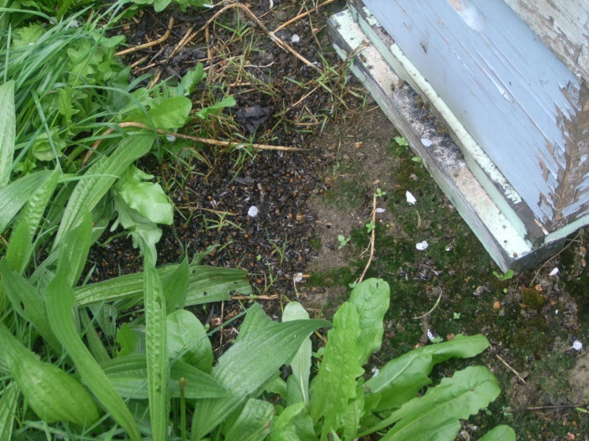

Photo: Dead bees outside a hive, which are suspected of having died as a result of spray drift. Source: Steven Field

Cover photo: Bee at almond pollination. Source: Daniel Martin

