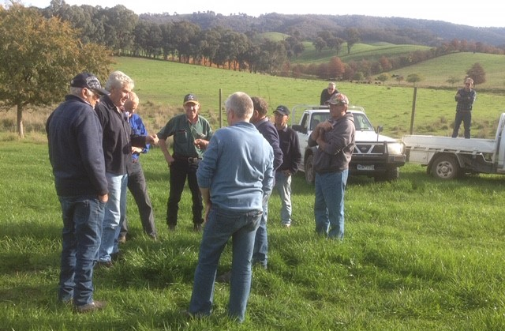
Caption: Tallangatta BetterBeef Group, Wal Wood’s property, Georges Creek, 2019
Coordinator – Phil Shannon
Group – Tallangatta
- 11 businesses from Chiltern to Upper Tallangatta Valley, Georges Creek and Talgarno
Enterprise mix
- Mainly beef production, with spring and autumn calving enterprises, and some sheep enterprises producing prime lambs as well. The group also has a member supplying cattle for Greenham’s certified grass-fed program.
Increasing feed supply through grazing management
An ongoing discussion with the Tallangatta BetterBeef Group is achieving the goal of using grazing management to increase farm-grown feed supply. Differing tools and techniques have been trialled and implemented by some of the group members.
A rotational grazing system has been successfully set up by group member Des Varker, who operates a beef operation in Chiltern. Des and Christine have invested both time and money in subdividing the family farm to more manageable paddock sizes. Not only has this involved lots of fencing they have also upgraded their reticulated water system, so stock have access to troughs in each paddock.
Des has a solar pump on one large storage dam that supplies a network of troughs. Another dam is spring-fed and relies on gravity feed to the connected troughs. Their weaning yards are within this system so Des will “cart a bit of water to get us through”, until he can move the cattle elsewhere on their property. Des has observed their cattle “do a lot better on better water”. Studies show that lower quality stock water can suppress dietary intake, and thus growth rates.
Since implementing the improved grazing system, Des has achieved his goal of conserving more fodder in spring and lowering his cost of production. The business principle for Des is “green feed is the cheapest feed”. He currently plans to buy hay, however “if there is a good spring and we have a spare paddock we’ll cut our own”. He aims to build a hay storage shed as part of this strategy, and then ‘bank’ a 12-month supply.
The goal of fodder conservation is not one made in isolation from other farm business decisions. For example, with the Varker’s business the steer weaners become trade cattle selling at optimum time. The decision to sell is based on the seasonal conditions (amount of conserved feed, prices, paddock feed, seasonal prospects for rain etc). Usually around August, Des assesses the trigger point for fodder conservation and adjusts his carrying capacity based on the outlook.
Improving soils and pasture quality
Group discussions on improving feed supply with grazing management are also linked to improving soils and pasture quality. Des is emphatic that, for him, the most significant learning from being a member of the Tallangatta BetterBeef Group has been the value of soil testing for the strategic use of fertiliser and lime.
Des now has an annual soil testing program to monitor soil pH, Olsen P and aluminium levels. He has 10 to 20 samples analysed per year, aiming to lift his soil pH to 5.5 and the phosphorus levels to an Olsen P of 16 across the farm. Additions of urea, liquid nitrogen and gibberellic acid are used when and where it will be cost effective to boost pasture growth.
Des has a plan to clean up paddocks and establish more phalaris and sub clover. Paddock renovation usually involves spraying weeds in autumn, then sowing annual rye grass or oats and cutting that for hay or silage before seed set. Only when he considers the paddock is free of weeds, will Des sow the phalaris. As a young plant it does not like competition.
Seeing how others are working their farm and enterprises can be one of the main benefits of being in a network group. Des said, “You get to see both sides of it, what works where and what doesn’t – and none of us are too proud, we all lay it out on the table.” “It’s a good group, and you get to hear from fellow farmers, and down-to-earth practical consultants.” “It’s given me confidence, with farm improvements, when you see what others are doing and find out about the science behind it.”
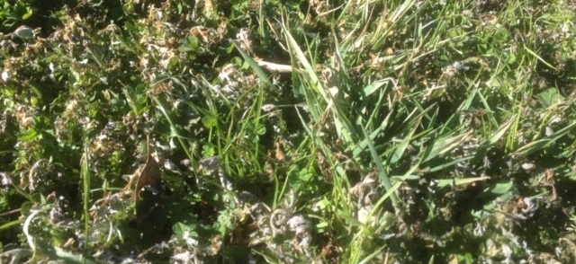 Caption: Pasture treated with liquid nitrogen, gibberellic acid and broad-leaf herbicide, 2019

