Plant-based sensors can provide complementary information to soil and weather-based approaches to irrigation management.
Plant-based sensors for irrigation management

Introduction
Plant-water status is a key determinant of growth, development and productivity. Insufficient water availability within the plant inhibits important metabolic processes including photosynthesis. Plant-water deficit occurs when there is not enough water available to meet demand.
The system of water movement in plants is driven by transpiration and available water in the rootzone. Water is released through small openings on the plant leaf (stomata). Gases and water vapour pass through stomata and the process is controlled by stomatal aperture. Closing stomata reduces the amount of water released through transpiration to help maintain hydration in the plant.
The plant-water status is affected by the interaction of atmospheric, plant, and soil factors. Plant type, age, and growth phase, as well as solar radiation, temperature, wind and humidity all affect water use. Different conditions trigger changes in the stomata, causing transpiration to increase or decrease.
To have adequate plant water status, roots must be able to take up enough moisture from the soil to satisfy the atmospheric demand (i.e. transpiration). If water availability is too low, or plants physically are unable to meet the demand, stomata will close, and metabolic processes slow down or stop. This can result in a decline in production.

principles of plant-based sensors
Plant water use is dynamic and changes throughout the day, as does water stress. Plant-based sensors work on the concept of using plants as “biosensors”, where soil-water, atmospheric conditions and plant response are integrated.
Plant-water status can be measured by either contact or non-contact sensors. Contact sensors provide useful measurements of daily patterns of water use, e.g. sap flow sensors. Non-contact sensors can provide spatial assessments of water use, e.g. canopy temperature sensors.
There are many sensing methods and plant variables available for measuring water status and stress. Automated and continuously recording devices are favoured in irrigation scheduling.
Each type of sensor can measure different indicators of water use and stress. Two sensors detailed here are sap flow sensors and dendrometers.

Sap flow sensors
Sap flow is the movement of fluid (water and nutrients) through a plant. It can be used as an indicator of transpiration. Increased sap flow is a signal of a healthy plant which is actively transpiring. Sap flow will reduce as a plant goes from an irrigation cycle to a stress cycle.

Measuring sap flow
Sap flow sensors measure the movement of fluid in the xylem. Sap flow sensors are installed by inserting probes into the plant’s sapwood.
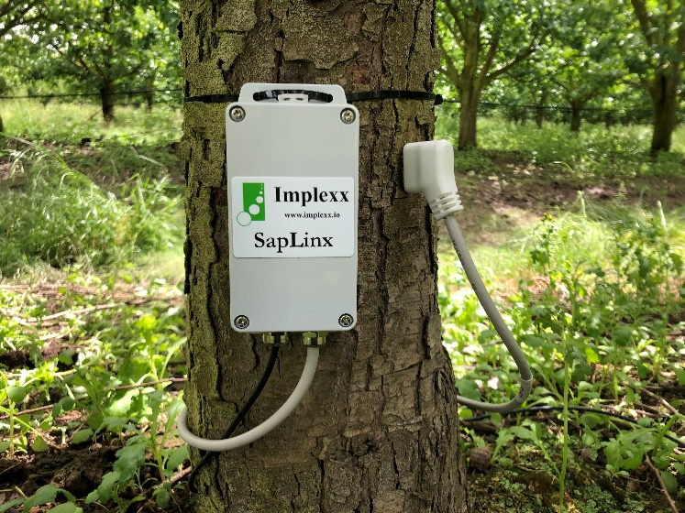
Sensors use a heater probe to measure the velocity of fluid moving through the stem.
Figure 1. Sap flow sensor probe (right) and data logger on a pear tree. (Photo: Edaphic Scientific)
Conversion factors are then used to translate readings to sap flow values which are measured in liters per hour.

Interpreting sap flow
Sap flow can be continuously logged to determine the amount of water used (transpired) by the plant each day.
Sap flow is highest during the day when plants are actively transpiring, and low during the night when little or no transpiration occurs.
Sap flow changes in response to the climatic conditions as it is directly related to transpiration. On a cloudy day, transpiration rates will be lower and sap flow declines.
Similarly, wet canopies can have reduced (up to half the normal) transpiration rates, causing lower sap flow.
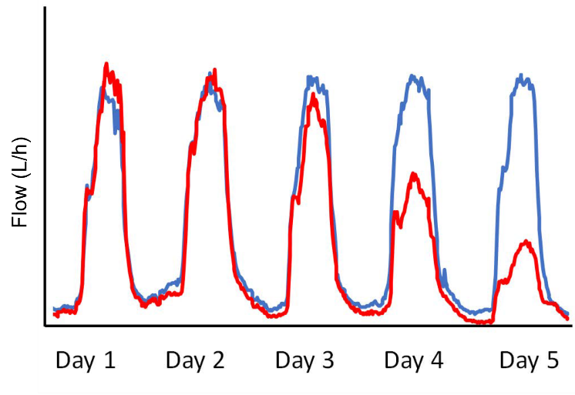
Peak sap flow will decline is a plant enters water stress. This can help indicate when an irrigation event is needed (Figure 2).
Figure 2. Daily sap flow patterns for two trees. The red line shows a tree entering water stress on day 3. (Image: Edaphic Scientific)
Sap flow readings can also be compared to daily evapotranspiration data or maximum air temperature to help identify when an irrigation event is needed. High evapotranspiration readings should correspond to high sap flow, if water is not limiting.

Accessibility
Raw data from sap flow sensors can be difficult to interpret without some training.
Sap flow measurements are calculated in litres per hour or per day. These readings can be converted to a figure in mm/day.

Accuracy
Sap flow sensors are invasive and cause damage to the tree. For most sensors, correction factors must be applied to account for the effects of probe misalignment, wounding and thermal diffusivity, otherwise there can be significant errors in the measured sap flow. These are becoming less of an issue with more modern sensors.
Sensors must be protected from direct sunlight and external heat to avoid errors—this can be managed by wrapping the sensors in foil.

Dendrometers
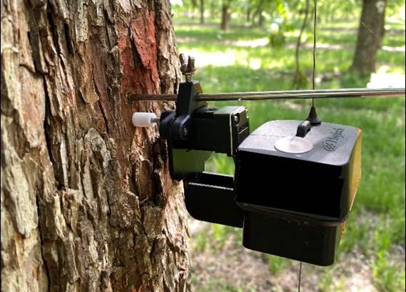
Daily patterns in water use cause plants to shrink and swell throughout a 24-hour period. As plants transpire during the day, water is mobilised from storages in plant tissue and transported to the leaves through the sapwood. As this occurs, the trunk or stem shrinks. When transpiration reduces or ceases overnight, water continues to enter the plant through the root system (provided there is enough water available) and redistributes though the plant causing the tissue to swell.
Figure 3. Wireless dendrometer on mature pecan tree. (Photo: Paul Grobler, Phytech)

Measuring diameter
Dendrometers measure microvariations in stem diameter caused by cycles of shrinking and swelling, which indicate changes in plant water content.
Dendrometers are band or point measuring devices. Bands are wrapped around the circumference of the tree which detect expansion and contraction via a position sensor.
Point devices measure a single point on the surface. A rod is drilled into the heartwood for stability and a second rod is placed against the bark to measure changes in diameter (Figure 3).
Throughout a 24-hour cycle, stem diameter variations are measured at regular intervals to identify maximum and minimum values. This method can also be applied to fruit.

Interpreting dendrometer data
Maximum daily shrinkage (MDS) and stem growth rate (SGR) are the most common measures used when interpreting dendrometer data.
MDS measures how much the stem contracts and expands within a 24-hour cycle. A plant that is not stressed will have a lower MDS than a plant that is stressed.
MDS graphs also indicate the rate at which moisture is being lost (transpiration) as well as the rate of recovery (from water available in the root zone).
SGR measures how much the stem grows through a cycle of contraction and expansion (24 hours). During periods of active growth, and when there is enough water available to meet demand, SGR will be positive.
A combination of SGR and MDS can be used to determine when plants are experiencing water stress.
Figure 4 shows the continuous log of stem diameter variation over 14 days.

Accessibility
Raw dendrometer data is not easy to interpret and requires calibration to determine a threshold for stress which indicates when irrigation is required.

Some providers have generated algorithms with integrated systems to process dendrometer data. These systems signal when plants are becoming stressed, significantly reducing the need for grower interpretation.

Accuracy
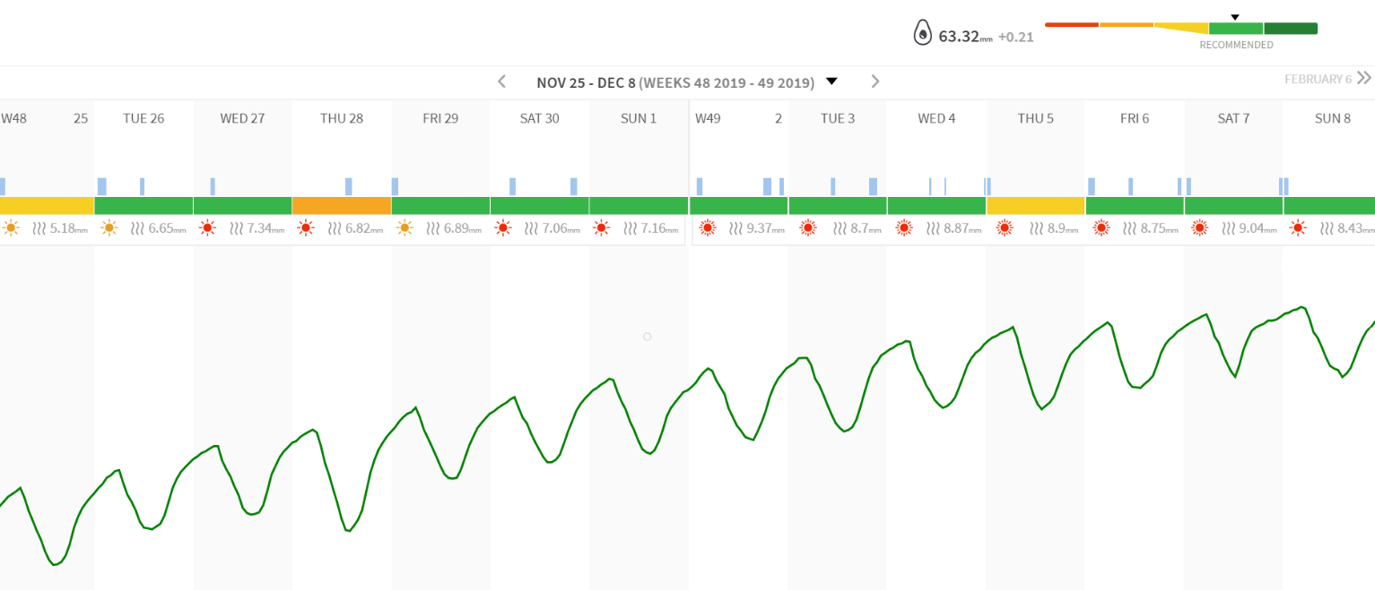
Correct installation is essential to ensure readings are as accurate as possible.
Figure 4. Dendrometer data presented in Phytech user interface (Image: Paul Grobler, Phytech)
Rain can distort dendrometer data in some crop varieties when bark swells, giving an inaccurate representation of water use until the bark dries.
There are many factors which affect dendrometer measurements (MDS or SGR) including crop load, phenological stage, age and environmental conditions. There is also high variability in stress threshold amongst crop types and varieties. These factors should be considered when interpreting data and are best evaluated by product or service suppliers with appropriate expertise.

Other Plant-based measurers
There are many options for measuring water status in plants to determine stress. Some alternatives are summarised in the table below.
Sensor | Measures | Comments
Canopy Temperature Sensors | Canopy temperature | - These non-contact sensors can provide readings at the plant level as fixed sensors, or from above the canopy using airborne imagery to measure spatial variation.  - Fixed sensors must be adjusted so the required distance between the sensor and a growing canopy is maintained.  - Requires plant variety specific physiological data to determine stress thresholds.  - More research needed to understand temperature thresholds of different growth phases.  - Potential for canopy temperature technology to model and predict future stress events.
Pressure Bomb | Stem water potential | - Good indicator of plant stress and used to complement soil moisture monitoring at critical growth stages of certain crops.  - Requires visual confirmation of the appearance of water on the cut stem surface which can be subjective.  - Requires destructive sampling so cannot be automated.  - Labour intensive requiring measurement at specific time of day (generally pre-dawn or midday).
Psychrometer | Stem water potential | - Continuously logs stem water potential.  - Has potential to reduce manual labour requirement of pressure bomb.  - Installation can be difficult and causes damage to the stem.  - Can be prone to gumming from sap which disrupts sensor measurements.
Porometer | Stomatal conductance | - Accurate measure of stress.  - Labour intensive and must be taken at the same time every day.  - No consensus for timing of measurement (pre-dawn or midday) to best indicate stress.  - Needs to be scaled up to the size of the property.  - Does not work if the surface of leaves is wet.

Conclusions
Plant-based sensors provide a unique opportunity for irrigators to make decisions based on the needs of their crop. Continually logged sensor data can show diurnal patterns in water use and the onset of stress in order to make better decisions about when irrigation is needed.
Because these methods measure plant stress, they can also be helpful in identifying pests and diseases which cause stress, affecting transpiration and water-use.

There are a range of plant-based sensors available. Not all are practical to use for irrigation scheduling. Those that are more practical are generally continuously logged and provide data in a format that can be used by irrigators to make informed decisions on irrigation management.
Plant-based sensors can provide an integrated measure of a plant’s response to soil moisture availability and evaporative demand. These measurements can be used in isolation or complement other irrigation scheduling techniques such as soil moisture-monitoring, to give a more detailed picture of irrigation demand.

References
Adeyemi, O., Grove, I., Peets, S., and Norton., T. (2017). Advanced monitoring and management systems for improving sustainability in Precision Irrigation. Sustainability. 9(3).
Agriculture Victoria. (2017). What is evapotranspiration and how do I use it to schedule irrigations. Tech note.
Conaty, W. C. (2010). Temperature-time thresholds for irrigation scheduling in precision application and deficit furrow irrigated cotton. PhD Thesis, The University of Sydney.
Cotton Info. (2019). CottonInfo webinar: Canopy Temperature Sensors.
Cotton Info. On-farm benefits of canopy temperature sensor – a grower perspective. Case Studies.
Cotton Research and Development Corporation. (2019). Partnerships bring agtech to growers. Spotlight Magazine. Spring 2019, 13-14.
Cull, P (2019). Webinar Recording: Plant water stress & sap flow measuring & monitoring tools. ICT International.
Department of Primary Industries. Riverina vineyard dendrometer and sap flow demonstration.
Edaphic Scientific. (2018). The Grape Monitor.
Fernández, J. E. (2014) Plant-based sensing to monitor water stress: Applicability to commercial orchards. Agric. Water Manage., 142.
Fernández, J. E. (2017). Plant-based methods for irrigation scheduling of woody crops. Horticulturae. 3(2).
Fernández, J. E. and Cuevas, M. V. (2010). Irrigation scheduling from stem diameter variations: A review. Agr. Forest Meteorol., 150(2).
Forster, M and Englefield, A. (2018). Dendrometers and plant growth monitoring. Factsheet. Department of Primary Industries.
Forster, M. and Englefield, A. (2018). Grapevine sap flow monitoring. Factsheet. Department of Primary Industries.
ICT International. PSY1 Stem psychrometer manual.
Implexx Sense. (2019). A Quick Guide to Sap Flow Sensors and Irrigation Management.
Jamali, H., Bange, M. and Dowling, T. (2019) Canopy temperature – bringing the doctor to the field. The Australian cottongrower. 40(2), 20-23.
Jones, H. M. (2004). Irrigation scheduling: advantages and pitfalls of plant-based methods. J. Exp. Bot. 55, 2427-2436.
Kisekka, I., Aguilar, J., Lamm, R. and Rogers, D. (2014). Using soil water and canopy temperature to improve irrigation scheduling for corn. Proceeding for the 2014 Irrigation Association Conference, Phoenix, Arizona.
White, S.C. and Raine, S.R. (2008). A grower guide to plant based sensing for irrigation scheduling. National Centre for Engineering in Agriculture Publication 1001574/6, USQ, Toowoomba.

Further information
For further information please contact Natalie Mason at Agriculture Victoria on (03) 50514500

acknowledgments
Michael Forster, Edaphic Scientific.
Paul Grobler, Phytech.

