Antibiotic use in Sheep: Stop, Think, Choose Wisely
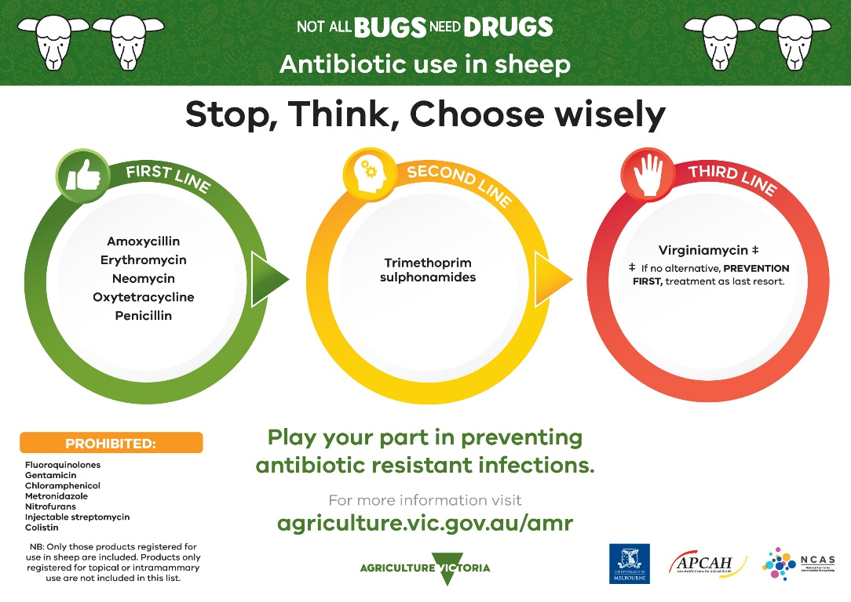
The information provided sets out the prioritisation of antibiotics for use by veterinarians as per Antibacterial Importance Ratings developed by the Australian Government with expert advice from the Australian Strategic and Technical Advisory Group (ASTAG). The antibiotics are displayed in circles corresponding to the colours of a traffic light; green, orange and red.

LOW IMPORTANCE (in a green circle)
Amoxycillin
Erythromycin
Neomycin
Oxytetracycline
Penicillin

MEDIUM IMPORTANCE (in an orange circle)
Trimethoprim sulphonamides

HIGH IMPORTANCE (in a red circle)
Virginiamycin (If not alternative, PREVENTION FIRST, treatment as last resort)
Prohibited
Fluoroquinolones
Gentamicin
Chloramphenicol
Metronidazole
Nitrofurans
Injectable streptomycin
Colistin
Note: Only those products registered for use in sheep are included. Products only registered for topical or intramammary use are not included in this list.
Play your part in preventing antibiotic resistant infections
For more information visit the Antimicrobial resistant infections webpage of the Agriculture Victoria website at agriculture.vic.gov.au/amr
Developed and designed by Agriculture Victoria, the University of Melbourne, the Asia-Pacific Centre for Animal Health and the National Centre for Antimicrobial Stewardship.

