Fodder beet – the lure of potential
While the lure of a high yielding fodder beet crop is strong, with the possibility of large amounts of high-quality feed carried over until needed, there is no such thing as a sure bet.
Since October 2020 a group of North-East Victorian beef farmers (based around the Upper Murray and Mudgegonga BetterBeef groups, coordinated by Chris Mirams) have been following the performance of two fodder beet crops to assess their potential to fill an autumn/winter feed gap.
There is no doubt that fodder beet can be a viable option to fill a feed gap, however, the experiences of the group shows that there are key steps that need to be addressed to achieve a high yielding crop.
Both sites had lower than anticipated plant establishment with an average of 47,000 plants per hectare (ha) three weeks after seeding (fodder beet is planted with a precision seeder, so plant numbers can be easily estimated from counting plants along a 20m drill row and multiplying up).
The crops were planted at 100,000 seeds/ha, with anticipated germination rates in the order of 85 per cent, or 85,000 plants/ha. With the lower than anticipated germination rates, overall crop production was always likely to be limited. It is uncertain why the germination rates were lower than expected, despite sowing into a worked seedbed and receiving gentle rain in the following days. Our current thinking is that the rain enabled a ‘crust’ to form over the germinating seeds which hindered germination, or that soil washed into the drill rows and resulted in a deeper than ideal seed placement. Whilst these are only ‘best guesses’ from group members, there is not much that could have done differently to address these issues.
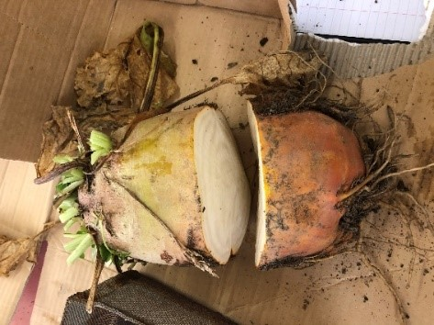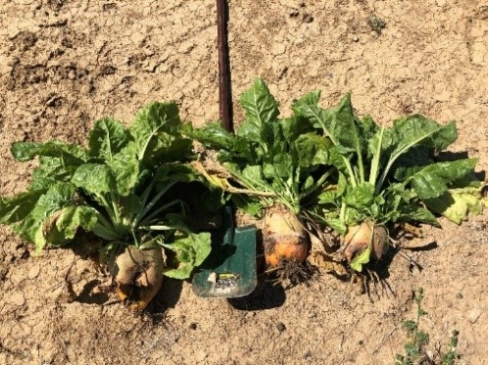
The additional downside of having low plant numbers was the sparse crop density, preventing canopy closure. The lack of canopy closure allows sunlight and ideal growing conditions for a multitude of weeds, both grass and broadleaf. While there are a range of chemical control options for grass weeds in fodder beet, broadleaf weed control can be problematic. The weed issues encountered post-establishment highlight the importance of prior weed control – it’s essential and non-negotiable to achieve high crop yield.
Figure 1: A fodder beet bulb divided into above and below group sections
Figure 2: A selection of freshly dug fodder beet bulbs
There is little doubt the competition from grass weeds suppressed crop development at one of our sites to the point that plant yields at this site were in the order of 1 tonne Dry Matter/ha (t/DM/ha) four months after sowing. This result would be outperformed by almost any of the other summer crop options such as millet or sorghum. Having a high weed burden also provided a disincentive to irrigate the crop as irrigation was going to further exasperate the competition from weeds. This is a chicken and egg scenario of encouraging crop growth but limiting competition from weeds.
Fodder beet plants were slower to develop at the site with significant weed competition, and approximately 70 per cent of herbage mass was in the leafy ‘top’ of the plant and 30 per cent in the bulb.
The second site had a lower weed burden and was able to irrigate more frequently and beet development was more substantial. In this case, there was closer to 9t DM/ha four months after sowing, and the individual plants were 70 per cent bulb and 30 per cent leafy ‘top’. Five months after sowing this same site had nearly doubled in DM production.
Whilst there are differences between varieties, the crop had 66 per cent of the bulbs fresh weight above the ground. Having a high percentage of the bulbs above ground should in theory make it easier for cattle that haven’t previously consumed a bulb crop to adapt to the new diet.
Whilst other producers will have had different experiences with fodder beet, this summary represents the group’s early experiences with fodder beet. Next steps are to observe utilisation rates at grazing and if establishment rates can be increased in the following season of the demonstration.
This Enhanced Producer Demonstration Site is funded by Meat & Livestock Australia and Agriculture Victoria. For more information or to discuss further elements of fodder beet, please contact Nick Linden, Agriculture Victoria 0438 369 486.

Accessibility
If you would like to receive this publication in an accessible format, contact Agriculture Victoria on beef.sheepnetworks@agriculture.vic.gov.au
This document is also available in PDF and Word format at http://agriculture.vic.gov.au/on-farm-demos

