BestWool/BestLamb – This HAT fits every farmer
April 2021
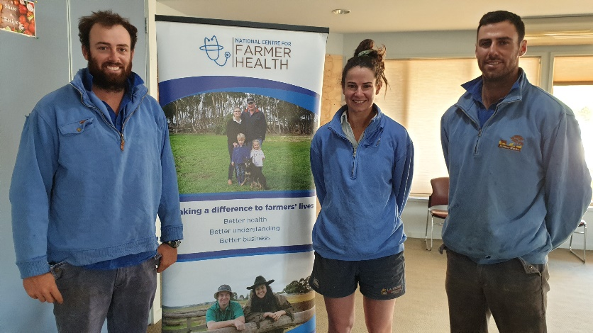
Siblings Anthony, Anna-Grace and Michael Close participated in the HAT pilot
Coordinator – James Whale
Groups – Apsley, Balmoral and Fiery Creek
- 28 businesses, south-west region
Enterprise mix
- Mixed Grazing: Wool, prime lambs, beef and cropping
Farmer health has been a key focus for the Apsley, Balmoral and Fiery Creek BestWool/BestLamb groups. Deep down, we all know our health and mental wellbeing should be at the forefront of any farming business. Not only is it important for you, but also your family, workers and community.
The National Centre for Farmer Health (NCFH) Director Susan Brumby has found a certain ‘reluctance’ by many farming men and women to make appointments with health professionals, or to make sure their own health screenings are up-to-date. In short, farmers are not looking after themselves and delay seeking help until it becomes difficult to function well.
The NCFH has developed an innovative online tool called the Farmer HAT (Health Assessment Tool) that farmers can access it in their own time and in the privacy of their own home.
The Farmer HAT platform was put through its paces by thirty-six BWBL members from the South-West Region last December during a pilot phase. Farmer HAT has been developed to promote a safe farming culture and healthy personal behaviours.
“The free online self-assessment tool is easy to use and only takes 10-15 minutes to complete, answering a series of questions about health, wellbeing, lifestyle behaviours and farm safety practices,” Susan says. “Part of the tool includes entering clinical health information of blood pressure readings, blood glucose and cholesterol test results but users are able to complete the Farmer HAT without these “We recommend users attend an AgriClinic™ or visit their GP to obtain these numbers to gain a complete picture of their health.”

BestWool/BestLamb – This HAT fits every farmer
April 2021
The Farmer HAT can be used to track and benchmark assessment results over time. The NCFH recommends that Farmer HAT be completed at least annually to review the progress of the users’ health and wellbeing and hopes that the outcomes from Farmer HAT will be convincing enough for all farmers to seek an appointment with a medical professional and/or take action to improve their own health.
“Using a traffic light system, the Farmer HAT provides easy to understand and visual feedback to users about the questions answered and includes relevant resources to improve personal behaviours and practices,” says Susan. “It puts the farmer in the driving seat of their own health, wellbeing and safety – and in the privacy of their own home, tractor or paddock!”
John Marriott, who is involved with the BWBL groups says “being able to benchmark personal physical and mental health information, just as we benchmark financial parameters (cost of production, farm profit, change in net worth etc.) or environmental issues (e.g. carbon sequestration) gives producers the ability to implement and see the impact these changes can make over time.”
Recognising that his role as coordinator is to challenge producers to see their health, wellbeing and safety as a core part of the success of their farming business, BWBL coordinator James Whale was happy to encourage his three groups to participate in the pilot test of the Farmer HAT.
“My role in getting producers involved in the Farmer HAT pilot test was quite easy,” James said. “The NCFH set up the Farmer HAT groups and then I invited the members from the Edenhope/Aspley, Fiery Creek and Balmoral BWBL groups to participate in a 20-minute Health and Lifestyle Assessment conducted by the NCFH. We then also asked them to complete the Farmer HAT.”
The Farmer HAT program is seeking more BWBL groups to get involved and participate in the program. For further information, please contact:
Cecilia Fitzgerald
Business Development and Industry Engagement Manager
National Centre for Farmer Health
P: (03) 5551 8447 | M: 0439 712 840
E: cecilia.fitzgerald@wdhs.net | W: http://www.farmerhealth.org.au

Accessibility
If you would like to receive this publication in an accessible format, contact Agriculture Victoria on beef.sheepnetworks@agriculture.vic.gov.au This document is also available in PDF and Word format at http://agriculture.vic.gov.au/on-farm-demos
Disclaimer
This publication may be of assistance to you but the State of Victoria and its employees do not guarantee that the publication is without flaw of any kind or is wholly appropriate for your particular purposes and therefore disclaims all liability for any error, loss or other consequence which may arise from you relying on any information in this publication.
Issued April 2021

Agriculture Victoria, BetterBeef, BestWool/BestLamb and Australian Wool Innovation Limited (AWI)

