Victoria Government Gazette
No. S 9 Monday 16 January 2023
By Authority of Victorian Government Printer
Livestock Disease Control Act 1994
Section 29(1)
ORDER DECLARING A CONTROL AREA IN RELATION TO VARROOSIS
I, Gayle Tierney, Minister for Agriculture, make the following Order under section 29 of the Livestock Disease Control Act 1994, having the suspicion that it is reasonably necessary to prevent, control or eradicate the exotic disease, Varroosis.

Part 1 – Preliminary

1. Objectives
The objective of this Order is –
- to declare an area to be a control area to prevent, control and eradicate the exotic disease, Varroosis, in bees; and
- to specify the prohibitions, restrictions and requirements which are to operate in relation to the control area.
2. Authorising provision
This Order is made under section 29 of the Livestock Disease Control Act 1994.

3. Duration of Order
This Order comes into operation at 12.00 am on 13 January 2023 and has effect until 11.59 pm on 10 March 2023.
4. Definitions
In this Order –
Affected livestock means the class of livestock specified in clause 6(1) of this Order;
Affected livestock products, fodder and fittings means the class of livestock products, fodder and fittings specified in clause 6(2) of this Order;
control area means the area described in clause 7 of this Order;
destroy means all processes and actions to isolate, destroy and dispose of an infested hive or linked hive by an inspector to prevent, control and eradicate Varroosis from those beehives;
diagnostic examination means identification of the presence of varroa mites by morphological examination and a positive loop-mediated isothermal amplification test, and where that identification has been endorsed by the Chief Plant Health Officer of the Department of Energy, Environment and Climate Action;
infested hive means a beehive in which Varroosis is apparently present, as ascertained by diagnostic examination, including any affected livestock products, fodder and fittings that have been in contact (directly or indirectly) with that beehive;
linked hive means a beehive, including any affected livestock products, fodder and fittings managed or controlled by a beekeeper that has had a confirmed diagnosis of Varroosis in relation to one of their beehives in the control area;
particular hive means an infested hive, linked hive or suspect hive;
permit means a permit issued by an inspector under section 30(2) of the Act;
pollen means any pollen used for feeding bees, other than pollen used for human consumption;
processed honey means any honey that has undergone extraction, filtering (to remove wax cappings and dead bees), decanting into clean containers and packaging in a facility which is inaccessible to bees;

SPECIAL

processed wax means any wax that has undergone melting, filtering (to remove bees, brood, debris), rendering, packing into clean containers and packaging in a facility which is inaccessible to bees; suspect hive means any beehive, including any affected livestock products, fodder and fittings that have come from or have been in contact (directly or indirectly) with that beehive, located within 7 kilometres of an infested hive or a linked hive; the Act means the Livestock Disease Control Act 1994.

5. Effect on other Control Area Orders
This Order does not affect the operation of the Order Declaring a Control Area for the Prevention, Control and Eradication of Varroosis in Bees, published in Victoria Government Gazette S 256 on 25 May 2022 at pages 6–12.

6. Application of Order
- This Order applies to the class of livestock of bees.
- This Order applies to the following classes of livestock products, fodder and fittings –
  - all livestock products produced by bees (excepting drone semen, processed honey, processed wax and propolis for human consumption);
  - fodder in the form of pollen; and
  - fittings that have been used in relation to bees or beekeeping.

7. Control area
- The land comprising the following regions of the State of Victoria: Loddon Mallee; Grampians; Barwon South West; Hume; Gippsland; and Port Phillip, as described in the map in the Schedule to this Order, is declared to be a control area for the purpose of preventing, controlling or eradicating the exotic disease, Varroosis.
- The prohibitions, restrictions, requirements and controls specified in Part 2 of this Order apply to the whole of the control area.

Part 2 Control area – prohibitions, restrictions and requirements

8. Prohibition – movement of affected livestock, affected livestock products and fittings
- A person must not move or cause the movement of affected livestock, or affected livestock products, fodder and fittings into the control area from any Australian State or Territory.
- Subclause (1) does not apply to a person if they have been issued a permit and the movement of affected livestock, affected livestock products, fodder and fittings into the control area is in accordance with the conditions of the permit.

9. Prohibition and requirements – movement and interference with particular hives
- A person must not move or interfere with particular hives.
- Subclause 1 does not apply to a person if they have been issued a permit and the movement or interference with particular hives is in accordance with the conditions of the permit.

10. Requirements and control – inspector
- An inspector may destroy an infested hive or linked hive if an inspector reasonably suspects that the infested hive or linked hive poses a risk to the control, eradication or prevention of the spread of Varroosis.
- An owner of a beehive must make an infested hive or linked hive available for destruction at the direction of an inspector.

11. Requirements and control – suspect hives
- The owner of a suspect hive in the control area, on the direction of an inspector, must present the suspect hive to one of the following persons, for inspection, for samples to be taken and testing conducted and for treatment considered necessary to control, eradicate or prevent the spread of Varroosis –
  - an inspector; or
  - the person nominated by an inspector in a direction given to the owner of the suspect hive.
- A person who owns a suspect hive in the control area must, on the direction of an inspector, carry out any treatment, inspection or any other action the inspector considers to be necessary to monitor, control or prevent the spread of Varroosis from a suspect hive.

12. Requirements and control – vehicles in contact with particular hives
A person who owns any vehicle that has been in contact with a particular hive must, on the direction of an inspector, carry out or make the vehicle available for treatment, inspection or any other action the inspector considers to be necessary to control, eradicate or prevent the spread of Varroosis.
Dated 11 January 2023

THE HON. GAYLE TIERNEY MP
Minister for Agriculture

The Victoria Government Gazette is published by IVE Group Limited with the authority of the Government Printer for the State of Victoria
State of Victoria 2023
This publication is copyright. No part may be reproduced by any process except in accordance with the provisions of the Copyright Act.
Address all enquiries to the Government Printer for the State of Victoria Level 2, 1 Macarthur Street Melbourne 3002 Victoria Australia

How To Order

Retail & Victoria Government Gazette
Mail Sales Ground Floor, Building 8,
658 Church Street,
Richmond 3121
Telephone (03) 8523 4601
email gazette@ivegroup.com.au

Price Code A

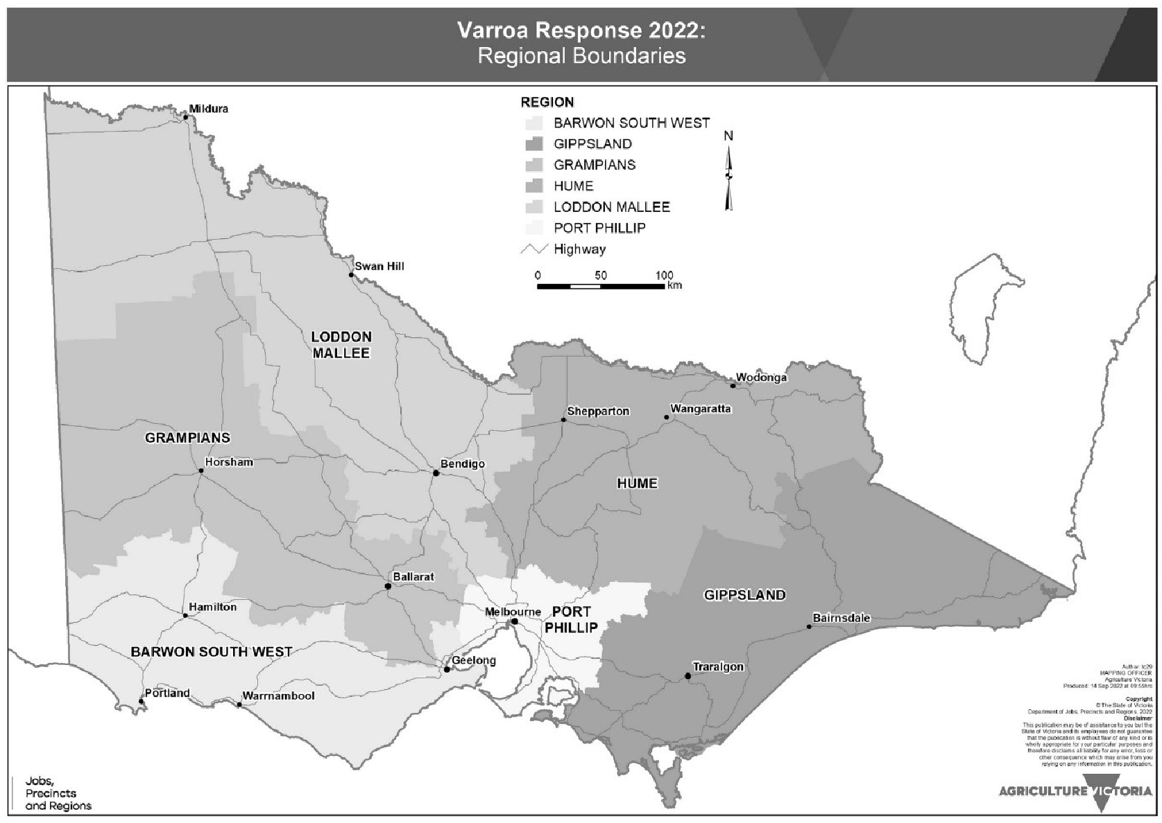
SCHEDULE

