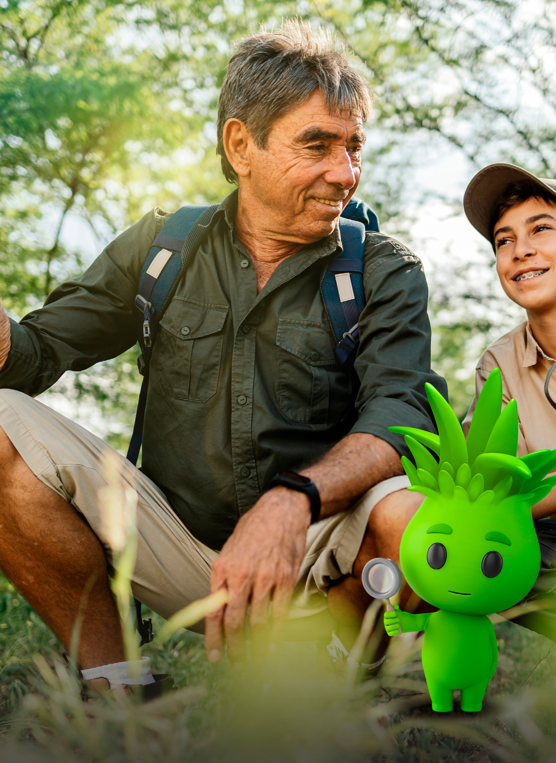
Resources

Apps and guides:
iNaturalist - iNaturalist helps you identify the plants and animals around you while generating data for science and conservation.
https://www.inaturalist.org/

MyPestGuide® – MyPestGuide® brings communities together in order to create a collaborative network of people to report, map and learn about pests and other organisms.
https://www.agric.wa.gov.au/pests-weeds-diseases/mypestguide

FeralScan – providing a community pest animal recording and management tool. https://feralscan.org.au/

WeedScan – WeedScan uses artificial intelligence to identify priority weeds. Users can create, view and share records through groups to improve weed control.
https://weedscan.org.au/

Marine pest deck – a guide to the highly invasive plants and animals from other parts of the world that pose a threat to our unique marine environment.
https://agriculture.vic.gov.au/biosecurity/marine-pests/marine-pest-deck-invasive- species-guide

Priority plant pest guide – a guide to the pests presenting the greatest biosecurity risk to plants in Victoria.
agriculture.vic.gov.au/getinvolved

Webpages:
Atlas of Living Australia Biosecurity Hub – the Atlas of Living Australia (ALA) aggregates species occurrence data within Australia, be they native or introduced species.
https://www.ala.org.au/biosecurity/

Museums Victoria – the museum leads and supports a number of great projects.
https://museumsvictoria.com.au/

State Wide Integrated Flora and Fauna Teams – SWIFFT is a network for knowledge sharing and information exchange that supports conservation and management of threatened species, biodiversity and the natural environment across Victoria.
https://www.swifft.net.au/

