Agriculture Victoria
Regulatory
Framework
April 2024

Foreword
I am excited to present Agriculture Victoria’s Regulatory Framework.
With responsibilities across a diverse range of regulatory systems, Agriculture Victoria seeks to continually improve our practices to support and encourage business, balancing innovation and growth with our need to protect against harms. Our recently published Regulatory Approach describes our regulatory role and responsibilities, our regulatory systems and why we regulate.
This Framework describes how we will fulfil our regulatory function and provides direction to enable us to embed our Approach into our regulatory work.
The Framework guides our staff as they undertake their regulatory duties and demonstrates how we will move toward best practice regulation and strive for continuous improvement. It aims to inform community and industry duty holders and those with whom we collaborate, how we will achieve our regulatory objectives and outcomes, and what they can expect from us in our regulatory work.
As part of the Department of Energy, Environment and Climate Action, Agriculture Victoria is committed to managing our regulatory systems to align with the purpose and vision of the Department. Notably, our journey toward best practice regulation enables us to contribute to a thriving agriculture sector.
Our regulation is also essential for improving the prevention and management of diseases and pests, supporting environmentally sustainable industry and community practices, and upholding animal welfare standards.
One of Agriculture Victoria’s commitments in the Regulatory Approach is to enable staff capability building and this Framework positions staff with a clear way forward in their regulatory work. Our strong agricultural sector, robust biosecurity system and high animal welfare standards would not be possible without our most valuable asset – our regulatory staff. It is therefore timely that this Framework has been developed to provide clear guidance to these staff and to enable us to share our journey with industry, community and those with whom we share regulatory responsibilities.

Matt Lowe
Chief Executive Agriculture Victoria

Acknowledgement
We acknowledge and respect Victorian Traditional Owners as the original custodians of Victoria’s land and waters, their unique ability to care for Country and deep spiritual connection to it.
We honour Elders past and present whose knowledge and wisdom has ensured the continuation of culture and traditional practices.
We are committed to genuinely partnering with Victorian Traditional Owners and Victoria’s Aboriginal community to progress their aspirations.

Contents
Foreword 2
Acknowledgement 3
Contents 4
2. Introduction 7
2.1 Agriculture Victoria’s roles and responsibilities 7
2.2 Purpose and use of the Framework 9
3. Agriculture Victoria’s Regulatory Framework 11
3.1 Legislative and policy design 13
Government authority and program design 14
Legislative and regulatory review 15
3.2 Program design, planning and improvement 16
Informing 17
Planning and design 18
Prioritising activities and resources, while remaining adaptive and responsive 18
3.3 Raise awareness, educate and encourage compliance 19
Raise awareness and educate on how to comply 20
Encourage compliance 22
3.4 Compliance activities 23
Permissioning 26
Monitoring and targeting compliance activities 27
Reviewing compliance 27
3.5 Monitor and evaluate 28
Defining objectives, outcomes and measuring success 29
Monitoring 30
Evaluating 31
Reporting 31
Developing a Program Monitoring and Evaluation Framework and Plan 32
4. Stakeholder Engagement 34
Why engage with stakeholders 34
Input to program planning and improvement 35
Raise awareness and educate 35
5. Building capability and implementing the Framework 38
5.1 Capability building 38
5.2 Knowledge sharing 38
5.3 Technology and data 38
5.4 Ensuring success 39
6. Appendices 41
6.1 List of useful resources 41
Framework context and regulatory program planning 41
Monitoring and evaluating 41
Stakeholder engagement 41
6.2 Stakeholder engagement planning 41
Inform program planning and improvement 42
Identify stakeholders 42
Level of interest and level of influence 42
Determine the best form of engagement 42
Raise awareness and educate 44
Identify stakeholders 44
Where are they currently / where do we need them to be? 44
Determine the best form of engagement 45
Plan your messaging 45

Introduction

2. Introduction

2.1 Agriculture Victoria’s roles and responsibilities
Agriculture Victoria’s regulatory roles and responsibilities are varied and complex, including responsibility to regulate more than 30 separate legislative Acts.
Through its regulatory role, Agriculture Victoria plays an important part in minimising harms to individuals, communities and the environment. To do this, the organisation has been delegated a range of powers and functions and the ability to place responsibilities on a range of duty holders. Agriculture Victoria delivers a range of regulatory programs to exercise these powers and functions.
These roles and responsibilities are detailed in the Agriculture Victoria Regulatory Approach 2022–2027 and are important considerations in the application of this Regulatory Framework to ensure consistency with organisation, government and community expectations and requirements. Agriculture Victoria’s roles and responsibilities span a range of systems, including:
Biosecurity
Management of risks to the economy, the environment, and the community, of pests and disease entering, emerging, establishing or spreading.
Food safety
Management of risks to food safety including safeguarding and promotion and food standards.
Animal welfare
Safeguarding and promotion of standards of care for animals; domestic, livestock, aquatic, exotic and those used for scientific purposes.
Property identification and traceability
Identification and traceability of animals or plants or groups of animals or plants and their products through the supply chain to support biosecurity, market access and food safety outcomes.
Agricultural and veterinary chemicals
Management of risks surrounding the use of agricultural and veterinary chemicals in agriculture.

Agricultural sector
Undertake regulation on behalf of other regulators, including novel industries such as medicinal cannabis, poppies and industrial hemp.
Agriculture Victoria is one of several agencies with regulatory responsibility across these areas. The others include the Australian Government, other state and territory governments, local governments, other regulating bodies within the Victorian State Government and statutory authorities.
As part of the Regulatory Approach Agriculture Victoria commits to:
- Work closely and collaboratively with partner organisations
- Establish best practice governance education, extension and training research and policy development
- Maintaining regulatory oversight of emergency preparedness and response management
- Reviewing regulatory system performance understanding and managing risks developing legislation and regulations
- Preparing and implementing policy and procedures
The Regulatory Approach sets out nine foundational principles which underpin our actions and activities.
Agriculture Victoria:
- is effective in addressing the underlying causes of harm, and in so doing maximises impact
- is cost effective
- responds in a manner which is proportionate to the harm or risk to the community
- is consistent with the government’s priorities
- is transparent
- responds in a consistent manner across government
- is responsive, to accommodate changes in technology, markets, risks and community views
- makes evidence-based decisions is clear and easily understood
- by business and the community
“This Framework is how we will meet the commitments and principles set out in the Regulatory Approach”
Matt Lowe, CEO Agriculture Victoria

2.2 Purpose and use of the Framework
The Regulatory Approach document outlines the organisation’s regulatory vision, objectives, roles, responsibilities, and guiding principles.
This Framework aims to provide actionable guidance on how to achieve the commitments and principles articulated in the Regulatory Approach. It provides staff across the organisation with a common understanding and practical guidance on best practice regulation.
It also articulates the links to Agriculture Victoria’s other plans, policies, and program strategies which is how each business area would plan and articulate how the Framework is put into practice. The links are depicted below.
Documents available
- Regulatory Approach
- This document
- Compliance Management Policy
Documents developed by program managers
- Compliance Program Strategies
- Annual Operational Plans
The Framework is to be used particularly by staff charged with responsibility for managing regulatory programs within the organisation, and to drive improvements in practice. As such it provides important input to the planning of regulatory programs.
It also provides a guide to external stakeholders on how Agriculture Victoria aims to manage its regulatory programs and activities.
These regulatory programs involve design, planning and coordination of resources required to execute the organisation’s regulatory roles and responsibilities. Best practice regulatory programs take a strategic, considered approach to harm minimisation, through effective planning, risk-based targeting, engagement with stakeholders, transparency and a focus on continuous improvement. Effective utilisation of all Agriculture Victoria’s regulatory tools is required to minimise harms whilst also reducing the burden of compliance on duty holders.

The Regulatory Framework

3. Agriculture Victoria’s Regulatory Framework
The Framework involves a cycle of activities that support effective regulatory program delivery.
These include program planning, raising the community’s awareness of compliance obligations and educating duty holders on how to comply, undertaking a range of compliance activities, and monitoring and evaluating the outcomes achieved and opportunities for improvement.
These activities are supported throughout by stakeholder engagement activities. It is also important to note these activities are performed within the construct of the legislation and the design, review and improvement of legislation and policy. This Framework is depicted in the diagram below:
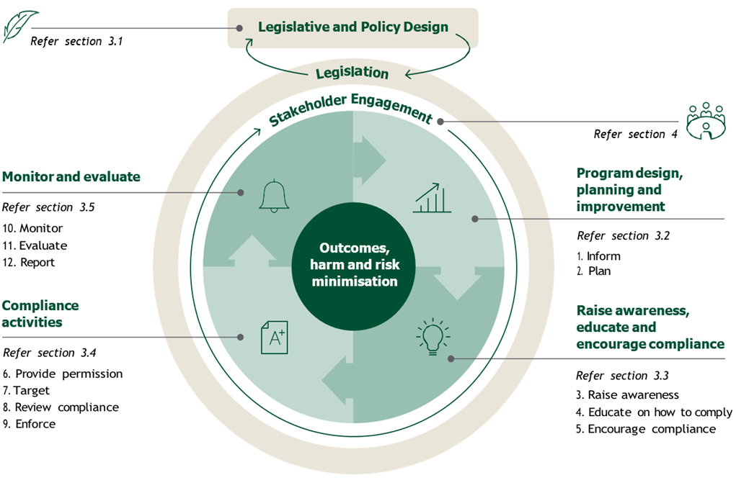
(Description of the above Agriculture Victoria Regulatory Framework overview diagram)
The diagram shows the interconnectedness of four key elements (and sub-elements) of a cycle of activities that support effective regulatory program delivery:
Program design, planning and improvement (refer section 3.2)
- Inform
- Plan
Raise awareness, educate and encourage compliance (refer section 3.3)
- Raise awareness
- Educate on how to comply
- Encourage compliance
Compliance activities (refer section 3.4)
- Provide permission
- Target
- Review compliance
- Enforce
Compliance activities (refer section 3.5)
- Monitor
- Evaluate
- Report
The diagram highlights that these activities are underpinned by stakeholder engagement (section 4) and the legislation (and shows the links to legislative and policy design – section 3.1), to achieve outcomes and minimise risks and harms.

3.1 Legislative and policy design
Governments use a mix of regulation and other policy approaches to influence community and business behaviour, and to increase overall community wellbeing. ‘Regulation’, at its broadest sense, means the actions and requirements of government that are intended to change the choices and actions of individuals, community organisations and businesses. It includes the rules backed by government authority and the activities of regulators, such as approval processes and enforcement activity (Victorian Guide for Better Regulation, 2016).
Government authority for a regulator is provided at two levels:
- primary legislation (acts of Parliament)
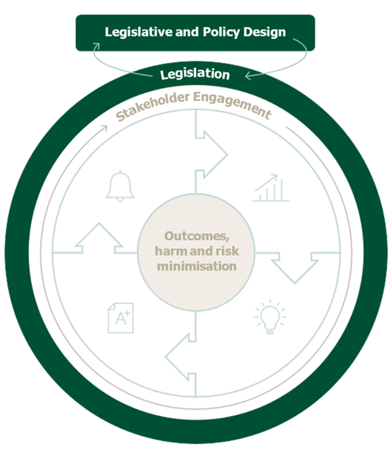
- subordinate legislation such as statutory rules (including regulations) and legislative instruments (including codes of practice, mandatory guidelines and orders)
(Description of the above Agriculture Victoria Regulatory Framework overview diagram)
This diagram is the same overview of the Regulatory Framework as previously described, however highlighting the legislation layer which underpins all activities and is linked to legislative and policy design.
The process for developing this primary and subordinate legislation requires specialist policy expertise to advise government on policy options including development of policy approaches, stakeholder consultation, impact assessments, cabinet and parliamentary processes and so on.
Government can also influence choices and behaviours through a range of policy settings, including education, grants and other incentives. These approaches support and complement other aspects of Government regulation, such as the implementation of rules and enforcement activity.

Government authority and program design
The primary and subordinate legislation provides the scope, objectives, powers and tools within which Agriculture Victoria must design our regulatory programs. Considerable judgement is required to effectively address the most significant harms within the legislative remit.
Better Regulation Victoria’s publication Towards Best Practice: A guide for regulators outlines 10 regulatory practice principles addressing how a regulator should consider strategy, operations and enabling practices (see Appendix 6.1).

Legislative and regulatory review
Given the importance of legislation and regulation to the operation of our regulatory programs, it is important that Agriculture Victoria takes the opportunity to propose improvements and provide input into reviews of legislation and regulations. This may occur, for example, with sunsetting regulations.

3.2 Program design, planning and improvement
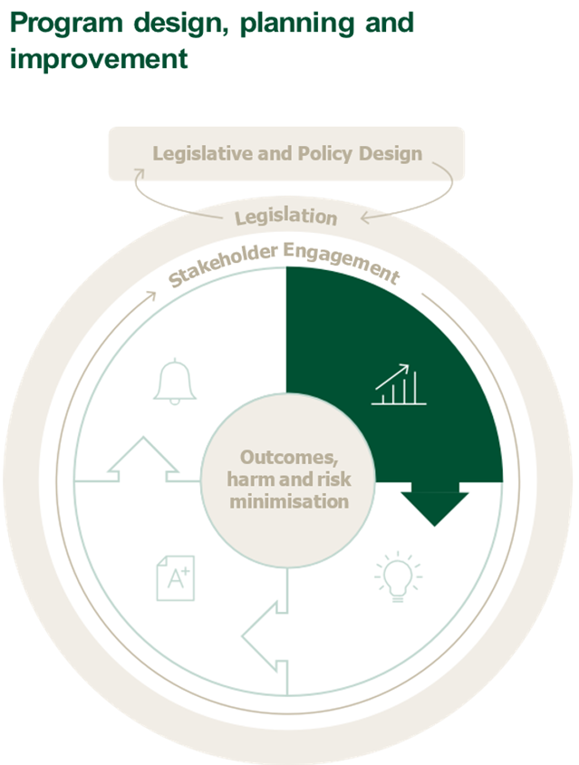
Program design and planning is a critical component of the management of regulatory programs. Program planning is informed by a range of inputs that both assist in improvement planning and enable scheduling of planned activities for the next 12 months and 3 years. This is depicted in the diagram and descriptions below:
(Description of the above Agriculture Victoria Regulatory Framework overview diagram)
This diagram is the same overview of the Regulatory Framework as previously described, however highlighting the program design, planning and improvement element and includes the following sub-elements:
- Informing: Collate results from monitoring and evaluation, stakeholder feedback, intelligence gathering, environmental scanning and risk assessments and use to inform program planning
- Planning: Plan program to include stakeholder engagement, awareness raising and educating, compliance activities, monitoring and evaluation and continuous improvement
Agriculture Victoria’s program planning and design is aimed at risk-based regulation. The organisation’s Compliance Management Policy (CMP) provides guidance to regulatory programs to plan and prioritise resources and regulatory tools, given the environmental context, assessment of risk and legislative remit.

Informing
Effective program planning is informed by development of:
- environmental scanning, including intelligence gathering and data analysis
- the results from the monitoring and evaluation phase, including feedback and lessons learned (refer section 3.5)
- benchmarking with other programs, regulators or jurisdictions
- stakeholder feedback on potential improvements, including any collected as part of evaluation of the program or via other forms of stakeholder engagement
- confirming desired regulatory outcomes
- identifying potential harms and assessing risk (likelihood and consequence)
- agreeing on priorities and approaches to address these risks of harm.
This information is used to identify improvements and innovations, including improvements to program design and better targeting of regulatory activities. This information is captured in and informs the program’s three-year compliance strategy.

Planning and design
Program planning in Agriculture Victoria considers implementation of identified improvements and innovations. Program planning includes development of three-year Program Compliance Strategies, and Annual Operational Plans that outline the allocation of resources, budget and performance measures for the coming year. Regulatory planning is aligned with departmental business planning processes.
Key elements that are considered include:
- stakeholder engagement (refer section 4)
- raising awareness and education on how to comply (refer section 3.3)
- compliance and enforcement activities (refer section 3.4)
- monitoring, evaluation and reporting (refer section 3.5).
Program compliance strategies and plans include clear statements as to the objectives, outcomes and anticipated level of impact the program has on such things as minimising harms and changing behaviours. How these outcomes and impacts are measured is another important consideration.
Guidance to support the above is referenced at Appendix 6.2.

Prioritising activities and resources, while remaining adaptive and responsive
The systems regulated by Agriculture Victoria are inherently complex and dynamic, and subject to changing priorities including critical and emergency situations. Programs need to adjust plans to be responsive to these changes.
There are times when the organisation is called on to react swiftly to an emerging harm and to manage regulatory activities accordingly. Staff and regulatory programs need to remain agile and dynamic in response to emerging and changing circumstances.
Programs need to consider what activities can be delayed to respond to emerging needs. Utilising regulatory best practice approaches, programs can ensure that activities that pose the greatest risk of harm are prioritised and critical activities are still completed during the year at appropriate times.
Critical activities include planned activities for:
- raising awareness and educating (as detailed in section 3.3)
- other forms of stakeholder engagement (as detailed in section 4)
- monitoring and evaluation (as detailed in section 3.5)

3.3 Raise awareness, educate and encourage compliance
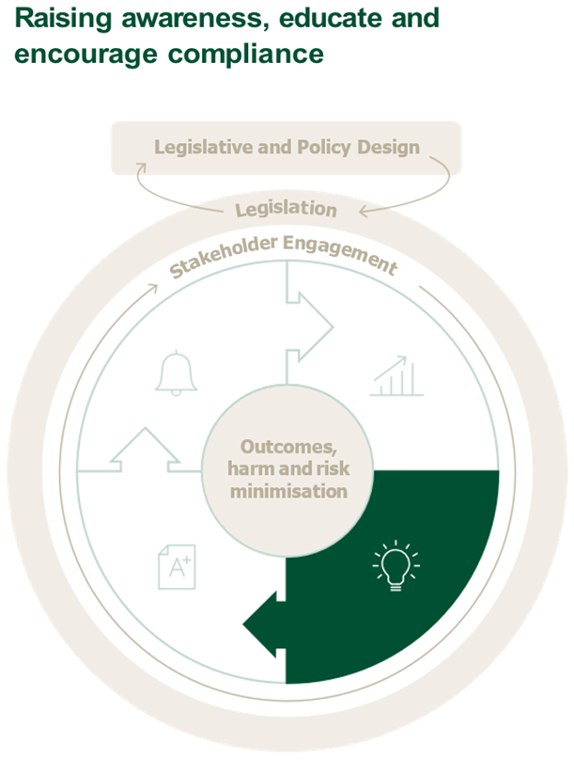
This element of the Framework addresses how to raise awareness of the program and compliance obligations, how to educate duty holders (and those that advise them) on how to comply and approaches to encourage behaviour towards meeting compliance obligations.
(Description of the above Agriculture Victoria Regulatory Framework overview diagram)
This diagram is the same overview of the Regulatory Framework as previously described, however highlighting the raise awareness, educate and encourage compliance element and includes the following sub-elements:
- Raising awareness: Raise awareness of the program and the need for compliance
- Educating on how to comply: Educate awareness of the program and the need for compliance
- Encourage compliance: Motivate duty holder to comply through incentives and disincentives

Raise awareness and educate on how to comply
The Towards Best Practice guide for regulators, published by Better Regulation Victoria, sets two guiding principles, requiring regulators to:
- support duty holders to understand the value of compliance and harm reduction – so that they are motivated to comply and aware that they have an obligation to comply
- support duty holders to comply – so they understand how to comply and are equipped to comply.
Most duty holders want to comply. It therefore follows that if a regulator has made them aware of their compliance obligations and educated them on how to comply, then compliance rates will increase. This results in a reduction in regulatory intervention activities required to achieve the overall outcomes of risk / harm minimisation. This is depicted in the diagram seen on page 20 below.
Program planning considers activities to raise awareness of compliance obligations and educate duty holders on how to comply. Prevention is better than enforcement – and over time this leads to more efficient use of resources.
As part of program planning activities, the program area is to identify the duty holders, as well as other stakeholders such as industry and community bodies and third-party consultants who support Agriculture Victoria to:
- raise awareness of compliance obligations
- educate duty holders on how to comply.
Once identified, the organisation considers how best to engage and communicate with those duty holders and stakeholders, including the key messages to convey. How to do this is further explained in section 4.2 and Appendix 6.2.
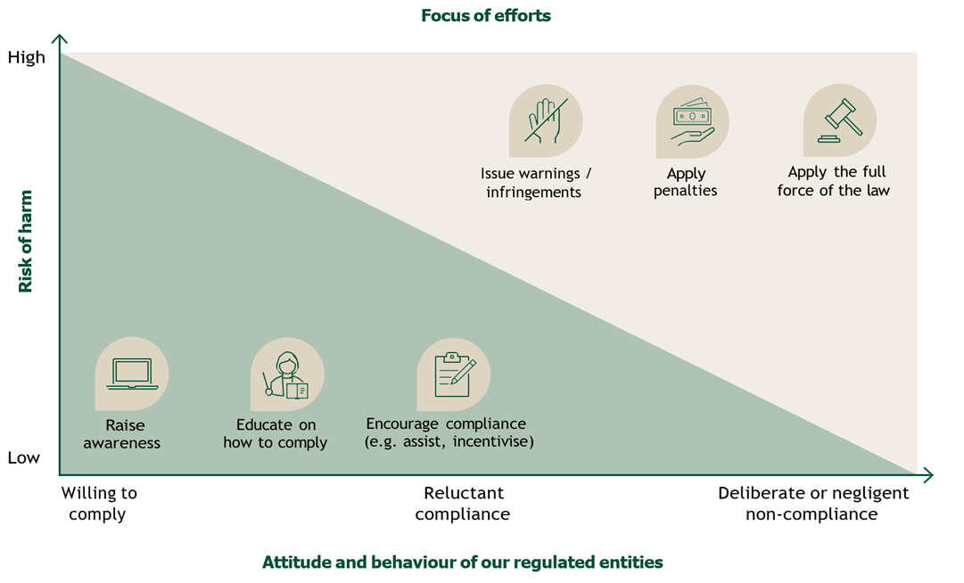
(Description of the above graph)
The graph shows the attitude and behaviour of our regulated entities on the x-axis (horizontal) and the risk of harm on the y-axis (vertical).
The graph shows where the risks of harm are lower and there is a higher degree of compliance, the focus of efforts should be: raising awareness, educating people on how to comply and encouraging compliance through assistance.
The graph shows where risks of harm are higher and there is a lower degree of compliance, the focus of efforts should include: issuing warnings, applying penalties and applying the full force of the law.

The extent of these activities is determined according to need and priorities. In some cases, these activities may not need to be extensive, while a new program or new compliance obligations to an existing program requires extensive communication.
Various communication methods are available, as detailed in section 4.2 and Appendix 6.2. These range from one-on-one sessions with bodies who can influence and communicate with duty holders, marketing via social media, online resources and guidance, through to education sessions and events.

Encourage compliance
Programs can consider encouraging a change in behaviour towards greater levels of compliance through approaches such as recognising and rewarding positive behaviours and providing incentives to act (before the threat of enforcement action). Self and co-regulatory models such as industry codes of practices (that may still be enforceable) are also examples of encouraging industry and businesses to take proactive action towards greater levels of compliance.

3.4 Compliance activities
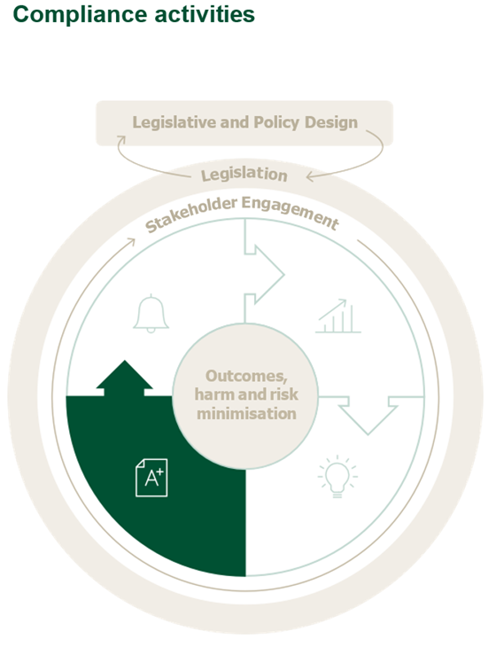
This element of the Framework addresses activities Agriculture Victoria undertakes to monitor and ensure compliance.
(Description of the above Agriculture Victoria Regulatory Framework overview diagram)
This diagram is the same overview of the Regulatory Framework as previously described, however highlighting the compliance activities element, and includes the following sub-elements:
- Permissioning: Grant permission through licences, permits, registration and other means
- Targeting: Target through surveillance, early detection and compliance monitoring, risk-based sampling and complaints and other means
- Reviewing compliance: Review compliance through audits, inspections and compliance assessments and other means
- Enforcing: Where required, enforce compliance through penalties, directives, removal of licences and permits, prosecution and other legal action.
Achieving compliance considers the full spectrum of compliance activities listed above (refer to 6 to 9), and the methods for undertaking them that are applicable to the program and legislation. These approaches are considered and articulated at multiple points when applying the Framework, including:
- In legislation, policy and program design
- At the point of program planning and improvement
- In planning specific compliance activities
The relevance of each of the compliance activities, and how that activity is undertaken in each program, is determined at a program level. In other words – the program considers each compliance activity and plans how that activity will be undertaken, to maximise compliance with available resources. Naturally, some compliance activities have less relevance to some programs, and greater relevance to others, in order for regulatory objectives to be achieved.
Some compliance activities may not be warranted for some programs. For example, permissioning and enforcement may not be a feature of achieving compliance with some regulations. All programs have some level of compliance review and assurance, with risk-based targeting enabling the most efficient use of limited resources.
The continuum of compliance and enforcement activities that applies is depicted in the diagram below:
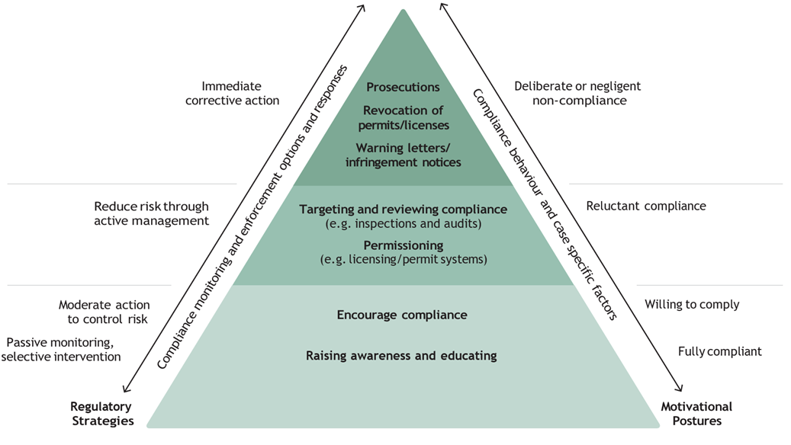

(Description of the above diagram)
The above diagram is a pyramid, split into three layers showing the continuum of compliance and enforcement activities and the corresponding regulatory strategies and motivational postures as outlined below (from bottom to top):

Regulatory Strategies  (Compliance monitoring and enforcement options and responses) | Continuum of compliance  and enforcement activities | Motivational Postures  (Compliance behaviour and  case specific factors)
Immediate corrective action | - Prosecutions  - Revocation of permits/ licences  - Warning letters/ infringement notices | - Deliberate or negligent non-compliance
Reduce risk through active management | - Targeting and reviewing compliance (e.g. inspections and audits)  - Permissioning (e.g. licencing/ permit systems) | - Reluctant compliance
Moderate action to control risk  Passive monitoring, selective intervention. | - Encourage compliance  - Raising awareness and educating | - Willing to comply  - Fully compliant

Permissioning
This is the process where permission is granted to entities and individuals to conduct activities regulated by Agriculture Victoria. This includes:
- registration of duty holders (eg. individuals or firms) to facilitate compliance activities in animal, food or product traceability
- granting of licences or permits – for example, a duty holder demonstrating some level of ability to comply before being issued a licence or permit to conduct regulated activities, or providing an acknowledgment they will comply.

Monitoring and targeting compliance activities
This is the process of targeting the compliance activities outlined below to ensure the highest level of compliance outcomes are achieved with limited resources. These activities also inform more targeted awareness and education activities discussed in section 3.3. Methods can include:
- conducting surveillance to identify higher risk areas or potential targets
- early detection monitoring
- compliance monitoring, typically using data or information sources
- risk-based sampling – targeting compliance activities at identified higher risk areas, sectors, duty holders or activities
- use of complaints or other forms of reporting from the public or stakeholders.

Reviewing compliance
This is the conduct of activities to identify levels of compliance. It includes such activities as desktop reviews of documentation/information, audits, inspections and other forms of compliance assessment. These can include routine or programmed activities, and one-off or reactive responses such as blitzes or task forces.

3.5 Monitor and evaluate
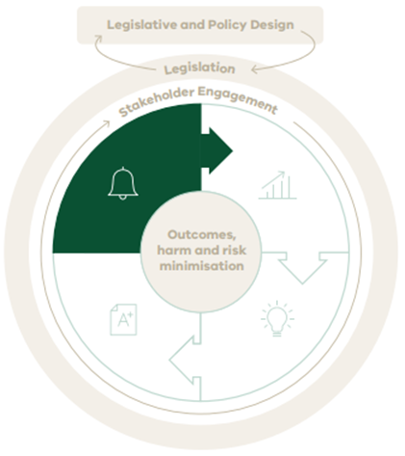
This element of the Framework addresses how Agriculture Victoria undertakes to monitor and evaluate the performance of the program, achievement of outcomes and objectives, identify improvements and lessons learned, and report on this internally and to key stakeholders. This section should be read together with the more detailed guidance included in Agriculture Victoria’s Biosecurity Evaluation Framework and the Performance Management Framework for Victorian Government Departments.
(Description of the above Agriculture Victoria Regulatory Framework overview diagram)
This diagram is the same overview of the Regulatory Framework as previously described, however highlighting the monitor and evaluate element and includes the following sub-elements:
- Monitoring: Monitor ongoing program performance
- Evaluation: Periodically evaluate the program
- Reporting: Report outcomes and improvement opportunities
Monitoring, evaluation, reporting and improvement (often abbreviated to MERI) are the activities associated with monitoring program performance, achievement of outcomes and identification of improvement opportunities, and reporting this to program stakeholders.

Defining objectives, outcomes and measuring success
Programs are articulated in terms of inputs, activities, outputs, and outcomes / impacts and objectives, both shorter and longer term. The Victorian Government’s Performance Management Framework depicts these aspects in the diagram below.
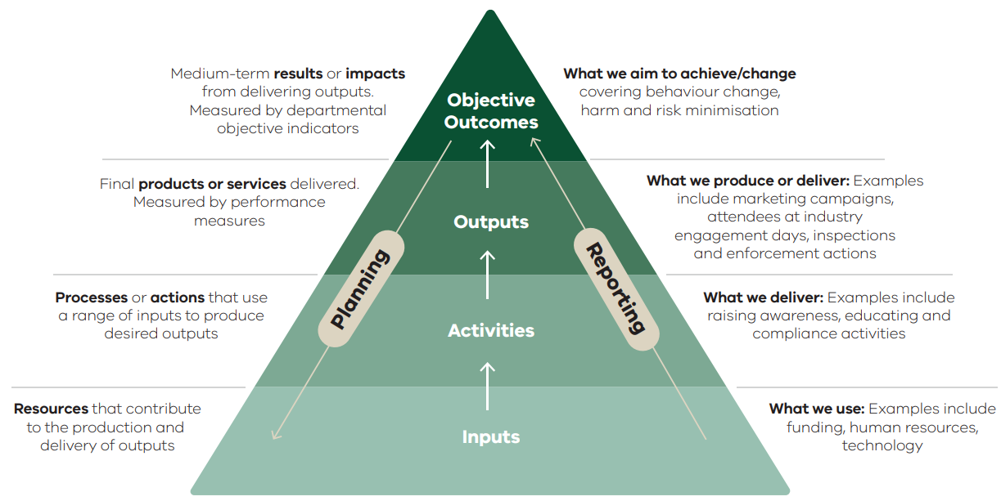
(Description of the above diagram)
The above diagram is a representation of how Programs are articulated under the Victorian Government’s Performance Management Framework, with inputs, activities, outputs, and outcomes / impacts and objectives shown across a pyramid split into four layers. The elements at each layer are as follows (from top to bottom as per the diagram):

Element | Planning | Reporting
Objective outcomes: | Medium-term results or impacts from delivering outputs. Measured by departmental objective indicators | What we aim to achieve/change covering behaviour change, harm and risk minimisation
Outputs: | Final products or services delivered. Measured by performance measures | What we produce or deliver: Examples include marketing campaigns, attendees at industry engagement days, inspections and enforcement actions
Activities: | Processes or actions that use a range of inputs to produce desired outputs | What we deliver: Examples include raising awareness, educating and compliance activities
Inputs: | Resources that contribute to the production and delivery of outputs | What we use: Examples include funding, human resources, technology
Although funding and program resourcing can sometimes be based on inputs, activities and outputs (such as the number of activities or participants), it is important that programs clearly articulate the objectives, outcomes and level of impact the program has on minimising harms and changing behaviours. Qualitative and / or quantitative measures are defined to monitor and report on these outcomes.
An ‘output’ may be a compliance activity such as an inspection. The outcome is a reduction in the potential for harm or risk resulting from that inspection. Emphasis is placed, where possible, on identifying the behaviour change required to achieve harm minimisation. For example, a better measure of effectiveness might be the level of behavioural improvement over time rather than measuring the number of compliance activities. This leads to improved targeting and greater emphasis on activities that aim to raise awareness and educate duty holders, to achieve a reduction in non-compliance.

Monitoring
Monitoring is the ongoing process of measuring and reporting on performance on a regular basis. Monitoring relies on data, including input and outputs, and wherever possible, lead indicators of outcomes, impact and success. Monitoring is used to manage delivery of the regulatory program.

Evaluating
Evaluation of regulatory programs is typically conducted periodically. Some evaluation activities may be conducted annually, but as comprehensive evaluation can be resource intensive, some evaluation activities might only be conducted every three years (to align with the program strategy cycle).
Evaluation is focused on assessing any combination of:
Appropriateness. Is there still a need for the program / activity – does the risk or harm still warrant effort and funding directed towards activities to minimise that risk. In other words, is the investment ‘value for money’ when looking at the risk and the level of harm minimisation achieved.
Effectiveness. Is the program achieving the expected outcomes, impact and objectives. Are there improvements that could be made to increase outcomes and risk/harm minimisation. Are there alternative approaches that might deliver improved outcomes and risk/harm minimisation.
Efficiency. Are we getting the most outputs and outcomes for the least amount of inputs, typically personnel and funding. Are there more efficient ways of delivering the outputs. Are there more efficient ways to achieve the same level of outcomes or to deliver more outcomes.
Evaluation primarily aims to identify ways to improve the program and forms a key input into program planning – where feedback, lessons learned and identified improvements are fed into continuous improvement activities.
Information informing evaluation comes from many sources including: stakeholder and staff feedback, program and compliance data, intelligence, benchmarking and knowledge sharing with other regulators or jurisdictions, complaints, surveys and workshops. Data sources not only target information on effectiveness (outputs, outcomes, impact and achievement of objectives) and efficiency, but also information that points to improvement. This includes not just quantitative data but also qualitative information.

Reporting
Agriculture Victoria is accountable to the government and the public for our regulatory activities and actions. Clear and robust reporting ensures transparency and promotes public confidence in the delivery of our regulatory responsibilities. It also helps us to improve compliance, by ensuring people are aware of legislative standards and the consequences of failing to meet these standards.
We regularly report our activities, outcomes and achievement of objectives to the Minister, parliament and the general public. This includes requirements for annual reporting and progress updates on the Minister’s Statement of Expectations, and the performance reporting requirements of the Performance Management Framework for Victorian Government Departments. We also report outcomes of evaluations to inform program planning and improvement. This reporting is shared internally and externally where possible, with regulated parties and key stakeholders to contribute to planning and improve our effectiveness. Agriculture Victoria also reports internally on a regular basis, to monitor and manage regulatory programs, including redirecting resources and activities. This reporting can occur on a monthly or even weekly basis and helps managers to efficiently implement programs.

Developing a Program Monitoring and Evaluation Framework and Plan
Monitoring and evaluation frameworks are developed as part of Compliance Program Strategies and evaluation activities planned as part of Annual Operational Plans. In addition to a clear statement of the objectives, outcomes and level of impact the program will have on minimising harms and changing behaviours, evaluation frameworks and plans cover:
- performance indicators that measure the achievement of objectives, outcomes and level of impact
- key evaluation questions (KEQs) that address:
- appropriateness - whether the program and current activities remains appropriate
- effectiveness of the program activities
- efficiency of the program activities
- what improvements and innovations can be identified and whether there are alternative approaches that might deliver improved outcomes and risk/harm minimisation.
- ongoing performance monitoring and reporting to manage the program (statistics, including input and outputs, and where possible, lead indicators of success).

Stakeholder Engagement

4. Stakeholder Engagement
Stakeholder engagement plays an important role in all regulatory phases, as outlined in the Framework below.
Stakeholder engagement is required to gain ideas and insights for better regulation, proactively prevent risks and harms from occurring, and react when they do. To achieve these outcomes, consideration of the stakeholder, the desired outcome, and the best form of engagement to achieve that outcome, is important.

Why engage with stakeholders
- to inform program design, planning and improvement
- to raise awareness and educate on how to comply
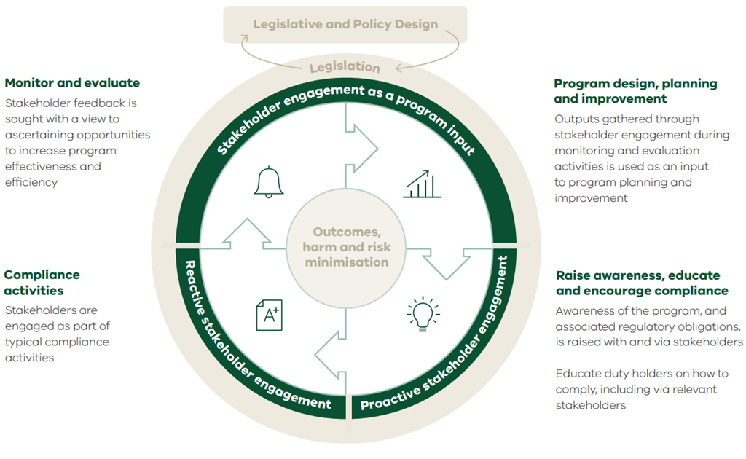
- sto respond to issues and opportunities, including those that come out of compliance activities (note that this is not further detailed in this section as the response/engagement is reactive to the circumstance).
(Description of the above Agriculture Victoria Regulatory Framework overview diagram)
This diagram is the same as the Agriculture Victoria Regulatory Framework overview. However, this diagram highlights that:
- Program design, planning and improvement, as well as monitoring and evaluating opportunities is supported by stakeholder engagement as a program input.
- Raising awareness, educating and encouraging compliance is supported by proactive stakeholder engagement.
- Compliance activities are supported by reactive stakeholder engagement.

Input to program planning and improvement
Stakeholders can be engaged to provide input into program evaluation and program planning activities. Stakeholders are a good source of feedback, improvements or benchmarks to inform program planning. Stakeholders should also be informed or consulted on potential changes to program planning to understand impacts of activities and to gain feedback.
The process for identifying stakeholders and planning for engagement is set out in Appendix 6.2. This includes determining the most effective frequency and timing of engagement for input to program planning.

Raise awareness and educate
Engagement is also, perhaps most importantly, undertaken to help stakeholders and duty holders improve awareness of compliance obligations and provide guidance and education on how to comply.
Stakeholders include other groups that can assist to raise awareness and education on how to comply. Examples include industry bodies, local farmer groups and local councils. Protecting our land and agricultural industries, and the welfare of animals, is a shared responsibility. The community also contributes to behavioural changes and can highlight risks of harm and compliance risks.
The process for identifying stakeholders that can impact on raising awareness and educating duty holders, and planning for engagement with them is set out in Appendix 6.2.
The lessons from prior activities to raise awareness and educate should be applied to planning future activities. This includes repeating/increasing those that were successful, and changing or avoiding those that were not successful.’

Strategic Priorities

5. Building capability and implementing the Framework
The Victorian Government’s strategy “Strong, Innovative, Sustainable: a new strategy for Agriculture in Victoria” has articulated a range of initiatives that relate to making Agriculture Victoria a better practice regulator.
The development and implementation of this Framework is one of those. The successful implementation of this framework aligns with other elements of that strategy, notably the initiatives to improve regulatory capability, improve the use of technology and harnessing of data to improve regulatory management and decision making.

5.1 Capability building
A capability framework has been developed, and assessment has shown the need to uplift capabilities in the following areas:
- stakeholder engagement, including raising awareness and educating on how to comply
- monitoring, evaluation and reporting
- data analysis and monitoring of compliance
- management strategy setting including development of strategic responses and use of innovative tools and approaches.
Many of these capabilities involve specialist skills, potentially requiring recruitment and/or development of specialists in these areas, and using ‘Communities of Practice’ to share specialist knowledge within Agriculture Victoria. Some specialist areas already exist. Regulatory program managers can consider leveraging this expertise to inform planning activities.

5.2 Knowledge sharing
One important way to build capability and improve program planning and management is to encourage knowledge sharing across programs, and with other regulators and jurisdictions.
Knowledge sharing forums and platforms, including online platforms such as SharePoint Hubs, and other knowledge sharing activities such as participation in Communities of Practices, are encouraged. Other specialist areas can also support this knowledge sharing.

5.3 Technology and data
While it is important to invest in building data analysis capability within programs, people and specialist areas, there will also be a need for further investment in technology and systems to support data collection and analysis. The sharing of insights within and across programs is vital.
Agriculture Victoria is developing a separate strategy around technology, systems and data.

5.4 Ensuring success
It is recommended that this Framework be subject to review 12 months from release, and then at three yearly intervals. The review should focus on:
- the level of awareness of the Framework by those managing programs and whether the process of communicating and upskilling management on the Framework has been effective or should be improved
- the level of adoption – are all aspects being adopted and implemented or is there a plan in place to implement it. Can more be done to support regulatory programs to apply the Framework
- whether the Framework is useful and fit for purpose, whether it could be improved, be clearer or have more information or supporting guidance documents, processes or templates
- whether the Framework has led to improved regulatory management outcomes. This entails asking program managers whether there
- have been tangible improvements to program planning and improvement, activities around raising awareness and educating stakeholders, compliance activities, monitoring and evaluation and stakeholder engagement as a result of applying the Framework.
- Those responsible for the Framework should also monitor 1 and 2 above on an ongoing basis throughout its implementation.

Appendices

6. Appendices

6.1 List of useful resources

Framework context and regulatory program planning
- Towards Best Practice: A guide for regulators
- Strong, Innovative, Sustainable: a new strategy for Agriculture in Victoria
- Regulatory Approach 2022 – 2027
- Agriculture Victoria’s Compliance Management Policy
- Agriculture Victoria’s Compliance Management Policy Guidelines.

Monitoring and evaluating
- Performance Management Framework for Victorian Government Departments
- Commonwealth guidance on Developing Good Performance Measures
- Agriculture Victoria’s Biosecurity Evidence Framework.

Stakeholder engagement
- Public Engagement Framework 2021 – 2025: https://www.vic.gov.au/public-engagement- framework-2021-2025
- IAP Engagement Spectrum: https://iap2.org.au/ resources/spectrum/ and: https://iap2.org.au/wp- content/uploads/2020/01/2018_IAP2_Spectrum.pdf
- Guidance for Traditional Owner engagement – First Peoples State Relations, DPC: https:// www.firstpeoplesrelations.vic.gov.au/engaging- traditional-owners
- Agriculture Victoria’s Engagement and Communication Plan template, and Stakeholder Tool checklist

6.2 Stakeholder engagement planning
As referenced in Section 4 Stakeholder Engagement, stakeholder identification, analysis and planning of engagement is important to:
- inform program design, planning and improvement
- raise awareness and educate on how to comply.
Guidance on the process for stakeholder analysis and engagement planning is detailed below.

Inform program planning and improvement
In this context, stakeholders are being engaged to provide input into program evaluation and program planning activities as a good source of feedback on improvements or benchmarks to inform program planning. Stakeholders would also be informed or consulted on potential changes to program planning to understand impacts of activities and to gain feedback.

Identify stakeholders
The first step is to identify all potential stakeholder groups and individuals, focussing on those stakeholders who are in a position to provide input to program design, planning and improvement.
Examples include internal Agriculture Victoria stakeholders, industry bodies, advocacy groups and co-regulators. Agriculture Victoria’s Engagement and Communication Plan template and Stakeholder Tool Checklist supports this process.

Level of interest and level of influence
Programs can then consider the level of interest in the program and program planning and improvement, and the level of influence each stakeholder might have on implementing any changes. This might help inform the level of engagement effort put into that stakeholder / group. Stakeholders that are the most impacted by regulatory activities, as well as those that are highly interested and engaged and with high levels of influence will be the highest priority.

Determine the best form of engagement
A program then selects the best form of engagement to get the input required. Stakeholders’ time is valuable. Consideration is therefore to be given to the most effective ways to engage, considering:
- collecting rich or detailed information
- being efficient with limited resources and time.
It’s important to keep in mind the purpose and type of engagement, for example:
- inform – are we looking to inform of planned or potential changes?
- consult – do we need to consult on planned changes?
- involve – do we need to involve stakeholders in program planning, potentially to provide feedback?
- collaborate – do we need to collaborate to co-design changes or plan activities?
The Engagement and Communication Plan template can be used to support programs to plan stakeholder engagement and the Stakeholder Tool Checklist provides examples and guidance on the range of methods that can be used to engage stakeholders.
Program managers are to determine the most effective frequency and timing of engagement for input to program planning. Typically, this would be in advance of or as part of developing the Annual Operational Plan and the (3-yearly) Program Strategies.

Worked example
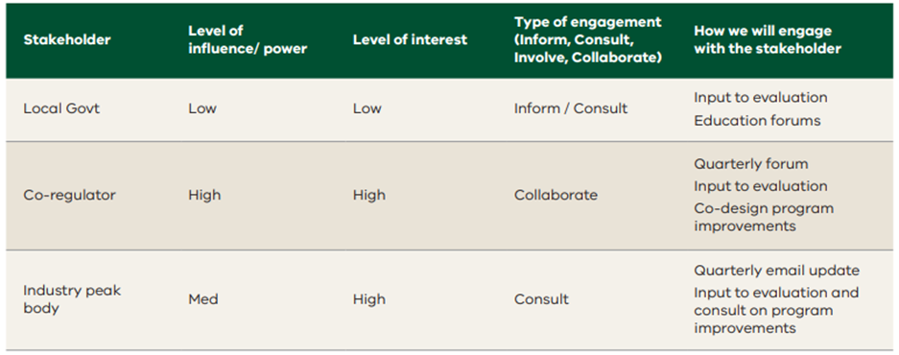
Description of what is inside the table:
Stakeholder: Local Government
Level of influence/power: Low
Level of interest: Low
Type of engagement (Inform, Consult, Involve, Collaborate): Inform/ Consult
How we will engage with the stakeholder: Input to evaluation, education forums
Stakeholder: Co-regulator
Level of influence/power: High
Level of interest: High
Type of engagement (Inform, Consult, Involve, Collaborate): Collaborate
How we will engage with the stakeholder: Quarterly forum input to evaluation, co-design program improvements
Stakeholder: Industry peak body
Level of influence/power: Med
Level of interest: High
Type of engagement (Inform, Consult, Involve, Collaborate): Consult
How we will engage with the stakeholder: Quarterly email update, input to evaluation and consult on program improvements

Raise awareness and educate
Engagement is also, perhaps most importantly, undertaken to help stakeholders and duty holders improve awareness of compliance obligations and provide guidance and education on how to comply. The approach to this is similar, but with a focus on impacting the level of awareness and commitment to behaviour change towards greater levels of compliance.

Identify stakeholders
First identify the stakeholders. Include duty holders and other groups that can assist to raise awareness and educate on how to comply, such as industry bodies, local farmer groups and local councils.
Protecting our land and agricultural industries, and the welfare of animals is also a shared responsibility. The community can also help bring about behavioural changes and highlight risks of harm and compliance risks.

Where are they currently / where do we need them to be?
Identify the stakeholder’s current level of awareness and knowledge about the program, their compliance obligations and how to comply. And then identify what level of awareness and knowledge is needed into the future to achieve success. Levels of awareness and knowledge can include:
- unaware
- aware – “I know what it is” (my compliance obligations)
- understanding – “I know what the implications for me are” (I know how to comply)
- engagement – “this looks worth a try” (I start changing my behaviour towards complying)
- acceptance – “the new rules” (this is the way it has to be done – we need to comply)
- commitment – “I like to do it this way” (it’s easy to comply and we like doing it this way)
- internalisation – “this is the way we do things” (behaviour is embedded).

Determine the best form of engagement
Consider what level of engagement is required to raise awareness and educate on how to comply for each stakeholder group. Agriculture Victoria’s Engagement and Communication Plan process would define this level of engagement as to ‘Inform’. The Stakeholder Tool Checklist provides a range of methods that can be used to engage with stakeholders including:
- media release
- letter box drop
- fact sheet
- email distribution (including bulk email to stakeholders)
- organisational website
- social media
- brochure/ leaflet
- advertising
- poster, banners, signage
- open house
- public meeting or information session
- briefings
- workshop
- community event
- information Displays & Exhibits
- newsletter.
It is important to acknowledge that resource / time constraints must be a consideration in deciding how to engage. Consider how it can be done in the most efficient and targeted way. Again, the Stakeholder Tool Checklist provides some guidance on this.
Consideration should be given to leveraging existing communication channels across Agriculture Victoria, or those used by other stakeholder groups. Consider ‘piggy backing’ off other existing channels and events or partnering with others to deliver joint communications.

Plan your messaging
Plan out what you need each stakeholder group to know, considering particularly how we effect change in behaviour towards compliance and harm minimisation.
Worked example:
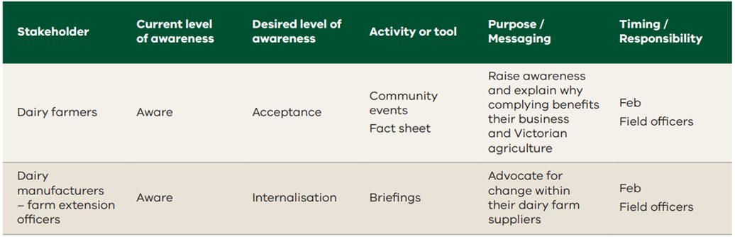

Description of what is inside the table:
Stakeholder: Dairy farmers
Current level of awareness: Aware
Desired level of awareness: Acceptance
Activity or tool: Community events, fact sheets
Purpose/ Messaging: Raise awareness and explain why complying benefits their business and Victorian agriculture
Timing/ Responsibility: Fed, Field Officers
Stakeholder: Dairy manufacturers – farm extension officers
Current level of awareness: Aware
Desired level of awareness: Internalisation
Activity or tool: Briefings
Purpose/ Messaging: Advocate for change within their dairy farm suppliers
Timing/ Responsibility: Feb, Field Officers
Apply lessons to future planned activities
The lessons from prior activities to raise awareness and educate should be applied to planning future activities. This includes repeating/increasing those that were successful, and changing or avoiding those that were not successful.

