|  |
| --- |
| Agriculture Victoria |
| Honey Bee Compensation and Industry Development Fund |
| 2023-24 Outcomes Summary |

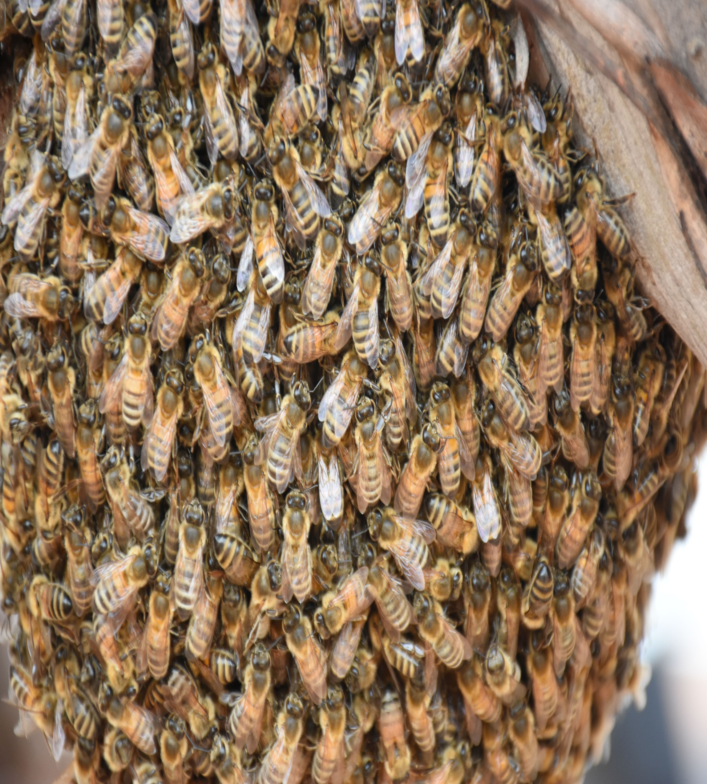



**Further information regarding the Livestock Biosecurity Funds may be obtained from:**

Monica Bird  
Agriculture Victoria  
475 Mickleham Road, Attwood, Victoria Australia

[LivestockBiosecurityFund@agriculture.vic.gov.au](mailto:LivestockBiosecurityFund@agriculture.vic.gov.au)

Authorised and published by the Victorian Government, Department of Energy, Environment and Climate Action (DEECA) 2024. © The State of Victoria Department of Energy, Environment and Climate Action 2024.

This publication is copyright. No part may be reproduced by any process except in accordance with the provisions of the *Copyright Act 1968*.

For more information contact the Agriculture Victoria Customer Service Centre on 136 186.

**Disclaimer**

This publication may be of assistance to you, but the State of Victoria and its employees do not guarantee that the publication is without flaw of any kind or is wholly appropriate for your particular purposes and therefore disclaims all liability for any error, loss or other consequence which may arise from you relying on any information in this publication.

**Accessibility**

If you would like to receive this publication in an accessible format, such as large print or audio, please telephone 136 186.

Deaf, hearing impaired or speech impaired? Call us via the National Relay Service on 133 677 or visit www. relayservice.com.au

This document is also available on the [Agriculture Victoria](https://agriculture.vic.gov.au/support-and-resources/funds-grants-programs/honey-bee-compensation-and-industry-development-fund) website.

# Apicultural Industry Advisory Committee

The Apicultural Industry Advisory Committee (AIAC) provides recommendations to the Minister for Agriculture for expenditure from the Honey Bee Compensation and Industry Development Fund (HBCIDF), through the annual Livestock Biosecurity Funds Grant Program. Successful projects and programs prevent, monitor, and control diseases, thereby enhancing animal health, biosecurity and market access for the benefit of Victorian apicultural industry.

The Minister for Agriculture appoints the AIAC chairperson and members on the basis of their skills and experience in the prescribed areas under the *Livestock Disease Control Act 1994* (the Act).

The AIAC met 6 times in the 2023-2024 financial year, supported by Agriculture Victoria as secretariat.

# Activities of the Committee

Key activities since July 2023 include:

* The assessment of 2024 Livestock Biosecurity Funds grant program and contributing to the continuous improvement of the annual grant rounds
* Finalisation of a AIAC Communications and Engagement Strategy, that is being rolled out over the next 3 grant rounds
* Reviewed the strategic focus for the 2024 Livestock Biosecurity Funds grant program
* Contributed to the new member’s selection process and improved induction and handover to new membership
* Oversight of the HBCIDF and milestones for successful projects.

## Livestock Biosecurity Funds Grant Program

Since the last report, the HBCIDF has been a part of the following Livestock Biosecurity Funds Grant Program rounds. See background below for more detail.

The AIAIC assessed every application received against the selection criteria set out in the Guidelines. In finalising their recommendation and supporting justification to the Minister, the AIAC considered their individual assessments, the available balance of their fund and a report from an independent assessment panel to determine the successful projects. An independent Probity Advisor oversaw the conflict-of-interest declarations and recommended the appropriate treatment of each.

### 2022 Livestock Biosecurity Funds Grant Program

The 2022 Livestock Biosecurity Funds Grant Program was open from 27 October to   
23 December 2022.

The AIAC assessed all applications in early 2023 and recommended 2 projects, totaling $39,708, to the Minister for Agriculture for approval:

* VAA 2023 conference speaker on Varroa
* Co-funding to support continued delivery of the National Bee Biosecurity Program in Victoria

### 2024 Livestock Biosecurity Funds Grant Program

The 2024 Livestock Biosecurity Funds Grant Program was open from 4 March to 15 April 2024, including a webinar to launch the round, presented by all 4 committees.

The AIAC assessed all applications in mid-2024 and recommended and recommended 3 projects, totalling $97,462, to the Minister for Agriculture for approval:

* eDNA approaches for early detection and management of varroa mite
* Online educational resource for beekeepers
* Hemp seed as a feed supplement for managed honey bee populations

## Improvements to the governance and operation of the committee

### Improved communications and engagement

The AIAC developed a Communications and Engagement Strategy that outlines the tools, channels and activities to ensure the grant round attracts quality applications, and the benefits of the HBCIDF projects are shared with industry. The AIAC Communications and Engagement Strategy will be implemented over the next 3 rounds and reviewed every   
3 years.

As part of the rollout of the AIAC Communications and Engagement Strategy, the inaugural webinar to launch the 2024 grant round was held on 4 March 2024. The   
4 chairpersons presented an overview of the 2024 Livestock Biosecurity Funds Grant Program and its strategic focus, eligibility, requirements and how to apply and held a Q&A session. The recording is available on the [Program Website](https://agriculture.vic.gov.au/support-and-resources/funds-grants-programs/livestock-biosecurity-funds).

### Strategic focus for annual rounds

The AIAC reviewed the strategic direction for the HBCIDF in late 2023 and identified 5 key themes:

1. Preparedness for response – building response capability, capacity and planning including the development of innovative control techniques to prevent and manage significant pests and diseases including AFB
2. Traceability – enhance system integrity and effectiveness
3. Early detection – improved surveillance and monitoring
4. Education – awareness and training for industry to better manage biosecurity risks, disease treatment and management and improve bee keeper competency
5. Research – particularly technologies for nutrition and genetic breeding programs, including for AFB, building honey bee resistance to significant pests and diseases, understanding of supplementary feeding of bees/husbandry practices to maintain healthy honey bee pollination stocks and benchmarking against national and international AFB standards

This strategic focus formed the selection criteria for the 2024 grant round and was incorporated in the Guidelines.

### Member selection changes and improved committee inductions and handover

From October 2022, changes were made to the *Livestock Disease Control Act 1994*, to allow for a maximum of 9 members appointed by the Minister for Agriculture based on skills and experience.

The Minister for Agriculture makes an appointment after considering a candidate’s experience in one or more of the following areas:

* the apicultural and allied industries
* biosecurity or market access
* quality assurance and food safety
* finance, legal practice, or business management
* agricultural, animal or veterinary science
* public policy
* any other area the Minister considers relevant to the functions of the Committee

The livestock advisory committees were consulted on the legislative changes and in the development of the selection process in 2022 and 2023.

The AIAC also worked with the Secretariat to develop the additional criteria for the selection of AIAC members and an improved induction package for the new AIAC membership.

## Appointment of a new committee

The previous membership, appointed by the Minister for Agriculture from prescribed nominating bodies expired on 27 January 2024. Following a 3-year term and a short-term extension, an Expression of Interest process for AIAC membership was open 30 October to 27 November 2023.

A Selection Panel, chaired by Agriculture Victoria and including industry representation, assessed all applications against the selection matrix. The Selection Panel conducted interviews and probity checks and recommended the preferred candidates to the Minister for Agriculture.

The Minister for Agriculture appointed the below members for a 3-year term, from 8 April 2024.

* Ms Angela Enbom (chairperson)
* Ms Gail Rochelmeyer (member)
* Mr Marc Higgins (member)
* Ms Peter McDonald (member)
* Ms Joseph Lewis Riordan (member)
* Ms Monique Leane (member)

# LBF grant program projects

Milestone management of the successful projects is overseen by the Department of Energy, Environment and Climate Action (DEECA), in consultation with the AIAC.

A summary of project activity since 1 July 2023 to 30 June 2024 is below.

## Summary of active HBCIDF projects

| Project  (Recipient) | Project Timeline | Total allocated from HBCIDF | Achievements to 30 June 2024 |
| --- | --- | --- | --- |
| 24.01 eDNA approaches for early detection and management of varroa mite  (Agriculture Victoria Research, DEECA)  Aims to collect eDNA samples from managed hives to assess the ability to detect varroa mite earlier than traditional methods and therefore enable faster and more effective management through monitoring of varroa mite | Oct 2024 – Jul 2026 | $80,000 | Not commenced. Grant agreement executed October 2024 |
| 24.26 Hemp seed as a feed supplement for managed honey bee populations  (La Trobe University)  Aims to research if hemp seed could be a potential sustainable source as a pollen substitute in both laboratory and field-based experiments. Improving the effectiveness of pollen substitutes is essential for modern beekeeping to maintain the health and nutrition of honey bees. | 2024 –2026 | $8,500 | Grant agreement executed November 2024 |
| 24.35 Online educational resource for beekeepers  (Victorian Apiarists Association)  Will develop the infrastructure, processes and roles to expand and maintain a biosecurity education resource library for beekeepers in Victoria and beyond | Oct 2024 – Aug 2025 | $8,962 | Grant agreement executed October 2024 |

## Summary of HBCIDF projects closed - July 2023 to June 2024

| Project  (Recipient) | Project Timeline | Total HBCIDF contribution | Outcomes |
| --- | --- | --- | --- |
| 20.05 Co-funding of the Bee Biosecurity Officer  (Plant Health Australia)  Co-funding to support a full time Biosecurity Officer in Victoria to support more than 14,000 registered beekeepers. | Nov 2020 – Jun 2023 | $58,340 | Since 2021, the Victorian BBO has delivered presentations to over 1,100 beekeepers providing education and awareness on the Code, biosecurity best practice and pests and diseases, and further supported 224 beekeepers specifically regarding endemic diseases such as American foulbrood.  The Victorian BBO has also supported over 155 beekeepers joining the State Quarantine Response Team (SQRT) and increased the numbers of the beekeepers who surround port areas become a Pest Warrior for the early detection of exotic pests. |
| 22.25 Co-funding National Bee Biosecurity Program  (Biosecurity Victoria, DEECA)  Co-funding to support a full time Biosecurity Officer in Victoria to support more than 14,000 registered beekeepers. | NA | NA | Applicant declined offer of funding, due to decreased amount recommended by AIAC for approval during project approval.  $35,004 approved reallocated to HBCIDF. |
| 22.24 2023 Conference speaker on Varroa  (Victorian Apiarists Association)  Guest speaker to share skills and knowledge on Varroa. | September 2023 | $4704 | The conference was held in July 2023 Presentation from Jason Marshall available to view [here](https://www.youtube.com/watch?v=jsk-pZJOKZU). |

# Background

## Honey Bee Compensation Industry Development Fund

Victoria's Honey Bee Compensation and Industry Development Fund (HBCIDF) is established under the Act and is funded by registration fees for Victorian beekeepers as follows:

* Beekeepers with up to 5 hives
* No charge, if registration is completed online
  + $30 if registering and paying via a paper application form
* Beekeepers with more than 5 hives
  + $30 to register 6 – 50 hives
  + 60 cents per hive to register 51 or more hives

The Act sets out how the money in the HBCIDF may be used. This is generally for projects and programs that benefit the Victorian honey bee industry, compensation for specified endemic diseases and administration of the HBCIDF.

All expenditure from the funds require approval from the Minister for Agriculture, after considering the advice from the AIAC.

## Livestock Biosecurity Funds Grant Program

The Livestock Biosecurity Funds Grant Program is administered by the Department of Energy, Environment and Climate Action, with funding from the respective fund:

* Cattle Compensation Fund
* Sheep and Goat Compensation Fund
* Swine Compensation Fund
* Honey Bee Compensation and Industry Development Fund.

The Livestock Biosecurity Funds Grant Program aims to fund projects and programs that prevent, monitor, and control diseases, thereby enhancing animal health, biosecurity and market access for the benefit of Victorian cattle, sheep, goat, swine and honey bee industries.

Livestock Biosecurity Funds Grant Program funds are used for projects producing outcomes, consistent with the Act, which demonstrates the following principles:

* Innovative solutions and emerging technologies for unsolved livestock biosecurity issues, needs or gaps.
* Collaboration where possible across value chains.
* Quantifiable benefits to the whole of the livestock industries, which are measured and evaluated with evidence and data.

Each of the funds has a statement of strategic intent, outlining areas for investment and outcomes within the purpose and objectives of the Act. These are included in the Guidelines each year.

For more information on the Program, see [agriculture.vic.gov.au/support-and-resources/funds-grants-programs/livestock-biosecurity-funds](https://agriculture.vic.gov.au/support-and-resources/funds-grants-programs/livestock-biosecurity-funds).

# Current membership

* Angela Enbom (chairperson) is a director of the family beekeeping business, President of the CVAA and a VAA executive. Angela grew up in a farming family in South Gippsland, then spent 20 years overseas, studying, working, travelling and starting a family.​ In 2007 Angela reconnected with her beekeeper cousin Col, established an organic permaculture farm, and joined the Wimmera CMA board.
* Gail Rochelmeyer (member) is a bee keeper and director Ballarat Honey, managing bee and hive health, honey packing, marketing and sales of honey. She is a member of the Geelong and Ballarat Beekeeping clubs .

Since 2015, Gail has held the role of Secretary for the Victorian Farmers Federation Beekeeper Branch. Gail is a Registered Nurse Division 1, working with Ballarat Community Health Centre and General Practice​.

Gail has been a member of the AIAC since 2016 and was the previous chairperson.​

* Marc Higgins (member) has been involved in the honeybee industry since 1988. He has served on the Apiculture Advisory Committee since 2020. Marc has been a commercial beekeeper and held numerous other key industry positions, including Deputy Chair of the AHBIC (Australian Honey Bee Industry Council) and Director of BQUAL. He has also held senior executive roles at Capilano and Superbee Honey Factory. Currently, Marc is the CEO of the national charity Community Resources.
* Peter McDonald (member) is first and foremost a Professional beekeeper. He operates within a family run business in Castlemaine for the past 19 years. McDonald Honey are mainly bulk honey producers with a portion of pollination services included. It has a long history through multiple generations of family involvement in both beekeeping and the many beekeeping industry groups that support all beekeepers.​

Peter has been involved in many industry committees over the years, including a term as Chairperson of the Australian Honey Bee Industry Council (AHBIC).

* Joseph Lewis Riordan (member) was an Apiary Inspector at Agriculture Victoria between 2001 – 2022, hobby beekeeper producing modest quantity of honey sold locally.

Joseph is currently running a beekeeping program in a correctional centre and is the Co-founder of the Victorian apiary State Quarantine Response Team (SQRT) 2002.

* Monique Leane (member) has over 15 years of public service experience in primary industry policy, strategy, management, and licensing. Moniques most recent tole was the Director of Fisheries Management at the Victorian Fisheries Authority.

Monique is currently the Independent Chair of the Victorian Aquatic Organism Translocation Evaluation Panel and western abalone zone annual total allowable catch setting workshop.

# Previous membership

* Ms Gail Rochelmeyer (chairperson) –nominated by the VFF
* Mr Robert Arnts – member –nominated by the VAA
* Dr Lisa Cowan – member – Department nominee
* Ms Mark Higgins – member – Department nominee
* Ms Robert McDonald – member –nominated by the VAA
* Ms Ashley Smith – member –nominated by the VAA