
Dairying in Victoria

Dairy Farm Monitor Project
2024-25 Victoria statewide performance

There were approximately 2,476
dairy farm businesses in Victoria that produced 5.27 billion litres or 63.3% of Australia’s national milk production in 2024-25.

Dairy Farm Monitor Project farm locations and rainfall in 2024-25

In 2024-25 farm profitability for the state has been influenced by:


8% ↓ in average milk price to $8.86/kg MS

8% ↑ in feed costs to $4.57/kg MS
6% ↑ in variable costs to $5.22/kg MS
No change in overhead costs to $2.97/kg MS

Profitability
The statewide average profit (earnings before interest and tax, EBIT) was $1.46/kg MS in 2024-25, falling below the
19-year average profit, accounting for inflation. Northern Victoria recorded a lower profit than last year, while South West Victoria and Gippsland fell below their respective regional long-term average.
$2.00

$1.93

$1.46

$1.26

$1.09
Profit (EBIT $/kg MS)

$1.50

$1.00

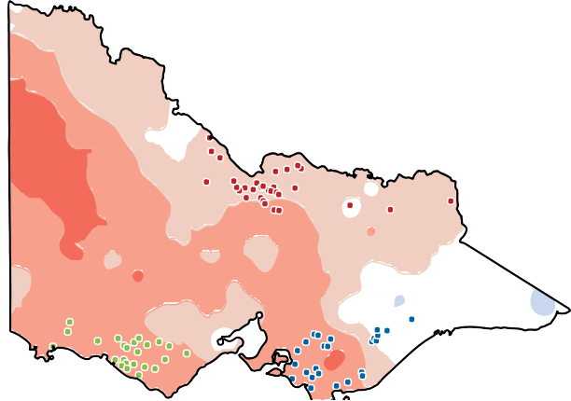
Northern Victoria South West Victoria Gippsland
Rainfall Decile Ranges
$0.50

$0.00

Statewide Northern
Victoria

South West Gippsland Victoria

Highest on record
3,911  t CO2-e/farm | 2024-25  Greenhouse gas emissions | 0.90  kg CO2-e/kg FPCM

Very much above average
Above average
Average Below
average
Very much below average
Lowest on record

Greenhouse gas emissions

In 2024-25, 86% of all Victorian participants had positive returns (69 out of 80)

2023-24 2024-25
$1.46
$2.64
Average EBIT ($/kg MS) Average net farm income ($/kg MS)
$0.47
$1.74
Victoria

Future expectations 2025-26

Two-thirds of the farmers expect business returns to improve

Average return on total assets
1.3%
7.7%
Further information: www.agriculture.vic.gov.au/dairyfarmmonitor
If you would like to receive this publication in an accessible format, telephone 136 186
or email fmp@victoria.agriculture.vic.gov.au
3.7%
6.1%
Average return on equity

