Greenhouse Gas Farm Monitor 2024-25



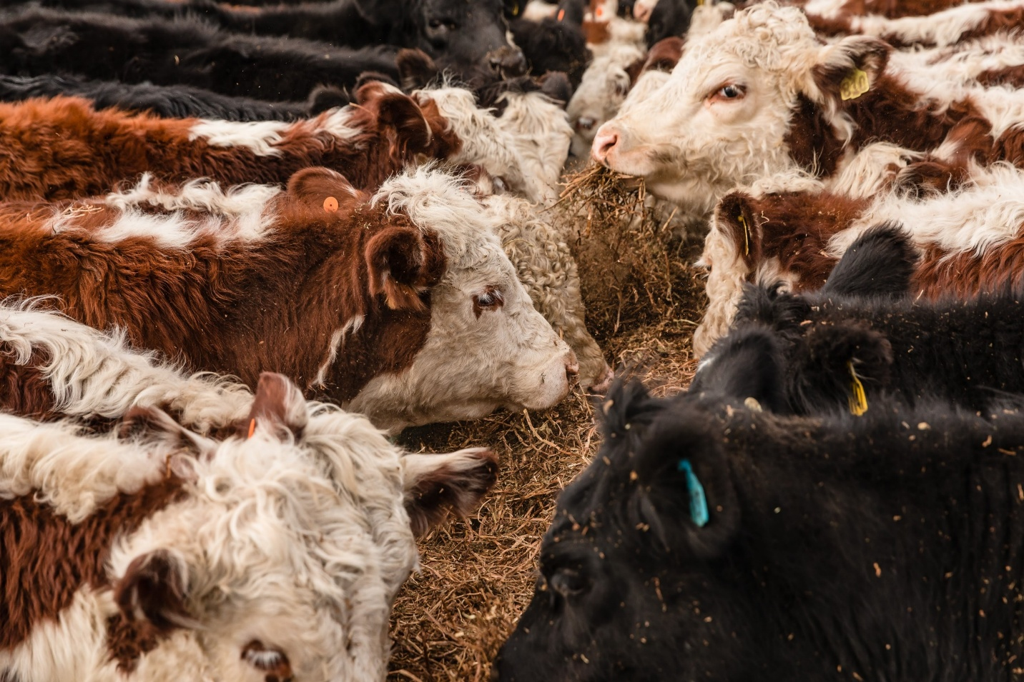
CONTENTS
ABOUT THE REPORT 2
DATA COLLECTION 3
TOTAL EMISSIONS 4
STATEWIDE SUMMARY 4
2024-25 FARM EMISSIONS 6
TREE CARBON SEQUESTRATION 8
EMISSIONS INTENSITY 10
2024-25 EMISSIONS INTENSITY 11
APPENDIX 12
GLOSSARY 15
FURTHER INFORMATION 18

ABOUT THE REPORT

Livestock Farm Monitor
The Livestock Farm Monitor Project is Agriculture Victoria’s primary source of farm-level information for sheep and beef production practices, resource use, and economic data. The results of the annual Livestock Farm Monitor Project provide farm-level data to inform Agriculture Victoria’s decisions that impact at a farm level and inform the direction of future policy design, research themes and service delivery programs.
Greenhouse gas emission estimates
In 2024-25 the type, source and quantity of greenhouse gas (GHG) emissions and sequestration was estimated using the University of Melbourne Sheep and Beef Accounting Framework (SB-GAF version 2.6) for each of the 134 farms surveyed. The aggregated emissions results generated from the analysis are summarised in this report. Farm emissions and sequestration are reported in carbon dioxide equivalents (CO₂-e). This allows for more meaningful comparisons of total emissions by adjusting each different GHG emissions type by its global warming potential.
Scope 1 emissions are direct GHG emissions that occur from sources owned or controlled by the farmer. Scope 2 GHG emissions are from purchased electricity consumed by the farm business. Scope 3 emissions are from upstream or downstream activities that are consequence of the farm business but from sources not controlled or owned by the farm business. For this analysis only upstream sources are included in the scope 3 emissions reported.
Acknowledgements
Agriculture Victoria staff are grateful for the cooperation of the farmers who contributed their data to this project.
This work is funded by Agriculture Victoria.

DATA COLLECTION
The Livestock Farm Monitor Project annually collects detailed financial and production performance information from 134 farm businesses from across Victoria. The map below shows the location of the 2024-25 participating farms, the rainfall decile they received during the financial year and whether they are categorised as being from Gippsland, Northern Victoria or South West Victoria. Rainfall was below average for most of the state except for East Gippsland.
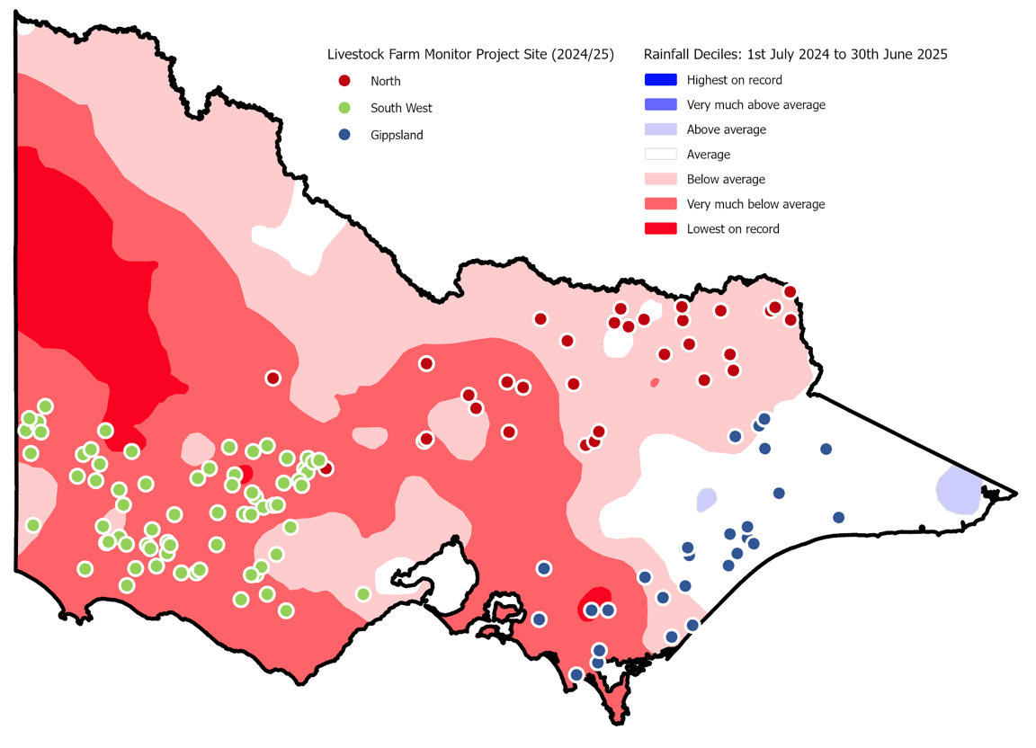

40
Sheep and beef businesses

13
Stock and grain businesses

50
Sheep specialist businesses
31
Beef specialist businesses

134
Farm businesses surveyed

TOTAL EMISSIONS

STATEWIDE SUMMARY
The median total net emissions per livestock farm was 2,004 tonnes CO₂-e, with a range of 1,121 to 3,710 t CO₂-e (Figure 1).
The major source of total farm emissions (scope 1, 2 and 3) from livestock farms was emissions released from the process of ruminant digestion (enteric methane. Enteric methane made up 77% of total emissions (Figure 2). The next largest emission sources were from urine and manure (8%), pre-farm emissions (7%) and fuel and electricity (1%).
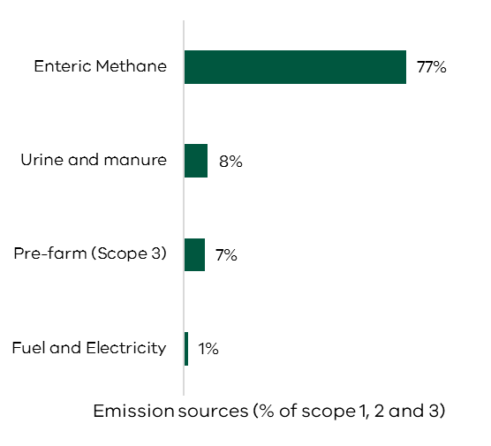
Figure 2. The statewide median proportion of emission sources per farm (% of Scope 1, 2 and 3).

Indirect emissions (Scope 3)
Net farm annual emissions footprint
Annual change carbon storage on the farm (new sequestration)
Carbon dioxide
Energy, lime, urea
Nitrous oxide
Fertiliser, urine and dung, crop residues
Methane
Enteric methane and manure

Upstream indirect emissions from farm purchases and inputs

Median emissions | 185 t  CO₂-e | 1,700 t  CO₂-e | 132 t  CO₂-e | 52 t  CO₂-e | 76 t  CO₂-e | 2,004 t  CO₂-e
Range | 42-425  t CO₂-e | 1,002-2,992  t CO₂-e | 77-221  t CO₂-e | 20-148  t CO₂-e | 19-249  t CO₂-e | 1,121-3,710  t CO₂-e
Figure 1. The median and range (as shown by Q1 to Q3) in different types and sources of emissions.

2024-25 FARM EMISSIONS
Total emissions per farm decreased by 6% in 2024-25 (Figure 3). This was mostly influenced by the management of dry seasonal conditions. Farmers reduced their stocking rates and fertiliser usage contributing to the lower methane and nitrous oxide emissions than the previous year. In 2024-25, scope 3 emissions increased by 14% due to an increase in the quantity of supplementary feed purchased as a result of poor pasture growth from dry conditions.

Figure 4 shows the number of livestock per farm can explain almost all the variation in farm emissions between regions. For example, South West Victoria farms had higher total emissions than participating farms in Northern Victoria and Gippsland because they had more livestock per farm (dry sheep equivalent per farm).
As livestock farm emission profiles are predominately comprised of emissions from livestock, the total number of livestock on a farm is therefore a good predictor of total farm emissions
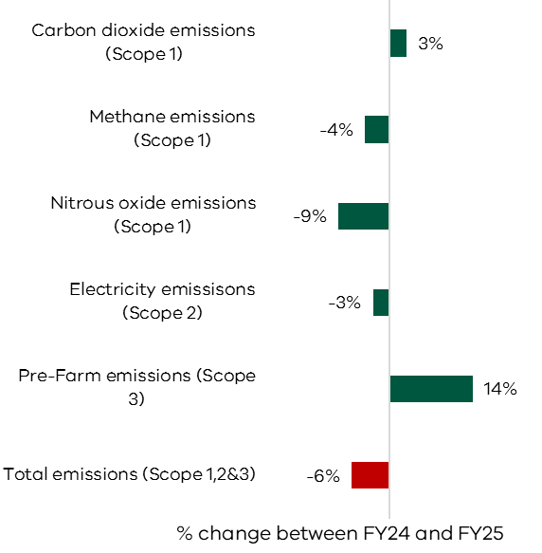
Figure 3. The statewide median percentage change of different emission types between financial year (FY) 2023-24 and 2024-25.

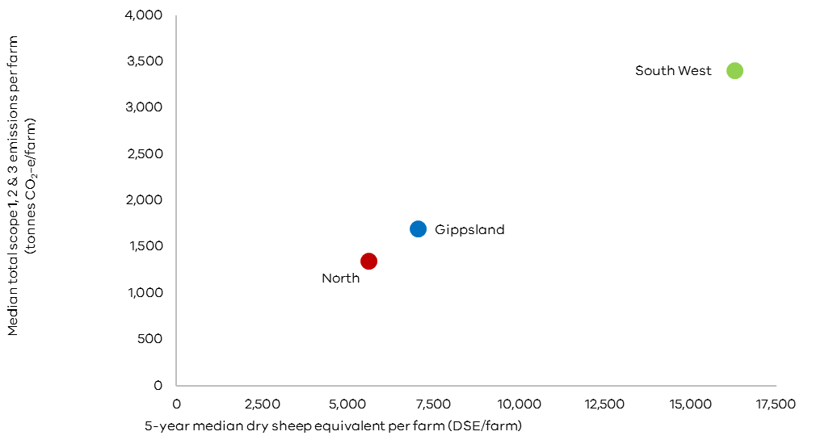
Figure 4. Regional 5-year median dry sheep equivalent per farm versus median total scope 1, 2 and 3 emissions per farm from 2020-21 to 2024-25.

TREE CARBON SEQUESTRATION
Trees can capture and store carbon; this process is called sequestration. Carbon that is sequestered in trees can be used in greenhouse gas accounting to balance emissions produced from a farm business. Trees on the 134 livestock farms captured and stored a total of 26,179 tonnes of CO₂-e in 2024–25 (Figure 5).
Gippsland livestock farms sequestered an average of 160 tonnes of CO₂-e per farm from trees in 2024–25, the highest of all regions (Figure 6). This is largely because Gippsland is a higher rainfall region. The percentage of farm area allocated to trees tends to increase in higher rainfall areas and often due to smaller farm sizes. Gippsland had the highest proportion of tree area per farm and therefore sequestered more carbon per farm than other regions (Figure 6).

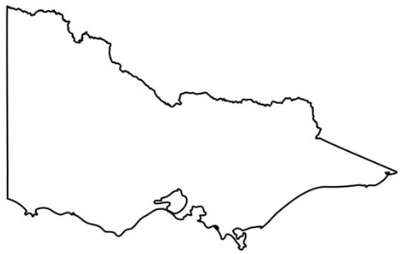

26,179 tonnes CO₂-e

Figure 5. 2024-25 total tonnes of CO₂-e sequestered by trees across 134 livestock farms

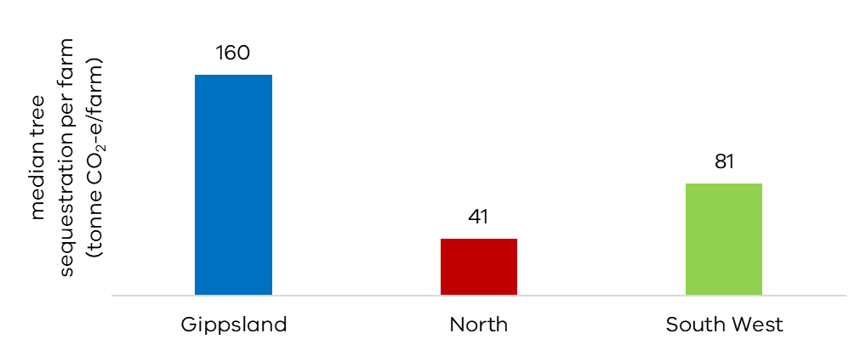
Figure 6. 2024-25 median carbon sequestration in trees per farm for each region.

EMISSIONS INTENSITY
Notes on emissions intensity
The measure of emissions intensity is used to provide a comparison of the amount of emissions per unit of product. Emissions intensity includes Scope 1, 2 and 3 emissions but not sequestration. The goal is to achieve a lower emissions intensity, which indicates fewer emissions produced per unit of farm product.
A variety of emission intensity benchmarks generated from the 2024-25 Livestock Farm Monitor Project dataset are listed in Tables 1-4 in the Appendix. Comparisons against project averages or median values need to be done with caution since individual farm circumstances, environment, resources and climatic variation between years can significantly affect the emissions footprint of a farm business.
Farmers should assess their baseline emissions, set goals and targets for emissions reduction in their own business, then track their progress over time.

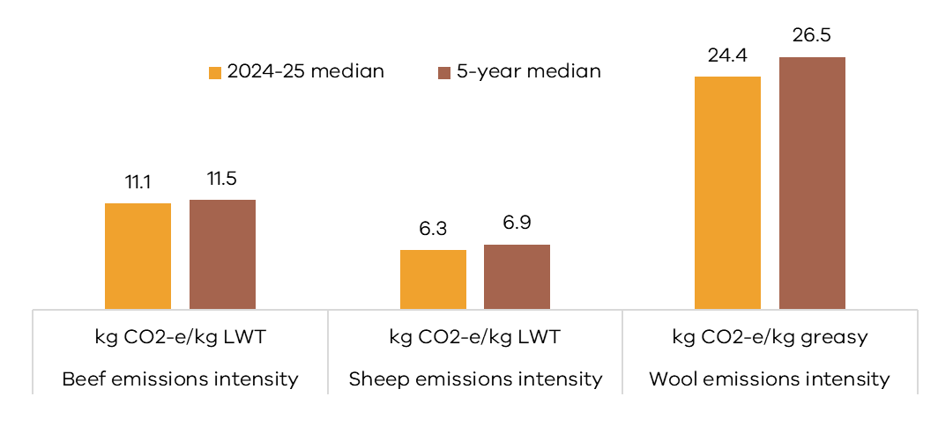
Figure 7. 2024-25 and 5-year median emissions intensity for production of beef, sheep and wool.

Median 24.4 kg CO₂-e emitted for every kilogram of greasy wool shorn.
(Q1 to Q3 range was 21 to 30)
Median 6.3 kg CO₂-e emitted for every kilogram of sheep liveweight sold.
(Q1 to Q3 range was 5 to 8)
Median 11.1 kg CO₂-e emitted for every kilogram of beef liveweight sold.
(Q1 to Q3 range was 7 to 13)

2024-25 EMISSIONS INTENSITY
The amount of liveweight sold relative to the number of livestock generating emissions on a farm (expressed as dry sheep equivalent) is a major influence on emissions intensity of sheep and beef enterprises. Enterprises that sold more liveweight per DSE tended to have lower meat emissions intensities.
Prime lamb and beef trading enterprises showed lower emissions intensity than wool sheep and beef breeding enterprises because they sold more liveweight per DSE (Figure 8 and 9).
For all sheep and beef enterprises, emissions intensity declined rapidly for increases in liveweight sold up to 50 kg LWT per DSE. After that, additional increases in liveweight sold produced smaller reductions in emissions intensity.
No single management variable explains differences in liveweight sold per DSE between farms. Improving total liveweight sold is highly specific to the farming system and operating environment.
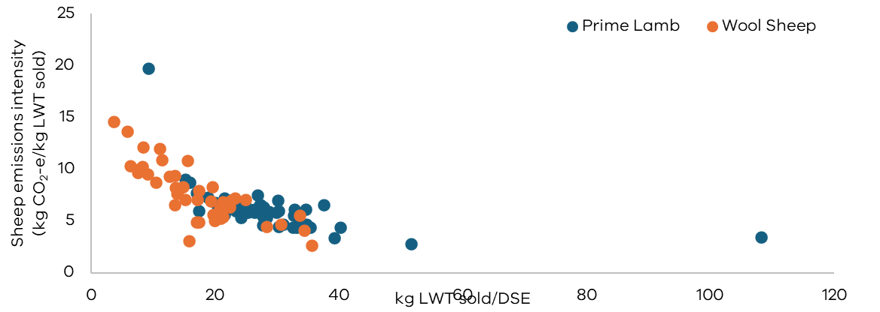

Figure 8. The influence of the amount of liveweight sold (kg LWT sold/Dry Sheep Equivalent) on sheep emissions intensity (kg CO₂-e/kg LWT sold) in 2024-25. The colour of the dots represents the different sheep enterprises.
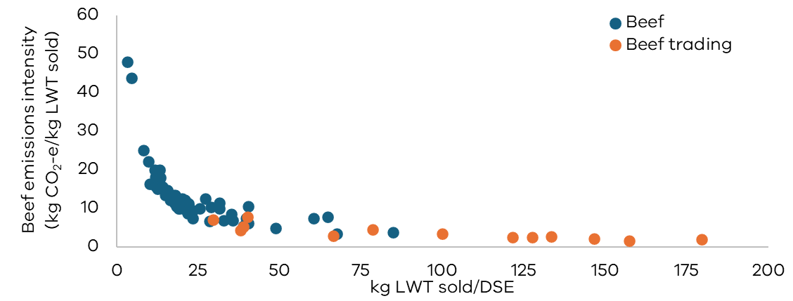

Figure 9. The influence of the amount of liveweight sold (kg LWT sold/Dry Sheep Equivalent) on beef emissions intensity (kg CO₂-e/kg LWT sold) in 2024-25. The colour of the dots represents the different beef enterprises.

APPENDIX

Table 1. 2024-25 statewide emissions intensity (scope 1, 2,3 excluding sequestration)
 | Whole farm emissions intensity | Whole farm emissions intensity | Whole farm emissions intensity | Whole farm emissions intensity | Whole farm emissions intensity | Sheep emissions intensity | Beef emissions intensity | Beef emissions intensity | Sheep meat emissions intensity | Wool emissions intensity
 | kg CO₂₋e  /cash income $ | t CO₂₋e/$m Assets | EBIT ($)/ t CO₂₋e | kg CO₂₋e  /DSE | kg CO₂₋e  /ha | kg CO₂₋e  /DSE | kg CO₂₋e  /DSE | kg CO₂₋e  /kg LWT | kg CO₂₋e  /kg LWT | kg CO₂₋e  /kg greasy
Statewide average | 2.5 | 158 | -$2 | 221 | 2,722 | 213 | 264 | 11 | 6.8 | 26
Statewide median | 2.5 | 159 | $7 | 212 | 2,673 | 206 | 222 | 11 | 6.3 | 24
Statewide Q1 to Q3 range | 2 - 3 | 109 - 203 | -78 - 55 | 196 - 232 | 1860 - 3350 | 190 - 229 | 205 - 246 | 7 - 13 | 5 - 8 | 21 - 30
Statewide 5-year median | 2.9 | 198 | 67 | 250 | 3,356 | 179 | 264 | 16 | 7.6 | 29
Statewide 5-year average | 2.5 | 192 | 66 | 213 | 2,912 | 185 | 212 | 12 | 6.9 | 26

Table 2. 2024-25 median emissions intensity (scope 1, 2,3 excluding sequestration) for each Livestock Farm Monitor region | Whole farm emissions intensity | Whole farm emissions intensity | Whole farm emissions intensity | Whole farm emissions intensity | Whole farm emissions intensity | Sheep emissions intensity | Beef emissions intensity | Beef emissions intensity | Sheep meat emissions intensity | Wool emissions intensity
Region  Median | kg CO₂₋e/cash income $ | t CO₂₋e/$m Assets | EBIT ($)/ t CO₂₋e | kg CO₂₋e  /DSE | kg CO₂₋e  /ha | kg CO₂₋e  /DSE | kg CO₂₋e  /DSE | kg CO₂₋e  /kg LWT | kg CO₂₋e  /kg LWT | kg CO₂₋e  /kg greasy
Gippsland | 3.0 | 184 | -$36 | 208 | 3,112 | 203 | 212 | 11.5 | 6.0 | 23
Northern Victoria | 2.8 | 143 | $7 | 219 | 2,734 | 215 | 224 | 11.6 | 6.5 | 27
South West Victoria | 2.2 | 162 | $12 | 206 | 2,399 | 204 | 237 | 9.8 | 6.3 | 24

Table 3. 2024-25 median emissions intensity (scope 1, 2,3 excluding sequestration) for each Livestock Farm Monitor business type.

 | Whole farm emissions intensity | Whole farm emissions intensity | Whole farm emissions intensity | Whole farm emissions intensity | Whole farm emissions intensity | Sheep emissions intensity | Beef emissions intensity | Beef emissions intensity | Sheep meat emissions intensity | Wool emissions intensity
Business type  median | kg CO₂₋e/cash income $ | t CO₂₋e/$m Assets | EBIT ($)/ t CO₂₋e | kg CO₂₋e  /DSE | kg CO₂₋e  /ha | kg CO₂₋e  /DSE | kg CO₂₋e  /DSE | kg CO₂₋e  /kg LWT | kg CO₂₋e  /kg LWT | kg CO₂₋e  /kg greasy
Sheep and Beef | 2.5 | 181 | $7 | 222 | 3,002 | 215 | 239 | 10.6 | 6.2 | 24
Beef specialist | 3.3 | 169 | -$11 | 215 | 3,206 |  | 215 | 12.2
Sheep specialist | 2.3 | 157 | -$7 | 206 | 2,329 | 206 |  |  | 6.3 | 24
Stock and grain | 1.0 | 68 | $173 | 190 | 1,332 | 190 | 204 | 10.5 | 5.7 | 22

 | Whole farm emissions intensity | Whole farm emissions intensity | Whole farm emissions intensity | Whole farm emissions intensity | Whole farm emissions intensity | Sheep emissions intensity | Beef emissions intensity | Beef emissions intensity | Sheep meat emissions intensity | Wool emissions intensity
Farm size  median | kg CO₂₋e/cash income $ | t CO₂₋e/$m Assets | EBIT ($)/ t CO₂₋e | kg CO₂₋e/DSE | kg CO₂₋e  /ha | kg CO₂₋e  /DSE | kg CO₂₋e  /DSE | kg CO₂₋e  /kg LWT | kg CO₂₋e  /kg LWT | kg CO₂₋e  /kg greasy
Smallest 25% | 3.1 | 148 | -$75 | 206 | 2,832 | 196 | 217 | 11.7 | 6.4 | 27
Lower mid 25% | 2.4 | 160 | -$8 | 219 | 2,357 | 217 | 222 | 11.0 | 6.2 | 24
Upper mid 25% | 2.2 | 157 | -$2 | 210 | 2,869 | 203 | 217 | 11.3 | 6.2 | 24
Largest 25% | 2.2 | 177 | $45 | 215 | 2,716 | 207 | 242 | 10.0 | 6.3 | 24
Table 4. 2024-25 median emissions intensity (scope 1, 2,3 excluding sequestration) for each farm size (defined by farm cash income) quartile in the Livestock Farm Monitor Project.

GLOSSARY

Average
The sum of a collection of numbers divided by the count of the numbers in the collection
Asset
Value of anything managed by the farm, whether it is owned or not. Assets include owned land and buildings, leased land, plant and machinery, stock and cash.
Business type
Specialist sheep: Businesses with more than 85% of DSE coming from sheep and less than 30% income coming from grain and cropping.
Specialist beef: Businesses with more than 85% of DSE coming from beef and less than 30% income coming from grain and cropping.
Sheep and beef: Businesses with less than 85% of DSE coming from beef, less than 85% DSE coming from sheep and less than 30% income coming from grain.
Stock and grain: Businesses with more than 30% of income coming from grain and cropping sales and greater than zero sheep or cattle DSE.
Carbon accounting
The process used to quantify greenhouse gas emissions from an enterprise.
Carbon sequestration
The process whereby carbon dioxide is removed from the atmosphere and stored in soils and vegetation.
Carbon dioxide equivalents (CO₂-e)
Carbon dioxide equivalents are a unit used to compare emissions from different greenhouse gases based on their global warming potential (GWP) over a specified time period, typically 100 years (GWP100).
Dry sheep equivalent (DSE)
A standardised animal unit. One DSE represents the daily energy requirement of a 50kg dry ewe that is maintaining condition (8 ME MJ).
Earnings before interest and tax (EBIT) The return on all the capital used in the business before accounting for finance costs. Calculated as gross farm income minus total variable and total overhead costs. Also known as ‘Operating Profit’ or ‘Profit’.
Enteric methane
Enteric methane is produced through enteric fermentation where plant material is broken down in the rumen. Enteric methane is the by-product of this process and is expelled by the animal through belching.
Global warming potential (GWP)
A measure of cumulative radiative forcing, which aims to quantify the long-term contribution of a gas to global warming. Each GHG has a specific GWP value and this is relative to a specified time period (typically 100 years, but values are also available for 20-year and 50-year time horizons). For the 100-year time horizon, this is abbreviated as GWP100. This report has use GWP100.
Greenhouse gases (GHGs)
Gases that absorb and emit radiant energy. The main GHGs associated with agriculture are carbon dioxide (CO₂), methane (CH₄) and nitrous oxide (N₂O).
Median
The middle value in a set of numbers when they are arranged in order from smallest to largest. The median is often used to find a "typical" value in a group and is less affected by very high or very low numbers than the average (mean).
Q1 to Q3 range
The range that covers the middle half of a set of numbers. Q1 (first quartile) is the point where the lowest 25% of numbers end, and Q3 (third quartile) is where the highest 25% begin. The difference between them (Q3 - Q1) shows how spread out the middle half of the data is.
Range
See Q1 to Q3 range
Return per emission Calculated as farm EBIT divided by the total farm greenhouse gas emissions in tonnes of carbon dioxide equivalents.
SB-GAF
The Sheep and Beef GHG accounting tool created and maintained by the University of Melbourne which generates farm emission and sequestration estimates. The version used for 2024-25 data in this report was 2.6.
https://piccc.org.au/resources/Tools.htm

FURTHER INFORMATION
Sam Henty
Agriculture Victoria
195-229 Lyttleton Terrace, Bendigo, Victoria, 3550
sam.henty@agriculture.vic.gov.au
Authorised and published by the Victorian Government, Department of Energy, Environment and Climate Action (DEECA) 2026. © The State of Victoria Department of Energy, Environment and Climate Action 2026.
This publication is copyright. No part may be reproduced by any process except in accordance with the provisions of the Copyright Act 1968.
For more information contact the Agriculture Victoria Customer Service Centre on 136 186.
Creative Commons
This work is licensed under a Creative Commons Attribution 4.0 International licence, visit the Creative Commons website (http://creativecommons.org/licenses/by/4.0/).
You are free to re-use the work under that licence, on the condition that you credit the State of Victoria as author. The licence does not apply to any images, photographs or branding,including the Victorian Coat of Arms, and the Victorian Government and Department logos.
ISSN 1835-9922

Disclaimer
This publication may be of assistance to you, but the State of Victoria and its employees do not guarantee that the publication is without flaw of any kind or is wholly appropriate for your particular purposes and therefore disclaims all liability for any error, loss or other consequence which may arise from you relying on any information in this publication.

Accessibility
If you would like to receive this publication in an accessible format, such as large print or audio, please telephone 136 186.
Deaf, hearing impaired or speech impaired? Call us via the National Relay Service on 133 677 or visit www. relayservice.com.au
This document is available on the Agriculture Victoria website.
www.agriculture.vic.gov.au/livestockfarmmonitor

