Important exotic diseases of dogs – rabies, leishmaniasis and ehrlichiosis

It is important that veterinary practitioners and pet owners are aware of the “big three” important exotic diseases of dogs: rabies, leishmaniasis and ehrlichiosis are all serious, sometimes fatal, diseases that can affect pets and humans.

Exotic diseases are those that do not exist in Australia. Our strict quarantine arrangements aim to protect our pets, livestock, wildlife and the human population from these serious diseases that occur in many other parts of the world.

Rabies
Rabies is a viral disease which targets nerves and parts of the brain. There are several strains of the classic rabies virus.
Rabies affects many species of animal with the potential to cause disease in domesticated animals including dogs, cats, horses, cattle, sheep and pigs. Humans can also become infected.
Animals or humans infected with rabies virus can show signs of illness shortly after infection or many months or even years later because the virus has a very variable incubation period. The clinical signs are described as either the ‘furious form’ or the ‘dumb form’ depending on which part of the brain is affected. The furious form typically appears as an animal or human with aggressive or anxious behaviour, whereas the dumb form typically exhibits as depression with paralysis of the face, throat and neck.
Rabies virus occurs throughout most of the world except Australia, New Zealand, Papua New Guinea, Japan, Great Britain and Ireland as well as many small island nations. Where animal rabies is found, cases of human rabies are also found. Australia has recorded several cases of human rabies including recent cases in 1987 and 1990 that involved children who had contracted rabies whilst overseas and did not shown signs until after their return to Australia.
Once clinical signs of rabies are observed the disease is invariably fatal.
Testing for rabies in a live animal is difficult and can be unreliable. There are no effective treatments for infected animals.
Post exposure vaccination may be used for humans exposed to the virus. This involves repeated vaccination of the person exposed on specific days post exposure.

Leishmaniasis
Leishmaniasis is transmitted by insects (sandflies) and is caused by single-celled parasites of the genus Leishmania. Internationally, more than 20 species have been described, most of which can affect humans as well as animals. The most important Leishmania species in domestic animals is Leishmania infantum, carried by dogs. It is considered exotic to Australia.
The incubation period for the disease can range from 1 month to 7 years, with infection developing into either clinical or subclinical disease.
The disease may affect the skin or internal organs. A typical presentation is accompanied by skin lesions, nose bleeding, eye abnormalities, swollen lymph nodes, weight loss and anaemia. Infection is potentially fatal in humans and animals.
- Wildlife mammal species are susceptible and domestic dogs are an important reservoir for human infection with Leishmania infantum in the developing world.
- If the disease became established in the Victorian dog population and if local sandflies can transmit the disease, then there could be significant risks to public health, mainly for children.
- Several diagnostic tests are used to diagnose leishmaniasis, but these tests are not very accurate, particularly in animals that are not showing any signs of illness or in the early stages of infection.
- Treatment of leishmaniasis is difficult requiring very long term (sometimes lifetime) treatment with very specific drug combinations.
- Specific insect repellents in collars or spot-on treatments can effectively reduce sand fly bites and transmission of leishmaniosis, and in some countries, vaccination is available to help prevent the disease.

Ehrlichiosis
Canine monocytic ehrlichiosis (CME) is caused by Ehrlichia canis, an intracellular bacterium transmitted by the brown dog tick. Ticks acquire E. canis by feeding on infected dogs and then transmit the infection when they feed on other dogs. The organism infects cells in the immune system of dogs, cats and humans.
Clinical findings in dogs with ehrlichiosis vary with the phase of the infection. During the acute phase, nonspecific signs such as fever, nasal discharge, anorexia, weight loss, and difficulty in breathing may occur. Later, signs may include depression, weight loss, pale mucous membranes, abdominal pain, bleeding, enlarged lymph nodes and stiff, swollen, painful joints. Eye abnormalities may also occur.
Blood smears and antibody tests are used to diagnose the condition but may not detect all cases. There is no vaccine for E canis infection, but antibiotic treatment is possible and may provide a cure if the dog is treated early enough, but severe, chronic or complicated cases may need a long course of treatment and the dog may never be fully cured.

What should you do if you suspect any of these diseases?
If you suspect your pet may be affected by any of these diseases, contact your veterinarian immediately or call the Emergency Animal Disease Hotline on 1800 675 888.

For more information
Visit: http://agriculture.vic.gov.au/agriculture/pests-diseases-and-weeds/animal-diseases/general-livestock-diseases/rabies-and-australian-bat-lyssavirus#
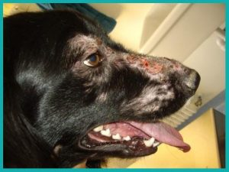

Image: Canine leishmaniasis in a dog. http://calviavet.com/en/leishmaniosis-canina/
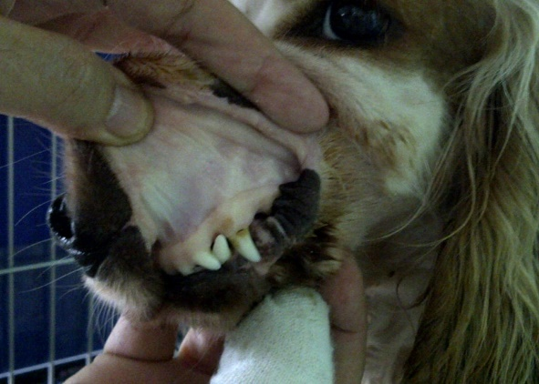
Image: Anaemia in a dog caused by Ehrlichia canis. http://www.vetbook.org/wiki/dog/index.php/File:Ehrlichia02

