Demonstration Summary

  - Shelter options for increased lamb survival – Enhanced Producer Demonstration Site

Producer demonstration sites in south-west Victoria evaluated five types of shelter for their ability to reduce exposure to high chill and ultimately improve lamb survival. The shelter options included: hay bales, corrugated iron, tall wheat grass, Dorycnium hirsutum hedgerows and eucalypt plantations.

Background

Lamb mortality in the high-rainfall zone of southern Australia represents a lost income to industry of around $100 million per annum. Research suggests a 10 per cent increase in weaning percentage can provide a corresponding 10 per cent increase in average gross margin per hectare (EverGraze, 2012).

Improved lamb survival in the first 48 hours post- birth is critical to weaning percentages as 70 per cent of lamb mortality (between birth and marking) occurs in this period. However, recent research indicates better survival can be expected from crossbred twin-born lambs versus Merino single- born lambs at the same birthweight (Hocking Edwards et al., 2019).

Over 80 per cent of lamb deaths are attributed to the mismothering/starvation/exposure (MSE) complex or dystocia. Exposure can be measured by chill index, which is comprised of wind speed, temperature and rainfall. Measurements above
1000kJ/m2/h have been proven to be high risk for lamb loss.

The social and economic impacts of high lamb mortality rates are significant, and this project sought to provide land managers with a range of options to reduce this impact.

This producer demonstration project was run with the Casterton, Cavendish and Avoca BestWool/BestLamb groups between 2015 and 2018, funded by Meat & Livestock Australia and Agriculture Victoria.

Aim and methodology

The project aimed to demonstrate the benefits for lamb survival through the establishment of hedgerows of tall wheat grass (TWG) and the leguminous shrub Dorycnium hirsutum, as well as constructed shelters using straw bales and corrugated iron sheets arranged in a Y, T or L-shaped formation. In the third and fourth years, an additional site was established using a eucalypt plantation, which are common in the local area. It also evaluated how to best establish and maintain the shelters.

Table 1 shows the different shelter types tested over the four years at different sites in south- west Victoria. TWG and D. hirsutum establishment was postponed in year one due to dry conditions, and in year two due to a late autumn break followed by an excessively wet spring.

Year 1

Shelter type | Site
Corrugated iron | Wando Bridge
Corrugated iron | Mooralla
Hay bale | Dobie

Year 2

Shelter type | Site
Corrugated iron | Wando Bridge
Corrugated iron | Bulart
Corrugated iron | Dobie

Year 3

Shelter type | Site
Tall wheat grass | Warrock
D. hirsutum | Gatum
Eucalypt plantation | Gatum
Hay bales | Wando Bridge
Hay bales | Gatum

Year 4

Shelter type | Site
Corrugated iron shelters | Dobie
Eucalypt plantation | Gatum
Hay bales | Wando Bridge
Hay bales | Gatum

Table 1. Shelter types tested each year at various sites.

A wind speed meter was set up at each site, to measure wind speed near the shelter in the sheltered paddocks, and in unsheltered (control) paddocks nearby. Each paddock contained twin- bearing ewes and lamb numbers were collected.

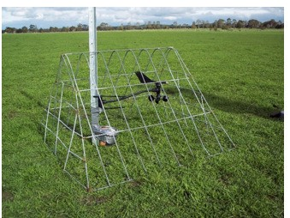

Figure 1. Wind speed meter set up in an unsheltered (control) paddock. The wind data was combined with Bureau of Meteorology temperature and rainfall data to calculate chill index.

Results

Establishment of TWG and D. hirsutum within the demonstrations was challenging, due to difficult seasonal conditions in the first two years of the demonstration.

All shelter options evaluated in the demonstration were effective at reducing the percentage of time when the chill index was considered high in the sheltered area (Figure 2), regardless of whether the lambs used the shelter or not. However, improvements in lamb survival were not consistent across all sites (Figure 3).

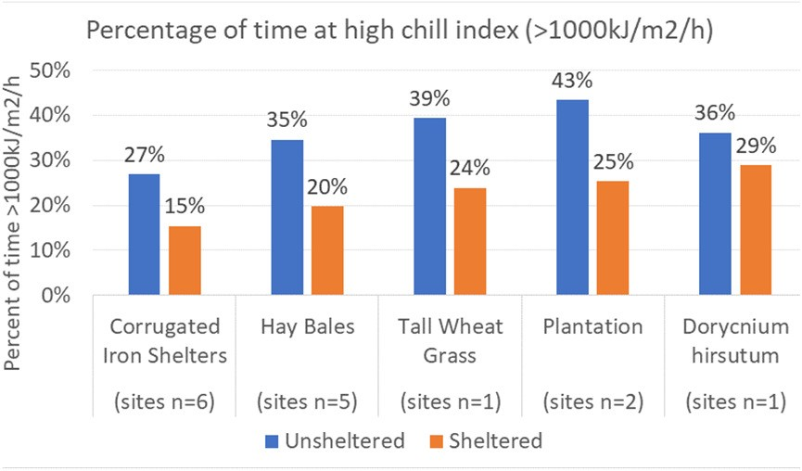

Corrugated iron shelters unsheltered (sites n=6) | 27%
Corrugated iron shelters sheltered (sites n=6) | 15%
Hay bales unsheltered (sites n=5) | 35%
Hay bales sheltered (sites n=5) | 20%
Tall Wheat Grass unsheltered (n=1) | 39%
Tall Wheat Grass sheltered (n=1) | 24%
Plantation unsheltered (n=2) | 43%
Plantation sheltered (n=2) | 25%
Dorycnium hirsutum unsheltered (n=1) | 36%
Dorycnium hirsutum sheltered (n=1) | 29%

Figure 2. Percentage of time at high chill index (greater than 1000kJ/m2/h).

The eucalypt plantation provided the biggest reduction in time at high chill index, driven by the density of understorey across the paddock slowing the wind at ground (lamb) level. It also provided the biggest improvement in lamb survival, from 66 per cent in the unsheltered (control) paddock to 82 per cent in the sheltered plantation paddock (Figure 3).
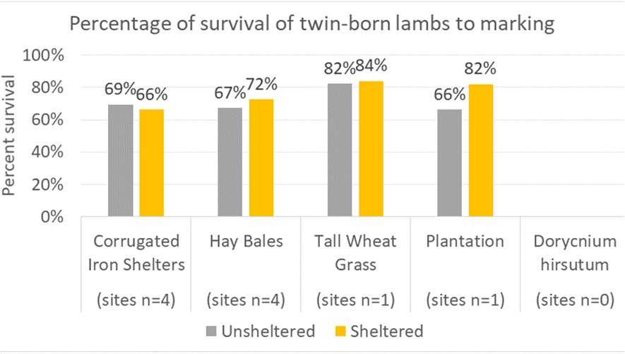
Corrugated iron shelters unsheltered (sites n=4) | 69%
Corrugated iron shelters sheltered (sites n=4) | 66%
Hay bales unsheltered (sites n=4) | 67%
Hay bales sheltered (sites n=4) | 72%
Tall Wheat Grass unsheltered (n=1) | 82%
Tall Wheat Grass sheltered (n=1) | 84%
Plantation unsheltered (n=1) | 66%
Plantation sheltered (n=1) | 82%
Dorycnium hirsutum unsheltered (n=0) | 0%
Dorycnium hirsutum sheltered (n=0) | 0%

Figure 3. Percentage survival: lambs marked/foetuses scanned.

The tall wheat grass hedgerows were well utilised, given their extensive coverage across the paddock, although only a small increase in survival was seen. However, this result is believed to be highly attributed to the high birth weights of the twin lambs in those paddocks, given the significant amount of available feed on offer (in excess of 2000kg DM/ha) and the composite breed type. This is consistent with the recent research of Hocking Edwards et al. (2019).

The presence of corrugated iron shelters in the lambing paddock did not correspond with an improvement in lamb survival. These shelters were poorly utilised by both ewes and at-risk lambs (within first 48 hours of life). Poor utilisation was also observed at the hay bale sites, so it is difficult to know whether the 5 per cent improvement was attributable to the presence of the shelter, or other factors.

The reduction in time at high chill index was smallest in the D. hirsutum site as the plants were small and not very dense, hence reducing their ability to slow wind speed. No survival information was available for comparison for the D. hirsutum site.

Learnings from this demonstration

Dorycnium hirsutum

D. hirsutum was slow to establish and proved palatable to stock, despite contrary advice. However, if it can be restricted from grazing for more than two years to allow sufficient development for shelter and reduced palatability, it may be a viable shelter option.

Establishment required transplanting seedstock in late autumn through to early spring into sprayed lines to conserve moisture and eliminate early competition from other plants.

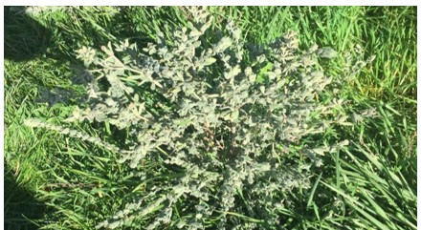

Figure 4. Dorycnium plant along creek line at Gatum site.

Corrugated iron and straw-bale shelters

Both man-made shelters (straw bales and corrugated iron) offered limited benefits, due to low utilisation by ewes.

Throughout the demonstration period it was observed on all sites that older lambs had been seen using shelters, however there was no indication that ewes utilised these structures for shelter while lambing or for their newborn lambs (less than 48 hours old when exposure to chill is critical).

In fact, one producer indicated mismothering may have been increased by the presence of the shelters, as ewes were not able to see their lambs through or over the shelter.

Furthermore, to provide benefit there would need to be enough shelters across the paddock to ensure that wherever the ewes were grazing, her lambs would be within protective distance of a shelter.

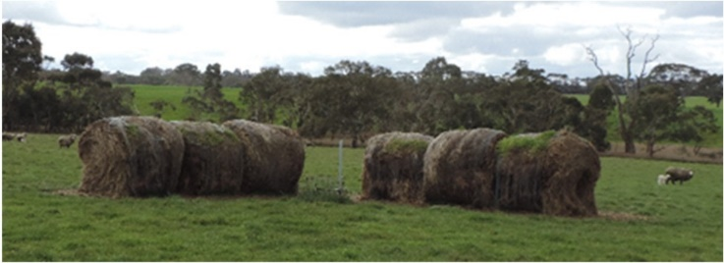

Figure 5. Hay bales laid end to end to form a shelter.

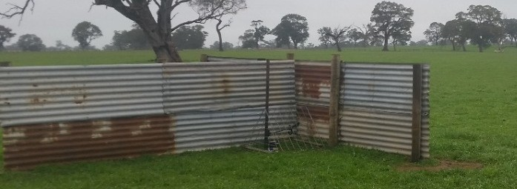

Figure 6. T-shaped corrugated iron shelter.

Tall wheat grass

Tall wheat grass (TWG) offered valuable shelter but has challenges for integrating into the farm system.

TWG requires management to ensure seed is harvested through spring and summer grazing. Application of nitrogen will optimise growth given the absence of a legume. Additionally, the potential of the TWG hedgerows to provide a habitat for vermin needs to be limited.

During establishment, close monitoring of TWG is crucial to ensure success. Germination of TWG hedgerows across multiple sites was marginal, impacted by slugs and red-legged earth mite. Regular, frequent monitoring is needed to identify and respond to such pest issues in a timely manner.

Established tree breaks, including plantations

The improvements in lamb survival seen at the 2018 Gatum plantation site highlights the potential to utilise established tree lines and plantations to improve lamb marking rates.

A key consideration when selecting whether a tree break, or plantation, is suitable is the density of understorey. If there is good protection from wind at the lamb level, chill index is likely to be reduced and lamb survival consequently improved.

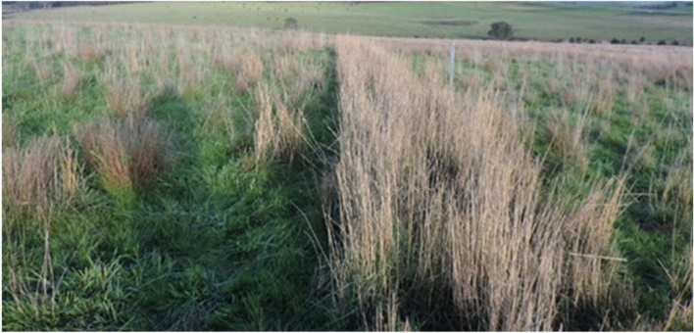

Figure 7. Tall wheat grass hedgerows at Warrock site in 2017.

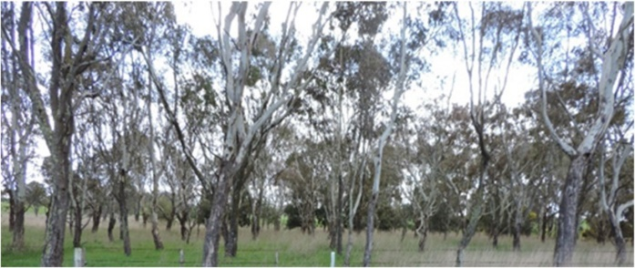
Figure 8. 2017 Gatum plantation site

Conclusion

The benefits of shelter were measured at all sites, through reduced time at high chill index. However, improvements in lamb survival were dependent on ewe breed type, the type of shelter, its utilisation by ewes with lambs less than 48 hours old, and its coverage over the paddock.

Utilising already existing forms of shelter on farm, such as eucalypt plantations with good understorey, presents a good opportunity to improve lamb survival. Tall wheat grass shelters are also effective once established.

© Meat & Livestock Australia 2019 ABN 39 081 678 364

This work is copyright. Apart from any use permitted under the Copyright Act 1968, all rights are expressly reserved. Requests for further authorisation should be directed to the Corporate Communications Manager, PO Box 1961, North Sydney, NSW 2059 or info@mla.com.au.

Published in March 2020.

References

King B., Friend M., Behrendt R., & Morant A. (2012). EverGraze Exchange: Improving Survival of Lambs [online]. Available at: https://www.evergraze.com.au/wp- content/uploads/2013/06/Evergraze-Exchange- Improving-survial-of-lambs-3.pdf

Hocking Edwards J.E., Winslow E., Behrendt R., Gordon D.J., Kearney G.A., & Thompson A.N. (2019). Crossbred ewes gain more weight and are fatter than Merino ewes when managed together but similar coefficients predict lamb birthweight and survival. Animal Production Science 59, 767–777.

With thanks to Grace Calder, Agriculture Victoria.

For further information contact:

Bindi Hunter
Agriculture Victoria
E: bindi.hunter@agriculture.vic.gov.au

Andrew Speirs
Meridian Agriculture
E: aspeirs@meridian-ag.com.au

Disclaimer

Any recommendations, suggestions or opinions contained in this publication do not necessarily represent the policy or views of Meat & Livestock Australia (MLA). No person should act on the basis of the contents of this publication without first obtaining specific, independent professional advice. MLA takes no responsibility, in any way whatsoever, to any person in respect to the document, including any errors or omissions therein, arising through negligence or otherwise however caused.

