Fact sheet

Matching cows and their calves using Pedigree MatchMaker –
Enhanced Producer Demonstration Site

Pedigree MatchMaker uses electronic ear tag data to match cows to their calves. Monitoring calf performance (through to weaning and beyond) provides a means to identify best- performing breeding stock.

Background

Pedigree MatchMaker (PMM) was developed for sheep enterprises. The system collects data from the ear tags of ewes and lambs in the paddock and, via association of ear tags that are repeatedly recorded together, matches the
lambs to their dams. This enables producers to identify the best-performing breeders by tracking the performance of their progeny.

Pedigree MatchMaker technology was adapted for cattle and demonstrated over three years in an on-farm project with Colac BetterBeef group.

The recommendations in this fact sheet were developed through the demonstration, which was co-funded by Agriculture Victoria and Meat and Livestock Australia (MLA).

Equipment required

While systems will vary, the following is a guide to the equipment required:

• panel reader and data logger (if not built into the panel reader)
• deep-cycle battery and optional solar panel
• electronic NLIS ear tags on cows and calves
• temporary cattle yard panels (construction details below)
• electric fencing e.g. poly wire and tread-ins
• solar energiser (if not located near existing electric fencing).
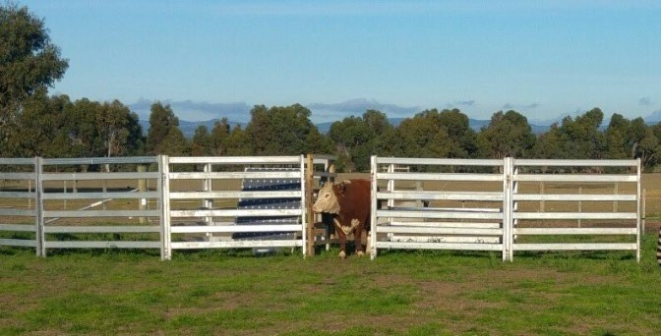

When to record

The best time to start recording is when calves are young, ideally soon after electronic NLIS tags have been applied.

Recording is easiest in late spring/early summer or autumn, when conditions are drier and animals are seeking water. The use of water as a successful attractant over summer fits in well with spring-calving herds. Wet conditions should be avoided, when there is a risk of pugging.

Tips for success

• PMM relies on animals being drawn to an attractant, which becomes their motivation to walk through the single-file entrance past the panel reader. In drier months, water is a great attractant. Hay and silage may also
work, although the demonstration had mixed success using these attractants.
• If using water as an attractant, ensure the trough is not too high for calves, as they will be unlikely to follow the cow if they cannot access water themselves.
• Set up a single-file entrance on an existing stock track to water. Cattle are creatures of habit and more likely to find their way through the entrance if following an existing track.
• Start with a wide entrance (~2m) for cattle to walk through. Once they are well
accustomed to the system, narrow the entrance to approximately 1m.

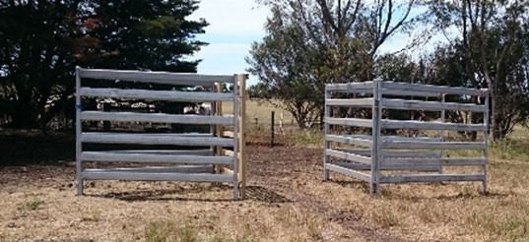

• The panel reader must be mounted on timber to allow a decent read range. Mounting on metal will cause interference.
• Timber panels can also be constructed cheaply using treated pine sleepers and timber. The cost of materials for a timber panel is around $50, whereas steel panels cost $180 each.

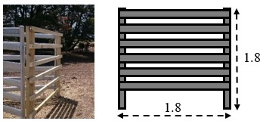

• The panel reader must be mounted at a height capable of reading both cow and calf tags. Test the read range of your panel reader with a tag to ensure the best possible positioning.
• Be aware it is possible for electrical interference to occur with a panel reader, if charging another device such as a data logger from the same battery. Always test the read range with all equipment installed.
• Battery failure is a major cause of recording issues. Make sure batteries are in good condition and fully charged. Consider using a solar panel to charge batteries, reducing the need to swap and recharge. Alternatively, purchase or hire a panel reader specifically designed for PMM which uses less power than a standard panel reader.
• Regularly check data is being recorded by the data logger and download data files at
regular intervals.
• Three separate files are required to have the data processed through PMM software:
1. List of cow EID tag numbers
2. List of calf EID tag numbers
3. The file recorded in the paddock.
• Data can be processed using commercial software with PMM capability, or by using an accredited PMM data analyst.
• The length of the recording period is determined entirely by the amount of movement through the system and should be based on the number of matches achieved at a given point. With good animal flow through the system, recording can be completed within 21 days, however this period can vary considerably depending on factors such as weather conditions, age of calves and the attractant used. The best results for the demonstration were 94%
accuracy in 30 days, and 100% accuracy in 60 days with 16 cows and 16 calves.
• The age of calves at foot did not have an impact on accuracy of data, however starting as early as possible with younger calves provides the opportunity to extend the recording period if needed.
• Training cattle to walk through a single-file entrance will significantly improve results. Ensuring the timber panels are in place prior to equipping with the panel reader will help reduce the time PMM equipment will be needed.
• This demonstration trialled PMM in cow mobs of up to 250 cows and calves, although better results were obtained with smaller mobs. Larger mobs are likely to need a longer data-collection period.

Using PPM

Recording cow–calf associations using PMM is relatively simple, however achieving enough animal flow through the system to ensure accurate matches between cows and calves is the greatest challenge.

Training of cattle and using effective attractants are the keys to success.
For further information contact:

Nathan Scott Achieve Ag nathan@achieveag.com.au

Chris Blore Agriculture Victoria christopher.blore@ecodev.vic.gov.au

Disclaimer

Any recommendations, suggestions or opinions contained in this publication do not necessarily represent the policy or views of Meat & Livestock Australia (MLA). No person
should act on the basis of the contents of this publication without first obtaining specific, independent professional advice. MLA takes no responsibility, in any way whatsoever, to any person in respect to the document, including any errors or omissions therein, arising through negligence or otherwise however caused.

© Meat & Livestock Australia 2019 ABN 39 081 678 364

This work is copyright. Apart from any use permitted under the Copyright Act 1968, all rights are expressly reserved. Requests for further authorisation should be directed to the Corporate Communications Manager, PO Box 1961, North Sydney, NSW 2059 or info@mla.com.au.

Published in March 2020.

