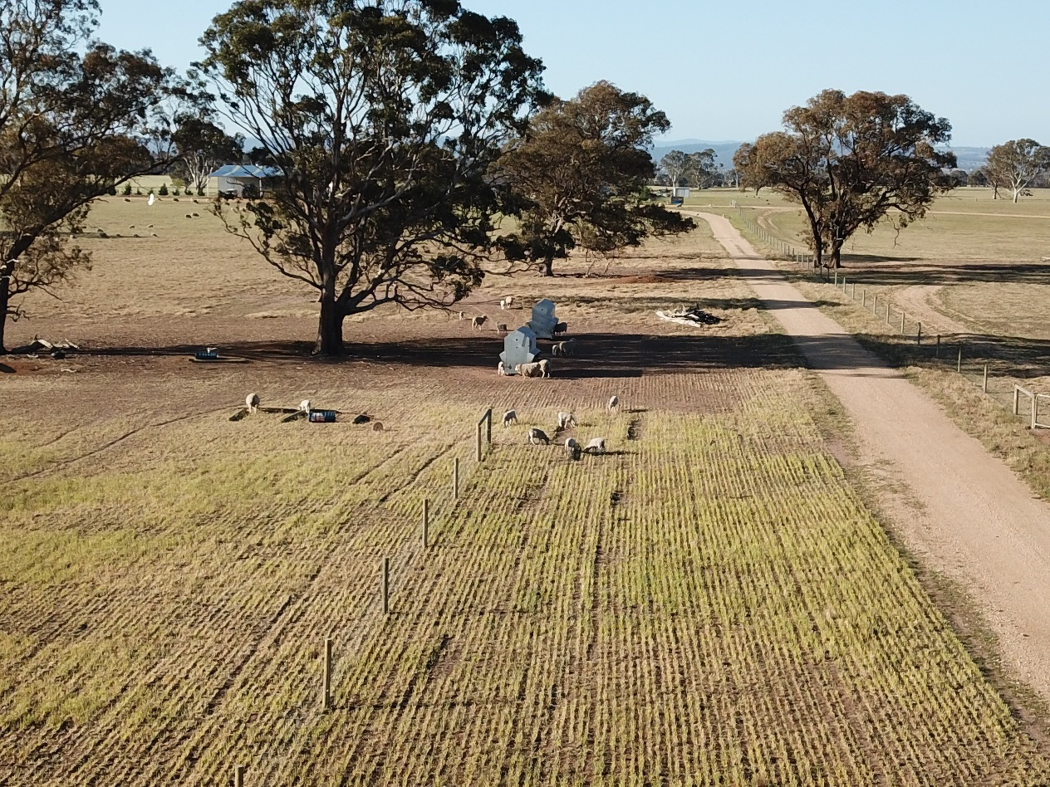
Picture: Lick feeders and stubble of winter-grazing wheat on Kane Stewart’s property, October 2019
Coordinator – Lisa Warn
Group – Bairnsdale
- The group formed around 20 years ago when the Bestwool program was first initiated in Victoria. The group meets 6 times a year, on farm, to discuss local issues and talk to industry experts on topics relating to running profitable and sustainable wool and prime lamb enterprises. Group members actively participate in on-farm research and demonstrations, contribute to the Victorian Livestock Farm Monitor Project and piloted the Lifetime Ewe Management program.
- The group was coordinated by Craig Bush, a local sheep and cattle producer, until 2016 when Lisa Warn took on the role.
- Currently has 13 businesses, ranging from: Walpa, Lindenow South, Meerlieu, Stratford, Perry Bridge, Nicholson, Bengworden, Hillside and Seacombe.
Enterprise mix
- Mainly self-replacing merino enterprises with some first cross and composite ewes, and a few producers have cattle.
Adjusting feed to drought conditions
Sheep producers in the Bairnsdale region are facing their third ‘failed’ spring in a row, preceded by a dry winter. The long-term average annual rainfall for the area is around 600 mm. Total annual rainfall totals for 2017 was 440 mm (decile 10 year, with 120 mm falling in late December, too late for most pastures), 2018 was 420 mm (decile 5) and 2019 (to date) has been 300 mm.
By early October 2019 most producers had low pasture availability across their farms and are resuming hand feeding ewes still with lambs at foot. With no soil profile moisture and the forecast for continued dry conditions, producers will soon be returning stock to containment areas or ‘sacrifice’ paddocks for feeding full drought rations.
Over the last few summers and autumns, group members, Andrew and Allan Sheridan, have used stock containment areas to protect pasture and soils. Ewes were joined in containment and released in mid-July onto saved pasture just prior to lambing. The containment areas have allowed autumn saving of pasture and avoided having to trail feed ewes at lambing. Following a group visit to Andrew and Allan’s property a few other members have set up similar containment areas. Insights into what worked well and what they might do differently were able to be shared with the group.
This autumn, tactics to aid pasture recovery were discussed. Many group members had secured seed supplies early and drilled in dry with annual ryegrass or barley, to try and aid pasture recovery if it rained and to build a feed wedge to avoid hand feeding ewes during lambing in late winter/spring. Other tactics such as using nitrogen or gibberellic acid were also used to try and grow more winter feed. Poor pasture growth in 2018 meant many members had to trail feed ewes during lambing and they wanted to avoid doing that again.
The unrelenting workload of trail feeding sheep has also seen some members invest in lick feeders and other new equipment such as larger feed wagons etc, to save time. Group members have been able to share their experiences about what brands of equipment and feeding regimes have worked well for them. After viewing the lick feeders being used by group member Kane Stewart, other group members also purchased them.
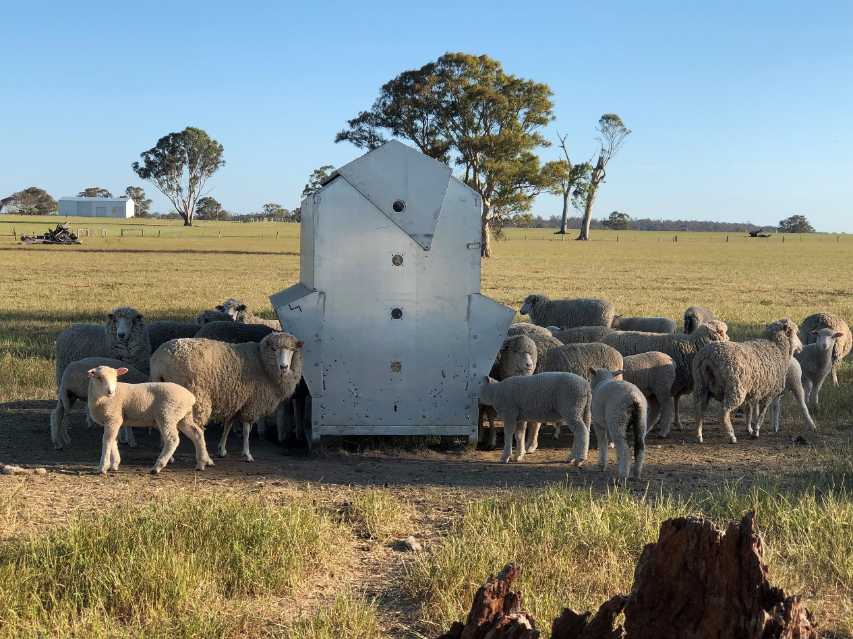
Picture: Lick feeder in action, Kane Stewart’s property, October 2019
Kane has found he can “use the lick feeders for a substantial part of the year, from pre-lambing right through to weaning if needed to make available dry matter go further”. He said “the feeders are then available to wean lambs onto when needed, particularly in the dry summers”. Currently using home-grown maize, barley and lupins in the feeders (alongside straw or cereal hay or lucerne silage), Kane said “The high energy feed results in an increase in the ewes’ milk and heavier lambs being weaned”.
Sourcing grain and hay has been a challenge for group members given the wide extent of drought conditions and the added cost of cartage to Gippsland. Feed testing of grain and hay has been essential to get best value for money and to calculate appropriate rations. Some members have been feeding pellets, so the energy and protein contents are more consistent.
At most meetings the group has discussed and reviewed costs of feed, feed test results and rations. Resources such as CSIRO’s GrazFeed (program), the Lifetime Ewe Management tables (app), the NSW Department of Primary Industries drought feed calculator (app) and the Agriculture Victoria drought feeding books (online) have been used to fine-tune rations.
- www.dpi.nsw.gov.au/animals-and-livestock/nutrition/feeding-practices/drought-feed-calculator-app
- www.feedinglivestock.vic.gov.au/
Another feed innovation, which has implications for soil health on degraded areas, is growing multi-species cover crops. Rick Robertson has prepared numerous multi-species paddocks that he will use over the next few months. The mix includes barley oats, canola, lupins, brassica and clover. He has recently sown a summer crop of maize, sunflower, brassica, buckwheat, oats, radish, lupins and cowpea that “may grow after a shower of rain”. The seed was purchased in a bulk amount at a low cost by local producers banding together.
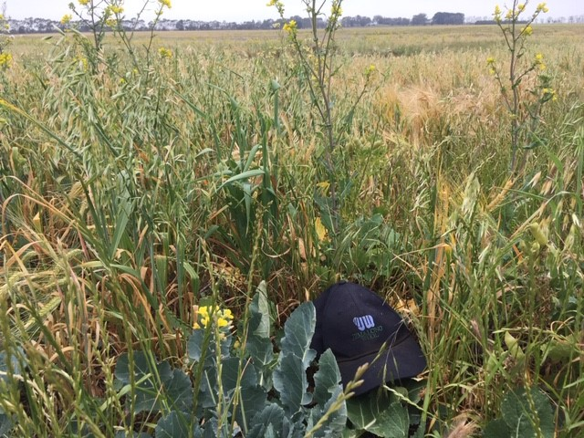
Picture: Mixed species cover crop, Rick Robertson’s property, October 2019
While feeding stock has been the key seasonal issue discussed at each meeting for the past few years, the group have still retained a focus on the longer-term strategic aspects of their businesses. For example, making continual improvements to the genetic merit of their sheep using new technology and tools. Also, keeping a focus on key profit drivers, monitoring and benchmarking their financial performance. Getting back into business and rebuilding stock numbers when seasonal conditions improve is on the radar.
Members of the group are well informed about drought support funding provided by the Victorian government for Central Gippsland. All have been eligible for the farm water infrastructure grants up to $5000, and some pasture recovery grants for seed and fertiliser.
- http://agriculture.vic.gov.au/agriculture/farm-management/drought/dry-seasons-support
Lisa Warn said “The morale of the group is very good despite what they are going through. Members are very willing to share information, such as where their hay or pellets are being sourced and the cost, their weaning and lamb survival percentages, and when and how they are feeding out. This information and support are critical to surviving the drought conditions on a week-to-week basis.”
A long-term group member, Andrew Sheridan, said “We are very blessed to have Lisa as our coordinator and we have a great group. Lots of us have been meeting for 20 years and our group includes a retired vet who is very generous with his skills and time as well as a long term ‘bench-marker’ who is very open with his own figures and goes above and beyond. Another highlight of our group is the younger generation coming in, some of them second generation group members. The group provides a fantastic opportunity for mentoring, particularly given we’ve had a few tough seasons and it’s looking like we’ll face another.”
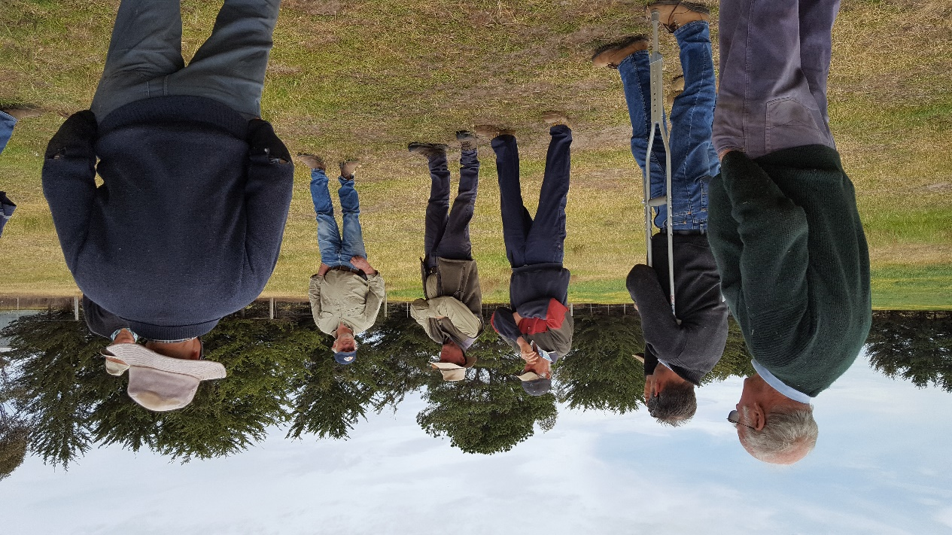
Picture: Andrew Sheridan (in Akubra hat) talking with group members about stock containment, 2018

