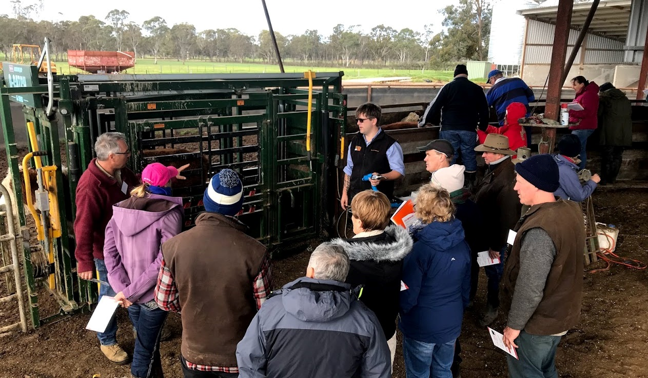
Picture: Mitchell River BetterBeef Group at the Zoetis ReproActive workshop, May 2019
Coordinator – Alison Gunn
Group – Mitchell River
- 17 businesses, located between Clifton Creek to Briagolong
Enterprise mix
- Mostly large-scale progressive producers running cows and calves, trading steers and/or fattening on grain-free pellets and/or irrigated pastures/crops, with a third also having sheep and some running a mix of beef/sheep/cropping
Early weaning for drought conditions and beyond
In response to the drought in East and Central Gippsland many producers in the Mitchell River BetterBeef Group shifted to earlier weaning. Those who were not already weaning at 5 to 6 months shifted to that time frame, others went to 4 to 5 months and, where the dry conditions have made it necessary, several producers are weaning at a minimum weight of 100 kg (10 to 12 weeks). With appropriate nutrition and a careful transition the calves have thrived, so most producers will continue with earlier weaning when the drought eases.
Alison Gunn, the group coordinator and a vet by profession, talked the first couple of producers through the very early weaning making sure that from 6 weeks the calves were on creep feed to develop their rumen. “The trick” said Alison, “is to grow the papillae in the rumen so the volatile fatty acids can be absorbed. The best way to do this is to have some grain in the pre-weaning ration”. Much of this knowledge has been developed for the dairy industry and can be adapted for beef calves.
Early weaning requires an adjustment to production methods and planning. While many of the group’s producers were already feeding out hay and silage to the cows, they needed to install a hot wire so only calves could access their designated feed. Lick feeders were also used, with calves more than 100 kg being yard weaned on a grain and silage mix.
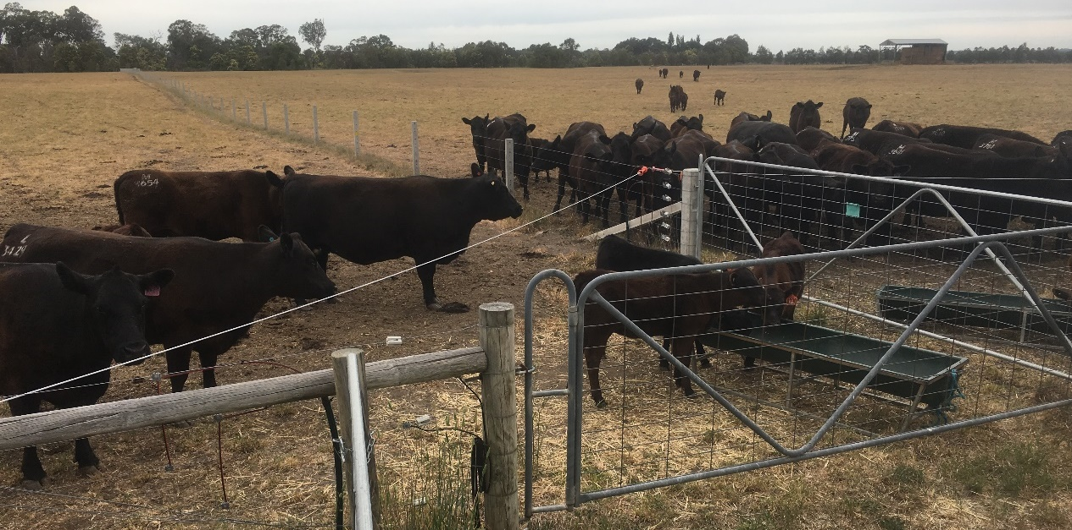Picture: Feeding calves separated by hot wire from cows, John Mosley’s property, 2019
Cows marked for sale were prioritised for early weaning of their calves. Alison said, “calves should be grouped on weight, not sex, and given adequate trough space to reduce competition for feed. Once the calves are weaned it is essential that they are fed high quality feed to make up for the lack of milk”. This can be achieved by putting them on irrigated pasture or crops or supplementing with weaner pellets and good quality hay.
The group also benefited from a ‘ReproActive’ workshop developed by Zoetis, about weaners and young stock, held at a member’s property near Bairnsdale. The focus of the workshop was on practical and nutritional aspects of weaning, quality water and good yards. With total attendance of over 60 regional producers, Alison said it was evident that “more are adopting a weaning time of 4 to 5 months, and this is becoming the ‘new’ normal”.
Given the ongoing drought in the region, with or without early weaning, the big considerations for the group are reducing stock numbers, working out the number of stock that is economic to feed and growing as much feed as they can.
Aiming to grow own feed
Due to the high cost of feed and the distance of East Gippsland from the major cropping areas, Alison said “most of the producers are focused on growing as much as they can from their own land. Many are growing summer crops with pivot irrigation, as their perennial pastures are not coping”. Those who irrigate are sourcing water from bores, with a few farms able to access river water.
If irrigation is not an option, some producers “are taking a late spring gamble on some east coast rainfall to grow summer crops of brassica, millet or sorghum”. While rainfall figures for 2019 are not much better than last year, Alison said “the timing of rain events has been more favourable, and paddocks are not totally brown – yet. However, the wind and hotter days are having a detrimental effect on temperate pastures and any rain we get now is unlikely to allow them to recover. East Gippsland in in desperate need of rain to fill dams and grow summer grasses and crops.”
At the start of each meeting of the Mitchell River Better Beef Group there is a ‘whip around’ with all sharing their priorities, successes and difficulties. Alison said, “that is the glue that holds the group together, especially with the long-term drought conditions”.

