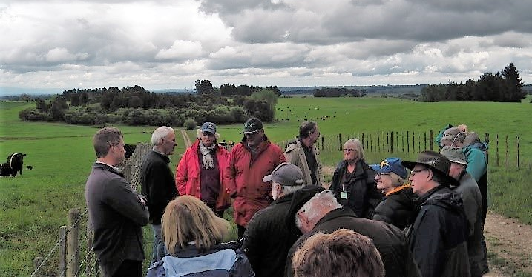
High Country BetterBeef Group at Strahan Land Co (owner Ian Strahan) in the Manawatu, North Island, NZ 2018
Coordinator – John Webb-Ware
Group – High Country
- 14 businesses, ranging from Broadford to Nagambie, Strathbogie and Mansfield
Enterprise mix
- Breeding enterprises and one finishing operation
From the ground up
Since the High Country BetterBeef Group of beef producers formed in 2011, they have had no trouble maintaining its membership. It is comprised of farmers from second or third ‘alternate careers’, including corporate and professional backgrounds. As a result, they have learned their farming practices from the ground up.
From the beginning, group members have drawn on their previous experiences to establish visions and missions for the group going forward. The vision and mission have evolved as the group has grown in knowledge and confidence. In December 2019, members revised their purpose statements to:
- manage sustainable and increasingly profitable cattle enterprises, and
aim for an annual farm profitability increase of at least 10 per cent.
Through group meetings, farm visits and in-between meeting discussions using a group email, members explore the details of production cost, on-farm improvements and waste minimisation, savings in operating costs, farm output increases and securing marketing opportunities to maximise sale prices.
In the paddock, group members apply practices of farm business planning and management along with assessing the quality, quantity and utilisation of pastures. Members regularly review stocking levels, animal health, reproduction, genetics and compliance to market specifications. A firm focus is also on occupational health and safety.
Starting from scratch, group members were open to learnings and opportunities. They have gained assurance in that approach and are continually chasing better practices. Based on their detailed understanding of their businesses and confidence built through group discussions, almost all members have purchased or leased land in addition to their initial holdings when the group began.
The group takes annual self-funded field trips around Victoria and further afield. In 2018 a New Zealand trip, centred around Palmerston North, was aimed at learning more about how they grow such brilliant grass and seeing how other farmers are making (or losing!) money. The field trips provide a means of reinforcing the group’s evidence-based approach to improving farm performance and profitability.
An example of on-farm change which the group has discussed regularly and pursued over the years is pasture renovation and improvement. Growing more grass with improved species chosen to suit soil type has been undertaken by most members. They have either done the sowing themselves or used contractors.
Given the high country winters have very low soil and air temperatures, gibberellic acid has been applied to build a bigger winter feed wedge. It has been highly successful for many enterprises, enabling a heavier carrying capacity over winter.
To lockdown
During the ‘lockdown’ restrictions the group have continued to meet successfully, albeit online. Using a video conferencing service, the meetings follow the usual framework of a face-to-face meeting without an accompanying farm visit. Discussions have focused on how to manage supply chain and market risks in the current environment. For the June online meeting, Group Coordinator John Webb-Ware is preparing some real-time farm footage for a virtual farm visit.
Since 2011, the High Country BetterBeef Group has evolved and adapted from the ground up, reflecting a dynamic group with members continually reviewing while also enjoying the many challenges farming offers.
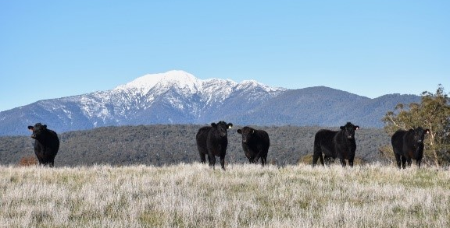
High country Angus cattle, Kym and Dick Lynch’s property, Merrijig, May 2020
This profile was developed with contributions from Kym Lynch, the group’s producer liaison.

