Pasture recovery after fire- Quick reference guide

Cool-Moderate burn
Most dead plant material is burnt, some seed and perennial grasses and clovers survive unhurt. Small residue (or stubble) of unburnt pasture remaining. Perennial grasses may be shooting leaves after rain.

Sown perennial pasture
Expect most established perennial grasses, perennial clovers and sub clovers to come back. Carrying capacity should return to 70% by spring and 100% within 12 months.

Actions
Apply phosphorus fertiliser (if Olsen P less than 15 milligrams per kilogram).
Keep Stock off until 4 to 6 weeks after the autumn rains to maximise recovery of perennials.
Rotational grazing will help plants recover size and productivity.
Consider controlling broadleaf weeds in Autumn and Winter

Native pasture
Expect most native grasses to come back. Carrying capacity should return to 70% by spring and 100% within 12 months.

Actions
Wait and see what comes back.
Keep stock off to protect cover and don’t re-stock until 4 to 6 weeks after autumn rains.
Rotational grazing will help plants recover size and productivity
Consider controlling broadleaf weeds in Autumn and Winter.

Mostly annual Pasture
Expect annual grass seeds to be destroyed but sub clover and broadleaf weeds should return.
Expect carrying capacity to be significantly reduced.

Actions
Consider watering a small area to help predict what will come back with autumn rains.
Option 1: Good recovery of annuals (greater than 100 seedlings of grasses and clover per square metre). Control broadleaf weeds in Autumn and Winter
Option 2: Take opportunity to sow a perennial pasture. Knockdown spray weeds after autumn rains and direct drill. Apply phosphorus and nitrogen fertiliser at sowing. Avoid cultivation
Option 3: Poor recovery of annuals (less than 100 seedlings per square metre) Sow a winter fodder crop such as oats or annual ryegrass with fertiliser to provide a quick source of feed. Sow perennial the following year.

Hot burn
All dead plant material, many seeds, young and weaker perennial grasses destroyed. The topsoil appears charred and bare.

Native pasture
Expect most native grasses to come back. Carrying capacity should return to 70% by spring and 100% within 12 months.

Actions
Wait and see what comes back.
Keep stock off to protect cover and don’t re-stock until 4 to 6 weeks after autumn rains.
Rotational grazing will help plants recover size and productivity
Consider controlling broadleaf weeds in Autumn and Winter.

Mostly annual Pasture
Expect annual grass seeds to be destroyed but sub clover and broadleaf weeds should return.
Expect carrying capacity to be significantly reduced.

Actions
Consider watering a small area to help predict what will come back with autumn rains.
Option 1: Good recovery of annuals (greater than 100 seedlings of grasses and clover per square metre). Control broadleaf weeds in Autumn and Winter
Option 2: Take opportunity to sow a perennial pasture. Knockdown spray weeds after autumn rains and direct drill. Apply phosphorus and nitrogen fertiliser at sowing. Avoid cultivation
Option 3: Poor recovery of annuals (less than 100 seedlings per square metre) Sow a winter fodder crop such as oats or annual ryegrass with fertiliser to provide a quick source of feed. Sow perennial the following year.

Sown Perennial Pasture
Well established stands of perennial grasses should return.

Actions
Consider watering a small area to help predict what will come back with autumn rains.
If there is a poor response (less than 20% of perennial plant cover), consider re-sowing perennial pasture or a winter fodder crop if quick feed is required.

Very hot burn
Soil is virtually sterilised. All plant material and seed is destroyed as the fire burns into the top organic matter layer of the soil

All pasture
Pasture species are not expected to recover

Actions
If time and finances permit, consider re-sowing with fertiliser to provide ground cover and return organic matter to the soil. Annual ryegrass or winter fodder crop could be a good fast-growing option.
If organic matter and structure of the topsoil is significantly damaged, the soil may need to be worked prior to sowing.

IMAGES OF PASTURE RECOVERY AFTER FIRE WITH DIFFERENT BURN INTENSITIES ON PERENNIAL BASED PASTURE

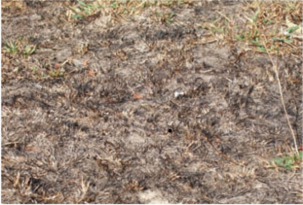
Cool-moderate burn – pasture is charred but not completely blackened. Recent rains have initiated recovery of perennials.

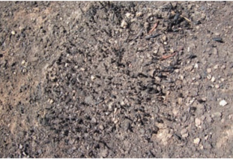
Close-up view of perennial plant affected by a hot burn. All dead material is burnt, perennial plant is blackened:

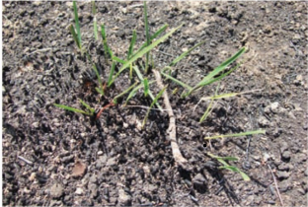
Perennial plant recovering from a hot burn.

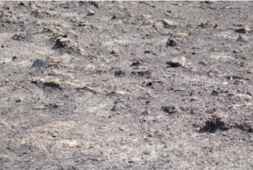
Very hot burn - no plant material is visible, earth has a blackened, charred appearance.

