final report

Project code: E.PDS.1410
Prepared by: Garry Armstrong
Armstrong Livestock Solutions

Date published: September 2019

PUBLISHED BY
Meat and Livestock Australia Limited
Locked Bag 1961
NORTH SYDNEY NSW 2059

Grazing Management For Improved
Reproductive Performance and Reduced Turn-Off Times

Meat & Livestock Australia acknowledges the matching funds provided by the Australian Government to support the research and development detailed in this publication.
This publication is published by Meat & Livestock Australia Limited ABN 39 081 678 364 (MLA). Care is taken to ensure the accuracy of the information contained in this publication. However MLA cannot accept responsibility for the accuracy or completeness of the information or opinions contained in the publication. You should make your own enquiries before making decisions concerning your interests. Reproduction in whole or in part of this publication is prohibited without prior written consent of MLA.

Executive summary
Between 2015-2017, the Rich River Best Wool Best Lamb (BWBL) group conducted work with a variety of cultivars and blends and using rotational grazing, to explore options to increase dry matter production and subsequent kilograms of lamb turned off. Members of the group were interested in practices that could deliver improved productivity and profitability for their prime lamb and wool production systems.
The project was conducted on properties owned by members of the producer group. Sites covered both irrigation and dryland areas and focussed on varietal selection (building on the results of 2014 trial plots) and management of fodder crops to fill the feed gap from the senescence of their existing fodder varieties in early September until the availability of the first stubble for grazing in early December. Key to this was understanding the role that grazing cereal crops could play in the system and how they could be managed to fit within existing production methods.
The first year of the demonstration incurred very low rainfall over the growing season and utilised existing fencing infrastructure rather than electric fencing. Dry matter production was low, ranging from 3.62t/ha for irrigated Winter Feed Gap Blend to 0.2t/ha for dryland Cavalier Medic. However, in Year 2 and Year 3, the combination of increased rainfall and rotational grazing produced results between 7t/ha and 14.67t/ha (with one additional failed Medic Blend site). This increase was largely attributed to improved grazing management and the avoidance of overgrazing, allowing plants to recover quickly.
The grazing barley and barley blends produced the greatest return on investment over the life of the project with a benefit:cost (BC) of nearly 20:1 for Hindmarsh Barley with Tetrone Rye and 14:1 for Moby Barley.
Improved rotational grazing to enhance cultivar production was one of the main outcomes from the project and participating farmers developed skills and techniques to strategically graze sheep in their cereal farming systems to their best advantage.
Annual reproduction rates showed no appreciable changes (measured as marking percentages), however the starting point was already reasonably high for the demonstration hosts. Other producers in the group indicated that their lamb survival (particularly for twins) had increased.

Seven extension events were held over the three years, incorporating topics around ewe/lamb management and use of EID as well as forage species and grazing management . An evaluation of group members showed improvements in monitoring and managing ewe pregnancy status, allocation of pastures for various classes of sheep, use of short-term forages and grazing management.
All producers either made changes or are planning to make changes as a result of the trial (although current dry conditions are impinging on putting plans into place). There was a 38% increase (6.5/10 to 9/10) in adoption for ‘growing and using fodder crops’. The ‘use of EID tags to monitor and manage livestock’ scored a 29% (4.1/10 to 5.3/10) increase for adoption and ‘monitoring and allocating pasture feed’ had 27% increase (6.3/10 to 8/10). One producer commented; ‘Our attitude and desire and how we do fodder conservation has changed, as has how we feed and maintain condition score and use RFID in our stud flock to make it simpler to ID individual animals. All this has come from the trial.’

Table of contents
1 Background 5
2 Project objectives 6
3 Methodology 6
3.1 Site details 6
3.2 Extension activities 9
3.2.1 Monitoring and evaluation 11
4 Results 11
4.1 Year 1 (2015) 11
4.1.1 Fodder Production 11
4.1.2 Lamb production 12
4.1.3 Benefit Cost Ratio Year 1 12
4.2 Year 2 (2016) 13
4.2.1 Fodder production 13
4.2.2 Lamb Production 14
4.2.3 Benefit Cost Analysis for Year 2 14
4.3 Year 3 (2017) 16
4.3.1 Fodder production 16
4.3.2 Lamb Production 16
4.3.3 Benefit Cost Analysis for Year 3 16
4.4 Combined years results 17
4.4.1 Reproduction 18
4.5 KASAA evaluation survey results 19
5 Discussion 20
5.1 Evaluation and learnings from the demonstration 23
5.1.1 Feedback from participants 23
6 Conclusions/recommendations 26
7 Appendices 27
7.1 Year 2: Grazing date, stocking rate and days grazed 27

Background
BestWool/BestLamb (BWBL) is a producer driven network recognised for its success in achieving on-farm practice change among sheep producers. In 2013 the Rich River BWBL group identified the need to improve the productivity and profitability in their prime lamb enterprises. Key to this was the need to better understand the role of improved livestock genetics and grazing management in farming systems and how this can be adapted to develop more effective and profitable production systems.
A decline in the perennial pasture base experienced by the group members in the Rich River/Central Murray region from the late 1990s has seen Rich River lamb producers moving towards the use of annual and bi-annual fodder crops to finish lambs. This adaptation had occurred in an environment of increasing costs for irrigation water and uncertainty around water allocations. The Rich River BWBL group were keen to investigate the benefits and costs of utilising their water allocation for irrigated fodder/pasture production compared to dryland pasture/fodder production.
A better understanding of the potential of these fodder crops along with improved grazing management were considered important to the growth and profitability of the prime lamb industry in the Central Murray region.
Large paddock sizes in the Central Murray region severely impacts on the grazing management of breeding ewes and the timely finishing of prime lambs. The Rich River BWBL group believed that using electric fencing to instigate a rotational grazing regime would deliver a viable method for precision grazing in their farming systems.
In 2014, a year prior to the demonstration, the Rich River BWBL group conducted a series of plot trials to investigate both irrigated and dryland dry matter (DM) production using the following 18 cultivars and proprietary blends:

• Moby Barley
• Tetrone Tetraploid Rye
• Perun Festulolium
• Australis Phalaris
• Zulu Arrowleaf Clover
• Dalsa Sub Clover
• Hatrik Sub Clover
• Clare Sub Clover
• Turbo Persian Clover
• Bouncer Brassica
• Subzero Brassica
• Caliph Barrel Medic
• Cavelier Spinless Burr Medic
• Ranger Plantain
• L91 Lucerne
• L56 Lucerne
• Winter Feed Blend
• Winter Gap Fill Blend

This EPDS expanded on these trials utilising the successful dryland and irrigation varieties identified in 2014. The Rich River group were keen to use rotational grazing strategies with these species to maximise pasture/ fodder production and utilisation. It was hoped that the improved nutrition provided by the varieties, coupled with improved grazing management would deliver more kilograms of lamb per hectare with a reduced turn off time.

Project objectives
The key objective of this demonstration was to investigate practices that decrease the turn off times and increase production (kg/ha) of lamb in Central Murray farming systems.

The specific objectives were:
- To examine the fodder varieties that performed well in the 2014 plot trials and develop grazing management systems suitable for the Central Murray region of Northern Victoria and Southern NSW.
- To understand the costs and benefits of growing fodder crops and pasture species to produce prime lambs in both dryland and irrigation farming systems.
- To develop, refine and enhance rotational grazing practices to better manage the nutritional requirements of prime lambs and their dams utilising solar electric fencing systems and rotational grazing of forage crops.
- To promote the new fodder/pasture species and improved grazing management within and outside the Rich River BWBL group.
- To demonstrate the use of Electron Identification (EID) and Walk Over Weighing (WOW) to group members.

Methodology

Site details
Species selection
In 2014, prior to commencing this demonstration, the Rich River group established trial plots using 18 cultivars and blends (see background) to establish which would perform best on farms in the Central Murray area under irrigation and dryland conditions. The group identified several varieties from these plot trials which they would take to paddock-scale production trials to evaluate on-farm using their own management practices. The cultivars and mixes selected are listed in the tables below.
Measurements
The following measurements were taken for each site in years 1,2 and 3:
- Feed On Offer (FOO) - assessed as sheep were moved into and out of paddocks.
- Sheep weights and condition scores into and out of the paddocks.
- Each paddock had strategically placed pasture cages to monitor plant growth (kg/DM/ha) and response to grazing.
- Feed tests were carried out on the trial sites.
- Lambing and marking percentages and lamb growth rates and carcass weight were recorded.
- Soil tests were taken for each site.

Prior to entering the trial blocks, all sheep were fitted with Electronic Identification (EID) tags and were familiarised to the electric fencing in containment areas.

Benefit: Cost ratios (BC) were generated in Year 1 using kilograms of lamb produced per hectare and the cost of generating the feed to grow them with a sale price of $5.20/kg for the 22-24 kg carcass. In Year 2 and Year 3, the BC was generated using the value of feed barley for each season. The value per Mega Joule (MJ) of energy was used to compare to the other feed tests to estimate the value of the feed produced on farm.
Walk Over Weighing (WOW) had initially been planned for the demonstration; however, it was removed from the methodology due to a lack of interest amongst the group.
Rainfall data
The closest meteorological stations to the sites were at Bunnaloo (Lat. 35.79⁰S; Long. 144.60⁰E) and Mathoura (Lat. 35.72⁰S; Long. 144.79⁰E). Rainfall data (mm) for 2015, 2016 and 2017, along with the long-term averages are shown in Figures 1 and 2 below.
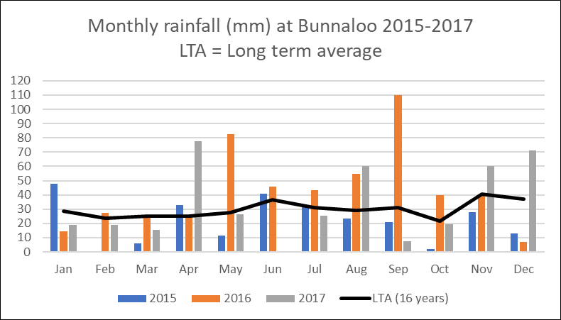
Figure 1: Monthly rainfall for Bunnaloo for 2015, 2016, 2017 and the long-term average
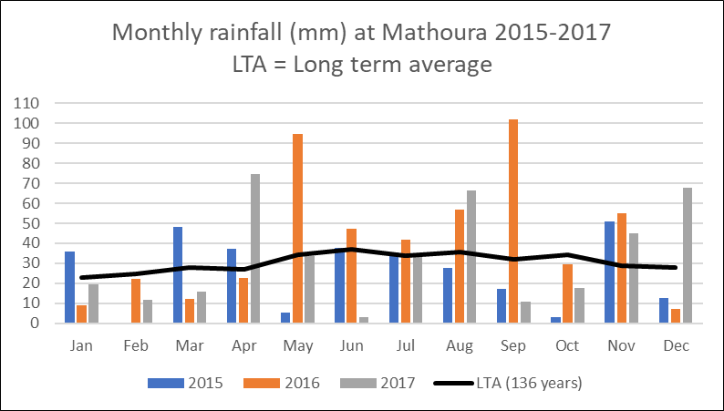
Figure 2: Monthly rainfall for Mathoura for 2015, 2016, 2017 and the long-term average
Year 1: 2015
Sites were sown on April 10 in line with local practice. Two 20 ha irrigated and two 20 ha dryland sites were sown to four mixes/cultivars as described in Table 1.
Soil tests were taken from the trial sites in April 2016 and all were within normal range for micro and macro nutrients.

Table 1: Year 1 site set up
Site | Area | Regime | Cultivar/ mix
Site 1  Bunnaloo | 20 ha | Irrigated | 10 ha of *Winter gap fill blend (Seed distributors) sown with 60kg/ha DAP  10 ha of *Winter gap fill blend (Seed distributors) sown with 60kg/ha DAP
Site 2  Bunnaloo | 30 ha | Irrigated | 10 ha of Titan Brassica (with a small amount of barley to encourage consumption) sown with 60kg/ha DAP  10 ha of Tetrone annual Rye grass sown with Shaftal clover at 7kg/ha and 60kg/ha DAP  10 ha Wedgetail Wheat sown with 60 kg/ha DAP
Site 3  Bunnaloo | 20 ha | Dryland | 10 ha of 6kg/ha Cavelier spineless burr medic and 7kg/ha Tetrone annual rye grass mix sown with 50kg/ha DAP  10ha of Moby Barley mix sown with 50kg/ha DAP
Site 4  Bunnaloo | 20 ha | Dryland | 10 ha of *Winter gap fill blend sown with 60kg/ha DAP  10 ha of Bouncer Brassica sown with 60kg/ha DAP
*Winter gap fill blend mix (Seed Distributors) consists of:
Moby Forage Barley 75%
Jivet Tetraploid Annual Italian Ryegrass 15%
Cavalier Spineless Burr Medic 7%
Bouncer Hybrid Forage Brassica+ XLR8 + Nutrient Enhanced 3%

Year 2: 2016
Year 2 sites and treatments are described in Table 2.

Table 2: Year 2 site set up
Site | Area | Regime | Treatment
Site 1  Mathoura | 10 ha | Irrigated | Moby Barley sown at 50 kg/ha sown with 60 kg/ha of MAP  Sprayed with glyphosate 450g/l at 1.5 l/ha and 75 ml/ha of oxyfluralin 240 g/l
Site 2  Mathoura | 10 ha | Irrigated | Wedgetail Wheat was sown at 50 kg/ha with 60 kg/ha of MAP on pre-watered irrigation bays  Sprayed with glyphosate 450g/l at 1.5 l/ha and 75 ml/ha of oxyfluralin 240 g/l
Site 3  Mathoura | 33 ha | Irrigated | 40 kg/ha of Hindmarsh Barley and 7 kg/ha of Tetrone tetraploid ryegrass60 kg/ha of MAP on pre-watered irrigation bays  Sprayed with glyphosate 450g/l at 1.5 l/ha and 75 ml/ha of oxyfluralin 240 g/l
Site 4  Mathoura | 4.5 ha | Dryland | 40 kg/ha of Moby Barley, 7 kg/ha of Tetrone Rye grass, 4 kg/ha of Aroura Lucerne, 3 kg/ha Shaftal Clover and 4 kg/ha of Trikala Sub clover sown with 50 kg/ha of MAP  No weed control
Site 5  Mathoura | 4.5 ha | Dryland | 7kg/ha of GTL 60 lucerne, 7 kg/ha of Tetrone rye grass and 30 kg/ha of Hindmarsh barley sown with 50 kg/ha  of MAP

Year 3: 2017
Site 1 was sown on April 10; however, Site 2 was sown in late May, following a delay in finding an available contractor with suitable equipment to handle the large amount of crop residue present.
Table 3: Year 3 site set up
Site | Area | Regime | Treatment
Site 1  Bunnaloo | 20 ha | Irrigated | Targa oats @50 kg/ha and *Small seed blend sown @ 10 kg/ha with 50kg/ha of MAP and rolled post sowing
Site 2a Mathoura | 10 ha | Irrigated | Outback Oats @50 kg/ha sown with 60 kg/ha of DAP
Site 2b  Mathoura | 10 ha | Irrigated | **Medic blend sown@ 15kg/ha sown with 60 kg/ha of DAP
Site 2c  Mathoura | 33 ha | Dryland | Moby Barley sown @ 50 kg/ha site sown with 60 kg/ha of DAP
Site 2d  Mathoura |  | Dryland | Moby Barley sown @ 50 kg/ha site sown with 60 kg/ha of DAP
Site 2e  Mathoura | 5 ha | Dryland | Tetrone rye sown @ 7kg/ha with Balansa clover @10 kg/ha sown with 60 kg/ha of DAP

*Small seed blend in site 1
Tatila Rye grass 40%
Sub clover 30%
Vortex Rye grass 16%
Arnie Rye grass 12%

**Medic blend sown in site 2b
Paradana Balansa Goldstrike 10%
Turbo Persian Clover Goldstrike 25%
Dalsa Sub Clover Goldstrike 20%
Zulumax Arrowleaf Clover Goldstrike 26%
Cavalier Spineless Burr Medic Goldstrike 19%

Extension activities
Year 1 (2015) extension activities
Initial workshop- June
The group hosted a workshop on setting up and running a rotational grazing system, attended by 15 members and local farmers. The implications of grazing management on plant growth and vigour were discussed along with the impacts of rotation length and overgrazing. The use of electric fencing was also discussed, but it was decided instead to utilise the conventional fencing on site to control grazing pressure.
Field day- August
The first field day was attended by 12 local farmers, group members and a representative of the Seed Distributors company. The day involved a tour of the previous (2014) trial sites to look at the cultivars, with intense discussion around the merits and issues of each fodder species.
Year 2 (2016) extension activities
Workshop- June
A workshop was held to discuss setting up and managing the rotational grazing enterprise, attended by 10 of the Best Wool Best Lamb group (Figure 3). The merits of electric fencing and grazing management were explained and demonstrated to the group members. Sites were inspected and progress discussed, including the relative performance of the sites.
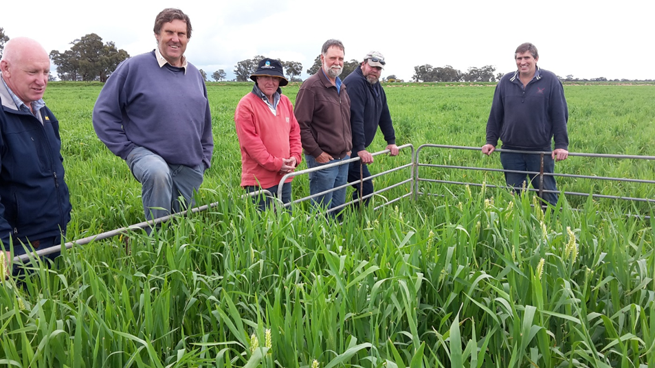
Figure 3: Group members looking over the Moby barley in the pasture cage

Workshop – September
A second workshop on setting up and managing rotational grazing was conducted in the last week of September. This workshop was attended by around 6 participants (Figure 4)
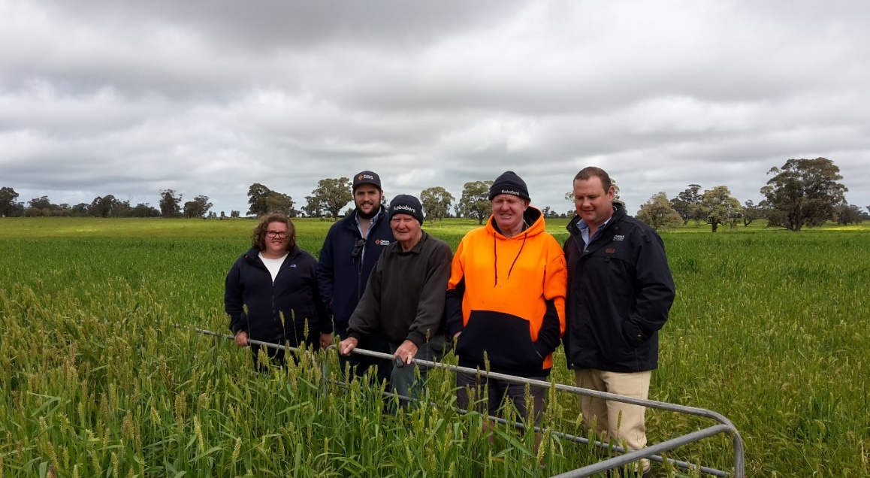
Figure 4: Rich River producers looking over Moby Barley Cage
Year 3 (2017) extension activities
Group presentation- April 2017
Results for years 1 and 2 were presented to the group on the 28th of April 2017.
Technology day – September 2017
A technology day was held on the September 25, attended by 40 producers and industry participants. The group was presented with a progress report on the project.
Final results workshop- January 2018
A workshop was held in January 2018 to deliver the final results of the EPDS to the Rich River BWBL group. This workshop was attended by 12 group members.

Monitoring and evaluation
KASAA change
Pre and post questionnaires were conducted with the Rich River BWBL group members to evaluate their change in Knowledge, Attitude, Skills, Aspirations, Adoption (KASAA).

Results

Year 1 (2015)

Fodder Production
The very low annual rainfall (160mm) recorded through the growing season meant that varieties sown on dryland (non-irrigated) were at a disadvantage and achieved poor production of only 0.43t/ha. As a result, there was no grazing carried out on the dryland Site 3 and Site 4. Dry matter measurements and feed tests were not undertaken for Site 4 given the extremely low production.
Fodder production for all sites in Year 1 was well below expectations, especially given that Site 1 and Site 2 were irrigated.
Feed quality and dry matter production for the sites and different varieties were taken throughout the growing season (Table 4). These sites were grazed using the existing, conventional fencing rather than more intensive rotational grazing.
Table 4: Fodder tests from site 1 Irrigated
Site | Regime | Sample Type | Dry Matter  t/Ha | DM % | Moisture % | CP % | ME MJ/kg  /DM | NDF % | DMD | DOMD
Site 1  Bunnaloo | Irrigated | Winter gap fill blend | 3.62 | 17.6 | 82.1 | 13.1 | 11.9 | 45.8 | 78.4 | 73.2
Site 1  Bunnaloo | Irrigated | Winter gap fill blend | 1.91 | 18.9 | 81.1 | 15.7 | 9.8 | 47.5 | 66.4 | 63.1
Site 2 Bunnaloo | Irrigated | Tetrone annual Rye grass sown with Shaftal clover | 1.35 | 10.8 | 89.2 | 26.1 | 11 | 37.7 | 73.6 | 69.1
Site 2 Bunnaloo | Irrigated | Wedgetail cut 1 | 1.56 | 16.4 | 83.6 | 27.3 | 11.4 | 42.3 | 75.8 | 71
Site 2 Bunnaloo | Irrigated | Wedgetail cut 2 | 1.52 | 15.8 | 84.2 | 29.6 | 11.7 | 45.4 | 77.2 | 72.2
Site 2 Bunnaloo | Irrigated | Hunter Brassica | 2.75 | 10.4 | 89.6 | 15.1 | 13.1 | 25.6 | 85.8 | 79.5
Site 2 Bunnaloo | Irrigated | Titan Brassica | 2.12 | 12.7 | 87.3 | 19.9 | 12.4 | 32.7 | 81.3 | 75.7
Site 3 Bunnaloo | Dryland | Cavalier Medic | 0.67 | 13.0 | 87 | 14.7 | 12.8 | 38.3 | 83.9 | 77.9
Site 3 Bunnaloo | Dryland | Cavalier Medic | 0.2 | 24.0 | 76 | NA | NA | NA | NA | NA

Lamb production
The growth rate of the lambs on the irrigated sites that were grazed, was much lower than expected in the 2015 autumn drop lambs. Site 1 Winter gap fill blend was grazed with twin and single 2nd cross lambs, achieving an average daily growth rate of 130g/head/day. Site 2 Bouncer Brassica and Tetrone annual ryegrass was also grazed with twin and single 2nd cross lambs, achieving an average daily growth rate of 144g/head/day.
The growth rates were well below expectation for these lambs; a result of the low dry matter production.

Benefit Cost Ratio Year 1
To generate a simple benefit cost ratio, (BC) the Rich River BWBL group decided to use the kilograms of lamb produced per hectare as the unit of measure and compared it to the cost of generating the fodder to support them. The average sale price (c/kg) for the season was calculated at $5.20 for the 22 -24 kg carcass which was the groups target specification. Labour costs were not built in to the cost of sowing.
Unfortunately, the benefit cost ratio could not be generated for the Cavalier Spineless burr medic as there was no grazing carried out due to low rainfall (Figure 1) on this site. The unavailability of irrigation water impacted severely on the demonstration in Year 1. The Cavalier Spineless Burr medic germinated but failed to produce much dry matter for grazing.
The BC ratios for the first year of the demonstration were lower than anticipated ranging from a loss in the dryland sites to 3.9:1 for irrigated Shaftal clover site.
Table 5: Benefit:Cost (BC) Ratio Year 1
Site # | Fodder Variety | Seed cost/ha | Chemical Cost/ha | Fertiliser cost/ha | Sowing cost/ha Fuel machinery ect. | Water cost/ha | Total cost/ha | Grazing Days/DSE/ha | BC Ratio
1 | Winter gap fill blend | $97.50 | 0 | $20.00 | $25.00 | $110.00 | $252.50 | 12/69 | 1.2:1
1 | Winter gap fill blend | $156.00 | 0 | $25.00 | $25.00 | $110.00 | $316.00 | 12/69 | 0.9:1
2 | Shaftal clover mix | $100.00 | $20.00 | $70.00 | $25.00 | $165.00 | $380.00 | 104/39.7 | 3.9:1
2 | Hunter Brassica | $60.00 | $10.00 | $70.00 | $25.00 | $126.00 | $291.00 | 119/16.8 | 2.5:1
2 | Wedgetail Wheat | $39.60 | $21.00 | $110.00 | $25.00 | $277.75 | $473.35 | 20/46  +2.85t grain yield @ $220/t | 1.9:1
3 | Cavalier Spineless Bur Medic/ Tetrone annual ryegrass | $25.00 | $5.00 | $50.00 | $25.00 | 0 | $105.00 | 0/0 | <0
3 | Cavalier Spineless Bur Medic/ Tetrone annual ryegrass | $25.00 | $5.00 | $50.00 | $25.00 | 0 | $105.00 | 0/0 | <0

The remainder of lambs held on the property were finished on grain and the remaining standing dry crops were sold in early 2016.
The poor lamb growth rates meant that lambs were held on farm longer than they should have been, increasing finishing costs. This was despite reasonable feed test results; however, fodder production was lower than anticipated.
At the end of Year 1, the emphasis moved to trying to understand the root cause of the lower than desirable growth rates for the second cross lambs. The focus for Year 2 was to improve on Year 1 results.

Year 2 (2016)

Fodder production
The total Dry Matter (DM) production was measured for all sites (Table 5) as well as the total number of grazing days and the grain and hay yield post grazing.
Of note is the extremely high kilograms of hay produced on the dryland areas with 425mm of effective rainfall. Rotational grazing was implemented at these sites, with grazing beginning when plant height was above 200mm and ceasing when the pasture had been grazed to 75mm. The effective grazing management delivered a significant dry matter production advantage compared to the previous year’s production, including the irrigated sites.
Moby Barley produced the greatest DM production at 14.67 t/ha on irrigation, followed by Hindmarsh barley with Tetrone rye; both producing large amounts of gain or hay post grazing.
Table 6: Days of grazing, total DM production and hay/grain yield
Site | Area (ha) | Irrigated Yes/No | Cultivar/Blend | Total number grazing days | Total DM Production t/Ha | Grain/Hay Yield Post Grazing
1 | 10 | Yes/pre watered only | Moby Barley | 50 | 14.67 | 0.8 t/Ha Grain
2 | 10 | Yes/pre watered only | Wedgetail Wheat | 43 | 11.11 | Not measured
3 | 33 | No | Hindmarsh Barley and Tetrone rye | 53 | 12.1 | 8.6 t/Ha Hay
4 | 4.5 | No | Moby Barley, Tetrone rye grass, Aroura Lucerne, Shatftal Clover Trikala Sub clover | 17 | 8.63 | 7.5 t/Ha Hay
5 | 4.5 | No | GTL 60 Lucerne, Tetrone rye grass and Hindmarsh barley | 18 | 7 | 6.2 t/Ha Hay

Lamb Production
The average daily growth rate of lambs on the site was 210 g/h/d, grazed with merinos. Cattle were also grazed on the site to control the swarth height and were not weighed; however, their grazing values were converted into a DSE for the purpose of generating a BC ratio for the grazing value.

Benefit Cost Analysis for Year 2
The BC ratio for Year 2 was generated using the value of feed barley for the season then relating the Mega joules (MJ) of energy produced to the relevant feed tests to deliver a value for the feed produced on farm. The value assigned to the feed produced on farm was estimated to be $153/t, giving the BC results in Table 7.
The Year 2 BC ratio produced much improved results from Year 1. With higher rainfall (Figure 2) and improved grazing management, the sites achieved BC’s ranging between 8.8:1 and 19.8:1 compared to a maximum of 3.9:1 in only one Year 1 site. Year 2 sites had adopted greater grazing control with electric fencing.
Furthermore, Year 1 had highlighted to the group the importance of tracking actual daily weight gain and the importance of understanding the nutritional value of feed consumed by lambs. This may also have contributed to the improvements in Year 2 results.
Table 7. Benefit Cost Ratio for all sites 2016 season
Site # | Fodder Variety | Seed cost/ha | Chemical Cost/ha | Fertiliser cost/ha | Sowing cost/ha Fuel machinery ect. | Water cost/ha | Total cost/ha | Grazing Days/DSE/+ tonnes Hay/Grain/ha | BC Ratio
1 | Moby Barley | $45.00 | $10.00 | $21.75 | $25.00 | $38.5 | $137.25 | 50/74  0.8 t Grain | 16:1
2 | Wedgetail Wheat | $45.00 | $10.00 | $21.75 | $25.00 | $38.5 | $137.25 | 43/60 | 12.3:1
3 | Hindmarsh Barley and Tetrone Rye | $63.95 | $10.00 | $21.75 | $25.00 | 0 | $93.40 | 53/18.8  8.6t/ha Hay | 19.8:1
4 | Moby Barley, Tetrone Rye grass, Aroura Lucerne, Shatftal Clover Trikala Sub clover | $64.00 | $10.00 | $21.75 | $25.00 | 0 | $120.75 | 17/42  7.5 t/ha Hay | 10.5:1
5 | GTL 60 Lucerne, Tetrone rye grass and Hindmarsh barley | $65.60 | $10.00 | $ 21.75 | $25.00 | 0 | $121.75 | 18/27  6.2 t/ha Hay | 8.8:1

Year 3 (2017)

Fodder production
Dry matter production for Year 3 was in-line with the results of Year 2 for both irrigated and dryland sites, however the Medic Blend (Site 2b) failed to establish adequately and was not grazed.
Table 8: Cultivar blend and total production
Site | Cultivar/Blend | Irrigated | Number Days grazing’s | Total DM Production/Ha | Grain/Hay Yield Post Grazing
1 | Targa Oats  Small Seed blend | Yes | 52 | 9.9 t/ha | Not measured
2a | Outback Oats | No | 10 | 7.6 | 1.2 t/ha
2b | Medic Blend | No | 0 | 0 | 0
2c | Moby Barley | No | 17 | 11.6 | 0.91 t/ha
2d | Moby Barley | No | 11 | 9.2 | 0.97 t/ha
2e | Tetrone/Balansa | No | 23 | 7.6 | 0

Lamb Production
The average daily growth rate of the pure merino lambs was 228 g/h/d. Cattle grazed on the site were used to control the swarth height and were not weighed as these were cows and calves and were simply converted into a DSE rating for the purpose of generating a BC ratio for the grazing value.

Benefit Cost Analysis for Year 3
The BC ratio for Year 3 was generated using the value of feed barley for the season then relating the Mega joules (MJ) of energy produced to the relevant feed tests to deliver a value for the feed produced on farm. The value assigned to the feed produced on farm was estimated to be $153.00/tonne giving the BC results estimated in Table 9.
The BC varied from 2.1:1 for Targa Oats with Small Seed Mix to 12.2:1 for Moby barley. Despite its high dry matter production, the Targa oats and Small Seed Mix did not compare well when the cost of irrigation was taken into account. The Medic Blend cost $160/ha to establish and provided no income as it was unable to be grazed.
Table 9: Benefit Cost Ratio for all sites 2017 season
Site # | Fodder Variety | Seed cost/ha | Chemical Cost/ha | Fertiliser cost/ha | Sowing cost/ha | Water cost/ha | Total cost/ha | Grazing Days/DSE/+ tonnes Hay/Grain/ha | BC Ratio
1 | Targa Oats Small seed mix | $60 | $10.00 | $35 | $25 | $192.50 | $322 | 51/27.6 | 2.1:1
2a | Outback Oats | $72 | $10 | $35 | $25 | $0 | $142 | 10/41.2 + 1.2t/ha Grain | 9.1:1
2b | Medic Blend | $90 | $10.00 | $35 | $25 | $0 | $160 | 0 | -160
2c/2d | Moby Barley Ave | $72 | $10.00 | $35 | $25 | $0 | $142 | 28/40/  .94 t/ha Grain | 12.2:1
2e | Tetrone/  Balansa | $50.00 | $10.00 | $35 | $25 | $0 | $120 | 23/7.6 | 9.6:1

Combined years results
The combined results for Year 2 and Year 3 were used to calculate the BC for the overall project using the cost of generating the feed and the value of the energy of the feed calculated against the cost of barley. Year 1 results were calculated using kg of lamb produced per hectare, so were not included in the combined results. Where irrigated, the cost of water was also factored into the calculations, although labour was not included.

Hindmarsh barley with Tetrone rye performed best according to the BC at 19.8:1, followed by Moby barley on 14.15:1 and Wedgetail wheat at 12.3:1 (Table 11). Targa oats with the Small Seeds blend had the lowest BC at 2.1:1, which incurred the greatest water cost. The Medic Blend did not establish at all and was a cost.
Table 10: Overall Benefit Cost ratio years 2 &3
Site # | Year | Fodder Variety | Seed cost/ha | Chem Cost/ha | Fertiliser cost/ha | Sowing cost/ha | Water cost/ha | Total cost/ha | Grazing Days/DSE/+ tonnes Hay/Grain/ha | BC Ratio
1 | 2 | Moby Barley | $45.00 | $10.00 | $21.75 | $25.00 | $38.5 | $137.25 | 50/74  0.8 t Grain | 16:1
2 | 2 | Wedgetail Wheat | $45.00 | $10.00 | $21.75 | $25.00 | $38.5 | $137.25 | 43/60 | 12.3:1
3 | 2 | Hindmarsh Barley and Tetrone Rye | $63.95 | $10.00 | $21.75 | $25.00 | 0 | $93.40 | 53/18.8  8.6t/ha Hay | 19.8:1
4 | 2 | Moby Barley, Tetrone Rye grass, Aroura Lucerne, Shatftal Clover Trikala Sub clover | $64.00 | $10.00 | $21.75 | $25.00 | 0 | $120.75 | 17/42  7.5 t/ha Hay | 10.5:1
5 | 2 | GTL 60 Lucerne, Tetrone rye grass and Hindmarsh barley | $65.60 | $10.00 | $21.75 | $25.00 | 0 | $121.75 | 18/27  6.2 t/ha Hay | 8.8:1
 | 3 | Targa Oats  Mixed small seed mix | $60 | $10.00 | $35 | $25.00 | $192.50 | $322 | 51/27.6 | 2.1:1
2 | 3 | Outback Oats | $72 | $10 | $35 | $25 | $0 | $142 | 10/41.2 + 1.2t/ha Grain | 9.1:1
3 | 3 | Medic Blend | $90 | $10.00 | $35 | $25 | $0 | $160 | 0 | <0
4 | 3 | Moby Barley Ave | $72 | $10.00 | $35 | $25 | $0 | $142 | 28/40/  .94 t/ha Grain | 12.2:1
5 | 3 | Tetrone/Balansa | $50.00 | $10.00 | $35 | $25 | $0 | $120 | 23/7.6 | 9.6:1

Table 11: Average BC ratio years 2 & 3
Cultivar/Blend | BC overall
Outback Oats | 9.1:1
Moby Barley | 14.15:1
Wedgetail Wheat | 12.3:1
GTL 60/Barley/Ryegrass blend | 8.8:1
Hindmarsh Barley and Tetrone Rye | 19.8:1
Targa Oats Mixed small seed mix | 2.1:1
Moby/Ryegrass Blend | 10.5:4

Reproduction
Reproduction rates were measured throughout the trial on two of the participating flocks, however details were not kept across the treatments. One flock was a merino XB flock and the second a merino flock
Over the three yeas of the trial the mixed flock returned the following:
2015: 131% overall
2016: 127% overall
2017: 127% overall

The merino flock returned the following:
2015: 90%
2016: 99%
2017: 105%
All ewes were paddock mated with 2% of rams used and a 6-week joining cycle.

KASAA evaluation survey results
A pre and post evaluation survey on the demonstration was completed with the Rich River BWBL Group. This evaluation measured changes in knowledge, attitude, skills, aspirations and adoption (KASAA) for five parameters relating to the demonstration objectives including;
- Monitoring ewe condition scores and reproductive rates
- Monitoring and allocating pasture feed
- Growing and using fodder crops for prime lamb production
- Using rotational grazing to improve grazing management and increase lamb growth rates
- Using EID and walk over weighing equipment to monitor and manage livestock
The following figures summarise the results of this evaluation survey. The survey indicated increases across knowledge, attitude, skills, aspirations and adoption of parameters demonstrated in the project. Increases in adoption and skills and knowledge were greatest, which was a pleasing outcome. Objective 5 included the use of EID and WOW to monitor and manage livestock, however WOW was not considered a useful option by the group and was not demonstrated. The scores for Objective 5 therefore focus on EID.
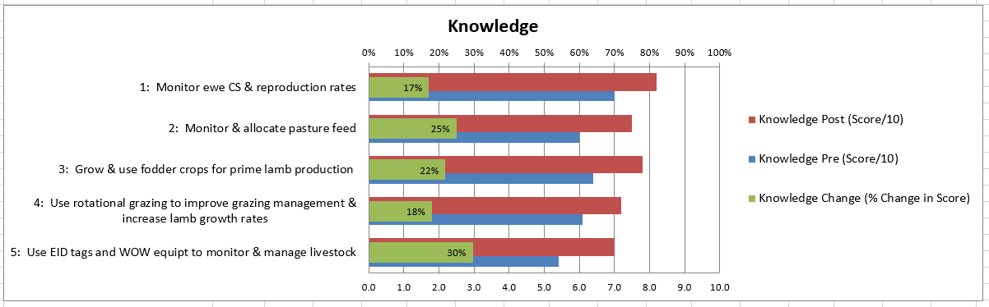
Fig. 5 Knowledge pre, post and change

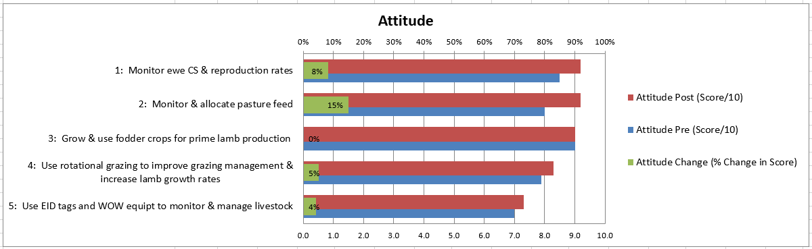
Fig. 6: Attitude pre, post and change

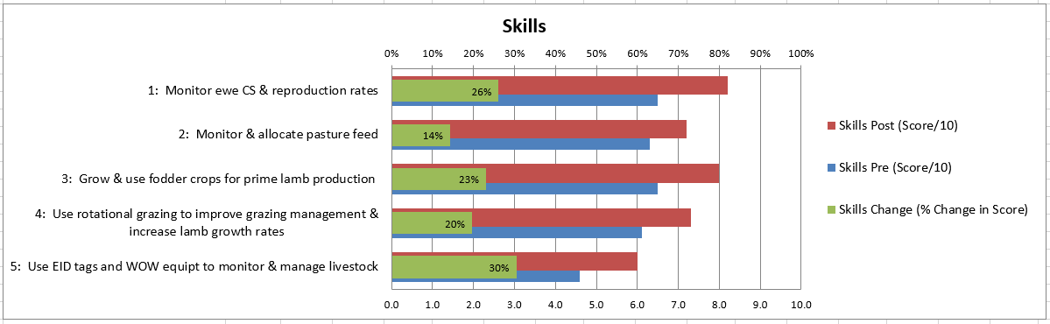
Fig. 7: Knowledge pre, post and change
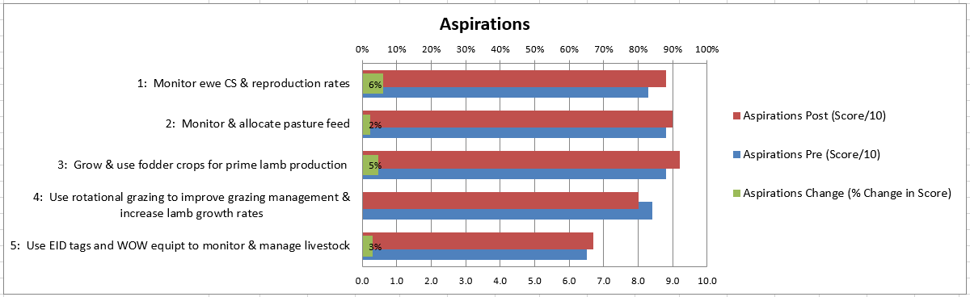
Fig. 8: Aspirations pre, post and change

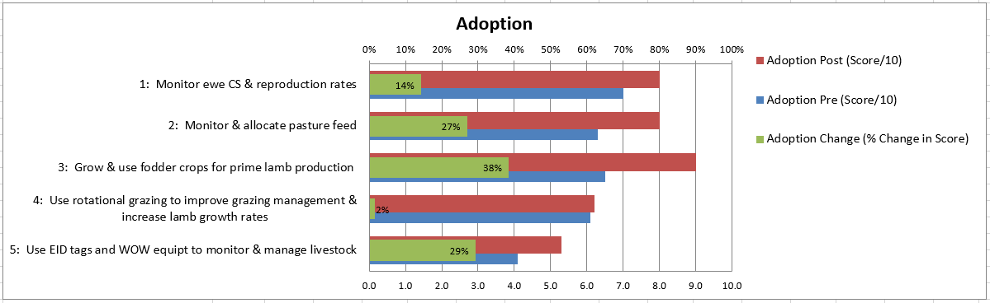
Fig. 9: Adoption pre, post and change

Discussion
Grazing management
Dry matter production and subsequent cost benefit results varied between years and sites, with differences in rainfall, grazing management, dryland/irrigation and cultivars/ blends.

The group felt the very low dry matter production in Year 1 was caused by a combination of low rainfall (Figure 1) and over grazing. The sites incurred high grazing pressure without adequate recovery time for plants . This created discussion around the value of water for generating fodder and the importance of using strategic rotational grazing to ensure the best return on the investment in water. It should also be noted that in this year of very low rainfall, the areas which were not irrigated delivered a net loss as there was no fodder grown.
Conversely, over the course of the demonstration, Year 2 and Year 3 results showed that the combination of appropriate rotational grazing strategies and irrigation can generate large volumes of dry matter for livestock fodder.
Strategic rotational grazing was implemented in Years 2 and 3 of the demonstration, introducing sheep to the site when plant height was above 200mm (Figure 10) and removing sheep when pasture reached 75mm (Figure 11). This left adequate biomass, plant energy reserves and leaf area for photosynthesis to occur and plants to recover quickly.

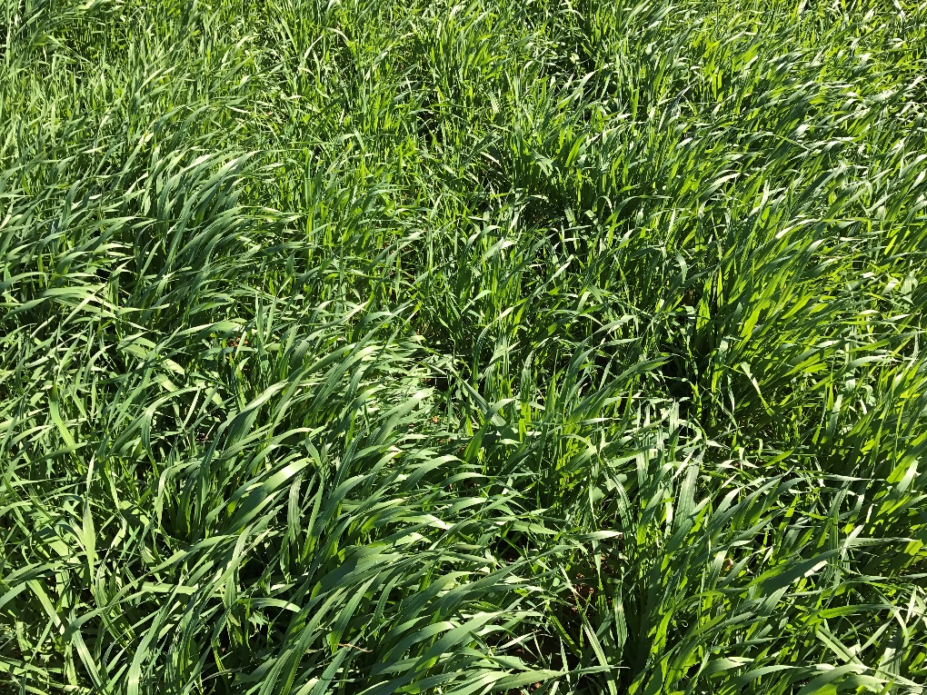
Figure 10: Time to commence or recommence grazing

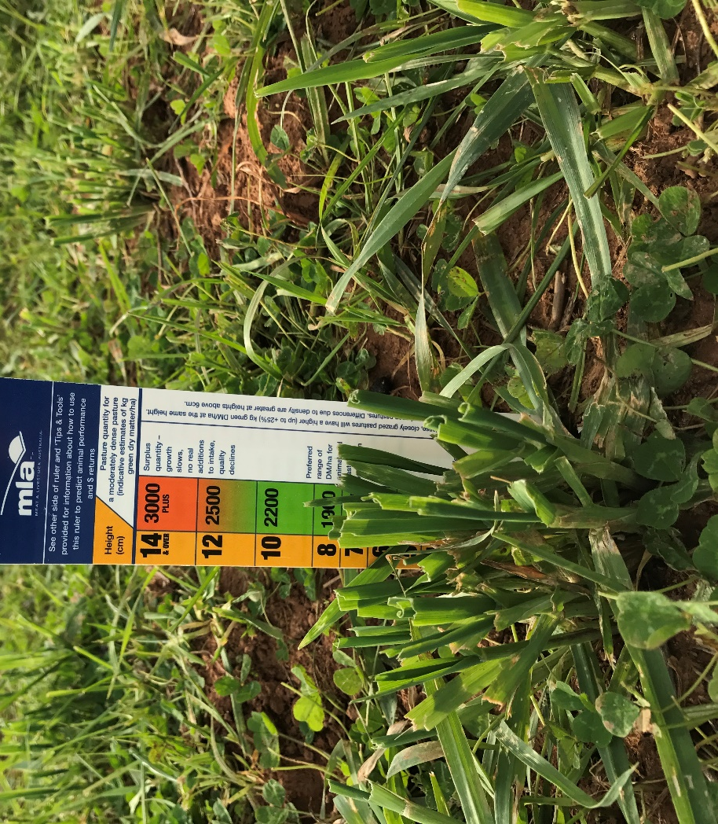
Figure 11: Time to move animals from the site

This strategy produced significant volumes of dry matter and high yields of both grain and hay, even in the non-irrigated areas. There was 377mm (Year 2) and 239mm (Year 3) of rainfall during the growing season and the result showed that even in low to moderate rainfall environments, large volumes of dry matter can be generated using strategic rotational grazing methodologies and suitable cultivar and blends.
Overall, barley performed well. Dryland Hindmarsh Barley /Tetrone Rye produced the best BC (19.8:1-Year 2), with dry matter production of 12.1 t/ha and 8.6 t/ha of hay produced after grazing. Moby Barley produced the highest dry matter (Year 2) at 14.67 t/ha with 0.8 t/ha grain produced post grazing, however this had a small amount of irrigation, pushing up the costs and reducing the benefit cost ratio. Wedgetail Wheat was another strong performer with a BC of 12.2:1.
However variation in production and BC was greater between years and with the influence irrigated versus dryland, than between cultivars and blends, making it difficult to their evaluate performance. Some of the more complex blends (e.g. Sites 4 & 5 Table 7) produced less dry matter at a higher cost for seed.
Annual reproduction rates of the flocks showed no appreciable changes, measured as marking percentages (see 4.4.1 above) however the starting point was already reasonably high for the demonstration hosts. A slight improvement in the reproduction of the merino flock was related to the survival of lambs rather than an increase in scanning rates. The fact that there were more lambs marked than scanned in both flocks suggests serious issues with the accuracy of the scanning contractor. Other non-host producers in the group indicated that their lamb survival (particularly for twins) had increased (see Feedback from participants 5.1.1).

Producer involvement
One of the big issues encountered in this EPDS was group member burnout. The Rich River BWBL group has been in existence for over twenty years and it was difficult to maintain the focus and interest from the group. This has been remedied by replacing the coordinator of the group, and the group is looking to become involved in further demonstrations.

The group was reluctant to use the precision management tool of Walkover Weighing as they could not see any benefit in these tools in a commercial system. One grower (a stud merino producer) did see the value and was already using the tools in his production system however no records of these data were collected for the EPDS.

Evaluation and learnings from the demonstration
Six of the eight producer participants were interviewed by phone in April 2019 by Kristy Howard (Inspiring Excellence) to collect feedback including knowledge, attitude, skills, aspirations and adoption (KASSA).
Self-assessment scores for KASAA (Figures 5-9) show a shift in all objectives except for:
- Producers attitude to growing and using fodder crops for prime lamb production – there was no change. However, this score was already high at a group average of 9.0.
- Producers aspiration to using rotational grazing to improve grazing management and increase growth rates. This score dropped slightly, most likely because many realised that it was not as simple as first thought and that they needed to invest in infrastructure to make it work.
The skills and knowledge areas had the greatest level of change for all objectives (Figures 5-9). This is not surprising given the topics. Aspirations and Attitude did not change much for most participants as they had already made the decision to be involved at the beginning of the trial.
The greatest KASAA change was a 38% increase (6.5/10 to 9/10) in adoption for ‘growing and using fodder crops’. The ‘use of EID tags and WOW equipment to monitor and manage livestock’ scored a 30% increase for knowledge and skills and 29% increase for adoption. Producers also indicated a 27% increase (6.3/10 to 8/10) for adoption for ‘monitoring and allocating pasture feed’ and a 26% increase in skills in monitoring ewe condition and reproductive rates. Feedback from participants
- What specific benefits can you see for your sheep enterprise arising from monitoring pregnancy status after joining and lamb mortality?
All participants spoke about getting more lambs on the ground’ as the main benefit. However only one person could quantify the benefits with actual marking % change (see comments below). For most it is an aspiration to improve twin survival and they now know how to and are committed to changing their practices in this area. Whether the project has contributed to them making change in this area was mentioned by one participant when he said ‘I don’t know whether I have made these gains from the project alone or whether they are building on what I learnt from lifetime ewe’. Comments made by participants include:
Should have more live lambs on the ground but last year miss-timed scanning so didn't get a good division of singles and twins ... ended up with more dead twins and large singles than I would have liked.
Always talking to my clients about doing it on their sheep and encouraging them to do it. Getting better weaning rates in my own flock.
Got better at twin management and understanding how to look after them in relation to what nutrition they need. Got better at keeping them alive overall (some years better than others)
We are weaning more lambs. We are feeding our ewes better.
Getting much better survival rates in twins. Was getting 140%, now >170% and 187% has been my best to date.
I think I am getting better ewe and lamb survival, still getting some dead ones but I think I would get more if I wasn't monitoring it.
- What specific benefits can you see for your sheep enterprise arising from the ability to accurately assess pasture and allocate it to the appropriate class of sheep?
Again, this is an area of aspiration for the participants, not necessarily wide spread adoption. They know what to do but are they doing it? There is still some working out of ‘how’ to do it that will come with time as they continue to put it into practice. The biggest learning has been how much more feed twinners need. Comments from participants include:
I still have a way to go to get it right - sheep are better at selecting the feed than I am at offering what I think they need.
Have learnt there is no point in feeding a dry ewe that is not giving me a lamb. Twinners need more feed and that it needs to be close at hand to feed the ewe...hand feeding twins is a recipe for disaster. Also learnt that we need the right kind feed for each class.
Ease of management and better understanding of when to have feed available and what they need. Improved management overall and have feed in front of you when possible
Planting more pastures as know need more for my sheep to feed them.
Much more aware of how pasture allocation affects all aspects of reproduction and the results I get from it.
I should be able to feed the sheep better and get rid of the lambs quicker. The main benefit is for the twin bearing ewes, they are getting everything, the singles are getting not much and they drys are getting paddy melons and Bathurst burrs. This season it has been hard to keep the condition on the ewes and I know I need to do better.
- What specific benefits can you see for your sheep enterprise arising from the use of short-term forage types?
The participants who were hosts to trial sites have gained the most benefits in this area as they got the practical experience of growing the forage types and what to do/what not to do. For the others that were looking over the fence, there was learning but with less practical experience or decision making. The thought of needing to sow every year was a bit off-putting for one and two said they would prefer to have a perennial solution like lucerne but water limits this. However, this trial gave them a chance to explore other annuals that they may not have seen before. Comments from participants include:
Can see benefits for weaning my lambs onto vetch and oats before the ewes drop too much in condition.
I thought I knew a fair bit but in doing this I have discovered I didn't know as much as I thought I did. I have more confidence to talk to people and encourage them to use different options. We tried two different varieties and managed them with rotational grazing - barley and ryegrass varieties. We got a big difference in DM from rotational grazing.
Probably realised that I needed a few new species. I tried moby and wedgetail. Would still prefer to use perennials like lucerne. Would prefer not to sow every year. Interested in finding more perennials - like sub-tropical grasses eg panics and others but haven't had the water to do it. We struggle to have something over the summer.
Know more about different species and getting better at sowing practices - depth of sowing, moisture, timing and how to sow. We are growing more and better-quality pastures on the same amount of irrigation water. We are putting in a lot of different species eg different ryegrasses, clovers and brassicas.
Where I have twins and big numbers, the green feedlots are good for these situations. Have 40 ha of brassica that has finished off 1500 lambs - had only just started doing this since we started the trial, now can see the benefits of it. Have now planted a sub and rye pasture paddock - have not done that before.
Helps to make better use of my water. Helps me to feed all my sheep better. We trialled the brassicas - Greenland and another variety (Titan). The ewes and lambs ate the other variety into the ground and ate the Greenland eventually. The sheep did alright. I am growing forage sorgham this year and the lambs have done alright but it is not a fattening feed. Think I would use irrigated Lucerne instead (next year) as fattening feed - think it is better.
- What specific benefits can you see for your sheep enterprise arising from the use of rotational grazing?
The participants can see the benefits of rotational grazing but struggle with putting it into practice. The issue is that they perceive they require more fencing and water for stock. Even though there are electric fencing options, these are not considered by the participants to be good enough and many seem to be reluctant to move stock regularly to have it work properly. Comments from participants include:
Benefits in managing worm burdens of ewes. At the moment have no feed. Need to do more fencing to make it work - not inspired by electric fencing. More interested in sowing fodder crops than doing the rotational grazing.
Used to think rotational grazing was a folly - used to just set stock but saw the difference in sheep that were rotationally grazed and were 15 kg heavier that livestock on other block (no rotational grazing). Would be using it more but haven't had the season to support it.
Haven't fully utilised it - gives the pastures a chance to recover. Want to get into a whole farm rotation - have put in electric fence - now waiting for the season to be able to do it. Need more troughs to get it started.
Have gone away a little bit from rotational grazing as it wasn't flexible enough around lambing as now lambing twice a year. We will still spell paddocks if we can. Maintenance of electric fences is an issue - forever chasing shorts. We have stopped breaking one paddock into 4, we have gone into larger blocks and allowing more DM to build up...but the issue is fencing - don't have the time to put into it. Are looking at up grading the permanent fencing and renewal of fencing.
Can't set stock brassica - have to rotationally graze it. Normally have 60-70 ha wedgetail wheat - they are in 10 ha paddocks to allow for rotational grazing. Now lamb on sub pasture, winter on wedgetail and wean lambs onto brassica.
If I was able to do it, the sheep would do better but fencing is the issue and water. Making smaller paddocks would enable me to do it. Haven't done the fencing required.
- What specific benefits can you see for your sheep enterprise arising from the use of EID and WOW?
Only two of the participants are using RFID tags to monitor either ewes or lamb growth rates currently. The others have this as an aspiration but doubt whether they will use RFID tags unless it becomes mandatory in NSW or they get a cheap source of tags and a project to use them in. One couldn’t see the benefit of weighing lambs on pasture where there were no other options for feeding them differently if they were not performing. Comments from participants include:
Can see there are benefits to help predict when lambs are ready for the works. Issue for me is the cost of equipment and the extra work to way animals Ie mustering.
I can identify ewes to go with certain rams and to draft animals in different ways. I can separate them out at shearing and for identifying preg status.
Better knowledge of animals weights and understanding of how they going. Need to buy equipment - if had the money I would buy a sheep handler but have no sheep at the moment because of the season. Think it is the future but circumstances at the moment make it difficult.
In the feedlot it was great to get instant to see growth rates per day. All my younger ewes have an RFID tag but not using it yet. Want to use it for history of scanning and number of lambs reared.
Can't see any benefits because can't see monitor lamb rates on pastures as being important. In feedlots yet - can identify poor doers and take them out. Think it is more important to have the right sheep for my farm rather than chase high growth rate lambs. It is more important to monitor the condition of my ewes rather than growth rates in my lambs. Too much emphasis on one component does not give you a complete sheep.
I have to get a feedlot pen set up to help me get a better understanding of what animals do when fed...when I get EID tags in my ewes I will be able to monitor ewe performance. It is a bit about the cost of tags as well - getting the use from tag.
- What changes have you made as a result of this demonstration? (e.g. to your grazing management, pasture/fodder varieties, use of EID and WOW)? If none, do you intend to make any changes?
All participants talked about having made changes or wanting to make changes. Some are still aspirations ‘if and when’ the season gets better. The last couple of years has been tough so this is understandable. The participants who have made changes are the ones that hosted trial sites. The observers to the trial sites were more ‘aspirational’ in their intent to make change. Producer comments include:
This year I have a paddock prepared to ready to sow with vetch. Should give me extra feed for my lambs.
Our attitude and desire and how we do fodder conservation has changed. As has how we feed and maintain condition score and using RFID in our stud flock to make it simpler to ID individual animals. All this has come from the trial.
Changing to more of a perennial base is what I want to do. Want to do more rotational grazing so that I can lessen the need for supplementary feeding. Whether I can do this will be season dependent, but it has been hard here the last few years.
Growing better pastures and better quality pastures. Now know more about growing pasture. Have moved into EID in younger stock - gradually tagging each new mob of maidens. We are splitting mobs better into singles, twins and this year triplets. Managing rams better and ewe condition better.
We tightened up our rotational grazing - now growing different feeds for our sheep. We have increased our lambing percentage from better grazing management.
We trialled more different forage crops and options for crops. Going to put a feedlot pen in over winter time and that will allow me to have options for lambs. The water job is too expensive and carrying them over is not an option. Can't afford to keep my lambs for as long as I do so that is a change I need to make.
Project participants all achieved changes in knowledge and skill as a result of the trial, in particular around the use of EID technology and growing and using fodder crops for prime lamb production.
All either made changes or are planning to make changes as a result of the trial, especially to the way they manage twin bearing ewes and the types of fodder they are growing for lambs and ewes.

Conclusions/recommendations
The main recommendations coming from the EPDS are around the use of suitable cultivars fit for the environment in which they are to be grown and the importance of managing grazing pressure and grazing duration on both irrigated and non-irrigated fodder.
Even in low rainfall environments the project demonstrated that with correct grazing management and cultivar selection it is possible to generate large volumes of fodder for livestock production. The low return achieved from perennial cultivars would tend to suggest that an annual system is more productive in terms of net return on investment under the local conditions. However, there was interest from the group to look further at perennial options with some producers preferring not to re-sow regularly.

The implementation of strategic grazing triggers will promote plant recovery post grazing and is essential to extract maximum return on the investment in sowing and watering fodder crops. The grazing barley and barley blends produced the greatest return on investment over the life of the project. As indicated by Year 1 results, the maximum return can only be expected when overgrazing is avoided.

In the merino flock, there was a modest improvement in the reproduction rate over the life of the three years, mainly due to the availability of adequate fodder (2 tonne average) for grazing in the latter stages of gestation and into lactation. There was however no appreciable difference in the reproduction rate of the cross bred flock, which may be due to other factors not investigated.

This EPDS also demonstrated the benefit of utilising electric fencing to control grazing pressure on fodder/pasture crops. The group was reluctant to use WOW as they could not see any benefit in this technology in their systems. They were however interested in the use of electronic tags to monitor daily growth rate of their lambs.

Appendices

Year 2: Grazing date, stocking rate and days grazed
Site | Cultivar | Irrigated Yes/No | Grazing commenced | Grazing concluded | Number of days grazed | Stocking rate (DSE/ha) | Total days grazing
1 | Moby Barley | Yes/pre watered only | 15/06/2016 | 28/06/2016 | 14 | 50
1 | Moby Barley | Yes/pre watered only | 11/07/2016 | 29/07/2016 | 19 | 100
1 | Moby Barley | Yes/pre watered only | 25/08/20165 | 10/09/2016 | 17 | 72 | 56
2 | Wedgetail Wheat | Yes/pre watered only | 28/06/2016 | 05/07/2016 | 8 | 50
2 | Wedgetail Wheat | Yes/pre watered only | 16/09/2016 | 01/10/2016 | 16 | 65
2 | Wedgetail Wheat | Yes/pre watered only | 10/11/2016 | 01/12/2016 | 22 | 65 | 46
3 | Hindmarsh Barley and Tetrone Rye | No | 22/05/2016 | 15/06/2016 | 25 | 15
3 | Hindmarsh Barley and Tetrone Rye | No | 15/06/2016 | 15/07/2016 | 31 | 18.8 | 56
4 | Moby Barley, Tetrone Rye grass, Aroura Lucerne, Shatftal Clover Trikala Sub clover | No | 10/06/2016 | 27/06/2016 | 18 | 42 | 18
5 | GTL 60 lucerne, Tetrone rye grass and Hindmarsh barley | No | 27/06/2016 | 15/07/2016 | 19 | 27 | 19

Table 2 Year 3 grazing days and stocking rate
Site | Cultivar | Irrigated Yes/No | Grazing commenced | Grazing concluded | Number of days grazed | Stocking rate (DSE/ha) | Average Stocking Rate | Total days grazing
1 | Targa Oats  Mixed small seed mix | Yes | 1/5/2017 | 14/5/2017 | 14 | 44
1 | As Above | Yes | 14/5/2017 | 17/5/2017 | 3 | 17.1
1 | As Above | Yes | 5/7/2018 | 17/7/2018 | 12 | 27.05
1 | As Above | Yes | 17/8/2017 | 22/8/2017 | 5 | 27
1 | As Above | Yes | 28/9/2017 | 8/10/2017 | 10 | 27.0
1 | As Above | Yes | 8/11/2017 | 16/11/2017 | 8 | 23.5 | 27.6 | 52
2a | Outback Oats | No | 5/7/2017 | 15/07/2017 | 10 | 41.2 |  | 10
2b | Small Seeds Blend | No | Nil | Nil | Nil | Nil | Nil | Nil
2c | Moby Barley | No | 15/07/2017 | 22/07/2017 | 7 | 40
2c | Moby Barley | No | 15/08/2017 | 25/08/2017 | 10 | 40 | 40 | 17
2d | Moby Barley | No | 22/07/2017 | 3/08/2017 | 11 | 40 | 40 | 11
2e | Tetrone/Balansa | No | 3/08/2017 | 15/08/2017 | 12 | 21
2e | Tetrone/Balansa | No | 25/08/2017 | 5/09/2017 | 11 | 21 | 21 | 23

Two producers have sold their property and moved on.

