Managing grapevines with less water in the Mallee

Introduction

Irrigators may be faced with managing vines with less water due to dry seasonal conditions. In this situation a range of decisions need to be made including:
- the purchase of additional water in a low availability market
- prioritise water onto preferred varieties and patches
- giving other patches reduced volumes with consequent reductions in production
- abandoning poorly performing patches, and
- possibly removing plantings of lowest priority and bringing forward redevelopment plans.
The success of a reduced irrigation strategy must consider the impacts during drought and in subsequent seasons. Grapevines are generally considered better at recovering from extended periods of low water applications than most other crop types. Vines are often chosen as the ‘sacrifice’ if prioritising irrigation in a mixed horticultural enterprise.

grapevine water requirEments
There are five main development stages in grapevines:
- Pre-budburst to flowering. This is a low water use period and accurate irrigation scheduling can result in water savings. It is also the most important stage for determining potential yield. Moisture availability at flowering is particularly important. A full soil-moisture profile at budburst encourages early season canopy development assisting to protect bunches later in the season.
- Flowering to fruit set. Flowering and berry set are very sensitive to water stress. It is a period of rapid shoot growth. Stress during fruit set can result in significant reductions in yield and vine development. If the soil profile is near field capacity at budburst and average spring rainfall occurs, it may be possible to delay irrigation until mid-October.
- Fruit set to veraison. Approximately a third or more of total seasonal water use takes place during this period (up to 35 per cent in winegrapes for example). Water deficit strategies are generally recommended for this period in winegrapes, and yield reductions are mainly due to reduced berry size.
- Veraison to harvest. Another large share of seasonal water use. Sugar accumulation will be decreased if water stress is applied during this period.
- Harvest to leaf-fall. This is a period of relatively low water use; however, excessively dry soils can affect carbohydrate accumulation and vine development the following season. A dry profile will also limit nutrient uptake.

Winegrapes
Undoubtedly winegrapes have had the most research conducted on deficit irrigation techniques. This crop type has the most options available when considering a reduced water supply strategy, with water deficits during the fruit set to veraison growth stage generally considered suitable, particularly for varieties that can produce large berries such as Shiraz.

Tablegrapes
Fully productive tablegrapes require more water than winegrapes and dried fruit. Any attempts at reducing water applications will generally result in a significant production loss. Reduced applications will result in smaller berries and bunches that may be unmarketable. For this reason, there may be very little that can be done to save significant amounts of water, other than those generated by efficient irrigation practices (depending on current irrigation management). In this scenario, prioritising patches or purchasing water become the main options.

Dried Vine Fruit
Dried fruit production using modern management practices such as swing-arm trellis have a much higher water requirement than that of traditional production methods, due to a larger canopy.
Deficit irrigation at any stage, will affect dried fruit production levels, but not to the same level as that expected for tablegrapes. Irrigation can be cut back from fruit-set to veraison when little sugar accumulation occurs, but final berry size may be reduced.
Water requirements are decreased following cutting, representing an opportunity to save some water. Recent observations suggest that this reduction is not as significant as previously thought.

regulated deficit irrigation (RDI)
Regulated deficit irrigation (RDI) is an irrigation strategy used to manipulate vine and berry growth to improve red wine quality. It involves applying a smaller amount of water than the vines require for unrestricted growth, at a particular growth phase. This results in moderate vine canopy growth and decreased berry size; smaller berries tend to result in better wine quality.
The period to implement RDI is generally recognised as being from the commencement of fruit set to veraison, applying sufficient water stress in a regulated and controlled manner. The practice has generally declined as returns for winegrapes have not offset the reduction in yield obtained.
If water availability requires managers to reduce irrigation applications at a chosen growth stage, the fruit set to veraison period would be the most suitable.

sustained deficit irrigation (SDI)
Sustained deficit irrigation (SDI) differs from RDI. With SDI the water deficit is not created by withholding water at a particular growth stage, but by applying less water at each irrigation event for the entire season. It is a technique that can potentially be adopted across the winegrape industry if water availability is reduced.
First season SDI trials have often found little production decline (except at extreme treatments around 25 per cent of full water treatments) as fruit is produced from fruiting canes and spurs produced in the previous season while the vines were presumably still receiving full irrigation. Chalmers (2007) found inconsistent outcomes to SDI among grapevine varieties, meaning strategies may need to be tailored to individual cultivar responses to water deficit.
After three seasons of 50 per cent SDI, yields were significantly reduced by up to 30 per cent in Cabernet Sauvignon and Shiraz.
Sommer and Hancock (2012) found that a deficit irrigation equal to or greater than 75 per cent ET_{c} (crop evapotranspiration under standard conditions) either applied as a sustained or regulated deficit irrigation is likely to give sustainable near optimum Sunmuscat production in the short to medium term.

rootstock
Drought tolerance is an important consideration when assessing rootstock suitability in warm climates. Drought tolerant rootstocks are generally those which have the ability to occupy a larger volume of soil and therefore have access to a greater amount of soil moisture. Ramsey, 1103 Paulsen and 140 Ruggeri have excellent drought tolerance (Dry 2007). 101-14 has high water requirements and may not perform well under restricted water availability.
Effective soil preparation at planting can also help ensure a well-established root system is developed which may be of benefit under low water supply situations.
A basic understanding of rootstock drought tolerance can provide informed decisions when conducting Water Budget Planning. Patches having a drought tolerant rootstock are generally able to withstand greater deficits.

irrigation strategy
During the most recent period of low water supply in the Mallee (2007–09), two methods of applying reduced water application were employed by grape producers: (1) frequent short irrigations, or (2) less frequent longer irrigations (typical application depths). The deeper irrigations (well monitored without creating deep drainage) have generally proven to be more efficient; less water is lost to evaporation and a greater percentage of the rootzone has access to water. If applications are too short, water will not infiltrate deeply into the soil, eventually leading to a higher percentage of water lost to evaporation. This is most applicable for vineyards with low level sprinklers where surface evaporation is more significant.

Water saving practices

Immediate strategies

Water budgeting
Estimating the monthly water requirements for patches using average water use figures and historical irrigation records can be used to develop a drought management plan and prioritise allocation of water to patches. See Water Budget Planning for more information on developing a water budget.

Install irrigation scheduling devices
It is crucial to use soil moisture monitoring devices to accurately check soil water levels and allow irrigations to be scheduled more precisely. Monitoring allows the effectiveness of water saving practices to be readily determined. Tensiometers have often been a recommended tool as they are relatively inexpensive, easy to install and use, although they are less useful for deficit irrigation.
Devices that continuously log soil moisture provide far more information and are more accurate. They are particularly useful in being able to immediately determine appropriate irrigation depth and encourage confident, informed decisions regarding this.
Determining irrigation application depth, and making appropriate adjustments, is something that can generally be adopted quickly with more sophisticated devices, even though it generally takes longer to learn how to use and fully understand the information generated from these tools. If multiple sensor depths are installed, the active rootzone is quickly determined. The long-term benefit from adopting continuously logged soil moisture monitoring and the production benefits that are possible, should be considered.

Check, manage and maintain the irrigation system
Irrigation systems should be checked for any leaks or blockages. The accuracy of water meters should be checked by cross-referencing readouts with application rates and system specifications. If irrigation uniformity is poor an irrigation consultant may be needed to advise on improvements. Correcting these issues may only result in modest water savings, but during a period of low water availability these savings may be significant. The effect an inefficient system has on a vineyard will be exacerbated during times of drought (as will soil variation).
Good system hygiene practices should still be maintained. If flushing the system, consider directing flush water towards the vineyard rather than running to waste.

Avoid leaching losses
Ensure water is not lost below the root zone by carefully monitoring soil moisture levels and irrigation depth. Sampling for soil salinity is recommended to determine if a strategic leaching program is needed. Water during a period of low availability may have elevated salinity levels.

Mulch the wetted strip
Applying mulch helps reduce soil evaporation and is often a general recommendation to save water (Figure 1).
Mulches can act as a barrier to effective water penetration, and then once wet-up can then quickly dry out. Accurate soil moisture monitoring is important in order to recognise this situation. The level of water potentially absorbed by mulches ranges from 2.0 to 3.7 mm depending on the mulch material (Sommer 2011).
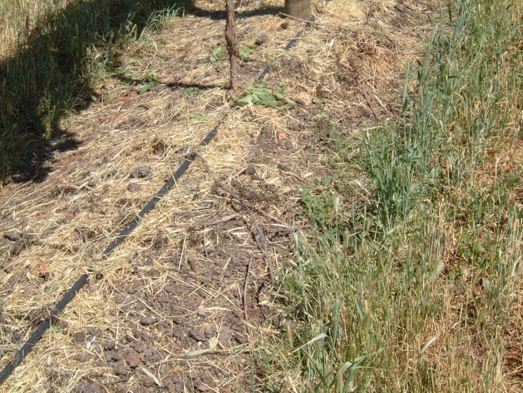
Figure 1. Manure and slashed cover crop applied to the wetted strip of a drip irrigated vineyard (Photo: Jeremy Giddings).

Irrigate at night
Low-level sprinkler irrigation at night can provide water savings of 20–30 per cent compared with daytime irrigation by reducing evaporation losses. The water savings with drip irrigation systems are variable depending on the amount of mulch, leaf litter and shade over the wetted soil surface.

Eliminate water runoff
Irrigation water should be kept in the vineyard. Runoff can occur if the irrigation application rate is too high, or the soil surface becomes sealed. If water runoff occurs, break up soil crusts to improve water penetration and soil aeration.
The traditional methods of improving water penetration are applying gypsum and/or ripping. Ripping in a low water supply scenario is not recommended due to the additional stress created through root damage, and the reduced ability of the vine to take advantage of any rainfall.
Pulse irrigation (example 1hr on / 1hr off) can help to improve water penetration and soil aeration.
Some soils were observed to have become ‘non-wetting’ during the 2007-09 low water supply period.

Reduce or cease windbreak irrigation
This can save water but consider the long-term importance of windbreaks. Also be aware that non-irrigated windbreaks can scavenge water from the adjacent crop, so deep ripping or trenching to trim windbreak roots may be required.

Re-use back-flush water
Speak to an irrigation designer to ensure excessive back-flush volumes are not being generated to begin with. Some minor savings may be possible. The back-flush water that is created from drip irrigation filters can be reused if run to a settling tank. Discuss this option with an irrigation designer. Media filters generally use 4.0–5.0 per cent of the water pumped to backflush, disc and screen filters 1.5–2.0 per cent.

Reduce transpiration
Kaolin-clay-based foliar spray products are claimed to reduce water losses through leaves. No water savings or reduction in plant stress indicators following their application have been documented.
New products enter the market frequently, and there is always the possibility that some may prove to be of benefit. If using these products, consider leaving untreated areas in order to determine the effectiveness of whatever was applied.

Buy/trade water
Buying or leasing-in water, if available, can be a viable option. Consider the long-term value of the vines and crops compared with the cost of water. If the cost of water is less than the value of produce lost by withholding that volume of water (including any ongoing recovery to production), then buying permanent or temporary water should be seriously considered. Spreadsheets such as that produced by CCW (Consolidated Co-operative Wineries – membership required) are available to quickly determine if buying water is a viable option.
Rural Financial Counsellors may be able to help with these tools (Ph. 1300 735 578).

Full cover weed control
Removing weeds and eliminating cover crops will reduce competition for water. Sods are best sprayed with herbicide (at recommended rates) and allowed to form a layer of mulch, protecting the soil and reducing evaporation.

Keep informed about water allocations
Maintain contact with the water supply authority for the latest information on water allocations, water flows and water levels in storage. Obtain information on current and next season’s likely water allocation scenarios to enable better long-term decision making. This information can be sourced from state (eg http://waterregister.vic.gov.au/) and local water authority web sites, Apps such as Water Market Watch and Waterflow. Look at long-term weather forecast information to help schedule irrigations.

Longer-term strategies

Install valves for each patch
Water use differs significantly with canopy size which is determined by variety, rootstock, age, and trellis. Installing valves to separate patches that have different water requirements will allow closer matching of crop water needs with water applications. Variable speed drives become a more beneficial option in these situations.

Install more sophisticated scheduling equipment
Sophisticated scheduling equipment (e.g. capacitance probes) will enable far more accurate irrigation applications and assessment of additional rainfall effectiveness than less sophisticated devices such as tensiometers. Leaching losses can be completely avoided while still ensuring that irrigations are fully effective.

Convert to more efficient irrigation systems
Drip irrigation is potentially the most efficient irrigation system currently available and has been widely adopted by the grape industries.
If looking to convert to drip, remember a new permanent drip system requires substantial investment and should be professionally designed. Consider the long-term financial viability of taking this step. If there is a high probability that water restrictions will continue in the future, serious consideration should be given to installing drip irrigation.
It is important to be aware that converting to drip from a full cover irrigation system changes the distribution of water in the root zone. Roots take time to respond to this change in water pattern, and vines will experience stress until the root system has adjusted. In a normal season, generous drip irrigation applications are recommended in the first year following conversion. Inadvertently superimposing water deficit on top of the conversion, is likely to lead to significant stress.
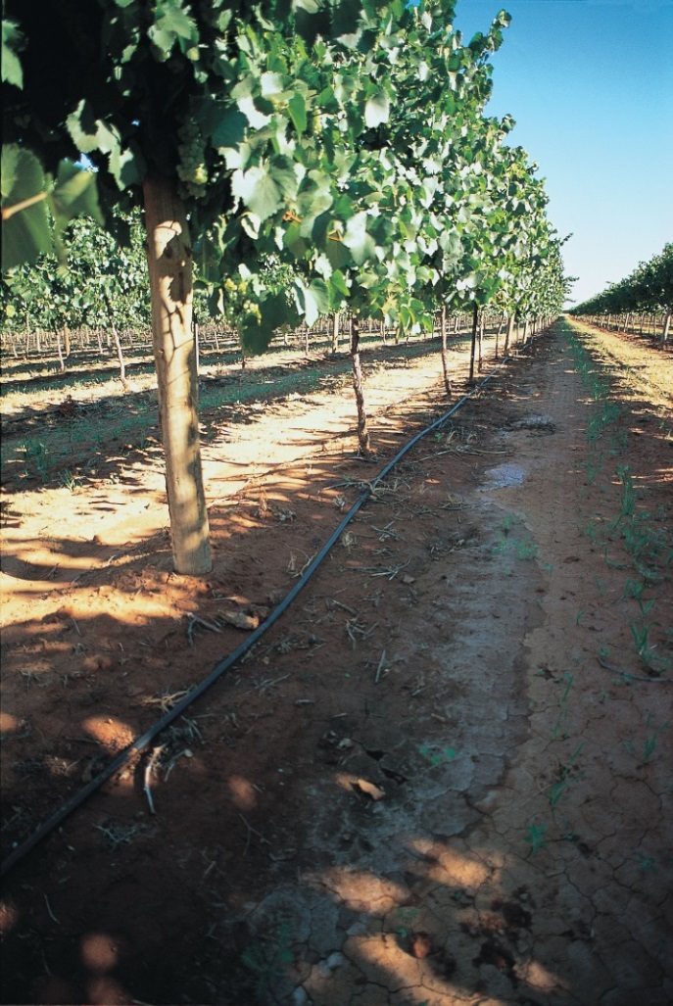
Figure 2. Drip irrigation is potentially the most efficient irrigation system available (Photo Jeremy Giddings).
Managing periods of low water availability will be less difficult in the future. Periods of low availability have previously been experienced by irrigators in the Mallee. Vineyard managers are much more proficient than previously. However, conversions to drip irrigation, adoption of sophisticated irrigation scheduling and the push for higher production has resulted in increased efficiency levels with little scope to achieve additional water savings.

water budget planning (Winegrape example)
Table 1 is a sample water budget for a 20 ha winegrape vineyard. The property has an entitlement of 180 ML. The table considers a scenario where the vineyards allocation has reached only 40 per cent, leaving 108 ML available.
Assuming discussions with wineries has taken place, water for particular patches is prioritised. Typical annual water use for each patch is estimated from previous records and experience. The proposed allocation for each patch can then be determined, and the management strategy implemented.

Patch | Variety  Rootstock  Irrigation system | Area (Ha) | Typical annual water use (ML) | Proposed water application (ML) | Management strategy
1 | Chardonnay  Ramsey  drip | 4 | 32 | 16 | 50 % SDI as strong rootstock
2 | Chardonnay  101-14  drip | 4 | 32 | 32 | Full production. Weak rootstock
3 | Colombard  Ramsey  drip | 4 | 32 | 0 | Abandon, redevelop
4 | Shiraz  Paulson  drip | 4 | 32 | 28 | RDI fruit set to veraison
5 | Cabernet Sauvignon  Ruggeri  Overhead sprinkler | 4 | 40 | 28 | Convert from overhead sprinkler to drip
 | TOTAL | 20 | 168 | 104
Table 1. Sample of a water budget for a winegrape vineyard with a 60 per cent allocation (This is an example and should be used as a guide only).

recovery
Recovery from water stress will depend on the previous health of the vines as well as the rootstock, soil type, and the duration, growth stage and level of stress experienced in the current season. As previously mentioned, grapes are generally more resilient than many other crop types; however, some recovery issues are still to be expected.

Winegrapes
An experiment on Chardonnay irrigated at 20 per cent of normal practice achieved similar yields to control vines in the recovery season. When subjected to one season of irrigation at 10 per cent of normal practice, yields decreased for at least one season after returning to normal irrigation practice (Pech et al., 2010).

Dried Fruit
Sommer et al. (2014) reported that Sunmuscat bunch numbers and yields tended to increase when irrigation was returned to 100 per cent after applying 25 per cent of estimated crop water requirement in previous season.

case studies

Ashley Johnston, Irymple VIC
In 2007/08 the market price of temporary water reached more than $1,000/ML in the first half of the season, as irrigators responded to a seasonal outlook of very low allocations. While some irrigators had carryover from the previous season, it was considered insufficient to maintain crops.
The market price of water decreased significantly later in the season as other states increased allocation, and demand eased as large horticultural enterprises had purchased sufficient water to preserve their crops and buying pressure dropped away from the market.
The initial allocation at the start of the 2007/08 season in Victoria was 0 per cent, and by 15 November 2007 was 23 per cent. Increases through the season resulted in a final allocation of 43 per cent by season’s end. In the following season, a total allocation of 35 per cent was eventually received, with 100 per cent allocations returning from 2009/10 onwards.
Ashley Johnston grows 25 ha of dried vine fruit at Irymple, supplied with water by Lower Murray Water in Victoria.

Two approaches
- “Purchase water. It looked like a pretty big crop in spring in 2008. I purchased water not knowing what we’d end up with. The alternative was to ration or dry off patches, but I was not in a position to do so at the time. I made the investment in water based on an assessment of the crop value I had hanging there at the time. The sultana crop was looking to be a good one. The 2009 harvest was the biggest I have ever produced, and it was a profitable year. Gross return was nine times the value of the water purchased.”
- “Some on-site water saving practices, such as spraying out the cover crop.”

Next time
- “Wouldn’t do much different. I’ve invested in permanent plantings and their long-term health can’t be jeopardised. There may be more forward planning, preparing for a foreseen drought by looking at other water products and options in the lead up to a possible drought.”
- “Various on-site water savings, but if we are good irrigators, we should be doing these anyway.”

Justin Kassulke, Curlwaa NSW
A 100 per cent allocation was announced for NSW Murray high security entitlements at the start of the 2006/07 season. However, by November 2006, allocations had been ‘suspended’ to approximately half following record low inflows. This had an enormous impact on NSW Murray irrigators who had developed and prepared their properties under the assumption that ample water would be made available in that season.
NSW Murray high security irrigators initially received zero allocation the following (2007/08) season. Suspended water from the previous season was gradually returned to irrigators over the season. Critical water was also obtained for NSW high security licences in an attempt to keep permanent plantings alive but not necessarily produce a crop. This critical water represented approximately 30 per cent of grapevine water requirements. At the same time, temporary water prices peaked at over $1,000/ML for the first half of the season (normally $100–$300) making water purchases on the open market uneconomic for many.
Justin Kassulke grows and manages 160 ha of winegrapes and citrus in the Curlwaa Irrigation District in NSW, located 25 km from Mildura, and is supplied with water by Western Murray Irrigation.

Three approaches
- “Back then prices were reasonable for winegrapes. We did not want to change what we normally did. We recognised that normal levels of irrigation were necessary for full production. That last ML/ha of water delivers a significant proportion of your yield. Therefore, we purchased water”.
- “We converted from overhead sprinkler to drip. The drip system cost two-thirds of the cost of purchasing water the previous year, and we did not have to purchase any more water after that”.
- “Removed the permanent cover crop and commenced a good weed control program”.

Next time
- “We would continue to look to purchase water, but not all in one hit like last time. We wouldn’t expect the price to rise to the same levels as last time. Most people understand the market better now”.
- “Since 2007 we have installed a variable speed drive and more automation, so that if a particular patch needs half hour less irrigation, then we can do that”.
- “We’ve removed the windbreaks now that the crops are mature. They were robing a few rows either side”.
- “We’re gradually moving to drippers with lower application rates to avoid losing water to run-off”.

further information
Irrigation Services, Agriculture Victoria. irrigation@agriculture.vic.gov.au
Australian Wine Research Institute. How to start irrigating with less water. Viti-notes. Research to practice.
Chalmers, Y.M. (2007). Influence of Sustained Deficit Irrigation on Physiology and Phenolic Compounds in Winegrapes and Wine. PhD Thesis, University of Adelaide.
Dry N. (2007). Grapevine Rootstocks. Selection and Management for South Australian Vineyards. Phylloxera and Grape Industry Board of South Australia.
Goodwin, I. (2009). Managing water stress in grape vines in greater Victoria. AG 1074
GWRDC. Water management for Wine Grapes in a Drying Environment.
Pech, J.M., Hall, A.P., Strachan, R.L., Ratcliff, A.M., McCarthy, M.G., and Skewes, M.A. (2010). Resuming irrigation after severe reductions — effects on grapevine productivity. Poster presented at: 14th Australian Wine Industry Technical Conference (Adelaide, Australia).
Sommer, K. (2011). Maximising Dried Fruit Production During Periods of Reduced Water Allocations. Horticulture Australia Ltd Project Number: DG08005
Sommer, K. and Hancock, F. (2012). Sunmuscat deficit irrigation and recovery.
Sommer, K.J., Hancock, F., Downey, M. (2011) Evaluating deficit irrigation strategies for the dried grape industry
Sommer, K.J., Hancock, F., Downey, M., and Goodwin, I. (2014). Impact of deficit irrigation on Sunmuscat production in Australia. Acta Hortic. 1038, 579–586 http://dx.doi.org/10.17660/ActaHortic.2014.1038.73.

acknowledgments
Ian Goodwin — Research Manager, Agriculture Victoria Research
Ashley Johnston — dried fruit grower, Irymple VIC
Justin Kassulke — winegrape and citrus grower, Curlwaa NSW
Belinda Kerridge — Research Scientist, Agriculture Victoria Research
Greg Moulds — Senior Land Services Officer, Local Lands Services Western Region
Michael Treeby — Group Leader, Agriculture Victoria Research

Accessibility
If you would like to receive this publication in an accessible format, please telephone Agriculture Victoria, Irrigation Services on 136 186.
This document is also available in (Word) format at www.agriculture.vic.gov.au

