Dairy shed water – How much do you use?

Contact details
Benita Kelsall
Agriculture Victoria, 1301 Hazeldean Road Ellinbank, Victoria, 3821
AUSTRALIA
Further information www.agriculture.vic.gov.au
Customer Service Centre 1300 502 656
Published by the Department of Primary Industries, 1 Spring Street, Melbourne, Victoria 3000 Australia
July 2009
© State of Victoria, Department of Primary Industries 2009
This publication is copyright. No part may be reproduced by any process except in accordance with the provisions of the Copyright Act 1968
Authorised by the Victorian Government, 1 Spring Street, Melbourne, Victoria 3000 Australia
ISBN 978-1-74217-625-3 (print) ISBN 978-1-74217-626-0 (PDF) ISBN 978-1-74217-627-7 (HTML)
Dairy shed water - How much do you use?
Content and instructional design by AgVet Projects
Layout by Griffin Graphics
Printed by Stream Solutions
Photos have been sourced from AgVet Projects, Dairy Australia, DPI, the EPA and Southern Rural Water
Disclaimer
This publication may be of assistance to you but the State of Victoria and its employees do not guarantee that the publication is without flaw of any kind or is wholly appropriate for your particular purposes and therefore disclaims all liability for any error, loss or other consequence which may arise from you relying on any information in this publication.
For more information about DPI visit the website at www.agriculture.vic.gov.au or call the Customer
Service Centre on 1300 502 656

Acknowledgements

This booklet has been prepared by the Department of Primary Industries (DPI) in consultation with farmers, dairy company field officers, the commercial sector and staff from the rural water corporations and the Department of Sustainability and Environment.
In particular, DPI gratefully acknowledges the assistance received in the preparation of this booklet from:
- AgVet Projects – Rob Greenall, Gabriel Hakim, Joanne Campbell
- Australian Dairy Products Federation – Peter Haynes Bendigo Scientific Data Analysts – Leigh Callinan Burra Foods – Suzanne Lee
- Catchment Management Authorities – for past funding of projects which resulted in dairy water use data being collected
- DPI’s Dairy Extension Centre team members – Julie Williams, Scott McDonald, Joel Spry, Benita Kelsall, Ann McDowell, Rod Eldridge, Nathan Shannon, Barrie Bradshaw and media & communications adviser Sue Keirnan
- Department of Sustainability and Environment (DSE) – Patrick O’Halloran, Denis Bergan
- Fonterra – John Kane, Durham Prewett
- Goulburn-Murray Water – Simon Cowan, Barry O’Donnell, Steve Gemmill
- Melbourne Water – Jan Smith
- Murray Goulburn Cooperative – Peter Haynes, Meaghan Johnston, Tim Cross
- National Foods – David Hester
- Southern Rural Water – Craig Parker, Chris Hughes
- Tatura Milk – Matthew Trevaskis
- Victorian Farmers Federation (VFF) – Basil Ryan, John Pye, Graeme Anderson, Jim McKeown, Daryl Hoey, Lindsey Jarvis, Barry Morey, Bill Bodman
- Warrnambool Cheese and Butter Factory – Rowan Ault, Greg Lemmens

Table of Contents
Introduction 4
Background 5
Section 1 – Dairy water use statistics 6
Daily water use 6
Predicting ‘reasonable’ daily water use 7
Reasonable water use 7
Section 2 – Calculating your water use in the dairy shed 9
Mapping where the water goes 9
Calculating your current dairy water use 12
Yard cleaning 13
Milk cooling 17
Activities in the pit 21
Fixed cluster and platform sprays 23
Milking machine and bulk tank/vat cleaning 24
Other tasks 30
Section 3 – Water saving options 35
Yard cleaning 35
Milk cooling 36
Activities in the pit 37
Fixed cluster and platform sprays 37
Milking machine and bulk tank/vat cleaning 37
Other tasks 38
Summary of total annual dairy water use 39

Introduction

A guide to calculating dairy shed water use
Whether it is washing teats, cleaning the machines or hosing out yards, water plays a key role in the dairy shed.
This booklet has been developed to help dairy farmers determine the current volume of water used in their dairy shed operations.
Knowing this is important for at least four reasons:
- To have a greater understanding and appreciation of the amount of water that is used
- To identify the scope for water savings and to encourage greater water use efficiency in the dairy
- To provide this figure to your water corporation to apply to update an existing licence or to apply for a new water licence
- To work out the volume of water you need to purchase if you are in a capped catchment.
This booklet is designed to help you calculate the water used in each of the main processes undertaken in the dairy shed.
By recording answers in the spaces provided, the booklet becomes a handy record for future reference. Just remember to use a new booklet for each dairy shed.

Background
Licences are required for dairy shed water use.
In Victoria, water for commercial use is regulated by water corporations on behalf of the Minister for Water to ensure the sustainable use of the resource.
Water corporations issue licences to ensure the amount of water taken from streams, rivers, bores, dams and channels is sustainable.
Although the legislation does not currently require water taken from these sources for ‘stock and domestic’ use to be licensed, all other agricultural uses of water in Victoria, including water for use in dairy sheds, require a licence.
This means:
- all operating dairies require a licence to take and use water
- the volume allocated for dairy shed use in section 51 licences must reflect your actual use
- water used in the dairy shed must be metered in line with national metering standards and Government policy.

Further information about licensing
For up to date information on the current requirements for water licensing contact your local water corporation.
Water corporation | Contact number | Website
Southern Rural Water | 1300 139 510 | www.srw.com.au
Goulburn-Murray Water | (03) 5833 5500 | www.g-mwater.com.au
Melbourne Water | 131 722 | www.melbournewater.com.au
Lower Murray Water | (03) 50513 400 | www.lmw.vic.gov.au
Grampians-Wimmera-Mallee Water | 1300 659 961 | www.gwmwater.org.au

Section 1 - Dairy water use statistics
Since early 2000, extension officers from the Department of Primary Industries have been visiting farms around Victoria to develop effluent management plans for dairy sheds. This included collecting estimates or calculating the volume of water used in each of the main processes carried out in the dairy. More than 1,500 farms had been visited to January 2009, and the data from about 780 farms (with complete data sets) has been used to undertake statistical analyses of water use in Victorian dairies*.

Daily water use
The volume of water used in each of the 780 dairies visited is presented in Figure 1. Each dot represents the amount of water used in a dairy on a day at mid lactation, or during a time of the year when effluent storage is an issue. The trend line shows that there is a strong relationship between water use and herd size, with larger dairies using more water.
Although the volume of water used is correlated to herd size, you will note that there is a large variation in water use between high and low users at any herd size. Generally the highest users do not re-use or recycle water in the dairy processes that use large volumes of water, such as in yard cleaning, milk cooling, fixed cluster and platforms sprays or the like.
Figure 1. Water use per day by herd size with linear trend line (1 outlier removed)
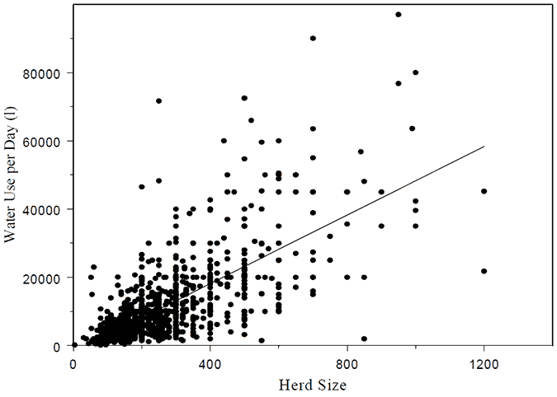
* Callinan, L. (2009). Water use in Victorian dairy sheds.
Available from the Department of Primary Industries www.dpi.vic.gov.au

Predicting ‘reasonable’ daily water use
Statistics can be used to describe and predict water use trends in a population. The analysis of the large Victorian data set reveals that we can expect that 75% of individual dairies would use a daily volume of water below the figures shown in Table 1 below. The 75th percentile threshold has been selected after discussions with industry and is the upper limit of reasonable water use.
Table 1. Predicted 75th percentile for dairy water use per day (L/day) by herd size and dairy type
Based on herd size (milking cows)
Dairy type | 50 | 100 | 200 | 300 | 400 | 500 | 600 | 700 | 800 | 900
Double-up | 5642 | 6456 | 8645 | 11131 | 14654 | 19348
Swingover | 4921 | 6113 | 9444 | 14618 | 22663 | 25195
Rotary |  | 18358 | 21057 | 24142 | 27694 | 31790 | 36509 | 41957 | 48243 | 55502

Low numbers of the larger herd sizes has reduced the reliability of this predictive threshold. There are only 3 double-up and 4 swingover dairies with a herd size greater than 400, and there were only 27 rotary dairies with herd size greater than 600 - so the percentiles for larger herd sizes may be unreliable.
No figures are presented for the walk-through dairy type due to insufficient data.

Reasonable water use
The original data was collected to work out effluent storage requirements and so was recorded in litres per day (L/day). However for licensing or other purposes, it is more convenient to describe water use in terms of mega litres (ML) per year.
Table 2 shows the figures from Table 1 converted into ML per year, after multiplying the figures by 365 days and dividing by 1,000,000 to convert litres to mega litres. The data from both herringbone dairy types have been combined to simplify the table further.
Table 2. Predicted 75th percentile for dairy water use per year (ML/yr) by herd size and dairy type
Dairy type | 50 | 100 | 200 | 300 | 400 | 500 | 600 | 700 | 800 | 900
Herringbone | 1.9 | 2.3 | 3.4 | 4.9 | 7.1 | 10.4
Rotary |  | 6.7 | 7.7 | 8.8 | 10.1 | 11.6 | 13.4 | 15.4 | 17.7 | 20.3

Low numbers of the larger herd sizes has reduced the reliability of this predictive threshold for rotary .
No figures are presented for the walk-through dairy type due to insufficient data.

Figure 2. Herringbone dairies: Calculated annual water use (ML/year) and predicted 75th percentile line for dairy water use by herd size
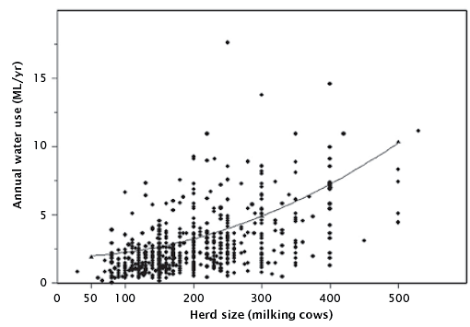
Figure 3. Rotary dairies: Calculated annual water use (ML/year) and predicted 75th percentile line for dairy water use by herd size

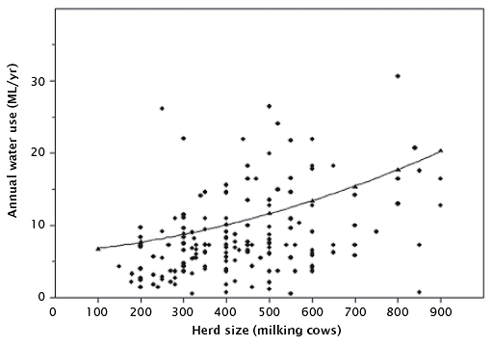

Section 2 – Calculating your water use in the dairy shed

Mapping where the water goes
The first step in calculating dairy shed water use is to sketch out how the water moves through your dairy – from the point of entry to the point of exit.
Mapping the flow of water from its source, through the various storage tanks, right through to where it leaves the dairy can help to ensure that you account for all water used. It is common to have different sources for different processes, or more than one source for each process depending on the time of the year.
Tracking the various pathways water takes also makes sure you don’t double count it – especially if re-using water from one process for another task in the dairy.
Whilst you are doing this exercise it is worth thinking about the source used for each task. Is the source and quality of water the most appropriate for that task?
Are other sources available that are not being utilised – like rainwater for instance?
Draw arrows joining each entry source with the exit point, picking up the storage points, water uses and recycling/re-use options on the way. Add notes/amend as necessary.
Here is an example of how the map may look. Use the single map provided on the next page and mark all pathways on it but beware – it could end up looking like spaghetti!

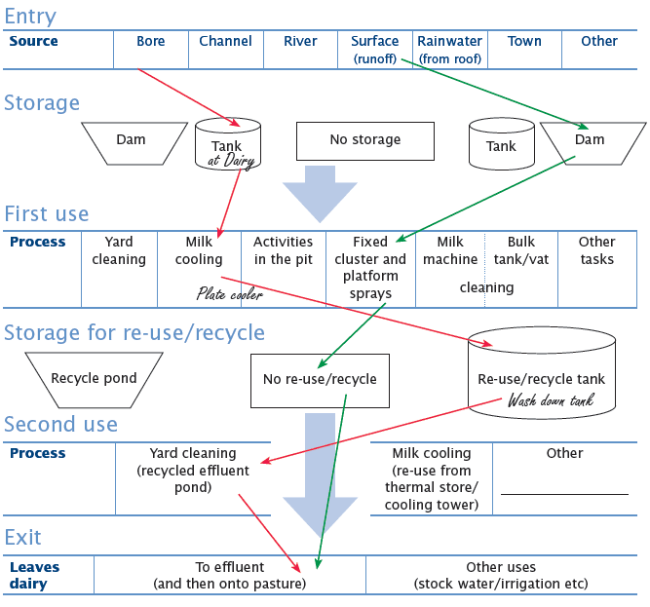
Your turn – draw arrows showing the various pathways water takes through your dairy.

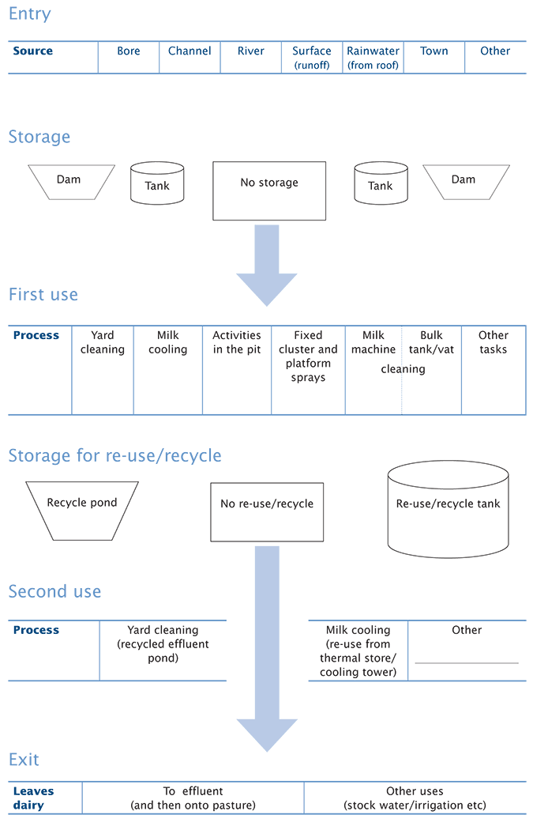

Calculating your current dairy water use
Now that you have mapped how water moves from the point of entry, through the various dairy processes to the point of exit, you can get started calculating the total annual volume of water you use.
You estimate your total dairy water use by calculating the annual water used for each of the dairy processes. Add these together to come up with a total figure.
The remaining pages in this Section guide you through how to calculate water use for each process of your dairy shed operation. Generally the water use estimates are undertaken for a day at mid lactation - as a day representative of average daily water use for the year. Once you have worked out the water used for each process, write your answer in the summary table on page 27.
Finally add up the totals for each dairy shed process in the summary table on page 27 to calculate your total annual dairy shed water use.
Dairy processes that use water:
- Yard cleaning
- Milk cooling
- Activities in the pit
- Fixed clusters and platform sprays
- Milking machine and bulk tank/vat cleaning
- Other task

Water for yard cleaning
Yard cleaning represents the largest single use of water in many dairies and includes all water used to wash down the holding yards.
Water facts and figures | Yard cleaning
Hoses | Flow rates can vary significantly so measure each one separately i.e. flow rate measured in litres per minute (L/min) for a 1.5 inch hose can range between  130 L/min -190 L/min.  High volume, medium pressure hoses deliver around 200 L/min.  Hosing yards can take anything between 10 minutes and 45 minutes per milking.
Hydrants | Can deliver up to 2,000 L/min.  Most outlets only operate for 1-2 minutes at each cleaning.
Flood wash | The volume of flood wash tanks is typically between 20,000 and 30,000 L. Elevated tanks are sometimes smaller.
Pipe risers | You will have to make an educated guess if the yards are cleaned by systems where the flow rates and/or storage volumes cannot be measured, such as in direct-feed pipe riser systems.

Remember:
- Include water from the plate cooler used for yard cleaning (it’s much easier to estimate the volume in this section).
- If recycled effluent water is used only estimate the percentage of ‘new’ top-up water used to supplement the recycled water.
- Exclude water used by yard hoses that service the pit, these are accounted for later.
- Exclude water used by sprinklers or other methods that keep the cows cool or the yard wet. These are picked up in later sections too.

Work out total water use for each yard cleaning hose

Flow rate method
You will need a watch to count the seconds and a large container of a known volume – an extra pair of hands might help too!
- First steps
Estimate | Calculate hose 1 | Calculate hose 2 | Calculate hose 3
Work out the volume of the measuring container/barrel in litres
Record how long it takes in seconds to fill the container/barrel
Estimate average time in minutes spent using hose each day at mid lactation
Estimate the number of days per year the yard is cleaned

- Calculate
Calculate | Record
Litres of container/barrel divided by the number of seconds it takes to fill
Litres per second multiplied by 60 seconds in a minute
Litres per minute multiplied by average minutes spent using this hose each day at mid lactation
Litres per day multiplied by number of days yard is cleaned per year
Add up water used by all hoses and then divide by 1,000,000
Total water volume used by yard cleaning hoses each year
Transfer this number to Final figures: Yard cleaning.

Work out total water use for flood wash and hydrant systems

Storage volume method
- First steps
Estimate | Calculate tank 1 | Calculate tank 2 | Calculate tank 3
Record the volume of the storage tank
Turn off replenishment valve, estimate proportion of the tank used each day
Estimate the number of days per year the yard is cleaned
- Calculate
Calculate | Record
Litres of tank multiplied by % of tank used daily,
divided by 100
Litres per day multiplied by number of days the yard is cleaned per year
Litres per day multiplied by number of days yard is cleaned per year
Add up water used by all storage tanks and then divide by 1,000,000
Total water volume used by flood wash and hydrant systems each year

Final figures: Yard cleaning
There is one last step to go. Add up the figures from the hose and the flood wash and hydrant systems calculations to find the total volume of water used in yard cleaning each year.
Water volume | Example 2.5ml/yr | ML/yr
Total water volume used by yard cleaning hoses each year
Total water volume used by flood wash and hydrant systems each year | 3.3 ML/yr
Total volume of water used by yard cleaning each year | 5.8 ML/yr

Transfer this number to the Summary table.

Need a reminder on how to calculate the volume of a tank?
To calculate the volume of a tank:
- Volume of tank = π x r² x h
- Where π (pi) = 3.14
- Where r = radius (half of the diameter in metres)
Then to convert volume (m³) into litres (L):
- multiply the answer by 1,000.
Example:
- Radius (r) = 1.7 Height (h) = 2.3
- Volume (m3) = 3.14 x (1.7)2 x 2.3 = 20.87 m3
- 20.87 x 1,000 = 20,870 L
Need a reminder on how to convert gallons to litres?

Gallons (Aust) | 1000 | 5000 | 10000
Litres | 4500 | 22500 | 45000

Water for milk cooling
After yard washing, milking cooling systems often use the next largest volume of water in the dairy. Any water used by the milk cooling system needs to be included in this section – by the plate cooler, cooling tower and associated systems.

Water facts n' figures: Milk cooling
Plate coolers:
- Older plate cooler systems generally use anywhere between 3 and 5 times the daily milk volume. However this can be very variable.
- Newer industrial plate coolers use roughly between 2 and 3 times the daily volume of milk.
Evaporative cooling towers:
- Cooling towers fitted with drift eliminators use very little water - less than 2% of the storage volume daily.
- Losses from other types can be substantial, particularly if located where the wind can blow the water droplets away.
'Closed' pre-cooling systems
- Systems like ice-banks or refrigerated thermal stores use very little water. Assume the water use by these systems is nil.
Remember:
- Allow for new ‘top-up’ water. Although the majority of water used in evaporative cooling towers is stored and re-used a number of times, new water is required to top these systems up from time to time. Only include estimates of the volume of water required to top up the system.
Exclude:
- Water used for milk cooling if it is then directed to storage for re-use in another dairy process such as yard cleaning – you account for it elsewhere in this booklet, so do not complete this section.
- However, if a large proportion of this water is lost (i.e. from an overflowing storage tank) you will still need to complete this section.

Work out total water use for the plate cooler
Remember not to count plate cooler water again here if it is re-used for yard cleaning or another process in the dairy.
Disconnect the water outlet pipe of the plate cooler so that the outflow can be measured. This may require you to attach a flexible rubber hose to the outlet so that the flow can be directed to the measuring bucket/barrel.
- First steps
Estimate | Calculate plate cooler 1 | Calculate plate cooler 2 | Calculate plate cooler 3
Work out the volume of the measuring bucket/barrel in litres
Record how long it takes in seconds to fill the bucket/barrel once plate cooler is turned on
Average time in minutes the plate cooler water is running per day at mid lactation
Average time in minutes the plate cooler water is running per day at mid lactation
Estimate the number of days per year the plate cooler is used
- Calculate
Calculate | Record
Litres of bucket/barrel divided by seconds it takes to fill
Litres per second multiplied by 60
Litres per day multiplied by number of days yard is cleaned per year
Litres per minute multiplied by average minutes the plate cooler is being used each day in mid lactation
Litres per day multiplied by number of days the plate cooler is used per year
Add water used by all plate coolers and then divide by 1,000,000
Total water volume used by plate coolers each year
Transfer this number to Final figures: Milk cooling.

Work out total water use for evaporative cooling tower systems
- First steps
Estimate | Calculate tank 1 | Calculate tank 2
Work out the volume of the storage tank
Turn off replenishment valve, work out proportion of the tank used each day
Estimate number of days per year the cooling tower is in use

- Calculate
Calculate | Record
Litres of tank multiplied by % of tank used daily, divided by 100
Litres per day multiplied by the number of days the cooling tower is used per year
Add together water used by all cooling towers and then divide by 1,000,000
Total water volume used by evaporative cooling tower systems each year
Transfer this number to Final figures: Milk cooling below

Final figures: Milk cooling
There is one last step to go. Add up the figures from the plate cooler and evaporative cooling tower systems calculations to find the total volume of water used in cooling milk on your farm each year.
Water volume | Example 2.5ml/yr | ML/yr
Total water volume used by plate coolers each year
Total water volume used by cooling tower systems each year | 3.3 ML/yr
Total volume of water used by milk cooling each year | 5.8 ML/yr
Transfer this number to the Summary table.

Water for activities in the pit
Activities in the pit that require water include washing the platform, the outside of the clusters and pipe work, as well as washing teats and test buckets etc. These activities are generally undertaken using manually held hoses. This section excludes fixed hoses, or systems that clean the platform and outside of clusters automatically (especially in rotary dairies) because these are accounted for in the next section.

Water facts n' figures: In the pit
Teat wash hoses:
- A typical half inch teat wash hose delivers around 25 L/min if turned on full.
- A typical ¾ inch hose will deliver about 40 L/min if turned on full.
- A typical one inch hose delivers about 60 L/min if turned on full.
Remember exclude:
- Hoses that are also used to clean the yard if they have already been accounted for in the 'yard cleaning' section.
- Fixed hoses or sprays that automatically clean clusters and/or the platform as these are accounted for in the next section.

Work out total water use for activities in the pit
- First steps
Estimate | Calculate pit hose 1 | Calculate pit hose 2 | Calculate other
Work out the volume of the storage tank
Turn off replenishment valve, work out proportion of the tank used each day
Estimate number of days per year the cooling tower is in use

Calculate
Calculate | Record
Litres of bucket/barrel divided by seconds it takes to fill
Litres per second multiplied by 60
Litres per minute multiplied by average minutes spent using this hose each day at mid lactation
Litres per day multiplied by number of milking days per year
Add water used by all pit hoses and other equipment and then divide by 1,000,000
Total water volume used by activities in the pit each year

Transfer this number to the Summary table.

Water for fixed cluster and platform sprays
Fixed cup and platform hoses or sprays are mainly associated with rotary sheds. Their purpose is to keep the platform and clusters clean and wet to ensure that manure doesn't stick, making cleaning at the end of milking easier.

Water facts n’ figures: Fixed clusters and platform sprays
Outlets in the dairy:
Water use by each outlet can vary enormously – generally set up to deliver between 30 and 90 L/min.
Remember:
- Exclude water used by manually held hoses. These are being accounted for in other sections.

Work out total water use for fixed cluster and platform sprays
Before you start, you may need to attach a flexible hose to the outlet to direct the flow into the measuring bucket or barrel.
- First steps
Estimate | Calculate outlet hose 1 | Calculate outlet hose 2 | Calculate outlet hose 3
Work out the volume of the storage tank
Turn off replenishment valve, work out proportion of the tank used each day
Estimate number of days per year the cooling tower is in use
- Calculate
Calculate | Record
Litres of bucket/barrel divided by seconds it takes to fill
Litres per second multiplied by 60
Litres per minute multiplied by average minutes spent using sparys each day at mid lactation
Litres per day multiplied by number of days sprays are used per year
Add water used by all fixed sprays and then divide by 1,000,000
Total water volume used by fixed cluster and platform sprays each year

Water for milking machine and bulk tank/vat cleaning
Significant volumes of water are used in the wash regimes to clean the inside of the pipe work, clusters and vat after milking and milk pick-up.

Water facts n' figures: Milking machines and bulk tank/vat cleaning
Milking machines:
- The volume of each rinse and detergent cycle within a wash regime can vary. A general rule of thumb is 5 - 10 litres of water per cluster per cycle per wash.
For example, a 32 unit swing-over uses about 8 L x 32 units x 3 cycles per wash x 2 washes per day = 1,536 L/day.
Bulk tank/vat:
- Water use should be around 3 - 5% of the volume of the vat for each cycle. Typically there are 4 - 5 cycles used per wash. However this can vary substantially, especially with the older systems that do not re-circulate the cleaning solutions.
- Bulk tanks and vats are usually cleaned after every pickup – once daily, twice daily or every other day.
- Domestic hot water services used to heat water for vat washing are generally 250 L, 315 L or 400 L in volume.
Remember:
- Include water from sources like rainwater, town water etc.
Exclude:
Do not include the cleaning of ancillary milking equipment (i.e. test buckets) or ancillary vats in this section – include these in the next section.

Work out total water use for cleaning milking machines
When you are working out the total number of times the wash barrel is filled per wash, don't forget to count all cycles after a milking (i.e. rinse, detergent wash, sanitising rinse).
When you are working out the total number of washes per year, don't forget to exclude the times when the dairy is not in use. The total number of washes will depend on the number of milkings (and so washes) undertaken at different times of the year (i.e. once, twice or three times daily).
- First steps
Estimate | Calculate wash barrel 1 | Calculate wash barrel 2
Work out the volume of the wash barrel that is used for cleaning in litres
Record total number of times the wash barrel is filled per wash proportion of the tank used each day
Number of washes per year
- Calculate
Calculate | Record
Litres of wash barrel multiplied by number of fills per day
Litres per day multiplied by number of washes per year
Add together water used by all wash barrels and then divide by 1,000,000
Total water volume used by milking machine cleaning each year | o
Transfer this number to Final figures: Milking machine and bulk tank/vat cleaning table.

Work out total water use for cleaning the bulk tank/vat
There are three ways you can estimate water use for the bulk tank/vat cleaning:
- Manufacturer's specifications method; or
- Method for re-circulating cleaning systems using size of the dedicated hot water service; or
- 'Fill and dump' method.

Method using manufacturer's specifications
You will need to get a copy of the manufacturer's specifications for your bulk tank/vat to be able to complete these calculations. Ring your local dealer or try the web if you can't find the paperwork.
When you are working out the total number of washes per year, consider times when there is no pick-up required, as well as times with twice daily, daily or every other day pick-up schedules.
- First steps
Estimate | Calculate bulk tank/vat main | Calculate bulk tank/vat 1 | Calculate bulk tank/vat 2
Check the specs for the volume of water used per cycle
Check the specs for the total number of cycles per wash
Number of washes per year
- Calculate
Calculate | Record
Litres per cycle multiplied by number of cycles per wash
Litres per wash multiplied by number of washes per year
Add together water used by all bulk tanks/vats and then divide by 1,000,000
Total water volume used by bulk tank/vat cleaning each year | o
*Transfer this number to Final figures: Milking machine and bulk tank/vat cleaning table.

Method using size of dedicated hot water service
Only use this method to estimate the water used in newer re-circulating bulk tank/vat cleaning systems where the manufacturer's specifications are not known.
To determine the volume of the hot water service that is used for cleaning the bulk tank/vat, check the 'rating plate' attached to the hot water service – it should state the volume of hot water. Vat technicians report that it is common for the wash programs to use about 1.5 times the volume of the hot water service for each wash.
When you are working out the total number of washes per year, consider times when there is no pick-up required, as well as times with twice daily, daily or every other day pick-up schedules.
- First steps
Estimate | Calculate bulk tank/vat 1 | Calculate bulk tank/vat 2
Check the rating plate for the volume of hot water used
Number of washes per year
- Calculate
Calculate | Record
Litres of hot water multiplied by 1.5
Litres per wash multiplied by number of washes per year
Add together water used by all bulk tanks/vats and then divide by 1,000,000
Total water volume used by bulk tank/vat cleaning each year
Transfer this number to Final figures: Milking machine and bulk tank/vat cleaning table.
This method makes assumptions about the hot water service being sized appropriately, according to the need stated by the manufacturer. Only use this method if the previous method cannot be used.

Method for 'fill and dump' systems
If your vat utilises a wash barrel you could estimate the total volume used by counting the number of times the barrel is filled and dumped for every wash. Make sure you account for all cycles in each wash (usually 4 or 5 cycles per wash).
When you are working out the total number of washes per year, consider times when there is no pick-up required, as well as times with twice daily, daily or every other day pick-up schedules.
- First steps
Estimate | Calculate wash barrel 1 | Calculate wash barrel 2
Work out the volume of the wash barrel that is used for bulk tank/vat cleaning in litres
Record total number of times the wash barrel is filled per wash – count all cycles in each wash
Number of washes per year
Litres of wash barrel multiplied by number of fills per wash
- Calculate
Calculate | Record
Litres of wash barrel multiplied by number of fills per wash
Litres per wash multiplied by number of washes per year
Add together water used by all wash barrels and then divide by 1,000,000
Total water volume used by bulk tank/vat cleaning each year
Transfer this number to Final figures: Milking machine and bulk tank/vat cleaning table.

Final figures: Milking machine and bulk tank/vat cleaning
There is one last step. Add up all the figures from the milking machine cleaning and bulk tank/vat cleaning calculations to find the total volume of water used in milking machine and bulk tank/vat cleaning each year.

Water volume | Example 2.5ml/yr | ML/yr
Total litres used each year for milking machine cleaning | 0.4 ML/yr | ML/yr
Total litres used each year for bulk tank/vat cleaning |  | ML/yr
Manufacturer's specification method  Hot water service volume method  Fill and Dump method  (Circle which method you used.) | ML/yr  0.2 | ML/yr
Total volume of water used by milking machine and bulk tank/vat cleaning each year | 0.6 ML/yr | ML/yr
Transfer this number to the Summary table.

Water for other tasks
Water is required for a range of other tasks - like yard sprinklers, fly mist sprays, washing ancillary milking equipment after milking, calf feeding equipment, ancillary vats, other equipment, cleaning related areas not already included (except for irrigation purposes), showers and toilets in dairy etc.

Water facts n’ figures: Other tasks
Mister heads:
- Mister heads use very small volumes
'Knocker' type sprinklers:
- Knocker type sprinklers deliver about 25 L/min at each sprinkler head.
- An allowance of 0.5-1 L per cow per hour is common for spray cooling dairy cows.
Garden hoses:
- Under town pressure (4.5 bar) garden hoses typically deliver about 60 L/min.
High pressure cleaners:
- These devices typically use 6-10 L/min
Remember:
Exclude water used for ‘stock and domestic’ and irrigation

Think about any other tasks that use water in and around the dairy. You can use one of three methods to help you work out the water use:
- Flow rate by time method
- Fill and dump method
- For sprinklers or misters, most have a maximum flow rate rating.
Almost any water use can be estimated by using one or other of these methods. Choose the most appropriate for your circumstances.

Work out total water use for other tasks

Flow rate by time method
- First steps
Estimate | Calculate task | Calculate task
Work out the volume of the measuring bucket/barrel in litres
Record how long it takes in seconds to fill the bucket/barrel
Estimate average time in minutes spent completing tasks/using hose each day
Estimate the number of days per year the task is carried out

- Calculate
Calculate | Record
Litres of bucket/barrel divided by seconds it takes to fill
Litres per seconds multiplied by 60
Litres per minute multiplied by average minutes spent completing task/using this hose each day
Litres per day multiplied by number of days per year the task is undertaken
Add together water used by all tasks to get the total water volume used for other tasks and then divide by 1,000,000
Total water volume used by other tasks each year
Transfer this number directly to Final figures: Other tasks

Fill and dump method
Be sure not to include water used in tasks already calculated using the 'flow rate by time' method.
- First steps
Estimate | Calculate task | Calculate task
Work out the container being used for the task.
Estimate total number of times the container is filled and then emptied per day
Number of days per year the task is carried out
- Calculate
Calculate | Record
Litres of container multiplied by number of fills per day
Litres per day multiplied by number of days per year the task is carried out
Add together water used by all these tasks and then divide by 1,000,000
Total water volume used by these tasks each year
Transfer this number to Final figures: Other tasks table.

Maximum flow rate rating method
If your sprinklers and misters have a maximum flow rate rating, use this to estimate their water use in L/min. This way eliminates the need for manual measurement. Just multiply the flow rate rating by the number of sprinkler outlets.
- First steps
Estimate | Calculate sprinkler system 1 | Calculate task sprinkler system 1
Number of sprinkler outlets in use
Look up flow rate of sprinkler outlets
Average time in a day the sprinkler system runs
Estimate number of days per year the system is used
- Calculate
Calculate | Record
Litres per minute multiplied by number of sprinkler outlets to give total litres per minute
Litres per minute multiplied by average time in minutes the sprinkler system runs per day
Litres per day multiplied by number of days per year the sprinkler system is used
Total water volume used by these tasks each year
Add together water used by all sprinkler systems and then divide by 1,000,000
Total water volume used by sprinkler systems each year
Transfer this number to Final figures: Other tasks table.

Final figures: Other tasks
There is one last step for this section. Add up all the figures from the different tasks to give your total volume used in all other tasks requiring water in the dairy per year.
Total litres used each year for other tasks | Example 2.5ml/yr | ML/yr
Flow rate by time method (specify task) | 0.4 ML/yr | ML/yr
Fill and dump method (specify task) |  | ML/yr
Maximum flow rate rating method (specify task) | ML/yr  0.2 | ML/yr
Total volume of water used by other tasks each year | 0.6 ML/yr | ML/yr
Transfer this number to the Summary table.

Section 3 – Water saving options
Now you should have a good idea about reasonable water use (from Section 1) and how much water you are using in the dairy shed (from Section 2).
- How does your current use compare with the reasonable water use for your dairy type?
- Which part of your operation uses the most water or has the best scope for water savings?
Reducing dairy water use can reduce farm costs for water, pumping and storage. Conserving supply is also an ever increasing priority on many farms, for our rural communities and for the environment.
Check back to the map you created on page 6. Is there an alternative source of water that is not being utilised? Are you using an appropriate water source for each of the dairy processes? What about capturing rainwater from the roof?
Some of the main options for reducing water use in your dairy are detailed below, together with some sources of further information.

Yard cleaning
Water efficient dairy sheds can use as little as 20% of the water used in less efficient dairy sheds. A key reason for this efficiency is that these farms re-use water from the second effluent pond for yard wash. This also reduces the loading of effluent ponds.
- Recycle water by diverting plate cooler water into storage tanks for reuse, for example in yard cleaning.
- Recycle water by installing a second effluent pond and using this water for yard cleaning. Large single ponds are also sometimes suitable.
- Handle the cows quietly and minimise the time they spend standing in the yard to reduce the amount of manure that needs to be cleaned up.
- Use high-volume, low-pressure systems to clean yards effectively.
- When designing new dairy yards or feed pads, utilise appropriate slopes and dimensions and site wash-down outlets to suit.
- Fix leaking pipes and hoses.
Re-evaluating the source of water used for dairy wash can pay big dividends.
Is there a cheaper source and/or a less wasteful option to clean your yards?

Further information
Contact your local milking machine technician or dairy refrigeration specialist.
- Saving water in dairies. Information sheets from Dairy Australia. Available at www.dairyaustralia.com.au
- Water at the dairy. Reduce, Re-use, Recycle – Dairy Industry Info sheet C1. Available at www.dairysa.com.au
- Cooling milk. Reduce, Re-use, Recycle – Dairy Industry Info sheet B4. Available at www.dairysa.com.au
- Dairy self-assessment tool (DairySAT) is an environmental self-assessment tool which includes information about improving the efficiency of water and energy use on Australian dairy farms. Available at www.dairyingfortomorrow.com
- CowTime has several Quicknotes and other resources about water use in milk cooling. Available at www.cowtime.com.au
- Information about the regulations to control Legionella in dairy cooling towers in Victoria is available at http://www.health.vic.gov.au

Milk cooling
Dairies can use large volumes of water for pre-cooling milk every day. More than 50% of farmers already save water by directing the used plate cooler water for yard wash or use a thermal store so the water can be used again and again.
Set up a system to store and re-use plate cooler water. Consider a modern cooling tower or thermal store to cool the water prior to re-use.
Consider collecting water from the roof to top up the tanks storing water for milk cooling.
Ensure the plate cooler is not over-using water. Check with your technician that it is correctly sized and set up. Industrial plate coolers use less water for cooling a given volume of milk and so are more efficient.
Link plate cooler water flow rate to milk pump flow rate with variable speed pumps or switches so that the water flow rate is proportional to milk flow rate.
Turn off the water supply to the plate cooler immediately after cows have left the platform.
Decommission old evaporative cooling towers, particularly if they lose excessive water through spray drift.

Further Information
Contact your local milking machine technician or dairy refrigeration specialist.
Saving water in dairies. Information sheets from Dairy Australia. Available at www.dairyaustralia.com.au
Water at the dairy. Reduce, Re-use, Recycle – Dairy Industry Infosheet C1. Available at www.dairyindustrysa.com.au
Cooling milk. Reduce, Re-use, Recycle – Dairy Industry Infosheet B4. Available at www.dairyindustrysa.com.au
Dairy self assessment tool (DairySAT) is an environmental self-assessment tool which includes information about improving the efficiency of water and energy use on Australian dairy farms. Available at www.dairyingfortomorrow.com
CowTime has several Quicknotes and other resources about water use in milk cooling. Available at www.cowtime.com.au
Information about the regulations to control Legionella in dairy cooling towers in Victoria is available at www.health.vic.gov.au/environment/legionella/industry

Activities in the pit
It is easy to spray lots of water around when milking – particularly if you are waiting for cows to finish milking out. In times of short supply this is one area where small savings can be made with little effort. However, do not compromise milk quality or udder health when looking for water savings.
- Re-use water by diverting warm plate cooler water into a storage tank for pit use.
- Repair and replace broken nozzles or leaking hoses.
- Equip hoses with trigger (spring-loaded) nozzles that have to be held open.
- Pre-wet pipe work, clusters, walls and concrete to prevent manure sticking to surfaces.
- Use mesh gloves to help remove manure from surfaces.
- Use good quality water and individual wipes to clean and dry teats prior to milking.

Further information
CowTime Guidelines for milk harvesting: Chapter 6 Cleaning Up.Available at www.cowtime.com.au
Saving water in dairies. Information sheets from Dairy Australia.Available at www.dairyaustralia.com.au

Fixed cluster and platform sprays
Fixed hoses can use huge quantities of water which is difficult to capture for re-use in the dairy.
- Size pump, hose and nozzles to deliver desired water volume at low to medium pressure.
- Turn off cup and platform sprays immediately after cows have left the platform and reduce unnecessary wastage.

Further information
Saving water in dairies. Information sheets from Dairy Australia. Available at www.dairyaustralia.com.au

Milking machine and bulk tank/vat cleaning
Reducing the quantity of water used for cleaning the milking machine and the bulk tank/vat may put milk quality at risk. Generally only small amounts of water can be saved and changes to the cleaning regimes should only be attempted in association with your dairy hygiene adviser and dairy company field officer.
- Your milking machine technician or vat supplier may be able to adjust the cleaning program to get the same results with less water. Savings are only likely to be minor but they may be significant in times of severe shortage.
- New automated chemical wash re-use systems are under development and should result in moderate savings in the future.

Further information
Contact your local milking machine technician, vat supplier or dairy hygiene adviser.
Water at the dairy. Reduce, Re-use, Recycle – Dairy Industry Info sheet C1. Available at www.dairysa.com.au
Saving water in dairies. Information sheets from Dairy Australia. Available at www.dairyaustralia.com.au

Other tasks
Substantial quantities of water can be used for other tasks, particularly if the systems are left running for prolonged periods such as holding yard sprinkler systems.
- Consider providing shade, improving air flow and changes to cow management to reduce the need to use water to cool cows.
- Run yard sprinklers at '2 minutes on - 10 minutes off' to conserve water when cooling cows.
- Ensure the water used is effective in doing its job.
- Use detergents to improve cleaning efficiency.
- Fix leaks and install water efficient appliances.
- Use high pressure cleaners to clean off vehicles, machinery etc.

Further information
Contact your local DEPI office and ask for the Dairy Extension Team or visit the latest Information Notes on effluent management.
Saving water in dairies. Information sheets from Dairy Australia. Available at www.dairyaustralia.com.au
Cool cows – dealing with heat stress in Australian dairy herds. Booklet from Dairy Australia. Available at http://www.coolcows.com.au

Summary of total annual dairy water use
Farmer's name: _______________ Date of estimate: _______________
Dairy name/address: ______________________________ No. of milking cows: _______________
Dairy type: Double-up Swingover Rotary Other (specify) _______________
Write the totals from each of the dairy processes into the summary table.
Process water is used in: | Water source(s) | Annual volume
Yard cleaning |  | ML/yr
Milk cooling |  | ML/yr
Activities in the pit |  | ML/yr
Fixed cluster and platform sprays |  | ML/yr
Milking machine and bulk tank/vat cleaning |  | ML/yr
Other tasks (please specify) |  | ML/yr
Total volume in mega litres (ML) |  | ML/yr
Based on my calculations from all parts of our dairy shed operation, the estimated total annual water volume currently used for our dairy is:
___________________________ ML
Keep this booklet for your records

Further information
Customer Service Centre 1300 502 656.

