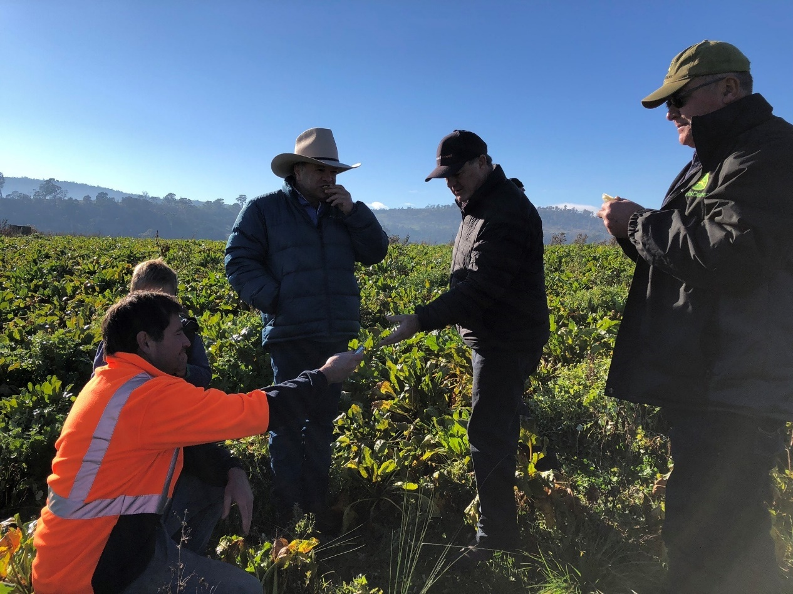
Picture: Upper Murray BetterBeef Group members, Glenn Galbraith, Mal McKimmie and coordinator Chris Mirams looking and tasting a fodder beet crop, Tasmania 2019.
Coordinator – Chris Mirams
Group – Upper Murray
- Corryong and Khancoban
Enterprise mix
- Beef cattle
Reflections from 2019 Tasmania study tour. This time last year we profiled the Upper Murray BetterBeef Group, based in North East Victoria and their study tour to Tasmania. This group has a focus on furthering production efficiency and profitability through participating in BredWell Fed Well courses and Meat Standards Australia training, as well as increasing their knowledge in grazing management, soil fertility and species selection.
The group were keen to investigate how to increase the price paid for their product, so since their 2019 trip to Tasmania they have embarked on a fact-finding mission, investigating the processes and requirements of branded contracts around Smithton in Tasmania. The trip was designed to increase their awareness of what is required to become an ‘ideal’ customer supplying a branded contract as well as find out what the end consumer is looking for in a premium product.
When they returned the group digested the key learnings and ideas that they had been exposed to, discussing the ideas amongst themselves at BetterBeef events throughout the year. Although they have currently put on-hold their thoughts of developing their own branded product it was “information well learnt” group member, Belinda McKimmie said. The information gathered on the trip has played a part in some changes to their businesses in 2020, with some members moving to supply premium branded contracts and others developing relationships with feedlot buyers to purchase cattle at specified weights for finishing.
Fast forward twelve months, it would be fair to say that 2020 has been a rollercoaster, but to those in fire affected areas it has been even more so! What a journey this group has been on, facing the uncertainty, heart break and perils of a fierce fire season, which put everything in jeopardy. Members of the group used funding from Meat & Livestock Australia’s Back to Business program to access three free one on one sessions with local farm business consultants, which helped keep their business on track.
Belinda McKimmie and Glenn Galbraith both lost pastures and fencing but through hard work, good management, and some luck, did not sustain any stock or infrastructure losses. This set them on the back foot in early 2020, however, the resilience shown by these producers, their communities and the greater farming network was evident when they were interviewed for this article.
Both farms will be introducing a heifer artificial insemination (AI) program for their enterprise this year. Belinda said, “we weren’t going to, but the autumn has been a good one, and the spring is shaping up nicely, so we went for it.”
“We always had breeding objectives, but they have been refined and nailed down.” Belinda purchased some stud cattle this year and has focused her attention on the female genetics, “ultimately looking for a better product” she said.
Belinda explained, “I have taken little snippets from the tour to take back to our business.” This is another theme that Glenn identifies with. Since the trip he has purchased a couple of new bulls from a stud visited in Tasmania.
Glenn is also implementing a heifer AI program in 2020, “I’m farming on my own, its where I spend my time, and the group is my encouragement to get out and about.” The group is good for challenging my management practices”, Glenn said. “For example, when I took over the farm ten years ago, I was calving in autumn. This meant young calves went through some miserable winters and I was using a lot of hay. So there was a lot of pressure in spring to conserve fodder, but grazing came second,” he said. He credits the group with providing him with the information and confidence to move his autumn calving herd to a spring calving herd, a change he made four years ago.
“Season wise, things are going quite well, I’ll have to renovate some ryegrass pastures that didn’t come back, but the phalaris is looking good, even what was burnt,” Glenn said.
When on tour in Tasmania, the group looked closely at a fodder beet trial. The group will be running their own fodder beef trial to see how this valuable fodder can be used to fill feed gaps in their part of Victoria.
The group are looking forward to meeting again in the future to discuss the experiences that 2020 has thrown on them since they last met.

