MRSP dermatology fact sheet
Methicillin-resistant Staphylococcus pseudintermedius (MRSP)
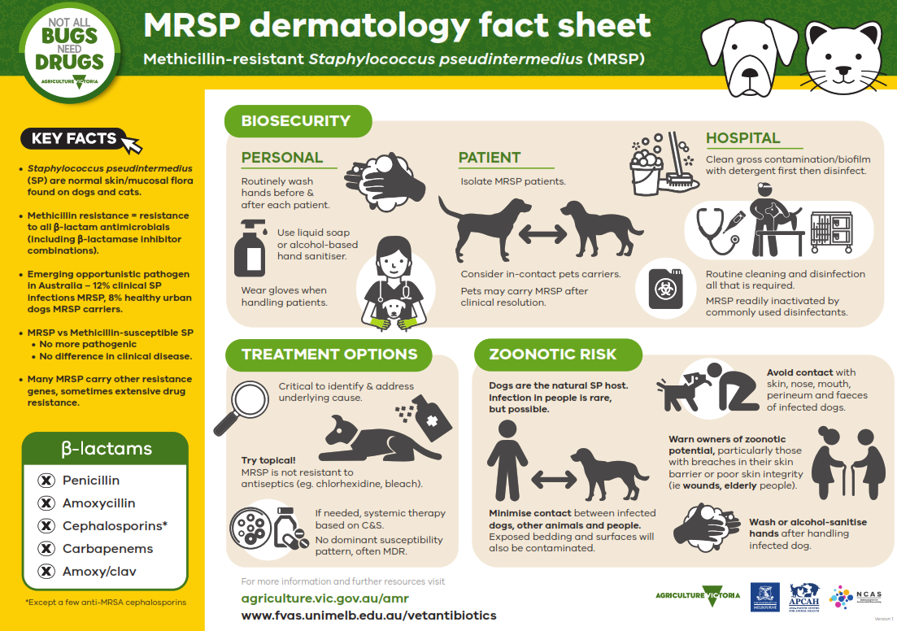
The A4 infographic contains educational messaging directed at vets regarding the treatment of MRSP infections in dogs and cats and is designed to be displayed in companion animal or mixed animal clinics.
KEY FACTS
• Staphylococcus pseudintermedius (SP) are normal skin/mucosal ﬂora found on dogs and Cats.
• Methicillin resistance = resistance to all β-lactam antimicrobials (including β-lactamase inhibitor combinations).
• Emerging opportunistic pathogen in Australia – 12% clinical SP infections MRSP, 8% healthy urban dogs MRSP carriers.
• MRSP vs Methicillin-susceptible SP
• No more pathogenic
• No difference in clinical disease.
• Many MRSP carry other resistance genes, sometimes extensive drug resistance.
Beta-lactams:
• Penicillin
• Amoxycillin
• Cephalosporins (Except a few anti-MRSA cephalosporins)
• Carbapenems
• Amoxy/clav
Biosecurity:
• PERSONAL
• Routinely wash hands before & after each patient.
• Use liquid soap or alcohol-based hand sanitiser.
• Wear gloves when handling patients.
PATIENT
• Isolate MRSP patients
• Consider in-contact pets carriers
• Pets may carry MRSP after clinical resolution
HOSPITAL
• Clean gross contamination/bioﬁlm with detergent ﬁrst then disinfect
• Routine cleaning and disinfection all that is required
• MRSP readily inactivated by commonly used disinfectants
Treatment options
• Critical to identify & address underlying cause
• Try topical! MRSP is not resistant to antiseptics (eg. chlorhexidine, bleach)
• If needed, systemic therapy based on C&S.
• No dominant susceptibility pattern, often MDR.
Zoonotic risk
• Dogs are the natural SP host. Infection in people is rare, but possible.
• Minimise contact between infected dogs, other animals and people. Exposed bedding and surfaces will also be contaminated.
• Avoid contact with skin, nose, mouth, perineum and faeces of infected dogs.
• Warn owners of zoonotic potential, particularly those with breaches in their skin barrier or poor skin integrity (ie wounds, elderly people).
• Wash or alcohol-sanitise hands after handling infected dog.

For more information visit the Antimicrobial resistant infections webpage of the Agriculture Victoria website at agriculture.vic.gov.au/amr or the Veterinary Prescribing Guidelines page of the the University of Melbourne website at www.fvas.unimelb.edu.au/vetantibiotics
Developed and designed by Agriculture Victoria, the University of Melbourne, the Asia-Pacific Centre for Animal Health and the National Centre for Antimicrobial Stewardship.

