Medicinal Cannabis:
Industry development modelling
Summary Report
Deloitte Access Economics
Agriculture Victoria, Department of Jobs, Precincts and Regions

Contents
Key findings 2
- Background 5
- Current demand 6
- Current supply 9
- Future industry development scenarios 10
- Economic contribution 16
- Implications of this study 18

Key findings
Medicinal cannabis industry development modelling
The Victorian medicinal cannabis industry emerged late in 2016, following the passing of the Access to Medicinal Cannabis Act 2016.
Recognising the potential for opportunity across both pharmaceuticals and agriculture, the Victorian Government has undertaken a range of initiatives to establish a thriving Victorian medicinal cannabis industry. These include commissioning a study in 2017 to investigate the industry’s growth prospects. Two years later the Victorian Government (Department of Jobs, Precincts and Regions (DJPR)) engaged Deloitte Access Economics to update the modelling and forecasts for the Victorian industry, through to 2028, so that the Department has the most up-to-date information on the industry and its future trajectory.

How has the industry changed between 2017-2019?
The medicinal cannabis industry in Australia has experienced rapid growth over the past two years, including significant increases in:
- Victorian production capacity and supply
- Patient cohorts
- Export opportunities
241,886 patients across 13 indications are expected to demand medicinal cannabis in 2028, compared to 166,000 in the 2017 modelling.
Patients suffering from chronic pain, sleep disorders, migraine, cancer and anxiety will make up the most significant portion of domestic demand in 2028.
Patient demand has been estimated using current prevalence rates, future population projections and uptake assumptions around future use and conditions.
The Victorian medicinal cannabis industry is expected to service between 30-50% of Australian demand for medicinal cannabis products.
- 241,866 patients
- 181,900 litres of Australian wide
- 60,600 kilograms of dried product

The Victorian Government’s early support for the industry has seen the State emerge as a medicinal cannabis hub. Planned volume of production and the current capacity of medicinal cannabis cultivation and manufacturing facilities has increased significantly. This study has estimated the potential size of the medicinal cannabis industry in Victoria by 2028, considering both demand and supply estimates.
Three supply development scenarios are considered in this study, reflecting a broad potential range for Victorian supply of medicinal cannabis products by 2028.
- The upper limit represents the sum of the production capacity estimated by industry. In other words, it is based on industry’s views.
- The medium scenario sits between the upper limit and lower bound estimates and is viewed as most likely based on the literature and stakeholder consultations.
- The lower bound scenario is defined by the approximate share of current Australian medicinal cannabis licences issued for Victorian premises (in September 2019).

Modelling Results
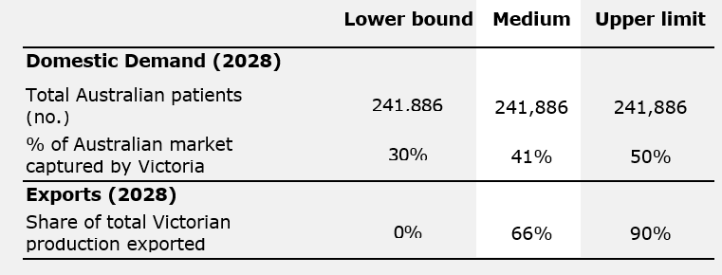

Medium scenario - Modelling results of future supply
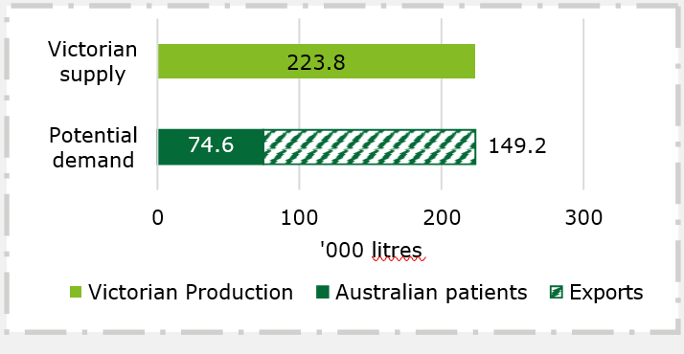

Medium scenario – Potential economic contribution
The medicinal cannabis industry could contribute an estimated $365 million to Victoria’s Gross State Product by 2028 under the medium scenario. This equates to approximately 0.08% of GSP, or, for $1.00 of value added generated by the Victorian medicinal cannabis industry, a further $0.57c of value added is generated in industries that supply inputs to the sector.
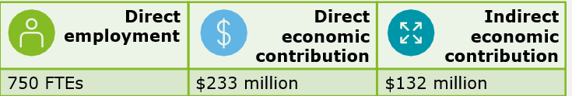

The findings of this study reveal that the medicinal cannabis industry is still in its infancy. The science, the regulatory environment, patient preferences and prescriber preferences are still changing.
The Victorian Government could seek to lead two activities to continue to support the Victorian industry:
- Continue to research medicinal cannabis plant strains and share this information with the Victorian industry.
- Strengthen the provision of advice to industry by capitalising on DJPR’s knowledge and experience in the development of the industry and the regulatory environment.

There are three key (interrelated) areas of action recommended for industry to reach the medium scenario, or potentially the more optimistic scenario. Each focus area has 2-3 recommended actions for industry to lead:
- Secure Victoria’s competitive advantage:
  - Maintain existing quality standards
  - Focus on industry efficiency
  - Support evidence collection through clinic trials

- Realise full export potential:
  - Promote export opportunities through the medicinal cannabis industry associations
  - Undertake more research and modelling of domestic and global markets

- Realise full domestic market potential:
  - Simplify the process for the medical industry to become aware of the efficacy and price of local products
  - Ensure local products are price competitive
  - Ensure local products can be supplied to pharmacies

Background

Industry background and context
The Victorian medicinal cannabis industry has emerged over the last few years, following the passing of state government legislation in 20161, and has experienced rapid growth since.
Having recognised the economic potential of the medicinal cannabis industry to both the pharmaceutical and agricultural sectors, the Victorian Government has developed a range of initiatives to establish a competitive local industry. This includes investigating the growth prospects and potential of the industry in 2017 to guide the development of the Victorian Government’s inaugural Medicinal Cannabis Industry Development Plan.2 This plan outlined the State’s strategy to grow the emerging sector to an established industry.
At the time of writing the Medicinal Cannabis Industry Development Plan, the Australian industry was in its infancy. While Australia had amended its Narcotic Drugs Act 1967 to allow the cultivation and production of cannabis for medicinal and scientific purposes, Victoria was the only state to have taken steps to establish local production to secure access for patients.
However, since the release of the Industry Development Plan, there have been significant changes to the market and the regulatory environment – both in Australia and abroad. This includes the passing of federal legislation in January 2018 to legalise exports, and the unification of state legislation controlling patient access to medicinal cannabis. Alongside these legislative changes, the number of Australian medicinal cannabis firms and patients demanding medicinal cannabis has increased rapidly.
Given these changes, the Victorian Government (the Department of Jobs, Precincts and Regions (DJPR)) engaged Deloitte Access Economics in 2019 to update the forecasts for the Victorian industry through to 2028, so that the Department has the most up-to-date information on the industry and its future trajectory.
This summary report presents the key findings and modelling from this project for DJPR, with findings current as of September 2019.

Approach
The findings in this summary report are based on the work undertaken by Deloitte Access Economics, which comprised:
- Primary data collection of demand and supply data from a literature scan, and through consultations with industry stakeholders, including producers and clinicians.
- Forecasting total Australian patient demand for medicinal cannabis through to 2028.
- Modelling the industry supply response from Victorian producers under three industry development scenarios – a lower bound, a medium scenario, and an upper limit scenario.
- Estimating the potential economic contribution of the local Victorian industry under each of these three scenarios through to 2028.
- Making recommendations to DJPR and industry for the future development of the industry.
The remainder of this summary report provides an overview of the current state of demand and supply, then outlines the methodology to estimate the potential size of the Victorian industry, including an estimate of the industry’s economic value across the three scenarios. The report concludes with the implications and recommendations of the study for DJPR and the industry.

¹ Access to Medicinal Cannabis Act 2016
² The full Industry Development Plan can be found here: <http://agriculture.vic.gov.au/agriculture/grains-and- other-crops/cannabis-in-victoria/medicinal-cannabis>

Current demand
Demand for Victorian medicinal cannabis products comes from both domestic and international patients. This chapter describes the current size of both patient cohorts.

Domestic demand
Patient demand for medicinal cannabis is influenced by factors such as barriers to access, price and product information. Domestic demand has increased significantly over the last two years due to improvements in the process for patient access, and is expected to continue increasing as product availability improves and prices reduce through competition.

Patient access
Access to medicinal cannabis is relatively more difficult than other medicinal products in Australia, as it is currently an unregistered drug and is not listed on the Australian Register of Therapeutic Goods (ARTG). Supply of medicinal cannabis products to the Australian market is provided by both local producers and through imported products, with patient access regulated by national legislation.
There are three methods for Australian patients to access unregistered medicines such as medicinal cannabis: the Authorised Prescriber Scheme (APS), the Special Access Scheme B (SAS- B), and clinical trials.
The SAS-B scheme is currently the largest route for Australian patients to legally access medicinal cannabis. The SAS-B process requires doctors to apply to the Therapeutic Goods Administration (TGA) for approval for a patient to access an unapproved medicinal cannabis product. Applications are assessed on a case-by-case basis and crucially, access is only granted as a medication of last resort.
In 2018 this scheme was streamlined by the TGA through the introduction of an online portal, making the application process simpler for the prescribing doctor, and in turn reducing the wait time for patients Australia-wide.
Since the streamlined process for the SAS-B scheme was introduced in 2018, the number of individual approvals through this pathway has increased from a handful per month Australia-wide in early 2018 to over 3000 per month in October 2019 (see Chart 2.1, overleaf.
Chart 2.1: Monthly number of SAS-B approvals, Australia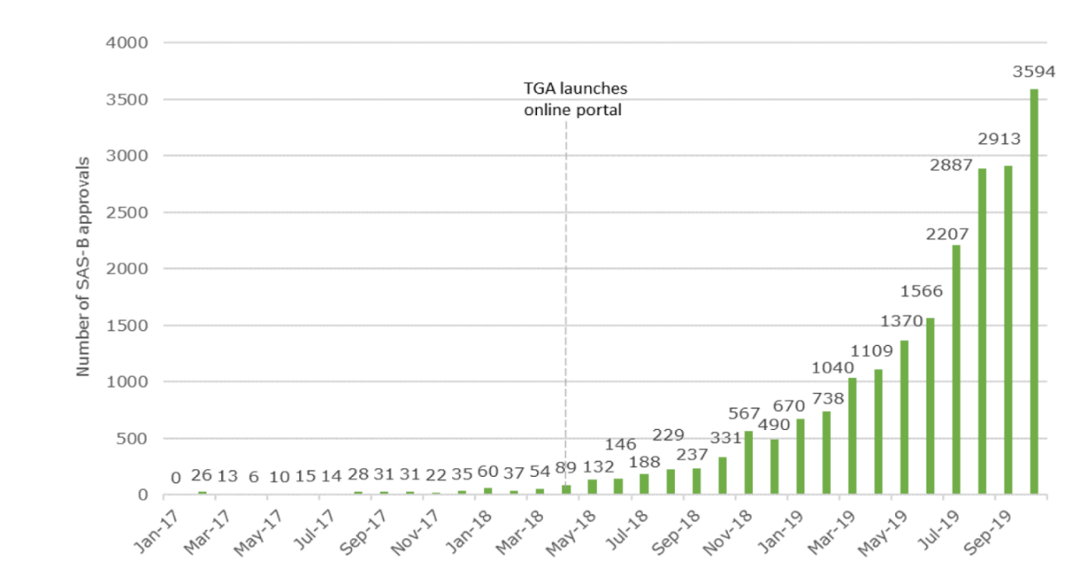
Source: Lambert Initiative for Cannabinoid Therapeutics.
Month | Number of SAS-B approvals | Month | Number of SAS-B approvals
January 2017 | 0 | June 2018 | 146
February 2017 | 26 | July 2018 | 188
March 2017 | 13 | August 2018 | 229
April 2017 | 6 | September 2018 | 237
May 2017 | 10 | October 2018 | 331
June 2017 | 15 | November 2018 | 567
July 2017 | 14 | December 2018 | 490
August 2017 | 28 | January 2019 | 670
September 2017 | 31 | February 2019 | 738
October 2017 | 31 | March 2019 | 1040
November 2017 | 22 | April 2019 | 1109
December 2017 | 35 | May 2019 | 1370
January 2018 | 60 | June 2019 | 1566
February 2018 | 37 | July 2019 | 2207
March 2018 | 54 | August 2019 | 2887
April 2018 | 89 | September 2019 | 2913
May 2018 | 132 | October 2019 | 3594

Comparatively, the other two pathways have relatively fewer recorded prescriptions across Australia, due largely to difficulty in patients accessing these pathways.
The APS allows doctors to freely prescribe a specific medicine to a class of patients directly under their care.3 At present, approximately 60 Australian doctors have been granted Authorised Prescriber status for medicinal cannabis, but this status is often not known by patients.4
Clinical trials, if approved under the clinical trials exemptions, can mean participants in the trial are allowed access to medicinal cannabis. However, clinical trials typically have low patient numbers and target a specific condition, limiting the number of patients accessing medicinal cannabis in this way.
Industry stakeholders consulted as part of this research also highlighted that a lack of knowledge and understanding of medical cannabis, particularly in relation to different indications5, can limit demand.6

Price of medicinal cannabis
Price continues to be a main barrier to patients demanding medicinal cannabis. Estimates provided by industry stakeholders during consultation suggest the price to fill a single prescription of medicinal cannabis can amount to several hundred dollars.

³ The APS allows doctors to prescribe the specific medicinal cannabis product they have been approved to prescribe, for example if they were approved to prescribe Tilray CBD Max, they would not be authorised to prescribe Tilray 10:10.
⁴ Lambert Initiative for Cannabinoid Therapeutics.
⁵ In medical terminology, an "indication" for a drug refers to the use of that drug for treating a particular disease.
⁶ There is no list of indications that are permitted to access medicinal cannabis as a form of treatment, as patient access under the most common scheme, SAS-B, is determined on a case by case basis.

A key challenge for patients and clinicians is the lack of price transparency for medicinal cannabis products and lack of transparency around the types of products available. This is because suppliers and manufacturers are prohibited from advertising directly to patients, which includes disclosing the costs and range of their products on their website or via other channels.
Moreover, there is high variability in price depending on the dosage required, meaning patients with different indications face different costs and so cannot easily estimate the likely cost of their treatment. The annual cost of accessing medicinal cannabis legally is estimated to range from
$20,000 (a leading paediatric neurologist), to between $30,000 and $40,000 (The Office of Drug Control (ODC)).
Currently patients must cover the entire cost of their prescription as there is no standardised subsidy available for medicinal cannabis.7 Consultations with industry have also indicated it is unlikely that medicinal cannabis will be listed on the Pharmaceutical Benefits Scheme (PBS) in the near future, meaning the price is likely to remain relatively unaffordable for many patients compared to alternative treatments for an indication that are listed on the PBS.8

Export demand
The export of medicinal cannabis products was federally legalised in February 2018 through the Narcotic Drugs Amendment (Cannabis) Regulations 2018. Industry regarded this as a critical change to ensure sustainability of the industry by allowing the development of economies of scale in production, however current exports remain small.
The potential size of future export opportunities also remains uncertain. Current high-demand- high-consumption countries already have relatively well-established local medicinal cannabis production. Given this, in the short-term, Victorian producers appear unlikely to establish a significant presence in the North American and Israeli markets.
Elsewhere in the world, the market for medicinal cannabis is developing. The largest opportunity for Australian exporters of medicinal cannabis is Europe – an opportunity that did not exist when Victoria first investigated the opportunity in 2017. Export to Germany, Italy, Luxembourg, France and the United Kingdom are all viewed as highly likely. The ODC estimates that 3,500 kilograms, or approximately half of Australia’s current production of dried plant material, will be exported to Germany by the end of 2019.
In terms of potential market demand for medicinal cannabis, these five European countries have a combined population over ten times Australia’s, indicating that the opportunity offered by the European market may be significant for Victorian producers. However, it is also important to note that there will be significant competition in these markets from other exporting countries such as Canada and Israel, which are already supplying product to some European countries. Therefore, the potential size of this export opportunity remains uncertain.
Closer to home, in 2017 there were no countries in the Asia-Pacific region with legalised medicinal cannabis. But since then five countries have legalised, or taken steps towards legalising, medicinal cannabis (New Zealand, Thailand, South Korea, the Philippines and Malaysia). This reflects a shift in global attitudes, meaning many of the industry stakeholders consulted by Deloitte Access Economics now expect other countries in the Asia-Pacific region will move to legalise medicinal cannabis, though this region is still viewed as being a number of years away from offering the export opportunity currently presented by Europe.

⁷ There is a highly targeted subsidy in the form of Victoria’s Compassionate Access Scheme for children with
intractable epilepsy.
⁸ Limited patient access schemes for children with epilepsy are available in some states.

Current supply
Medicinal cannabis cultivated or manufactured in Australia requires a licence and permit. This chapter provides an overview of the current number of licences and permits Australia-wide, and volume of Victorian production.

Licence and permit approvals
Interest nationally in the medicinal cannabis industry from all parts of the supply chain (including cultivators, producers, manufacturers and exporters) has grown rapidly since the industry was legalised in 2016. The ODC has granted licences to 45 firms and organisations across Australia, up from just one in 2017. Of these licenced producers, 13 have been granted a permit to cultivate, manufacture and research medicinal cannabis products, which is the regulatory precursor for a producer to develop product for the market.
Victoria has seen a similar surge in interest in licences and permits since 2016. Consultation undertaken with the ODC in September 2019 revealed that Victorian firms or organisations account for almost half of the permits held nationally.
The increase in licence applications and approvals has been influenced by a number of regulatory changes to the industry in recent years. The removal of restrictions on the export of medicinal cannabis products from Australia in January 2018 had an immediate impact on the structure and number of producers in Australia. Not only did existing licence holders increase the scale of their planned operations to service both the domestic and international market, but there was almost a doubling (86 per cent increase) in the number of licence applications in the year following the legislative change.
More recently, the Commonwealth Government’s streamlining of the licence process has seen some medicinal cannabis projects eligible to apply for Major Project Status from September 2019. The scheme, managed by the Department of Industry, Innovation and Science, gives priority access to medicinal cannabis licences that meet AU$50 million in investment and contribute substantially to exports, jobs and industry development (particularly in regional areas).
On top of this, the regulatory system continues to be streamlined. The Commonwealth Government recently announced it will work towards a single licence model, following a review of the Narcotic Drugs Act 1967. The final report from the review contains 26 recommendations to improve the regulatory framework and was tabled to Parliament in September 2019. All 26 recommendations have been accepted by Government and have led to a two-stage reform process, though the details and timeline for this have not yet been announced (as of March 2020).

Production capacity
Despite the flurry of licence and permit applications, across Australia current production of
medicinal cannabis products is still low relative to planned capacity. Australia’s current permit holders have an estimated production capacity of 7,000 kilograms of dried plant matter per year as at mid-2019, with plans to at least double this over the remainder of 2019 as more facilities are completed or modules are brought online.
Australian supply is not yet sufficient to meet domestic demand. The majority of medicinal cannabis products currently prescribed in Australia are imported. Imports are viewed by many stakeholders consulted with as a short-term solution to develop a domestic patient base, until Australia’s production capacity can wholly supply the domestic market.

Future industry development scenarios
This chapter provides an overview of the estimated patient demand in Australia by 2028 and the possible volume of domestic production, and revenue, in response to this demand and supply to export markets.

Future patient demand in Australia
This section estimates future Australian patient demand for medicinal cannabis, reflecting new information on likely use of medicinal cannabis as a suitable treatment.

Methodology to estimate demand
Australian patient demand has been calculated using a bottom-up approach, meaning it considers a range of possible indications for which medicinal cannabis would be a suitable treatment, and the likely demand from each patient group for these indications. Over the past 18 months the TGA has approved numerous SAS-B applications for medicinal cannabis for 13 indications. Table 4.1 details the prevalence of each indication (presented as a percentage of the Australian population), the share of the cohort likely to access medicinal cannabis, and the resulting estimated patient numbers.

Table 4.1: Modelling assumptions for medicinal cannabis patient cohorts, Australia-wide
Indication | Prevalence of indication in Australia | Share of cohort likely to access medicinal cannabisb | Patient numbers
Chronic pain | 16.00% | 5% | 109,229
Sleep disorders | 22.40% | 3% | 42,058
Migraine | 20.55% | 3% | 38,585
Cancer | 4.60% | 5% | 31,403
Anxiety (incl. PTSD)a | 6.57% | 3% | 12,336
Alzheimer’s Disease | 1.10% | 3% | 2,065
Epilepsy | 0.28% | 4% | 1,529
Multiple sclerosis | 0.07% | 15% | 1,434
Tourette’s Syndrome | 0.5% | 3% | 939
HIV/AIDS | 0.07% | 10% | 956
Gastrointestinal disorders | 0.40% | 3% | 751
Parkinson’s Disease | 0.21% | 3% | 394
Eating disorders | 0.11% | 3% | 207

Notes: (a) Post Traumatic Stress Disorder (PTSD) (b) Due to limited available evidence, the cohort adoption rate is based on assumptions adopted in the 2017 forecasts for the industry development plan, and for those indications not included, a conservative estimate of 3 per cent was adopted.
Source: Deloitte Access Economics analysis.

Notably, this list is not exhaustive and there are other indications that have received TGA approval, however they have not been included due to one or both of the following:
  - The indications are uncommon, meaning that their inclusion would have limited impact on the modelling results.
  - There has been a low number of SAS-B approvals for the indication, suggesting that the indication is either rare, lacks evidence that medicinal cannabis is a suitable treatment, and/or there is a lack of willingness for medical professionals to prescribe medicinal cannabis for this indication.
To calculate the prevalence of each indication, prevalence estimates were obtained from the Global Health Data Exchange, which contains estimates of prevalence for multiple indications across numerous jurisdictions.9,10
Adoption rates were then applied to each of these indications. This factored in the likelihood that patients who receive a SAS-B approval and subsequent prescription for medicinal cannabis may not fill their prescription (assumed to be 20 per cent of patients who receive a prescription).
An adoption model was then used to estimate the uptake of medicinal cannabis over time.11 The adoption model reflects a number of factors that could influence the length of time for full adoption of medicinal cannabis by applicable patients. These factors include a patient’s willingness to adopt medicinal cannabis, prescriber willingness to prescribe medicinal cannabis and an evolving understanding of the effectiveness of medicinal cannabis as a treatment for each indication.

Estimated demand in 2028
Our analysis indicates that patient demand in Australia is likely to comprise approximately 242,000 patients in 2028, across 13 different indications. Patients suffering from chronic pain, sleep disorders, migraine, cancer and anxiety will make up the most significant portion of the nearly 242,000 domestic patients. It is assumed that Victorian medicinal cannabis products will service some, but not all, of this estimated demand. The remaining share is expected to be met by products from other Australian States or through international imports. Chart 4.1 below displays the expected growth in Australian patient numbers through to 2028 for medicinal cannabis.

⁹ Global Health Data Exchange <http://ghdx.healthdata.org/>.
¹⁰ Estimates for chronic sleep conditions, Tourette Syndrome, Inflammatory Bowel Disease and chronic pain were obtained from the following sources:
Deloitte Access Economics, Asleep on the job: Costs of inadequate sleep in Australia (2017) Report commissioned by Sleep Health Foundation
<https://www.sleephealthfoundation.org.au/files/Asleep_on_the_job/Asleep_on_the_Job_SHF_report- WEB_small.pdf>.
Tourette Syndrome Association of Australia Inc., What is Tourette Syndrome?
<http://www.mhcs.health.nsw.gov.au/publicationsandresources/pdf/publication-pdfs/diseases-and- conditions/8410/oth-8410-eng.pdf>.
PWC, Improving Inflammatory Bowel Disease care across Australia (Commissioned by Crohn’s and Colitis Australia, 2013) <https://www.crohnsandcolitis.com.au/site/wp-content/uploads/PwC-report- 2013.pdf>.
Deloitte Access Economics, The cost of pain in Australia (Commissioned by Painaustralia, 2019)
<https://www.painaustralia.org.au/static/uploads/files/the-cost-of-pain-in-australia-final-report- 12mar-wfxbrfyboams.pdf>.
¹¹ The Bass adoption model was used, which considers the coefficient of innovation and the coefficient of imitation. An application of the Bass adoption model can be found in the following article:
Dunn AG, Braithwaite J, Gallego B, Day RO, Runciman W, Coiera E. Nation-scale adoption of new medicines by doctors: an application of the Bass diffusion model. BMC Health Serv Res. 2012;12:248
<https://www.ncbi.nlm.nih.gov/pmc/articles/PMC3441328/>.

Chart 4.1: Projected patient demand for medicinal cannabis (number of Australian patients), 2028

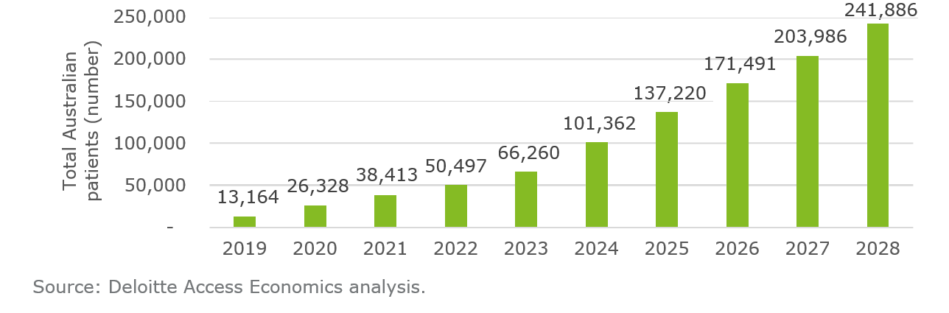

Future supply in Victoria
The two key areas of uncertainty for supply from Victorian producers are the share of the Australian medicinal cannabis market (patient demand) that they will capture over the long run, and the likely demand for Victorian products in international export markets.
Reflecting this uncertainty, three supply scenarios are considered that reflect the potential range of supply to the domestic and international market by Victorian producers – a lower bound scenario, a medium scenario, and an upper limit scenario.
The development of these scenarios follows consultations with Victorian medicinal cannabis producers, who provided estimates of future (maximum) production capacity. It is assumed that producers will gradually increase production to their maximum capacity in response to the gradual increase in demand.
Of these three scenarios, Deloitte Access Economics believes that the medium scenario is the most realistic future path for the industry in Victoria. This assessment reflects the likely competitiveness of the Victorian industry based on employment and export benchmarks, and represents the general consensus of the literature and consultations undertaken with key stakeholders.
Each scenario is described below, along with the estimated revenue generated in the scenario.

Upper limit scenario
Under the upper limit scenario, Victorian medicinal cannabis production is estimated to total 881,250 litres of oil annually by 2028 (equivalent to 293,750 kilograms of dried plant matter). This is sufficient oil to supply approximately 1.2 million patients per year.
This volume of production represents approximately 80 per cent of the maximum capacity of all known major medicinal cannabis companies operating in Victoria.12 These production estimates were provided by stakeholders during consultation.
In this scenario, Victorian producers capture 50 per cent of the domestic demand for medicinal cannabis (90,957 litres of oil) in 2028 and export the rest of their expected

¹² Producers are assumed to increase their production in a linear fashion such that by 2028 they are producing at 80 per cent of their total capacity (if they commenced production in 2020). While this linear approach is a simplified assumption, there is insufficient information available to apply an alternate ramp-up function. Despite this limitation, this approach considers the commencement dates of different production facilities, giving a single industry-wide production estimate for 2028.

production to international markets. This equates to producers exporting 90 per cent of their medicinal cannabis supply.
Despite Victorian producers anticipating they will supply 50 per cent of the domestic market, given current production projections equate to Victorian producers exporting 90 per cent of their medicinal cannabis supply, it is likely that these current production projections represent a maximum level of output for the Victorian industry, rather than a most-likely central estimate. This upper limit scenario reflects a strong degree of investor optimism within a new industry.
Chart 4.2: Comparison of annual Victorian supply and domestic demand (medicinal cannabis oil equivalent), 2028, upper limit of supply.
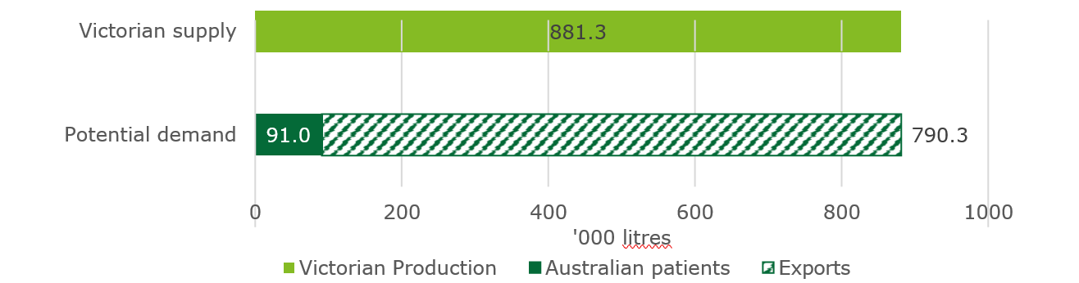
Source: Deloitte Access Economics analysis.

Medium scenario
The medium scenario is based on current Victorian employment in the pharmaceutical and agricultural sectors, and export benchmarks for these industries. These industries are potential indicators of the medicinal cannabis sector’s competitiveness in the domestic and international market. As such, this scenario is viewed as the most likely, central estimate.
In this scenario Victorian producers are expected to supply 41 per cent of the Australian market for medicinal cannabis. This assumption is consistent with Victoria’s share of Australian employment in the Pharmaceutical and Medicinal Product Manufacturing sector in 2016.
Under this assumption, Victorian medicinal cannabis products would service the demands of approximately 300,000 patients by providing 233,754 litres of medicinal cannabis oil (74,585 kilograms of dried plant matter). Of these patients, approximately 99,173 would be Australia patients, demanding 74,585 litres of oil.
Exports also occur in this scenario and represent two-thirds13 of Victorian production of medicinal cannabis, reflecting the current share of exports across agriculture more broadly in Australia.14

¹³ Australian Bureau of Agricultural and Resource Economics and Sciences 2018, Snapshot of Australian Agriculture <http://www.agriculture.gov.au/abares/Documents/snapshot-australian- agriculture.pdf>.
¹⁴ Producers have indicated they intend to export mostly harvested agricultural products (not finished pharmaceutical products), as such the share of exports in Australian Agriculture is used rather than the Human Pharmaceuticals sector, which exports 50 per cent of production by sales revenue. Source: IBISWorld 2019, Pharmaceutical product manufacturing in Australia, Industry report C1841
<https://www.ibisworld.com.au/industry-trends/market-research-reports/manufacturing/basic- chemical-product/pharmaceutical-product-manufacturing.html>.

Chart 4.3: Comparison of annual Victorian supply and domestic demand (medicinal cannabis oil equivalent), 2028, medium scenario
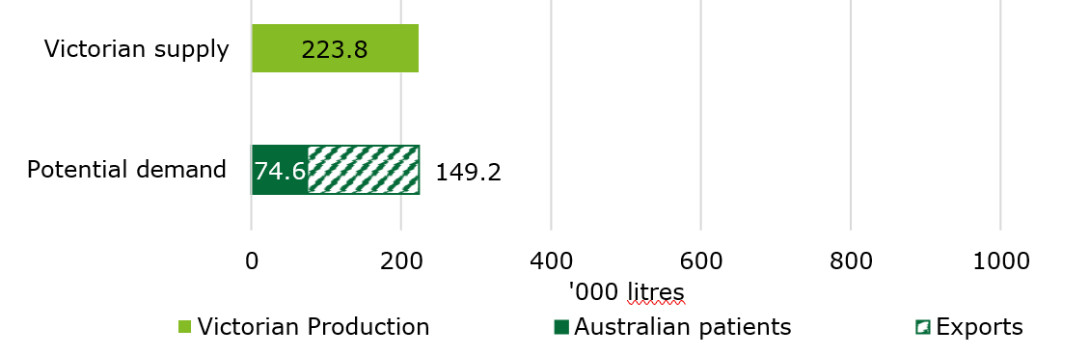
Source: Deloitte Access Economics analysis.

Lower bound of supply scenario
In the lower bound scenario Victorian producers are assumed to supply the equivalent of 30 per cent of the total Australian market for medicinal cannabis products. This assumption reflects the approximate share of current Australian medicinal cannabis licences issued for Victorian premises (in September 2019).
The lower bound scenario assumes that there is no export demand for Victorian product.
This share of the Australian market equates to 18,191 kilograms of dried plant matter, which would be enough dried material to make 54,574 litres of oil, or supply approximately 70,000 patients. Assuming Victoria’s share of the Australian population remains constant through to 202815, Victoria would have approximately 61,000 patients demanding medicinal cannabis so would likely not need to import under this production scenario.
Further, in this scenario, Victorian producers are assumed to not export any material, which is consistent with the lower bound estimate in 2017 when Victoria first investigated the opportunity.16 Given this, the lower bound scenario likely reflects the floor of Victorian production given most producers expect to export a portion of their products.

Chart 4.4: Comparison of annual Victorian supply and domestic demand (medicinal cannabis oil equivalent), 2028, lower bound scenario
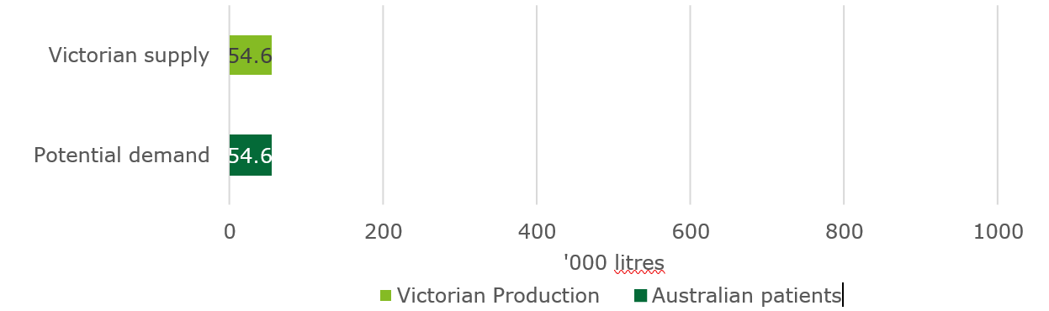
Source: Deloitte Access Economics analysis.

¹⁵ 25% at the 2016 Census
¹⁶ In reality it is likely that exports would make up at least a small share of product sales even under the lowest production volumes given that exports are legal and many Victorian producers have an export focus

Industry revenue
Revenue is a function of price, product type and the market supplied to. Victorian medicinal cannabis producers are assumed to be producing one of two products through to 2028 – dried plant matter and oil products, as follows:
  - Dried plant matter: includes dried leaf and flower from the cannabis plant, which can then be used as an input into the production of oil, or exported.
  - Oil products: Presently in Australia, oil products are typically prescribed to patients under SAS-B. While it is likely that medicinal cannabis products will take numerous forms by 2028, for this study it has been assumed that medicinal cannabis oil is the only product in the Australian market in 2028.
Currently, the market price of medicinal cannabis oil (comprising both CBD and THC) is approximately $5,000 to $6,000 per litre, with labelled 50ml tinctures of medicinal cannabis oil typically sold to pharmacies for $250-$300.17 However, most industry stakeholders consulted by Deloitte Access Economics anticipate that this price will fall once the domestic industry becomes established and producers are operating with economies of scale. Reflecting this, it has been conservatively assumed that the price of each bottle of medicinal cannabis oil will fall to $150 by 2028, equating to $3,000 per litre in nominal terms.
Stakeholders estimated that the price of dried plant product would settle somewhere between $3,000 to $5,000 per kilogram. Averaging this range, it was assumed that dried plant matter has a market value of $4,000 per kilogram (in nominal terms), and this holds to 2028.
In terms of the share of oil and dried plant matter sold by each producer, consultation with industry has revealed that Victorian producers intend to supply oil to the domestic market, and also export some dried plant matter. Although this product split is unknown, for this analysis it is assumed that 75 per cent of dried plant matter cultivated in Victoria is sold locally as oil, while the remaining 25 per cent will leave the state as dried plant matter in an unprocessed form. One gram of medicinal cannabis dried product is assumed to be equivalent to three millilitres of finished medicinal cannabis oil product.
Given this, under the upper limit scenario industry revenue is estimated to be $2.3 billion in 2028 if the price of medicinal cannabis is $3,000 per litre of oil, and $4,000 per kilogram of dried plant matter. Under the medium scenario it could be $609 million and under the lower bound scenario it could be $164 million (in nominal terms).

¹⁷ Deloitte Access Economics consultations with industry.

Economic contribution

Economic contribution to the Victorian economy
This section summarises the economic contribution that the Victorian medicinal cannabis industry could make to growing the Victorian economy, based on the three development scenarios outlined in Chapter 4.

Economic contribution modelling
Economic contribution modelling takes industry revenue and estimates the contribution to the economy (here, in Gross State Product (GSP) terms) based on the activity undertaken to generate this revenue.18 This measure can be split into two components – direct economic contribution within the industry, and indirect economic contribution outside of the industry. The latter recognises that the establishment of a Victorian medicinal cannabis sector will stimulate value added in other parts of the Victorian economy that supply inputs to the medicinal cannabis sector.
To quantify economic contribution, the Deloitte Access Economics’ regional Input Output (IO) tables for Victoria have been used (more detail on the approach is provided in the full report).19 This model has been developed using the Australian Bureau of Statistics’ (ABS) Input Output (IO) tables.20

Results
In total, the medicinal cannabis sector could directly and indirectly contribute up to $1.39 billion each year to GSP by 2028. Meanwhile under the medium scenario this total contribution could be $365 million and $99 million under the lower bound scenario.

Direct economic contribution
If the Victorian industry was to generate $2.3 billion in revenue, as per the upper limit scenario, then it could directly contribute up to $884 million to GSP each year. In the medium scenario, the industry direct value added would be $233 million, and in the lower bound scenario it would be $63 million.21
On average, Victorian firms in the pharmaceutical manufacturing sector contribute more value added to the state for each dollar of output than the industry average across

¹⁸ Economic contribution – or value added - is the preferred measure of economic value over industry revenue, as revenue captures the cost of intermediate inputs supplied by other sector. As such, revenue over-estimates an industry’s contribution to the economy as it includes some of the value added of supplying sectors.
¹⁹ Deloitte Access Economics maintains a proprietary regional input-output model that captures the complexity of economic activities of a firm or an industry and the relationships with other industries in the economy. The model is built on well-established economic theories and has been effectively deployed for various projects.
²⁰ Currently the medicinal cannabis sector is not a formal industry recognised by the ABS in its reporting of industry purchasing and selling activity in IO tables. As such, we use the cost structure of a similar industry to do this modelling. Of the 114 sectors represented in the ABS IO tables, the Human Pharmaceutical and Medicinal Product Manufacturing sector most closely represents the cost structure of the medicinal cannabis sector given it is a pharmaceutical product.
²¹ This is based on the current value added of Human Pharmaceutical and Medicinal Product Manufacturing industry within Victoria. See footnote 19 for further detail.

Australia22. This difference likely reflects the high-value nature of pharmaceutical manufacturing activity located in Victoria.
In the upper limit scenario, employment in the medicinal cannabis industry is estimated to comprise approximately 2,900 Full Time Equivalents (FTEs). In the medium scenario, industry employment is approximately 750 FTEs, while in the lower bound scenario it is 180 FTEs.
Across all three scenarios, it is estimated that the majority of FTEs would be working as manufacturers, cultivators, and in technical roles.
This estimate was informed by stakeholder consultations with current producers in the industry, but it is important to note that there is a high degree of variability associated with the estimates provided.

Indirect Economic contribution
The value added generated from the Victorian medicinal cannabis industry’s expenditure on
intermediate inputs is estimated to be $505 million in 2028, in the upper limit scenario. Under the medium scenario, value added from Victorian sectors would be $132 million in 2028, while under the lower bound scenario this figure would be $36 million.23
In other words, for every dollar of value added generated in the medicinal cannabis sector, there is a further $0.57 in value added generated in the Victorian economy.24
Table 5.1 below summarises the results of this modelling exercise across the three scenarios (lower bound, medium and upper limit).

Table 5.1: Summary of economic contribution of the Victorian medicinal cannabis industry to the Victorian economy, 2028
 | Lower bound | Medium | Upper limit
Total industry revenue ($) | $164m | $609m | $2,314m
Direct value add ($) | $63m | $233m | $884m
Indirect value add ($) | $36m | $132m | $505m
FTE (direct)a | 180 | 750 | 2,900

Note: (a) Full Time Equivalent (FTE) Source: Deloitte Access Economics.

²² Value add to output ratio of 0.38 compared to the national average 0.33
²³ Note: Type II multipliers, which capture the consumption induced effects of a given sector, have not been provided as these are no longer recognised as standard methodology – see this publication: Australian Bureau of Statistics, Australian National Accounts: Input-Output Tables - Electronic Publication, Final release 2006-07 tables, Summary, cat no. 5209.0.55.001 (21/12/2010).
²⁴ For every dollar of direct value added generated in the Victorian Human Pharmaceutical and Medicinal Product Manufacturing sector, there is a further $0.57 in value added generated in the Victorian economy. This is the effective ratio to estimate the indirect economic contribution of the Victorian medicinal cannabis sector.

Implications of this study
The medicinal cannabis industry in Victoria can still be characterised as emerging. Drawing on the above analysis, this report identifies three focus areas and eight associated actions for the nascent medicinal cannabis industry to develop into a sustainable and viable industry. These three focus areas are:
1. Secure Victoria’s competitive advantage. Realise full export potential.
2. Realise full export potential.
3. Realise full domestic market potential for Victorian producers.
These three focus areas and the recommended actions for each are discussed in further detail below.

1: Secure Victoria’s competitive advantage
Industry stakeholders consistently noted that Victoria has a competitive advantage in cultivating and manufacturing medicinal cannabis compared to other Australian states, and indeed much of the world, due to the combination of:
- Australia’s reputed high-quality standards across both agricultural and pharmaceutical products
- Australia’s reputation for efficient agricultural production
- Victoria’s reputation for world-class clinical research trials.25
It would be prudent for the Victorian industry to actively work to maintain and strengthen these advantages, to ensure the Victorian industry can continue to compete locally and globally.
To secure Victoria’s competitive advantage, we recommend three actions for industry:
- Maintain quality standards: by innovating across the technological and regulatory environment and monitoring changes in other countries.
- Focus on industry efficiency: by sharing knowledge and expertise and in turn working to reduce costs.
- Support evidence collection through clinical trials: by collaborating with research institutions.

2: Realise full export potential
The opening up of export markets for Victorian producers has a material impact on the viability of local production. To realise Victoria’s full export potential, it is recommended that industry works closely with the Victorian Government to actively seek out export opportunities to supplement the industry’s supply to the domestic market, and that it does so strategically. There are two recommended actions to help the Victorian industry realise its full export potential:

²⁵ Australian Trade and Investment Commission, Clinical Trials (2018)
<https://www.austrade.gov.au/International/Buy/Australian-industry-capabilities/Health-and- wellbeing/Health-and-Wellbeing> Accessed 13 November 2019

- Promote export opportunities through the medicinal cannabis industry associations: to ensure industry is aware of all potential export opportunities and the requirements for each export market.
- Undertake more research and modelling of domestic and global markets: so that industry is aware of the markets its competitors are targeting and can therefore make strategic decisions concerning export market development.

3: Realise full domestic market potential
Victoria, and Australia as a whole, currently imports a large portion of its medicinal cannabis product. This is because the domestic industry is yet to develop a significant production capacity. This is likely to change over the coming years, as the many producers that have approved medicinal cannabis manufacturing and cultivation licences finish planning and constructing their sites.
As more domestic products become available locally, Australian medical practitioners will have more choice when prescribing products to patients. However local product will not simply become the preferred choice for doctors and pharmacists. Rather, the local industry must work to ensure their products satisfy the medical community so that it feels comfortable recommending local products to patients and that local products are available in pharmacies.
There are three recommended actions for industry to realise its full domestic market potential:
- Simplify the process for the medical industry to become aware of the efficacy and price of local products: by working to share evidence from clinical trials and price information with medical industry associations.
- Ensure local products are price competitive: by working to reduce the cost of production.
- Ensure local products can be supplied to pharmacies: by negotiating a supply agreement with an approved wholesaler of medicinal cannabis products.

Key actions for government
To continue to support the emerging medicinal cannabis industry in Victoria, the Victorian Government could seek to lead two additional actions:
- Continue to research medicinal cannabis plant strains.
- Strengthen the provision of advice to industry.
These actions will work to improve the quality and yield of product and disseminate important and timely information t throughout the local industry.

Limitation of use
General use restriction
This report is prepared solely for use of the Department of Jobs, Precincts and Regions. This report is not intended to and should not be used or relied upon by anyone else and we accept no duty of care to any other person or entity. The report has been prepared for the purpose of set out in the engagement letter (PAS Order) dated 4 June 2019. You should not refer to or use our name or the advice for any other purpose.

Deloitte Access Economics is Australia’s pre-eminent economics advisory practice and a member of Deloitte's global economics group. For more information, please visit our website: www.deloitte.com/au/deloitte-access-economics
Deloitte refers to one or more of Deloitte Touche Tohmatsu Limited (“DTTL”), its global network of member firms, and their related entities. DTTL (also referred to as “Deloitte Global”) and each of its member firms and their affiliated entities are legally separate and independent entities. DTTL does not provide services to clients. Please see www.deloitte.com/about to learn more.
Deloitte is a leading global provider of audit and assurance, consulting, financial advisory, risk advisory, tax and related services. Our network of member firms in more than 150 countries and territories serves four out of five Fortune Global 500®companies. Learn how Deloitte’s approximately 286,000 people make an impact that matters at www.deloitte.com.
Deloitte Asia Pacific
Deloitte Asia Pacific Limited is a company limited by guarantee and a member firm of DTTL. Members of Deloitte Asia Pacific Limited and their related entities provide services in Australia, Brunei Darussalam, Cambodia, East Timor, Federated States of Micronesia, Guam, Indonesia, Japan, Laos, Malaysia, Mongolia, Myanmar, New Zealand, Palau, Papua New Guinea, Singapore, Thailand, The
Marshall Islands, The Northern Mariana Islands, The People’s Republic of China (incl. Hong Kong SAR and Macau SAR), The Philippines and Vietnam, in each of which operations are conducted by separate and independent legal entities.
Deloitte Australia
In Australia, the Deloitte Network member is the Australian partnership of Deloitte Touche Tohmatsu. As one of Australia’s leading professional services firms. Deloitte Touche Tohmatsu and its affiliates provide audit, tax, consulting, and financial advisory services through approximately 8000 people across the country. Focused on the creation of value and growth, and known as an employer of choice for innovative human resources programs, we are dedicated to helping our clients and our people excel. For more information, please visit our web site at https://www2.deloitte.com/au/en.html.

Liability limited by a scheme approved under Professional Standards Legislation. Member of Deloitte Asia Pacific Limited and the Deloitte Network.
©2020 Deloitte Access Economics. Deloitte Touche Tohmatsu

