Using stock containment areas
Case study – Trevor Roberts, Wooroonook, west of Charlton - North Central Victoria
Trever and Diane Roberts are sheep and cropping farmers at Wooroonook. Their enterprise is two-thirds cropping and one-third prime lambs and Merino ewes on their 1,400 hectare (ha) property.
The Roberts’ have about 2,000 ewes that lamb in April-May. Despite a good crop harvest in 2016, they decided to scale down cropping in 2017 and increase their sheep numbers. Stock containment is a key on-farm management tool during dry times.
Farm information
Producer: Trever and Diane Roberts
Location: Taradale, Wooroonook, 10 km west of Charlton
Property size: 1400 ha
Annual Rainfall: 360 mm
Soils: Red Sodosols and Grey Vertosols (cracking, self-mulching clay)
Enterprise: Cereal grains, legumes for grain and hay; wool and prime lamb production from Merino and White Suffolk breeds
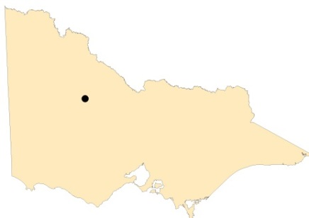
Figure 1 Map of Victoria identifying Wooroonook in North Central Victoria.

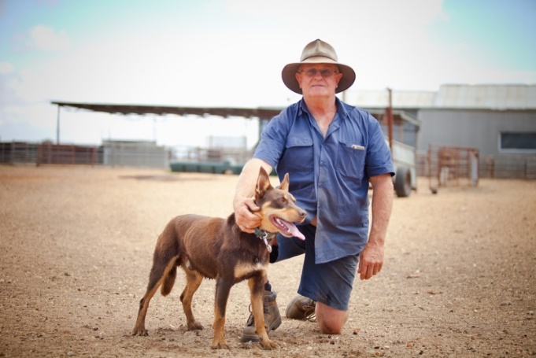
Photo: Trever Roberts and lead sheep dog, Russell.
“The sheep have been very good to us,” Trever said. “With sheep there is less money required up front, so we decided to cut back a bit on the cropping in 2017. We recently got a valuation for our wool and it was all over 1,000 cents, and I can’t remember seeing that for a long time. So we will probably shift our enterprise mix to half cropping and half sheep.
“In the last two years we have built a stock containment area (SCA) for managing in dry times. The SCA grant in 2017 helped us to build it. We made use of some existing fence lines and I made the gates myself. We also use the yards for other management activities throughout the year.”

SITING AND SHADE
Because the site didn’t have a shelterbelt of trees to provide ready-made shade, Trever installed shade cloth along the fence line on the western side of the yards. At about a metre high, the same height as the top of the fence line, and running along the length of each yard, Trever said it was quite easy to install. “The sheep are very happy to get under the shade cloth on a hot day,” Trever said. He is also planning on planting trees on the western side of the SCAs for longer-term permanent shade.
SCA location was important. The initial location Trever considered was low-lying and water runs down into the area. “We came back near the shearing shed, which allows us to make better use of the yards. It is also easier to keep an eye on the stock when we come in for meals. You can easily see if there is a problem. We have no more problems in the containment area than we do out in the paddocks.”

WATER
The Roberts have the Wimmera Mallee pipeline going past the front gate and have installed multiple tanks on the farm so that they can store water in case there is ever a problem with the pipeline. A pressure pump supplies water to the troughs in each yard, however there are also several tanks that can gravity feed the troughs if necessary and they have a generator as a back-up if there is a long-term power outage.
FEEDING
Trever has a range of feeders for hay and self-feeding grain, with a Keenan mixer to make up a mix of grain to provide sufficient protein. Currently peas, barley and oats are used but can be changed to whatever is the cheapest at the time. Trever said all grain was tested before use and the sheep were introduced slowly to the oats first, then barley, wheat and peas or legumes were added at a slower rate. “The sheep have access to food and water at all times and we find that if they have a full belly they are very happy,” he said.
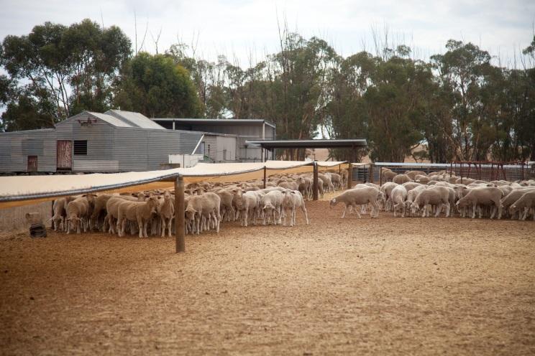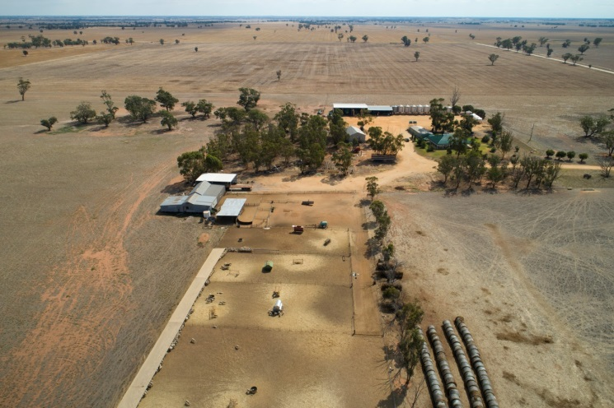
Photo: sheep using the shade in the SCA.
Photo: Drone image of the Roberts’ stock containment areas, Wooroonook (note shade cloth on western boundary)

“We move the hay bales around because it puts a bit of straw on the ground, which helps prevent any erosion and stops the dust from blowing. It’s a very light soil where we have located the containment area so the straw is important for holding it together.”
Managing stock through dry times has changed quite dramatically over the years for the Roberts. “Dad would say we would have to destock in a drought, that we could not feed them through. In those days we did not have the grain, and we did not have balers, so you couldn’t keep the hay.”
“Now we have silos to store the grain and balers so we can stack the hay up. We can keep the enterprise going through dry times without having to sell stock at a cheap price and then restock at higher prices,” Trever said.
“It was not easy getting sheep through the Millennium drought. We ran out of hay and grain and started using almond hulls mixed with barley. We used a fair bit of molasses on hay – long straw stuff that the sheep don’t really like – but the molasses helps them to eat it. We got through.
“Managing stock through dry times has changed a lot and the stock containment areas will really help.”

FURTHER INFORMATION
For further information or to obtain a copy of the relevant Drought Feeding Guide visit agriculture.vic.gov.au/dryseasons contact your local Agriculture Victoria Extension Officer or call the Customer Service Centre on 136 186.

Accessibility
If you would like to receive this publication in an accessible format, please telephone Agriculture Victoria on 136 186 or email drought.support@agriculture.vic.gov.au

This document is also available in (HTML and/or PDF and/or Word) format at agriculture.vic.gov.au

Disclaimer
Republished by Agriculture Victoria 2020.
This publication may be of assistance to you but the State of Victoria and its employees do not guarantee that the publication is without flaw of any kind or is wholly appropriate for your particular purposes and therefore disclaims all liability for any error, loss or other consequence which may arise from you relying on any information in this publication.

