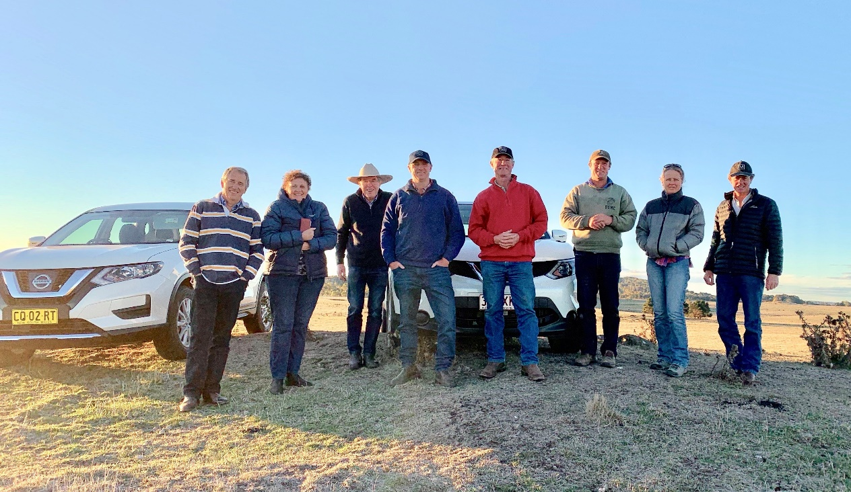
Picture: Western District BetterBeef Group, New England tour, May 2019
Coordinator – Meg Bell
Group – Western District
- Based in Hamilton (from Casterton to Woodhouse and Coojar to King Island).
- Active approximately 7 years, currently with 22 businesses
Enterprise mix
- Mainly beef producers (average breeding herd of 400)
- Includes stud operations, paddock-to-plate supply chain, feedlot market and direct to slaughter market with some additional sheep enterprises
New England, NSW tour
In May 2019, Meg Bell arranged a tour to the New England region for five producers from the Western District group and two producers from the South Eastern Buffalo group.
The five-day tour included a visit to the University of New England (UNE) in Armidale. The UNE is a leading innovator in agricultural studies and applied research. The group were keen to visit UNE’s SMART Farm Innovation Centre (SFIC) to view the different technologies in action and how they may be incorporated into their own farm enterprises.
- SMART Farm www.une.edu.au/research/research-centres-institutes/smart-farm
The UNE visit also took in the Tullimba Research Feedlot and the Meat Science Laboratory. Current work of the lab was ably demonstrated by Laura Garland from MLA. Many would know Laura from her previous role with Agriculture Victoria at Hamilton.
The Animal Genetics and Breeding Unit (AGBU) and the Agricultural Business Research Institute (ABRI) were part of the UNE tour. AGBU researches the genetics of livestock, and developed BREEDPLAN helping producers to identify the best genetics for their herds. ABRI is the commercial operator of BREEDPLAN and provides an agribusiness information service across domestic and international livestock industries.
Visits to farms in the region were considered a highlight of the tour. The Rangers Valley Feedlot is a huge enterprise and the group were guided by the feedlot manager, Sean McGee. It was the first time some in the group had visited a feedlot and Rangers Valley provided an opportunity to see one being run very well.
Rangers Valley specialise in long-fed pure Black Angus and Wagyu cross breeds for the domestic and export markets. The feedlot is the fourth largest in Australia with a capacity of 32,000 head and located on a property of approximately 5,000 hectares.
- Rangers Valley Feedlot www.rangersvalley.com.au
Jackson Agriculture was another large enterprise that the group visited. The owner, John Jackson, was originally a butcher and now operates the business from farm through processing to the consumer. The business comprises four different properties throughout the New England region, with the ability to turn off 15,000 steers annually.
- Jackson Agriculture www.jacksonag.com.au
Other properties visited included ‘Glenavon Angus’, ‘Yalgoo’ where Poll Herefords and Merinos are the focus, ‘Walcha Dairy’ in an area dominated by beef cattle and wool sheep, and ‘Congi Station’ primarily Merino, with Hereford x Angus as a secondary focus.
Two of the main ‘take home’ considerations arising from the tour were:
- Succession planning
Business management
These were not intended themes of the tour however they became very topical considerations among the group members after hearing from producers, especially Richard Post of Glenavon Angus who has operated their business through their region’s worst drought year on record.
Richard Post is the sixth generation at Outer Bald Blair, the home of Glenavon Angus. The farm business has 400 stud cows and 300 commercial cows. Glenavon joins a proportion of their sale bulls as yearlings each year. The commercial and stud herds are run alongside a crossbred ewe flock.
- Glenavon Angus www.glenavonangus.com
Ways in which the Post family have adapted their business to the conditions were of great interest to the group. Glenavon selects heavily on bull performance, taking account of weight for age, moderate birth weights and structural soundness. In early May, when the group visited, Richard Post was feeding their weaner bulls. While this would be a usual activity for May, Richard said they are feeding for much longer than ‘usual’.
The group also looked at the Glenavon shed that Richard uses for sales. It is an older style shed but well suited to the task. Discussion ensued about budget-friendly facilities and how they can be just as good as facilities that are not so budget friendly!
ACCESSIBILITY
If you would like to receive this publication in an accessible format, please email the Beef Sheep Network on beef.sheepnetworks@agriculture.vic.gov.au
This document is also available in Word format at https://agriculture.vic.gov.au/support-and-resources/newsletters/newsflash
The group’s next session will focus on cattle yard design and incorporate a tour of local properties to look at their yard designs to see how they function. The local tour, while focusing on newly built yards, will also look at yard designs that are budget conscious yet work well, are safe to use and easy to manage.

