2020 Industrial Hemp update

Industrial Hemp Taskforce Victoria

Industrial Hemp Taskforce
On 29 August 2019, the Victorian Government established the Industrial Hemp Taskforce to explore the challenges and opportunities facing the industrial hemp industry.
The Taskforce engages directly with industry stakeholders, participants and research organisations to gain a thorough understanding of the industry and how Victoria can maximise its economic potential.

Terms of reference

Purpose of the Taskforce
To oversee a targeted investigation into the Victorian industrial (non-therapeutic) hemp industry, engaging directly with the industry, relevant research organisations and other key stakeholders to gain a better understanding of the growth prospects and challenges for the developing industry.
The Taskforce will focus on new opportunities for the industry in Victoria and whether there are regulatory barriers to growth. The Taskforce will look at the job creating benefits of the industry and potential economic value to the state, especially in regional areas.
Demand for hemp as a food product has grown rapidly in Australia since being permitted under the Australia New Zealand Food Standards Code in 2017. Hemp has a variety of potential applications across a diverse range of products including textiles, bio composites, paper, automotive, construction, biofuel, functional food, oil, cosmetics and personal care that will be examined.

Terms of reference
The Taskforce will:
- examine information from key stakeholders on the current state of the industry, issues, barriers and opportunities;
- consider uses of industrial hemp in other jurisdictions and appropriate learnings for Victoria;
- examine how the Victorian Government can support industry development and growth across Victoria;
- examine the regulatory and licencing framework for hemp cultivation and hemp products; and
- consider any other relevant matters.
The Taskforce will report its findings upon concluding its investigation to inform government and industry about opportunities to develop this emerging industry.

Membership
- Jaclyn Symes, Minister for Agriculture, Regional Development
- Ali Cupper MP, Member for Mildura
- Fiona Patten MP, Member for Northern Metropolitan Region
Agriculture Victoria (Agriculture Policy branch) provides secretariat support to the taskforce.

Industry snapshot
Hemp and cannabis are both terms used to describe a plant in the genus Cannabis. Hemp, or “low THC-cannabis”, is a plant with low levels of the psychoactive substance tetrahydrocannabinol (THC).
Hemp can be grown to produce hemp seed for food purposes. Hemp also has potential applications in a diverse range of products including industrial purposes (textiles, biocomposites, paper, automotive, construction, biofuel), functional foods, oils, cosmetics, personal care, and pharmaceutical.
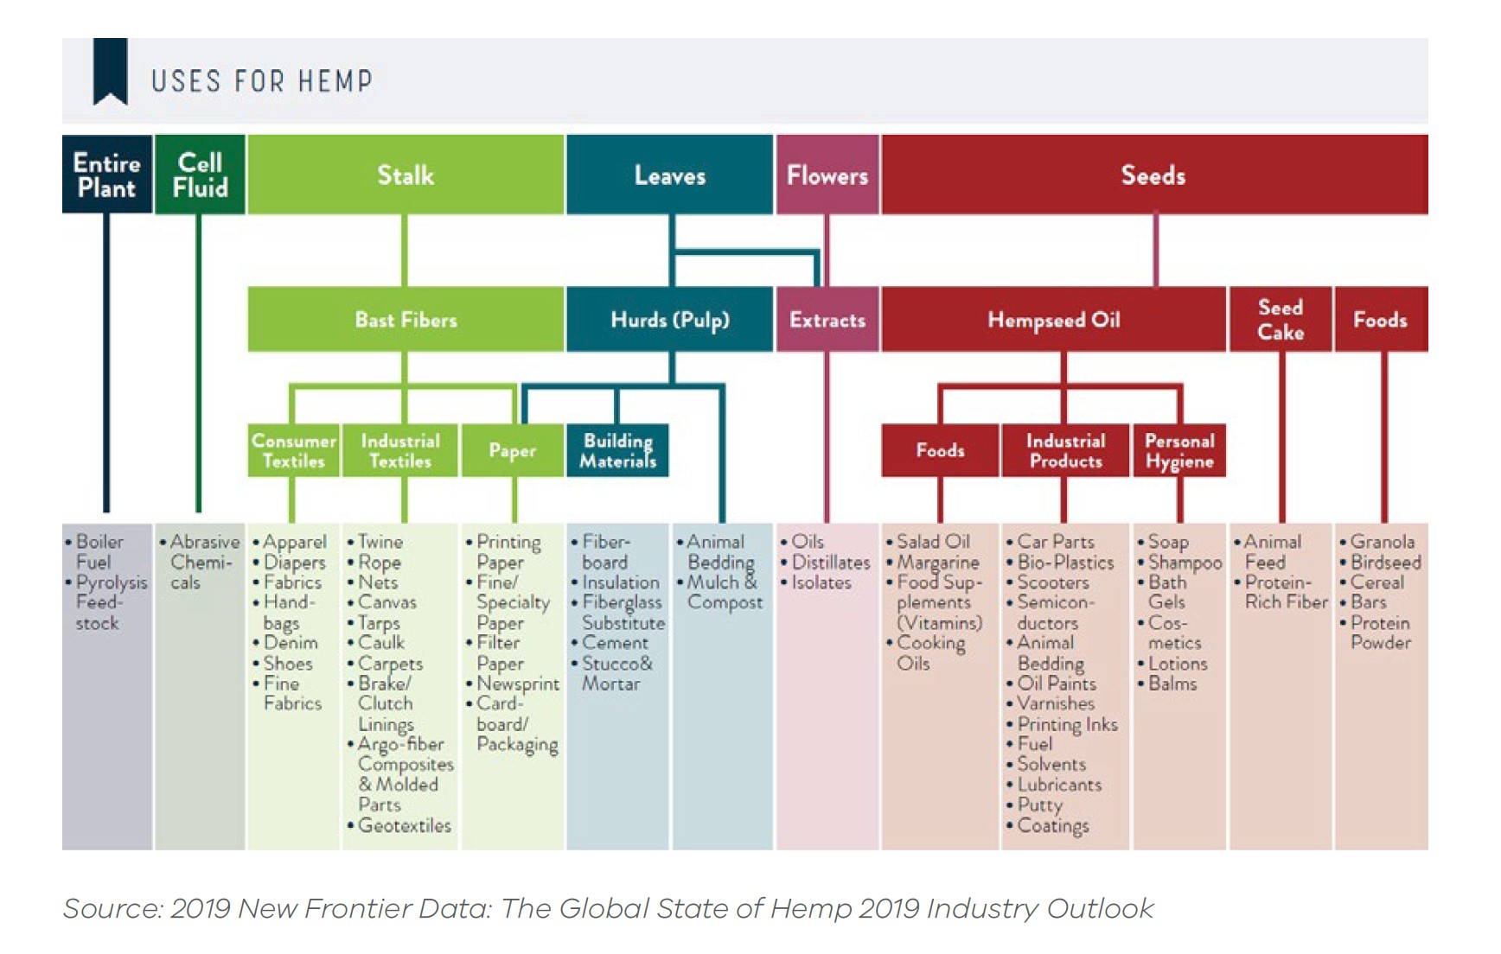
Text alternative for 'Uses for hemp’ chart
- Entire Plant- Boiler fuel and pyrolysis feed-stock
- Cell Fluid- Abrasive chemicals
- Stalk- Bast Fibres-Consumer textiles- Apparel, diapers, fabrics, handbags, denim, shoes, fine fabrics
- Stalk- Basic Fibres – Industrial Textiles- Twine, rope, nets, canvas, tarps, caulk, carpets, brake/clutch linings, argo-fiber composites & molded parts, geotextiles
- Stalk- Basic Fibres- Paper/ Leaves – Hurds (Pulp) – Building Materials- Paper Printing paper, fine/speciality paper, filter paper, newsprint, cardboard/packaging
- Leaves- Hurds (Pulp)- Building Materials- fibreboard, insulation, fibreglass substitute, cement, stucco & mortar, animal bedding, mulch & compost
- Flowers- Extracts- oils, distillates, isolates
- Seeds- Hempseed Oil- Foods- salad oil, margarine, food supplements (vitamins) and cooking oils
- Seeds- Hempseed Oil- Industrial Products- car plates, bio-plastics, scooters, semiconductors, animal bedding, oil paints, varnishes, printing links, fuel, solvents, lubricants, putty, coatings
- Seeds- Hempseed Oil- Personal Hygiene- soap, shampoo, bath gels, cosmetics, lotions, balms
- Seeds- See Cake- Animal feed, protein- rich fibre
- Seeds- Foods- granola, birdseed, cereal, bars, protein powder
Source of chart: 2019 New Frontier Data: The Global State of Hemp 2019 Industry Outlook

Hemp in Australia
Due to the regulatory environment, hemp is specifically grown in Australia for food or industrial purposes. The many available varieties of industrial hemp make the crop suitable for cultivation in various geographical farming locations across Australia. It is a high yielding, hardy and fast-growing annual crop, which can be sown from early spring to late summer/early autumn. A large proportion of its production is irrigated.
Commercial or trial hemp crops are grown in all states in Australia. Most Australian commercial production is in Tasmania. In the 2019-20 growing season, approximately 1600 hectares was planted in Tasmania, with a farm gate value of $4.5 million. This compares to 280 hectares planted in Western Australia and 200 hectares in Victoria. Tasmania was the first state to permit hemp cultivation. Tasmanian hemp growers have also developed seed varieties suited to the Tasmanian climate.

Hemp in Victoria
Hemp is grown in Victoria mainly to produce hemp seed, which can now be legally sold for food purposes. Most crops in Victoria are planted in spring. As hemp is a regulated plant, a person must hold an Authority under Part IVA of the Drugs, Poisons and Controlled Substances Act 1981 to cultivate, process, sell or supply low-THC cannabis and low-THC cannabis seed.
In Victoria, approximately 200 hectares of hemp was planted in the 2019-20 growing season. In comparison, 170 hectares was cultivated in 2018-19 and 600 hectares in 2017-18. The reduction in plantings was primarily due to low
water availability.
Hemp may be cultivated for seeds or fibre, but generally not both at the same time. Most Authority holders cultivate hemp to produce hemp seed for food purposes and for selling seed to other growers for cultivation. A large increase in Victorian hemp Authorities was observed after approval of hemp seed for use in food under the Australia New Zealand Food Standards Code in 2017.
Three Authority holders process hemp seed in Victoria. This process usually involves de-hulling for food purposes or crushing to produce hemp seed oil.
Only a small number of Authority holders are commercial broadacre farmers, with the remainder considered enthusiasts. These growers produce the bulk of the hemp seed. Larger growers include Waltanna Farms and Australian Primary Hemp (both located in the Western Districts).
With the exception of Queensland, other Australian states and territories have standalone legislation to regulate the hemp industry.
The hemp industry in Victoria is represented by Hemp Victoria (formerly the Industrial Hemp Association of Victoria).

Global production
Globally, its estimated that around 30 countries in Europe, Asia, and North and South America permit farmers to grow hemp. However, there are three mature hemp producing markets: China, Canada and the European Union.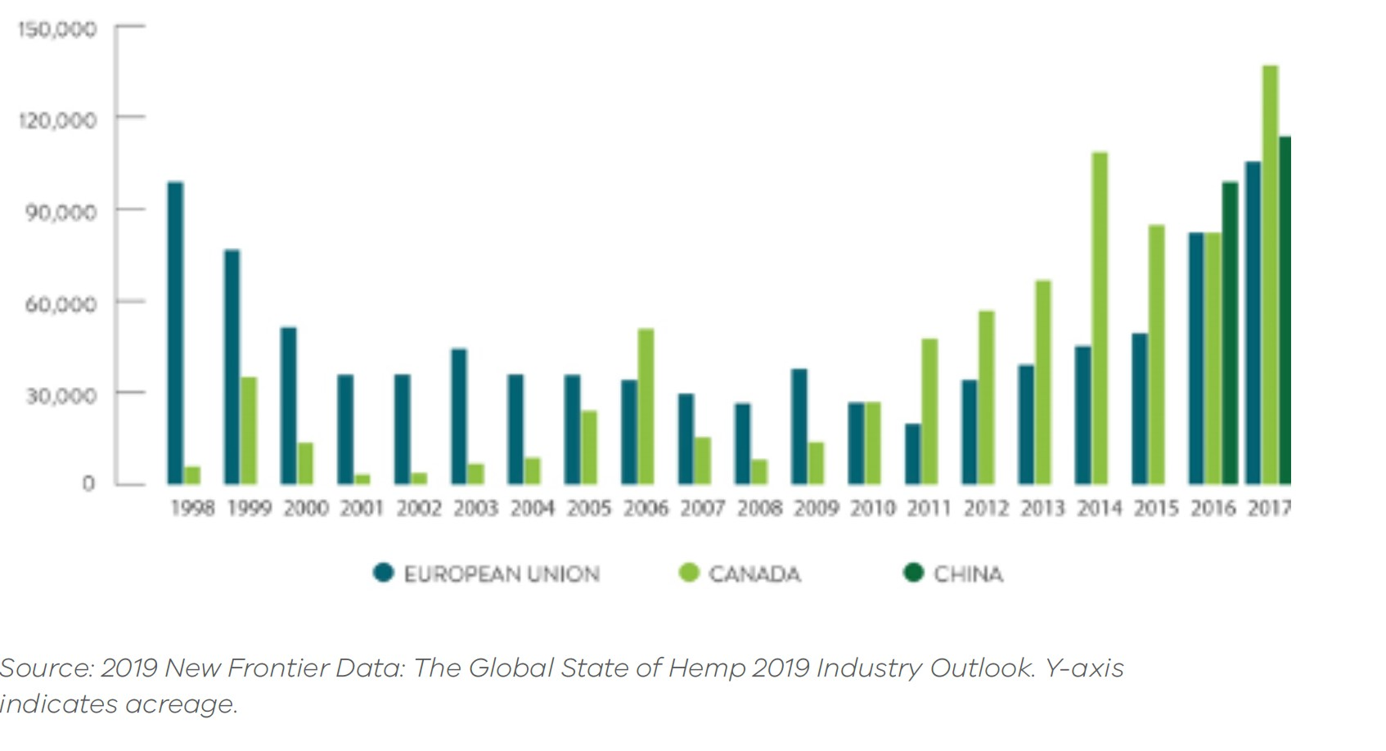
Text alternative for Global Production in European Union, Canada and China graph
- 1998- 90,000 to European Union and 5,000 to Canada
- 1999- 80,000 to European Union and 30,000 to Canada
- 2000- 55,000 to European Union and 13,000 to Canada
- 2001- 35,000 to European Union and 3,000 to Canada
- 2002- 35,000 to European Union and 4,000 to Canada
- 2003- 45,000 to European Union and 7,000 to Canada
- 2004- 35,000 to European Union and 10,000 to Canada
- 2005- 35,000 to European Union and 25,000 to Canada
- 2006- 35,000 to European Union and 55,000 to Canada
- 2007- 28,000 to European Union and 14,00 to Canada
- 2008- 30,000 to European Union and 8,000 to Canada
- 2009- 37,000 to European Union and 10,000 to Canada
- 2010- 28,000 to European Union and 28,000 to Canada
- 2011- 25,000 to European Union and 53,000 to Canada
- 2012- 35,000 to European Union and 60,000 to Canada
- 2013- 35,000 to European Union and 70,000 to Canada
- 2014- 35,000 to European Union and 105,000 to Canada
- 2015- 40,000 to European Union and 88,000 to Canada
- 2016- 85,000 to European Union, 85,000 to Canada and 93,000 to China
- 2017- 100,000 to European Union, 140,000 to Canada and 110,000 to China
Source of graph: 2019 New Frontier Date: The Global State of Hemp 2019 Industry Outlook. Y-axis

Canada
Canada is the largest hemp food producer and exporter globally. In 2018, over 31,500 hectares was licensed for hemp production. Canada’s hemp production and export are in hulled hemp seeds, hemp oil, and hemp protein powder. Hemp varieties are controlled by the federal government and producers may only plant varieties from the official list of approved cultivars.
New Canadian hemp regulations in 2018 mean that growers can also harvest hemp flowers, leaves and branches and sell them to licensed cannabis processors to extract cannabidiol (CBD) and other compounds. Although the new hemp regulations are meant to open additional revenue sources and market opportunities, high CBD varieties have yet to be registered for use in Canada.

China
While China is a major producer of hemp products, it allows hemp growing in just two regions: Yunnan Province in the south and Heilongjiang Province in the north. Textiles make up about three-quarters of hemp sales. Other products like cosmetics, CBD products, food and supplements make up the rest.

Europe
Hemp cultivation in Europe is currently estimated to account for 25 per cent of the world’s production. France accounts for 40 per cent of the European production, with at least 20 other countries contributing to the European Union’s total.
European hemp cultivation has been increasing for several years, as producers and consumers become more aware of new usage opportunities. Europe has developed strong processing infrastructure, as well as a finished-goods industry based on using hemp fibres in industrial applications.
Paper and pulp, along with bio-composites (used in the automotive industry, and for insulation materials) are Europe’s most established uses for hemp fibres.
Hemp shivs (by-products of the fibre extraction process) also have long-established European commercial uses – primarily as animal bedding, but also increasingly for use in the construction industry, especially for insulation.

Summary of Victorian Taskforce meetings
In 2019, the Taskforce met four times (29 August, 17 October, 27 November and 9 December 2019). Members have received briefings and had discussion with representatives from the following organisations:
- Hemp Victoria Inc. (HVI) – Industrial Hemp Association
- Australian Industrial Hemp Alliance
- Textile & Composite Industries Pty Ltd
- Australia Primary Hemp (producer & manufacturer)
- CSIRO Agriculture and Food
- Cann Global Limited
- SuniTAFE Smart Farm
- Mallee Regional Innovation Centre
- Sunraysia Community Health Services
- Agriculture Victoria.
Stakeholders commented that industrial hemp fibre is an environmentally sustainable material for the building industry. Other opportunities for use are in food, beverage, cosmetic and pet food industries. For example, one stakeholder is pursuing a proposal to Food Standards Australia New Zealand (FSANZ) to have hemp leaf legalised for human consumption (teas and micro-greens).
Challenges include a lack of investment in processing capability, confusion within the industry between hemp seed and hemp fibre markets, prohibition on the use of hemp leaf for feedstock and high costs for transport and water.
Breeding suitable varieties for Victoria was also raised. Organisations, including AgriFutures, are looking to develop varieties suitable for all Australian growing conditions.

Other meetings

Ministerial visit to the United States
On 4 December 2019, as part of the Minister for Agriculture’s visit to the United States, the Minister engaged with the following hemp and medicinal cannabis stakeholders:
- Gabriel Youtsey, Chief Innovation Officer with University of California, Agriculture and Natural Resources Division. The Minister learned about the Agriculture program including hemp at the University of California, Davis.
- John Ferrara, Chief of Staff to California Assembly and Assembly member, Cecilia Aguiar-Curry. The Minister received an overview of the legislative framework for industrial hemp and CBD in the US and California.
- California Department of Food and Agriculture Deputy Secretary Rachael O’Brien and Branch Chief of Industrial Hemp, Joshua Kress. The Minister received a briefing on California’s industrial hemp regulation.
- David Culver, Vice President of Government and Stakeholder Relations Canopy Growth Corporation Legal and Regulatory Affairs and Farming Operations. The Minister learned about Canopy Growth’s hemp business in the US.

Mildura Taskforce meeting December 2019
A special meeting of the taskforce was convened at SuniTAFE in Mildura on 9 December 2019. Ms Patten and Ms Cupper were in attendance. Other attendees included representatives of:
- Australian Primary Hemp
- Mildura Regional Innovation Centre
- Sunraysia Community Health
- Agriculture Victoria.
The purpose of the meeting was to bring the community together to develop strategies to kickstart the local industry and provide new opportunities for farmers, industry and jobs in regional Victoria.
Discussion covered a range of issues and opportunities including many of the issues raised in previous taskforce meetings around lack of experience with hemp cultivation, lack of suitable varieties and agronomic knowledge, lack of data on inputs, outputs and prices needed for viability, and restrictive regulation.
The issue of CBD regulation was raised. Globally, regulation of CBD is being examined. If Australia was to reduce the regulatory burden around the cultivation and manufacture of CBD, opportunities for a higher-value product from industrial hemp may emerge. The taskforce was advised that this is initially a matter for the Commonwealth. Harmonisation of THC thresholds with other states was also discussed. The taskforce was advised that the Victorian Government is considering this issue.

Australian Industrial Hemp Conference 2020
On 26 and 27 February 2020, Ms Fiona Patten MP, Member for Northern Metropolitan Region, and member of the Taskforce, attended and spoke at the Australian Industrial Hemp Conference. The conference was an opportunity to hear about the latest findings in growing industrial hemp and producing and marketing industrial hemp products. Ms Patten engaged with hemp stakeholders on issues including:
- Research and development
- Industry stakeholders agreed that there is a need to invest in research and development to create suitable varieties for Australian conditions.
- AgriFutures is leading the development of a National Industrial Hemp Variety Trial business case. AgriFutures is currently identifying and costing a range of variety trial options and negotiating co-investment from public, private and not-for-profit sectors.
- Western Australian industry development
- WA amended its THC threshold from 0.35 per to 1 per cent in September 2018.
- The WA government is currently investing in dryland and irrigated variety trials in tropical and Mediterranean climate zones.
- WA is providing an Industrial Hemp Grants Scheme to generate agriculture productivity improvements in the hemp industry. To date, more than $300,000 has been awarded across six projects.
- WA is also supporting stockfeed trials with Charles Sturt University to examine the nutritional value of hemp as a summer grazing option for sheep.
- Cannabidiol (CBD)
- Industry stakeholders were supportive of amending Commonwealth and state regulations to permit CBD to be extracted through a state-based industrial hemp licence.

COVID-19 impact on Hemp Taskforce activities
The coronavirus (COVID-19) pandemic has limited the Taskforce’s ability to hold further external stakeholder meetings in 2020. Taskforce members have continued to monitor industry developments and challenges during this time.
One recent positive development has been the partnership between the business Australian Primary Hemp and SuniTAFE to conduct pilot industrial hemp trials at SuniTAFE’s Mildura SMART Farm. The Taskforce facilitated this research and development collaboration at its meeting in Mildura in December 2019. The trials will produce food, fibre and building material products over the next two to three years.

Victorian regulatory framework
Cannabis is classified as a ‘prohibited substance’ under the Commonwealth Poisons Standard, except where separately specified. Part IVA of the Victorian Drugs, Poisons and Controlled Substances Act 1981 (the Act) provides for the issuance of Authorities for low-THC cannabis. For the purposes of Part IVA of the Act, low-THC cannabis is cannabis where the leaves and flowering heads do not contain more than 0.35 per cent THC.
An Authority for low-THC cannabis may authorise a person, for commercial or research purposes relating to non-therapeutic use, to possess, cultivate, process, sell or supply low-THC cannabis and low-THC cannabis seed.

Administration of the low-THC cannabis Authority program
Low-THC cannabis Authorities are administered by Agriculture Victoria.
The assessment of applications must confirm whether the applicant is a fit and proper person, that the applicant has a legitimate reason to be authorised and that the site(s) to be authorised are appropriate.
Some aspects of the fit and proper person test have recently been amended following the debate of the Primary Industries Legislation Amendment Act 2019. During the debate of this Bill the Minister for Agriculture and Regional Development committed the Taskforce to examine whether industrial hemp belongs in an Act that deals with drugs and poisons.
All hemp crops are sampled prior to harvest and analysed for THC concentration to confirm crops are low-THC cannabis. Authority holders are charged a fee directly from an external laboratory for the THC analysis of their crop and are charged fees for the inspector’s time in sampling the crop.
All Authorities are issued with standard conditions that impose record keeping, security and reporting requirements on the authority holder.

Future regulatory change
The Hemp Taskforce has received feedback from industry and other stakeholders about further regulatory changes to the Victorian hemp regulatory scheme. In light of this feedback, the Taskforce recommends regulatory amendments that will make it easier for Victorian growers to grow hemp.
Further, The Taskforce considers harmonisation of THC thresholds with the other jurisdictions as an important issue for the Victorian industry. The Taskforce recommends the Victorian Government work towards raising the THC threshold to 1 per cent to be in line with other states and territories.

Cannabidiol (CBD)
Stakeholders have frequently raised the need for Cannabidiol (CBD) extraction to be permitted and streamlined through an industrial hemp cultivation licence. While the therapeutic uses of the hemp plant are not within the terms of reference for this Taskforce, it has become clear that the two are closely linked.

What is it?
Cannabis plants contain over 100 different phytocannabinoids. CBD is a chemical component of the cannabis plant. CBD is non psychoactive and thought to reduce the negative effects that people can experience from THC, the primary psychoactive component in medicinal cannabis. Studies on the effectiveness of CBD to treat a wide variety of health issues are ongoing. To date, the Commonwealth Department of Health has approved the use of medicinal cannabis containing CBD for the following indications:
- chemotherapy-induced nausea and vomiting
- refractory paediatric epilepsy
- palliative care indications
- cancer pain
- neuropathic pain
- spasticity from neurological conditions
- anorexia and wasting associated with chronic illness (such as cancer).

Australian CBD regulation
Under the United Nations’ Single Convention on Narcotic Drugs 1961 (Single Convention), any extract of cannabis, including CBD, is a drug. Australia is a signatory to the Single Convention and implements some of its obligations through the Narcotics Drugs Act 1967. Under this Act, the cultivation of cannabis for CBD extraction, and the manufacture of CBD, requires medicinal cannabis licences issued by the Office of Drug Control.
CBD is a drug and a medicinal cannabis product under Australian law. It may only be accessed by prescription from a doctor who has been granted approval from the Therapeutic Goods Administration.
From 1 June 2015, cannabidiol has been included under the Commonwealth Government’s Schedule 4 Prescription Only Medicine of the Poisons Standard when preparations for therapeutic use contain two per cent or less of other cannabinoids found in cannabis. Previously, CBD was classified as a Schedule 9 Prohibited Substance.
On 9 September 2020, the Commonwealth Government announced an interim decision to down-schedule low dose CBD products from Schedule 4 to Schedule 3 of the Poisons Standard. This means companies can apply to register their applicable products to be available through a pharmacist, without the need for a prescription. Consultation of the Commonwealth’s interim decision closed on 13 October 2020.
Currently, a hemp licence issued by Agriculture Victoria cannot authorise the processing of leaves and flowering heads, which is where the cannabinoids are found. In addition, a hemp licence issued by Agriculture Victoria cannot authorise activities related to the therapeutic use of cannabis.
In response to the Australian hemp industry’s interest in cultivating hemp for CBD production, the Commonwealth Government is investigating ways to exempt the cultivation of hemp for CBD under the Single Convention. This would allow state and territories to licence this activity under existing industrial hemp licences. CBD would remain a Schedule 4 Prescription Only Medicine. This proposal is being considered in conjunction with the current Commonwealth review of the Narcotic Drugs Act 1967. This proposal would require amendment to Victoria’s Drugs, Poisons and Controlled Substances Act 1981.

Food Standards Australia New Zealand (FSANZ) application – hemp leaves as food
One hemp producer is currently in the advanced stages of applying to FSANZ to permit the use of hemp leaves as food (e.g. for use in teas, as micro sprouts etc). This application, once registered by FSANZ, is likely to be considered within the next 12 months.
If this application were to be permitted, amendments to Victoria’s Drugs, Poisons and Controlled Substances Act 1981 to allow the sale of cannabis leaves as food would most likely be required. This is because section 64(1)(c) of the Act only provides for an Authority to authorise the possession, processing, sale or supply of low-THC cannabis which is substantially free of leaves and flowering heads.

Other jurisdictions: CBD regulation

Tasmania
In Tasmania, the Department of Primary Industries, Parks, Water and Environment is responsible for issuing licences to authorise the possession, cultivation, supply and manufacture of industrial hemp for non-therapeutic (non-medicinal) purposes. Tasmania’s Industrial Hemp Act 2015 does not authorise cannabinoid extraction for any purpose.
The legal THC threshold for industrial hemp products is consistent with other states, except in Victoria, at one per cent. However, the seed genetics that the hemp crop comes from must not exceed 0.5 percent in THC level. By contrast, the Victoria THC threshold for both the plant and crop genetics is 0.35 per cent.

New Zealand

Cultivation of hemp
The New Zealand Ministry of Health issues licences to cultivate industrial hemp under the Misuse of Drugs (Industrial Hemp) Regulations 2006.
A licence is issued for a period of one year. This allows for the cultivation, processing, possession and supply of low-THC (0.35 per cent) cannabis varieties approved by the New Zealand Director-General of Health. A research and breeding licence is issued only if the applicant holds a general licence. It allows for the cultivation and processing of approved and non-approved varieties.
The Australia New Zealand Food Standards Code was amended in 2017 to permit low-THC hulled hemp seeds to be sold as, or used as an ingredient in, food. New Zealand implemented this change on 12 November 2018. This has resulted in increased interest in hemp cultivation.
Industrial hemp or industrial hemp products cannot be supplied to any person for the therapeutic use or for the purpose of creating a therapeutic product. That means that a person wishing to extract CBD from hemp needs a medicinal cannabis licence (discussed below).

Cultivation of medicinal cannabis
New Zealand’s Misuse of Drugs (Medicinal Cannabis) Regulations commenced on 1 April 2020, enabling commercial cultivation and manufacture of cannabis products for medicinal use under a licence. There is a single, overarching medicinal cannabis licence to cover medicinal cannabis activities. This licence specifies activities that can be undertaken.

CBD products
In New Zealand, CBD is no longer a controlled drug but a prescription medicine under the Medicines Act 1981. CBD products are all non-consented (unapproved) medicines.
Approval from the Ministry of Health to prescribe CBD is not necessary. As with all prescription medicines, patients must have a prescription to import or use CBD products. In contrast, in Australia, CBD may only be provided by prescription from a doctor who has been granted approval from the Therapeutic Goods Administration.

Recreational cannabis use
On 17 October 2020, New Zealand voted on whether to legalise cannabis for recreational use. The hemp and medicinal cannabis licensing schemes will remain in operation. The final voting result will be released on 6 November 2020 and in the event of a yes vote, New Zealand will take a tightly regulated approach to the cultivation, production and sale of cannabis. It is unclear at this stage, how the legalisation of recreational cannabis will affect the current regulation of CBD and hemp production.

USA

Federal Law
Two regulatory frameworks are relevant to the regulation of hemp and hemp products in the USA: The Controlled Substances Act and the Food, Drug and Cosmetic Act.
The 2018 Farm Bill (the Agriculture Improvement Act 2018) removed hemp with no more than three per cent THC from the definition of cannabis in the Controlled Substances Act. However, CBD products remain drugs under the Food, Drug and Cosmetic Act because they are intended for use in the diagnosis, cure, mitigation, treatment or prevention of disease. The Food and Drug Administration (FDA) considers CBD unlawful in foods and supplements.
In June 2018, the FDA approved the first CBD-based drug, Epidiolex, for treatment of childhood seizures associated with two forms of epilepsy. Drugs in the US typically require prior approval from the FDA based upon clinical trials to establish product safety and efficacy.

State law
While states regulate food alongside and in cooperation with the FDA, states are responsible for food safety within state borders while the FDA’s mandate is to regulate interstate food and drug safety.
Kentucky is a leading US state in agronomic industrial hemp research. While other states have reported significantly more hectares under production, no other state has conducted science-based research on the same scale as Kentucky. The Kentucky state department of agriculture administers hemp production in the state.
In 2017, the Kentucky House Bill 333 provided state-wide legal status to the consumption and retail sale of CBD products in Kentucky. The extract can only contain 0.3 per cent THC content and must be derived from industrial hemp. Interstate commerce with processed fibre, and hemp seeds does occur. By federal law, interstate commerce of cannabinoid products is illegal.
California currently allows the manufacturing and sale of recreational cannabis products (including edibles). However, the use of industrial hemp as the source of CBD to be added to food products is prohibited. Therefore, California takes the position that CBD sourced from cannabis is permitted in food products and can be sold by retailers properly licensed under state cannabis regulations. On the other hand, CBD sourced from industrial hemp is not permitted in any food product under any condition.

European Union and UK

Regulation
In the European Union, the cultivation of hemp must come from varieties containing less than 0.2 per cent THC. All extracts of hemp and derived products containing cannabinoids are considered “novel”, whereas hemp seeds, flour and seed oil are permitted.
According to EU’s Novel Food Regulation, a pre-market approval as novel foods are required to enter the EU market. However, within the EU, there is no consistency in which parts of the hemp plant may be cultivated and used. In Germany and Romania, hemp flowers and leaves can be harvested, but in the UK, France, and the Netherlands, only the fibres and seeds can be used.
In Portugal, under its new laws for hemp products, industrial hemp farmers must now submit to a licensing procedure as strict as the one for medical cannabis.

CBD products
CBD sales are flourishing in some European countries despite confusion around European Food Safety Authority classification of CBD as a “novel food”. Some countries such as the UK and Italy have a hands-off approach and are not enforcing these guidelines, while other countries (e.g. France, Austria and Spain), are investigating these CBD sales.
CBD products in some EU countries are available from tobacco shops, vape stores and traditional supplement stores like UK based Holland and Barrett. These products are also in convenience stores, supermarkets, and online retailers, including Amazon.

Asia

China
On 13 March 2019, the Chinese National Anti-Drug Committee announced the country’s stance on industrial hemp farming. The announcement stated that CBD is not included on the list of narcotic drugs in the country, and that it is not a controlled drug. It also stated that cannabis with a THC content of 0.3 per cent or less can be grown in certain parts of China.
Currently China permits the sale of hemp seeds, hemp seed oil and the use of CBD in cosmetics. It has not approved CBD for use in food and medicines.

Japan
Japan legalised the use and import of CBD products from hemp in 2016. However, it is only when CBD is derived from permitted hemp farms and extracted with no by-product of THC, that it is eligible for sale in Japan. The ‘Elixinol’ brand has been granted approval for supply in the Japanese market. Elixinol has also been approval to actively promote its product range in the market.

South Korea
The use of CBD is now legal for medicinal use in South Korea. South Korea permits the importation of CBD for medicinal use, however, prohibits manufacture of cannabis-based drugs. The manufacturing of CBD cosmetic products has also been recently permitted. The country’s biggest pharmaceutical contract manufacturer, Kolmar Pharma will be the first company to supply CBD to cosmetic manufacturing companies in Korea.

Malaysia
In November 2019, the Malaysian Government announced that the cultivation of hemp will be allowed for purposes of industrial research including production of fibre and seeds.

International regulation
The United Nations Single Convention requires all parties to implement controls on the cultivation of the cannabis plant. The Single Convention extends to cultivation of all forms of cannabis except where the plant is used for fibre and seed. Australia implements some of these controls through the Commonwealth Narcotic Drugs Act 1967.
Currently, the cultivation of hemp to produce CBD requires not only a state/territory licence, but also licenses under the medicinal cannabis provisions in the Narcotic Drugs Act 1967.
Authorised by the Department of Jobs, Precincts and Regions, 1 Spring Street Melbourne Victoria 3000. Telephone 1800 318 182. Email hemptaskforce@agriculture.vic.gov.au
© Copyright State of Victoria, Department of Jobs, Precincts and Regions 2020
Except for any logos, emblems, trademarks, artwork and photography this document is made available under the terms of the Creative Commons Attribution 3.0 Australia license.
This document is also available in an accessible format at agriculture.vic.gov.au

